Final Project Documentation & Reflection
TaskFlow – Task Management System
1. Project Title
TaskFlow – Task Management System
2. Project Objective
The objective of this project is to develop a responsive and interactive task management website using HTML, CSS, and JavaScript. It aims to help users organize daily activities, manage tasks efficiently, track completion status, and improve productivity through a simple and user-friendly interface.
3. Project Overview
TaskFlow is a web-based task management application designed to make everyday task organization easier. Users can add new tasks, mark tasks as completed, delete tasks, and search for specific tasks. The application uses browser local storage to save task information, allowing tasks to remain available after refreshing the page. The website is designed to work on desktops, tablets, and mobile devices.
4. Technologies Used
- HTML5: Creates the structure and semantic elements of the website.
- CSS3: Provides styling, layouts, Flexbox, Grid, and responsive design using media queries.
- JavaScript: Implements task operations, event handling, DOM manipulation, and search functionality.
- Local Storage: Stores task information in the browser.
- Git and GitHub: Supports version control and project hosting.
- GitHub Pages: Publishes the website online.
5. Main Features
- Add new tasks using an input form.
- Mark tasks as completed or pending.
- Delete tasks that are no longer required.
- Search tasks using keywords.
- Save and retrieve tasks through local storage.
- Responsive layout for different screen sizes.
- Interactive buttons and dynamically updated task lists.

6. Website Screenshots
1. TaskFlow Homepage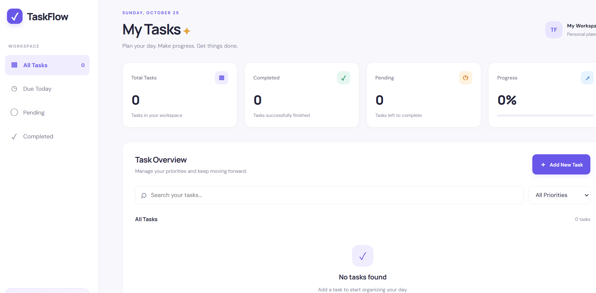
2. Adding a New Task
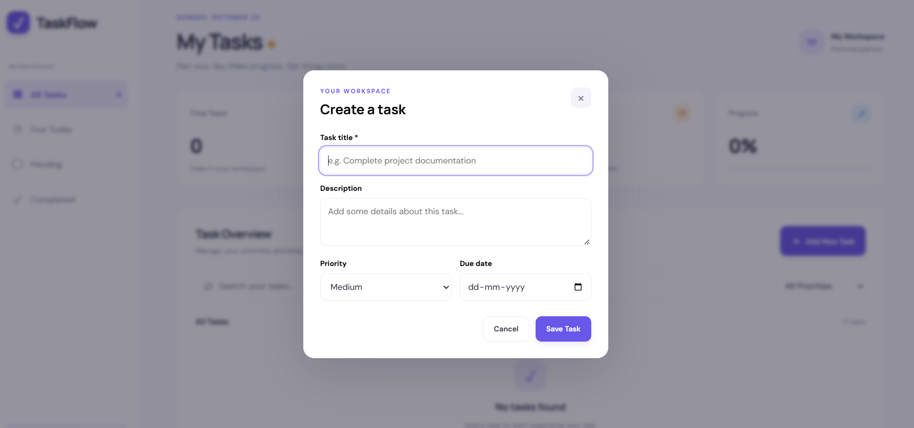
3. Task List with Completed and Pending Tasks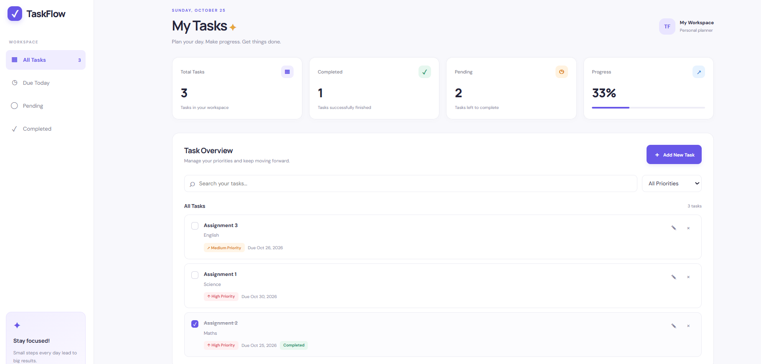

4. Search Functionality
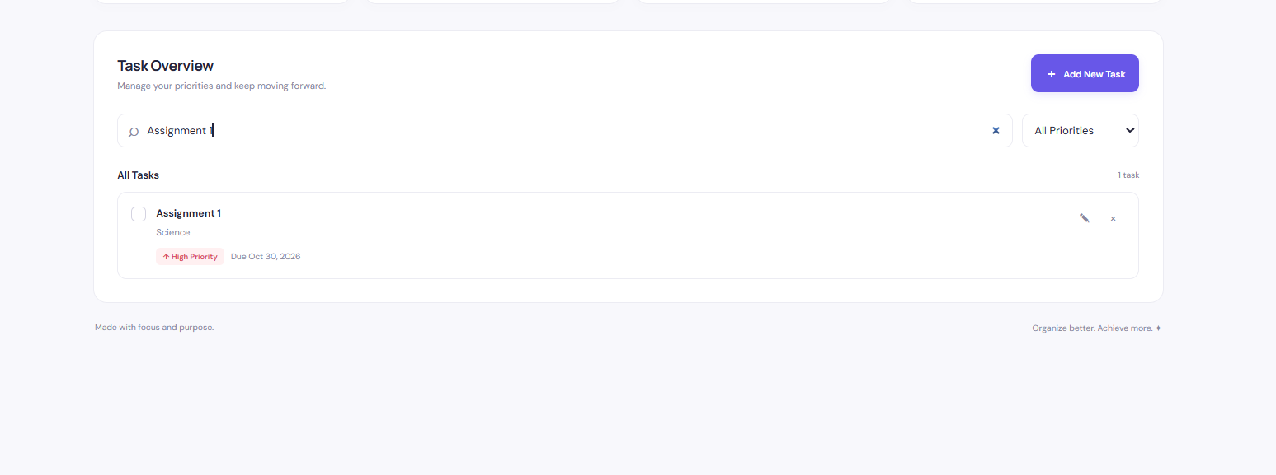
5. Website Displayed on a Mobile Screen
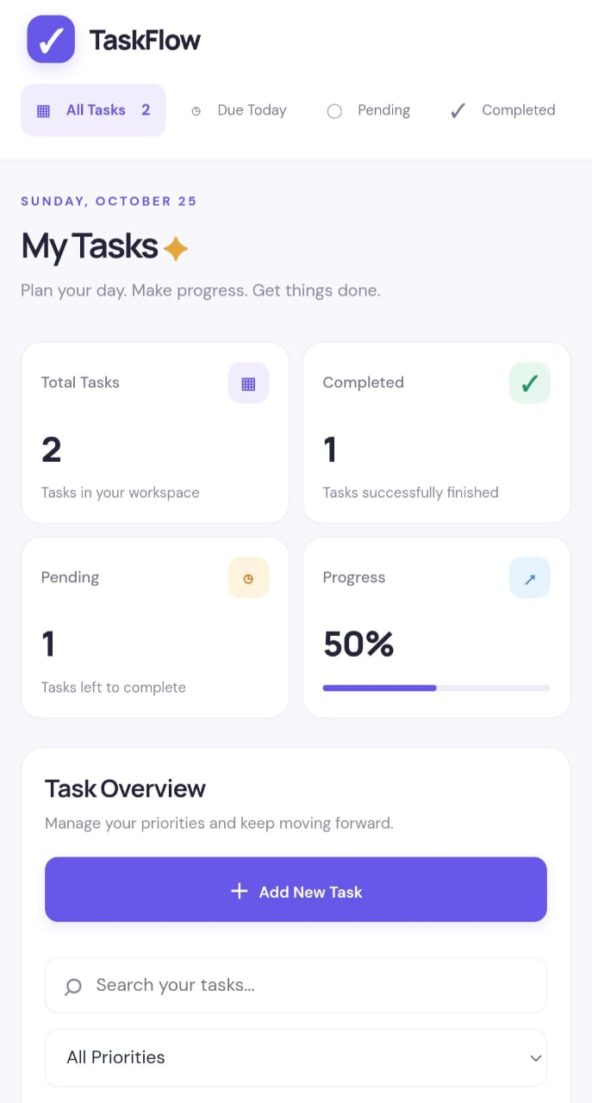
7. GitHub Repository and Live Website
- GitHub Repository: [https://github.com/shabbir-lokh/InternNova__Final_Project]
- Live Website: [https://shabbir-lokh.github.io/InternNova__Final_Project/]
8. Challenges Faced
During development, challenges included connecting JavaScript to the correct HTML elements, updating the task list dynamically, saving information after page refreshes, and making the layout responsive. Debugging JavaScript errors and ensuring that buttons worked correctly also required attention.
9. Solutions Implemented
These challenges were addressed by checking HTML element IDs, using JavaScript event listeners, storing tasks in local storage, and applying CSS Flexbox, Grid, and media queries. The application was tested by adding, completing, searching for, and deleting tasks.
10. Key Learnings
This project improved my understanding of HTML structure, CSS styling, responsive web design, JavaScript functions, arrays, objects, events, and DOM manipulation. I also learned how to use GitHub for version control and GitHub Pages for deployment.
11. Future Improvements
- User registration and login functionality.
- Task deadlines and dynamic reminders.
- Task categories and priority filters.
- Drag-and-drop task organization.
- Cloud synchronization across multiple devices.

