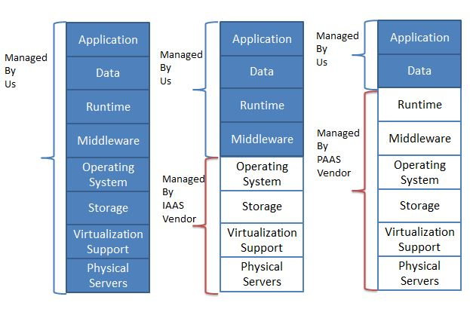

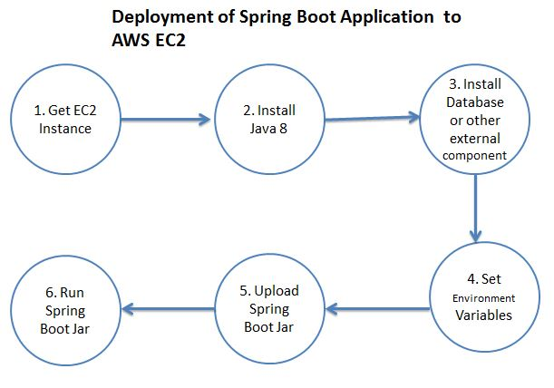

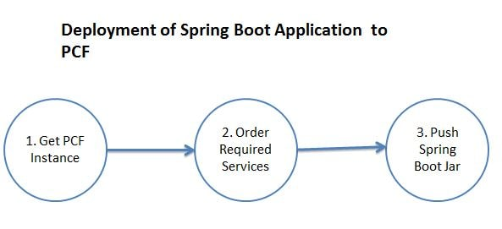

Cloud foundry CLI

cf login

It will ask for Cloud Foundry API. Enter The following API value-

https://api.run.pivotal.io

Go to the project root location and using the following command push the employee-producer jar file to PCF for deployment

cf push test-environment -p target\employee-producer-0.0.1-SNAPSHOT.jar

Select the application and we will be taken to another page which has the route on which this application has been deployed.

**UI**

<https://login.run.pivotal.io/login>

**command line CLI**

cf push spring-eureka-server -p target\spring-eureka-server-0.0.1-SNAPSHOT.jar