**Intelligent Restaurant With Smartbeacons**

**Team –ECE-C13**

1.Pavan Nandika - 19485A0430

2. Paladugu Sai Krishna - 19485A0431

3. Shabbir Khan Pathan - 19485A0432

4. Shaik Nadeem - 19485A0433

**Table of contents:**

1.Introduction

2. Literature Review

* Problem Statement
* Problem Evolution

3.Theoritical Analysis

* Block diagram
* Hardware/software designing

4.Flowchart

5.Results

6. Advantages &Disadvantages

7. Applications

8. Conclusion

9. Future Scope

10. Bibliography

11. Appendix

* Source Code
* UI output Screenshot

**Introduction**

Now day’s automation systems are everywhere whether its home, office or any big industry, all are equipped with automation systems. Restaurants/Hotels are also adopting recent automation trends and are installing robots to deliver food and tablets for taking orders. Using these digital menu cards like tablets, customers can easily select the items. This information will be sent to the kitchen of the Restaurant and also displayed on the display. According to a recent survey, around five billion people are using mobile phones, customers’ wants to network and connect with their favorite restaurants. Beacon technology has entered the restaurant market. And, beacons in restaurants is about to transform the entire industry. For a few years from now, the term “beacon” is circulated among tech enthusiasts. Earlier, very limited entrepreneurs were actively using beacon. However, a lot of other industries, including restaurants, have started exploring beacon. For those who are not aware about beacon technology for restaurant, here is some brief about it.

**Features**

* Adds intelligence to the restaurant by sending Welcome messages and special offers to attract the customers.
* The beacon broadcaster at each table sends the online Menu card for the customer where they can select the food items and place an order.
* While placing the order they need to specify their table number and any special instructions for cooking
* The orders placed at the tables are displayed in a web app in the kitchen.
* Voice command is also spoken out at the Kitchen for alerting the chef.

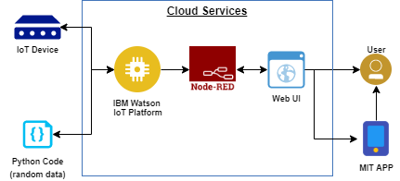

**Objectives**

The main objective of this project is to make the ordering system of restaurant digital and effective. People would not have to wait for ordering the food and any kind of booking services which will be eliminating delay in services.

**How do beacons work in restaurants?**

Beacons are small battery-powered devices that use Bluetooth low energy signals to connect with other smart devices. When a Bluetooth-enabled device such as a smartphone or tablet comes in the range of a beacon, the two devices can communicate.

There are many solutions and one such solution is making use of IoT. We have designed a mobile application which the customer uses when he/she enters the SMART restaurant. The beacon device which is deployed in the restaurant authorises the app and gives access to the server (for security purpose) where the information about the restaurant like Table availability, Menu ,Order placement and billing will be stored. Beacons are a small and inexpensive piece of hardware that transmits a message directly to a Smartphone or tablet using a low-energy Bluetooth connection. The message automatically transmits when customers and their phones come within a predefined range.

**Literature Review**

**Problem Statement**

Traditionally the method in which customers specify their desired menu to the waiter who takes the order on a paper. Personally, he then takes the order to the kitchen department and then he supply the food item to the customer. So, it was a time-consuming process. It leads to wastage of paper and also it requires reprinting of all menu cards. Also, in many cases for small change to be making in menu card it is not convenient to print all menu cards again and again. Simply saying that the menu card once printed can’t be changed. After some days, the menu card lost its worthy look and attractiveness.

**Problem Evolution**

Now a day everybody goes to the hotel or restaurant. At that time they have to spend too much time to give the order with pen and paper system. For that purpose they also have to wait for the waiter. To overcome this problem we had designed the system named as automatic menu ordering system. With the help of our system we had tried to reduce the task of manager by inventory management system.

The proposed system is a basically a combination of wireless communication system, a database, and an android application to place the order [2]. The android application is used by the touch screen device which fitted at the table. This android application contains all the information related to menu like picture of food item. The ordered details are sent to the kitchen and the cashier by wireless system. Android application at the manager side is used to update the menu a central Database, view and manage table wise customer’s orders, and receive feedbacks from the customer.

**Theoritical Analysis**

**Block Diagram:**

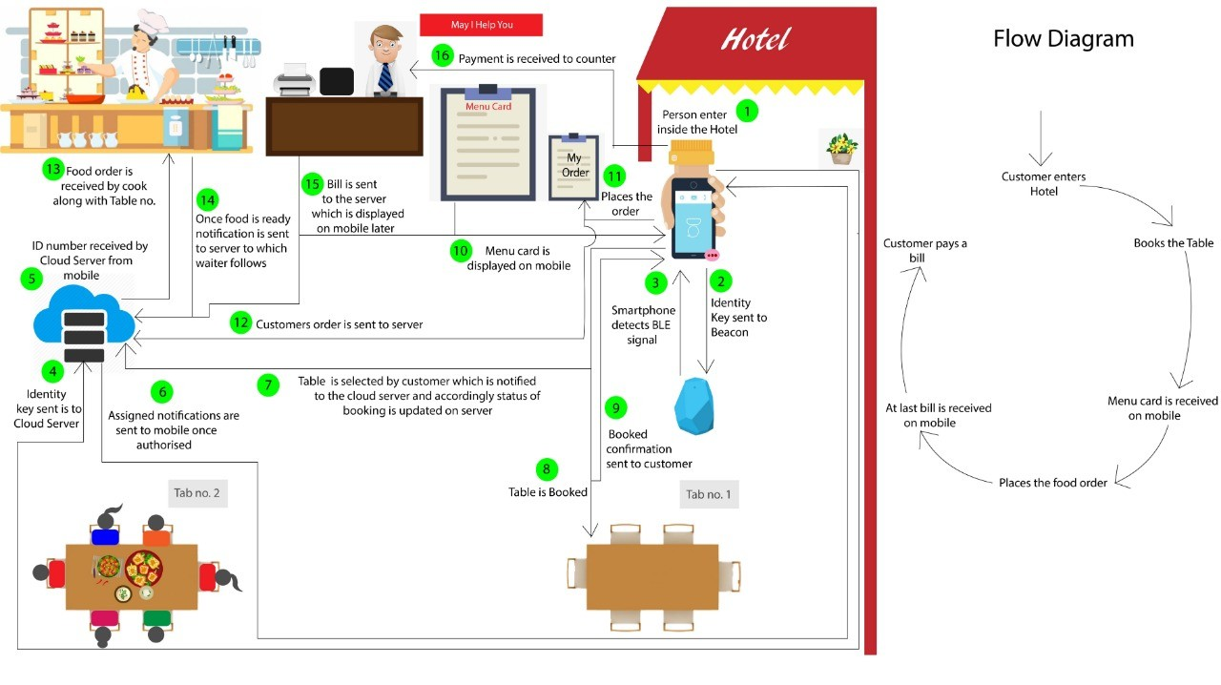

**Software/Hardware:**

1. Smartbeacons

2. IBM cloud Account

3. IBM IoT Platform

4. NodeRed

5. MIT App Inventor

Flowchart:

Customer Enters Restaurant

Books the Table

Customer pays a bill

Places the food order

Menu Card is received on mobile

At last bill is received on mobile

**Result**

**Python Code:**

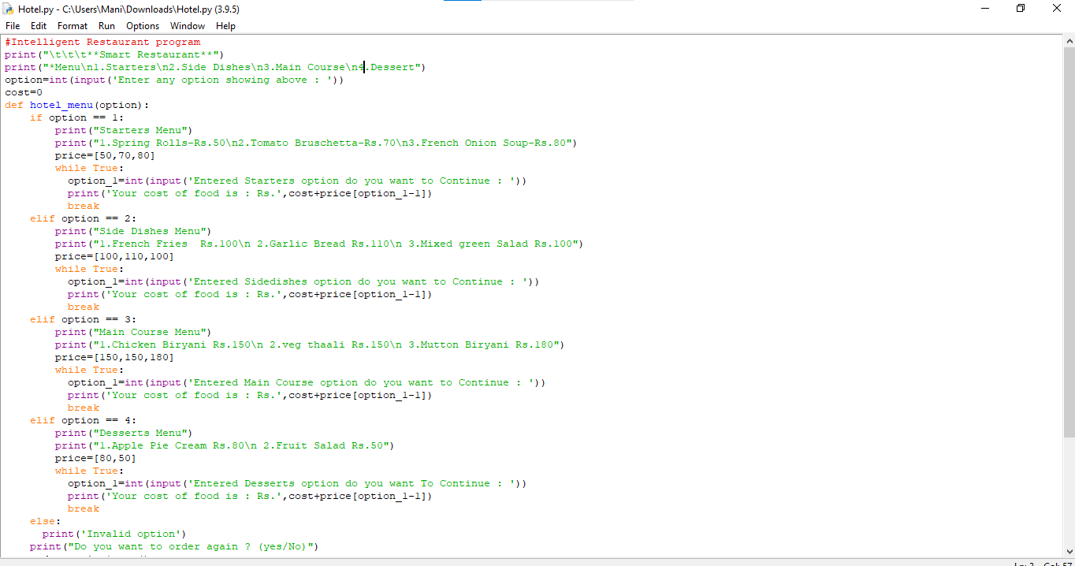

**Node-Red:**

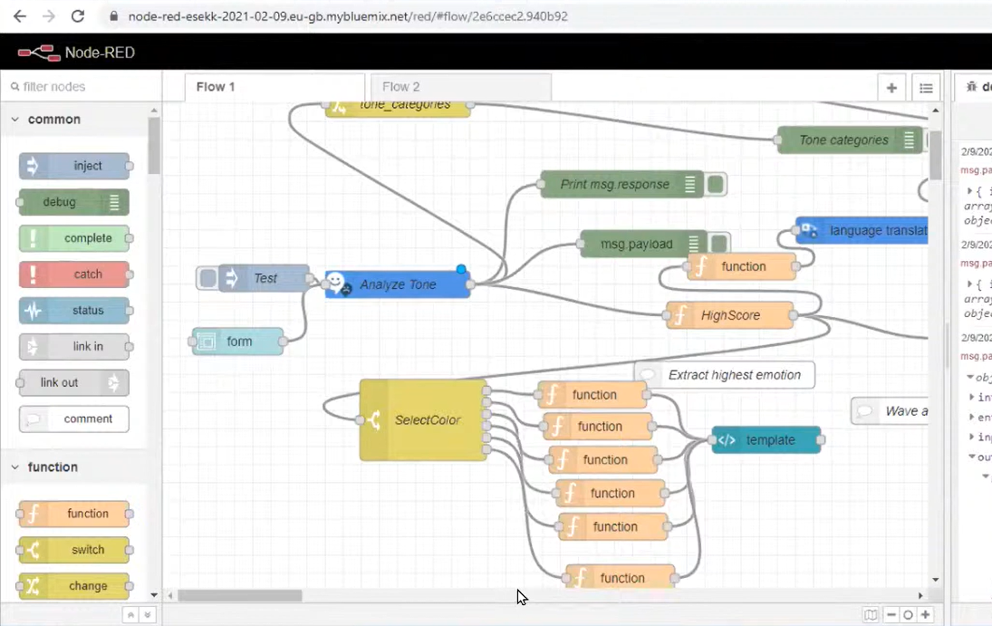

**MIT App:**

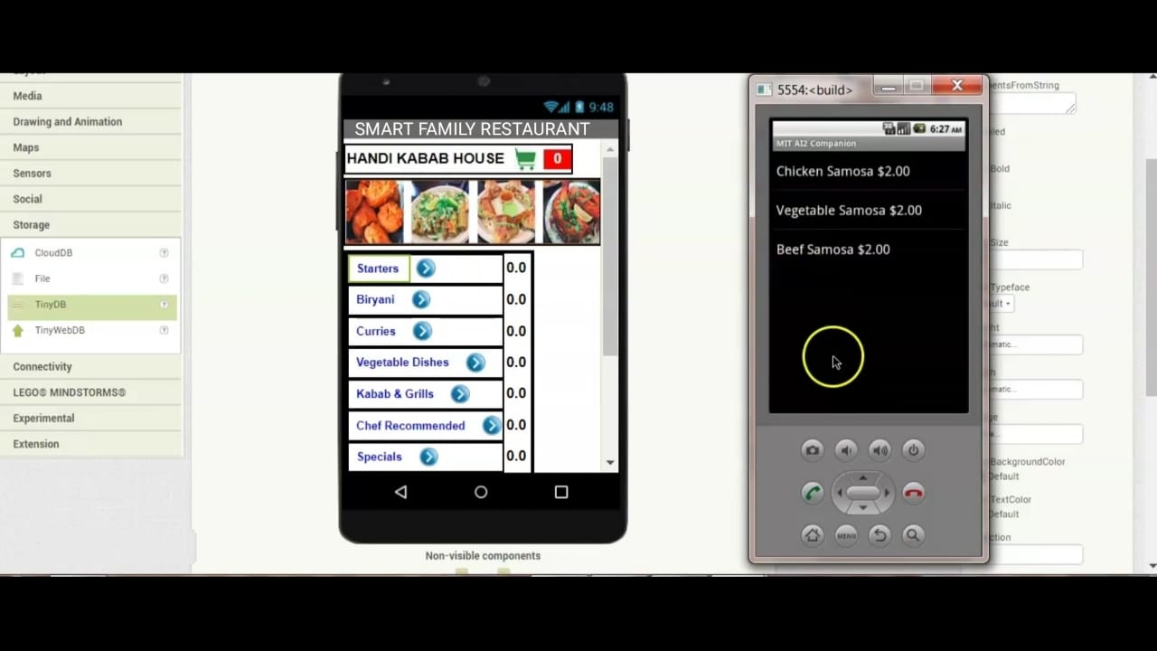

Smart Restaurant Menu

**Adavantages And Disadavntages**

**Advantages:**

* Better customer/user experience: By providing an interactive console it will satisfy the customer
* very well.
* Time saver: The delay in ordering of food in a fully packed restaurant can be overcome.
* No confusions: Sometimes the staff of the hotel/restaurant delivers the stuff to the wrong table
* which is not only irritating to customer but also embarrassing to the staff member. Thus providing
* a smart solution we can also handle this situation.
* Easy payments: The customer can now pay through e-wallet and Credit/Debit cards as well right from
* there table. Its Cashless era!!

**Dis-advantages:**

* Hard to use
* Not every customer who wants to eat at an automated restaurant will be familiar or comfortable with using technology which can make the experience daunting and intimidating. If a customer is having difficulty using any part of the automated restaurant, they may feel embarrassed to ask for help. This is especially the case if they see everyone else around them experiencing no difficulties.

**Applications**

Applications Now a days due to advancement of technology people are accustomed with touch screen interface. It is easily accessible by user to navigate by simply touching the display screen. With slight modification in this project, this system can be widely used at different public places like at canteens, hospitals, public transport, college libraries, theatres etc.

**Conclusion**

There is great advancement in technology due to its features like low cost and ease of use. This technology allows us a faster and more convenient access to the world. The Restaurant automation is a revolutionary concept & is sure to take people by surprise. This system is convenient, effective and easy thereby improving the performance of restaurant’s staff. It will also provide quality of service and customer satisfaction. It will undoubtedly change the way people dine & their dining habits. It would lead to increased revenues; give the customer a better insight into the kind of food they wish to have, give them a great touch experienced.

**Future Scope**

This project takes the order from the customer & lets him pay the bill without any human intervention. Here we used smart beacons, in future we can also use wifi, Bluetooth, Zigbee etc. We can add graphic images by using SD card and a display with higher dimensions. With the help Internet of Things (IoT), we can easily place the order just by sitting at home.

**Bibliography**

<http://cloud.ibm.com/registration>

<https://cloud.ibm.com/catlog/services/watson-studio>

<https://www.fast2sms.com/dashboard/sms/bulk>

<https://Ai2.appinventor.mit.edu>

<http://flows.nodered.org/node/nod-red-dashboard>

<https://developer.ibm.com/recipes/tutorials/ui-dashboard-for-iot-device-data-using-node-red/>

<http://appinventor.mit.edu>

**Result**

**Output:**

