Hi Mark,
I have put up the release on the staging server. http://focusdirect.dnsalias.com/ This will go in to production tomorrow after I hear a positive feedback and if there are not too many issues. Please test the site with your regular operations such as creating brief take/web ads. Sending stuff. This is critically important before we move to production. Also look at the following resolved issues. Please do not send any more requests for additions to the already implemented issues as it would delay the release further.
When trying to edit an expired web ad to make it LIVE so that we can attach a test CV to the assignment the following error appears:
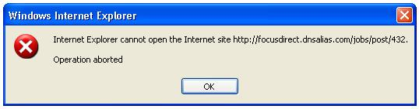

Please check and rectify to do a check on the complete process of the system

Resolved Issues
Feature #48: Additions to the awards page
Wednesday 27 August 2008 05:37 PM
Modify the awards page by adding the stuff sent in the email. – DISABLE the link to SGR only.
Feature #43: Announcement line
Tuesday 26 August 2008 05:31 PM
The announcement line should extend all the way to the right. – we want the announcement scrolling on all the pages – i.e. Candidates. Clients, Emiratisation, Careers with Us, Contact Us etc. This top section has to be same on ALL PAGES
Feature #42: Change logo of the backend
Tuesday 26 August 2008 05:30 PM
Change the logo displayed on the backend to Since 1999 – Done OK
Feature #40: New Assignment
Tuesday 26 August 2008 02:50 PM
New Assignment: Colour of email to be different (for 10 days). Cannot check no emails in inbox – Done OK
Feature #38: Sourcing CV
Tuesday 26 August 2008 02:26 PM
Sourcing CV's
Need to have an option to select the content of the mail that is sent to the candidate when we source the CV, this is required as some candidates mention their official id in the CV, for that purpose we want to select content that will be sent to the candidate: 1. Personal Id (default), 2. Official Id. Not Done, system does not ask for email content selection –To be able to Edit the SUBJECT line also. To confirm with Ma’am if (mail content Box) is OK
Feature #36: Backend color
Monday 25 August 2008 07:07 PM
Change the backend color to maroon, the same color used on the front end. This is a small change but will make the clients very happy. – Done but the links to be in another colour as Blue clashes with Maroon
Feature #35: Inbox and career with us
Monday 25 August 2008 04:38 PM
Backend: Option to view 'x' number of CV's per page
I have already implemented this. Check if that works – Done OK
Careers with Us: to be put in a subfolder of INBOX, to be kept as BOLD if new/unread mail is in the folder access to this folder is by admin only. Done, but cannot check-no emails in inbox
Feature #34: Schedule to Meet email to candidate
Monday 25 August 2008 04:31 PM
The date format to be elaborated for i.e September 10, 2007 in the mails we send for appointments instead of 2007-09-10. Cannot check as error while Scheduling a meet as mentioned above. When scheduling a meet, to display interview name by default will be log in name which can be edited by coordinator who is arranging meeting for the consultant on their behalf. – Done the Confirmation of Appointment email is not being displayed in the OUTBOX

Feature #33: Placed Candidates
Monday 25 August 2008 04:27 PM
Change colour of listing or flashing image saying placed. On clicking link can see the Assignment / Client Applications Received Page Yet to CHECK as process of recruitment on the system is not complete
Listing is to be displayed in descending order of date received – Done OK
Feature #32: Consultant information
Monday 25 August 2008 04:22 PM
When a registered candidate is due to be met by a consultant, to avoid duplicacy : this can reflect on the met column as in scheduled to meet by(consultants name) Cannot check as error while Scheduling a meet. Error message is: no such file or directory….. public/docs/roadmap.doc – Done OK
Feature #31: Candidate photo
Monday 25 August 2008 03:47 PM
We want to include a field where the candidate is to attach his / her photo. This field is to be mandatory as we would like to have a better recall on each candidate. A short note is to be put below that field informing the candidate about this requirement. Not Done - Not Working – Error being displayed, snap shot below:
Need to keep a check that the file attached is not more than 20 Kb and must be a .jpg / image file (please confirm is this size is appropriate) Not Done – NOT WORKING when I attached a JPEG file to my profile on the TEST site the profile is not being saved and gives the message below.
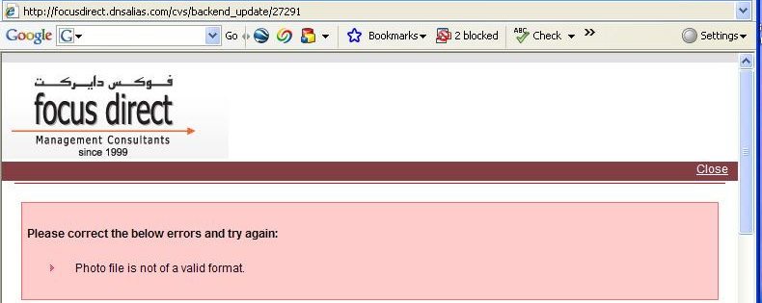

This field is Not to be mandatory in the sourcing module. Done OK
Feature #30: CV list
Monday 25 August 2008 03:37 PM
Applied For link to show reference number of the ad as its very difficult to check which assignment has the candidate actually applied for. System Error, contact webmaster is being displayed Done but reduce the space in the box as candidates apply for several positions
Feature #29: CV list pages
Monday 25 August 2008 03:33 PM
The view notes link should be visible only when there are notes to be viewed else the add link to be visible, that way when viewing the page consultants know that a particular CV has notes that can be viewed. Done, but after adding a NOTE, the Add note link is not being displayed, both VIEW & ADD links are required so that several notes can be added to a profile. Done OK The same goes for the History & Applied For links Not Done Need to have a way to identify which CV displayed is sourced or Direct need to mention "sourced" or "direct" in CV Details page Not Done – Still NOT DONE
Feature #28: Inbox Message View Page
Monday 25 August 2008 03:31 PM
Need the link saying next and previous mail – currently we have to Done OK
Feature #27: Awards Page
Monday 25 August 2008 02:56 PM
Awards (new section with backend interface to manage content). Done, but when clicking on the Events Gallery link in the About Us page, the link goes to the Contact Us page which does not have the Awards link. The Menu on the left side in About Us should not change when we click on a link. PLEASE REMOVE THE DETAILS ON SGR along with Ms Jennifer’s Photo from this link.
Check if the page and the links are showing up fine. Emailed are the images to be shown.
Comments on Awards Link:
- Gateway
  - Image has been distorted, to be reduced in size (if required) but proportionately, Image to be clickable, on clicking the image the FULL view (larger size image with the content to be displayed)
- Princeton Premier
  - This is a separate award.
  - Content: Due to her outstanding efforts in the field of business management, Princeton Premier is proud to announce Jennifer Randive as a lifetime member and is considering her for the 2007-2008 Princeton Premier Professional of the Year Award.

