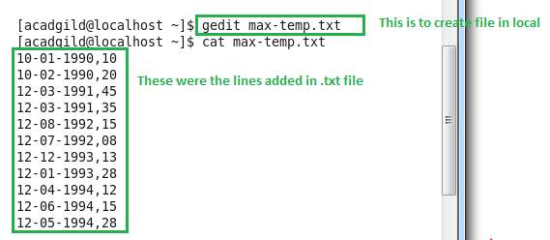

Command for moving file from local to HDFS

hadoop fs –put /home/acadgild/max-temp.txt /user/acadgild/hadoop/

