                              

* Fetch date and temperature from temperature_data where zip code is greater than 300000 and less than 399999.

Select date,temperature from temperature_data where zipcode>300000 And zipcode<399999;

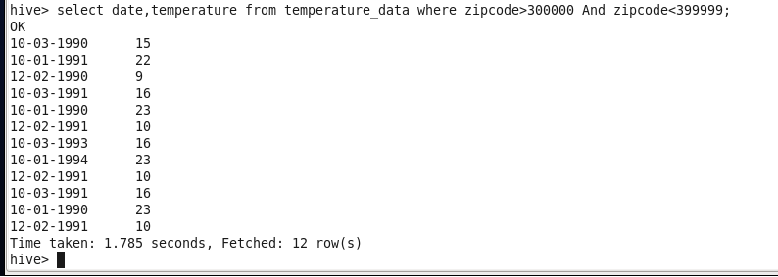

* Calculate maximum temperature corresponding to every year from temperature_data table.

Select year(cast_to(date(from_unixtime(unix_timestamp(date,’dd-mm-yyyy’))) As date)) ,max(temperature) from

temperature_data Group By year(cast_to(date(from_unixtime(unix_timestamp(dd,’dd-mm-yyyy’))) As date));

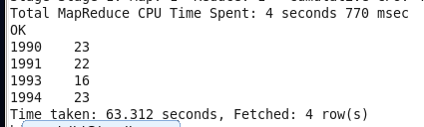

* Calculate maximum temperature from temperature_data table corresponding to those years which have at least 2 entries in the table.

Select year(cast_to(date(from_unixtime(unix_timestamp(date,’dd-mm-yyyy’))) As date)) ,max(temperature) from

temperature_data Group By year(cast_to(date(from_unixtime(unix_timestamp(dd,’dd-mm-yyyy’))) As date)) Having

Count(year(cast_to(date(from_unixtime(unix_timestamp(date,’dd-mm-yyyy’))) As date)))=2;

          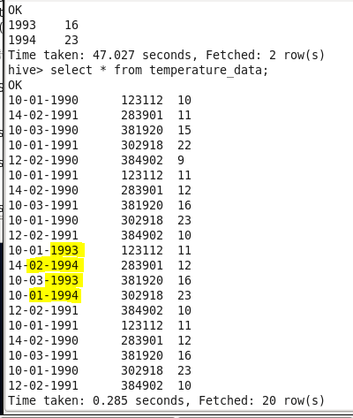

* Create a view on the top of last query, name it temperature_data_vw.

Create view temperature_data_vw As

Select year(cast_to(date(from_unixtime(unix_timestamp(date,’dd-mm-yyyy’))) As date)) ,max(temperature) from

temperature_data Group By year(cast_to(date(from_unixtime(unix_timestamp(dd,’dd-mm-yyyy’))) As date)) Having

Count(year(cast_to(date(from_unixtime(unix_timestamp(date,’dd-mm-yyyy’))) As date)))=2;

To view the result as view will not display the data;

Select * from temperature_data_vw;

        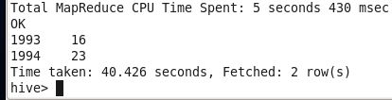

* Export contents from temperature_data_vw to a file in local file system, such that each file is '|' delimited.

Insert Overwrite local directory ‘/home/acadgild/hiveoutput5’ ROW FORMAT DELIMITED FIELDS TERMINATED BY ‘|’

Select * from temperature_data;

