(a) Top 5 employees (employee id and employee name) with highest rating.

(In case two employees have same rating, employee with name coming first in dictionary should get preference)

A = LOAD ‘employee_details.txt’ Using PigStorage(‘,’) AS (ID:int, Name:chararray, Salary:int, Rating:int);

B = ORDER A BY Rating,Name ASC;

C = LIMIT B 5;

D = FOREACH C GENERATE ID,Name;

DUMP D;

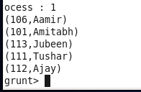

(b) Top 3 employees (employee id and employee name) with highest salary, whose employee id is an odd number.

(In case two employees have same salary, employee with name coming first in dictionary should get preference)

A = LOAD ‘employee_details.txt’ Using PigStorage(‘,’) AS (ID:int, Name:chararray, Salary:int, Rating:int);

B = ORDER A BY Salary DESC;

C = Filter B By ID%2!=0;

D = Limit C 3;

E = FOREACH D GENERATE ID,Name;

DUMP E;

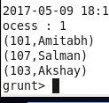

(c) Employee (employee id and employee name) with maximum expense

(In case two employees have same expense, employee with name coming first in dictionary should get preference)

A = LOAD ‘employee_details.txt’ Using PigStorage(’,’) AS (ID:int, Name:chararray, Salary:int, Rating:int);

B = LOAD ‘employee_expenses.txt’ Using PigStorage(‘\t’) AS (OID:int, Expenses:int);

C = JOIN A BY ID,B BY OID;

D = ORDER C BY Expenses DESC,Name ASC;

E = FOREACH D Generate ID,Name;

F = Limit E 1;

DUMP F;

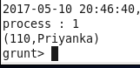

(d) List of employees (employee id and employee name) having entries in employee_expenses file.

A = LOAD ‘employee_details.txt’ Using PigStorage(’,’) AS (ID:int, Name:chararray, Salary:int, Rating:int);

B = LOAD ‘employee_expenses.txt’ Using PigStorage(‘\t’) AS (OID:int, Expenses:int);

C = JOIN A BY ID,B BY OID;

D = FOREACH C Generate ID,Name;

E = Distinct D;

Dump E;

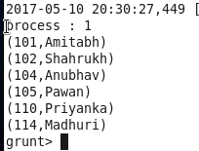

(e) List of employees (employee id and employee name) having no entry in employee_expenses file.

A = LOAD ‘employee_details.txt’ Using PigStorage(’,’) AS (ID:int, Name:chararray, Salary:int, Rating:int);

B = LOAD ‘employee_expenses.txt’ Using PigStorage(‘\t’) AS (OID:int, Expenses:int);

C = JOIN A BY ID LEFT OUTER,B BY OID;

D = Distinct C;

E = Filter D BY Expenses IS NULL;

F = FOREACH E Generate ID,Name;

DUMP F;

