1. **What is the total amount of petrol in volume sold by every distributer?**

A = Load ‘home/acadgild/dataset4pigtask1of9.txt’ Using PigStorage(‘,’) As (dID:chararray, Dname:chararray, brate:chararray, srate:chararray, vIn:int, vOut:int, year:int);

B = Group A By Dname;

C = Foreach B Generate group As grp,SUM(A.vOut);

Dump C;

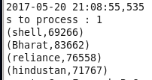

1. **Which are the top 10 distributers ID's for selling petrol? Also display the amount of petrol sold in volume.**

A = Load ‘home/acadgild/dataset4pigtask1of9.txt’ Using PigStorage(‘,’) As (dID:chararray, Dname:chararray, brate:chararray, srate:chararray, vIn:int, vOut:int, year:int);

B = Group A By dID;

C = Foreach B Generate group As grp,SUM(A.vOut) As tsale;

D = Order C By tsale DESC;

E = Limit D 10;

Dump E;

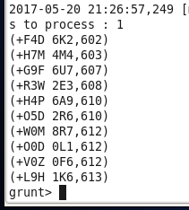

1. **List 10 years where consumption of petrol is more with the distributer id who sold it.**

A = Load ‘home/acadgild/dataset4pigtask1of9.txt’ Using PigStorage(‘,’) As (dID:chararray, Dname:chararray, brate:chararray, srate:chararray, vIn:int, vOut:int, year:int);

B = Group A By year;

C = Foreach B Generate group As grp,A.dID As Did,SUM(A.vOut) As maxs;

D = Order C By maxs DESC;

E = Limit D 10;

Dump E;

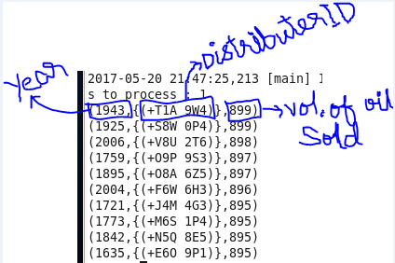

1. **Find the distributer name who sold petrol in least amount.**

A = Load ‘home/acadgild/dataset4pigtask1of9.txt’ Using PigStorage(‘,’) As (dID:chararray, Dname:chararray, brate:chararray, srate:chararray, vIn:int, vOut:int, year:int);

B = Group A By Dname;

C = Foreach B Generate group As grp,SUM(A.vOut) As tsale;

D = Order C By tsale ASC;

E = Limit D 1;

Dump E;

