We have Pokemon file. Use MR mode while running Pig and write Pig Latin script to get below results:

Form two lists of 5 randomly selected Pokémons with some parameters listed below.

1) For all Pokemon DEFENCE must be greater than 55

2) **random()** is must to use in the script.

3) List should be arranged in descending order

4) Store the list in Local Drive.

Load_Data = LOAD '/user/acadgild/data1/Pokemon.csv' USING PigStorage(',') As(Sno:int, Name:chararray, Type1:chararray, Type2:chararray, Total:int, HP:int, Attack:int, Defense:int, SpAtk:int, SpDef:int, Speed:int);

selected_list = FILTER Load_Data BY Defense>55;

gourp_selcted_list = Group selected_list All;

count_selcted_list = foreach gourp_selcted_list GENERATE COUNT(selected_list);

random_include1 = Foreach selected_list GENERATE RANDOM(),Name,Type1,Type2,Total,HP,Attack,Defense,SpAtk,SpDef,Speed;

random1_desending = ORDER random_include1 BY $0 DESC;

random_include2 = Foreach selected_list GENERATE RANDOM(),Name,Type1,Type2,Total,HP,Attack,Defense,SpAtk,SpDef,Speed;

random2_desending = ORDER random_include2 BY $0 DESC;

limit_data_random1_desending = LIMIT random1_desending 5 ;

limit_data_random2_desending = LIMIT random2_desending 5 ;

filter_only_name1 = Foreach limit_data_random1_desending Generate ($1,HP);

filter_only_name2 = Foreach limit_data_random2_desending Generate ($1,HP);

STORE limit_data_random1_desending INTO '/user/acadgild/PigOutput/player1.txt';

STORE limit_data_random2_desending INTO '/user/acadgild/PigOutput/player2.txt';

Files in PigOutput folder:-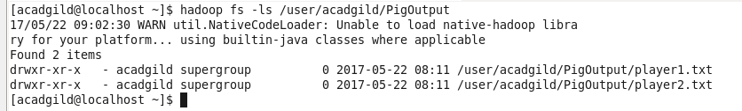

Player1 output

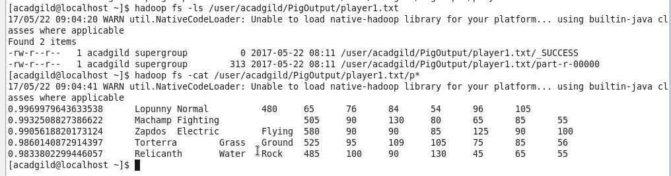

Player2 Output

