Create a file max-temp.txt in local FS.

Put some 10-15 records of date and temperature example: dd-mm-yyyy,temperature

Example: 10-01-1990,10 10-02-1991,20 Move this file to HDFS at /user/acadgild/hadoop.

Command for creating file in local is gedit max-temp.txt

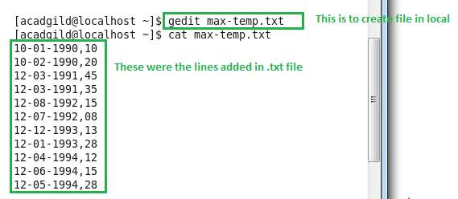

Command for moving file from local to HDFS

hadoop fs –put /home/acadgild/max-temp.txt /user/acadgild/hadoop/

