The UI Table Displays columns with

* Number of comments
* Points
* Pointer
* Title
* url (clickable and opens in the new window)
* Author
* Time in hours of the content uploaded. The logic is calculated accordingly to the completed hours.
* Hide – clicking on hide will hide the following row. As requested the row is pushed to the local storage of the browser. Can be viewed in the browser local storage memory.
* The setState is performed for remaining list of items to be displayed in the page.

API used : https://hn.algolia.com/api/v1/search?tags=front_page

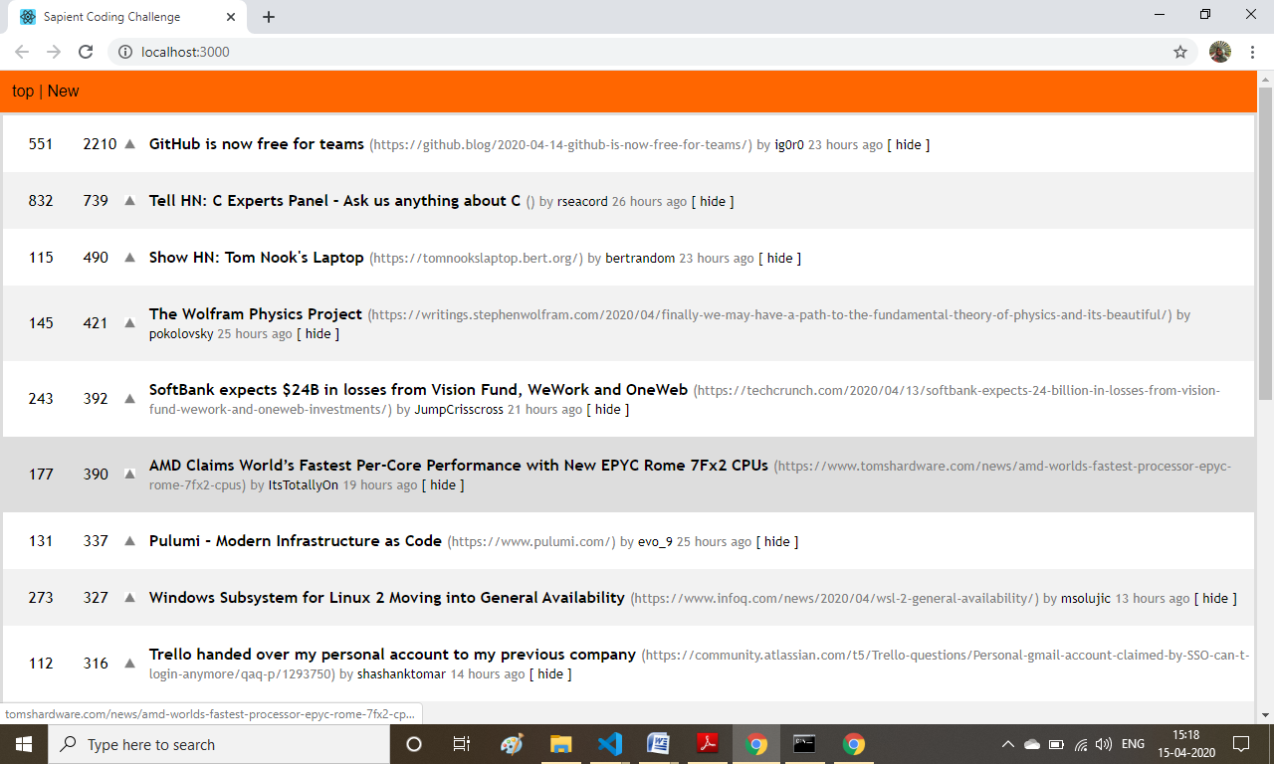

Local Storage items – when clicked on hide button

