PRODUCT AND ENGINEERING SPECIFICATION • VERSION 1.0

Offline Social-Engineering Training & Evaluation Application
  - A self-contained build brief for a safe, scenario-rich system limited to WhatsApp, Instagram, Email and SMS
AUDIENCE: Developer / technical lead | DEPLOYMENT: closed offline LAN, with standalone mode | ATTEMPT: 10 scenarios, 5-6 stages each | RESULT: 0-100 + progress history
BUILD OUTCOME A learner signs in with name and service/personal number, works inside four generic application simulators, completes ten unpredictable but coverage-balanced narratives, receives explainable feedback, and logs out. The next learner can use the same PC without seeing the prior session. Instructors manage content and results locally; the product never sends a real message or reaches the internet.

1. Product contract and reconciled scope
Purpose. Train and evaluate the pause-inspect-verify habit against attempts to obtain information, money, credentials/OTP codes or access to a mobile account/device. It is an educational simulator, not an offensive toolkit or a clinical psychology test. Success means realistic decisions, consistent scoring, saved improvement and safe offline operation - not pixel-perfect copying of commercial brands.
Decision | Version-1 requirement
Channels | WhatsApp-style chat/call UI, Instagram-style feed/DM, webmail-style Email, native-style SMS. Every attempt includes all four.
Attempt | Exactly 10 version-locked scenarios. Each is a 5-6-node decision story; it may stay in one channel or hand off only to another allowed simulator.
Modes | Evaluation: explanations withheld until the end. Guided training: explain after each scenario. Mode is fixed when the attempt starts.
Identity | Learner baseline: name + unique service/personal number on a controlled network. Instructor/admin uses a separate authenticated role.
Deferred / excluded | Telegram, QR-only module, normal telephone/vishing module, live email/SMS, external SSO, cloud services, online AI/LLM, camera/microphone, real payments and malware.

2. End-to-end learner flow
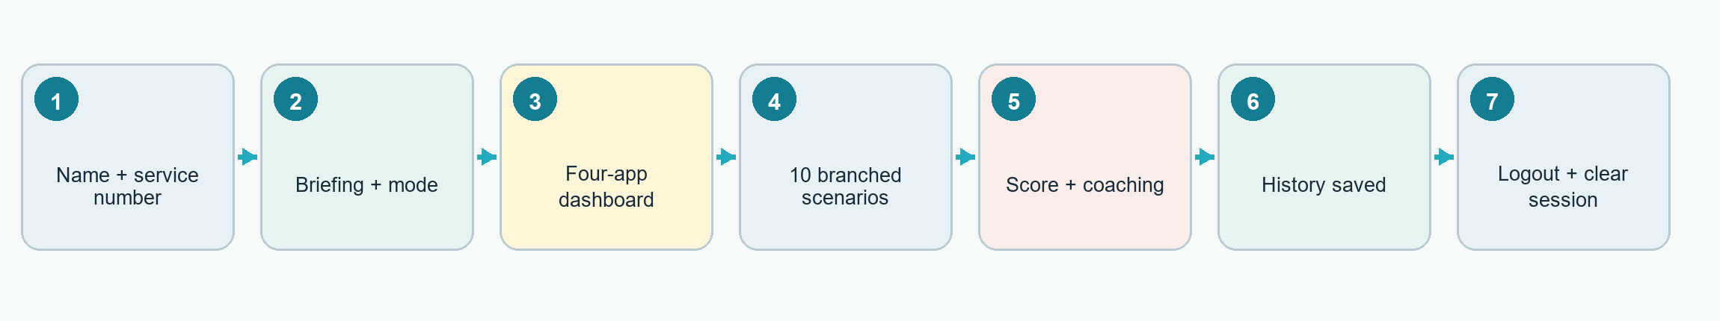
Figure 1. Required learner journey and session boundary.

3. Screens, roles and visible behavior
Role | Surface | Must do
Learner | Login / briefing | Validate unique number; display simulation consent, rules and mode. Never reveal which queued messages are malicious.
Learner | Four-app dashboard | Unread badges, attempt progress, current score hidden in evaluation mode, resume state and completed-scenario indicators.
Learner | Simulators | Familiar generic layout; inspect sender/profile/domain/context; reply, click internal link, ignore, report, block, delete or verify via a known channel.
Learner | Result / history | Score, scenario explanations, platform and trigger breakdown, false-positive caution, safer action, and comparison with prior attempts.
Instructor | Local admin console | Users/units, scenario draft-preview-publish-retire, assignments, attempts, reset/void, reports, exports, backup/restore and audit log.

Reconciliation: retain the safe randomized engine and four-interface telemetry/scorecard; replace the linear module order with a balanced ten-scenario attempt. The .crdownload is a duplicate MHTML snapshot of the PDS.

2 | Offline architecture & runtime behavior
Local-first, reproducible and deployable on one PC or multiple PCs inside a closed network.
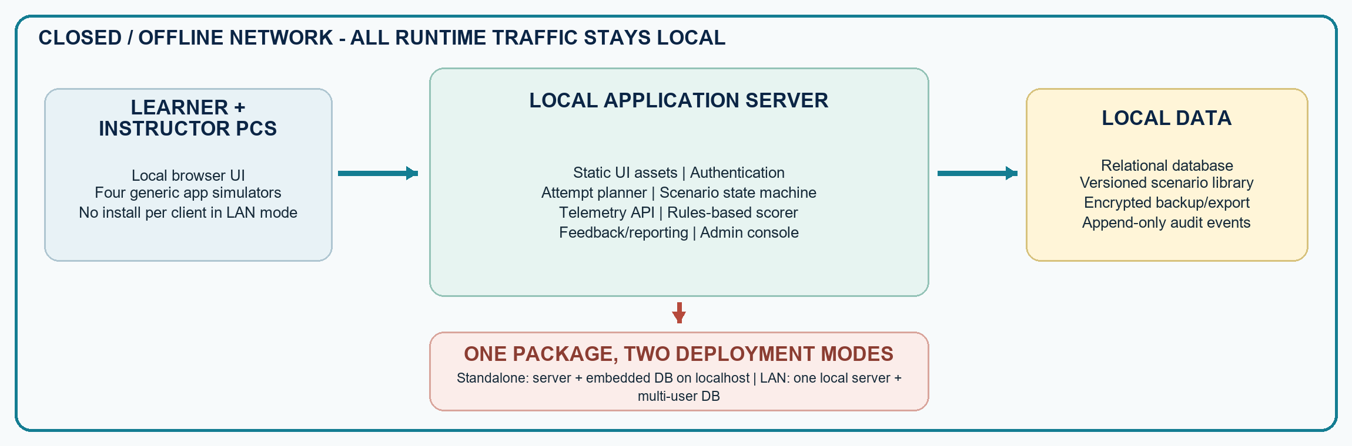
Figure 2. Logical architecture and the two supported deployment modes.

4. Component responsibilities and interfaces
Component | Responsibility | Invariant
Local web client | Renders dashboard and four simulators; keyboard-accessible interactions; holds only transient view state. | No CDN, remote font, analytics, ad, map, avatar or external URL.
Auth/session | Learner lookup/create; admin role check; inactivity timeout; explicit logout; kiosk/session cleanup. | Server-side session ID; no score or role trusted from client storage.
Attempt planner | Selects 10 scenario versions using constraints and a stored random seed; supports replay/audit. | Selection is atomic and immutable after first scenario starts.
Scenario engine | Loads current node, validates permitted action, applies branch, emits next node and safe consequence. | Server is authoritative; client cannot submit arbitrary next_node or points.
Event + scoring | Records purposeful interactions and calculates rules-based stage/scenario/attempt scores. | Deliberate events only; never raw mouse trails, clipboard, unrelated keys or actual secrets. Idempotency prevents duplicate scoring.
Feedback/reporting | Produces learner coaching, history comparison and local instructor reports/CSV/PDF export. | Derived from stored scenario version + responses; export contains a sensitivity marking.
Content/admin | Draft, validate, preview, publish immutable version, clone and retire scenarios; manage units/users. | Published content used by an attempt is never edited or hard-deleted.

5. Deployment and operational model
- Baseline: one local server on a closed/offline LAN; learner PCs use a supported browser at a local address. The same package runs on localhost for a standalone PC. Use a database adapter: embedded relational DB for standalone; multi-user relational DB for LAN.
- Ship an offline installer/bundle containing runtime, UI assets, fonts, database migrations, starter content, license notices and a health-check utility. Installation, normal use, reporting and backup must succeed with the internet physically disconnected.
- Bind only to the configured local interface; firewall to the training subnet; use local TLS where certificates can be administered. Deny outbound DNS/HTTP at host and application layers. Content Security Policy should restrict scripts, media, forms and connections to self/local approved origins.
- Atomic persistence after every learner action enables crash recovery. On restart, resume the latest in-progress attempt at its last committed node; never silently generate a replacement sequence or recalculate against a newer scenario version.
- Concurrency target for initial acceptance: 25 simultaneous learners on agreed reference hardware, with screen transitions under 500 ms at the 95th percentile and no cross-session data leakage. Make this target configurable for larger unit deployments.

6. Runtime request flow
Step | Transaction | Required behavior
A | Sign in | POST learner identity → normalize service number → find/create permitted profile → create server session.
B | Start | Choose mode/assignment → planner persists attempt, seed and ordered scenario-version list → return dashboard.
C | Interact | Client requests node → renders only approved synthetic payload → posts action/event with idempotency key.
D | Decide | Server validates current node/action → stores response and deliberate telemetry → applies branch + points → returns next node.
E | Finish | After scenario 10, freeze total → generate feedback snapshot → update history → offer local print/export.
F | Logout | Invalidate session; clear client state, cached rationale and simulated form fields; return to neutral login screen.

3 | Scenario engine, content model & scoring
Unpredictable presentation with reproducible selection, safe branching and explainable negative marking.

7. Attempt composition and randomization
Constraint | Rule
Count | 10 scenarios; each maximum +10 and minimum -8; every scenario has 5-6 interactive nodes.
Platforms | Each of four platforms appears 2-3 times; no same platform more than twice consecutively.
Difficulty | 2 Easy + 5 Medium + 3 Hard; difficulty changes ambiguity/branching, not maximum points.
Legitimacy | 7 malicious + 3 believable legitimate scenarios; legitimate items are required to measure excessive suspicion.
Diversity | At least four attack families and four manipulation triggers; avoid the learner's last-attempt items when the pool permits.
Library floor | Launch with at least 60 validated scenarios: ≥15/platform, ≥4 legitimate/platform, all difficulty levels represented.

Selection algorithm. Filter active compatible versions, then run seeded weighted backtracking until all constraints pass. Weight under-exposed platforms, attack families, triggers and unseen scenarios. Persist the seed and ordered version IDs before play. If the library cannot satisfy the contract, stop with an instructor-facing insufficiency report; never weaken constraints silently.

8. Scenario state machine
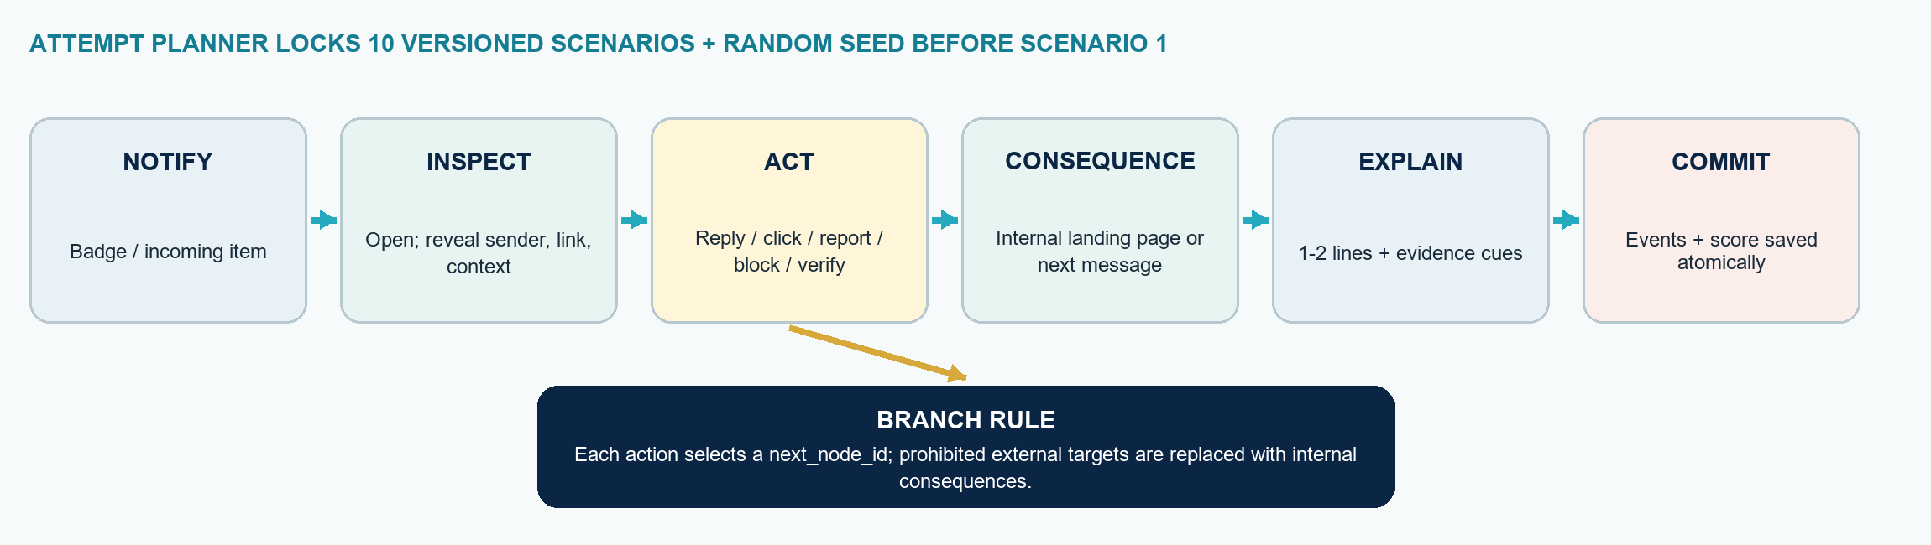
Figure 3. Authoritative 5-6-stage scenario state machine.
Node types: notification, inbox/feed/chat, inspection reveal, action prompt, internal landing/consequence, reply composer, verification prompt, rationale and terminal feedback. Choice record: action_code, allowed current node, next_node_id, point rule, severity flag, feedback key and expected evidence tags. Any typed response is HTML-escaped; only the rationale is retained.

9. Scenario taxonomy and authoring coverage
Platform | Required families and legitimate controls
Email | Credential/reset or policy lure; executive/vendor payment change; invoice/attachment; HR/recruitment; data request; safe calendar/newsletter/receipt.
SMS | KYC/account freeze; parcel/customs; e-challan/utility; SIM/OTP; job/reward; callback pressure; safe bank/appointment/delivery notice.
WhatsApp | OTP misdirection; known-contact takeover; relative in distress; parcel/payment; group/admin impersonation; digital-arrest chat/simulated in-app call; safe team/family chat.
Instagram | Cloned friend; fake support/copyright appeal; giveaway/influencer; brand collaboration; romance/trust grooming; recovery scam; safe DM/order/update.

Every published scenario must also declare: learning objective; attack family; platform; difficulty; legitimate/malicious flag; manipulation trigger (authority, urgency, fear, trust, curiosity/reward, empathy, scarcity/social proof); observable cues; safest action; acceptable alternatives; branch map; score rubric; feedback; synthetic assets; accessibility text; expiry/review date; author, reviewer and immutable version.

10. Explainable scoring and feedback
FORMULA Per scenario S = Observation O(0..2) + Judgment J(-2..2) + Action A(-4..4) + Rationale R(-2..2); attempt = clamp(round(sum of 10 S), 0, 100). Rationale: +2 specific cues + trusted verification, +1 generic, 0 blank, -2 unsafe logic; use deterministic evidence tags and store the 1-2-line text. Bands: 85-100 Strong, 70-84 Developing, 50-69 Reinforcement, below 50 Immediate coaching.
Part | Points | Rule
Observation | +2 inspect decisive cues; +1 partial; 0 none | Never reward time delay alone; accessibility or reading speed must not become a penalty.
Judgment | +2 correct; 0 uncertain; -2 wrong | Calling a verified legitimate item malicious is a false positive and loses marks.
Action | +4 safest; +2 safe/incomplete; 0 neutral; -2 over-cautious; -4 risky | OTP/credential/payment/data disclosure is critical. Reporting/blocking a legitimate item without evidence is over-cautious.

Feedback: cues, safer action, impact, platform accuracy, false-positive rate and attack/trigger trend. The trigger profile is non-clinical; never use it for diagnosis or personnel suitability.

4 | Data model, safety boundaries & acceptance
Minimum entities, controls and testable conditions for delivery hand-off.

11. Relational data model and retention
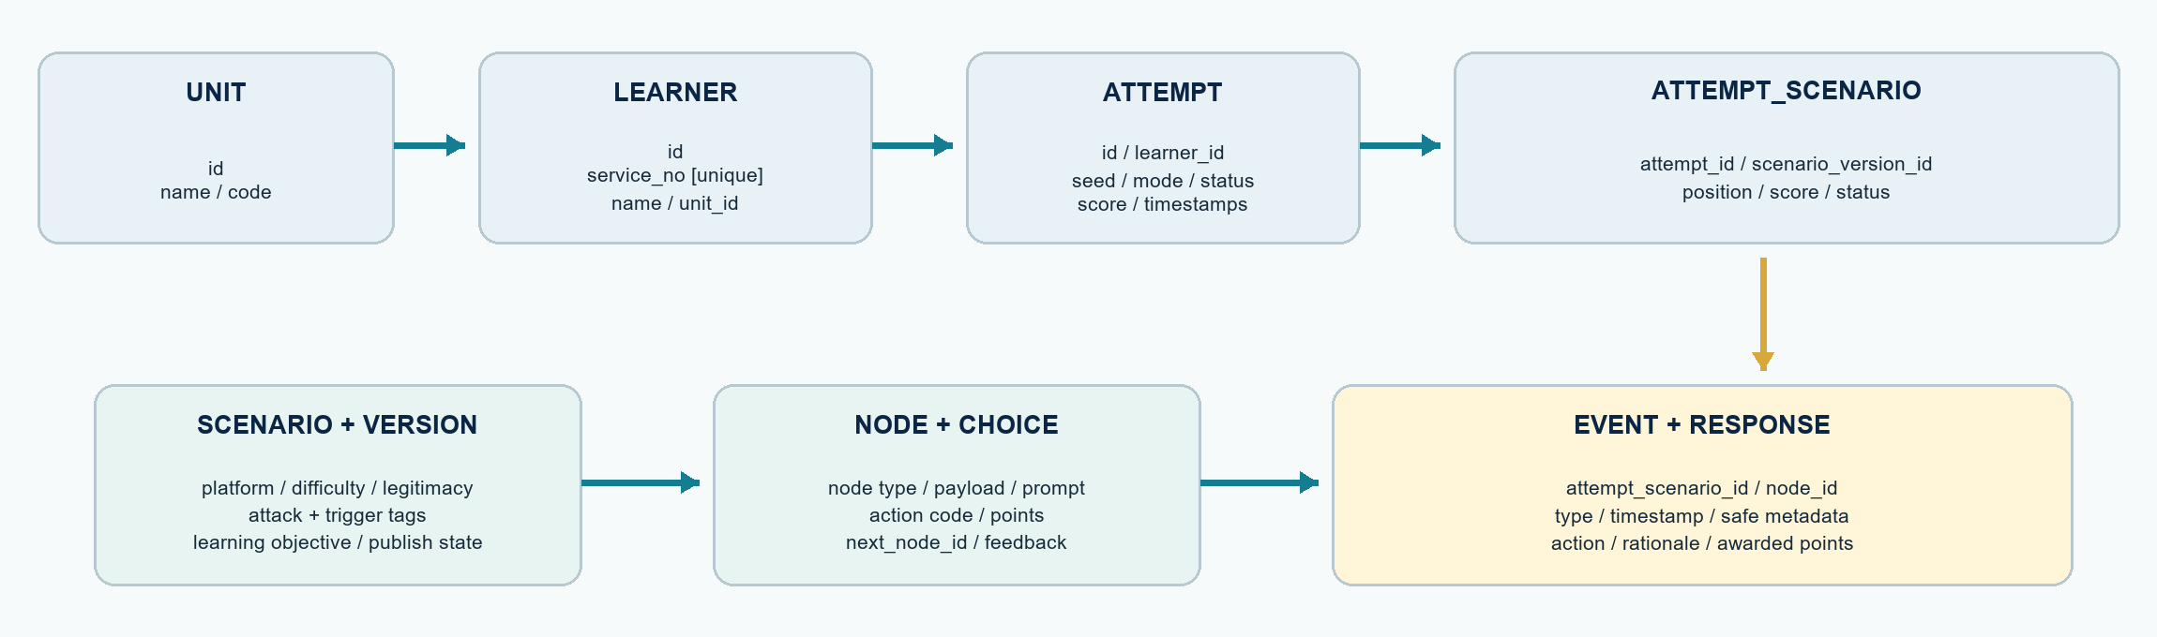
Figure 4. Minimum relational entities and cardinality direction.
Additional entities: AdminAccount/Role, Assignment, FeedbackSnapshot, ExportJob, BackupRecord and AdminAudit. Enforce unique service_no; foreign keys; UTC timestamps plus deployment timezone; attempt status state machine (created/in_progress/completed/void); and indexes on learner, unit, attempt date, platform and scenario version. Store timestamps and safe categorical metadata in Event; store selected action, sanitized rationale and awarded points in Response. Derive dashboards from these records rather than duplicating totals without reconciliation.

12. Safety, security and privacy boundaries
Boundary | Non-negotiable requirement
Synthetic-only content | Fictional people/units, reserved example domains, non-working phone numbers, locally generated codes and internal links. No real credential, OTP, bank or identity data is requested.
Contained interaction | Every link, attachment, call and payment page resolves inside the application. No email/SMS/WhatsApp/Instagram API, browser navigation to the public web, camera, microphone or device access.
Brand/training clarity | Use recognizable interaction patterns but generic names, icons and styling; avoid copying logos/trade dress. Keep a persistent TRAINING SIMULATION marker and briefing/consent.
Input protection | Disable browser autofill on simulated secrets; reject/purge accidental sensitive formats; never persist dummy credential/OTP/payment field contents; sanitize rationale and content fields.
Access + session | Separate learner and admin permissions; adaptive salted admin password hashing; failed-login throttling; server-side authorization; idle timeout; CSRF/XSS/SQL injection defenses; logout cache clear.
Data governance | Collect minimum identity and training evidence; configurable retention; unit-scoped instructor access; encrypted OS volume/backups; audited export/reset/restore; restore test before deployment.
Content governance | Two-person review before publish, prohibited-live-indicator validator, scenario expiry/review date, versioning and retire/rollback. Do not include operationally reusable attack instructions or working payloads.

13. Definition of done / acceptance tests
ID | Acceptance condition
FR-01 | Learner can sign in, complete/resume exactly 10 scenarios, receive a 0-100 result, view prior-attempt comparison and log out; another learner sees a clean session.
FR-02 | Across 100 seeded test attempts, every attempt satisfies 4-platform, 2/5/3 difficulty, 7/3 legitimacy, diversity and sequencing constraints; same seed + versions reproduces the same order.
FR-03 | Every published scenario has 5-6 reachable nodes, no orphan/dead-end branch, valid points in range, approved internal assets/targets and matching learner feedback.
FR-04 | Unsafe and unjustified over-cautious actions reduce score exactly per rubric; duplicate submissions do not double-count; total and component scores reconcile.
FR-05 | Evaluation withholds correctness until completion; guided mode explains after each scenario; switching is impossible. Admin can draft, validate, preview, publish/retire, assign, void/reset, export and audit.
NFR-01 | Fresh install, migration, use, report, backup and restore succeed with network disconnected; automated test confirms zero outbound DNS/HTTP and all browser assets are local.
NFR-02 | 25 concurrent learners meet the response target; a crash resumes without loss/duplicates/changed sequence. Keyboard flow, focus, contrast, labels, alt text and non-color cues pass accessibility review.
SEC-01 | Role/access, input validation, session isolation, export marking, backup encryption, restore integrity and no-real-secret retention are covered by automated and manual security tests.

BUILD SEQUENCE + HAND-OFF M1 vertical slice: login → dashboard → one scenario/platform → save → score → logout. M2 engine/content: versioning, branching, selector, 60 scenarios, both modes and admin preview. M3 readiness: reports, backup/restore, concurrency, accessibility, security/offline tests and pilot. Deliver source, reproducible offline build/installer, migrations, API + scenario schemas, seed fixtures/tests, threat model, operator/content/backup guides and release checksum.

