TECHNICAL ARCHITECTURE DOCUMENT
Cyber Awareness Social Engineering Training Platform
Technical Architecture & Application Workflow
Web application: React frontend · Node.js / Express API · MongoDB
Document property | Value
Project | Social Engineering & Fraud Detection Training Simulation (Cyber Awareness Training)
Document | Technical Architecture & Application Workflow
Version | 1.0
Date | 21 September 2026
Audience | Client technical stakeholders, system owners, security reviewers, hosting / operations team
Basis | Application source code and technical records as of 21 September 2026
Classification | Restricted — describes assessment evaluation; not for distribution to learners

Document Purpose
This document is the technical handover description of the platform. It explains the technologies used, how the application is structured, how the frontend, backend and database communicate, how a learner moves through an assessment, how scenarios are selected and executed through the six-stage workflow, how learner actions are processed and scored, how progress survives interruption, how the design prevents learners from manipulating scores, how administrators manage the system, and how the application is intended to be hosted on a central server so that authorised users can reach it through a browser.
It distinguishes clearly between what the code does today and what the production hosting environment still requires.
Revision History
Version | Date | Description
1.0 | 21 September 2026 | First issue. Reflects the current code architecture (immersive scene coverage 90 of 100 scenarios). Production deployment components are identified as current or planned where applicable.
Table of Contents

About This Document 5
1. Executive Technical Overview 5
1.1 What the platform does 5
1.2 Primary users 5
1.3 High-level architecture 6
1.4 Major application layers 6
1.5 How a user interacts with the platform 6
1.6 How interactions are processed 7
1.7 How results are stored 7
2. Technology Stack 7
2.1 Frontend 7
2.2 Backend 7
2.3 Database 8
2.4 Development and quality tooling 8
2.5 Deployment 8
3. High-Level System Architecture 9
4. Frontend Architecture 9
4.1 Entry point and routing 9
4.2 Layouts, pages and reusable components 10
4.3 State management 10
4.4 Services and API calls 11
4.5 From page to API: component relationship 11
4.6 Loading, errors, code splitting 12
4.7 Responsive behaviour and accessibility 12
5. Backend Architecture 12
5.1 Application startup 12
5.2 Configuration 12
5.3 Middleware 13
5.4 Routes, controllers and services 13
5.5 Request processing pattern 14
5.6 Error handling 14
5.7 Authentication and authorisation 14
6. Database Architecture 15
6.1 Collections 15
6.2 Lifecycle of assessment data 16
6.3 Integrity rules enforced in the models 16
6.4 Transaction boundaries 16
7. Scenario Content Architecture 17
7.1 The ScenarioDefinition 17
7.2 Bank composition 17
7.3 Separation of content, execution, scoring and presentation 18
8. Immersive Scene Architecture 18
8.1 Scene registry 18
8.2 The scene model 19
8.3 Interaction rules 19
8.4 Platform-specific presentation over shared infrastructure 19
8.5 Scene state and stage transitions 19
9. Six-Stage Scenario Workflow 20
9.1 How the next state is determined 20
9.2 Preventing invalid transitions 20
10. Learner Action Processing 21
10.1 Neutral identifiers and action codes 21
10.2 Why the canonical intent is not exposed 22
10.3 Protections 22
10.4 What the browser receives 22
11. Scoring Engine 22
11.1 Scoring vocabulary 23
11.2 Per-scenario and total scores 23
11.3 False positives and missed threats 23
11.4 Protection from client manipulation 24
12. Assessment Workflow 24
12.1 Step by step 24
12.2 Time limit 25
12.3 Persistence of progress 25
12.4 Interruption, reload and recovery 25
13. Scenario Selection 25
13.1 Implemented composition rules 26
13.2 Target and planned behaviour 26
14. Data Flow 26
15. Security Architecture 28
15.1 Known security gaps for central-server hosting 29
16. Administration & Management 30
16.1 Access controls 30
16.2 Current limitations 30
17. Reporting & Results 31
18. Testing & Quality Assurance 31
19. Application Deployment Architecture 32
19.1 Components 32
19.2 Deployment and update process (planned) 33
19.3 Rollback strategy (planned) 33
20. Production Data Migration Strategy 34
20.1 Migration sequence 34
21. Maintainability & Future Scalability 34
21.1 Horizontal scaling (future option, not implemented) 35
22. Complete End-to-End Workflow 35
23. Current Implementation vs Production Target 36
24. Technical Glossary 37

About This Document
This document describes the technical architecture and application workflow of the Cyber Awareness Social Engineering Training Platform. It is written for technically knowledgeable client stakeholders, system owners, security reviewers and the operations team that will host the platform on a central server. It explains how the application is built, how its parts communicate, how a learner moves through an assessment, how scoring is protected, and what is still required for production hosting.

Scope and basis
Every statement about current behaviour is derived from the application source code and its technical records as they stand on 21 September 2026. Where this document describes a component that is part of the intended server deployment but is not yet implemented in the repository, it is explicitly labelled Planned production configuration. Nothing in this document should be read as a claim that the platform has already been deployed to a production server.

Conventions
Label | Meaning
Implemented | Present in the source code and covered by the automated test suites.
Implemented (partial) | Present in the code, with a documented limitation described alongside it.
Planned production configuration | Infrastructure or configuration required for central-server hosting that is not yet part of the repository.
Not implemented | Designed or requested, but no code exists yet.

File and component names are shown in monospace and refer to paths in the repository: frontend/src/... for the React client and backend/src/... for the Node.js server.
Note: This document describes how assessment decisions are evaluated. It should be handled as restricted technical material and should not be distributed to learners. It contains no passwords, keys, tokens or environment secrets, and it deliberately omits the server-side control-to-intent mappings that are kept out of the learner-facing application.

1. Executive Technical Overview

1.1 What the platform does
The platform is a browser-based training and assessment system for social-engineering and fraud awareness. It places a learner inside realistic, fully synthetic simulations of four communication channels (WhatsApp, Instagram, Email and SMS) and observes how they handle each message: whether they inspect it, verify it through a trusted channel, act on it, report it, or accept it when it is legitimate.
Each assessment presents 10 scenarios drawn from a bank of 100 client-authored scenarios (25 per platform, 80 malicious and 20 legitimate controls). Every scenario runs through the same six-stage workflow (Notify, Open, Inspect, Branch, Verify, Resolve), and every learner decision is scored by the server against the scenario definition.

1.2 Primary users
User | Access | Purpose
Learner | Sign-in with name and personal / service number; candidate session cookie | Complete the briefing, take assessments, review results and feedback
Instructor / administrator | Username and password; separate administrator session cookie | Manage scenario versions, view attempts, export reports, reset attempts, archive profiles, set feedback policy, read the audit log
Operator | Server shell access | Install, configure and run the services; create the administrator account; import the scenario bank

1.3 High-level architecture
The application is structured as a web-based client/server system. A React single-page application runs in the user’s browser and communicates with a Node.js / Express backend through a JSON API under /api. The backend holds all authoritative assessment state and all scoring logic, and persists it in MongoDB, which runs as a replica set so that related writes commit atomically.
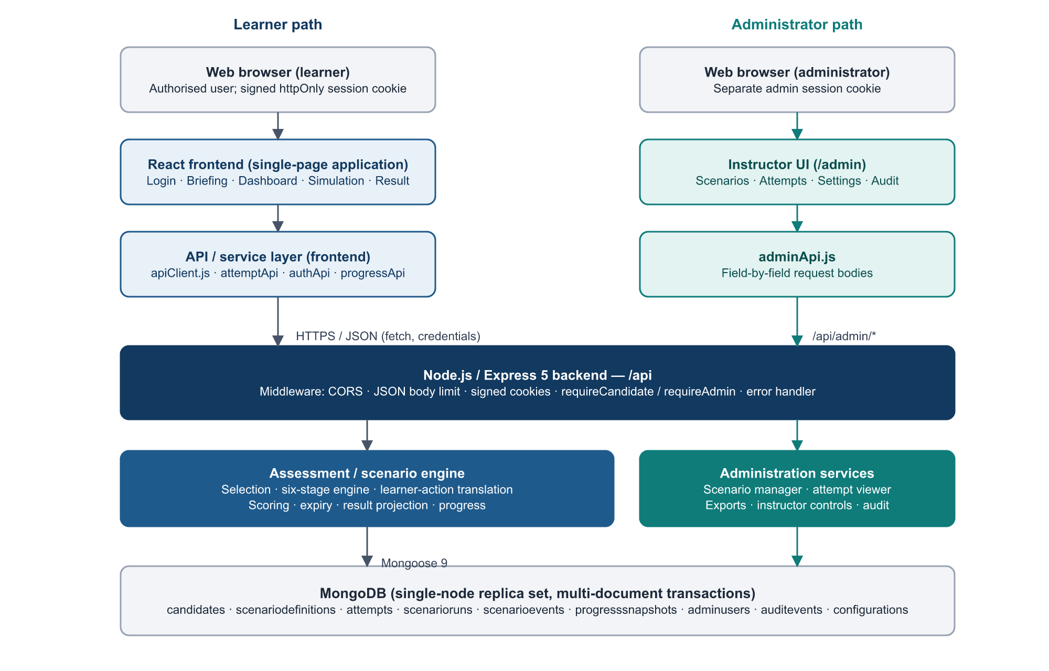
Figure 1. High-level architecture: learner and administrator paths share one backend and one database.

1.4 Major application layers
Layer | Responsibility
Presentation (React) | Screens, the simulated phone, platform-specific scenes, results and admin UI
Application / UI state | Session context, the attempt state machine, dashboard notification orchestration
Scene / interaction | Turns a scenario into an explorable app experience with neutral controls
API | Frontend service modules and Express routes, guards and controllers
Assessment / scenario engine | Scenario selection, action translation, the six-stage state machine, scoring, expiry, results
Persistence | Mongoose models, indexes, transactions, append-only audit
Administration / reporting | Scenario manager, attempt viewer, exports, instructor controls, audit log

1.5 How a user interacts with the platform
A learner signs in, acknowledges the briefing, and starts an assessment from the dashboard. The simulated phone receives notifications one at a time. The learner opens each item in the relevant app, investigates it freely (sender details, link previews, account pages, attachments), makes a decision, optionally verifies through a trusted route, and finally reports, blocks, ignores or keeps the item. After the tenth scenario the learner sees a result with per-scenario feedback.

1.6 How interactions are processed
The browser never sends a score, a stage, or even the meaning of a button. Each scored control carries a neutral identifier, and the browser sends the opaque, per-run action code the server issued for that control. The backend translates the code into a canonical engine intent, validates it against the run’s current stage and the scenario definition, decides the event code and point value, and commits the event and the updated run in a single database transaction. The browser receives only the new neutral state.

1.7 How results are stored
Each learner action is stored as an immutable, sequenced ScenarioEvent in an event ledger. Each scenario has a ScenarioRun that caches its running score and, once resolved, its final 0–10 score. The Attempt stores the frozen 10-scenario sequence, the 90-minute deadline and the 0–100 total. A derived ProgressSnapshot summarises each learner’s completed attempts. Results and feedback are computed on request from these authoritative records.

2. Technology Stack
Versions below are the declared ranges in frontend/package.json and backend/package.json, confirmed against the imports used in the source. The runtime versions are those used for the current verification runs.

2.1 Frontend
Technology | Version | Use in the platform
React / React DOM | ^19.2.8 | Component model for every screen; StrictMode enabled in main.jsx
Vite | ^8.2.2 | Development server and production bundler (vite build → dist/)
@vitejs/plugin-react | ^6.1.0 | JSX transform and fast refresh
JavaScript (ES modules) / JSX | — | All source; no TypeScript. @/ alias resolves to src/
Tailwind CSS (+ @tailwindcss/vite) | ^4.3.3 | Utility styling; design tokens in src/styles/index.css (@theme)
React Router DOM | ^7.18.3 | Client-side routing (BrowserRouter, nested guarded routes)
lucide-react | ^1.39.0 | Icon set (bundled, no external icon CDN)
State management | — | React Context and useReducer. Redux / Redux Toolkit is not used.
Vitest + jsdom | ^5.0.0 / ^30.0.1 | Unit and component tests run against a stubbed fetch
Testing Library (react, user-event) | ^16.3.3 / ^14.6.7 | Component interaction tests
oxlint | ^1.79.0 | Linting (npm run lint). ESLint is not used.

2.2 Backend
Technology | Version | Use in the platform
Node.js | 24.x (v24.15.0 verified) | Runtime. Version 24 is required: administrator passwords use the Argon2id KDF built into node:crypto
Express | ^5.2.1 | HTTP server, routers, middleware (ES module project)
Mongoose | ^9.9.4 | MongoDB object modelling, schema validation, sessions and transactions
cookie-parser / cookie-signature | ^1.4.7 / ^1.2.2 | Signed, httpOnly session cookies (candidate and administrator use separate secrets)
cors | ^2.8.6 | Single allowed origin with credentials
dotenv | ^17.4.2 | Environment configuration from .env
node:crypto (built-in) | — | Argon2id password hashing, keyed hashing of learner action codes, timing-safe comparison
The backend has six runtime dependencies. CSV and PDF export writers are implemented in-house (utils/csvWriter.js, utils/pdfWriter.js) rather than through third-party packages.

2.3 Database
Aspect | Implementation
Engine | MongoDB 8.3 (8.3.8 verified), WiredTiger storage
Topology | Single-node replica set (rs0). Required: the engine refuses to run on a non-replicated instance because it cannot commit multi-document transactions
Collections (current pipeline) | candidates, scenariodefinitions, attempts, scenarioruns, scenarioevents, progresssnapshots, adminusers, auditevents, configurations
Collections (legacy pipeline) | scenarios, assessments — the earlier 40-question journey, retained but no longer the learner assessment
Transactions | Attempt creation, every learner action, attempt completion, expiry, and every administrative change that writes an audit entry
Write concern | Journaled writes (j: true) for authoritative commits; bounded retry of transient transaction errors

2.4 Development and quality tooling
Area | Tool / command | Notes
Frontend unit & component tests | npm test (Vitest) | 39 test files; 3,530 tests at the last full run
Backend tests | npm test (node --test) | 42 test files; database-free suites run anywhere
Real-engine / database tests | npm run test:engine | Runs the database suites against an isolated, throwaway replica set
Lint | npm run lint (oxlint) | Frontend
Production build | npm run build | Vite build to frontend/dist/
Bundle security check | npm run check:bundle | Fails if scoring or intent vocabulary appears in the shipped bundle
API validation scripts | scripts/validateApi.js, validateAdminApi.js | Scripted end-to-end API checks
Topology check | npm run verify:replicaset | Confirms the database supports transactions
Browser validation | Production build served by vite preview against an isolated API and database | Manual, scripted walkthroughs of each scene batch

2.5 Deployment
The repository contains the application services and their configuration, but no production hosting components: there is no reverse-proxy configuration, container definition, process-manager configuration, TLS setup or backup automation. The intended server architecture is described in Section 19 and is labelled as planned production configuration throughout.

3. High-Level System Architecture
The application is organised in seven layers. Each layer has a single responsibility and communicates only with its neighbours through well-defined data shapes. The most important boundary is between layers 4 and 5: nothing that decides a score or a stage exists on the client side of it.
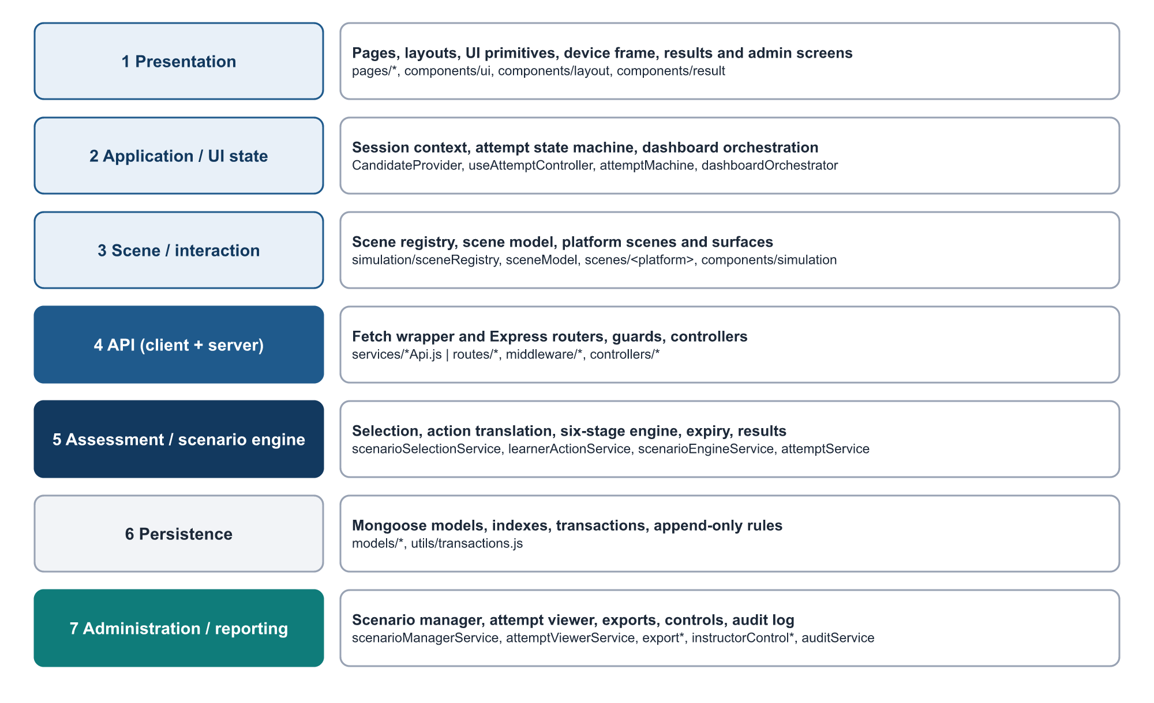
Figure 2. Layered architecture with the principal files in each layer.
Layer | Data in | Data out | Relationship
1 Presentation | Server projections held in state | Rendered screens; user gestures | Reads layer 2 state; renders layer 3 scenes
2 Application / UI state | API responses | State for components; calls to layer 4 | Reducer records only what the server committed; nothing authoritative is stored in browser storage
3 Scene / interaction | Candidate scenario payload + current stage | Beats, surfaces, neutral controls | Pure data: no scores, no dispositions, no intents
4 API | HTTP requests with cookies | JSON projections, error codes | Guards establish identity from signed cookies; controllers translate HTTP to service calls
5 Engine | Validated requests, pinned definitions | Events, run and attempt state, results | Owns selection, the state machine, scoring and expiry
6 Persistence | Documents and transactions | Stored records | Schema validation, unique indexes, immutability hooks
7 Administration / reporting | Administrator requests | Projections, export files, audit entries | Reuses the same result projection learners receive; every change is audited

4. Frontend Architecture

4.1 Entry point and routing
index.html loads src/main.jsx, which renders <App/> inside React StrictMode. App.jsx wraps the application in BrowserRouter and CandidateProvider (the learner session context) and delegates to routes/AppRoutes.jsx.
Route | Component | Guard
/login | LoginPage | Public
/briefing | BriefingPage | RequireCandidate
/dashboard | DashboardPage | RequireCandidate
/assessment | SimulationPage (six-stage simulation) | RequireCandidate
/result/:attemptId | ResultPage | RequireCandidate (ownership enforced by the server)
/history | HistoryPage (legacy pipeline — see Section 17) | RequireCandidate
/assessment/legacy | AssessmentPage (legacy 40-question journey) | RequireCandidate
/admin/login | AdminLoginPage | Public
/admin, /admin/scenarios[/:id], /admin/attempts[/:id], /admin/settings, /admin/audit | Admin pages nested in AdminLayout | RequireAdmin
Guards are redirect conveniences only. RequireCandidate and RequireAdmin ask the server who the session belongs to (the session cookies are httpOnly and unreadable by script); the server enforces the same boundaries independently on every API route.

4.2 Layouts, pages and reusable components
- Layouts: AuthLayout (sign-in screens), AppLayout / AppHeader / PageContainer (learner screens), AdminLayout (instructor navigation and header).
- UI primitives (components/ui): Button, Card, Input, FormField, Modal, Alert, ProgressBar, Spinner.
- Simulation (components/simulation): PhoneShell, DeviceFrame, PhoneHome, NotificationTray, AttemptHeader, TimeRemaining, ActionSheet, InspectSheet, TrustedDirectory, ConsequencePanel, ScenarioOutcome, SceneControl, SceneActionList, per-platform scenes and the shared surfaces/* screens (browser, call, mail, social, payment sheet, installer, viewer).
- Results (components/result): ResultSummary, ScenarioResultCard, BehaviourBreakdown, PathReplay, RemediationList, AssessmentReview, ScenarioReview.
- Admin (components/admin): AdminLayout, AttemptControls, AttemptExportPanel, ConfirmDialog, shared admin primitives.

4.3 State management
Module | Role
context/CandidateProvider.jsx | Holds the signed-in learner’s public profile, obtained from GET /api/candidates/me
hooks/useAttemptController.js | The only place the assessment talks to the attempt API. Generates one idempotency key per learner action and reuses it on retry
state/attemptMachine.js | Pure reducer with phases loading, ready, submitting, completing, completed, expired, error, no_attempt. It records server responses; it never invents a stage, score or next scenario
state/dashboardOrchestrator.js | Pure projection of the committed run into the home screen: badge count, toast and app list are computed from one input so they always agree; the 1–4 second delivery delay is a deterministic function of the run id
simulation/useSceneNavigation.js | In-scene navigation stacks (surface and page history). React state only; never persisted
Key point: No authoritative state is kept in localStorage or sessionStorage. A page reload asks the server for the current attempt and run, which is also the recovery path after an interruption.

4.4 Services and API calls
services/apiClient.js wraps fetch for every call. It sends credentials: "include", serialises JSON, and converts failures into a typed ApiError carrying the HTTP status and the server’s stable error code. Network failures are reported as status 0 (NETWORK_ERROR) so the UI can distinguish infrastructure faults (retry) from real refusals (show the message). The API base path defaults to the same-origin /api and can be overridden at build time with VITE_API_BASE_URL.
Service module | Endpoints used
authApi | POST /candidates, GET /candidates/me, POST /candidates/logout, POST /candidates/me/briefing
attemptApi | POST /attempts, GET /attempts/current, GET /attempts/:id, GET /attempts/:id/current-run, POST …/runs/:runId/events, POST …/runs/:runId/resolve, POST …/complete, GET …/result
progressApi | GET /progress
adminApi | All /admin/* endpoints; builds every request body field by field
assessmentApi | Legacy /assessments endpoints (legacy journey and /history)

4.5 From page to API: component relationship
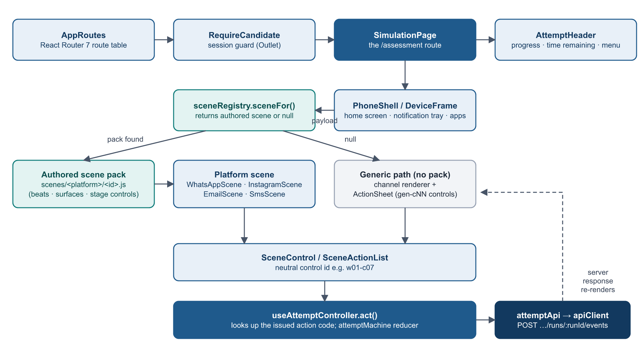
Figure 3. Page → layout → scene → renderer → learner action → API.
SimulationPage renders the attempt header and the simulated device. For the current run it calls sceneFor(scenario) in simulation/sceneRegistry.js. If an authored scene pack exists, the matching platform scene (WhatsAppScene, InstagramScene, EmailScene or SmsScene) draws it; otherwise the generic channel renderer and the shared ActionSheet are used. Either way, a scored control is a SceneControl with a neutral id, and pressing it calls useAttemptController, which looks up the action code issued for that id and posts it. The device only moves (opens a page, closes a sheet) after the server has accepted the action.

4.6 Loading, errors, code splitting
- Every data-loading screen shows a Spinner state and an inline or full-screen error state. Recoverable action errors (stale state, refused action, lost connection) are shown inline and the learner can retry; unrecoverable ones replace the screen.
- A 409 STALE_STATE answer (for example, the same attempt open in two tabs) triggers an automatic resynchronisation from the server and an explanatory banner.
- Code splitting is not implemented. The production build is a single JavaScript bundle and a single CSS file; all routes are imported statically.

4.7 Responsive behaviour and accessibility
- Layouts are built with Tailwind utilities and validated at desktop, 375 px and 320 px widths with no horizontal page overflow.
- Visible :focus-visible outlines, a prefers-reduced-motion guard for device animations, labelled controls (over 480 aria-* attributes in the component tree), dialogs with labelled close buttons and Escape handling.
- An accessibility panel is always available from the assessment menu, including under time pressure.

5. Backend Architecture

5.1 Application startup
- server.js connects to MongoDB (config/database.js, 5-second server selection timeout).
- Startup recovery: any attempt whose deadline passed while the service was stopped is finalised from its stored deadline before the first request is served. A failure here is logged, not fatal; the per-request guard still enforces every deadline.
- createApp() (app.js) builds the Express application: CORS, JSON body parser (1 MB limit), signed-cookie parser, the /api router, a 404 handler and the central error handler.
- The server listens on HOST:PORT (default 127.0.0.1:5000; the loopback default is deliberate so the API is only reachable through whatever sits in front of it).
- The expiry sweeper starts: every 30 seconds it finalises up to 50 overdue attempts. SIGINT/SIGTERM stop the sweeper and close the server cleanly.

5.2 Configuration
config/env.js reads environment variables through dotenv and fails fast when a required value is missing. Values (not shown here) are supplied per environment.
Variable | Purpose | Default behaviour
NODE_ENV | production enables secure-only cookies and hides internal error detail | development
PORT, HOST | Listening address | 5000, 127.0.0.1
MONGO_URI | Database connection string | Development value in code; set explicitly for any server
CORS_ORIGIN | The single browser origin allowed to call the API with credentials | Development origin
SESSION_SECRET | Signs the learner session cookie | Development fallback exists — must be set for any real deployment
ADMIN_SESSION_SECRET | Signs the administrator cookie | No default; the server refuses to start without it or if it equals SESSION_SECRET
SESSION_MAX_AGE_MS, ADMIN_SESSION_MAX_AGE_MS | Session lifetimes | 8 hours (learner), 1 hour (administrator)
ADMIN_LOGIN_* | Failed-login throttling | 5 failures in 15 minutes → 15-minute lockout
LEARNER_ACTION_SECRET | Keys per-run action codes | Optional; derived from the session secret if unset
EXPORT_DIR | Directory for instructor exports | backend/exports

5.3 Middleware
Middleware | Function
cors | Allows exactly one origin, with credentials
express.json | Parses JSON bodies up to 1 MB
cookieParser(SESSION_SECRET) | Verifies signed learner cookies
requireCandidate (middleware/session.js) | Resolves the learner from the signed candidate_session cookie only; rejects missing, unknown or archived profiles with 401
requireAdmin (middleware/adminSession.js) | Verifies the separately signed admin_session cookie and that the administrator still exists. A learner session is rejected, never upgraded
adminLoginThrottle | In-process failed-login counter keyed by client address and username
notFound, errorHandler | Uniform JSON error envelope { error: { code, message, details } }

5.4 Routes, controllers and services
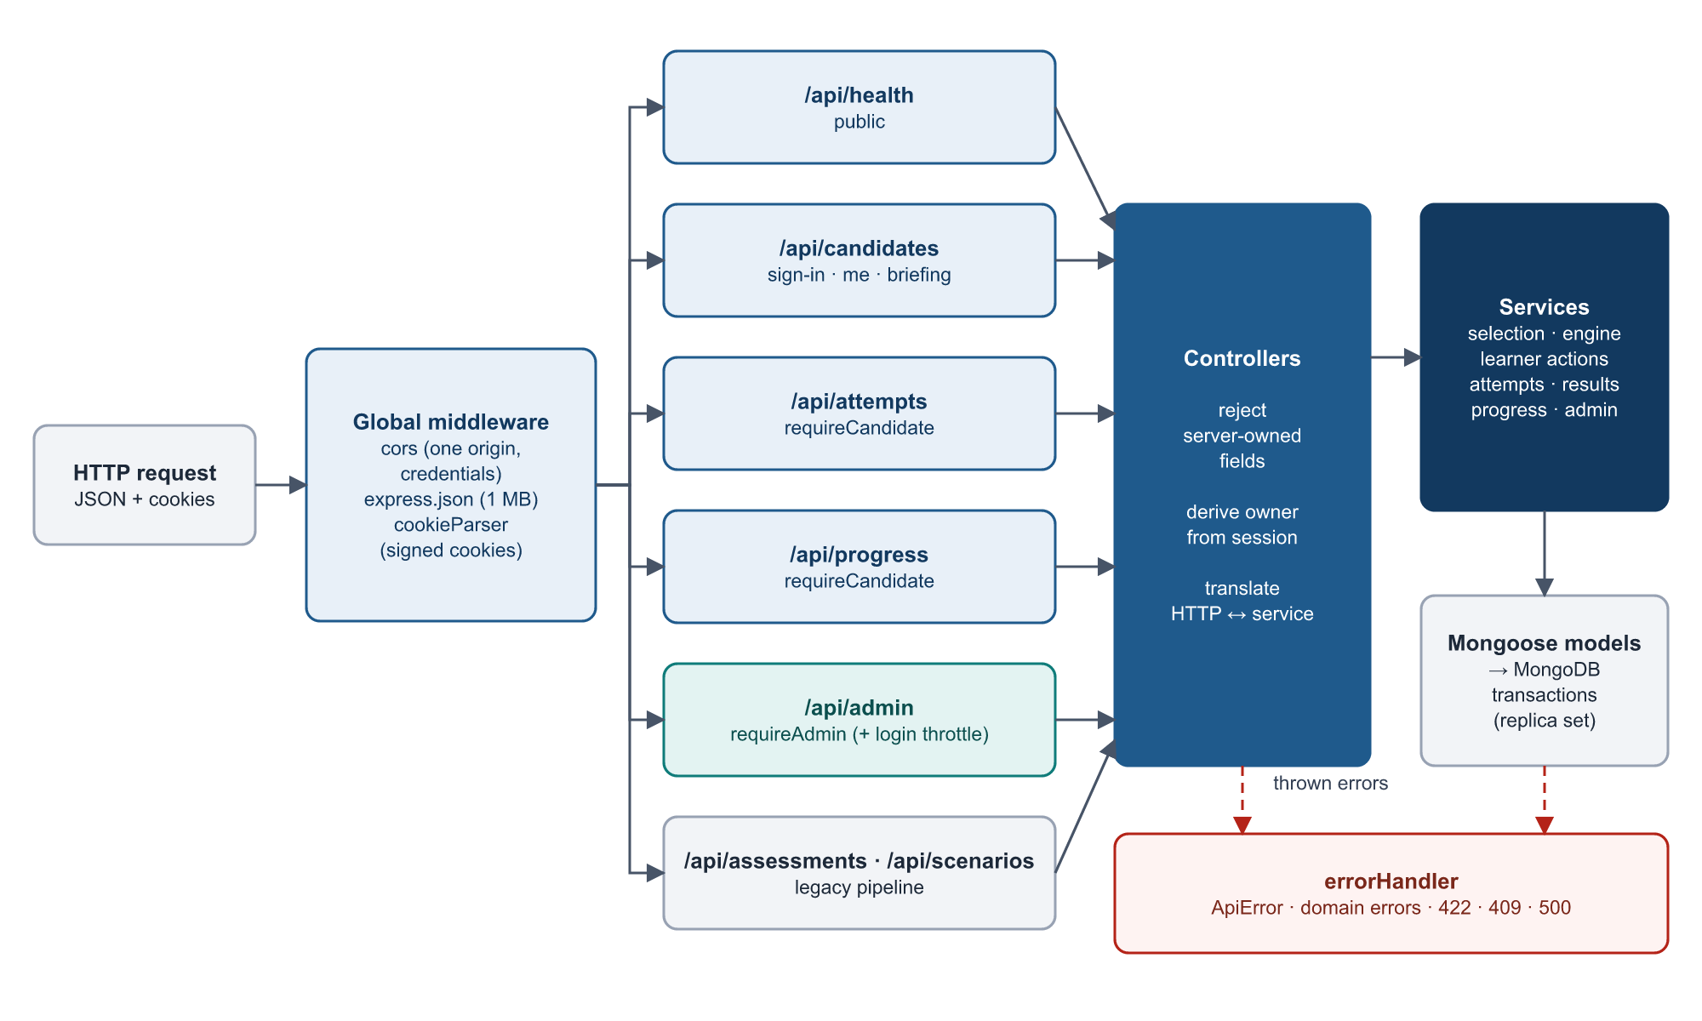
Figure 4. API architecture: request → middleware → route group → controller → service → model.
API group | Endpoints | Controller → services
Health | GET /api/health | healthController — reports database connection state (200 / 503)
Candidates | POST /candidates, POST /candidates/logout, GET /candidates/me, POST /candidates/me/briefing | candidateController → candidateService
Attempts | POST /attempts, GET /attempts/current, GET /attempts/:id, GET /attempts/:id/current-run, POST /attempts/:id/runs/:runId/events, POST /attempts/:id/runs/:runId/resolve, POST /attempts/:id/complete, GET /attempts/:id/result | attemptController → attemptService, scenarioSelectionService, learnerActionService, scenarioEngineService, attemptExpiryService, attemptResultService
Progress | GET /progress | progressController → progressService
Admin | /admin/login|logout|me, /admin/scenarios…, /admin/attempts…, /admin/learners, /admin/exports…, /admin/config/feedback, /admin/audit | adminController, scenarioManagerController, attemptViewerController, exportController, instructorControlController, auditController
Legacy | /assessments (6 routes), /scenarios/summary | assessmentController, scenarioController — earlier 40-question pipeline

5.5 Request processing pattern
Every mutating API follows the same sequence: Request → Validation → Business logic → Database → Response.
Group | Validation | Business logic | Database | Response
Candidate sign-in | Name and number required; identifier normalised | Find or create profile; refuse archived | candidates | Public profile + session cookie
Attempt start | Session; server-owned fields refused | Enforce any overdue deadline; seeded selection | Attempt + 10 runs in one transaction | Candidate attempt projection
Learner action | Session, ownership, deadline, forbidden fields, action code | Translate code; engine decides event, points, stage | Event + run in one transaction | Neutral run state
Completion | All 10 runs resolved; deadline | Sum scenario scores | Attempt update in a transaction; snapshot rebuild after | Attempt + result
Admin change | Admin session; allow-listed fields | Lifecycle / control rules | Change + audit entry in one transaction | Updated record

5.6 Error handling
Services raise either ApiError (HTTP-shaped) or domain errors from the engine and selection solver, which carry a stable code and intended status (for example STALE_STATE 409, INVALID_ACTION 422, ATTEMPT_EXPIRED, TRANSACTION_UNAVAILABLE 503). Mongoose validation errors become 422 VALIDATION_ERROR; duplicate keys become 409. Unexpected errors return 500 INTERNAL_ERROR; internal detail is omitted when NODE_ENV=production. On learner routes, engine messages that could name a canonical intent are replaced by a neutral message.

5.7 Authentication and authorisation
- Learners identify with name and personal / service number. There is no learner password: the signed cookie prevents a learner from pointing a session at another profile, but anyone who knows a learner’s number can sign in as that learner. See Sections 15 and 23.
- Administrators authenticate with username and password. Passwords are hashed with Argon2id and compared in constant time. The account is created only by the operator script npm run admin:create; there is no HTTP route that creates an administrator and no default account.
- Authorisation is structural: every learner route derives ownership from the session, never from the request body, and returns 404 (not 403) for another learner’s attempt so that identifiers cannot be probed.

6. Database Architecture
MongoDB stores six entities from the client specification (LearnerProfile, ScenarioDefinition, Attempt, ScenarioRun, Event, ProgressSnapshot) plus three administrative collections. Each model is defined in backend/src/models/ with schema validation, cross-field checks and explicit candidate-safe projections built from allow-lists.
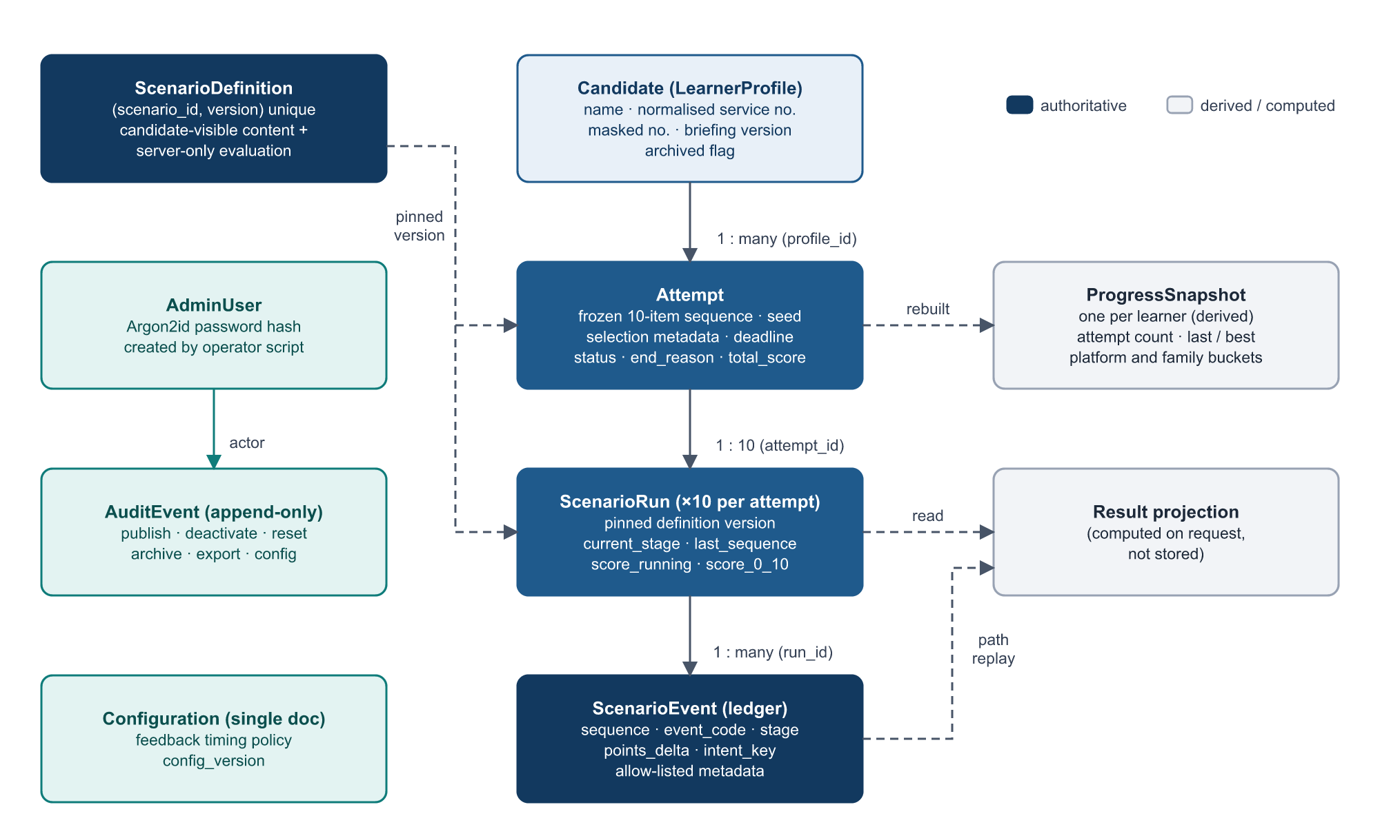
Figure 5. Collections and relationships. Solid arrows are ownership; dashed arrows are pinning or derivation.

6.1 Collections
Collection / model | Purpose and key fields | Indexes | Authority
scenariodefinitions / ScenarioDefinition | One document per scenario per content version: identity, classification, candidate-visible synthetic content and stages, server-only evaluation (title, feedback, expected actions, per-stage scoring), quality gate, lifecycle state | Unique (scenario_id, version); selection indexes on active + platform/level, disposition, family, triggers, military flag | Authoritative content
candidates / Candidate (LearnerProfile) | Display name, identifier, normalised identifier, masked service number, briefing version and time, last seen, archival fields | Unique normalised identifier; archived | Authoritative identity
attempts / Attempt | Profile, seed, mode, status, frozen 10-item sequence with pinned versions, selection metadata, content/taxonomy versions, total score, start/complete times, time limit, deadline, end reason, expiry fields | (profile_id, status), (profile_id, started_at), (started_at, _id), (status, expires_at) | Authoritative
scenarioruns / ScenarioRun | One per scenario position: pinned definition version, platform, status, current stage, last sequence, running score, final 0–10 score, outcome, optional rationale | Unique (attempt_id, ordinal); (attempt_id, status); (scenario_id, definition_version) | Authoritative state; score is a cache reproducible from events
scenarioevents / ScenarioEvent | Immutable ledger: run, sequence, event code, stage, points delta, synthetic target, idempotency key, client and server timestamps, allow-listed metadata | Unique intent_key; unique (run_id, sequence) | Audit source of truth
progresssnapshots / ProgressSnapshot | Per-learner aggregate: completed attempts, scenarios completed, last and best score, platform and family buckets, comparability signature | Unique profile_id | Derived, regenerable
adminusers / AdminUser | Username, normalised username, Argon2id hash (never selected by default) | Unique normalised username | Authoritative
auditevents / AuditEvent | Actor, action, resource, status, metadata, idempotency key, timestamp. Insert-only: every update and delete path is blocked in the model | occurred_at; (resource_type, resource_id, occurred_at); unique partial idempotency key | Authoritative, append-only
configurations / Configuration | Single document: training and assessment feedback-timing policy, version, last editor | Unique scope | Authoritative

6.2 Lifecycle of assessment data
ScenarioDefinition → Attempt → ScenarioRun → Events → ProgressSnapshot → Results / history. An attempt pins the exact definition version of each of its ten scenarios at creation, so republishing content never changes the rules of a run already in flight. Runs accumulate sequenced events; resolution clamps and stores the scenario score; completion sums the ten scores into the attempt; the progress snapshot is rebuilt from completed attempts; and the result projection is computed on request from runs, events and the pinned definitions.

6.3 Integrity rules enforced in the models
- The attempt’s scenario sequence, seed, selection metadata, time limit and deadline are frozen after creation (pre-save hooks reject changes).
- An attempt must hold exactly ten distinct scenarios with ordinals 1–10; a completed attempt must carry a completion time; an expired attempt must carry expiry metadata.
- A resolved run must carry a score, a resolution time and an outcome; an unresolved run may not carry a final score.
- Event metadata is restricted to an allow-list of bounded scalar fields; free-form learner text is never stored in the ledger.
- A scenario definition must have exactly six correctly ordered stages, only transitions the six-stage model permits, only events that belong to each stage, and asset references that resolve.

6.4 Transaction boundaries
Operation | Documents written atomically
Create attempt | Attempt + ten ScenarioRun documents
Learner action (and resolve) | ScenarioEvent + ScenarioRun (sequence, score, stage, status)
Complete attempt | Attempt status, completion time, total score, end reason (guarded re-read prevents double completion)
Expire attempt | Expiry event for each unresolved run + those runs + the Attempt
Publish / deactivate / clone scenario, reset attempt, archive profile, change configuration, create export | The change + its AuditEvent
Progress snapshot | Deliberately outside any transaction: rebuilt after the commit by full recomputation, so it can never block or corrupt a completed attempt
Idempotency does not depend on transactions: the unique intent_key index guarantees that a retried action cannot create a second event, and the unique (run_id, sequence) index guarantees that two concurrent actions cannot both advance a run.

7. Scenario Content Architecture

7.1 The ScenarioDefinition
Scenario content is data, not code. The 100 client scenarios are held in versioned source files and imported into the scenariodefinitions collection by npm run import:definitions (scenarioDefinitionImportService.js). The importer merges three inputs: the client’s scenario records (backend/data/scenarios/v1, reproduced verbatim with provenance and content hashes), structured synthetic content (backend/data/synthetic/v1) and the canonical taxonomies (backend/data/taxonomy). It supports dry runs, staging (inactive import) and new content versions.
Field group | Fields | Visible to learner?
Identity | scenario_id (W01–W25, I01–I25, E01–E25, S01–S25), version, platform, schema_version | Id, version and platform only
Lifecycle | active, lifecycle_state (draft / published / retired), published_at, owner, review_date | No
Classification | level (easy / medium / hard), disposition (malicious / legitimate), family (client wording, verbatim), canonical_family (19 values), trigger (verbatim), canonical_triggers (22 values), military_flag, legitimate_control, taxonomy versions | No
Synthetic content | Sender, prior context, assets (notification, thread, profile, link, file, QR, browser page, call screen, directory entry, payment and install screens, image) | Yes
Stages (visible half) | Six stages: index, key, UI description, permitted transitions, telemetry events, asset references | Yes
Evaluation (server-only) | Title, end state, feedback (result, cues, safe action, impact, prevention habit), per-stage learner flow, expected safe behaviour, expected actions, per-stage scoring events and point values | Never during an attempt; feedback released after completion
Quality gate | Reviewers, safety and accessibility checks, pilot status | No
The evaluation block is excluded from ordinary queries (select: false) and the learner projection toCandidateJSON() is rebuilt from an allow-list, so a field added in future is hidden by default.

7.2 Bank composition
Dimension | Values in the current bank
Platforms | WhatsApp 25 · Instagram 25 · Email 25 · SMS 25
Disposition | 80 malicious / deceptive · 20 legitimate controls
Attack / case families | 15 malicious mechanisms + 4 legitimate patterns (canonical taxonomy v1.0.0)
Psychological triggers | 22 canonical levers, folded from the client’s raw trigger strings (trigger taxonomy v1.0.0)
Military context | 35 scenarios flagged as fictional military context
Difficulty | Easy / medium / hard per scenario

7.3 Separation of content, execution, scoring and presentation
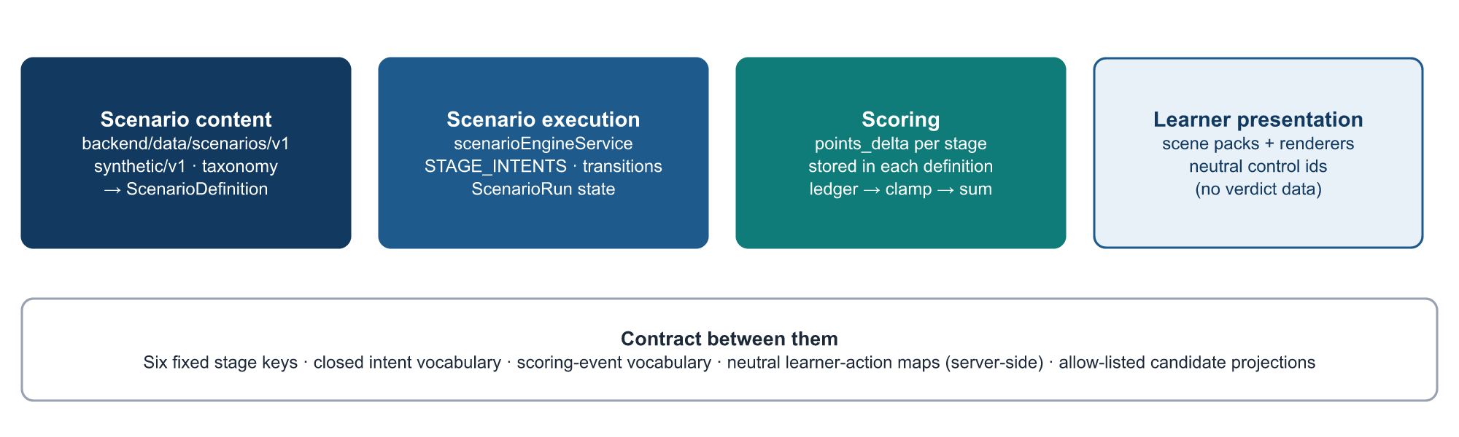
Figure 6. Four concerns, one contract.
Concern | Where it lives | What it knows
Scenario content | ScenarioDefinition documents | What the learner sees, what the item really is, the feedback, and the points each stage’s outcomes are worth
Scenario execution | scenarioEngineService.js and constants/scenarioEngine.js | The six-stage state machine and which kinds of intent are legal at each stage — never what a particular scenario is worth
Scoring | Per-stage scoring arrays inside each definition, applied by the engine, recorded in the ledger | Point values; the engine only chooses which declared code applies
Learner presentation | Frontend scene packs and renderers; server-side neutral action maps | Layout, wording, navigation; no disposition, family, trigger or score
Key point: Because the engine reads rules and point values from each scenario’s own definition, a new scenario that follows the six-stage contract can be added, versioned, published or retired without changing the engine, the selection solver or the scoring code.

8. Immersive Scene Architecture
The immersive scene layer turns a scenario into something that looks and behaves like the real app on a phone: a chat list, a conversation with history, contact and group pages, a mail client with message details and “show original”, an Instagram profile with its posts and account history, an SMS conversation-details page, a browser, a call screen, a payment sheet or a system installer prompt.
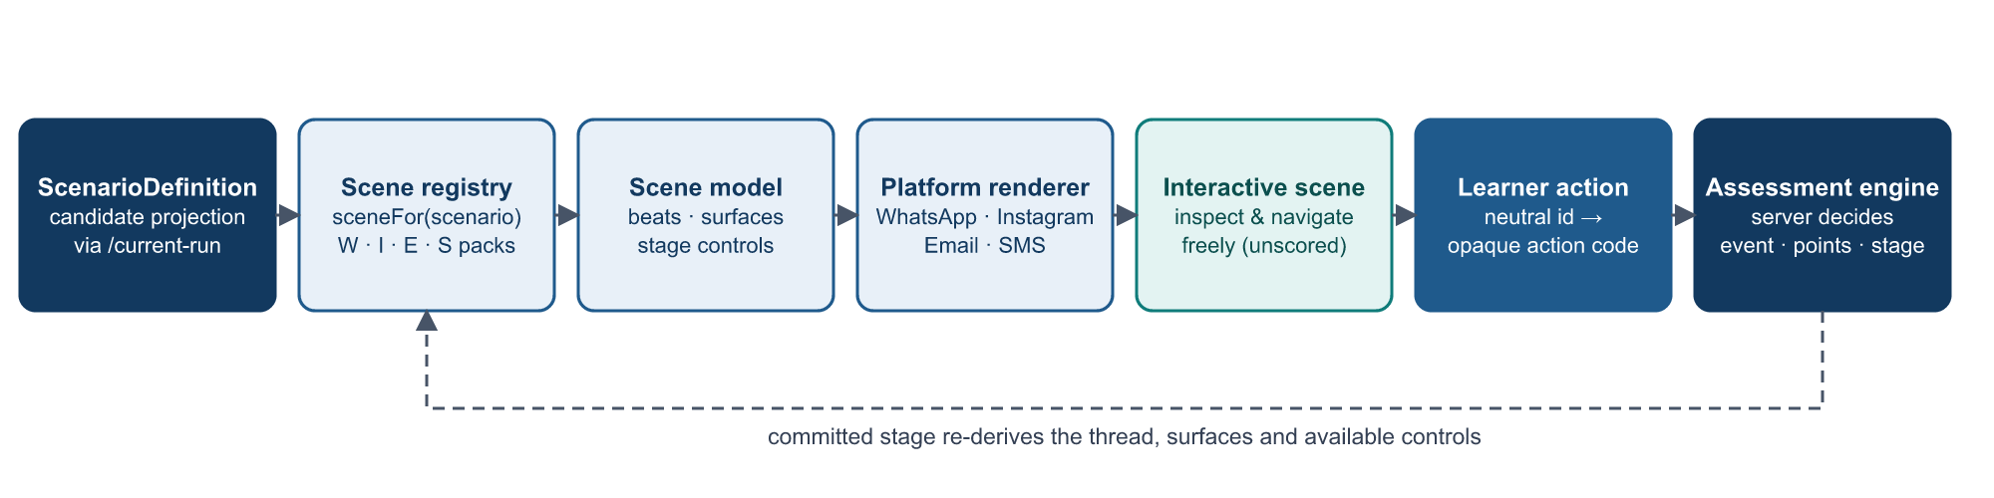
Figure 7. How a scenario becomes a playable scene.

8.1 Scene registry
simulation/sceneRegistry.js maps scenario ids to scene-pack builders. sceneFor(scenario) returns the authored scene for the scenario payload, or null when no pack exists. A pack built for a different platform than the run is rejected. Adding a batch of scenes is adding entries; nothing about scoring or the stage machine changes.
Platform | Authored scenes | Scene component
WhatsApp | W01–W25 (25 / 25) | simulation/whatsapp/WhatsAppScene.jsx
Instagram | I01–I25 (25 / 25) | simulation/instagram/InstagramScene.jsx
Email | E01–E25 (25 / 25) | simulation/email/EmailScene.jsx
SMS | S01–S15 (15 / 25) | simulation/sms/SmsScene.jsx
SMS S16–S25 | Not yet authored (10 scenarios) | Generic channel renderer (SmsRenderer) + shared ActionSheet
Current coverage is 90 of 100 scenarios. The ten remaining SMS scenarios are fully playable and scored through the generic path; they do not yet have the immersive presentation.

8.2 The scene model
simulation/sceneModel.js defines the scene vocabulary. A scene is a plain data structure built from the scenario payload, with no React code and no engine knowledge:
Element | Meaning
Conversation / list | The app’s list screen and the open conversation (title, subtitle, group or direct)
Beats | Items in the thread (messages, previews, polls, payment requests, voice notes, calls, notices) with since / until stages. The thread is a pure function of the stage the server committed, so it is reproduced exactly after a reload
Surfaces | Screens the learner can walk into: CONTACT, GROUP, SETTINGS, APP, BROWSER, CALL, FILE, PAYSHEET, VIEWER, INSTALLER, SOCIAL, MAIL, SMS
Affordances | action(...): a scored control with a neutral id and the app’s own label. navigate(...): in-scene navigation that submits nothing
Slots | Where a control belongs: overflow menu, composer, inline on a beat, or on a pushed surface

8.3 Interaction rules
- The engine owns the run. A scene never decides a stage, score or outcome. action() refuses to accept an intent or verification source; that mapping exists only on the server.
- One scored decision per stage, unlimited investigation. Opening a contact sheet is one committed event; everything inside it (tabs, member lists, second pages, typing into a form) is navigation and records nothing.
- Nothing executes. Surfaces are descriptions: there is no working link, file, form submission, camera, microphone, clipboard or geolocation access. Pictures and QR codes are drawn, not loaded. Typed form values stay in the component and are never sent, stored or logged.
- Nothing is optimistic. The device moves to a new page only after the server accepts the action, so the learner can never stand on a screen the ledger has no record of.

8.4 Platform-specific presentation over shared infrastructure
Shared infrastructure (PhoneShell, DeviceFrame, NotificationTray, SceneControl, SceneActionList, the surfaces/* screens and threadLayout.js) is used by all four platforms. Each platform adds its own chrome and blocks: ChatBlocks and AttachmentTile for WhatsApp, IgBlocks for Instagram, MailBlocks for Email and SmsBubbles for SMS. Scene packs live in simulation/scenes/<platform>/<id>.js, with per-platform shared.js helpers.

8.5 Scene state and stage transitions
Scene state has two parts. The committed stage comes from the server and determines which beats exist and which controls are offered. The navigation state (which surface and page the learner is looking at) is React state only and is intentionally not persisted: after a reload the learner returns to the conversation at the committed stage, with the ledger intact.

9. Six-Stage Scenario Workflow
Every scenario is executed by the same server-side state machine. The stage keys, their order and the permitted transitions are fixed in constants/scenarioDefinition.js (STAGE_KEYS, STAGE_TRANSITIONS) and enforced both when a definition is saved and when the engine processes an action.
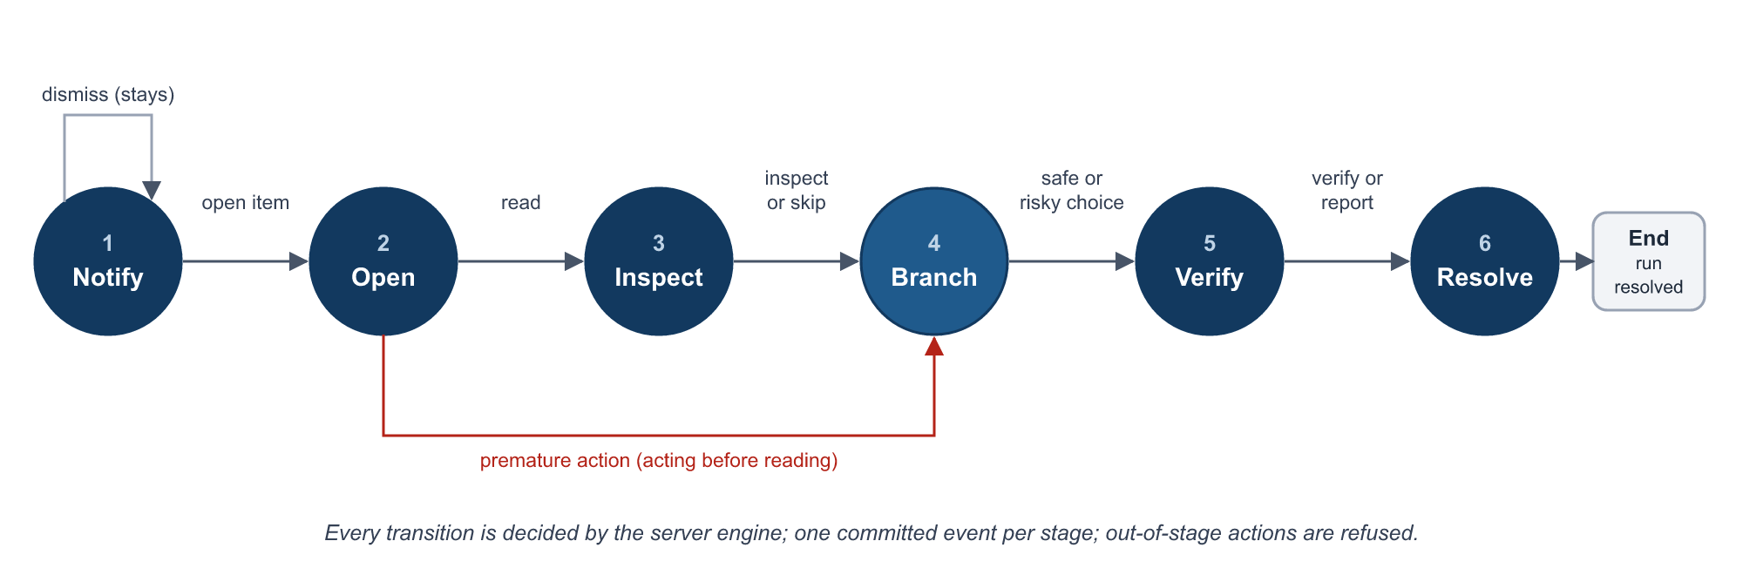
Figure 8. The six-stage state machine.
Stage | Purpose | Possible learner interactions | Transition | Event and scoring
1 Notify | A notification arrives on the simulated home screen | Open the item; dismiss the notification | Open item → Open. Dismiss → stays at Notify | Seen (0 points); dismissal telemetry (0)
2 Open | The learner opens the app and item | Read the item; or act immediately (reply, open link, pay, submit, install, call) | Read → Inspect. Acting before reading → Branch | Opened (0). Premature action: −1
3 Inspect | Examine context and evidence | Inspect sender, profile, link, file, QR or thread; or skip | Either → Branch | Context inspected: +2. Skip: telemetry (0)
4 Branch | The decision point | Safe pivot / correct use; needless reject; risky open or reply; release of data, payment, install, device link, secret or location | Any → Verify | Safe: +3. Needless reject: −2. Risky: −3 (or −4). Release: −8 (or −4)
5 Verify | Confirm through an independent route | Trusted directory, known app or number; contact details inside the message; report or block without checking | Any → Resolve | Trusted verify: +3. In-message contact: 0. Report without check: +1 (malicious) / false report: −4 (legitimate)
6 Resolve | Final disposition | Report, block, continue, retain, ignore; optional one-line rationale (≤250 characters) | → End (run resolved) | Matches disposition: +2. Contradictory / unsafe final: −4
Point values shown are the client specification’s scoring vocabulary (Section 11). The exact event code for an interaction is chosen by the engine from the codes the scenario’s own definition declares at that stage, which is how the same kind of action scores differently on a malicious and a legitimate item. Inside a stage, the learner can investigate freely; only the scored controls advance the stage.

9.1 How the next state is determined
The engine (resolveIntent in scenarioEngineService.js) looks up the intent in the stage’s rule table. The rule names the next stage and an ordered list of candidate event codes. The first candidate that the scenario’s definition declares at that stage is used, and its point value is read from the definition. Resolution intents are evaluated against the scenario’s disposition: a malicious item must end reported or blocked; a legitimate item must end continued or retained.

9.2 Preventing invalid transitions
- An intent that is not legal at the run’s current stage is refused (INVALID_TRANSITION).
- An intent that is legal in principle but not declared by this scenario at this stage is refused; the scenario data gates the engine, not the reverse.
- Each action code is bound to the stage of its control. The controller passes that stage to the engine as the expected stage; if the run has moved on, the engine answers 409 STALE_STATE inside its transaction and nothing changes.
- A resolved run accepts no further actions (RUN_NOT_ACTIVE); an attempt that is no longer in progress accepts no further actions.
- Sequence numbers are strictly increasing per run and protected by a unique index, so two concurrent actions cannot both commit.

10. Learner Action Processing
The neutral learner-action contract (docs/NEUTRAL_LEARNER_ACTION_CONTRACT.md) ensures that nothing in the browser reveals what a control means or how it will be scored. The browser knows a control’s neutral position and the opaque code issued for it; only the server can turn that code into a canonical intent.
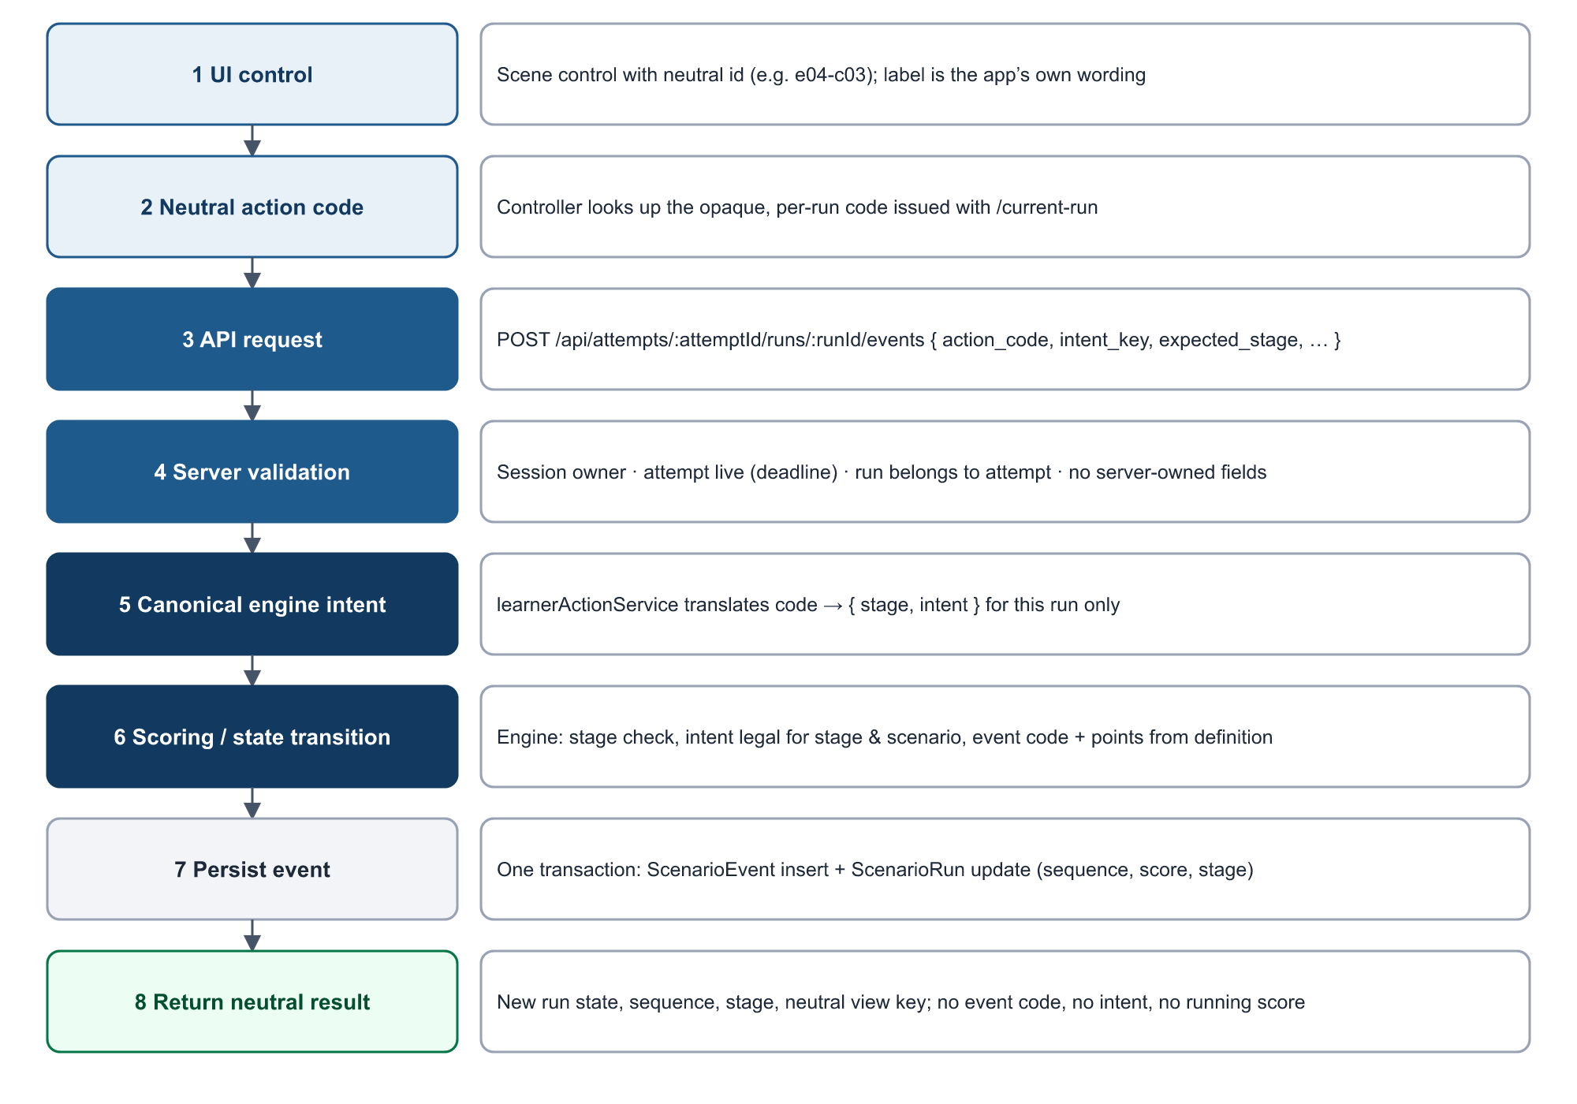
Figure 9. The eight steps of processing one learner action.

10.1 Neutral identifiers and action codes
- Each scored control has a neutral id: <scenario>-cNN for scene controls (for example w01-c07) and gen-cNN for the generic action sheet. The id is a position, not a description.
- The mapping from control id to { stage, intent } is held only on the server in backend/data/learner-actions/v1/*.json (1,798 scene controls and 37 generic controls at present). It is validated at start-up; a malformed map stops the server from starting.
- When the browser loads a run, /current-run returns a table of neutral id → action code for that run. Codes are generated with a keyed cryptographic hash over the run, scenario, version and control, using a server secret. The same control has a different code on every run, and a code carries no information about stage, intent or verdict.

10.2 Why the canonical intent is not exposed
If the browser held canonical intents (for example the name of a “safe pivot” control) or scoring codes, a learner could read the page source or network traffic and discover which choice is correct, or craft a request for the best-scoring action. Keeping the intent server-side means the browser can only say “the learner pressed this control on this run”, and the production bundle is checked automatically (npm run check:bundle) to confirm that no intent or scoring vocabulary is shipped.

10.3 Protections
Threat | Control in the current implementation
Client-side score manipulation | No score is accepted from the browser. Points are read from the pinned scenario definition; the running score is not even sent to the browser during an assessment
points_delta / score injection | Requests containing server-owned fields (points, score, stage, sequence, event code, status, deadline, selection data and similar) are refused with 422 FORBIDDEN_FIELD rather than ignored
Intent injection | Requests carrying an intent or verification-source field are refused; the intent is derived only from the action code
Wrong-stage actions | Each code is bound to its control’s stage; the engine rejects a mismatch with STALE_STATE; a request whose declared stage contradicts its own code is refused
Stale actions | Optimistic concurrency on the run’s stage and sequence; the client resynchronises on 409
Duplicate actions | Each action carries a client-generated idempotency key; a retry with the same key replays the original result without re-scoring (unique index on intent_key)
Cross-run action reuse | Codes are bound to one run; a code from another run, attempt, scenario or learner matches nothing and receives the same neutral 422 INVALID_ACTION. A key already used on another run is refused
Malformed metadata | Only three timing keys may be sent by the browser; values are bounded; anything else is refused. The ledger’s other metadata is written by the server
Replay attempts | A replayed request either matches an existing idempotency key (returns the original outcome, no new event) or targets a run that has moved on (refused). Ownership of attempt and run is checked on every request
Probing | All invalid-code cases return the same neutral refusal; comparison is constant-time

10.4 What the browser receives
After a committed action the response contains the run’s new candidate projection (stage, status, sequence), the accepted event’s sequence, stage and timestamp, an optional rendering instruction for a simulated consequence, and a neutral view key naming the inert panel to open. It does not contain the event code, the intent, the points, or the running score. The final 0–10 score is released only once the run is resolved.

11. Scoring Engine
Scoring follows section 5 of the client specification. The engine applies it; it does not define it: point values are stored in each scenario definition so that an attempt remains explainable from what was stored when it ran.
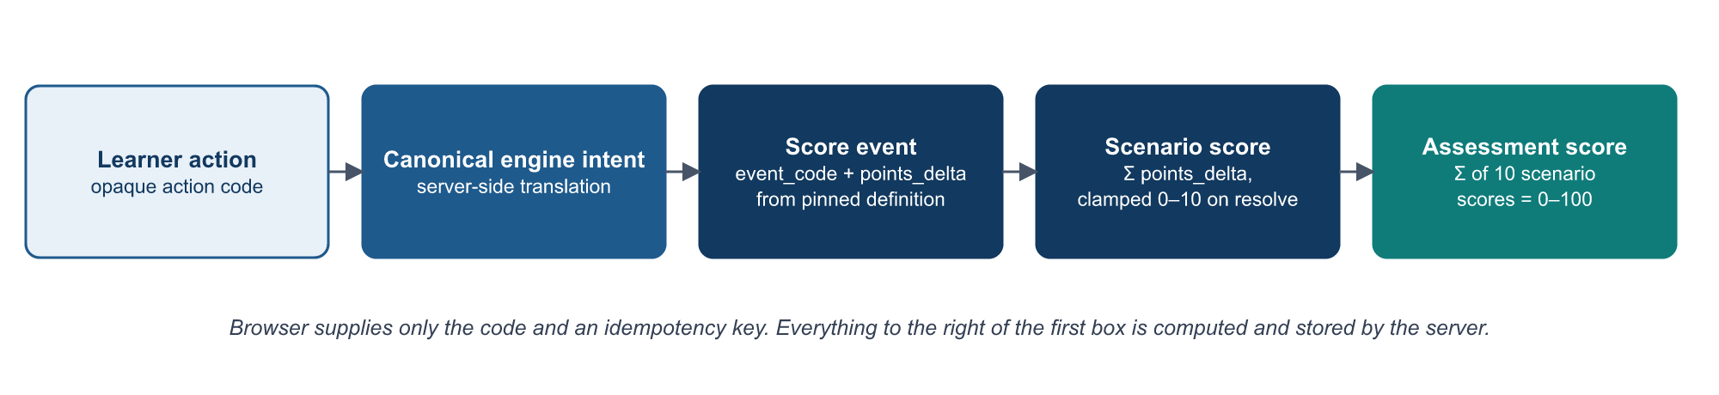
Figure 10. From learner action to assessment score.

11.1 Scoring vocabulary
Scoring event | Points | Category
INSPECT_CONTEXT | +2 | Positive
SAFE_PIVOT / CORRECT_USE | +3 | Positive (malicious / legitimate item)
TRUSTED_VERIFY | +3 | Positive
RESOLVE_CORRECT | +2 | Positive
REPORT_ONLY_WITHOUT_CHECK | +1 | Partial credit
NOTIFY_SEEN, ITEM_OPEN, VERIFY_THROUGH_MESSAGE | 0 | Neutral
PREMATURE_REPLY | −1 | Negative
NEEDLESS_REJECT_IGNORE | −2 | Negative (false-positive behaviour at the decision point)
RISKY_OPEN_REPLY | −3 | Critical unsafe action
FALSE_REPORT_BLOCK | −4 | Negative (false positive: reporting a legitimate item)
UNSAFE_EXTERNAL_ACTION | −4 | Critical unsafe action
CONTRADICTORY_UNSAFE_FINAL | −4 | Critical unsafe action (final decision contradicts the disposition)
SECRET_PAYMENT_INSTALL_DATA_RELEASE | −8 | Critical unsafe action
Engine telemetry codes (STAGE_SKIPPED, RUN_ABANDONED, RUN_EXPIRED) always carry 0 points and are never mistaken for scoring events.

11.2 Per-scenario and total scores
- Per-scenario score: the sum of the run’s points_delta values, clamped to 0–10 when the run is resolved. The safe path sums to exactly 10 (+2 +3 +3 +2), so the clamp acts as a floor.
- Assessment score: the sum of the ten clamped scenario scores, 0–100. Computed on completion from the stored run scores, never from client input.
- Integrity: the running score on a run is a cache; it must always equal the sum of its ledger events, and the result service checks that the stored total equals the sum of the ten run scores before releasing a result.

11.3 False positives and missed threats
Legitimate controls exist so that over-caution is measured. Rejecting or reporting a legitimate item is penalised (NEEDLESS_REJECT_IGNORE, FALSE_REPORT_BLOCK), and resolving it with report, block or ignore scores CONTRADICTORY_UNSAFE_FINAL. The result projection classifies each scenario as handled safely, missed threat, false positive, unsafe handling (a legitimate item kept but with a critical unsafe action along the way) or not resolved (closed by the time limit).

11.4 Protection from client manipulation
The browser sends only an action code and an idempotency key. The code is translated server-side, the event code and points are chosen from the pinned definition, and the event and the run update are committed atomically. There is no API through which a learner can submit, adjust or read a running score.

12. Assessment Workflow
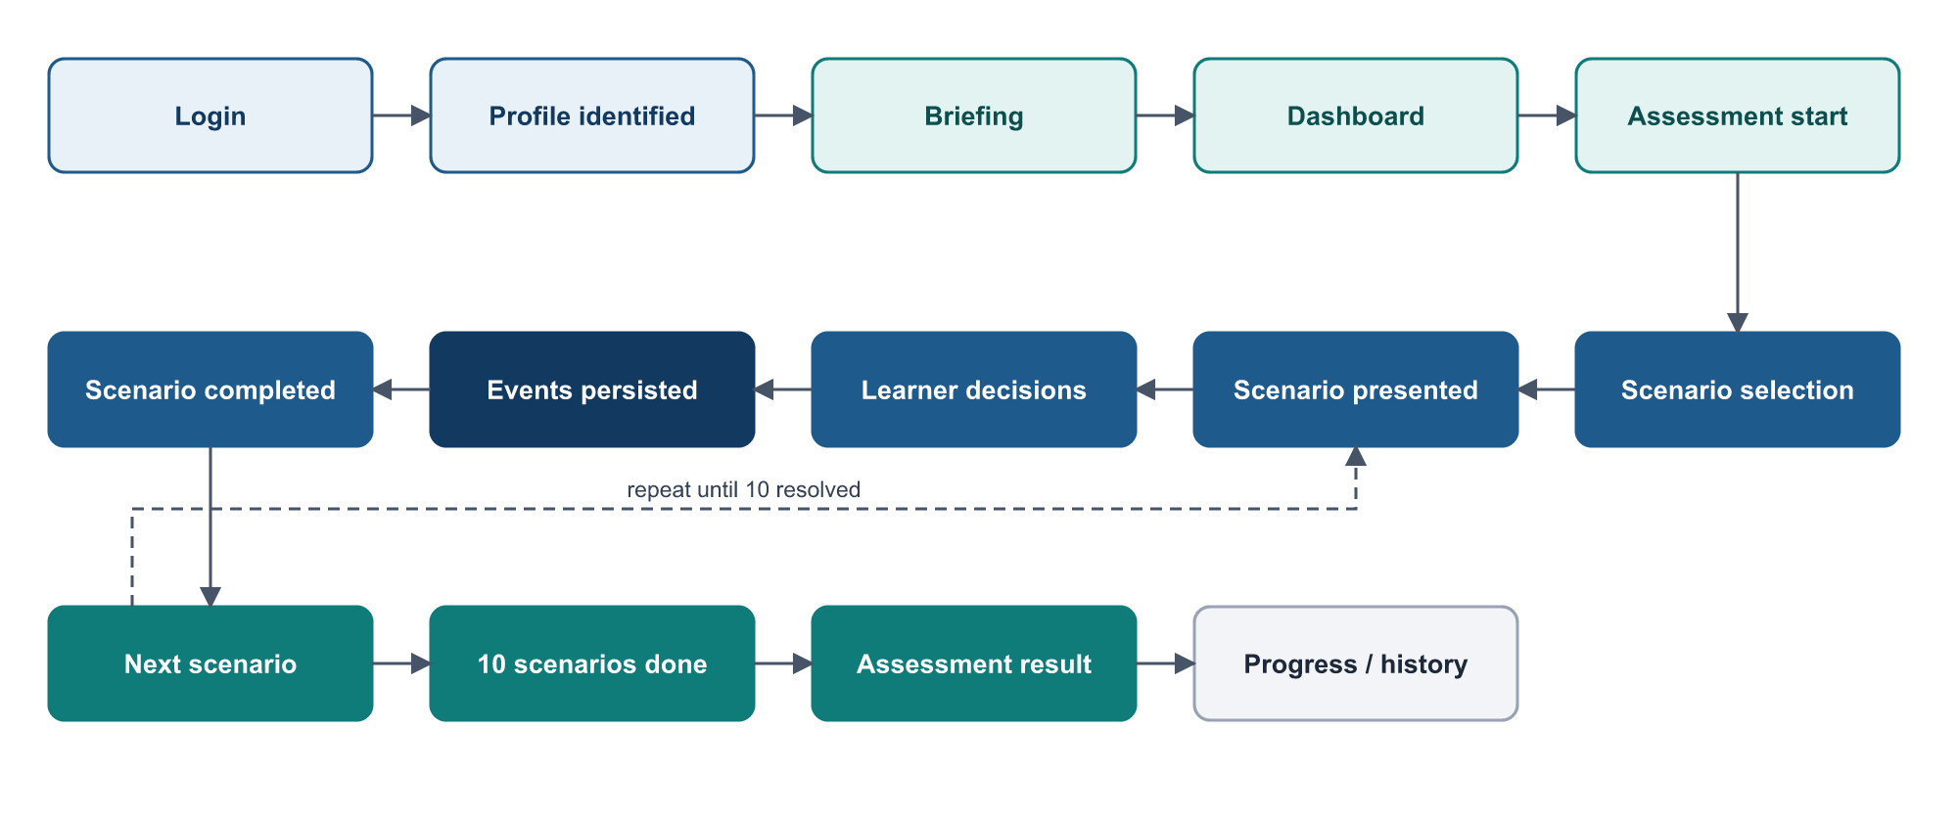
Figure 11. The learner journey.

12.1 Step by step
Step | What happens | Technical detail
Login | The learner enters name and personal / service number | POST /api/candidates; the identifier is normalised (case, spaces, hyphens and slashes removed) so one person maps to one profile; archived profiles are refused; a signed httpOnly session cookie is set
Profile identification | The app shows the learner’s name and masked number | GET /api/candidates/me returns display name, masked number and briefing state; raw numbers and internal ids are never sent to the browser
Briefing | The learner reads and acknowledges the current briefing version | POST /api/candidates/me/briefing stores the version and time; acknowledgement is an explicit action, not a side effect of loading a page
Dashboard | Progress summary and a Start / Resume button | GET /api/attempts/current and GET /api/progress
Assessment start | A new attempt is created, or the in-progress one is resumed | POST /api/attempts; an overdue attempt is finalised first so it cannot block a new one
Scenario selection | Ten scenarios are chosen and frozen | Seeded constraint solver; attempt and ten runs committed in one transaction (Section 13)
Scenario presentation | A notification is delivered to the simulated phone | GET …/current-run returns the lowest unresolved run, its candidate-safe content and its action codes; the notification appears 1–4 s after the home screen is idle
Learner decisions | The learner investigates and acts | One committed event per stage via POST …/events; the resolve step uses POST …/resolve
Event persistence | Each accepted action is stored | Event and run update in one transaction before the response is sent
Scenario completion | Run resolved, score clamped | Next run is delivered through the dashboard tray
10 scenarios completed | The attempt is completed | POST …/complete sums the ten scores; idempotent
Assessment result | Score, outcome summary, per-scenario feedback, review | GET …/result (Section 17)
History | Progress across attempts | GET /api/progress (dashboard and in-assessment panel); see Section 17 for the legacy /history page

12.2 Time limit
Each assessment has a 90-minute limit, fixed at creation from the server clock (time_limit_ms, expires_at) and frozen thereafter. The browser shows a countdown corrected by the server’s clock (server_now), with warnings at 10 and 2 minutes, but it never decides when time is up. Enforcement happens in three places: a guard on every attempt request, a background sweeper every 30 seconds, and a recovery pass at server start-up. When time expires, unresolved runs are closed with a zero-point RUN_EXPIRED event (no decision is fabricated for them), the attempt is completed with end_reason: expired, and the result is available immediately.
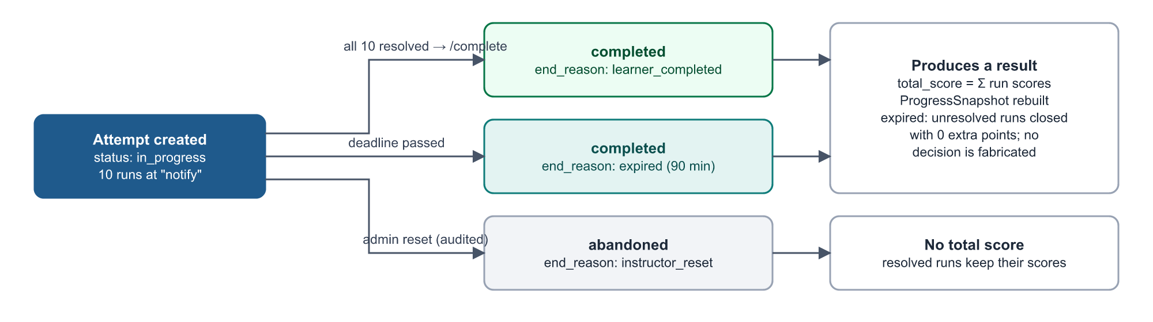
Figure 12. Attempt lifecycle and end reasons.

12.3 Persistence of progress
Progress is persisted continuously, not at the end. Every accepted action is committed before the browser is told the outcome, and the attempt’s frozen sequence determines which scenario comes next. There is no “save” step and no progress held only in the browser.

12.4 Interruption, reload and recovery
Situation | Behaviour
Page reload or browser restart | The page asks the server for the current attempt and run and resumes at the last committed stage. The thread is re-derived from that stage. In-scene navigation (which sub-page was open) is not restored, and a transient consequence banner is not rebuilt; the ledger is unaffected
Lost response after an action | The retry reuses the same idempotency key; the server replays the original result instead of scoring again
Same attempt open in two tabs | The second tab’s stale action is refused with 409 STALE_STATE; it resynchronises from the server
Learner signs out | Logout ends the session only. The attempt continues and the clock keeps running; the learner is told this before confirming
Learner leaves and does not return | The sweeper finalises the attempt at its deadline; the result exists without anyone requesting it
Learner returns after the deadline | GET /api/attempts/current reports the recently expired attempt so the learner is taken to the result rather than told there is no assessment
Server restarted | Overdue attempts are finalised at start-up; downtime is not credited back
Instructor reset | The attempt becomes abandoned (nothing is deleted); further actions are refused; the learner starts a new attempt

13. Scenario Selection
Selection is implemented in services/scenarioSelectionService.js (algorithm version 1.0.0) and called by attemptService.createAttempt(). It is a pure, synchronous solver: given the same seed, pool and history it returns the same result on any machine. It constructs a valid attempt directly (slot matrix plus depth-first search with forward checking) rather than drawing random sets and testing them, and every result is independently re-validated before it is stored.

13.1 Implemented composition rules
Rule | Implemented behaviour
Size | Exactly 10 scenarios, no duplicates
Malicious / legitimate | Exactly 8 malicious and 2 legitimate; the two legitimate items come from different platforms
Platform coverage | Rotating 3 / 3 / 2 / 2 allocation over WhatsApp, Instagram, Email and SMS, rotated by the learner’s attempt count so exposure balances over every four attempts
Difficulty | Exactly 3 easy, 4 medium and 3 hard
Military context | Between 2 and 4 fictional military-context scenarios
Triggers | At least 5 distinct canonical psychological triggers
Attack families | No canonical family more than twice
Recent exclusion | The learner’s 20 most recent scenario ids are excluded; if that makes the pool unsatisfiable, the minimum number of recent items is re-admitted and the relaxation is recorded on the attempt
Content version | Only active definitions, one version per scenario; the selected ten must share a content version
Presentation order | Shuffled with the same seed; no more than two consecutive scenarios from the same platform
Seed | Generated server-side, never client-supplied; stored on the attempt with the algorithm version, platform quota, composition counts and recent-exclusion details so the selection can be replayed and audited
Failure | An unsatisfiable pool fails with a clear error; composition rules are never silently relaxed

13.2 Target and planned behaviour
Behaviour | Status
Adaptive difficulty | Not implemented. Difficulty uses the fixed 3 / 4 / 3 quota. The specification treats adaptive practice as a separate mode so that assessment scores stay comparable
Training mode | Implemented (partial). The attempt model and API accept mode: training, but the learner interface starts assessment mode only, and immediate in-attempt feedback is not yet delivered (Section 16)
Duplicate prevention | Implemented within an attempt (model validation and solver) and across recent attempts (recent-20 exclusion)
Selection metadata stored on the attempt carries aggregate counts only; the learner projection of an attempt contains no seed, no composition and no per-scenario classification.

14. Data Flow
Each flow below shows the browser request, the API boundary, the backend logic, the database interaction and the response. All flows use JSON over HTTP with cookies; all learner flows derive identity from the session cookie.

A. Login
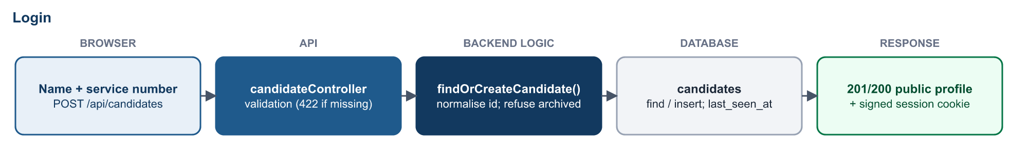
Figure 13. Login data flow.
The signed session cookie is the only credential the learner holds; it is httpOnly and cannot be read by page scripts.

B. Start assessment
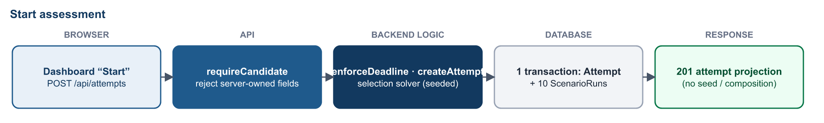
Figure 14. Start assessment data flow.
If a live attempt exists it is returned instead of creating a second one; an overdue one is finalised first.

C. Load scenario
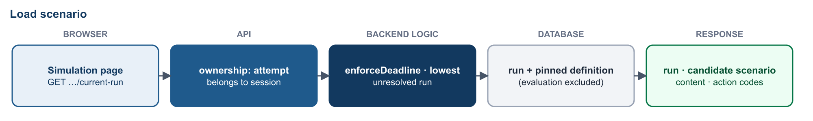
Figure 15. Load scenario data flow.
Content is loaded by the run’s pinned version; the evaluation block is never requested for a learner.

D. Learner action
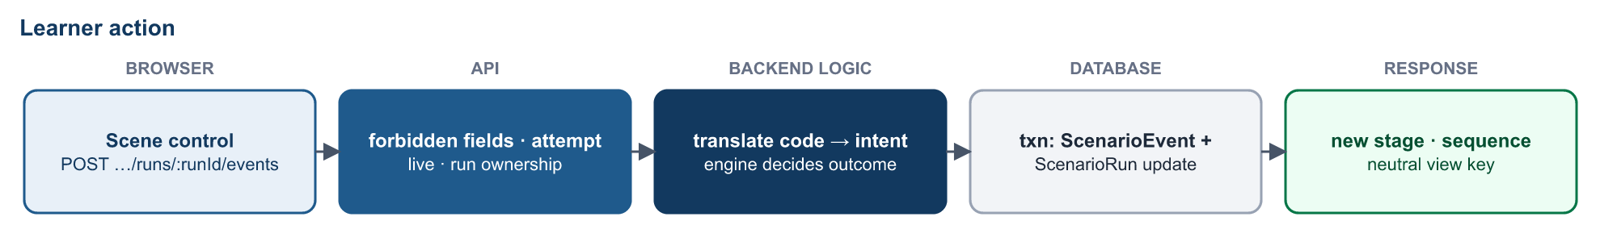
Figure 16. Learner action data flow.
The event and run update commit together, before the response is sent.

E. Verify action
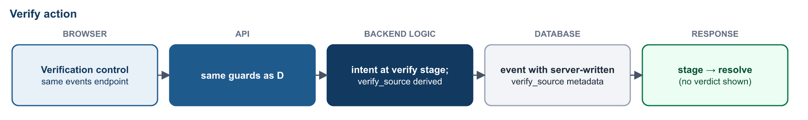
Figure 17. Verify action data flow.
The verification source recorded in the ledger is derived from the intent on the server; the browser does not send it.

F. Score action
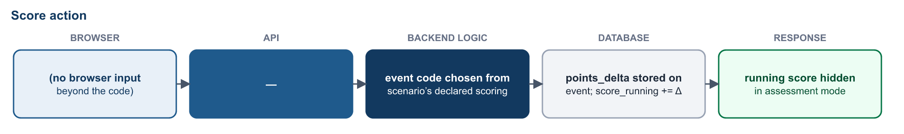
Figure 18. Score action data flow.
Scoring is part of step D; it is shown separately because no browser input other than the action code influences it.

G. Complete scenario
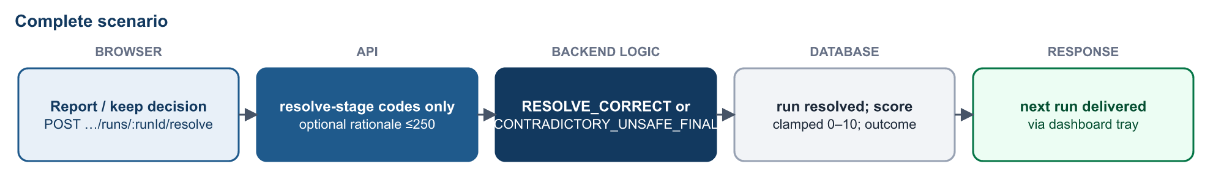
Figure 19. Complete scenario data flow.
Only resolve-stage codes are accepted on the resolve route; the final 0–10 score becomes visible only after resolution.

H. Complete assessment
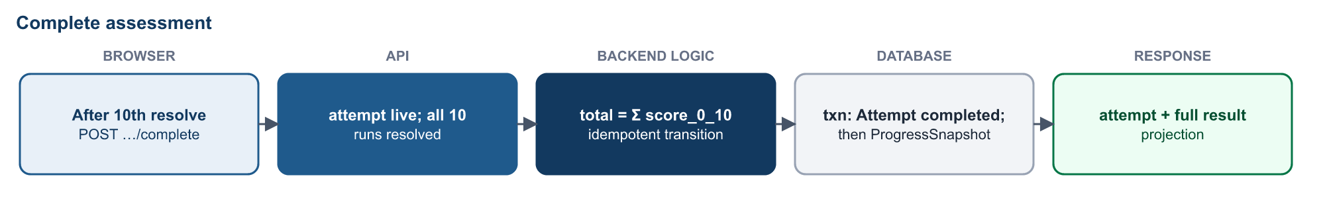
Figure 20. Complete assessment data flow.
A repeated completion returns the already-completed attempt; the progress snapshot is recomputed rather than incremented.

I. View result and history
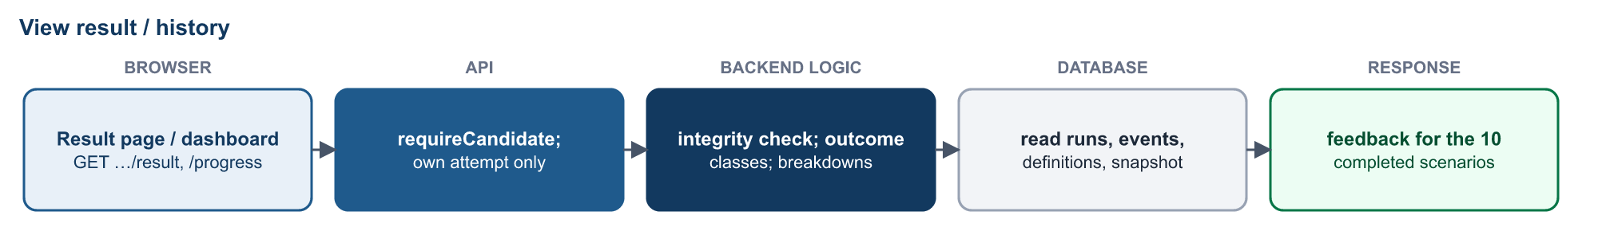
Figure 21. View result and history data flow.
The result is recomputed on each request from authoritative records and integrity-checked against the stored total.

J. Admin scenario management
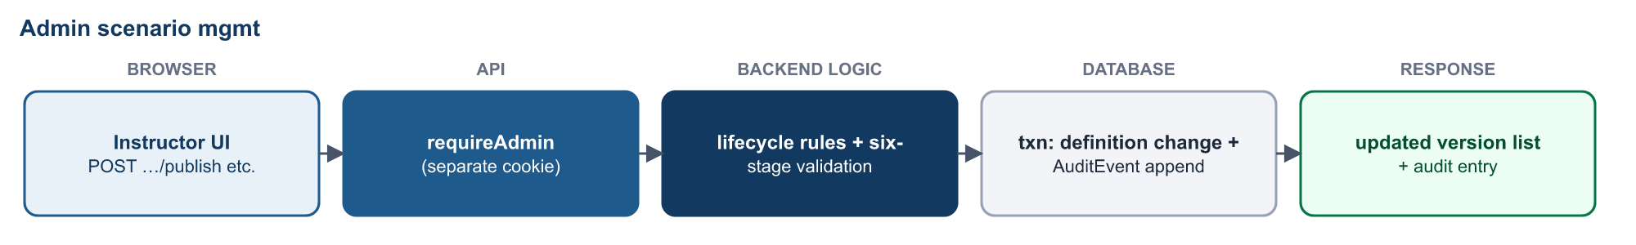
Figure 22. Admin scenario management data flow.
Every publish, deactivation and clone writes an append-only audit entry in the same transaction.

15. Security Architecture
Key point: The browser is treated as an untrusted client; authoritative assessment state and scoring decisions remain server-controlled. This statement reflects the current code: the browser holds no stage logic, no scoring data and no canonical intents, and every request is re-validated on the server.
Control | Implementation
Server-side validation | Every learner request is checked for session, ownership, attempt status, deadline and forbidden fields before any business logic runs
Neutral learner actions | Opaque per-run action codes; control-to-intent maps held only on the server; production bundle scanned for leaked vocabulary (Section 10)
Authorisation | Separate learner and administrator sessions with different cookie names, different signing secrets and different collections; a learner session never satisfies an admin route
Input validation | Mongoose schema validation with enums and bounds; allow-listed request fields for admin authoring; allow-listed filters so no client-supplied database operator reaches a query; 1 MB body limit; rationale limited to one line of 250 characters without markup
Replay and duplicate handling | Unique idempotency key per action; duplicate requests replay the stored outcome; a key cannot be reused on another run
Stage and run validation | Expected-stage check inside the transaction; unique run sequence; resolved runs and finished attempts accept nothing
Cross-run protection | Action codes bound to run, scenario, version and control; run must belong to the attempt, attempt must belong to the session
Database integrity | Multi-document transactions for every multi-document change; journaled writes; frozen fields on attempts; append-only audit collection; ledger-reproducible scores
Data containment | All synthetic assets use reserved example domains; links, files, QR codes, calls and payments are simulated and inert; typed form values are never transmitted or stored
Browser storage | Nothing authoritative in localStorage, sessionStorage or readable cookies; session cookies are httpOnly, SameSite=Lax, and Secure when NODE_ENV=production
External network dependencies | The application loads no third-party scripts, fonts, analytics or CDNs and calls no external service at run time; icons and styles are bundled
Sensitive data minimisation | No password, phone number, e-mail, rank or unit is collected for learners; service numbers are shown masked; internal ids and the seed are not sent to learners; admin views exclude raw events and typed rationale
Administrator credentials | Argon2id hashing, constant-time verification, failed-login throttling with lockout, 1-hour session, account created only by an operator script
Auditability | Append-only AuditEvent for publish, deactivate, attempt reset, profile archive, export and configuration change, written in the same transaction as the change
Error hygiene | Stable error codes; internal detail suppressed in production; engine messages neutralised on learner routes

15.1 Known security gaps for central-server hosting
Current limitation: These items are not implemented in the repository and must be addressed as part of production configuration (see Sections 19 and 23).
- Learner authentication is identification only (name + service number, no password or single sign-on). Over a shared network, anyone who knows a learner’s number can act as that learner. A stronger learner authentication method, or network-level access control, is required before multi-user server hosting.
- No rate limiting on learner endpoints; admin login throttling is per process and in memory.
- No HTTP security headers (Content-Security-Policy, HSTS, frame options) are set by the application; these are planned at the reverse proxy.
- HTTPS is not terminated by the application; it relies on the planned reverse proxy. The Secure cookie flag is enabled only when NODE_ENV=production.
- Proxy awareness: Express is not yet configured to trust a reverse proxy, so behind one the admin throttle would key on the proxy address. A small configuration change is needed at deployment.
- Database authentication is not configured in the current installation; production must enable MongoDB authentication and bind it to a private interface.
- The connection-failure log prints the configured database URI; if a production URI embeds credentials this log line should be masked.

16. Administration & Management
The instructor area is a separate, guarded branch of the frontend (/admin/*, AdminLayout) backed by /api/admin/*, where every route except login and logout requires an administrator session.
Capability | What administrators can see | What they can change | API
Scenario manager | All scenario versions with lifecycle (Draft / Published / Retired), metadata, filters; the evaluation answer key behind an explicit disclosure toggle | Publish a draft (retires the current live version after six-stage validation), deactivate a version, clone into a new draft, edit owner and review date | GET/POST /admin/scenarios, GET/PATCH …/versions/:v, POST …/clone|publish|deactivate
Attempt viewer | All attempts, newest first, filtered by learner, status, mode and date; attempt detail with scores, outcome classes, breakdowns, path replay, remediation and comparison | Nothing (read-only) | GET /admin/attempts, GET /admin/attempts/:id, GET /admin/learners
Exports | Generated CSV / PDF reports for one attempt | Create an export (written to the server’s configured export directory); download a copy | POST /admin/exports/attempts/:id, GET /admin/exports/:filename
Instructor controls | Attempt status and archival state | Reset an incomplete attempt (to abandoned, nothing deleted); archive a learner profile (no deletion, no un-archive route) | POST /admin/attempts/:id/reset, POST /admin/learners/:id/archive
Configuration | Feedback-timing policy for training and assessment modes, with its enforcement status | Set each to immediate or on_completion (optimistic version check) | GET/PATCH /admin/config/feedback
Audit log | Every administrative change: actor, action, resource, outcome, time | Nothing (append-only) | GET /admin/audit

16.1 Access controls
- Separate administrator session cookie with its own secret and a 1-hour lifetime; the account must still exist on every request.
- Failed-login throttling (5 failures within 15 minutes → 15-minute lockout per client address and username).
- Every lifecycle change is a POST with its own transaction and audit entry; there is no DELETE endpoint anywhere in the admin API.
- Administrator requests are built field by field in adminApi.js, and the server rejects unknown fields rather than ignoring them.

16.2 Current limitations
- Scenario content is not authored in the UI. Only owner and review_date are editable; the six stages, assets, scoring and evaluation are client material maintained through the versioned data files and importer. A new scenario id cannot be created because all 100 ids in the specification’s pattern are in use; cloning is the working authoring path.
- One administrator account is supported by the creation script; there is no role model or multi-administrator management.
- Exports cover one attempt at a time; there is no bulk or cohort export and no retention policy for generated files.
- The immediate feedback-timing setting is stored, versioned and audited, but no learner surface yet releases feedback during an attempt; the API states this explicitly.

17. Reporting & Results
Results are produced by attemptResultService.buildAttemptResult() from authoritative records only. The same projection is used for the learner result page, the instructor attempt viewer and exports, so all three always agree.
Result element | Content | Status
Total score | 0–100, with maximum, resolved count, duration and end reason (including timed-out attempts) | Implemented
Outcome summary | Counts of handled safely, missed threats, false positives, unsafe handling and not resolved | Implemented
Scenario-level results | For each of the ten: platform, sender and preview as shown, 0–10 score, outcome class, final action, compact path replay (step, stage, action) | Implemented
Feedback | What the item actually was, warning or confirming cues, the preferred safe action, likely impact and one prevention habit — released only for the ten scenarios just completed | Implemented
Mistake review | For each scenario, the stage where it went wrong and the stage-specific safe behaviour in the scenario’s own words | Implemented
Behavioural breakdown | Points by platform, attack family, psychological trigger and decision stage (with missed-threat and false-positive counts per bucket) | Implemented
Remediation | Up to three weakest families with a reason and the number of practice scenarios available | Implemented
Comparison | Change against the previous completed attempt, only when both attempts share mode, content and taxonomy versions; otherwise a stated reason | Implemented
Progress across attempts | Attempt count, scenarios completed, last and best score, platform and family totals (ProgressSnapshot) | Implemented
Learner list of past six-stage attempts | A per-attempt history list for learners | Not implemented — see below
Cohort / organisational reporting | Aggregates across learners, trends, dashboards | Not implemented
Current limitation: The learner /history page still reads the earlier 40-question pipeline (/api/assessments) and does not list six-stage attempts. Learners see their latest result directly after completion and cumulative progress on the dashboard and inside the assessment; instructors see every attempt in the attempt viewer. Migrating or retiring the legacy history page is recorded as deferred work.
What is withheld from learners even after completion: scenario titles, difficulty, the raw disposition value, event codes, point deltas, the raw ledger, the seed, and every field of scenarios they have not taken.

18. Testing & Quality Assurance
Testing is layered because each layer catches a different kind of failure. A component test cannot prove that a transaction commits, and a database test cannot prove that a scene shows no hint of the answer. The figures below are from the most recent complete verification run (21 September 2026).
Layer | Scope | What it protects
Frontend unit and component tests (Vitest, jsdom) | 39 files, 3,530 tests | Reducer and orchestration logic, every page state, scene structure, neutral wording (no verdict or trigger words), containment (no links, media or form submission), accessibility attributes
Scene model guard tests | sceneModel.test.js, sceneResearch.test.js | Every scene is legal for the engine, reachable with the decision still unspent, distinct from earlier scenes, and uses neutral control ids
Backend unit tests (node --test) | 632 database-free tests | Schema rules, selection solver, scoring arithmetic, taxonomy mapping, action-code translation, projections, CSV/PDF writers, throttling, password hashing
Database integration and real-engine tests | 18 suites, 366 tests, each against an isolated replica set | Transactions, idempotent retries, stale-state and cross-run refusals, attempt creation, completion, expiry, admin controls, audit writes, and complete safe and unsafe routes through the real engine for each scene batch
Security tests | Within the above suites | Forbidden-field rejection, neutral refusals, learner/admin session separation, archived-profile lock-out, export path safety, append-only audit
Scenario content and taxonomy validation | Importer dry-run; schema and taxonomy tests | Six-stage structure, permitted transitions and events, asset references, reserved domains, family and trigger canonicalisation
Lint and production build | oxlint, vite build | Code hygiene; the shipped bundle builds cleanly
Bundle check | npm run check:bundle | No intent, scoring or verification vocabulary in the production bundle
Browser validation | Production build against an isolated API and database | Real clicks through safe and unsafe routes, reload recovery, live API refusals, DOM and network inspection, 375 / 320 px layouts, keyboard focus, zero outbound requests
Regression protection comes from running the full suites for every change and from guard tests that automatically include each new scene batch. Database suites never touch the main database: they create their own isolated replica set or database and refuse to run against the production database name.

19. Application Deployment Architecture
Planned production configuration: The platform has not yet been deployed to a production server. This section describes the intended central-server architecture. Components marked as planned are not part of the current repository.
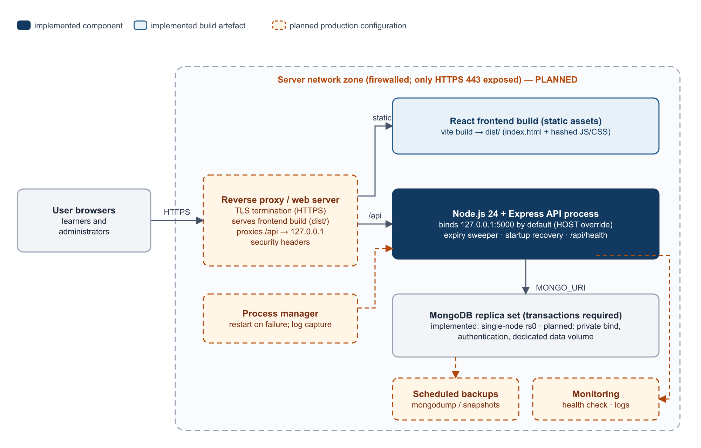
Figure 23. Intended production deployment. Dashed amber components are planned production configuration.

19.1 Components
Component | Current implementation | Production configuration
Frontend build | vite build produces static index.html plus hashed JS and CSS in frontend/dist/ | Served as static files by the web server; SPA fallback to index.html for client routes (planned)
Static asset serving | Not performed by the backend (Express serves only /api) | Reverse proxy / web server serves dist/ (planned)
Backend process | Single Node.js process (npm start), loopback bind by default, graceful shutdown on SIGTERM | Run under a process manager or OS service for restart-on-failure and log capture (planned)
API routing | All endpoints under /api; frontend defaults to same-origin /api | Reverse proxy forwards /api to 127.0.0.1:5000, so browser and API share one origin (planned)
MongoDB | Single-node replica set with transactions; bound to loopback in the current installation | Replica set on the application host or a private database host; authentication enabled; dedicated data volume (planned)
Environment variables | Validated at start-up; admin secret mandatory and distinct | Production values set in the service environment, not in the repository; NODE_ENV=production (planned)
HTTPS | Not handled by the application | TLS certificate at the reverse proxy; HTTP redirected to HTTPS; HSTS (planned)
Firewall | None configured | Only 443 (and optionally 80 for redirect) exposed; API port and database port closed externally (planned)
Database network isolation | Loopback-only in the current installation | Database reachable only from the application host (planned)
CORS | One configured origin with credentials | Set to the production origin; with a same-origin proxy CORS is effectively not exercised
Session security | httpOnly, SameSite=Lax, Secure in production, separate admin secret | Strong unique secrets; trust-proxy setting so client addresses are correct (planned)
Logging | Structured JSON lines to standard output for engine, selection, completion and expiry events; errors to standard error | Captured and rotated by the process manager or a log collector (planned)
Health checks | GET /api/health returns 200 with database state, or 503 | Polled by monitoring; alert on failure (planned)
Backups | None automated | Scheduled mongodump or volume snapshots with off-host copies and tested restores (planned)

19.2 Deployment and update process (planned)
- Build the frontend (npm ci && npm run build) and run the full test suites, lint and bundle check.
- Back up the production database.
- Deploy the backend code and install dependencies (npm ci --omit=dev).
- Apply any content changes through the importer (dry run first), never by editing documents directly.
- Restart the backend service; start-up recovery finalises any overdue attempts.
- Publish the new dist/ directory to the web server.
- Run smoke tests: health check, sign-in, start an attempt as a test learner in a non-production profile, one action, admin sign-in.

19.3 Rollback strategy (planned)
Keep the previous backend release and previous dist/ directory alongside the new one so that either can be switched back instantly. Scenario content is versioned: a problematic content version can be deactivated and the previous version republished through the scenario manager without touching attempts already pinned to either version. A database restore from the pre-deployment backup is the last resort, because it discards learner activity recorded after the backup.

20. Production Data Migration Strategy
Production must be built from a validated release dataset, not by copying a development or test database. Development databases contain test learners, test attempts, retargeted runs used for browser validation and legacy pipeline data, none of which belongs in production.
 | Development / test data | Production release data
Scenario definitions | May contain staged or experimental versions | The approved 100-scenario bank, imported from the versioned data files at a known content version
Learner profiles, attempts, runs, events | Test learners and synthetic activity | None at go-live; created only by real use
Administrator | Development accounts | One account created on the server by the operator script
Legacy collections (scenarios, assessments) | Present | Excluded unless the legacy journey is deliberately retained
Secrets and configuration | Development values | New, unique production secrets; never copied

20.1 Migration sequence
- Complete scenario development (including the remaining SMS scenes S16–S25).
- Complete the final content and technical audit.
- Validate the final scenario bank: importer dry run, taxonomy validation, full test suites, bundle check, browser validation.
- Prepare the production release data: versioned scenario, synthetic and taxonomy files with manifests and content hashes; learner-action maps.
- Remove or disable obsolete test and legacy playable data as appropriate (for example retire the legacy /assessment/legacy and /history paths if the client does not require them).
- Back up any existing target database.
- Import the validated dataset into a fresh production database (npm run import:definitions) and create the administrator (npm run admin:create).
- Configure the production environment (secrets, origin, NODE_ENV=production, database URI with replica set and authentication).
- Start the backend and confirm transaction support (npm run verify:replicaset) and /api/health.
- Serve the frontend build through the web server.
- Run smoke tests on the live URL.
- Verify database integrity: 100 active definitions, one active version per scenario, expected indexes present.
- Verify the assessment workflow end to end with a designated test profile, then archive that profile.
- Monitor logs and health for the first days of operation.

21. Maintainability & Future Scalability
Change | How the architecture supports it | Current capability
Add new scenarios | Author the record, synthetic content and taxonomy mapping; import as a new content version; the engine, selection and scoring are unchanged | Implemented for new versions. The 100 id slots are all used; a larger bank needs an id-pattern extension
Add a platform-specific scene | Add a scene pack under simulation/scenes/<platform>/, register it, add its neutral control map on the server and its tests; the guard tests pick it up | Implemented; used for 90 scenes
Update scenario content | Clone to a draft, edit, validate, publish; running attempts keep their pinned version; audited | Implemented (metadata editing in UI; content through data files)
Update scoring rules | Point values live in each definition; a new content version carries new values without affecting past attempts | Implemented through content versions
New assessment types | mode exists on attempts; feedback-timing policy exists; comparison gates on mode | Partial: training mode has no learner UI yet
Admin management | Separate admin area and API with audit | Single admin; no roles
Reporting enhancements | Single result projection reused by UI and exports; ledger supports further analysis | Per-attempt and per-learner only
Server deployment | Stateless HTTP layer with cookie sessions; loopback bind behind a proxy; env-based configuration | Planned (Section 19)
Concurrent users | Transactions, unique indexes and optimistic stage checks make simultaneous learners safe on one instance | Supported on a single backend process; not load-tested

21.1 Horizontal scaling (future option, not implemented)
Running several backend instances behind a load balancer is feasible because sessions are signed cookies rather than server memory and all authoritative state is in MongoDB. Before doing so, three process-local mechanisms would need attention: the admin login throttle (would need a shared store), the expiry sweeper (safe to run on several instances because each expiry re-checks inside a transaction, but wasteful), and the action-code key (every instance must use the same secret). None of this is required for a single-server deployment.

22. Complete End-to-End Workflow
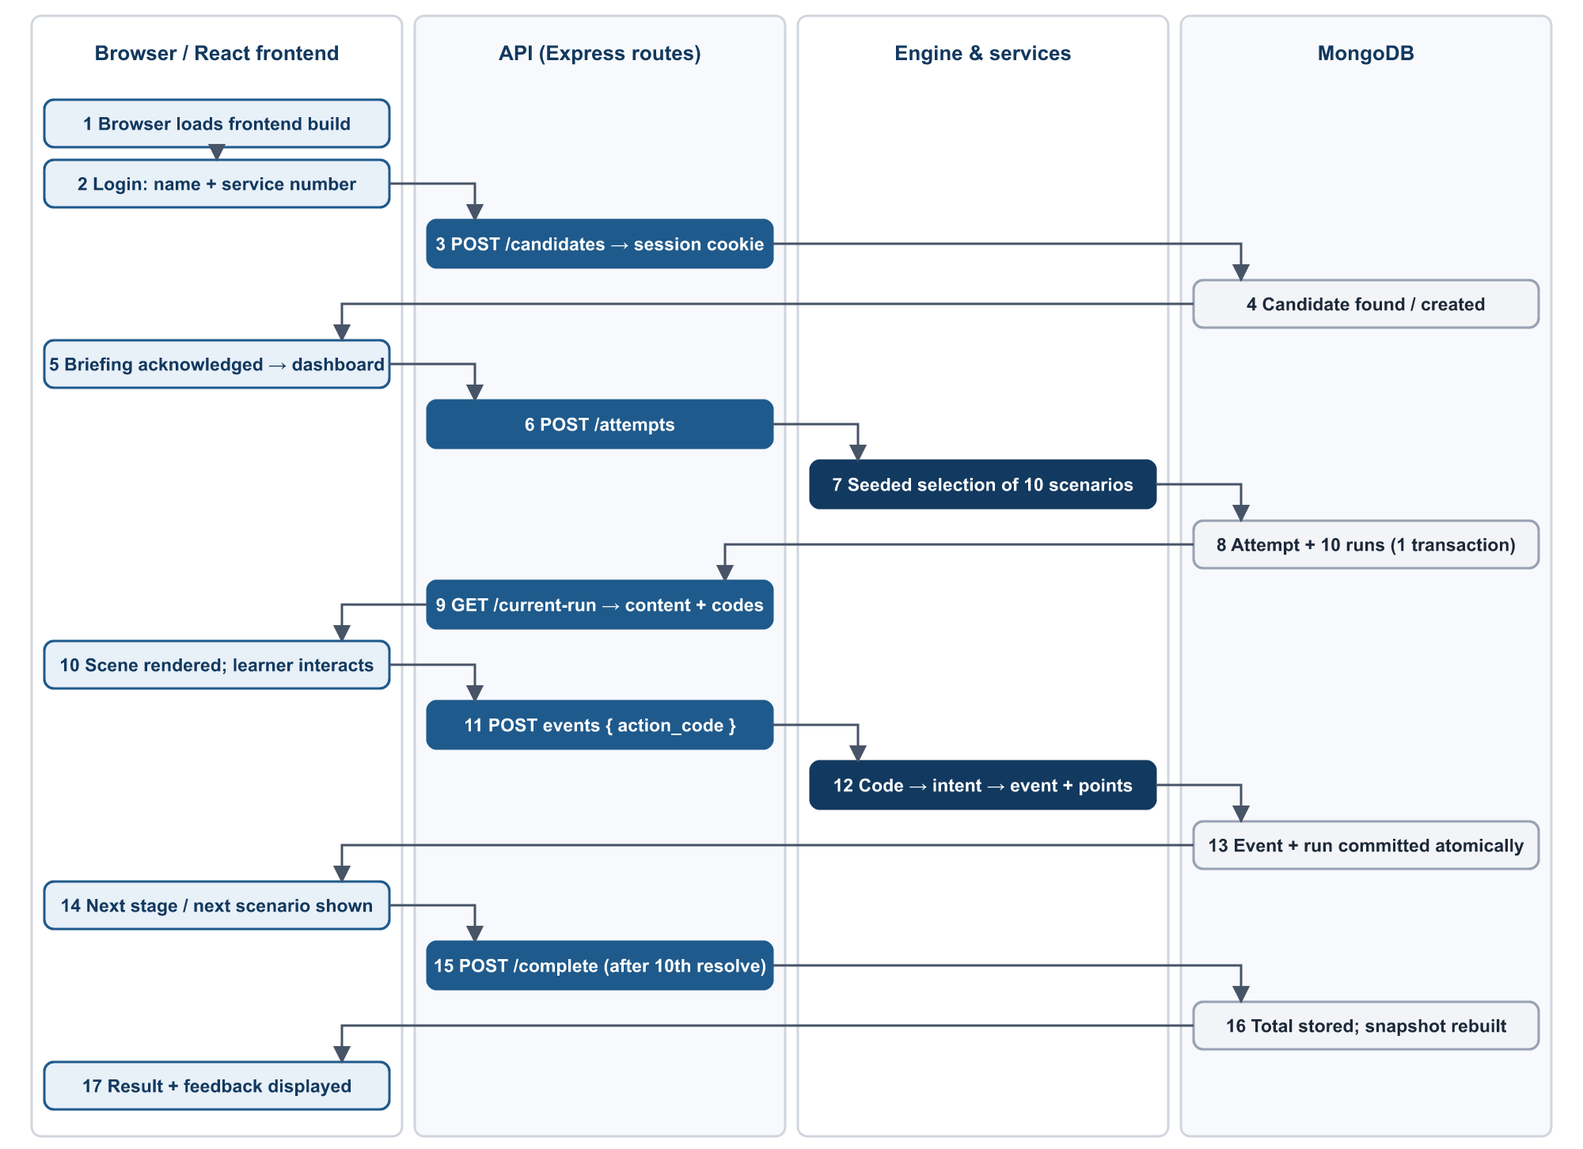
Figure 24. End-to-end technical workflow across browser, API, engine and database.
# | Step | Technical detail
1 | User opens browser; frontend loads | Static index.html and bundled JS/CSS are served; CandidateProvider asks /candidates/me
2 | User logs in; profile identified | POST /candidates → profile found or created → signed session cookie
3 | Briefing acknowledged; dashboard loaded | POST /candidates/me/briefing; dashboard reads /attempts/current and /progress
4 | Assessment started; scenarios selected | POST /attempts → seeded selection → attempt + 10 runs in one transaction
5 | Scene rendered | GET /current-run → candidate content + action codes → sceneFor() → platform scene
6 | Learner interacts; neutral action generated | Free navigation records nothing; a scored control sends its action code and a new idempotency key
7 | API receives and validates action | Session, ownership, deadline, forbidden fields, run membership
8 | Canonical engine decision | Code → intent for this run; stage check; event code and points from the pinned definition; next stage
9 | Event and scenario result persisted | Event insert + run update commit together; on resolve the 0–10 score and outcome are stored
10 | Next scenario selected | Lowest unresolved run of the frozen sequence is delivered through the notification tray
11 | 10 scenarios completed; final result calculated | POST /complete → total = Σ scenario scores → attempt completed → progress snapshot rebuilt
12 | History updated; learner views result | GET /result → integrity-checked projection with feedback, review, breakdown, remediation and comparison

23. Current Implementation vs Production Target
Area | Current implementation | Production target | Status
Frontend | React 19 SPA, Vite build, 90 immersive scenes + generic path for 10 | All 100 scenes immersive; served over HTTPS | Implemented (partial)
Backend | Node 24 / Express 5 API, single process, loopback bind | Same, under a service manager behind a reverse proxy | Implemented
Database | MongoDB single-node replica set, transactions, indexes | Same with authentication, private network and dedicated storage | Implemented (partial)
Authentication | Learner: name + service number (identification only). Admin: Argon2id password, throttled | Stronger learner authentication or network access control; multiple admin accounts | Implemented (partial)
Scenario engine | Six-stage server-authoritative engine; 100 definitions | Unchanged | Implemented
Scoring | Ledger-based, clamped, idempotent, server-only | Unchanged | Implemented
Security | Neutral actions, forbidden fields, sessions, audit, containment | Plus security headers, rate limiting, trust-proxy, DB auth | Implemented (partial)
Admin | Scenario lifecycle, attempt viewer, exports, reset, archive, config, audit | Plus multi-admin roles, bulk export, retention | Implemented (partial)
Reporting | Per-attempt result, review, breakdowns, progress snapshot | Learner attempt history list; cohort reporting | Implemented (partial)
Deployment | Development and verification runs only | Central server deployment | Planned
HTTPS | None in the application | TLS at reverse proxy, HSTS | Planned
Reverse proxy | None | Static hosting + /api proxy | Planned
Backups | None automated | Scheduled, off-host, restore-tested | Planned
Monitoring | /api/health endpoint and structured logs | Health polling, log retention, alerting | Implemented (partial)
Concurrent users | Transaction- and index-safe on one instance; not load-tested | Load-tested for the expected cohort size | Implemented (partial)

24. Technical Glossary
Term | Definition
Scenario | One simulated message situation (for example W07 or E12) that the learner must handle through six stages
ScenarioDefinition | The stored, versioned description of a scenario: synthetic content, six stages, classification, feedback and per-stage scoring
Attempt | One assessment sitting for one learner: a frozen sequence of 10 scenarios, a deadline, a status and a total score
ScenarioRun | The execution of one scenario inside an attempt, pinned to one definition version, holding its current stage and score
Event (ScenarioEvent) | An immutable, sequenced ledger entry recording one accepted action, its event code and its points
ProgressSnapshot | A derived per-learner summary of completed attempts, rebuilt by recomputation
Scene | The data structure that makes a scenario look and behave like a real app: beats, surfaces and controls per stage
Scene registry | sceneRegistry.js: the map from scenario id to scene-pack builder
Scene model | sceneModel.js: the vocabulary scenes are written in (surfaces, slots, actions, navigation)
Learner action | A learner pressing a scored control; transmitted as an opaque action code
Canonical engine intent | The server-side meaning of a learner action (for example an inspection or a verification) that the engine evaluates
Trigger | The psychological lever a scenario uses (for example urgency or authority); 22 canonical values
Family | The attack or case mechanism a scenario represents; 15 malicious and 4 legitimate canonical values
Disposition | Whether a scenario is malicious or legitimate
Assessment | The scored 10-scenario activity (attempt mode assessment)
Neutral action contract | The rule that the browser identifies controls only by neutral ids and per-run opaque codes, with meaning resolved on the server
Production release | The validated scenario dataset, configuration and build that are installed on the production server, as distinct from development and test data

