CLIENT TECHNICAL OVERVIEW
Cyber Awareness Training & Social Engineering Simulation
Technical Workflow & Technology Overview
Version 1.0 · September 2026

1. System Overview
The platform trains and assesses how personnel respond to social-engineering fraud: the deceptive messages, links, calls and requests that arrive through everyday apps. Learners work through realistic scenarios on a simulated phone, and every decision they make is recorded, validated and scored by the server.
It is a browser-based web application designed to be hosted on a central server. All scenario content is synthetic: no real messages, calls or payments are ever sent or received.

How the system works
- The learner signs in through a web browser and reads a short briefing.
- Each assessment presents 10 scenarios drawn from a bank of 100 (25 each for WhatsApp, Instagram, Email and SMS).
- Every action the learner takes is sent to the backend, validated, recorded and scored.
- Results are stored in MongoDB and available to the learner (history) and to instructors (Admin).
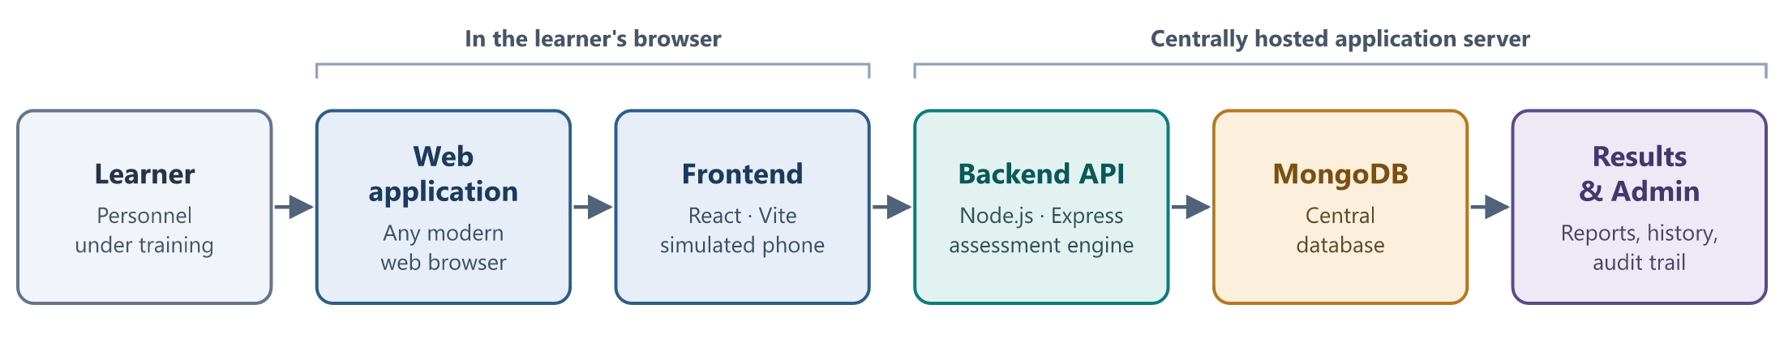
Figure 1. High-level architecture
Key component | Role
Learner web application | Sign-in, briefing, dashboard, results and history pages
Immersive simulation | Simulated phone apps in which each scenario is played out
Assessment engine | Selects scenarios, validates actions and calculates scores on the server
MongoDB database | Stores scenarios, attempts, actions, results and the audit trail
Admin console | Protected instructor area for scenarios, attempts, exports, settings and audit

2. Technology Stack
The application uses a JavaScript stack end to end: React in the browser, Node.js on the server and MongoDB for storage. The table lists the technologies that make up the working architecture.
Area | Technology | Role in the platform
Frontend | React 19 (JavaScript / JSX) | Component-based user interface for learner and Admin screens
 | Vite 8 | Development server and optimised production build
 | React Router 7 | Page navigation, with separate guards for learner and Admin areas
 | Tailwind CSS 4 + custom stylesheet | Styling, including the simulated phone and app surfaces
 | React context + state machines | Session state, attempt progress and dashboard orchestration
Backend | Node.js 24 | Server runtime; also provides the built-in Argon2id password function
 | Express 5 | REST API with a routes → controllers → services structure
 | Signed session cookies | Separate, signed, HTTP-only sessions for learners and Admins
Database | MongoDB 8 (replica set) | Persistent store; replica set enables multi-document transactions
 | Mongoose 9 | Data models, validation, indexes and transaction handling
Quality | Vitest, Testing Library, Node test runner, oxlint | Automated frontend and backend tests, and code linting
Tooling | npm | Package management and build / test scripts

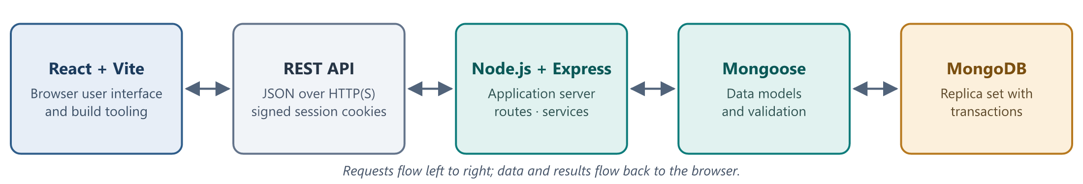
Figure 2. Technology stack flow
Planned / Production Configuration. The built frontend and the Node.js API are deployed on a centrally hosted server, with MongoDB configured as a replica set. Learners and instructors connect with a standard web browser; in production, session cookies are restricted to secure (HTTPS) connections. Server, domain and certificate details are confirmed at deployment.

3. Application Architecture
The application is organised in layers. The top three run in the browser and create the immersive experience; the next three run on the server and own all assessment logic; MongoDB sits underneath. Scores are never calculated in the browser.
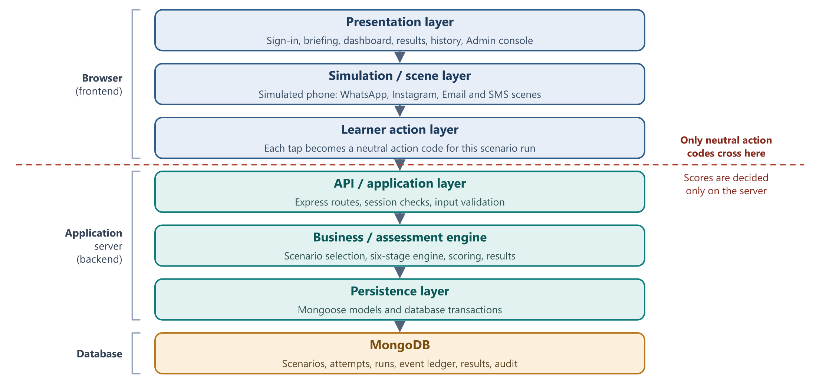
Figure 3. Layered application architecture
Layer | What it does
Presentation | The screens learners and instructors see: sign-in, briefing, dashboard, results, history and the Admin console. React Router keeps learner and Admin pages behind separate guards.
Simulation / scene | Presents each scenario as a realistic phone app (WhatsApp chat, Instagram DM, email inbox or SMS thread), including simulated web pages, calls, payment sheets and installers. Each of the 100 scenarios has its own scene, found through the scene registry.
Learner action | Turns each tap into a neutral action code issued by the server for that scenario run. The browser does not know which choice is safe or what it is worth.
API / application | Express routes receive requests, confirm the session (learner or Admin) and reject malformed input before handing work to services.
Business / assessment engine | Selects the 10 scenarios, moves each through its six stages, validates every action, applies the scenario’s scoring rules and builds results. It is the single authority on scores.
Persistence | Mongoose models define and validate every stored record. An action, the updated scenario run and its score are committed together in one database transaction.
MongoDB | Holds the scenario bank, learner profiles, attempts, scenario runs, the event ledger, results, progress summaries, Admin settings and the audit trail.

4. Learner End-to-End Workflow
A learner signs in with their name and personal / service number, acknowledges the briefing and starts an assessment. The server selects 10 scenarios for that attempt and the dashboard delivers them one at a time as phone notifications. The assessment is timed (90 minutes by default).
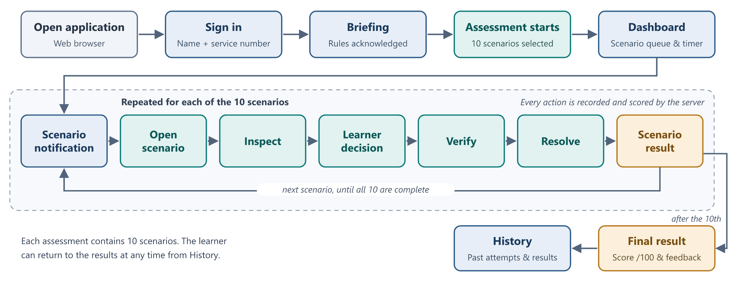
Figure 4. Learner end-to-end workflow

The six stages of every scenario
Stage | What the learner does
Notify | A notification arrives on the simulated phone
Open | The learner opens the message, email or post
Inspect | The learner can examine the sender, profile, link, attachment or thread
Decide | The learner chooses how to respond: engage, decline or take the official route
Verify | The learner can check through a trusted channel, or report or block
Resolve | The learner closes the scenario with a final action and sees the outcome

Learner decisions are recorded at every stage, not only at the end, so the result reflects the whole path the learner took. After the tenth scenario the final result is shown, and it remains available from History.

5. Immersive Scenario Data Flow
This is the core of the platform: how a scenario defined in the database becomes an interactive scene, and how the learner’s choices inside that scene become a score.
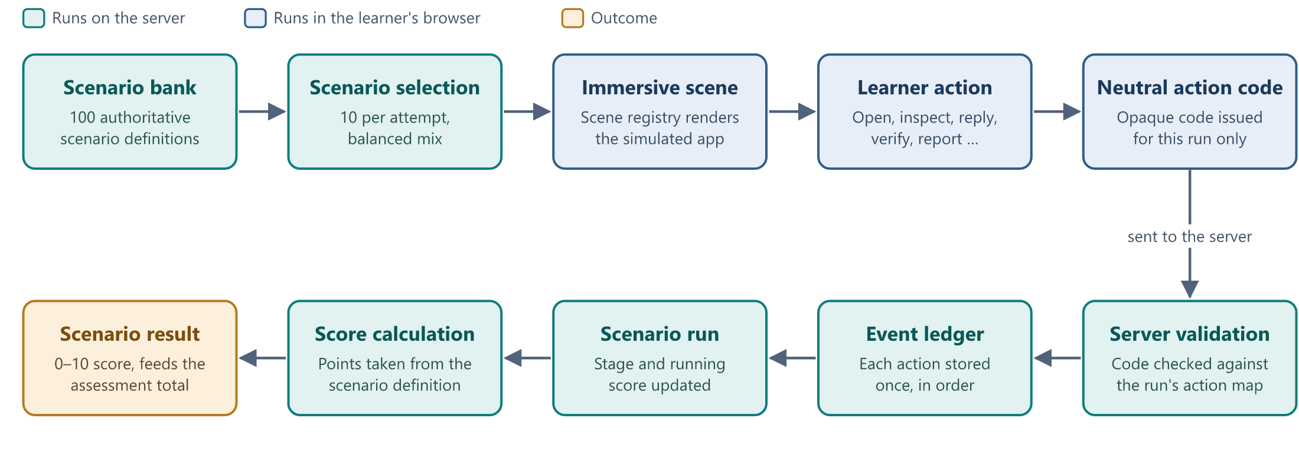
Figure 5. Immersive scenario data flow
Step | In simple terms
Authoritative scenario bank | All 100 scenarios, including their stages and scoring rules, are defined as scenario definitions in the database. They are the single source of truth.
Selection | When an attempt starts, the server chooses a balanced set of 10: across all four platforms, mostly deceptive with some genuine messages, and mixed difficulty.
Immersive presentation | The browser looks up the matching scene in the scene registry and renders it as a realistic app. Presentation is entirely a frontend concern.
Neutral action identifiers | Every on-screen control carries an opaque code issued for this scenario run only. The code reveals nothing about whether the choice is safe.
Server validation | The server translates the code using its own action map and checks that the action is allowed at the current stage. Anything else is rejected.
Event persistence | Each accepted action is written to the event ledger exactly once and in order; a repeated submission is not counted twice.
Scoring and result | Points come from the scenario definition. The scenario run keeps a running score, and the final 0–10 scenario score feeds the assessment total.

6. Data Flow & Database
MongoDB stores both the scenario content and everything learners do. The diagram shows the main logical entities and how data moves between them. Field-level detail is intentionally omitted.
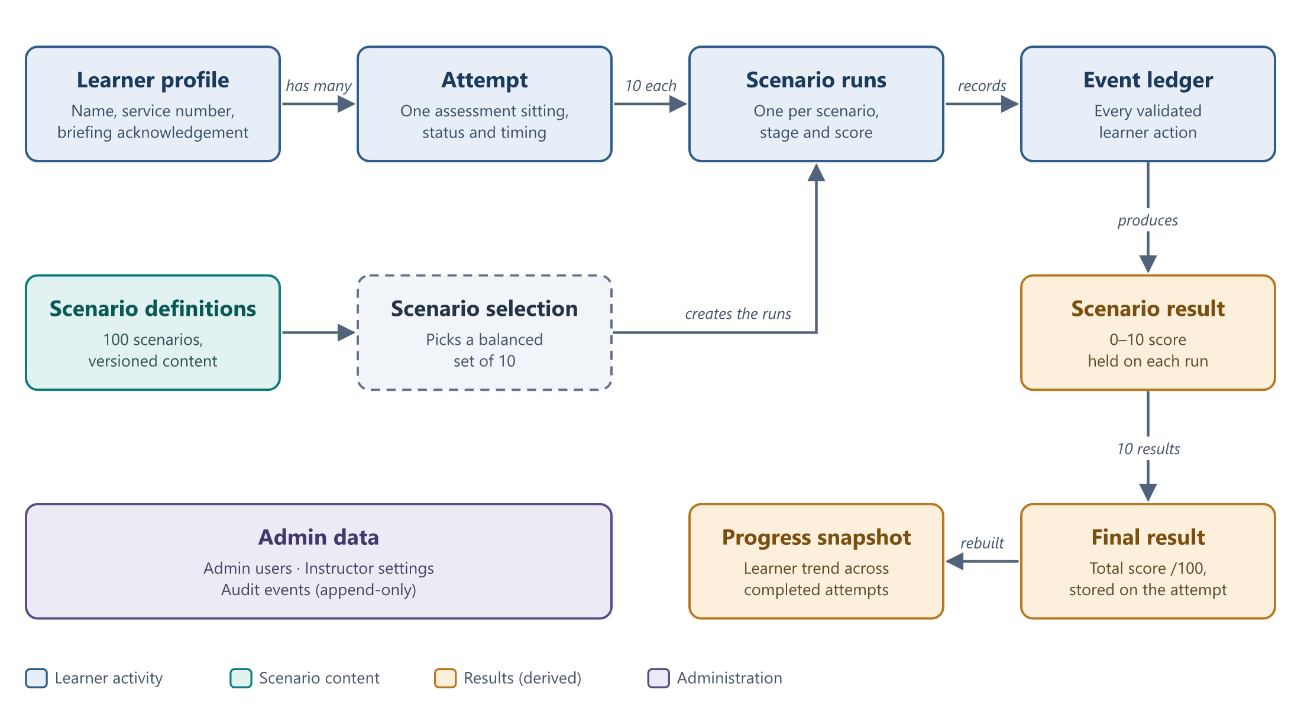
Figure 6. Database and data flow
Entity | Role
Scenario definitions | The 100 authored, versioned scenarios. Only published, active versions are selected.
Learner profile | Who the learner is, and whether they have acknowledged the briefing.
Attempt | One assessment sitting: its status, timing and, once complete, the total score out of 100.
Scenario runs | One per selected scenario (10 per attempt), holding the current stage and the scenario score out of 10.
Event ledger | Every validated learner action, in order. It is the audit source from which any score can be reproduced.
Progress snapshot | A summary of each learner’s performance across completed attempts, rebuilt from the attempts themselves.
Admin data | Administrator accounts, instructor settings and the append-only audit trail.

Transactional persistence. MongoDB runs as a replica set so that related writes are committed together in a single transaction. For example, an action is only recorded if the scenario run and its score are updated at the same moment, which keeps events and results consistent even if a request is retried or interrupted.

7. Scoring & Results Flow
Scoring is performed only on the server, from validated actions. Each scenario is scored out of 10 and the ten scenario scores add up to an overall score out of 100.
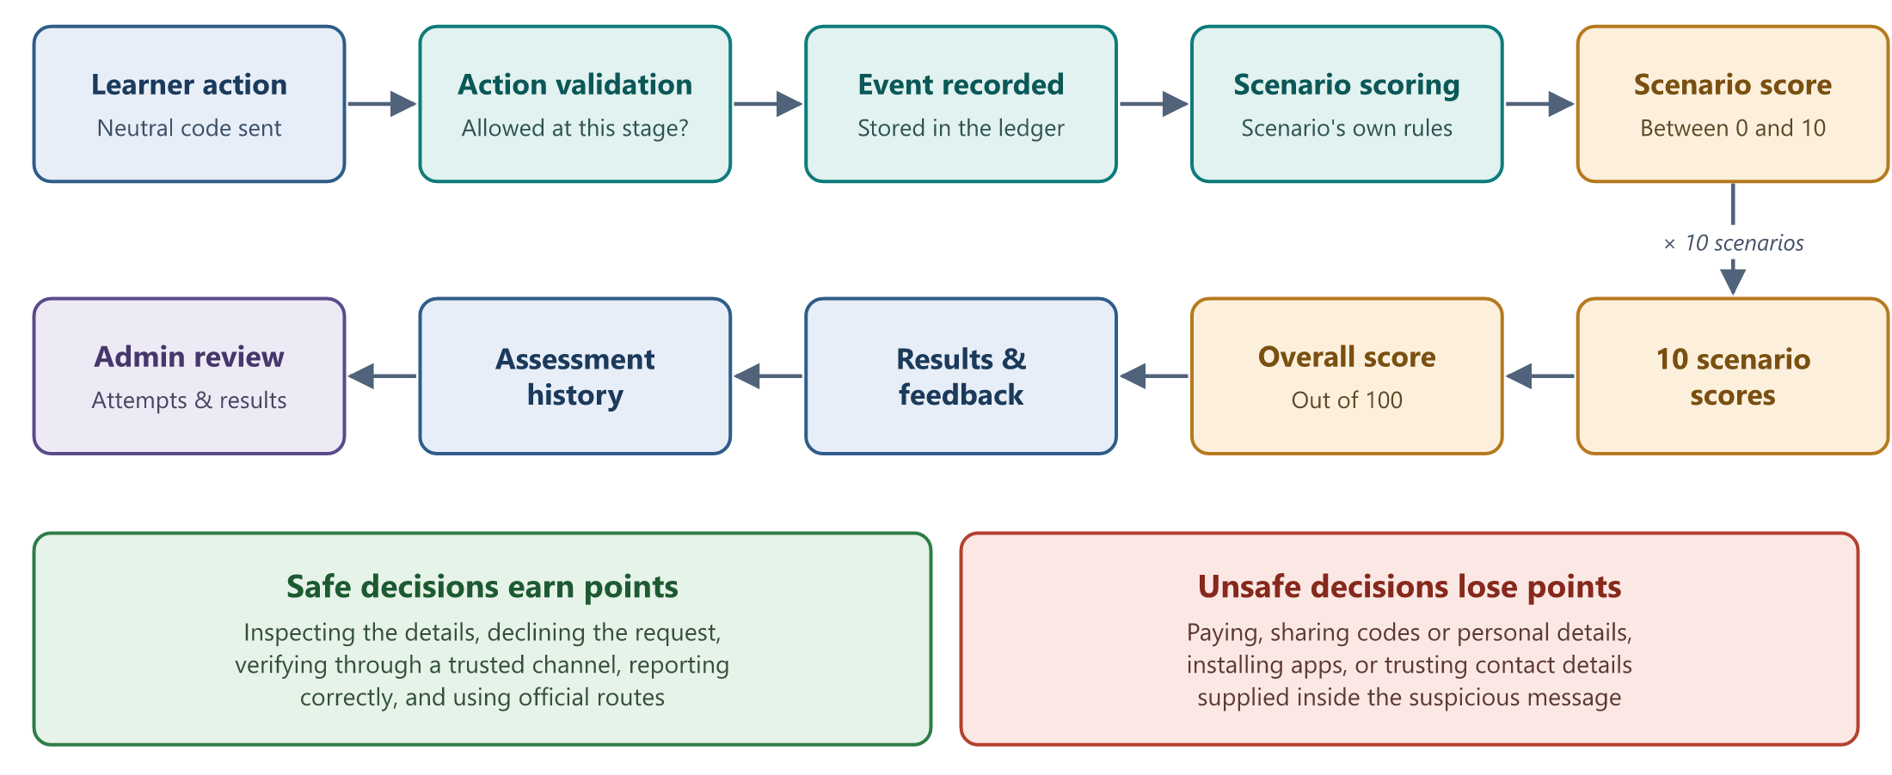
Figure 7. Scoring and results flow
- Scenario scores build the final score. Each of the 10 scenarios contributes up to 10 points to the overall score out of 100.
- Safe and unsafe decisions score differently. Careful behaviour earns points and risky behaviour loses them. Genuine messages are also included, so over-reacting to a legitimate request (for example, reporting it without checking) is scored too.
- Points come from the scenario itself. Each scenario definition carries its own scoring rules, so the engine applies them consistently and the browser never sees them.
- Results are persisted. The final result is stored with the attempt, and the learner can reopen it from History at any time.
- Feedback. The results page shows the overall score, each scenario’s score, the path the learner took and a breakdown of behaviour by stage, platform and threat type.
- Admin review. Instructors can open any learner’s attempt and results through the Admin console.

8. Admin Workflow
The Admin console is a separate, protected area of the same application for instructors. It has its own sign-in, its own session and its own access checks on every request.
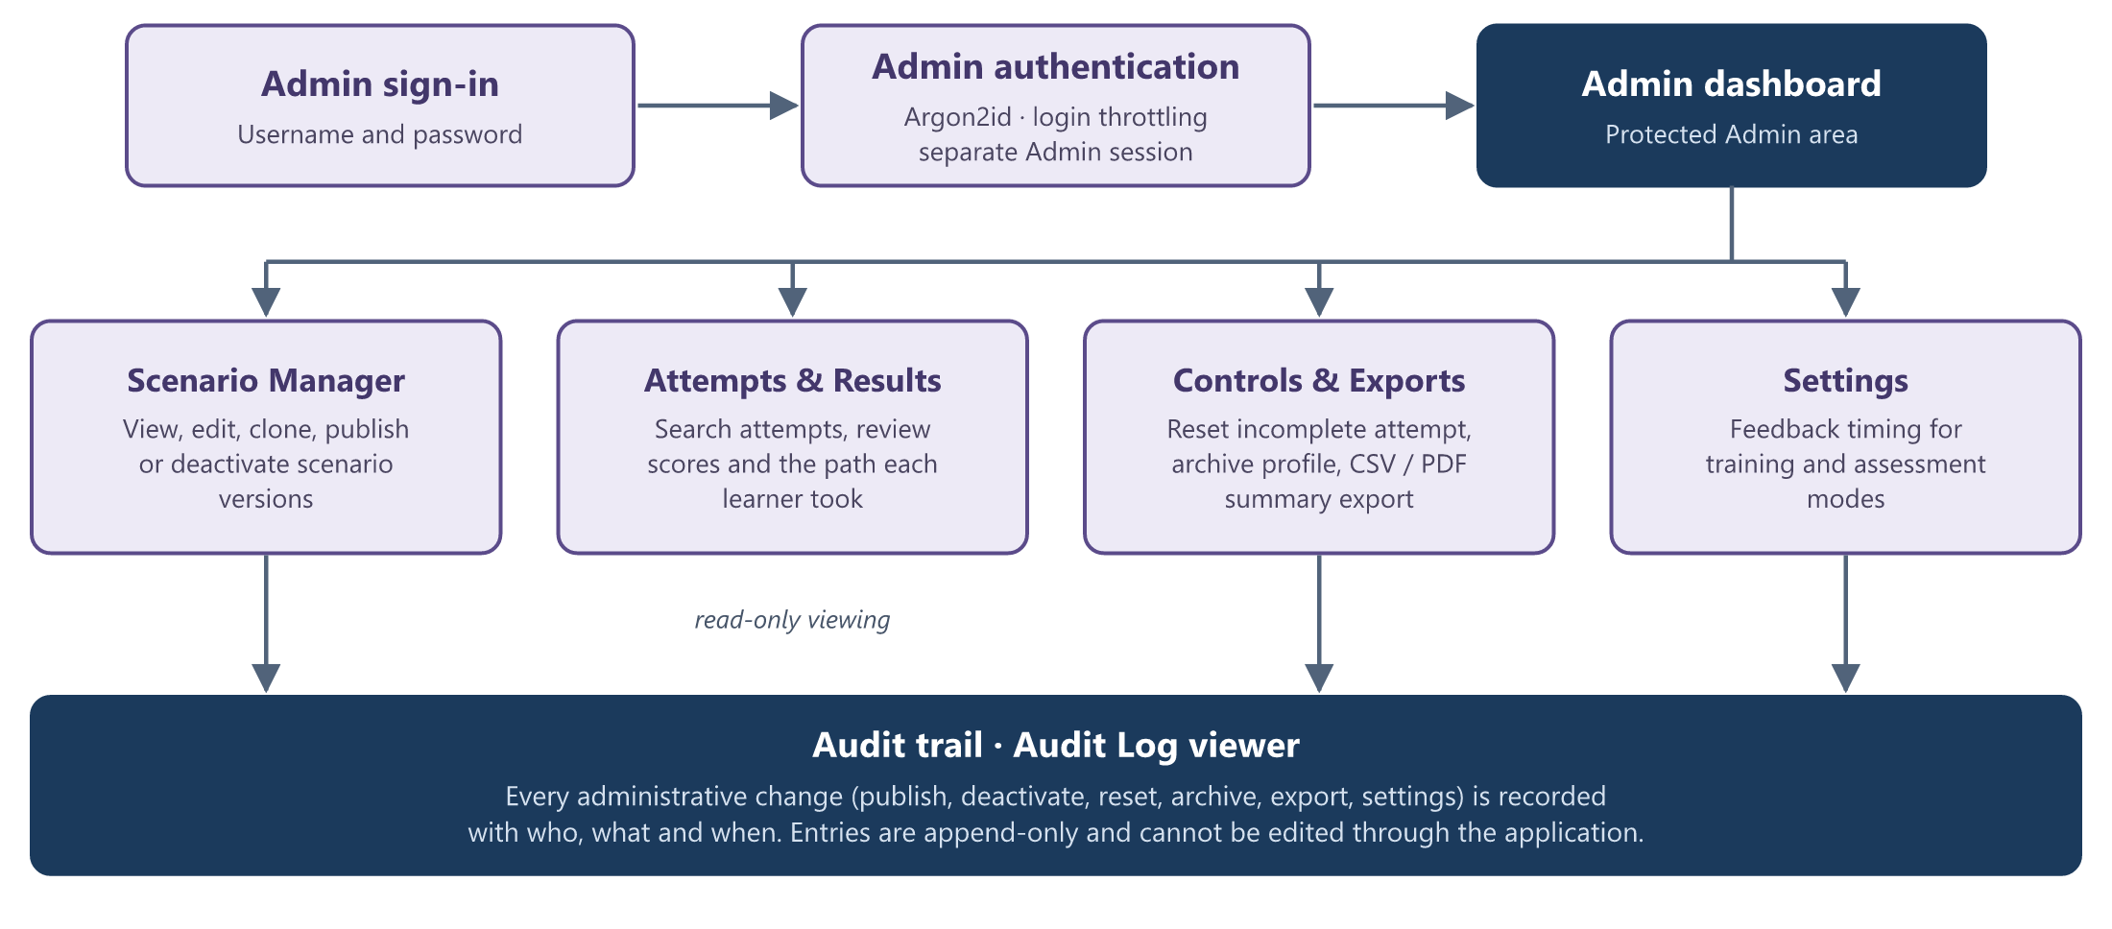
Figure 8. Admin workflow
Capability | What it provides
Admin authentication | Username and password sign-in. Passwords are stored as Argon2id hashes and repeated failed sign-ins are throttled.
Access protection | Every Admin page and API route requires a valid Admin session; a learner session is always rejected.
Scenario management | Browse the scenario bank, edit draft versions, clone, publish or deactivate a version. Earlier versions are kept.
Attempt viewer | Search attempts by learner or status and review scores and the action path, read-only.
Results & exports | Produce a CSV or PDF summary of an attempt, clearly marked as training data with its content version.
Instructor controls & settings | Reset an incomplete attempt, archive a learner profile (nothing is deleted), and set feedback timing for training and assessment modes.
Audit trail | Every administrative change is recorded automatically and can be reviewed in the Audit Log. Entries cannot be edited.

9. Security & Overall System Data Flow
Security concept | How it is applied
Separate learner and Admin sign-in | Two distinct sessions with different cookies and signing secrets; one can never be used as the other.
Protected Admin routes | Every Admin page and API call is checked on the server, independently of the browser.
Password hashing | Admin passwords are stored only as Argon2id hashes.
Server-side validation | Every learner action and every request is validated on the server; unknown or out-of-stage input is rejected.
Neutral learner action contract | The browser only sends opaque, per-run action codes; what they mean and what they score stays on the server.
Synthetic simulation content | All messages, links, calls and payment screens are simulated inside the application.
No real external services | No real messaging, email, SMS, telephone or payment service is contacted by any scenario.
Controlled persistence | Transactional writes, one-time recording of each action, and archiving instead of deletion.
Audit trail | Administrative changes are logged automatically and cannot be altered through the application.

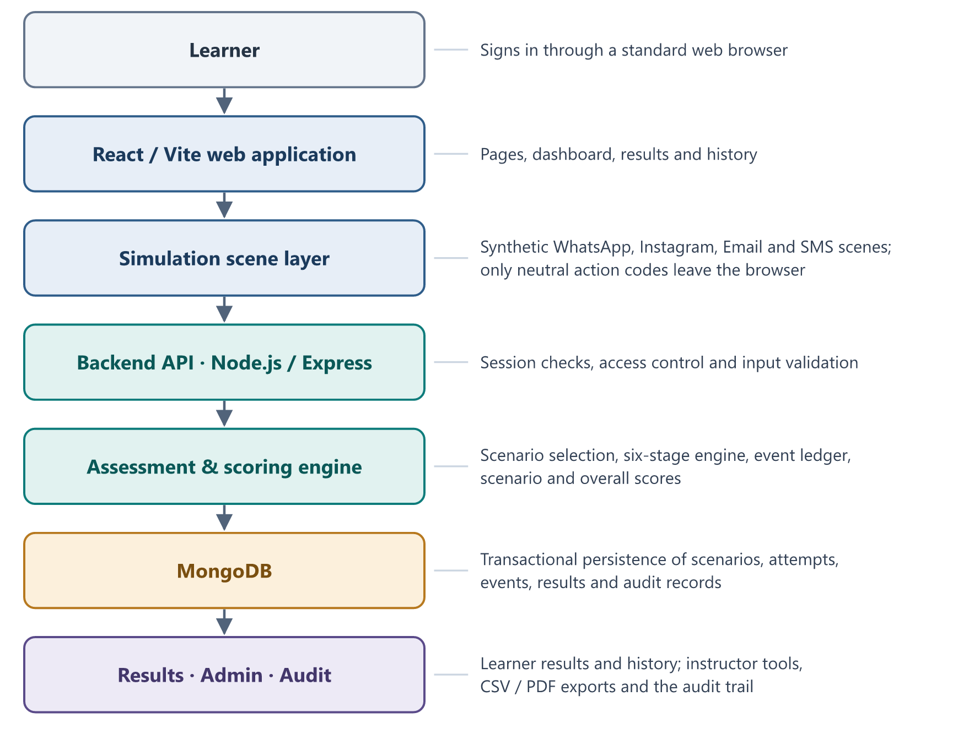
Figure 9. End-to-end system architecture
The platform combines an immersive browser-based simulation with a structured backend assessment engine and persistent reporting layer.

