CENTRALLY HOSTED ONLINE TRAINING & ASSESSMENT APPLICATION
Social Engineering Cyber Awareness Training & Assessment System
Complete Application Architecture, Workflow & Technical Documentation
Based on the current implemented codebase

Item | Detail
Project | Cyber Social Engineering & Fraud Detection Simulation (Social Engineering Fraud Training PDS)
Document purpose | Describe exactly how the current application works - architecture, workflows, scoring, data, security and code organisation - for the client, the project owner and future technical maintainers.
Scope | The implemented system only: a centrally hosted, browser-based application - frontend (React), backend API (Node.js/Express), MongoDB database - with a self-contained synthetic simulation, 100-scenario bank, admin area and demo user. No roadmap or proposals.
Deployment context | Online web application accessed through a browser. Hosting-infrastructure details are not part of the repository and are therefore not described. The simulated communication channels use no real external services.
Document date | 26 September 2026 (documentation revision 2 - deployment context corrected to a centrally hosted online application)
Codebase basis | Git branch main, last commit ab41199, plus the current uncommitted working tree (inspected read-only).
Versions established in the project | No product release number is defined (package.json: backend 0.1.0, frontend 0.0.0). Scenario content version 1; taxonomy 1.0.0 (family and trigger); selection algorithm 1.0.0; briefing version 1; release database build MIGRATION-001 (22 Sep 2026).
Classification | Contains answer-bearing scenario information. For client, instructors and maintainers - not for learners.

Reading Guide
Sections 1-3 give the overview, technology and architecture. Sections 4-5 map the codebase and its call chains. Sections 6-23 follow the learner journey from login to result, including the two dedicated explanations requested by the client: Section 10 - What happens when the same learner starts a second assessment? and Section 15 - How scoring works. Sections 24-30 cover the instructor area, database and API. Sections 31-40 cover the frontend, platforms, security, online connectivity versus simulated services, testing, content, an end-to-end example, edge cases and data lifecycle. Section 41 states the exact delivered scope. The online deployment topology and the evolution of the deployment context are in Sections 3.5 and 3.6. Section 42 is a glossary; Appendices A-H are reference material.
Many important topics are explained twice: a green Client Understanding box in plain language, and a grey Technical Implementation box with the code-level detail. Orange Current Implementation Behaviour boxes mark places where the current code behaves in a way that a reader of older planning documents might not expect.
Code references use the form backend/src/services/attemptService.js or a function name such as createAttempt(). All paths are relative to the project root.

Table of Contents
If the table below is empty, right-click it and choose Update Field (Word updates it automatically when the document is opened and fields are refreshed).

1. Executive Overview

1.1 What the system is
The Social Engineering Cyber Awareness Training & Assessment System is a centrally hosted, browser-based online training and assessment application that measures how a learner handles realistic social-engineering and fraud attempts. Learners and instructors reach it through a web browser; the browser talks to the application's backend API, which stores everything in MongoDB. Instead of answering quiz questions, the learner is handed a simulated phone and works through messages that arrive in four simulated communication apps - WhatsApp, Instagram, Email and SMS. Some messages are malicious (phishing, account takeover, payment diversion, malware and similar); some are genuine and must be handled normally.
Every assessment consists of exactly 10 scenarios, chosen by the server from a bank of 100 scenarios (25 per app). Each scenario is played through the same six-stage flow - Notify, Open, Inspect, Branch (decide), Verify and Resolve - and every choice the learner makes is recorded on the server, scored by the server, and later explained back to the learner in a result review.

1.2 Who interacts with it
Role | How they reach the system | What they do
Learner | Web browser, opening the hosted application at /login - enters name and personal / service number (no password) | Reads the briefing, starts or resumes an assessment, plays 10 scenarios, reviews the result and past assessments.
Demo User | The same online login page, using the configured demonstration service number | Plays a fixed 10-scenario demonstration set and may skip scenarios. Kept out of the admin dashboard statistics.
Instructor / Administrator | Web browser, opening /admin/login on the hosted application - username and password (Argon2id-hashed account created by an operator script) | Views the dashboard, browses attempts, exports CSV/PDF reports, manages scenario versions, resets unfinished attempts, archives profiles, sets feedback timing, reads the audit log.

1.3 How the application is accessed
Client Understanding
The application is an online web application. It is installed on a central server environment, and learners and instructors use it by opening its address in a web browser. Every choice a learner makes is sent over the network to the application's server, which checks it, scores it and saves it.
The messages inside the assessment are not real. The WhatsApp, Instagram, Email and SMS screens are simulations drawn by the application itself from made-up (synthetic) scenario content. They never connect to the real WhatsApp, Instagram, email, SMS, payment, QR or telephone services, and no real link, file or call is ever opened. Section 35 explains this distinction in full.

Technical Implementation
Browser → frontend (a React single-page application built with Vite and served as static files) → HTTP JSON API under /api (Node.js + Express) → MongoDB replica set. Deployment values (API address and port, allowed browser origin, database URI, secrets) are supplied through environment variables; the repository contains no hosting-infrastructure configuration. The simulated channels are rendered in the browser from the synthetic part of each ScenarioDefinition and make no outbound requests.

1.4 What the assessment measures
The assessment measures safe behaviour, not recall. At each stage the learner can take a safe action (read before acting, inspect the sender and links, decline the request or use the official path, verify through a trusted directory or known app, and close the item correctly) or a risky one (reply straight from a preview, open a link, submit details, pay, install, trust contact details inside the message, report a genuine item). The server converts those actions into scoring events. A perfect safe path earns 10 points per scenario; 10 scenarios give a total out of 100.
The result distinguishes a missed threat (a malicious item that was not stopped, or was engaged with unsafely) from a false positive (a genuine item that was rejected, reported or blocked), which is the core learning distinction of the product.

1.5 How scenarios simulate communication platforms
Each scenario is a server-side ScenarioDefinition (classification, six stages, synthetic content, scoring and authored feedback). The browser receives only the candidate-safe part: synthetic sender, notification, message thread, links, files, QR codes, call screens, payment and install screens. For every one of the 100 scenarios there is an authored scene pack in the frontend (frontend/src/simulation/scenes/...) that renders the scenario inside a realistic app screen - a WhatsApp chat with contact info, an Instagram profile with its follower list, an email with "show original" headers, an SMS thread with conversation details. All links, files, calls and payments are inert and synthetic: they are handled entirely inside the application.

1.6 How the assessment progresses and how results are generated
The high-level flow below is the actual path through the implemented application. Each block is explained in detail in later sections.
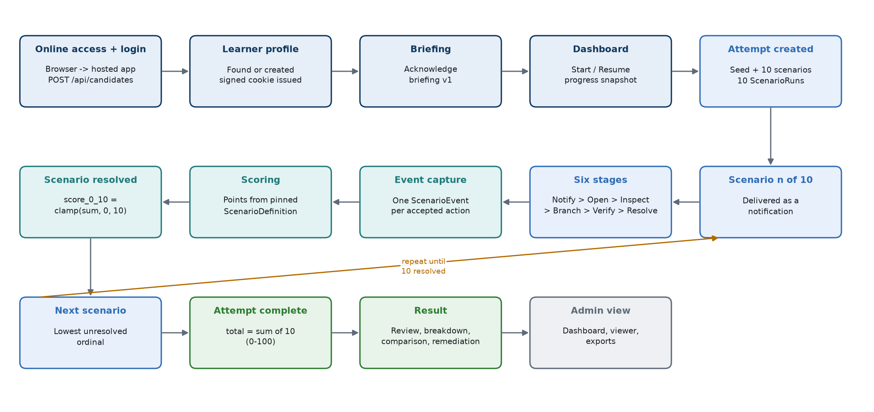
Figure 1. End-to-end flow from login to admin view (as implemented)
- Online access - the learner opens the centrally hosted application in a web browser.
- Login - POST /api/candidates finds or creates the learner profile by normalised service number and sets a signed, httpOnly session cookie.
- Learner profile - a new learner goes to the briefing; a returning learner sees a "profile found" card first.
- Briefing / acknowledgement - the learner ticks the acknowledgement; the server stores briefing version 1 and a timestamp.
- Assessment start - the dashboard's Start button calls POST /api/attempts. The server selects 10 scenarios, fixes their order, sets a 90-minute deadline and creates the attempt plus 10 scenario runs in one database transaction.
- Scenario interaction - the current scenario arrives as a phone notification 1-4 seconds after the hub is idle. The learner works through the six stages on the simulated phone.
- Event capture and scoring - every accepted action becomes one ledger ScenarioEvent with server-decided points. The run's running score is updated in the same transaction.
- Scenario resolution - the resolve-stage action closes the run. Its score is clamped to 0-10.
- Next scenario - the next unresolved run (by ordinal) is served until all ten are resolved.
- Attempt completion - POST /api/attempts/:id/complete sums the ten scenario scores into a 0-100 total.
- Result review - the result page shows the total, outcome mix, a per-scenario learning review, behaviour breakdown, comparison with the previous comparable attempt and 2-3 remediation areas.
Scope of this document
This document describes the application exactly as implemented in the current codebase (branch main, last commit ab41199 plus the current uncommitted working tree). It contains no roadmap and no proposals. Where an earlier planning document differs from the code, the code is documented and the difference is labelled "Current implementation behaviour".
The document contains answer-bearing information (scenario dispositions, families and scoring). It is intended for the client, the project owner and technical maintainers - not for learners.

2. Technology Stack
The dependency set is deliberately small (the code comments record that every added package carries a supply-chain review and update obligation). Every runtime dependency listed below is actually imported by application code. No third-party communication, payment, analytics or external authentication SDK is used.

2.1 Backend runtime
Technology | Version (package.json) | Where / why it is used
Node.js | Node 24+ required (uses crypto.argon2) | Runs the API (backend/src/server.js). ES modules ("type": "module"). Node's built-in crypto supplies Argon2id password hashing, HMAC for learner action codes, SHA-256 and random seeds. Node's built-in test runner (node --test) runs the backend tests.
Express | ^5.2.1 | HTTP server and routing (src/app.js, src/routes/*). Express 5 forwards rejected promises; the project also wraps handlers in asyncHandler.
Mongoose | ^9.9.4 | All MongoDB access: schemas, validation hooks, indexes, sessions/transactions (src/models/*, src/utils/transactions.js).
cookie-parser | ^1.4.7 | Parses cookies and verifies the signed candidate session cookie (req.signedCookies).
cookie-signature | ^1.2.2 | Signs/verifies the admin session cookie with its own secret (src/middleware/adminSession.js).
cors | ^2.8.6 | Allows exactly one configured browser origin, with credentials (CORS_ORIGIN).
dotenv | ^17.4.2 | Loads backend/.env into process.env (src/config/env.js, src/config/demo.js).

2.2 Database
Technology | Detail
MongoDB | MongoDB server used as a replica set (the documented setup is a single-node set named rs0). The release database was built on MongoDB 8.3.8 (per docs/PRODUCTION_RELEASE_MANIFEST.md). A replica set is mandatory because every authoritative write uses multi-document transactions; the engine refuses to run on a standalone server (assertTransactionSupport).
Connection | MONGO_URI (development default mongodb://127.0.0.1:27017/cyber_awareness_training; the deployment supplies its own URI, which must reach a replica set, e.g. with ?replicaSet=rs0). serverSelectionTimeoutMS: 5000, strictQuery: true.

2.3 Frontend
Technology | Version | Where / why it is used
React | ^19.2.8 | The whole learner and admin UI (frontend/src). Function components and hooks only.
react-dom | ^19.2.8 | Mounts the app (src/main.jsx, StrictMode).
react-router-dom | ^7.18.3 | Client routing (src/routes/AppRoutes.jsx), guards RequireCandidate and RequireAdmin.
lucide-react | ^1.39.0 | Icon set used across pages and simulated apps.
Vite | ^8.2.2 (dev) | Dev server (port 5173) and production build; @ alias to src.
Tailwind CSS | ^4.3.3 via @tailwindcss/vite | Utility-class styling; theme tokens and custom utilities in src/styles/index.css.
Vitest + Testing Library + jsdom | vitest ^5, @testing-library/react ^16, jsdom ^30 | Frontend unit/component tests against a stubbed fetch (no network).
oxlint | ^1.79.0 | Linting (npm run lint).

State management
There is no Redux or other global store. State is held in: one React context (CandidateProvider - the signed-in learner), one reducer-based state machine for the assessment (state/attemptMachine.js driven by hooks/useAttemptController.js), pure orchestration helpers (state/dashboardOrchestrator.js), and ordinary component state. No authoritative state is kept in localStorage or sessionStorage; every reload asks the server.

2.4 PDF and CSV generation
No PDF or CSV library is installed. backend/src/utils/csvWriter.js is a small RFC 4180 writer (UTF-8 BOM, CRLF, formula-injection neutralisation for text cells). backend/src/utils/pdfWriter.js writes a genuine PDF 1.4 file by hand using the built-in Courier fonts, so nothing is embedded or fetched. XLSX export does not exist.

2.5 Authentication and session mechanism
Session | Mechanism
Learner (candidate) | Cookie candidate_session, httpOnly, sameSite=lax, secure in production, signed with SESSION_SECRET via cookie-parser; value = the profile's MongoDB id. Lifetime SESSION_MAX_AGE_MS (default 8 hours). No password - identity is name + personal/service number.
Administrator | Cookie admin_session, httpOnly, sameSite=lax, signed with the separate ADMIN_SESSION_SECRET via cookie-signature; lifetime ADMIN_SESSION_MAX_AGE_MS (default 1 hour). Username + password verified against an Argon2id hash (64 MiB, 3 passes). The server refuses to start without an admin secret or if it equals the learner secret.

2.6 Tooling and scripts
Operator and development scripts live in backend/scripts (see Appendix A). The relevant npm scripts are: start, dev, test, test:engine (runs the DB-backed suites against a throwaway replica set on port 27018), admin:create, import:definitions, generate:synthetic, verify:replicaset, backfill:profile and the release:* build/validate/inventory/smoke scripts. The frontend has dev, build, test, lint and check:bundle (scans the production bundle for leaked scoring vocabulary).

3. Complete Application Architecture
The application is a centrally hosted, three-tier web application: a React single-page application delivered to the user's browser, a Node.js/Express JSON API, and a MongoDB replica set. Learners and instructors connect to it over the network. All business rules - selection, stage transitions, scoring, expiry, result projection - live in backend services. The frontend renders server state and sends opaque learner actions; it never decides a stage, a score or which scenario comes next.
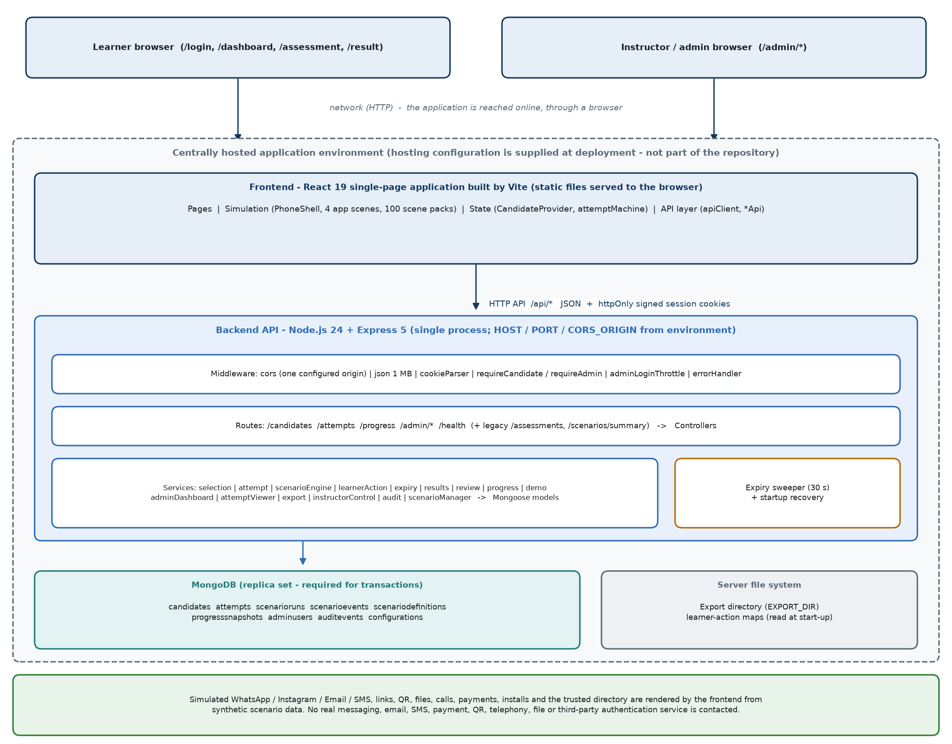
Figure 2. Online application architecture (browser → hosted frontend → API → MongoDB) and the self-contained simulation

3.1 Layer responsibilities
Layer | Location | Responsibility
Pages & components | frontend/src/pages, components | Render screens; collect learner input; never compute a score.
State | frontend/src/state, hooks, context | Hold the last server response; decide what to render; manage retries and resync.
API layer | frontend/src/services/*Api.js | The only place fetch is called; always credentials: include; normalises errors into ApiError.
Express app | backend/src/app.js | CORS, JSON body parser (1 MB limit), cookie parser, /api router, 404 and error handler.
Routes | backend/src/routes | URL-to-controller mapping; mounts requireCandidate / requireAdmin guards.
Controllers | backend/src/controllers | Translate HTTP to service calls; reject forbidden body fields; resolve ownership from the session; never compute scores.
Services | backend/src/services | All rules: selection, engine, scoring, expiry, results, reviews, progress, admin features, exports, audit.
Models | backend/src/models | Mongoose schemas, invariants (pre-validate / pre-save hooks), indexes, and allowlisted output projections (toCandidateJSON, toPublicJSON, toAdminJSON).
Database | MongoDB replica set | Persistent storage; unique indexes enforce idempotency and ordering; transactions give atomicity.

3.2 Request lifecycle
- The browser calls apiClient.request() with credentials: include, so the session cookie travels automatically.
- cors checks the origin; express.json parses the body (max 1 MB); cookieParser(SESSION_SECRET) populates req.cookies and req.signedCookies.
- The route's guard (requireCandidate or requireAdmin) loads the profile/admin from MongoDB. Missing, invalid or archived → 401.
- The controller rejects forbidden fields (score, stage, seed, deadline, intent, etc.) with 422, resolves ownership (findOwnAttempt(attemptId, req.candidate._id) - another learner's id returns 404), and calls a service.
- The service applies rules and, for any authoritative change, runs inside withEngineTransaction (write concern { w: 1, j: true }, up to 3 attempts for transient errors only).
- The model's projection method builds the response from an allowlist, so fields not explicitly published never leave the server.

3.3 Response and error lifecycle
middleware/errorHandler.js converts every failure into { error: { code, message, details } }: ApiError keeps its status; domain errors (isDomainError, e.g. EngineError, SelectionError) keep their stable code and status (clamped into 400-599); Mongoose validation → 422 VALIDATION_ERROR; duplicate key → 409 DUPLICATE_KEY; anything else → 500 INTERNAL_ERROR (message detail hidden in production). The frontend ApiError exposes status, code and details; a network failure is reported as status 0 NETWORK_ERROR.

3.4 Where each cross-cutting concern lives
Concern | Implemented in
Validation | Model schemas and hooks (e.g. ScenarioDefinition six-stage checks, Attempt frozen sequence); controller allowlists; service-level parsers (viewer filters, export body, config body).
Authentication | middleware/session.js (learner), middleware/adminSession.js + services/adminService.js (admin), middleware/adminThrottle.js.
Authorisation | Ownership queries always include the session's profile_id; admin routes all mount requireAdmin; demo features re-check the session profile.
Transactions | utils/transactions.js (assertTransactionSupport, withEngineTransaction).
Scoring | services/scenarioEngineService.js (per event) using points stored on the pinned ScenarioDefinition; clamping on resolution; attemptService.completeAttempt (sum).
Scenario selection | services/scenarioSelectionService.js (pure solver), services/attemptService.js (DB side), services/demoSelectionService.js (demo).
Event persistence | scenarioEngineService.submitIntent, attemptExpiryService.expireAttempt, demoAssessmentService.skipDemoRun - the only writers of ScenarioEvent.

3.5 Online deployment topology as implemented
Layer | What the code provides | How it is configured
Browser (learner / instructor) | Any modern browser; no installation. Cookies must be allowed (sessions are httpOnly cookies). | -
Frontend | npm run build (Vite) produces static files (frontend/dist) - HTML, JavaScript and CSS only. | VITE_API_BASE_URL is compiled into the build. Default /api (API on the same origin as the frontend). The repository's development .env points to a locally running API.
Backend API | Single Node.js process (npm start → node src/server.js) serving JSON under /api. | HOST (default 127.0.0.1), PORT (default 5000), CORS_ORIGIN (the one browser origin allowed to call the API with credentials), session secrets, NODE_ENV=production (secure cookies, generic 500 messages).
Database | MongoDB replica set; all authoritative writes use transactions. | MONGO_URI. A release database (cyber_awareness_training_release: 100 scenarios, empty operational collections) is provided as backend/deploy/migration-001/*.archive.gz.
Server file system | Export reports (EXPORT_DIR, default backend/exports) and the learner-action maps read at start-up. | EXPORT_DIR.

What the repository does not contain
There is no hosting-infrastructure configuration in the repository - no reverse-proxy, process-manager, container, cloud or domain configuration. The code defines the three runtime layers and their environment variables; how they are placed on the central server is decided at deployment. Per the Minutes of Meeting of 24 September 2026, the frontend build, backend and database are handed over to the senior developer for deployment.

3.6 Evolution of deployment context
Earlier project documents - the client specification v1.0 and several internal design notes (for example the DEPLOY-001 decision and docs/DEPLOYMENT_AND_TRANSACTION_STRATEGY.md) - described operation on a standalone, offline training machine, with the API bound to the loopback interface and MongoDB running locally. Traces of that context remain in the code as defaults and labels: HOST defaults to 127.0.0.1, CORS_ORIGIN defaults to http://localhost:5173, and some interface and report text still uses the word "offline" (listed in Section 35.4).
The current delivered application is a centrally hosted online web application: learners and instructors access it through a browser over the network, and the three layers (frontend, API, database) are configured through environment variables for the hosting environment. What has not changed is the design of the simulation: it remains self-contained and synthetic, with no dependence on real third-party communication services.

4. File-by-File Architecture
This section explains the files that actually drive behaviour. Generated output, node_modules, caches and pure styling assets are not listed. Paths are relative to the project root. Where a file is tiny or self-describing it is grouped with its neighbours.

4.1 Backend - entry point, configuration and utilities
File / folder | Purpose and key functions | Interactions (called by -> calls; data in -> out)
backend/src/server.js | Process entry. start() connects MongoDB, runs recoverExpiredAttemptsOnStartup(), builds the app, listens on env.host:env.port, starts the expiry sweeper, handles SIGINT/SIGTERM. | Called by npm start. Calls config/database.js, app.js, attemptExpiryService.
backend/src/app.js | createApp() - Express instance: cors, express.json({limit:"1mb"}), cookieParser(SESSION_SECRET), /api router, notFound, errorHandler. | Called by server.js and by API tests. Calls routes/index.js.
backend/src/config/env.js | Reads environment: port (default 5000), host (default 127.0.0.1), Mongo URI, CORS origin, both session secrets and lifetimes, export directory, admin throttle numbers, optional LEARNER_ACTION_SECRET. Throws if ADMIN_SESSION_SECRET is missing or equals SESSION_SECRET. | Imported everywhere configuration is needed. In: process.env. Out: frozen env object.
backend/src/config/database.js | connectDatabase(), disconnectDatabase(), databaseStatus(). | server.js, scripts, health controller.
backend/src/config/demo.js | demoConfig - Demo User display name (default "demo user") and service number (default "1223334444"); overridable with DEMO_DISPLAY_NAME / DEMO_SERVICE_NUMBER. | Read only by demoSelectionService.
backend/src/utils/transactions.js | assertTransactionSupport() (refuses a standalone mongod), withEngineTransaction(work) (write concern {w:1, j:true}, 3 attempts for transient errors, never retries a domain error), duplicate-key helpers. | Used by attemptService, engine, expiry, demo skip, instructor controls, scenario manager, exports.
backend/src/utils/seededRandom.js | createSeed() (16 random bytes, hex) and seededRandom(seed) - SHA-256-seeded xoshiro128 (star-star) generator with shuffle and rankBy (hash ranking independent of DB order). | Used by scenarioSelectionService and attemptService.
backend/src/utils/ApiError.js, asyncHandler.js | HTTP error class with status/code/details; promise wrapper forwarding errors to the error middleware. | Every controller and many services.
backend/src/utils/serviceNumber.js | maskServiceNumber() - shows only the last 4 characters, up to 8 bullets before them. | Candidate model hook, admin viewer, exports.
backend/src/utils/password.js | Argon2id hashPassword / constant-time verifyPassword using Node's crypto.argon2 (m=64 MiB, t=3, p=1, PHC string). | adminService, createAdmin scripts.
backend/src/utils/csvWriter.js, pdfWriter.js | Dependency-free RFC 4180 CSV (BOM, CRLF, formula neutralising) and deterministic PDF 1.4 writer (Courier, A4, repeated header, page numbers). | exportReportService / exportService.
backend/src/middleware/* | session.js (startSession, endSession, requireCandidate incl. archived check), adminSession.js (startAdminSession, requireAdmin), adminThrottle.js (in-memory login lockout), errorHandler.js, notFound.js. | Mounted by routes; requireCandidate sets req.candidate, requireAdmin sets req.admin.

4.2 Backend - constants (the vocabularies)
Constants files hold every fixed number and allowed value, so rules are declared once.
File / folder | Purpose and key functions | Interactions (called by -> calls; data in -> out)
constants/scenarioDefinition.js | Platforms, ID pattern W/I/E/S01-25, levels, dispositions, 15 malicious + 4 legitimate canonical families, 22 canonical triggers, military marker, STAGE_KEYS, STAGE_TRANSITIONS, STAGE_EVENTS, SCORING_EVENTS (16 codes with points), SCENARIO_POINTS {0..10}, learner action lists, asset kinds, reserved-host pattern. | Imported by models, importer, engine, selection, results.
constants/scenarioEngine.js | Run statuses; engine telemetry codes (STAGE_SKIPPED, RUN_ABANDONED, RUN_EXPIRED, RUN_DEMO_SKIPPED); INTENTS; STAGE_INTENTS (intent → candidate event codes and next stage per stage); CORRECT_RESOLUTION; local consequences; metadata allowlist; engine error codes. | scenarioEngineService, learnerActionService, attemptController.
constants/scenarioSelection.js | Attempt count 10; 8 malicious + 2 legitimate; 3/4/3 difficulty; 3/3/2/2 platform pattern; military 2-4; >= 5 triggers; <= 2 per family; recent window 20; modes; statuses; 200,000 search steps; selection errors. | scenarioSelectionService, Attempt model, attemptService.
constants/attemptTiming.js | 90-minute limit, end reasons, resolve_expired, RUN_EXPIRED, sweeper 30 s / batch 50, ATTEMPT_EXPIRED code, warning thresholds. | Attempt model, expiry service, attemptService.
constants/learnerAction.js | Action-code version, ac_ + 20 hex pattern, neutral control-id patterns, VERIFY_SOURCE_BY_INTENT, VIEW_BY_INTENT, allowed client metadata keys, neutralised error codes. | learnerActionService, attemptController.
constants/resultProjection.js | Path labels (event code → neutral stage/action), constructive actions, critical codes, outcome classes, family/trigger/platform labels, comparability fields, remediation limits. | attemptResultService, viewer, dashboard, progress.
constants/scenarioReview.js | Review statuses, mistake kinds, commission and omission rules with learner-facing text, headlines. | scenarioReviewService.
constants/demoAssessment.js | Fixed demo sequence (W01 E01 S16 I04 E21 W24 E14 I11 S25 W16), 6+4 quota, demo-fixed-1.0.0 selection version, demo seed, skip event and outcome codes. | demoSelectionService, demoAssessmentService.
constants/adminDashboard.js, attemptViewer.js, export.js, instructorControls.js, auditLog.js, scenarioLifecycle.js, learnerProfile.js | Allowlists, page sizes, date formats, masking, export naming/marks, reset/archive reasons, feedback timings, audit actions/metadata, scenario lifecycle states and authorable fields, BRIEFING_VERSION = 1, last-seen throttle (15 min). | The corresponding admin and profile services.
constants/assessment.js | Legacy 40-scenario quiz vocabulary (channels, compositions 6+4/7+3/8+2, judgement marks, performance bands). | Legacy Assessment/Scenario pipeline only.

4.3 Backend - models
File / folder | Purpose and key functions | Interactions (called by -> calls; data in -> out)
models/Candidate.js | The LearnerProfile. Normalises the identifier (uppercase, remove spaces, hyphens, slashes), stores the masked number, last_seen_at, briefing version/time, archival fields. toPublicJSON() returns display name, masked number, dates and briefing state only. | candidateService, session middleware, viewer, dashboard.
models/Attempt.js | One 10-scenario attempt. Frozen scenario_sequence, seed, selection and deadline (pre-save hook throws if changed). Timer invariants. toCandidateJSON() publishes id, mode, status, totals only when completed, expires_at, server_now, end_reason. | attemptService, expiry, results, viewer, dashboard, controls.
models/ScenarioRun.js | One scenario inside an attempt: pinned (scenario_id, definition_version), current_stage, last_sequence, score_running, score_0_10, outcome_code, rationale. Unique (attempt_id, ordinal). | Engine, attemptService, expiry, demo skip, results.
models/ScenarioEvent.js | The Event ledger: run_id, sequence, server event_code, stage, points_delta, intent_key, timestamps, allowlisted metadata. Unique intent_key and unique (run_id, sequence). | Written by engine/expiry/demo skip; read by results, viewer, dashboard.
models/ScenarioDefinition.js | The 100-scenario bank. Classification, synthetic assets, six candidate-visible stages, scoring envelope, quality block and the server-only evaluation (select:false). Cross-field validation. toCandidateJSON() allowlist. | Importer, selection pool, engine, results, scenario manager.
models/ProgressSnapshot.js | Derived per-learner progress (attempt count, scenarios completed, last/best score, per-platform and per-family points). Rebuilt by recomputation. | progressService.
models/AdminUser.js | Admin account; normalised unique username; Argon2id passwordHash (select:false). | adminService, requireAdmin.
models/AuditEvent.js | Append-only audit log; every update/delete hook throws. | auditService.
models/Configuration.js | Single settings document (scope: "instructor"): training and assessment feedback timing, config_version. | instructorControlService.
models/Assessment.js, Scenario.js | Legacy 40-scenario quiz pipeline. Still mounted at /api/assessments; the release database contains 0 legacy scenarios. | assessmentService (legacy).

4.4 Backend - routes and controllers
File / folder | Purpose and key functions | Interactions (called by -> calls; data in -> out)
routes/index.js | Mounts /health, /candidates, /scenarios, /assessments, /attempts, /progress, /admin under /api. | app.js.
routes/candidateRoutes.js + controllers/candidateController.js | POST / sign-in/register (createCandidate), POST /logout, GET /me (getCurrentCandidate + touchLastSeen), POST /me/briefing. | authApi -> candidateService.
routes/attemptRoutes.js + controllers/attemptController.js | All learner assessment endpoints (start, list, current, get, current-run, events, resolve, demo-skip, complete, result). Contains rejectAuthoritativeFields, submitLearnerAction (action-code translation + engine call + response shaping) and feedbackRelease. | attemptApi -> attemptService, learnerActionService, scenarioEngineService, attemptExpiryService, demo services, attemptResultService.
routes/progressRoutes.js + controllers/progressController.js | GET /api/progress - own snapshot only. | progressApi -> progressService.
routes/adminRoutes.js + controllers/admin*.js, attemptViewerController, exportController, instructorControlController, scenarioManagerController, auditController | Every /api/admin/* endpoint; login is throttled, all others need requireAdmin. | adminApi -> admin services.
routes/assessmentRoutes.js + controllers/assessmentController.js | Legacy quiz endpoints. | assessmentApi (legacy page only).
routes/healthRoutes.js, scenarioRoutes.js | GET /api/health (DB state, 200/503) and GET /api/scenarios/summary (legacy pool counts). | Operational checks.

4.5 Backend - services
File / folder | Purpose and key functions | Interactions (called by -> calls; data in -> out)
services/candidateService.js | findOrCreateCandidate, touchLastSeen (15-min throttled, race-safe query), acknowledgeBriefing (only the current version), legacy recordScenarioSeen. | candidateController.
services/scenarioSelectionService.js | Pure solver: platformQuotaFor, selectAttemptScenarios (slot matrix + DFS + minimal recent-20 relaxation), validateSelection (independent checker), summarise. | attemptService.createAttempt.
services/attemptService.js | createAttempt (pool, history, selector, deadline, transaction creating Attempt + 10 runs), recentScenarioIdsFor, attemptIndexFor, findActiveAttempt, findCompletedAttempts, findRecentlyExpiredAttempt, findOwnAttempt, findOwnRun, findCurrentRun, attemptStateFor, runPayloadFor, completeAttempt, attemptResultFor. | attemptController, demoAssessmentService.
services/scenarioEngineService.js | Six-stage engine: resolveIntent (pure), submitIntent (transactional hot path, idempotent), clampScenarioScore, recomputeScoreFromEvents, verifyRunIntegrity. | attemptController (via submitLearnerAction), scripts, tests.
services/learnerActionService.js | Loads data/learner-actions/v1/*.json at start-up (fails fast if invalid); actionCodesForRun (HMAC codes per control); translateActionCode (code → stage + intent, constant-time compare). | attemptService.runPayloadFor, attemptController.
services/attemptExpiryService.js | isPastDeadline, enforceDeadline, assertAttemptLive, expireAttempt (transaction), expireDueAttempts, sweeper start/stop, startup recovery. | server.js, attemptController.
services/attemptResultService.js | buildAttemptResult (full learner result), assertResultIntegrity, pathFromEvents, classifyOutcome, behaviourBreakdown, comparisonFor, remediationFor, resolvedRunFeedback. | attemptService, attemptViewerService, adminDashboardService.
services/scenarioReviewService.js | buildScenarioReview, detectMistakes, correctPathFor, skippedScenarioReview, reviewSummary - per-scenario learning review from ledger + authored content. | attemptResultService.
services/progressService.js | rebuildProgressSnapshot (full recomputation), getProgressSnapshot (read-repair), refreshProgressAfterCompletion. | progressController, completeAttempt, expireAttempt.
services/demoSelectionService.js, demoAssessmentService.js | isDemoCandidate, isDemoAttempt, isDemoSkippedRun, selectDemoScenarios; createDemoAttempt, skipDemoRun, demoProfileIds, excludeDemoAttempts. | attemptController, results, viewer, dashboard.
services/adminService.js | authenticateAdmin (constant-time decoy for unknown usernames), createAdminUser (scripts only). | adminController, scripts.
services/adminDashboardService.js | buildDashboard - aggregates over completed assessment attempts, demo excluded. | adminDashboardController.
services/attemptViewerService.js | listAttempts, getAttemptForAdmin, lookupLearners, strict query parsing. | attemptViewerController, exportReportService.
services/exportService.js, exportReportService.js | Export request validation, artifact naming, write-verify-audit-rename, read-back; report models and CSV/PDF rendering for attempt and learner scope. | exportController.
services/instructorControlService.js | resetAttempt, archiveProfile, getFeedbackConfig, updateFeedbackConfig, effectiveFeedbackTiming. | instructorControlController, attemptController (feedback release).
services/auditService.js | append (validated, allowlisted metadata), listAuditEvents, auditTrailFor. | All admin-changing services, auditController.
services/scenarioManagerService.js | List/read/create/edit/clone/publish/deactivate scenario versions with safety validation and audit. | scenarioManagerController.
services/scenarioDefinitionImportService.js | DATA-002 importer: loads taxonomies, synthetic content and the 100 source records; maps client text to canonical values and scoring; validates the whole dataset; idempotent import. | scripts/importScenarioDefinitions.js, release build, scenario manager.
services/assessmentService.js, sequenceGenerationService.js, scoringService.js, scenarioImportService.js | Legacy quiz pipeline (judgement + action + reason marks). | Legacy routes only.

4.6 Backend - data files
File / folder | Purpose and key functions | Interactions (called by -> calls; data in -> out)
backend/data/scenarios/v1/*.json + MANIFEST.json | The client's 100 scenario records verbatim (title, platform, difficulty, disposition, family, trigger, end state, feedback, six stages with learner flow, UI to build, expected safe behaviour and scoring text) plus SHA-256 fingerprints. | Importer input.
backend/data/synthetic/v1/*.json | Generated synthetic assets per scenario (notification, thread, sender profile, links, files, QR, call, payment, install, trusted directory entries) and stage asset references. | Importer input; regenerated by generate:synthetic.
backend/data/taxonomy/*.json | Attack-family taxonomy v1.0.0 (raw family → canonical) and trigger taxonomy v1.0.0 (raw primitive → canonical). | Importer.
backend/data/learner-actions/v1/*.json | Server-only map from neutral control ids to {stage, intent}: generic.json (37 action-sheet controls) and one file per platform (1,986 scene controls across 100 scenarios). | learnerActionService (read once at start-up).
backend/deploy/migration-001/* | Release database archive, build report, inventory and validation report (12/12 PASS). | Release process evidence.

4.7 Frontend - application shell, routing, state and services
File / folder | Purpose and key functions | Interactions (called by -> calls; data in -> out)
src/main.jsx, App.jsx | Mounts React in StrictMode; BrowserRouter → CandidateProvider → AppRoutes. | -
src/routes/AppRoutes.jsx | Route table: /login; learner routes behind RequireCandidate (/briefing, /dashboard, /assessment, /assessment/legacy, /result/:attemptId, /history); /admin/login; admin routes behind RequireAdmin + AdminLayout. | Uses constants/routes.js.
src/routes/RequireCandidate.jsx, RequireAdmin.jsx | Guards: spinner while checking, redirect to the login page when there is no session. The admin guard calls GET /api/admin/me. | useCandidate / adminApi.
src/context/CandidateProvider.jsx | Session context: candidate, checking, sessionError (infrastructure failure vs 401), signIn, signOut, retrySession, acknowledgeBriefing, clearSession. | authApi.
src/services/apiClient.js | request() with credentials: include, JSON body, ApiError, isInfrastructureError (status 0 or 5xx). | All *Api modules.
src/services/authApi.js, attemptApi.js, progressApi.js, adminApi.js, assessmentApi.js | One function per endpoint; request bodies are built field by field (allowlists). | Pages and hooks.
src/state/attemptMachine.js | Pure reducer for the assessment screen: phases LOADING, READY, SUBMITTING, COMPLETING, COMPLETED, EXPIRED, ERROR, NO_ATTEMPT; holds run, scenario, action codes, consequence, resolution, stale/resynced flags; recoverable vs fatal error codes. | useAttemptController.
src/hooks/useAttemptController.js | The only code that calls attemptApi during play: resume, loadCurrentRun, submit (action code + stable intent key + telemetry), skip (demo), advance, complete, syncDeadline. | SimulationPage.
src/state/dashboardOrchestrator.js, hooks/useActivityDelivery.js | Phone hub projection: 1-4 s deterministic delivery delay (FNV hash of run id), tray (max 3 toasts), four app tiles, interruption detection. | SimulationPage, PhoneShell.
src/utils/validation.js, assessmentClock.js | Login field rules; countdown arithmetic (display only). | LoginPage, TimeRemaining.

4.8 Frontend - pages
File / folder | Purpose and key functions | Interactions (called by -> calls; data in -> out)
pages/LoginPage.jsx | Entry form, "profile found" card for returning learners, record-store-unreachable state with up to 3 Retries, redirect to /briefing. | CandidateProvider.signIn.
pages/BriefingPage.jsx | Explains the assessment; acknowledgement checkbox → POST /candidates/me/briefing → /dashboard. | acknowledgeBriefing.
pages/DashboardPage.jsx | Shows "Start Assessment" or "Resume Assessment" (only if the server reports in_progress), progress line (last/best score), link to history. | GET /attempts/current, GET /progress, POST /attempts.
pages/SimulationPage.jsx | The assessment: phone device, training panel, stage strip, timer, action sheet or scene controls, trusted directory, outcome card, completion, expiry screen, support dialogs, demo skip. | useAttemptController, sceneRegistry, PhoneShell.
pages/ResultPage.jsx | Renders the result projection: ResultSummary, AssessmentReview, BehaviourBreakdown, RemediationList, per-scenario ScenarioResultCard/ScenarioReview. | GET /attempts/:id/result, GET /progress.
pages/HistoryPage.jsx | Past completed assessments (date, score) linking to their results. | GET /attempts.
pages/Admin*.jsx | Login, dashboard, scenarios (list/detail), attempts (list/detail with controls and export panel), settings (feedback timing), audit log. | adminApi.
pages/AssessmentPage.jsx | Legacy 40-scenario quiz screen at /assessment/legacy. | assessmentApi.

4.9 Frontend - simulation (scene engine and platform UIs)
File / folder | Purpose and key functions | Interactions (called by -> calls; data in -> out)
src/simulation/sceneRegistry.js | sceneFor(scenario) - maps each of the 100 scenario ids to its builder (buildW01 … buildS25). | SimulationPage.
src/simulation/sceneModel.js | Scene vocabulary: surfaces (chat, contact, group, browser, call, file, settings, app, paysheet, viewer, installer, social, mail, sms), slots (menu, composer, inline, surface), action() (scored control - refuses an intent property), navigate() (local, unscored), form field()s, beatsAt(stage). | Scene packs and scene components.
src/simulation/scenes/<platform>/<id>.js (100 files) + shared.js | One scene pack per scenario: thread beats per stage, surfaces/pages, scored affordances per stage with neutral ids (w01-c08), ambient navigation. | sceneRegistry.
src/components/simulation/PhoneShell.jsx | The device: home screen with notification at notify, the authored scene app (or the platform renderer fallback), pushed surfaces and consequence panels. | SimulationPage.
components/simulation/whatsapp|instagram|email|sms/* | Platform apps: WhatsAppScene/ChatBlocks/AttachmentTile, InstagramScene/IgBlocks, EmailScene/MailBlocks, SmsScene/SmsBubbles. | PhoneShell.
components/simulation/surfaces/* | Inert surfaces: Browser, Call, Detail, Installer, Mail, PaySheet, SceneForm, Sms, Social, Viewer, App. | Scene apps.
components/simulation/ActionSheet.jsx, SceneActionList.jsx, InspectSheet.jsx, TrustedDirectory.jsx | Generic action sheet (37 neutral controls), scene control lists, inspection sheet, and the Trusted Directory overlay (entries only from scenario directory assets). | SimulationPage.
components/simulation/AttemptHeader.jsx, TimeRemaining.jsx, SegmentedProgress.jsx, TrainingPanel.jsx, TrainingRail.jsx, QueueStatus.jsx | Progress "Scenario n of 10", stage strip, countdown and warnings, instructions. | SimulationPage.
components/simulation/ScenarioOutcome.jsx, ConsequencePanel.jsx, DemoSkip.jsx, SupportDialogs.jsx, AssessmentSessionPanels.jsx | End-of-scenario card (optional immediate feedback), consequence notice, demo skip with confirm, Rules/Report issue/Accessibility/Restart dialogs, history and logout panels. | SimulationPage.
components/assessment/channels/*Renderer.jsx | Earlier generic platform renderers, still the fallback path if sceneFor returns null (it does not for any of the 100 current scenarios). | PhoneShell.
components/result/* | Result screen blocks. | ResultPage, admin attempt detail (BehaviourBreakdown, PathReplay).
components/admin/* | AdminLayout (navigation), AdminPrimitives, DashboardCharts (plain HTML/CSS bars, columns and stacked strips - no chart library), AttemptControls (reset/archive), AttemptExportPanel. | Admin pages.

4.10 Tests
Backend tests are in backend/tests/*.test.js (Node test runner); DB-backed suites skip unless ENGINE_TEST_MONGO_URI is set and are executed by npm run test:engine. Frontend tests are co-located *.test.js(x) files run by Vitest in jsdom. Details and current results are in Section 36.

5. Code Call-Flow Reference
The following chains show how the major files call each other for the most important operations. Each arrow is a real call in the current code.

5.1 Login
pages/LoginPage.jsx handleSubmit() | Client-side validateName / validateIdentifier; then signIn(name, identifier) from context.
↓
context/CandidateProvider.jsx signIn() | Calls authApi.signIn; stores candidate; returns created.
↓
services/authApi.js -> apiClient.post("/candidates") | HTTP POST with cookies enabled.
↓
routes/candidateRoutes.js POST / | No guard (this is the sign-in).
↓
controllers/candidateController.js createCandidate | Reads name, identifier; calls the service; startSession(res, id); 201 or 200.
↓
services/candidateService.js findOrCreateCandidate | Trim/require; lookup by identifierNormalised; archived → 403; update or create.
↓
models/Candidate.js pre-validate hook | Normalises identifier; computes service_no_masked.
↓
MongoDB candidates | Unique index identifierNormalised_1.

5.2 Starting an assessment
pages/DashboardPage.jsx handleStart() | Only when the server does not report an in-progress attempt.
↓
services/attemptApi.js start() | POST /api/attempts with no body (mode defaults to assessment).
↓
middleware/session.js requireCandidate | Signed cookie → Candidate; archived → 401.
↓
controllers/attemptController.js startAttempt | Forbidden fields; existing attempt → enforceDeadline; demo or normal path.
↓
services/attemptService.js createAttempt | Transaction check; in-progress guard; pool; history; selector; deadline.
↓
services/scenarioSelectionService.js selectAttemptScenarios | Deterministic 10-scenario plan from the seed.
↓
utils/transactions.js withEngineTransaction | Attempt.create + ScenarioRun.create x10 atomically.
↓
models/Attempt.js, ScenarioRun.js -> MongoDB | Validation hooks; unique (attempt_id, ordinal).

5.3 A scenario action (and its scoring)
components/simulation/<platform>/*Scene.jsx | Learner taps a scored control (neutral id).
↓
pages/SimulationPage.jsx act() | Passes the control to the controller.
↓
hooks/useAttemptController.js submit() | Finds the run's action code; stable intent_key; telemetry; events or resolve endpoint.
↓
services/attemptApi.js submitEvent() / resolveRun() | POST /attempts/:a/runs/:r/events or /resolve.
↓
controllers/attemptController.js submitRunEvent / resolveRun | Forbidden fields, ownership, assertAttemptLive, status check.
↓
attemptController submitLearnerAction() | Translates code; checks expected stage; adds verify source; calls engine.
↓
services/learnerActionService.js translateActionCode | Code → {stage, intent, view, verifySource} or 422 INVALID_ACTION.
↓
services/scenarioEngineService.js submitIntent | Duplicate replay; transaction; stale check; resolveIntent; insert event; update run; clamp on resolve.
↓
models/ScenarioEvent.js, ScenarioRun.js -> MongoDB | Unique intent_key, unique (run_id, sequence).
↓
attemptController feedbackRelease() | If the run resolved and timing is immediate, attach the authored feedback card.
↓
state/attemptMachine.js SUBMIT_OK | UI re-renders from the committed stage.

5.4 Scenario completion and attempt completion
components/simulation/ScenarioOutcome.jsx | "Continue to the next scenario" → advance() → GET current-run (next ordinal).
↓
After the 10th run: SimulationPage completion gateway | current-run returns run: null; the page shows "All scenarios resolved" with a View results button that calls complete().
↓
attemptApi.complete() -> POST /attempts/:id/complete | -
↓
attemptController.finishAttempt | assertAttemptLive; completeAttempt; attemptResultFor.
↓
attemptService.completeAttempt | 10 runs, all resolved; total = sum; transaction sets completed, completed_at, total_score, end_reason: learner_completed.
↓
progressService.refreshProgressAfterCompletion | Rebuilds the learner's ProgressSnapshot (outside the transaction).
↓
attemptResultService.buildAttemptResult | Integrity check and full result projection returned with the response.

5.5 Results
pages/ResultPage.jsx | Loads on /result/:attemptId.
↓
attemptApi.result() -> GET /attempts/:id/result | Ownership check (404 for others).
↓
attemptController.getAttemptResult | enforceDeadline (never refuses a result read).
↓
attemptResultService.buildAttemptResult | Runs, events, pinned definitions → summary, scenarios, review, behaviour, comparison, remediation.
↓
scenarioReviewService.buildScenarioReview | Per-scenario learning card.

5.6 Admin dashboard
pages/AdminDashboardPage.jsx | On mount.
↓
adminApi.getDashboard() -> GET /api/admin/dashboard | No query parameters allowed.
↓
middleware/adminSession.js requireAdmin | Admin cookie signature + AdminUser exists.
↓
controllers/adminDashboardController.getDashboard | -
↓
services/adminDashboardService.buildDashboard | Demo exclusion; 7 bounded reads; classifyOutcome per resolved run; aggregateDashboard.
↓
components/admin/DashboardCharts.jsx | Renders rate bars, columns and stacked strips from the returned numbers.

6. Authentication and Login Workflow
Client Understanding
A learner does not have a password. They type their full name and their personal / service number. If the number has been used before, the system recognises the same profile (even if typed with different spacing, hyphens or case) and shows a "profile found" card; otherwise it creates a new profile. The browser then holds a secure session cookie for up to 8 hours.

Technical Implementation
POST /api/candidates → candidateController.createCandidate → candidateService.findOrCreateCandidate. Identity key = Candidate.identifierNormalised (unique index). Session = signed httpOnly cookie candidate_session containing the profile id (middleware/session.js). No server-side session store.

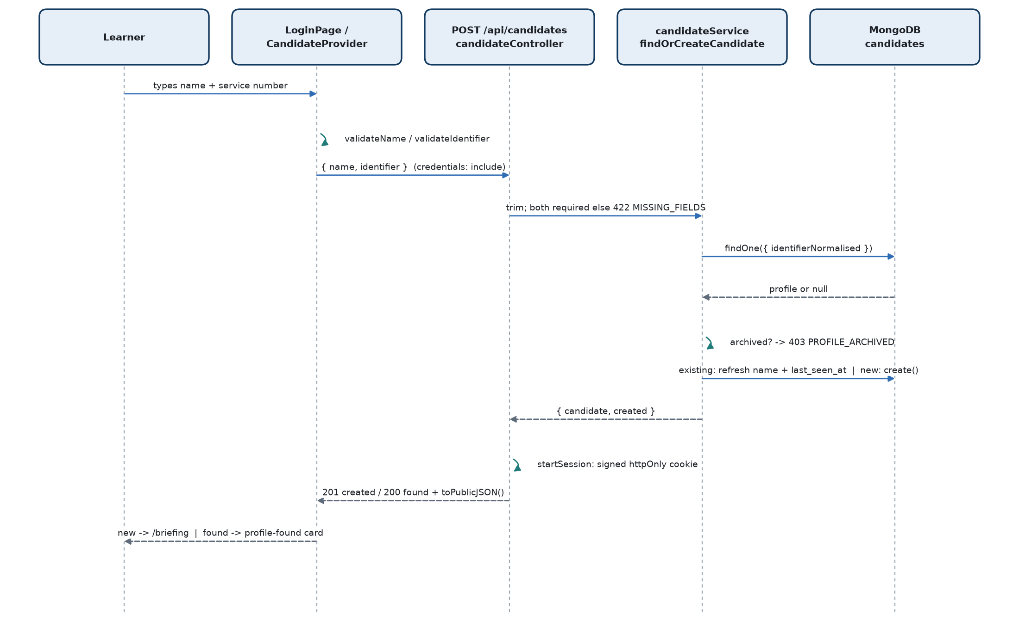
Figure 3. Learner login sequence

6.1 Step by step
- User opens the application in a web browser at the hosted address. / redirects to /login. CandidateProvider immediately calls GET /api/candidates/me. If a valid cookie exists the learner is sent straight to /briefing.
- Login page. LoginPage.jsx shows the entry form (full name, personal / service number).
- Client-side validation (utils/validation.js): name 3-60 characters, starting with a letter, letters/spaces/./'/- only; number 6-20 characters, letters/digits/spaces/-// only, at least 4 digits.
- API request. authApi.signIn(name, identifier) → POST /api/candidates with { name, identifier }.
- Backend validation. Both values are trimmed and must be non-empty, otherwise 422 MISSING_FIELDS. The schema limits name to 60 and identifier to 20 characters (longer → 422 VALIDATION_ERROR). The stricter character rules are enforced only in the browser.
- Lookup / creation. The identifier is normalised (uppercase; spaces, hyphens and slashes removed) and looked up. Archived profile → 403 PROFILE_ARCHIVED. Existing profile → the display name is refreshed to what was typed and last_seen_at is set. Unknown number → a new Candidate is created.
- Session creation. startSession(res, candidate._id) sets candidate_session (httpOnly, signed, sameSite=lax, secure when NODE_ENV=production - browsers then send it only over HTTPS, maxAge = SESSION_MAX_AGE_MS, default 8 h).
- Response. 201 { candidate, created: true } for a new profile or 200 { candidate, created: false } for an existing one. candidate = toPublicJSON(): display_name, service_no_masked, created_at, last_seen_at, briefing state. The profile id and raw number are never returned to the learner.
- Frontend state. CandidateProvider stores candidate.
- Redirect. New profile → /briefing. Existing profile → the "profile found" card (masked number shown), then "Continue" → /briefing, or "use different details" to return to the form.

6.2 Related behaviours
Topic | Current behaviour
Service-number normalisation | "ic-45872 h", "IC/45872H" and "IC 45872H" all become IC45872H and resolve to the same profile.
Protected routes | RequireCandidate wraps /briefing, /dashboard, /assessment, /assessment/legacy, /result/:attemptId, /history. Server side, every learner route except sign-in and logout uses requireCandidate.
Logout | POST /api/candidates/logout clears the cookie only. It does not end, reset or submit any attempt. In the simulation, logout is behind a confirmation dialog.
Rejected login | 422 missing fields, 403 archived profile - shown on the form, not retried.
Server unavailable | Network failure (status 0) or 5xx is treated as an infrastructure error: the form becomes a "record store unreachable" panel with a Retry button (max 3 retries), and the typed values are kept.
Session expiry | Any learner API returning 401 clears the local candidate and redirects to /login.
Archived during a session | requireCandidate re-checks archived on every request, so an open session gets 401 PROFILE_ARCHIVED immediately.
Duplicate / concurrent login | There is no single-session restriction. Signing in on another browser simply issues another valid cookie for the same profile; both see the same server-side attempt.
Demo-user identification | Not at login. Login is identical for everyone. Demo status is decided later, per request, by comparing the session profile's normalised number with the configured demo number (Section 21).

6.3 Administrator login (for comparison)
/admin/login → POST /api/admin/login { username, password }. adminLoginThrottle blocks a (client address + username) key for 15 minutes after 5 failures within 15 minutes (held in the memory of the API process; cleared on restart). authenticateAdmin verifies the Argon2id hash; an unknown username is verified against a decoy hash so both failures take the same time and return the same 401 INVALID_ADMIN_CREDENTIALS message. Success sets admin_session (own secret, 1 h). Admin accounts are created only by the operator script npm run admin:create (username 3-32 chars, password >= 12 chars); there is no HTTP route that creates an admin. A separate development script admin:create-demo creates a temporary demonstration administrator, refuses to run with NODE_ENV=production, and is documented in the code as a credential that must be replaced before real deployment.

7. Learner Profile Architecture
The learner profile is the Candidate model (collection candidates). Earlier plans refer to it as "LearnerProfile"; the code kept the model name Candidate, and every attempt references it through profile_id.
Field | Meaning / rule
_id | The profile id (profile_id in attempts). Never sent to the learner's own screens.
name | Display name, max 60 chars, refreshed on every sign-in.
identifier | The number as typed, max 20 chars.
identifierNormalised | Uppercase, no spaces/hyphens/slashes. Unique - the identity key.
service_no_masked | Recomputed on every validate from the normalised value: bullets + last 4 characters (e.g. ••••••4444).
last_seen_at | Set on sign-in; refreshed by GET /candidates/me at most once per 15 minutes (conditional update).
briefing_version / briefing_acknowledged_at | Set by POST /candidates/me/briefing only when the posted version equals the current BRIEFING_VERSION (1); otherwise 422 BRIEFING_VERSION_MISMATCH. "Acknowledged" is derived: briefing_version === BRIEFING_VERSION.
archived / archived_at / archived_by | Set by an administrator (ADMIN-004). Blocks sign-in (403) and any open session (401). Never deleted; no unarchive route.
seenScenarios | Legacy field used by the old 40-scenario quiz only. The current selector does not read it.
createdAt / updatedAt | Mongoose timestamps.

Data deliberately NOT stored
The profile holds no password, OTP, Aadhaar, personal email, phone number, rank or unit. Only the name and the personal / service number are collected. The raw and normalised numbers never leave the server; the learner and the instructor see only the masked form.

7.1 Relationship to attempt history
A profile has zero or more Attempt documents (Attempt.profile_id). Attempt history is never stored on the profile itself; it is read from the attempts collection when needed (selection history, history page, progress snapshot, admin viewer). The derived ProgressSnapshot (one per profile) caches aggregate progress and is rebuilt from completed attempts.

7.2 Briefing acknowledgement
After login the learner lands on /briefing. If the current version is not yet acknowledged, the "Continue to Dashboard" button is disabled until the checkbox is ticked; pressing it posts the version and only navigates on success. If already acknowledged, the page shows the date and continues directly.
Current implementation behaviour
The acknowledgement is enforced by the briefing screen, not by the server or the dashboard route. POST /api/attempts does not check briefing_version, and a learner who navigates directly to /dashboard can start an assessment. The acknowledgement record itself is stored and versioned as described.

8. Assessment Start Workflow
Client Understanding
When the learner presses Start Assessment, the server picks ten scenarios for them, fixes the order, starts a 90-minute clock and prepares all ten scenario slots at once. If the learner already has an assessment running, pressing Start simply resumes it - a second one is never created.

Technical Implementation
DashboardPage.handleStart → attemptApi.start() → POST /api/attempts → attemptController.startAttempt → createAttempt or createDemoAttempt → one transaction inserting Attempt + 10 ScenarioRuns.

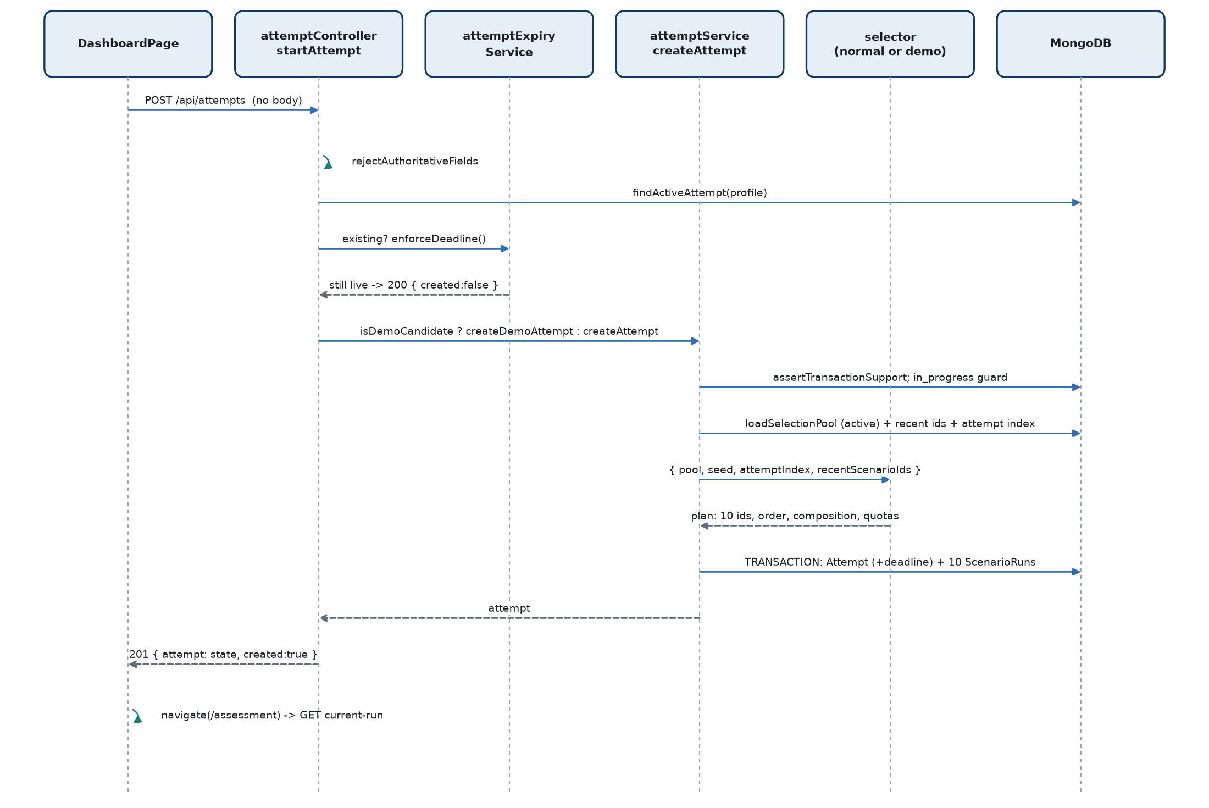
Figure 4. Assessment start sequence

8.1 Step by step
- Frontend action. The dashboard reads GET /api/attempts/current. If the server reports an attempt with status: in_progress, the button reads Resume Assessment and simply navigates to /assessment. Otherwise it reads Start Assessment and calls attemptApi.start() (no body → assessment mode).
- Validation. rejectAuthoritativeFields refuses any body carrying seed, scenario ids, scores, stages, deadline fields, intent, etc. (422 FORBIDDEN_FIELD). Ownership comes only from the session.
- Existing active attempt. findActiveAttempt(profile). If one exists, enforceDeadline runs: still within 90 minutes → it is returned with 200 and created: false; past the deadline → it is finalised as expired (Section 19) and a new attempt is created.
- Normal vs demo. isDemoCandidate(req.candidate) decides: the Demo User gets createDemoAttempt (fixed set); every other learner gets createAttempt with the SELECT-002 solver.
- Pre-checks. assertTransactionSupport() (503 if MongoDB is not a replica set) and a second in-progress guard (409 SELECTION_ATTEMPT_IN_PROGRESS).
- Inputs to selection. loadSelectionPool() reads all active: true definitions (only the fields selection needs; evaluation is never loaded) and fails if a scenario has two active versions. recentScenarioIdsFor(profile) and attemptIndexFor(profile) read history.
- Seed and selection. createSeed() generates 16 random bytes (hex). The selector returns the 10 ids in presentation order plus composition metadata.
- Version check. All ten must share one content version (currently version 1 for all 100), stored as content_version.
- Deadline. started_at = server clock, time_limit_ms = 90 min, expires_at = started_at + 90 min.
- Transaction. Attempt.create(...) with scenario_sequence (ordinal, scenario_id, definition_version), selection metadata, versions and deadline; then ScenarioRun.create(...) for ordinals 1-10, each status: active, current_stage: notify, score_running: 0. Committed together, {w:1, j:true}.
- Response. 201 { attempt: attemptStateFor(attempt), created: true } - candidate-safe attempt fields, progress {resolved:0, total:10}, current_run pointer (ordinal 1, stage notify), plus is_demo: true only on a demo attempt. A JSON log line attempt_created (with seed and relaxations) is written to the server console.
- Transition. The dashboard navigates to /assessment; useAttemptController calls GET /attempts/current then GET /attempts/:id/current-run, and the first notification is delivered 1-4 seconds later.

8.2 Records created
Collection | Records | Key content
attempts | 1 | profile_id, seed, mode, status in_progress, frozen 10-item sequence, selection metadata (algorithm version, attempt index, platform quota, composition, recent-exclusion report, relaxations), content/taxonomy versions, started_at, time_limit_ms, expires_at.
scenarioruns | 10 | attempt_id, ordinal 1-10, scenario_id, definition_version, platform, status active, stage notify, last_sequence 0, score_running 0.
scenarioevents | 0 | None until the first learner action.
progresssnapshots | 0 | Not touched at start (only rebuilt after completion, expiry or on read).

Notification
No separate notification record exists. The "notification" is the scenario's own synthetic notification asset, shown by the frontend when the current run is at notify with no events. The 1-4 second delay is a deterministic hash of the run id (deliveryDelayMs).

9. Scenario Selection Engine
Client Understanding
Every learner gets a balanced set of ten: eight deceptive and two genuine items, three easy, four medium and three hard, spread over all four apps, with a few military-context cases and a variety of persuasion techniques. The same attack family never appears more than twice. Scenarios the learner saw in their recent attempts are avoided. The choice is random for each attempt but fully reproducible from the stored seed.

Technical Implementation
backend/src/services/scenarioSelectionService.js - selectAttemptScenarios({ pool, seed, attemptIndex, recentScenarioIds }). Pure and synchronous: no DB, no clock. Algorithm version 1.0.0. Constructs a solution by constraint-directed depth-first search rather than random sampling, then validates it with an independent checker.

9.1 The rules (normal learner)
Rule | Value in code | Constant
Scenarios per attempt | Exactly 10 | ATTEMPT_SCENARIO_COUNT
Malicious / legitimate | Exactly 8 malicious + 2 legitimate; the 2 legitimate on different platforms | DISPOSITION_QUOTA, LEGITIMATE_PLATFORM_MINIMUM
Difficulty | Exactly 3 easy, 4 medium, 3 hard | DIFFICULTY_QUOTA
Platform distribution | Pattern 3/3/2/2 over [WhatsApp, Instagram, Email, SMS], rotated by attempt index | PLATFORM_PATTERN, PLATFORM_ORDER
Military context | 2 to 4 scenarios with military_flag | MILITARY_RANGE
Triggers | At least 5 distinct canonical triggers across the 10 | MIN_DISTINCT_TRIGGERS
Families | No canonical family more than twice | MAX_PER_CANONICAL_FAMILY
History | Exclude the learner's most recent 20 scenario ids where possible | RECENT_EXCLUSION_WINDOW
Presentation order | Shuffled; never more than 2 consecutive scenarios from one platform | MAX_CONSECUTIVE_SAME_PLATFORM
Search bound | 200,000 search steps | MAX_SEARCH_STEPS

9.2 Platform rotation
platformQuotaFor(attemptIndex) rotates the 3/3/2/2 pattern by attemptIndex mod 4, where attemptIndex = the number of attempts this learner has already started (any status). Over any four consecutive attempts each platform receives exactly 10 scenarios.
Attempt index (attempts already started) | WhatsApp | Instagram | Email | SMS
0 (1st attempt), 4, 8 … | 3 | 3 | 2 | 2
1 (2nd attempt), 5, 9 … | 3 | 2 | 2 | 3
2 (3rd attempt), 6 … | 2 | 2 | 3 | 3
3 (4th attempt), 7 … | 2 | 3 | 3 | 2

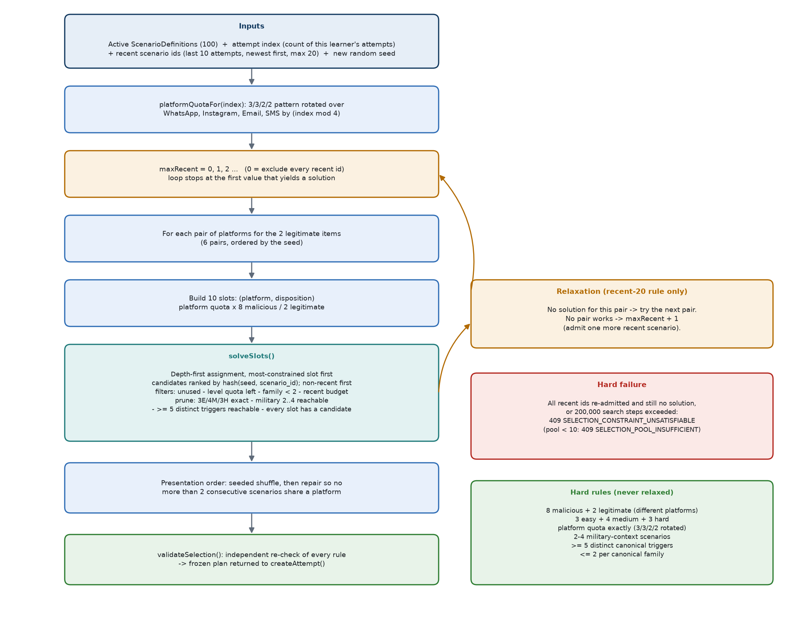
Figure 5. Scenario selection algorithm (normal learner)

9.3 Exact order in which the constraints are applied
- Pool check. Fewer than 10 active definitions → 409 SELECTION_POOL_INSUFFICIENT.
- Seeded generator. seededRandom(seed): SHA-256 of the seed initialises xoshiro128 (star-star); rankBy orders items by sha256(seed + ":" + key), so the result does not depend on database order.
- Platform quota from the attempt index (table above).
- Recent list. The first 20 of recentScenarioIds (newest first).
- Legitimate platform pairs. All 6 pairs of distinct platforms, ordered by the seed.
- Relaxation loop. For maxRecent = 0, 1, 2 … up to the size of the recent list: for each legitimate pair in seed order, try to solve. The first success wins.
- Slot matrix. 10 slots of (platform, disposition): each platform gets its quota of slots; the two slots on the chosen legitimate platforms are marked legitimate, the other 8 malicious.
- Candidates per slot. Active scenarios matching the slot's platform and disposition, ranked by the seed hash, with non-recent scenarios ahead of recent ones.
- Search order. Slots with the fewest candidates are filled first (legitimate slots, 5 candidates per platform, are decided early).
- Candidate filter at each step. Not already used; its difficulty still has quota; its canonical family used fewer than 2 times; if recent, the recent budget (maxRecent) is not exhausted.
- Forward checking (pruning) at each depth. Remaining difficulty quota must equal remaining slots; military count must not exceed 4; recent usage within budget; every remaining slot must still have a candidate; the military minimum (2) must still be reachable; at least 5 distinct triggers must still be reachable; each outstanding difficulty quota must be servable by enough remaining slots.
- Leaf check. A complete assignment is accepted only if military is 2-4, triggers >= 5 and recent usage within budget.
- Presentation order. Seeded Fisher-Yates shuffle, then a deterministic repair pass that swaps a later scenario from another platform into any run of 3 same-platform scenarios (where such a scenario exists).
- Independent validation. validateSelection() re-checks every rule from scratch. If it disagrees with the solver → 500 SELECTION_INTERNAL_ERROR (a solver bug, never silently accepted).
- Output. Scenario ids and objects in order, seed, algorithm version, attempt index, platform quota, legitimate platforms, composition summary, recent-exclusion report and relaxations list.

9.4 Relaxation - what can and cannot be relaxed
Only the "recent 20" rule is ever relaxed, and only minimally
Every composition rule (8+2, 3/4/3, platform quota, military 2-4, >= 5 triggers, <= 2 per family, legitimate on different platforms) is hard: it is never relaxed.
The recent-history exclusion is relaxed one scenario at a time: the solver first tries with zero recent scenarios allowed; only if no platform pair yields a valid set does it allow one recent scenario, then two, and so on. It stops at the first number that works, and within that budget the solver chooses which recent scenario(s) to re-admit.
When relaxation happens, the attempt records selection.relaxations = ["SELECTION_RECENT_EXCLUSION_RELAXED"] and recent_exclusion.allowed_recent_ids lists exactly which recent ids were reused.
If even re-admitting every recent scenario cannot satisfy the hard rules, or the 200,000-step search budget is exceeded, selection fails with 409 SELECTION_CONSTRAINT_UNSATISFIABLE and no attempt is created.

Earlier planning text sometimes describes this as a "one-step relaxation". In the current code it is an incremental relaxation of the single recent-history rule, admitting the minimum number of recent scenarios required (0, then 1, then 2 …), with all other rules held fixed.

9.5 Normal selection vs demo selection
Aspect | Normal learner | Demo User
Selector | selectAttemptScenarios (solver) | selectDemoScenarios (fixed list)
Scenarios | Chosen per attempt by seed | Always W01, E01, S16, I04, E21, W24, E14, I11, S25, W16 in that order
Composition | 8 malicious + 2 legitimate | 6 malicious + 4 legitimate (checked against the bank's own dispositions)
Difficulty | 3 / 4 / 3 | 3 / 4 / 3 (by the chosen set)
Platforms | 3/3/2/2 rotated | WhatsApp 3, Email 3, Instagram 2, SMS 2 (every time)
Seed | 16 random bytes per attempt | Constant "demo-fixed-sequence"
Recent exclusion | Applied (recent 20) | Not applied (recorded as fixed_demo_sequence)
Algorithm version stored | 1.0.0 | demo-fixed-1.0.0 (this is how a demo attempt is recognised)
Persistence | createAttempt() | The same createAttempt() with the selector swapped - same transaction, deadline and 10 runs

10. What Happens When the Same Learner Starts a Second Assessment?
Short answer
The second assessment is a new, independent set of ten scenarios with the same balanced structure as the first: 8 deceptive + 2 genuine, 3 easy + 4 medium + 3 hard, 2-4 military-context items, at least 5 persuasion techniques and no attack family more than twice.
None of the ten scenarios from the first attempt is repeated, because the learner's most recent 20 scenario ids are excluded.
The mix of apps rotates: attempt 1 has WhatsApp 3, Instagram 3, Email 2, SMS 2; attempt 2 has WhatsApp 3, Instagram 2, Email 2, SMS 3.
Difficulty does NOT increase and is NOT adaptive. The selector is never given the learner's previous score or outcomes. Every attempt uses the same fixed 3 easy / 4 medium / 3 hard target, whether the learner scored 20 or 100.

10.1 First attempt → history stored
- Attempt 1 is created with attempt index 0, a fresh random seed and platform quota W3/I3/E2/S2.
- Its 10 ScenarioRun documents are created immediately, so the 10 scenario ids are part of the learner's history from the moment the attempt starts - whether the learner finishes it, times out, or an instructor resets it.
- On completion the attempt stores total_score, end_reason and completed_at; the ProgressSnapshot is rebuilt.

10.2 Second attempt → selection
Step | What happens in code
Previous history considered | recentScenarioIdsFor(profile) reads the learner's 10 most recently started attempts, their runs newest first (up to 40 runs), and collects up to 20 distinct scenario ids. For a second attempt this is exactly the 10 ids of attempt 1.
Eligible pool | All active scenarios (100). Pass A (maxRecent = 0) removes the 10 recent ids, leaving 90 eligible.
Attempt index | attemptIndexFor = count of the learner's attempts = 1 → platform quota W3 / I2 / E2 / S3.
Constraints applied | Identical hard rules to attempt 1 (Section 9.1).
New selection seed | A new 16-byte random seed is generated and stored on attempt 2.
New 10 scenarios | Solver output; independent validation.
New ScenarioRuns | 10 new runs with fresh state (stage notify, score 0).
New event ledger | Events are keyed by run, so attempt 2 has its own ledger; nothing carries over.
New score | Scored exactly as attempt 1; completion sums its own 10 runs.
Comparison | The result compares attempt 2 with attempt 1 only if mode, content version, taxonomy version and trigger taxonomy version all match (they do for two assessment attempts on the current bank).

10.3 Third and later attempts
The recent window holds 20 ids, i.e. two full attempts. Attempt 3 excludes the scenarios of attempts 1 and 2. Attempt 4 excludes attempts 2 and 3, so scenarios first seen in attempt 1 become eligible again (they are not preferred or avoided beyond that). Attempts that were reset by an instructor or ended on the clock still count, because their runs exist.

10.4 What does NOT change between attempts
- The composition rules (8+2, 3/4/3, 2-4 military, >= 5 triggers, <= 2 per family, legitimate items on different platforms).
- The scoring table and the 0-10 per-scenario / 0-100 attempt scale.
- The six-stage flow and the 90-minute time limit.
- Nothing about the learner's previous score, missed threats, false positives or weak families influences which scenarios are chosen. Weak families appear only as remediation recommendations on the result screen; they are not fed back into selection.
- Families and triggers are not tracked across attempts for avoidance; only exact scenario ids are excluded.

10.5 If not enough eligible scenarios remain
With the full 100-scenario bank, excluding 20 recent ids still leaves 80 eligible scenarios. A simulation run for this document, calling the real solver code directly on the current bank data (no database involved) (300 simulated learners × 8 consecutive attempts = 2,400 attempts, 20-id window) required no relaxation and produced zero overlap between any attempt and the one before it. Relaxation (Section 9.4) is therefore reached only if the eligible pool cannot satisfy the hard rules - for example if an administrator deactivates scenarios. In that case the minimum number of recent scenarios is re-admitted and the reuse is recorded on the attempt; if the rules still cannot be met, starting the attempt fails with 409.
Current implementation behaviour - demo profile
The Demo User always receives the same ten scenarios in the same order on every attempt; recent-history exclusion and platform rotation do not apply to demo attempts.

11. Scenario State Machine
Client Understanding
Every scenario moves through the same six steps. First something arrives (Notify). The learner opens it (Open), looks at the details (Inspect), decides what to do (Branch), checks it somewhere trustworthy or escalates it (Verify), and finally closes it with a decision (Resolve). Each step accepts exactly one scored choice; looking around inside the simulated phone is free and does not count as a choice.

Technical Implementation
ScenarioRun.current_stage ∈ notify | open | inspect | branch | verify | resolve. Legal moves per stage are STAGE_INTENTS in constants/scenarioEngine.js. scenarioEngineService.resolveIntent() accepts an intent only if it is defined for the current stage AND the pinned ScenarioDefinition declares a matching scoring code at that stage.

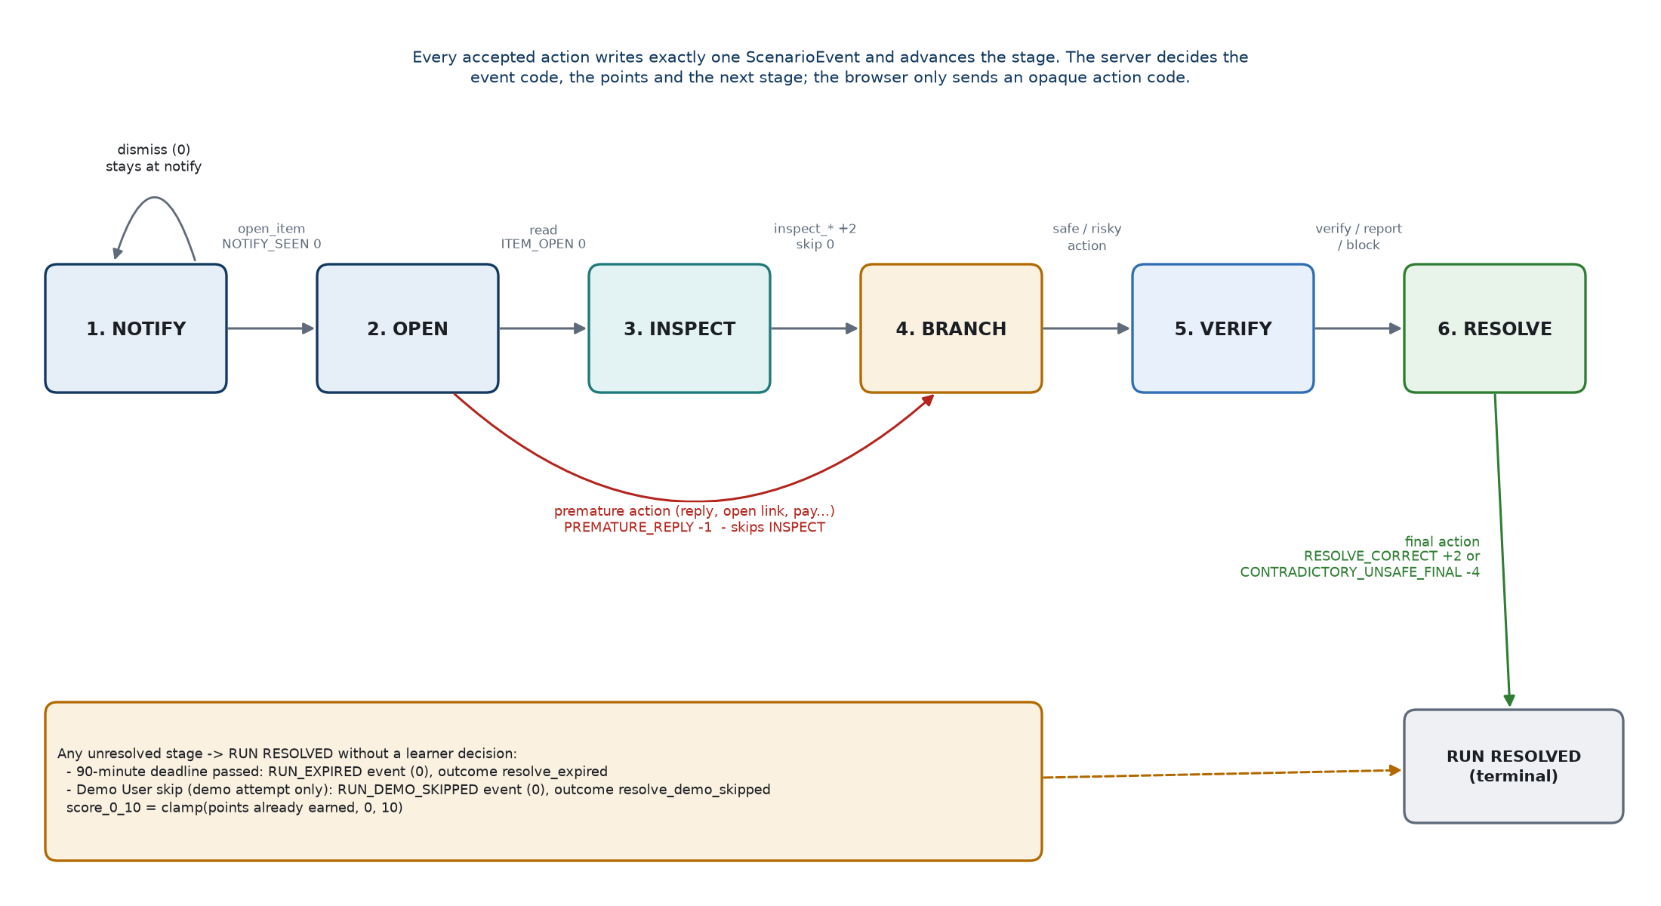
Figure 6. Six-stage scenario state machine (engine transitions)

11.1 Stage reference
Stage | Purpose and UI | Learner intents (server side) | Events / points | Moves to
1 Notify | Phone home screen; toast + badged app tile appear 1-4 s after the hub is idle. | open_item, dismiss | NOTIFY_SEEN 0; dismiss → notification_dismissed 0 (telemetry) | open; dismiss stays at notify
2 Open | The app opens on the item (chat, post, email, SMS thread). | read; premature: reply, open_link, submit_data, attempt_payment, attempt_install, call_number | ITEM_OPEN 0; premature action → PREMATURE_REPLY -1 | inspect; premature → branch (inspection skipped)
3 Inspect | Contact/profile sheet, message details, link target, file preview, QR decode, re-read the thread. | inspect_sender, inspect_profile, inspect_link, preview_file, inspect_qr, read_thread, skip_inspection | INSPECT_CONTEXT +2; skip → STAGE_SKIPPED 0 | branch
4 Branch | The request becomes actionable (link card, form, payment request, composer, install prompt). | Safe: safe_pivot; legit only: reject_ignore; risky: open_link, open_file, scan_qr, reply, call_number, submit_data, attempt_payment, attempt_install, approve_device_link, share_secret, share_location | Malicious: SAFE_PIVOT +3, RISKY_OPEN_REPLY -3, SECRET_PAYMENT_INSTALL_DATA_RELEASE -8. Legitimate: CORRECT_USE +3, NEEDLESS_REJECT_IGNORE -2, UNSAFE_EXTERNAL_ACTION -4 | verify
5 Verify | Action sheet / menu, Trusted Directory overlay, "known app", "number I already hold". | verify_trusted_directory, verify_known_app, verify_known_number, verify_in_message_contact, report, block | TRUSTED_VERIFY +3; VERIFY_THROUGH_MESSAGE 0; report/block: REPORT_ONLY_WITHOUT_CHECK +1 (malicious) or FALSE_REPORT_BLOCK -4 (legitimate) | resolve
6 Resolve | Final choice; optional one-line rationale (max 250 chars). | resolve_report, resolve_block, resolve_continue, resolve_retain, resolve_ignore | RESOLVE_CORRECT +2 if the choice matches the disposition, else CONTRADICTORY_UNSAFE_FINAL -4; resolve_ignore is always -4 | end - run resolved

11.2 Rules enforced at every stage
Situation | Server behaviour
Moving forward | Only by one accepted action. Each accepted action writes exactly one ScenarioEvent and sets current_stage to the rule's next stage.
Invalid transition (intent not allowed at this stage, or not declared by this scenario) | 409 INVALID_TRANSITION (engine); on learner routes a code for another stage is refused before that (see below). Nothing is written.
Wrong stage / stale tab | Each action code belongs to one stage. The controller passes that stage to the engine as expectedStage; if the run has moved on → 409 STALE_STATE with the current stage. The frontend reloads the run and shows "This scenario moved on while you were deciding".
Request's expected_stage disagrees with the code's own stage | 422 INVALID_ACTION ("That action is not available here.").
Replay of the same action (same intent_key) | The original outcome is returned with duplicate: true; no second event, no second score.
Resolved run | 409 RUN_NOT_ACTIVE for any further action.
Tampered / unknown / other-run action code | 422 INVALID_ACTION - one neutral message for every case.
Client sends score, stage, event code, sequence, points etc. | 422 FORBIDDEN_FIELD (controller) / INVALID_INTENT (engine). Refused, not ignored.

Current implementation behaviour
- The engine vocabulary also contains an abandon intent (resolve stage → run status abandoned, event RUN_ABANDONED). No learner control maps to it (learnerActionService rejects map entries for abandon), so it cannot be triggered through the learner API.
- STAGE_TRANSITIONS in the scenario schema also lists "verify → branch on in-message check"; the engine's runtime rule sends verify_in_message_contact to resolve.
- Each stage accepts exactly one scored action. After one inspection the run moves to branch; further inspection on the phone is local navigation and is not scored again.

12. Immersive Scenario Architecture
A scenario exists in three coordinated places: the server-side definition (what it is and how it scores), the server-side learner-action map (which neutral control means which intent), and the frontend scene pack (how it looks and where each control sits).
Element | Where | Role
ScenarioDefinition | MongoDB scenariodefinitions (imported from backend/data/scenarios/v1 + synthetic/v1) | Identity (scenario_id, version), classification, synthetic content, six candidate-visible stages, scoring envelope, server-only evaluation.
platform | Definition + run | whatsapp | instagram | email | sms; must match the id prefix W/I/E/S.
level (difficulty) | Definition only (server) | easy | medium | hard. Used by selection; never sent to the learner.
disposition | Definition only (server) | malicious | legitimate. Decides which scoring codes exist and which final action is correct.
family / canonical_family | Definition | Client text verbatim + one of 19 canonical families (taxonomy 1.0.0). Legitimate scenarios must use a legit_* family.
trigger / canonical_triggers | Definition | Client text verbatim (e.g. "Authority + care | FICTIONAL MILITARY CONTEXT") + canonical trigger ids (22-value taxonomy).
military_flag | Definition | True exactly when the raw trigger ends with "| FICTIONAL MILITARY CONTEXT" (validated).
stages[6] | Definition (candidate-visible) | index, key, ui_to_build, allowed transitions, telemetry event names, asset references.
evaluation.stages[6] | Definition (server-only) | Client learner flow, expected safe behaviour, scoring text and the parsed scoring[] {event_code, points_delta, critical}.
evaluation.feedback | Definition (server-only until the attempt ends) | result, cues, safe_action, impact, prevention_habit.
synthetic.assets | Definition (candidate-visible) | notification, message_thread, sender_profile, link, file, qr_payload, browser_page, call_screen, trusted_directory_entry, payment_screen, install_screen, image. Every scenario has 4-7 assets.
Learner-action map | backend/data/learner-actions/v1/<platform>.json | Neutral control id → {stage, intent}. 17-24 controls per scenario (1,986 in total) plus 37 generic controls.
Scene pack | frontend/src/simulation/scenes/<platform>/<id>.js | Beats (messages that appear from a given stage), surfaces/pages, scored affordances with neutral ids and app-realistic labels, local navigation.

12.1 From database definition to the screen
- GET /attempts/:id/current-run → runPayloadFor(run) loads the definition by the run's pinned (scenario_id, definition_version).
- definition.toCandidateJSON() builds an allowlisted payload: id, scenario_id, version, platform, synthetic content (sender, assets - with third-person narration removed from threads and browser pages), and the six stages. Title, level, disposition, family, triggers, military flag, feedback, expected actions and scoring are absent.
- actionCodesForRun(run) adds actions: a map of every allowed neutral control id to its opaque per-run code.
- SimulationPage calls sceneFor(scenario); the scene builder reads the synthetic assets and returns the scene (beats, surfaces, affordances per stage).
- PhoneShell draws the platform app (WhatsAppScene, InstagramScene, EmailScene or SmsScene) at the stage the server reports; controls for that stage are rendered in their slots (menu, composer, inline, surface).

12.2 The 100-scenario bank at a glance
Platform | Total | Malicious | Legitimate | Easy | Medium | Hard | Military
WhatsApp (W01-W25) | 25 | 20 | 5 | 8 | 9 | 8 | 10
Instagram (I01-I25) | 25 | 20 | 5 | 8 | 9 | 8 | 12
Email (E01-E25) | 25 | 20 | 5 | 8 | 9 | 8 | 8
SMS (S01-S25) | 25 | 20 | 5 | 8 | 9 | 8 | 5
Total | 100 | 80 | 20 | 32 | 36 | 32 | 35

All 100 definitions are version 1 and active. Full distributions are in Section 37 and the complete catalogue is in Appendix E.

13. Scenario Sequence Examples
One real scenario per platform is walked through below - two malicious and two legitimate - using the current scene packs and server maps. Labels are the on-screen text of the controls. Points are what the engine awards for that choice on that scenario.

13.1 WhatsApp - W01 "The Accidental Login Code" (malicious, easy)
Family: account takeover / OTP theft (account_takeover_authorisation_abuse). Triggers: helpfulness + urgency.
Stage | What the learner sees and can do | What happens internally
Notify | Home screen toast: an unknown number says it sent a 6-digit code by mistake and asks for it back. WhatsApp tile shows a badge. Choices: open it or dismiss the alert. | Run at notify, sequence 0. Open → open_item → NOTIFY_SEEN 0 → stage open. Dismiss → notification_dismissed 0, stays at notify.
Open | Chat list row → "Open the chat with …" or "Reply from the preview without opening the chat". | Open → read → ITEM_OPEN 0 → inspect. Reply from preview → PREMATURE_REPLY -1 → branch (inspection skipped).
Inspect | "Contact info" (number, no groups in common, on WhatsApp since yesterday), "Read the conversation from the start", or "Skip the checks and act on this message". | Contact info → inspect_sender, reading → read_thread: both INSPECT_CONTEXT +2. Skip → STAGE_SKIPPED 0. → branch.
Branch | A system code bubble appears. Composer: "Send the code", "Ask who this is". Menu: "Do not reply, and open Account settings instead", "Call …". | Send the code → share_secret → SECRET_PAYMENT_INSTALL_DATA_RELEASE -8 (critical). Ask / call → RISKY_OPEN_REPLY -3 (critical). Account settings → safe_pivot → SAFE_PIVOT +3. → verify.
Verify | "Settings > Account > Linked devices", "Look up the unit support desk" (Trusted Directory), "Call the number that messaged you", Report, Block. | Linked devices → verify_known_app, directory → verify_trusted_directory: TRUSTED_VERIFY +3. Call the sender → VERIFY_THROUGH_MESSAGE 0. Report/Block → REPORT_ONLY_WITHOUT_CHECK +1. → resolve.
Resolve | "Report and close the chat", "Block and delete the chat" (correct for a malicious item), "Keep the chat", "Carry on helping them", "Leave it and move on". | Report/Block → RESOLVE_CORRECT +2. Keep / Carry on / Leave → CONTRADICTORY_UNSAFE_FINAL -4 (critical). Run resolved; score = clamp(sum, 0, 10).

Safe path: 0 + 0 + 2 + 3 + 3 + 2 = 10. Sending the code after inspecting, then reporting: 0 + 0 + 2 - 8 + 1 + 2 = -3 → 0.

13.2 Instagram - I11 "Official Welfare Helpline Update" (legitimate, medium, military context)
Family: legitimate routine broadcast (legit_routine_broadcast). Triggers: authority + empathy.
Stage | What the learner sees and can do | What happens internally
Notify | Toast from the fictional official welfare account: helpline extension updated; use the contact in the approved directory. | NOTIFY_SEEN 0 → open.
Open | "Open the notice" or "Comment 'what's the new number?' from here". | Open → ITEM_OPEN 0. Commenting from the preview → PREMATURE_REPLY -1 → branch.
Inspect | Tap the account handle (profile, verified status, contact details, account history), "Read the notice and its comments", or "Go straight to saving it". | Handle → inspect_profile, reading → read_thread: INSPECT_CONTEXT +2. Skip → 0.
Branch | "Save the notice" / "File it under Unit notices…" (normal in-app use), "Comment with your file number, service number and unit", "Message the cell your case…", "Mute the account…". | Save / file → safe_pivot → CORRECT_USE +3. Comment with details → submit_data → UNSAFE_EXTERNAL_ACTION -4 (critical). Message → reply → UNSAFE_EXTERNAL_ACTION -4. Mute → reject_ignore → NEEDLESS_REJECT_IGNORE -2.
Verify | "Compare the account and the extension with the approved directory", "Open the unit welfare application…", "Comment asking the account to confirm", Report the post, Block. | Directory / app → TRUSTED_VERIFY +3. Comment → VERIFY_THROUGH_MESSAGE 0. Report / Block a genuine account → FALSE_REPORT_BLOCK -4.
Resolve | "Keep the saved notice and carry on", "Use extension … next time" (correct for a genuine item), "Report the account…", "Block …", "Unfollow and stop reading these notices". | Keep / use → resolve_retain / resolve_continue → RESOLVE_CORRECT +2. Report / Block / Unfollow → CONTRADICTORY_UNSAFE_FINAL -4.

Safe path: 2 + 3 + 3 + 2 = 10. Treating it as a scam (inspect, mute, report, report): 2 - 2 - 4 - 4 = -8 → 0, classified as a false positive.

13.3 Email - E01 "Password Expires Today" (malicious, easy)
Family: credential phishing. Triggers: urgency + authority.
Stage | What the learner sees and can do | What happens internally
Notify | Toast: "IT Service Desk: Password expires today - retain access by validating now." | NOTIFY_SEEN 0.
Open | "Open the email from IT Service Desk" or "Reply from the list to ask for a reset". | Open → 0. Reply from the list → PREMATURE_REPLY -1 → branch.
Inspect | Tap the sender (From, Reply-To and authentication summary), "Read the whole thread", or "Skip ahead to the button". | Sender → inspect_sender +2; read → +2; skip → 0.
Branch | "Validate password now" (opens the synthetic sign-in page on .example domains), the page's "Validate" button after typing, "Close the sign-in page", "Leave the email without clicking anything". | Validate now → open_link → RISKY_OPEN_REPLY -3. Submitting the form → submit_data → SECRET_PAYMENT_INSTALL_DATA_RELEASE -8. Close / leave → SAFE_PIVOT +3. Typed values never leave the component.
Verify | "Open your Account portal from your bookmark", "Look up the IT desk in the trusted directory", "Reply to the sender to ask if it is real", Report, Block. | Portal / directory → TRUSTED_VERIFY +3. Reply → VERIFY_THROUGH_MESSAGE 0. Report / Block → +1.
Resolve | "Report and delete it", "Block the sender and report" (correct), "Keep it and validate later", "Ignore it and move on". | Report / Block → +2. Keep / Ignore → -4.

13.4 SMS - S16 "Learner-Initiated Login Code" (legitimate, medium)
Family: legitimate system confirmation. Trigger: routine. The learner has just started a sign-in in a synthetic official app and receives the matching code.
Stage | What the learner sees and can do | What happens internally
Notify | Toast: "Your TRAINING PORTAL code is … Do not share it. Expires in 5 minutes." | NOTIFY_SEEN 0.
Open | "Open the code message" or "Copy … from the list". | Open → 0. Copying from the list → submit_data premature → PREMATURE_REPLY -1.
Inspect | Tap the sender header (who sends these codes), "Compare with the earlier codes", or "Skip the details". | +2 for either inspection; skip 0.
Branch | In the already-open portal page: "Fill … from Messages", "Not now - cancel this sign-in"; inline: "Forward this text to the IT help desk". | Fill → safe_pivot → CORRECT_USE +3. Cancel → reject_ignore → -2. Forward the code → share_secret → UNSAFE_EXTERNAL_ACTION -4.
Verify | "Open Training Portal and compare the sign-in under Security", "Look up the support desk in the trusted directory", "Look up …/help, the address the code line names", Report as junk, Block. | App / directory → +3. The address named in the text → VERIFY_THROUGH_MESSAGE 0. Report / Block → FALSE_REPORT_BLOCK -4.
Resolve | "Finish signing in and let the code run out", "Keep the thread…" (correct), "Report the code text as junk", "Block … and delete", "Ignore it". | Continue / Retain → +2. Others → -4. A one-line rationale may be added (max 250 characters, never scored).

14. Learner Action Architecture and Security
Client Understanding
The buttons on the simulated phone do not tell the browser what they mean. Each button has a meaningless name such as "w01-c08", and for each scenario the server hands out secret codes for those buttons. When the learner presses a button, the browser sends the code; only the server knows whether it meant "report it" or "send the code". This stops anyone from reading the answers out of the web page or replaying another session's actions.

Technical Implementation
SECURITY-001 "neutral learner action contract". Frontend: neutral control ids only (<scenario>-cNN, gen-cNN). Server: backend/data/learner-actions/v1/*.json maps id → {stage, intent}; learnerActionService issues ac_ + 20 hex chars = first 80 bits of HMAC-SHA256 over v1|runId|scenarioId|version|controlId, keyed by LEARNER_ACTION_SECRET (or a key derived from SESSION_SECRET).

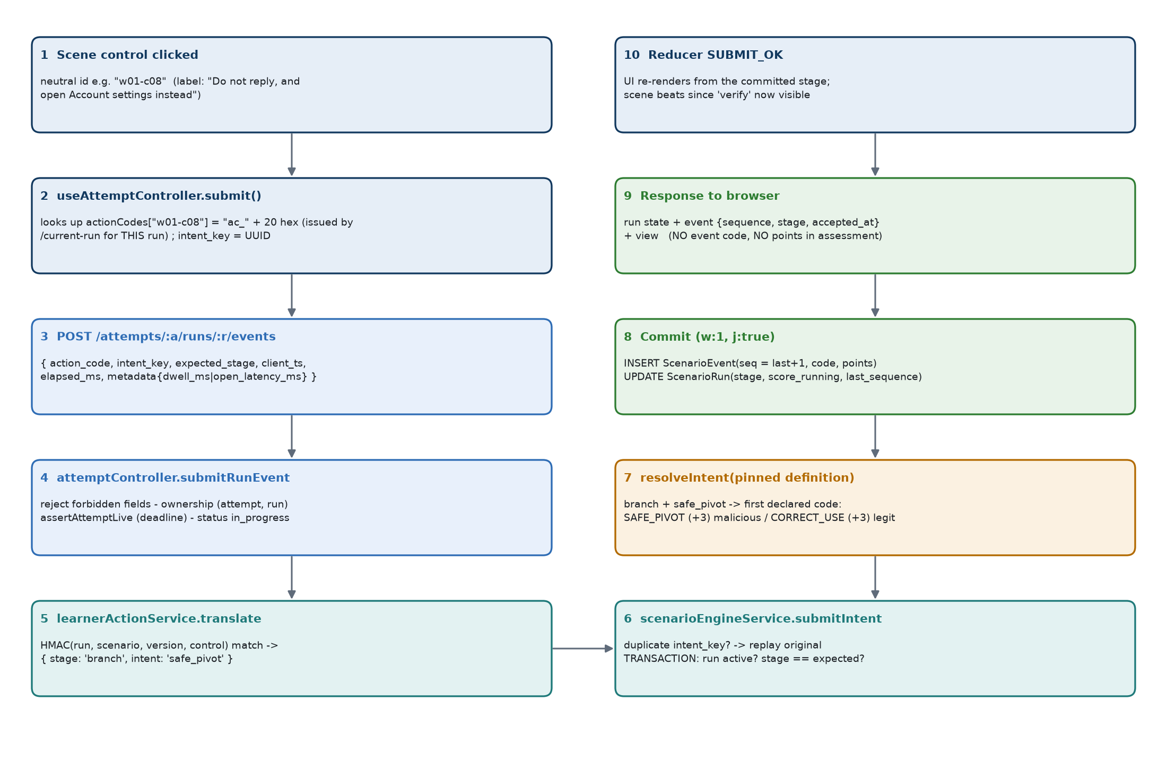
Figure 7. From a tapped control to a committed, scored event

14.1 How the pieces fit
Concern | Implementation
Why neutral codes | Earlier builds carried engine intents (e.g. share_secret) in the bundle and requests, which revealed the meaning - and effectively the correct answer - of every control. Now the bundle, the DOM and the request carry only positions and opaque tokens. npm run check:bundle scans the production build for leaked intents, event codes and verification sources.
How the frontend submits | useAttemptController.submit(control): looks up state.actionCodes[control.id] (issued by /current-run); generates a stable intent_key (UUID) per (run, stage, code) so a retry reuses it; sends {action_code, intent_key, expected_stage, synthetic_target_id, metadata, client_ts, elapsed_ms} - or, at resolve, {action_code, intent_key, rationale, expected_stage} to /resolve.
How the backend validates | Forbidden fields (intent, verify_source, scores, stages, deadline…) → 422. Metadata keys limited to dwell_ms, open_latency_ms, link_hover_ms. Code must match ^ac_[0-9a-f]{20}$ and equal (constant-time) the HMAC of one control allowed for this run's scenario.
Mapping to scenario behaviour | translateActionCode returns {stage, intent, verifySource, view}. The engine then decides the event code from the pinned definition's declared scoring for that stage (e.g. safe_pivot → SAFE_PIVOT on malicious, CORRECT_USE on legitimate).
Canonical scoring intent kept server-side | Intents, event codes and points never appear in the learner response. The accepted response returns run state, {sequence, stage, accepted_at} and a neutral view key (which inert panel to open). Engine error messages that could name an intent are replaced with "That action is not available here."
Cross-run replay rejected | Codes are bound to the run id: a code copied from another run, attempt, learner or scenario matches nothing → 422 INVALID_ACTION. A reused intent_key from another run → DUPLICATE_INTENT.
Wrong-stage action rejected | The code's own stage is passed as expectedStage; mismatch with the run → 409 STALE_STATE; mismatch with the request's expected_stage → 422.
Tampered codes rejected | Malformed or unknown → the same 422 INVALID_ACTION, so a refusal reveals nothing.
Duplicate / replayed actions | Same intent_key on the same run → the original committed outcome is returned (duplicate: true); unique index on intent_key guarantees a single event even under concurrency.
Not exposed to the learner | Disposition, difficulty, family, triggers, military flag, scenario title, expected actions, scoring table, points per action, running score (in assessment mode), event codes, seed and selection metadata.
Deterministic codes | The same run always yields the same codes (reload, second tab, retry all work); no state is stored. Changing the secret invalidates codes; the page recovers by reloading the run.
Map integrity | The maps are validated at server start (neutral id pattern, known stage, intent legal at that stage, no abandon); a malformed map stops the server from starting.

Current implementation behaviour
The generic action sheet deliberately omits a "reject / ignore" choice at the branch stage because the engine accepts it only on legitimate scenarios. In the authored scenes, a branch-stage reject/ignore control is present in exactly the 20 legitimate scenes (it maps to NEEDLESS_REJECT_IGNORE -2) and in none of the 80 malicious scenes. "Ignore it and move on" at the resolve stage is available in 96 scenes and always scores CONTRADICTORY_UNSAFE_FINAL.

15. How Scoring Works (Client Explanation)

15.1 What the learner does → what the system records
Every time the learner makes a choice in a scenario, the server writes one line in that scenario's ledger: which step it was, what kind of behaviour it was, and how many points it is worth. Looking around inside the phone - opening a contact card, walking between screens - writes nothing and scores nothing.

15.2 How points are assigned
Behaviour | Points
Opening the notification, reading the item | 0
Inspecting the sender, profile, link, file, QR code or thread | +2
Declining the request / using the official in-app path | +3
Checking through a trusted directory, a known app or a number already held | +3
Reporting a threat without checking first | +1
Checking via contact details supplied inside the message | 0
Closing the item correctly (report/block a threat; keep/continue a genuine item) | +2
Acting on the preview before reading it | -1
Walking away from a genuine item without checking | -2
Opening a suspicious link/file/QR, replying or calling the number given | -3
Unsafe external action on a genuine item (e.g. posting details publicly) | -4
Reporting or blocking a genuine sender | -4
Closing with the wrong final action | -4
Handing over a secret, credentials, payment, an install or data | -8

15.3 How a scenario score is finalised
The points of all choices in the scenario are added up. When the learner makes the final (Resolve) choice, the total is limited to the range 0 to 10: anything below 0 counts as 0, and the safe path is designed to reach exactly 10. That 0-10 number is stored with the scenario and never changes afterwards.

15.4 How ten scenario scores become the final score
When all ten scenarios are resolved the learner presses View results. The server adds the ten stored 0-10 scores to produce the assessment score out of 100. During an assessment the learner does not see per-scenario points; they see them in the result.

15.5 Worked examples
Example | Choices | Sum | Scenario score
Safe path (malicious) | open 0, read 0, inspect +2, decline +3, trusted check +3, report +2 | 10 | 10
Safe path (legitimate) | open 0, read 0, inspect +2, normal use +3, trusted check +3, keep/continue +2 | 10 | 10
Good instincts, no verification | inspect +2, decline +3, report without checking +1, report +2 | 8 | 8
Trusted the message | inspect +2, decline +3, used the number in the message 0, report +2 | 7 | 7
Risky path (malicious) | reply from preview -1, share the code -8, report without checking +1, report +2 | -6 | 0
Engaged then kept it | inspect +2, open the link -3, check via message 0, keep it -4 | -5 | 0
False positive (legitimate) | inspect +2, ignore it -2, report -4, report and close -4 | -8 | 0

A ten-scenario assessment where the learner handled six scenarios perfectly (6 × 10), two at 8, one at 7 and one at 0 scores 60 + 16 + 7 + 0 = 83 / 100.

16. Scoring Engine (Technical)
Scoring is performed entirely by scenarioEngineService inside the same transaction that records the event. The browser never sends a score, a point value or an event code.

16.1 Scoring event catalogue
The 16 scoring codes and their canonical values are declared in SCORING_EVENTS (constants/scenarioDefinition.js). The importer parses each scenario's client scoring text through a closed lookup table and stores the points on the scenario (evaluation.stages[].scoring[].points_delta); the engine reads the stored value, so an attempt stays explainable from what was stored when it ran.
Event code | Points | Stage | Critical | Declared on | Produced by (intent)
NOTIFY_SEEN | 0 | notify |  | all 100 | open_item
ITEM_OPEN | 0 | open |  | all 100 | read
PREMATURE_REPLY | -1 | open |  | all 100 | reply / open_link / submit_data / attempt_payment / attempt_install / call_number at open
INSPECT_CONTEXT | +2 | inspect |  | all 100 | any inspect intent
SAFE_PIVOT | +3 | branch |  | 80 malicious | safe_pivot
CORRECT_USE | +3 | branch |  | 20 legitimate | safe_pivot
NEEDLESS_REJECT_IGNORE | -2 | branch |  | 20 legitimate | reject_ignore
RISKY_OPEN_REPLY | -3 | branch | yes | 80 malicious | open_link / open_file / scan_qr / reply / call_number
SECRET_PAYMENT_INSTALL_DATA_RELEASE | -8 | branch | yes | 80 malicious | submit_data / attempt_payment / attempt_install / approve_device_link / share_secret / share_location
UNSAFE_EXTERNAL_ACTION | -4 | branch | yes | 20 legitimate | any risky branch intent on a legitimate scenario
TRUSTED_VERIFY | +3 | verify |  | all 100 | verify_trusted_directory / verify_known_app / verify_known_number
REPORT_ONLY_WITHOUT_CHECK | +1 | verify |  | 80 malicious | report / block at verify
FALSE_REPORT_BLOCK | -4 | verify |  | 20 legitimate | report / block at verify
VERIFY_THROUGH_MESSAGE | 0 | verify |  | all 100 | verify_in_message_contact
RESOLVE_CORRECT | +2 | resolve |  | all 100 | resolve_report / resolve_block (malicious); resolve_continue / resolve_retain (legitimate)
CONTRADICTORY_UNSAFE_FINAL | -4 | resolve | yes | all 100 | any other resolve choice, incl. resolve_ignore always

Zero-point engine telemetry codes (never in the client scoring table): notification_dismissed (dismiss), STAGE_SKIPPED (skip inspection), RUN_ABANDONED (not reachable by learners), RUN_EXPIRED (deadline), RUN_DEMO_SKIPPED (demo skip).
Uniform bank
Every one of the 80 malicious scenarios declares the same scoring set (NOTIFY_SEEN, ITEM_OPEN/PREMATURE_REPLY, INSPECT_CONTEXT, SAFE_PIVOT/RISKY_OPEN_REPLY/SECRET…, TRUSTED_VERIFY/REPORT_ONLY_WITHOUT_CHECK/VERIFY_THROUGH_MESSAGE, RESOLVE_CORRECT/CONTRADICTORY_UNSAFE_FINAL); every one of the 20 legitimate scenarios declares the legitimate set (CORRECT_USE/NEEDLESS_REJECT_IGNORE/UNSAFE_EXTERNAL_ACTION at branch and FALSE_REPORT_BLOCK at verify). This was confirmed from the source data for all 100.

16.2 How the engine chooses the event code
- The intent must be in INTENTS and allowed at the run's current stage by STAGE_INTENTS (else INVALID_INTENT / INVALID_TRANSITION).
- The scenario's evaluation stage for the current stage is loaded from the pinned definition.
- If a synthetic_target_id was sent it must name an asset of this scenario (else 422 INVALID_TARGET).
- Telemetry intents (dismiss, skip_inspection, abandon) take their fixed code and 0 points.
- Resolve intents: if the intent is in CORRECT_RESOLUTION[disposition] the code is RESOLVE_CORRECT, otherwise CONTRADICTORY_UNSAFE_FINAL; the points come from the scenario's declaration.
- All other intents: the rule lists candidate codes in preference order; the first code the scenario declares at that stage is used. If none is declared the intent is illegal for this scenario → 409 INVALID_TRANSITION.
- The decision returns event_code, points_delta, next_stage, whether it resolves the run, and any inert local consequence (e.g. simulated_browser_open).

16.3 Positive, negative, critical and zero-point events
- Positive: INSPECT_CONTEXT +2, SAFE_PIVOT +3, CORRECT_USE +3, TRUSTED_VERIFY +3, REPORT_ONLY_WITHOUT_CHECK +1, RESOLVE_CORRECT +2.
- Negative: PREMATURE_REPLY -1, NEEDLESS_REJECT_IGNORE -2, RISKY_OPEN_REPLY -3, UNSAFE_EXTERNAL_ACTION -4, FALSE_REPORT_BLOCK -4, CONTRADICTORY_UNSAFE_FINAL -4, SECRET_PAYMENT_INSTALL_DATA_RELEASE -8.
- Critical (flagged in the scoring table; used by result classification): RISKY_OPEN_REPLY, UNSAFE_EXTERNAL_ACTION, CONTRADICTORY_UNSAFE_FINAL, SECRET_PAYMENT_INSTALL_DATA_RELEASE. A scenario that passed through one of these is never "handled safely", even if it ended with the right final action.
- Zero-point: NOTIFY_SEEN, ITEM_OPEN, VERIFY_THROUGH_MESSAGE and all telemetry codes.
- False positives (legitimate items): NEEDLESS_REJECT_IGNORE, FALSE_REPORT_BLOCK and a wrong final action are penalised, and the result classifies the scenario as false_positive.

16.4 Clamping, minimum and maximum
Value | Rule | Where
ScenarioRun.score_running | Unclamped running sum of the run's points_delta. Can be negative during play. | submitIntent (run.score_running += decision.points_delta)
ScenarioRun.score_0_10 | Written once, when the run resolves: min(10, max(0, score_running)). Integer 0-10. | clampScenarioScore (engine); same clamp in expiry and demo skip
Safe-path maximum | 2 + 3 + 3 + 2 = 10, so the clamp is effectively a floor guard; a real path cannot exceed 10 because each stage accepts one action. | SAFE_PATH_CODES
Attempt.total_score | Sum of the ten score_0_10 values, 0-100 (schema min 0, max 100). | completeAttempt / expireAttempt

16.5 Timing and source of truth
Points are decided at the moment each action is accepted, inside its transaction. The scenario score is fixed at resolution; the attempt score is fixed at completion or expiry. The authoritative record of how a score was reached is the ScenarioEvent ledger: recomputeScoreFromEvents(runId) replays it and verifyRunIntegrity(runId) checks that the cached score_running and last_sequence match the ledger (used by tests and scripts). Section 23 summarises all sources of truth.

16.6 Score visibility
In assessment mode the learner never sees per-action points or a running score. ScenarioOutcome shows points only when the attempt mode is training (scoreVisible), which the learner UI does not start. Scores appear on the result page after completion.

17. Event Ledger
Client Understanding
Every accepted choice becomes one permanent line in a ledger - in order, with a timestamp and the points it earned. The scenario's score is simply the sum of its ledger lines, so any score can be re-checked at any time from the ledger.

Technical Implementation
Collection scenarioevents (model ScenarioEvent, the client's "Event" entity). Written only by scenarioEngineService.submitIntent, attemptExpiryService.expireAttempt and demoAssessmentService.skipDemoRun, always in a transaction together with the ScenarioRun update.

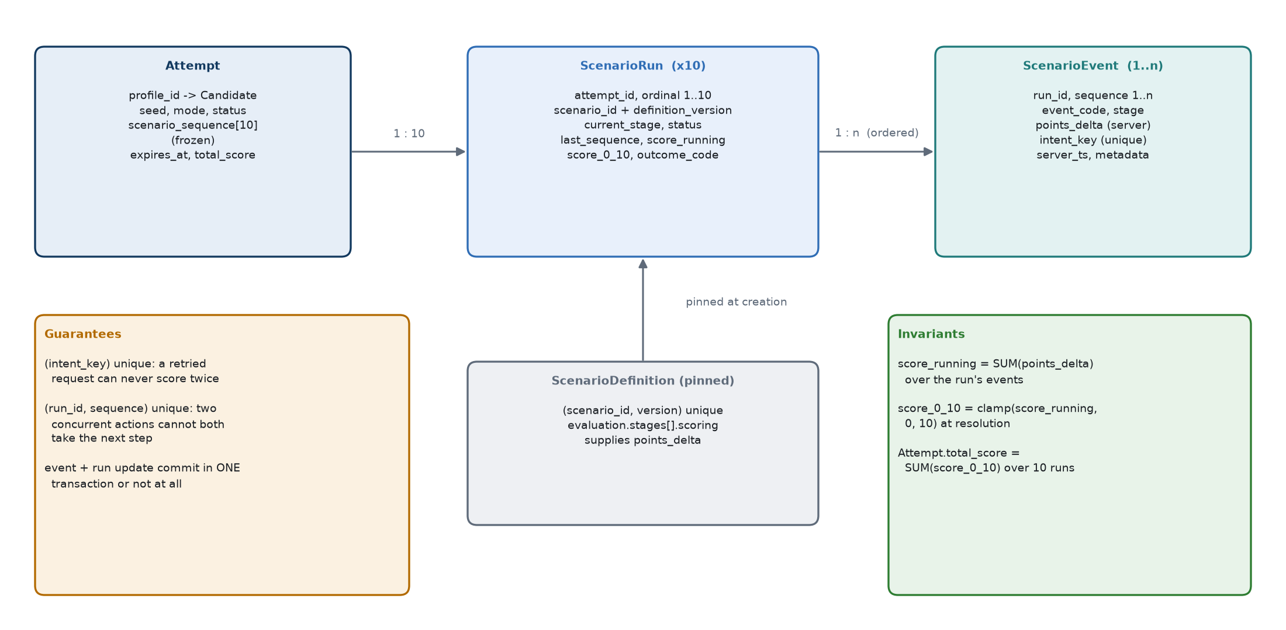
Figure 8. Attempt → ScenarioRun → ScenarioEvent and the ledger invariants
Field | Meaning
_id | event_id
run_id | The ScenarioRun (and therefore the attempt).
sequence | run.last_sequence + 1 - strictly increasing from 1 with no gaps; unique per run.
event_code | Server-decided (scoring code or telemetry code).
stage | The stage the run was in when the event was accepted.
points_delta | Server-decided from the pinned definition (-10..10).
synthetic_target_id | Optional asset id acted on; must belong to the scenario.
intent_key | Client-generated idempotency key (UUID) - globally unique. Expiry uses expiry:<attempt>:<run>; demo skip uses demo-skip:<attempt>:<run>.
client_ts / elapsed_ms | Browser telemetry only; never used for decisions.
server_ts | Authoritative timestamp (server clock).
metadata | Allowlist only: intent, transition (e.g. "branch->verify"), consequence, resolution_code, dwell_ms, open_latency_ms, link_hover_ms, verify_source, premature.

17.1 Guarantees
- Ordering: unique index (run_id, sequence). Two concurrent actions on one run cannot both claim the next sequence; the loser receives 409 STALE_STATE.
- Duplicate protection: unique index intent_key. A retried request replays the original outcome; a concurrent duplicate that loses the race is converted to the replay.
- Atomicity: the event insert and the run update commit together or not at all (withEngineTransaction, {w:1, j:true}).
- Replay protection: intent_key reused on another run → DUPLICATE_INTENT; action codes are bound to the run.
- Contribution to score: score_running = Σ points_delta; score_0_10 = clamp(Σ, 0, 10).

17.2 Later use of events
Consumer | Use
Result projection | Path replay (event codes → neutral labels), critical-event detection for outcome classes, review mistakes and omissions.
Admin attempt viewer / exports | Same path replay and classification, per scenario.
Admin dashboard | Only critical event codes of resolved runs (for outcome classification).
Integrity tools | recomputeScoreFromEvents, verifyRunIntegrity.

18. Scenario Completion Transaction
A scenario is completed by the resolve-stage action, sent to POST /api/attempts/:attemptId/runs/:runId/resolve. The same engine path as every other action is used, restricted to resolve intents.

18.1 Step by step
- Controller checks (resolveRun): forbidden fields; attempt ownership; assertAttemptLive (if the deadline has passed the attempt is finalised as expired and 409 ATTEMPT_EXPIRED is returned); attempt must be in_progress; run must belong to the attempt.
- Validate action: translateActionCode; the intent must be one of the five resolve intents, else 422 INVALID_ACTION; expected_stage must match.
- Validate rationale: optional, string, single line, no < or >, max 250 characters after trimming (422 INVALID_RATIONALE).
- Duplicate fast path: an existing intent_key returns the original outcome.
- Transaction begins: re-read the run; it must be active (resolved → RUN_NOT_ACTIVE); its stage must equal the expected stage (STALE_STATE).
- Decide: resolveIntent → RESOLVE_CORRECT or CONTRADICTORY_UNSAFE_FINAL with the scenario's declared points.
- Record event: ScenarioEvent.create with sequence last_sequence + 1, metadata {intent, transition: "resolve->resolve", resolution_code: <intent>}.
- Update run: last_sequence, score_running += points, status = resolved, score_0_10 = clamp(score_running), outcome_code = <intent>, resolved_at, optional rationale. Model validation requires score, resolved_at and outcome on a resolved run.
- Commit with {w:1, j:true}. Transient errors retry up to 3 times; domain errors abort immediately.
- Feedback release (feedbackRelease): reads the instructor's timing for the attempt mode. immediate → the scenario's authored feedback card is added to the response; on_completion (default) → feedback: null.
- Response: run state, score_visibility: "final", score_0_10, outcome_code, event summary (no code), view, feedback timing and the refreshed attempt state (progress resolved n/10, pointer to the next unresolved run).
- Next scenario: the learner presses "Continue to the next scenario"; the page calls GET current-run, which returns the lowest-ordinal run not yet resolved.
- Attempt completion: after ten, current-run returns run: null; the learner presses View results → POST /complete → completeAttempt checks exactly 10 runs all resolved (409 ATTEMPT_INCOMPLETE / SCENARIOS_OUTSTANDING otherwise), sums the scores and, in a transaction that re-reads the attempt under an in_progress guard, sets completed, completed_at, total_score, end_reason: learner_completed. The ProgressSnapshot is then rebuilt outside the transaction, and the full result is returned.
How inconsistent state is prevented
- The event and the run update are one transaction - there is never an event without its score effect, or a score without its event.
- Unique indexes make double-submission and concurrent submission safe.
- completeAttempt is idempotent: a repeated call returns the already-completed attempt. Its re-read under the guard means two concurrent completions cannot both transition.
- The attempt's sequence, seed, selection and deadline are frozen by a model hook.
- The result projection re-verifies that the stored total equals the sum of the ten scores before showing anything (500 RESULT_INTEGRITY otherwise).

19. Assessment Timer
Client Understanding
Each assessment has 90 minutes from the moment it starts. The countdown on screen is only a display; the real deadline is held by the server. Closing the browser, changing the computer clock or restarting the server does not add time. When time runs out, anything already earned is kept, unfinished scenarios score only what they had earned so far, and the result is saved automatically.

Technical Implementation
ASSESSMENT_TIME_LIMIT_MS = 90 min (constants/attemptTiming.js). Attempt.time_limit_ms and expires_at = started_at + time_limit_ms are written in the creation transaction and frozen by the model. Enforcement in services/attemptExpiryService.js has three layers.

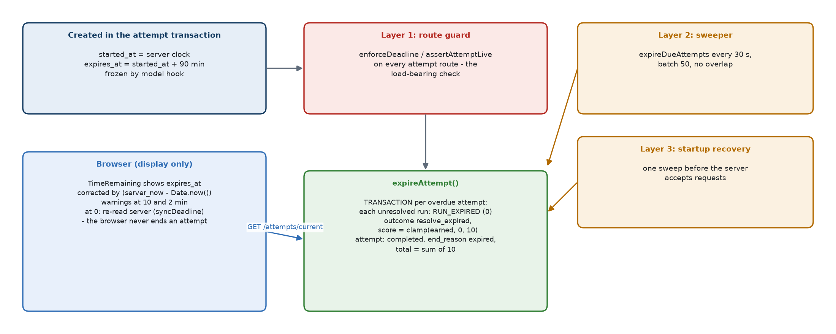
Figure 9. Deadline creation, the three enforcement layers and the display-only countdown
Topic | Current behaviour
Where the timer lives | On the Attempt document (expires_at). Not in the browser, not in memory.
How it starts | At attempt creation, from the server clock.
How it is derived for display | toCandidateJSON() publishes expires_at and server_now. TimeRemaining measures server_now - Date.now() once and counts down against the corrected clock (mm:ss or h:mm:ss). Warnings appear at 10 and 2 minutes remaining.
Expiry determination | isPastDeadline: expires_at <= now. An attempt with expires_at: null (created before the timer existed) never expires.
Layer 1 - route guard | enforceDeadline / assertAttemptLive run on start, current, get, current-run, events, resolve, demo-skip, complete and result. This is the load-bearing check.
Layer 2 - sweeper | Every 30 s, up to 50 overdue attempts, no overlapping sweeps, timer unref'd.
Layer 3 - startup recovery | One sweep before the server starts listening.
What expiry does | Transaction: for each unresolved run write RUN_EXPIRED (0 points, intent_key expiry:<a>:<r>), set run resolved, score_0_10 = clamp(score_running), outcome_code: resolve_expired; set attempt completed, completed_at = expired_at = now, end_reason: expired, unresolved_at_expiry = n, total_score = sum. Then rebuild the ProgressSnapshot.
Browser at zero | syncDeadline() re-reads GET /attempts/current. If the server agrees, the page shows "Time is up" with a link to the saved result; if the browser clock was fast, play continues.
Active vs expired on the dashboard | The dashboard offers Resume only when the server reports status: in_progress. After expiry it offers Start; the expired result is in past assessments. GET /attempts/current reports the most recent expired attempt when none is in progress so the simulation page can explain the timeout.

20. Interruption, Retry, Expiry and Recovery
All recovery follows one principle: the browser holds nothing authoritative, so any interruption is resolved by asking the server what is current.
Situation | Current behaviour
Browser refresh on /assessment | useAttemptController.resume() calls GET /attempts/current then GET current-run; the scenario re-renders at the committed stage. Scene beats are derived from the stage, so the conversation is rebuilt identically. Typed form values are discarded by design.
Session continuation | The signed cookie is valid up to 8 hours; GET /candidates/me restores the learner on reload.
Returning to the dashboard | Leaving the page does not pause anything. The dashboard shows Resume Assessment (with n of 10 completed) while the attempt is in progress.
Interrupted attempt | A run that is already past notify or has ledger entries, loaded without interaction in this tab, is shown as interrupted with a Resume control that re-reads the server. Delivery of a notification already seen is not repeated.
Expired attempt | Finalised by the guard, sweeper or startup sweep (Section 19). Actions after the deadline → 409 ATTEMPT_EXPIRED with result_available: true; the page shows the expired screen; GET /result always works.
Duplicate request / lost response | The same intent_key is reused for a retry of the same action, so the server replays the original result (duplicate: true) and scores once. A lost connection (NETWORK_ERROR) is recoverable: the learner can press the control again.
Replayed action from another run | 422 INVALID_ACTION (code bound to run) or DUPLICATE_INTENT (intent key from another run).
Wrong-stage action (stale tab) | 409 STALE_STATE; the reducer marks the view stale and reloads the run.
Wrong-run action | Run not in this attempt → 404; attempt not owned by the learner → 404 (not 403, to avoid confirming ids).
Server errors | Recoverable engine errors (stale, invalid action, network, etc.) stay on the scenario with an inline message; other errors replace the screen with a Retry that re-reads the server.
Starting after expiry | Pressing Start creates a new attempt; if the old one is still marked in progress but overdue, it is finalised first.
Server restart | No state is lost: attempts, runs and events are in MongoDB; the startup sweep finalises deadlines that passed while the server was down.
Instructor reset during play | The attempt becomes abandoned; further actions → 409 ATTEMPT_NOT_IN_PROGRESS; current-run returns run: null. The learner can start a new attempt.
Transaction failure | Transient MongoDB errors are retried up to 3 times; otherwise the whole transaction aborts and nothing is written. If MongoDB is not a replica set every authoritative write returns 503 TRANSACTION_UNAVAILABLE.

21. Demo User
Client Understanding
A special demonstration login lets a presenter show the product with a known, fixed set of ten scenarios and skip any scenario during the demonstration. It behaves like a normal assessment in every other respect, and it is deliberately kept out of the instructor's learner statistics. Ordinary learners cannot see or use the skip function.

Technical Implementation
Identity: config/demo.js. Recognition: demoSelectionService.isDemoCandidate(req.candidate) compares the session profile's identifierNormalised with the normalised DEMO_SERVICE_NUMBER. Demo attempts are recognised by selection.selection_algorithm_version === "demo-fixed-1.0.0".

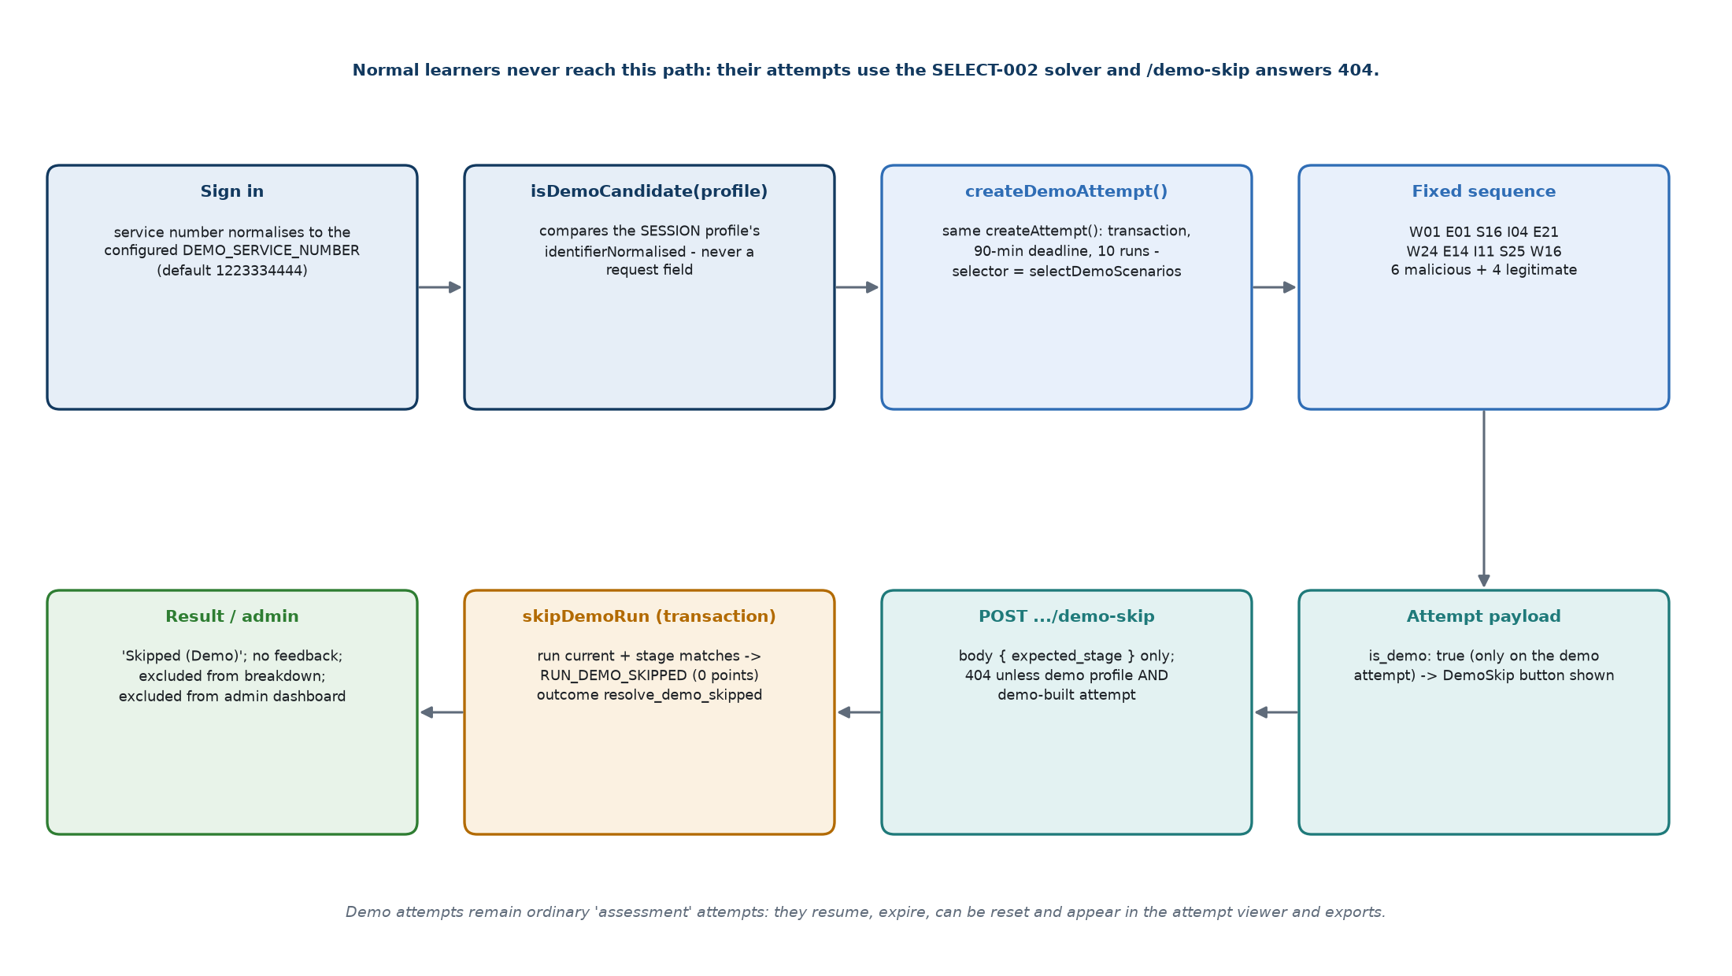
Figure 10. Demo User flow
Topic | Current implementation
Default demo name | "demo user" (DEMO_DISPLAY_NAME) - informational only; not used for recognition.
Default service number | 1223334444 (DEMO_SERVICE_NUMBER), compared in normalised form. Setting it to empty disables the demo entirely.
Profile creation | No seed script: the profile is created on first normal sign-in with that number.
Fixed sequence | W01, E01, S16, I04, E21, W24, E14, I11, S25, W16 (always this order).
Composition | 6 malicious (W01, E01, I04, W24, E14, S25) + 4 legitimate (S16, E21, I11, W16), verified against the bank's dispositions at every creation; any missing/inactive id or changed split → 409, no attempt.
Platforms | WhatsApp 3, Email 3, Instagram 2, SMS 2.
Difficulty | Easy 3 (W01, E01, I04), medium 4 (S16, E14, I11, W16), hard 3 (E21, W24, S25).
Military context | 3 (E14, I11, W16).
Differences from normal selection | No solver, no seed randomness (seed "demo-fixed-sequence"), no recent exclusion, no platform rotation. Same creation transaction, 90-minute deadline, ten runs, engine and scoring.
Demo Skip - UI | Shown only when the attempt payload carries is_demo: true (present only on a demo attempt). A confirm step, then POST /attempts/:a/runs/:r/demo-skip with body { expected_stage } only.
Demo Skip - server checks | Session profile must be the Demo User and the attempt demo-built (otherwise the same 404 as an unknown route); ownership; deadline; in progress; run belongs to attempt. In a transaction: run unresolved (RUN_NOT_ACTIVE), run is the current lowest-ordinal run (RUN_NOT_CURRENT), stage matches (STALE_STATE).
Skip event and scoring | One RUN_DEMO_SKIPPED event with 0 points (intent_key demo-skip:<a>:<r>, unique so a second skip cannot write twice). Run → resolved, outcome_code: resolve_demo_skipped, score_0_10 = clamp(points already earned, 0, 10) - normally 0.
Result behaviour | Outcome class demo_skipped ("Skipped (Demo)"), no feedback, a review card with no scenario content, excluded from the family/trigger/stage breakdown and remediation; summary.skipped count. Instructor screens classify it as not_resolved but label it "Skipped (Demo)".
Admin behaviour | Demo attempts appear in the attempt list, detail and exports like any attempt (identified by the demo learner's name and masked number). They are excluded from the admin dashboard only.
Dashboard exclusion | Two independent filters: profile id not the demo profile, and selection version not demo-fixed-1.0.0. The demo profile is also excluded from learner counts.
Security restrictions | Demo status is never read from the request. A normal learner gets 404 from /demo-skip; the demo profile cannot skip inside a non-demo attempt; the body is an allowlist of one field.

22. Result Generation
Client Understanding
After the tenth scenario the learner sees their score out of 100, how many threats they stopped or missed, how many genuine items they wrongly rejected, a step-by-step review of every scenario with what they should have done, a breakdown by app, attack type, persuasion technique and decision stage, a comparison with their previous comparable attempt, and two or three areas to practise.

Technical Implementation
attemptResultService.buildAttemptResult(attempt) - a pure read, recomputed on every request from Attempt, ScenarioRun, ScenarioEvent and the pinned ScenarioDefinitions. Returned by POST /complete and GET /result; rendered by ResultPage.

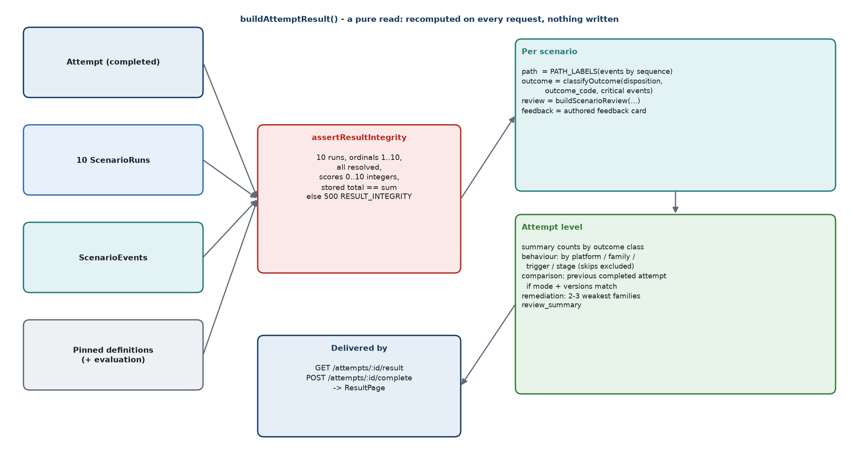
Figure 11. Result generation pipeline

22.1 Contents of the result
Block | How it is calculated
Header | attempt id, status, mode, total_score (verified sum), max_score 100, scenarios resolved/total, started/completed, end_reason, timed_out, time limit, unresolved_at_expiry.
summary | Counts per outcome class: handled_safely, missed_threats, false_positives, unsafe_handling, not_resolved (+ skipped for demo), and duration_ms = completed_at - started_at.
scenarios[10] | Per ordinal: platform, score_0_10, outcome_code, final stage, resolved_at, identity (scenario_ref, platform label, synthetic sender, notification preview - never the authoring title), outcome_class, path (neutral steps), feedback (authored card), review.
Outcome classification | classifyOutcome: expired or demo-skipped → not_resolved. Malicious: correct final action and no critical event → handled_safely, else missed_threat. Legitimate: wrong final action → false_positive; correct but with a critical event → unsafe_handling; otherwise handled_safely.
review (per scenario) | Status correct, mistake, not_resolved or skipped; headline; learning issue (missed threat / genuine item rejected / unsafe step); mistakes (commissions from ledger events, omissions where the scenario offered a safe-path step that was never earned); missed cues; what it was; correct action (from the stage's authored expected safe behaviour); why it mattered; safe response; your path vs correct path.
review_summary | correct decisions, scenarios with mistakes, not resolved, total mistakes, missed threats, false positives, unsafe handling, verification successes.
behaviour | Buckets by platform, canonical family, canonical trigger (a multi-trigger scenario counts in each) with scenarios, points, max points, missed threats, false positives; and by stage (inspect, branch, verify, resolve): scenarios reaching the stage and how many took the constructive action. Demo skips excluded.
comparison | The learner's most recent completed attempt before this one. Offered only if mode, content_version, taxonomy_version and trigger_taxonomy_version all match; returns previous total and delta. Otherwise no_previous_attempt or not_comparable (with field names).
remediation | Families where points < max, sorted by missed threats, then false positives, then points lost; only families with active scenarios; top 3, each with a blame-free reason and the number of active practice scenarios. Families only - never scenario ids.

22.2 What is live vs persisted
Persisted (written once) | Computed live on every result request
ScenarioRun.score_0_10, outcome_code, rationale; Attempt.total_score, end_reason, completed_at; the event ledger. | Integrity check, outcome classes, paths, reviews, summary counts, behaviour breakdown, comparison, remediation, feedback text (from the pinned definition).

22.3 Released vs withheld
For the ten finished scenarios the result releases the authored feedback, the stage-specific expected safe behaviour (inside mistake cards), family and trigger labels in aggregate, and the outcome class. It withholds event codes, point deltas, difficulty, the raw disposition enum, the authoring title, the learner's typed rationale and everything about the other 90 scenarios. The typed rationale is stored on the run but shown to nobody.

22.4 Frontend result page
ResultPage renders ResultSummary (score, outcome mix, comparison, "exposure count" from the progress snapshot), AssessmentReview (review summary), BehaviourBreakdown, RemediationList and a ScenarioResultCard / ScenarioReview per scenario. It computes nothing; a field the server omits is not shown. Past results are reached from /history (GET /api/attempts).

23. Result and Score Source of Truth
Value | Authoritative source | Derived / cached? | When (re)calculated
Points for one action | The pinned ScenarioDefinition's evaluation.stages[].scoring[].points_delta | Copied into the event | At acceptance, inside the transaction
How a scenario score was reached | ScenarioEvent ledger | Source | Never rewritten
Running scenario score | ScenarioRun.score_running | Cache of Σ ledger (verifiable by verifyRunIntegrity) | Every accepted event
Scenario score (0-10) | ScenarioRun.score_0_10 | Persisted once = clamp(score_running) | At resolution / expiry / demo skip
Attempt total (0-100) | Attempt.total_score | Persisted once = Σ score_0_10; re-verified on every result read | At completion or expiry
Outcome class, review, breakdowns, comparison, remediation | Computed | Derived, not stored | Every result / viewer / export request
Progress (last/best score, per-platform/family points) | ProgressSnapshot | Derived, rebuildable, never read back to decide a score | After completion/expiry; on read if the completed-attempt count changed
Dashboard figures | Computed from attempts, runs, events, definitions | Derived | Every dashboard request

How score manipulation is prevented
- The client cannot send points, scores, event codes, stages, sequences, outcomes, deadlines or intents - such fields are rejected, not ignored.
- Actions are opaque per-run HMAC codes; the meaning and value of each is known only to the server.
- Points come from the stored scenario definition, not from code constants or the request.
- Every scoring write is transactional and idempotent; unique indexes block duplicates.
- Totals are sums of stored scenario scores and are re-verified before any result is shown.
- The sequence, seed and deadline of an attempt are frozen by the model.

24. Admin Architecture
Client Understanding
Instructors have a separate, password-protected area. They can see overall statistics, browse and inspect every attempt, export reports, manage scenario versions, reset an unfinished attempt, archive a learner, choose when learners see feedback, and read a tamper-resistant log of every administrative change.

Technical Implementation
Frontend branch /admin/* guarded by RequireAdmin and wrapped in AdminLayout (navigation: Dashboard, Scenarios, Attempts, Settings, Audit). Backend namespace /api/admin/*: POST /login throttled; every other route requireAdmin. Each administrative change appends an AuditEvent in the same transaction.

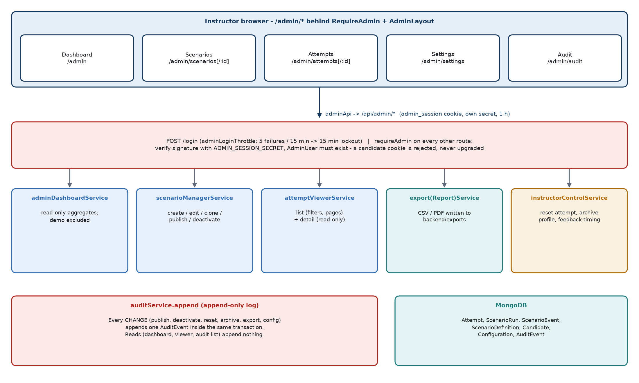
Figure 12. Admin architecture
Area | Screen | API | Behaviour
Authentication | /admin/login | POST /admin/login, POST /admin/logout, GET /admin/me | Argon2id, throttle 5/15 min, 1-hour cookie with its own secret.
Dashboard | /admin | GET /admin/dashboard | Read-only aggregates (Section 25).
Attempts | /admin/attempts, /admin/attempts/:id | GET /admin/attempts, GET /admin/attempts/:id, GET /admin/learners | Read-only list and detail (Section 26).
Attempt controls | Attempt detail page | POST /admin/attempts/:id/reset, POST /admin/learners/:profileId/archive | Reset: only in_progress → abandoned (unresolved runs → abandoned), reason code from a closed list, audited ATTEMPT_RESET. Archive: sets archived flags, audited PROFILE_ARCHIVED; no delete, no unarchive.
Exports | Attempt detail (export panel) | POST /admin/exports/attempts/:id, POST /admin/exports/learners/:profileId, GET /admin/exports/:filename | CSV/PDF files (Section 27).
Scenarios | /admin/scenarios, /admin/scenarios/:id | GET/POST /admin/scenarios, GET /admin/scenarios/:id, GET/PATCH …/versions/:v, POST …/clone, …/publish, …/deactivate | Versioned lifecycle draft → published → retired. Only drafts are editable; editing a published version creates the next draft. Publishing validates all six stages, asset references and simulation safety - validateOfflineSafety / validateSyntheticSafety: reserved test domains only, no data URIs, inert assets - retires the previously active version, audits SCENARIO_PUBLISHED. Deactivation audits SCENARIO_DEACTIVATED. Runs stay pinned to the version they started on.
Settings | /admin/settings | GET/PATCH /admin/config/feedback | Two enums: training_feedback_timing, assessment_feedback_timing ∈ {immediate, on_completion}, default on_completion. Optimistic concurrency via expected_config_version; audited CONFIG_CHANGED per changed key.
Audit | /admin/audit | GET /admin/audit | Newest first; filters action, resource type/id, actor, from/to; page size default 50, max 200 (UI uses 10). Append-only.

Page size
The admin UI requests 10 rows per page on the attempts, scenarios and audit lists (ADMIN_PAGE_SIZE = 10). The API default is 25 (attempts, scenarios) or 50 (audit); the API maximum is 100 (200 for audit).

24.1 Admin request flow
- Admin page calls a function in adminApi (body built field by field).
- requireAdmin verifies the admin_session signature with ADMIN_SESSION_SECRET and loads the AdminUser (401 NO_ADMIN_SESSION otherwise). A learner cookie never satisfies it.
- The controller passes the raw query/body to a service that validates against allowlists (unknown filter → 422 FORBIDDEN_FILTER; values must be plain strings, so ?x[$ne]=… is refused).
- Read services project allowlisted fields; change services run a transaction and call auditService.append inside it.

24.2 Audit log
AuditEvent records who (admin id + username at the time), what (action ∈ SCENARIO_PUBLISHED, SCENARIO_DEACTIVATED, SCENARIO_RESET, ATTEMPT_RESET, PROFILE_ARCHIVED, EXPORT_CREATED, CONFIG_CHANGED), on which resource, succeeded/failed, an error code, allowlisted metadata (keys containing words like password, token, secret, card, rationale, message, content are rejected), an optional idempotency key (unique) and occurred_at. Append-only is enforced by immutable fields, a pre-save hook that rejects updates, hooks that throw on every update/replace/delete query, and the absence of any mutating route. Reads are not logged.

25. Admin Dashboard
Client Understanding
The dashboard summarises how learners are doing across all completed assessments: how many learners and attempts there are, how scores are distributed, which app learners handle best and worst, how often attacks succeed, how often genuine messages are wrongly rejected, and recent activity. The Demo User is excluded so demonstrations do not distort the figures.

Technical Implementation
GET /api/admin/dashboard (no parameters accepted) → adminDashboardService.buildDashboard(). Seven bounded reads, then pure aggregation (aggregateDashboard). Outcome classes come from the same classifyOutcome() used by the learner result, so both always agree.

25.1 Scope
- Attempts with mode: assessment only (training attempts are outside the figures).
- Demo excluded: attempts whose profile_id is the demo profile, and attempts with selection version demo-fixed-1.0.0; the demo profile is excluded from learner counts.
- Score and outcome figures use completed attempts (learner-completed and expired) and their resolved runs. Attempt counts include all statuses.
- Nothing identifying is returned: no names, service numbers, profile/attempt ids, scenario ids, event codes or rationales.

25.2 Metrics
Metric (response key) | Calculation
learners.total / archived | Count of Candidate documents (excluding demo) / with archived: true.
learners.with_any_attempt | Distinct profile_id among in-scope attempts.
learners.with_completed_attempt | Number of learners with at least one completed attempt.
attempts.total / by_status | Count by status (in_progress, completed, abandoned).
attempts.completion_rate | completed / total (numerator, denominator and rate 0-1, 4 decimals).
attempts.completed_end_reasons | Completed attempts split into learner_completed and expired.
scores.attempts | count, mean (1 decimal), median, min, max of total_score over completed attempts.
scores.attempt_bands | Ten bands 0-9 … 80-89, 90-100 over completed attempts.
scores.learners_latest / learner_bands | Same statistics over each learner's most recently completed attempt.
platforms[] | Per platform (all four always present): scenarios, points, max points, average score, score_rate = points / max, outcome counts, attack_success_rate = missed_threat / malicious decided, safe_handling_rate = handled_safely / decided, false_positive_rate = false_positive / legitimate decided. "Decided" excludes not_resolved runs.
extremes | Highest/lowest platform for attack success rate and score rate (only if >= 2 platforms have data; ties reported together).
scenarios | classified runs, unclassified runs (definition missing), outcome totals.
activity.completions_by_day | Completions per UTC day for the last 14 days.

25.3 Frontend rendering
AdminDashboardPage renders the payload with plain HTML/CSS chart components (DashboardCharts.jsx: rate bars, column charts, stacked strips, legends) - no chart library. Sections: key figures, platform risk summary (highest/lowest malicious success, strongest/weakest by score), platform performance, score distribution, outcome mix by platform, assessment completion, completions over the last 14 days, and a "platform detail" table with every figure and its counts. Empty states are shown until data exists. The dashboard is not paginated.

26. Admin Attempt Viewer

26.1 List - GET /api/admin/attempts
Feature | Detail
Filters | profile_id (valid ObjectId), service_no (normalised, exact match via the profile), status (in_progress/completed/abandoned), mode, started_from, started_to (YYYY-MM-DD or ISO instant; a date as upper bound means end of that UTC day; range <= 366 days). Any other key → 422.
Learner lookup | GET /api/admin/learners?display_name=…|service_no=… - anchored, escaped prefix match (2-60 chars), max 50 results, returns profile id, name and masked number only.
Order and paging | Newest started first, _id tie-break; page, page_size (UI 10, API default 25, max 100). Returns total and total_pages.
Row content | attempt id, learner (profile id, name, masked number), mode, status, started/completed, duration taken, end reason, timed_out, time limit, unresolved at expiry, total_score (only when completed), resolved/total runs, content version, result_available.

26.2 Detail - GET /api/admin/attempts/:attemptId
Attempt state | What the instructor sees
Completed | Built from the learner's own buildAttemptResult() (same score and classes) plus instructor-only classification per scenario: difficulty (level), military_flag, disposition, family label, trigger labels. Per scenario: score, outcome class, final action (outcome_code), sender/preview, duration, path replay, feedback card. Summary, platform coverage, behaviour breakdown (scope complete), remediation, comparison.
In progress / abandoned | total_score null; resolved_points shown separately; resolved scenarios classified; unresolved scenarios listed as pending (stage, no score, no disposition, no feedback); behaviour marked partial; remediation and comparison unavailable (attempt_not_complete).

Header also shows profile (with created and last-seen dates), content and taxonomy versions, and duration. Demo attempts are listed like any other and identified by the demo learner's name and masked number; skipped scenarios display "Skipped (Demo)". The seed and selection metadata are never shown. The typed rationale is never shown. The detail page hosts the attempt controls (reset / archive) and the export panel.

27. Export System
Client Understanding
Instructors can produce a report for one attempt, or for all completed attempts of one learner, as CSV (for spreadsheets) or PDF (for printing). Every report is clearly marked as training data, synthetic and versioned. The server writes the file into its export folder, and the instructor downloads a copy through the browser from the attempt page.

Technical Implementation
exportService + exportReportService. Formats: csv, pdf only (no XLSX). Scopes: attempt, learner. Body: { format, idempotency_key? } only; any path/filename field is rejected (422). Files are written on the server to env.exportDir (default backend/exports) - never to a client-chosen path - named training-attempt|learner-<24 hex>-<YYYYMMDDTHHMMSSZ>-<8 hex>.<ext>.

27.1 Generation process
- Validate body; replay if the idempotency key was already used for the same operation (200, no second file or audit entry).
- Require transaction support.
- Build the report model in memory from getAttemptForAdmin() (the admin viewer projection) - learner scope: every completed attempt of the profile (max 100); none → 409 NO_COMPLETED_ATTEMPTS.
- Render CSV (sectioned #SECTION blocks, BOM, CRLF, formula-neutralised text) or PDF (A4 Courier, header on every page, "Page n of N").
- Write to <exportDir>/.pending/<name>.part, verify size (max 8 MB).
- Append EXPORT_CREATED audit entry in a transaction; on failure delete the part file.
- Rename into place; return artifact id, filename, bytes, generated time, scope, content version, content_is_current, markers and location (201).
- The UI can fetch the bytes with GET /api/admin/exports/:filename (strict filename pattern, Content-Disposition: attachment, nosniff); reading is not audited.

27.2 Content
Section | Fields
REPORT | product, title, TRAINING SIMULATION, OFFLINE, synthetic-data notice, report schema version, format, generated at/by, content version, current content version, whether current, taxonomy versions.
ATTEMPT | attempt id, learner display name, masked service number, profile id, mode, status, started/completed, duration, scenarios total/resolved, total score (null unless completed), resolved points.
SUMMARY | total, handled safely, missed threats, false positives, unsafe handling, duration.
BEHAVIOUR | by platform, family, trigger, stage (+ scope).
SCENARIOS | ordinal, scenario ref, platform, resolved, status, score, max, outcome class, disposition, level, military flag, family, triggers, final stage, duration, resolved at, sender, preview, path replay, feedback (result, cues, safe action, impact, habit). Unfinished scenarios carry no score, disposition or feedback.
REMEDIATION / COMPARISON | As in the result.

Authorisation and demo handling
All export routes require an admin session; there is no learner export. Demo attempts can be exported like any other attempt (they are only excluded from the dashboard).

Current implementation behaviour - report wording
The report text is fixed in backend/src/constants/export.js and still reflects the earlier offline deployment context: every report carries the network marker "OFFLINE", the notice ends "This report was produced offline on the local training machine", and the PDF producer field reads "… (offline)". In the hosted deployment the report is produced on the application server and downloaded through the browser. The admin export panel descriptions likewise say "An offline report, written on this machine" (AttemptExportPanel.jsx).

28. Database Architecture
MongoDB database named in MONGO_URI: cyber_awareness_training is the development default and cyber_awareness_training_release is the release database built by MIGRATION-001. Eleven collections exist; nine are used by the current application and two belong to the legacy quiz.
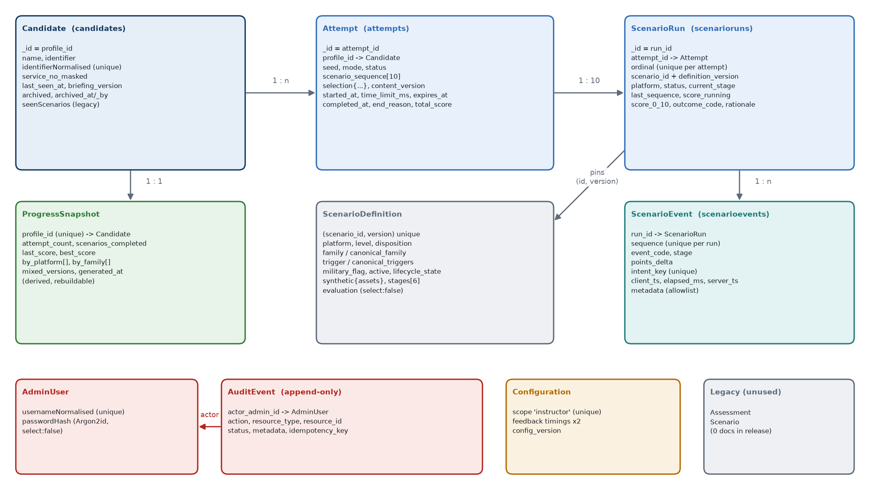
Figure 13. Collections and relationships
Collection (model) | Purpose | Indexes / unique constraints | Created by | Updated by | Read by
candidates (Candidate) | Learner profiles | identifierNormalised unique; archived | Sign-in | Sign-in, /me (last seen), briefing, archive | Session guard, viewer, dashboard, exports
attempts (Attempt) | One assessment of 10 | profile_id; (profile_id,status); (profile_id,started_at -1); (started_at -1,_id -1); (status,expires_at) | createAttempt | complete, expire, reset (sequence/seed/deadline frozen) | All learner routes, results, viewer, dashboard, progress
scenarioruns (ScenarioRun) | One scenario inside an attempt | (attempt_id,ordinal) unique; (attempt_id,status); (scenario_id,definition_version); status | createAttempt (10 at once) | Engine, expiry, demo skip, reset | current-run, results, viewer, dashboard, history
scenarioevents (ScenarioEvent) | Event ledger | intent_key unique; (run_id,sequence) unique | Engine, expiry, demo skip | Never | Results, viewer, dashboard, integrity
scenariodefinitions (ScenarioDefinition) | Scenario bank | (scenario_id,version) unique; (active,platform,level); (active,disposition); (active,canonical_family); (active,canonical_triggers); (active,military_flag) | Importer, scenario manager | Scenario manager (drafts, lifecycle) | Selection, engine, current-run, results, viewer
progresssnapshots (ProgressSnapshot) | Derived learner progress | profile_id unique | First read or completion (upsert) | Rebuilt by recomputation | GET /progress
adminusers (AdminUser) | Administrator accounts | usernameNormalised unique | admin:create script only | Never via HTTP | Admin login, requireAdmin
auditevents (AuditEvent) | Append-only admin log | occurred_at (both directions); (resource_type,resource_id,occurred_at); actor_admin_id; action; resource_type; idempotency_key unique (partial) | Admin changes | Never (hooks throw) | Audit page, export/controls idempotency
configurations (Configuration) | Feedback timing singleton | scope unique (single value) | First read/update | Settings PATCH | Settings, resolve path
assessments, scenarios (legacy) | Old 40-scenario quiz | As declared | Legacy routes | Legacy routes | Legacy page; 0 documents in the release DB

Release database state
Per backend/deploy/migration-001/cyber_awareness_training_release.validation.json (validated 22 Sep 2026, 12/12 PASS): 100 scenario definitions (all active, version 1) and every other collection empty; 45 indexes exactly as the models declare; no legacy scenario selectable. This document does not modify or clean any database.

29. Database Transactions and Consistency
Mechanism | Current implementation
Replica-set requirement | Multi-document transactions need a replica set. assertTransactionSupport() probes hello; a standalone server makes every authoritative write fail with 503 (TRANSACTION_UNAVAILABLE / SELECTION_TRANSACTION_UNAVAILABLE) instead of degrading. npm run verify:replicaset checks the deployment. The documented setup (docs/LOCAL_MONGODB_REPLICA_SET.md, written for the development machine) is a single-node set rs0 with ?replicaSet=rs0 in the URI; any replica-set deployment satisfies the check.
Transaction helper | withEngineTransaction: session per call; readConcern: local; write concern {w:1, j:true} (journaled); up to 3 attempts with 25/50 ms backoff only for TransientTransactionError / UnknownTransactionCommitResult; domain errors abort immediately.
Transactions used | Attempt + 10 runs creation; each learner action (event + run); completion (attempt); expiry (events + runs + attempt); demo skip (event + run); reset (runs + attempt + audit); archive (profile + audit); config change (config + audit); scenario publish/deactivate (definitions + audit); export (audit, with file write ordered around it).
Deliberately outside transactions | ProgressSnapshot rebuild (derived, idempotent recomputation - its failure is logged and never undoes a completion); export file write/rename (filesystem is not transactional; part-file deleted if the audit fails).
Uniqueness / duplicate prevention | intent_key (idempotency), (run_id,sequence) (ordering), (attempt_id,ordinal) (one run per slot), (scenario_id,version), identifierNormalised, usernameNormalised, audit idempotency_key, configuration scope, progress profile_id.
Concurrency | Guards are re-read inside transactions: completion (status: in_progress), expiry (in_progress and overdue), reset (in_progress), demo skip (run unresolved + current + stage), publish (still draft). A second concurrent request finds nothing to change. An in-progress check prevents two open attempts per learner (not a unique index; a check before creation).
Score consistency | score_running always equals Σ ledger points; score_0_10 = clamp; total_score = Σ score_0_10, re-verified by assertResultIntegrity.

30. API Architecture
All routes are under /api. Responses are JSON; errors are { error: { code, message, details } }. "Learner" = signed candidate_session cookie required (requireCandidate); "Admin" = admin_session required (requireAdmin). Full reference in Appendix B.

30.1 Authentication and learner profile
Method & route | Auth | Request | Response / notable errors
POST /candidates | none | { name, identifier } | 201/200 { candidate, created } + cookie. 422 MISSING_FIELDS / VALIDATION_ERROR; 403 PROFILE_ARCHIVED.
GET /candidates/me | Learner | - | { candidate } (touches last_seen_at, throttled). 401 NO_SESSION / PROFILE_ARCHIVED.
POST /candidates/me/briefing | Learner | { version } | { candidate }. 422 BRIEFING_VERSION_MISMATCH.
POST /candidates/logout | none | - | { ok: true }, cookie cleared.
GET /progress | Learner | - | { progress } (own snapshot, rebuilt if stale).

30.2 Attempts, scenario runs and actions
Method & route | Controller → service | Request | Response / notable errors
POST /attempts | startAttempt → createAttempt / createDemoAttempt | (optional { mode }) | 201 { attempt, created:true } or 200 existing. 409 SELECTION_ATTEMPT_IN_PROGRESS / UNSATISFIABLE / POOL_INSUFFICIENT; 503 transactions; 422 FORBIDDEN_FIELD.
GET /attempts | listCompletedAttempts | - | { attempts[] } completed, newest first.
GET /attempts/current | getCurrentAttempt | - | { attempt | null, expired? } - in progress, else most recent expired.
GET /attempts/:id | getAttempt | - | { attempt } (deadline enforced). 404 not owned.
GET /attempts/:id/current-run | getCurrentRun → runPayloadFor | - | { run, scenario, actions, attempt } or run: null when none left / not in progress.
POST /attempts/:id/runs/:runId/events | submitRunEvent → translateActionCode → submitIntent | { action_code, intent_key, expected_stage, synthetic_target_id?, metadata?, client_ts?, elapsed_ms? } | { run, event{sequence,stage,accepted_at}, consequence, view, score_visibility, duplicate?, attempt }. 422 INVALID_ACTION/FORBIDDEN_FIELD/INVALID_TARGET/INVALID_METADATA; 409 STALE_STATE/RUN_NOT_ACTIVE/ATTEMPT_EXPIRED/ATTEMPT_NOT_IN_PROGRESS; 404.
POST /attempts/:id/runs/:runId/resolve | resolveRun (resolve intents only) | { action_code, intent_key, rationale?, expected_stage } | As above + score_0_10, outcome_code, feedback_timing, feedback. 422 INVALID_RATIONALE.
POST /attempts/:id/runs/:runId/demo-skip | skipDemoScenario → skipDemoRun | { expected_stage } | { skipped: true, attempt }. 404 for non-demo; 409 RUN_NOT_ACTIVE/RUN_NOT_CURRENT/STALE_STATE.
POST /attempts/:id/complete | finishAttempt → completeAttempt | - | { attempt, result }. 409 SCENARIOS_OUTSTANDING/ATTEMPT_INCOMPLETE/ATTEMPT_EXPIRED.
GET /attempts/:id/result | getAttemptResult → buildAttemptResult | - | { result }. 409 ATTEMPT_NOT_COMPLETE; 500 RESULT_INTEGRITY.

30.3 Admin
Login/logout/me, dashboard, attempts (list, detail, reset), learners (lookup, archive), exports (create attempt/learner, read file), scenarios (list, create, read, versions, edit, clone, publish, deactivate), config/feedback (read, update) and audit (read). See Section 24 and Appendix B.

30.4 Other
- GET /api/health - {status, uptimeSeconds, database}; 200 when MongoDB is connected, 503 otherwise.
- GET /api/scenarios/summary - counts of the legacy scenario pool (not the 100-scenario bank).
- /api/assessments/* - legacy quiz endpoints (start, history, active, get, answers, complete) behind requireCandidate.
- Unknown route → 404 NOT_FOUND.

31. Frontend Workflow
Phase | What happens
Bootstrap | main.jsx renders <App> in StrictMode; App = BrowserRouter → CandidateProvider → AppRoutes. Tailwind styles from styles/index.css. VITE_API_BASE_URL (compiled into the build; default /api = same origin as the frontend) sets the API base URL the browser calls.
Authentication state | CandidateProvider calls GET /candidates/me on mount; distinguishes "no session" (401 → show form) from "cannot reach the record store" (status 0/5xx → Retry panel).
Routing and guards | Learner screens behind RequireCandidate; admin screens behind RequireAdmin + AdminLayout; / → /login; unknown → NotFound.
Dashboard | Welcome, assessment card (status, n of 10, progress bar, Start/Resume), progress line (attempts, last and best score), "View your past assessments", a panel describing the four apps.
Simulation | SimulationPage + useAttemptController: resume → current run → render phone at the committed stage → submit action → re-render from the committed response → outcome card → next scenario → completion gateway → /result/:id.
Timer | AttemptHeader / TimeRemaining show the corrected countdown and warnings; at zero the page re-reads the server.
Progress | "Scenario n of 10" and a segmented progress bar from attempt.progress; a stage strip from run.current_stage.
Feedback | End of each scenario: "Scenario n recorded" + the final action; the authored feedback card only when the instructor set immediate; points only in training mode. Full review on the result page.
Results / history | ResultPage (read-only projection); HistoryPage lists completed attempts.
Support panels | Rules, Report a simulation issue (explanatory, not scored, sends nothing), Accessibility (keyboard, screen reader, zoom, reduced motion), Restart (explains that only an instructor can release an attempt), History, Logout (confirm; does not end the attempt).
API communication | Only through services/*Api.js → apiClient. Credentials always included. No tokens or state in local/session storage.
Error states | Session expired (401) → login. Recoverable action errors → inline message, stay on scenario. STALE_STATE → auto-resync + notice. ATTEMPT_EXPIRED → expired screen. Fatal → error card with Retry.
Admin application | Separate navigation; each page loads its data through adminApi with abort-on-unmount; lists paged 10 per page.

31.1 Assessment screen phases
Phase (attemptMachine) | Meaning
loading | Reading the attempt / current run.
no_attempt | No attempt in progress - the dashboard, not this page, starts one.
ready | A run is shown (or the completion gateway when run is null).
submitting | One action in flight; only that control shows busy.
completing | POST /complete in flight.
completed | Attempt completed → link to result.
expired | Server reported the deadline passed → "Time is up" and link to the saved result.
error | Fatal error card with Retry.

32. Frontend Scenario Rendering
How one database scenario becomes the visible simulated app:
ScenarioDefinition (MongoDB) | Pinned by the run: (scenario_id, definition_version).
↓
toCandidateJSON() + actionCodesForRun() | Allowlisted synthetic content and stages + opaque action codes per neutral control.
↓
GET current-run → attemptMachine RUN_LOADED | state.run, state.scenario, state.actionCodes.
↓
sceneRegistry.sceneFor(scenario) | The scenario's scene pack builds beats, surfaces and per-stage affordances from the synthetic assets.
↓
PhoneShell | Stage notify → phone home screen (tiles, badge, toast tray). Other stages → the platform app.
↓
WhatsAppScene / InstagramScene / EmailScene / SmsScene | Draw the thread as it stands at the committed stage (beatsAt(stage)), the header, composer and menus.
↓
affordancesFor(scene, stage) | Only the current stage's scored controls are drawn, in their slots; navigate() controls allow free local exploration.
↓
Learner taps a scored control | submit({ id, targetId }) → action code for that id.
↓
API → server validation → event → score → next stage | Engine transaction (Sections 14, 16).
↓
SUBMIT_OK | Re-render at the new stage; an affordance's opens/thenPage/closes is applied only after acceptance; any engine consequence opens the matching inert surface.

Fallback path
If sceneFor() returned null, the page would fall back to the generic platform renderer plus the generic action sheet (constants/simulation.js, controls gen-c01…gen-c37, filtered by the scenario's assets). All 100 current scenarios have a scene pack, so the fallback is not used by the current bank; the notification controls on the home screen always use gen-c01 (open) and gen-c02 (dismiss).

33. Platform Architecture
All four platforms share one architecture: a scene pack per scenario (data), a platform app component (drawing), a common set of inert surfaces, the same slot system for controls, and the same engine path for every scored action. They differ in chrome and in which screens hold the evidence.
Platform | UI representation | Evidence screens and platform-specific interactions | Components
WhatsApp (W01-W25) | Chat list, chat thread with bubbles, ticks and timestamps, composer with authored quick replies, header menu. | Contact info (number, groups in common, since when), group info, links opening the simulated in-app browser, attachments in a viewer, QR decode, simulated calls, payment sheet with PIN step, account settings / linked devices, device package installer, location share sheet. | whatsapp/WhatsAppScene.jsx, ChatBlocks.jsx, AttachmentTile.jsx
Instagram (I01-I25) | Feed/post, DMs, stories, profile with grid and counts. | Social pages: profile, "About this account" history, follower/following lists, single post with comments, story, in-app search, settings; comments and DMs as composer actions. | instagram/InstagramScene.jsx, IgBlocks.jsx, surfaces/SocialSurface.jsx
Email (E01-E25) | Inbox list, message view with sender, subject, body, buttons and attachments. | Mail pages: expanded details (From, Reply-To, authentication summary, real link targets), "Show original", other folders, older messages, attachment preview; reply/forward compose sheets. | email/EmailScene.jsx, MailBlocks.jsx, surfaces/MailSurface.jsx
SMS (S01-S25) | Messages app thread list and conversation. | Conversation details: real sending number, registered sender header vs ordinary mobile, contact status, receiving SIM, shortened-link expansion, other threads from the same sender. | sms/SmsScene.jsx, SmsBubbles.jsx, surfaces/SmsSurface.jsx

Shared surfaces (components/simulation/surfaces): BrowserSurface (simulated browser: authored page graph with a read-only address bar), CallSurface (ringing/connected/ended with captions and timer), ViewerSurface (file/photo/QR viewer), PaySheetSurface (summary, synthetic PIN, confirm), InstallerSurface (unknown-sources block, install and permission prompts), DetailSurface, AppSurface (another app on the device), SceneForm (form fields whose values never leave the component). Trusted Directory is a separate overlay.

34. Security Architecture
Control | Current implementation
Network exposure | The API listens on HOST:PORT (code defaults 127.0.0.1:5000, set per deployment) and serves only /api; CORS allows exactly one configured origin with credentials; JSON bodies are limited to 1 MB. The repository contains no transport/TLS or proxy configuration - that belongs to the hosting environment.
Learner authentication | Name + service number (no password, by design). Signed httpOnly cookie; signature prevents pointing the cookie at another profile. Archived profiles blocked at sign-in and on every request.
Admin authentication | Argon2id (64 MiB, t=3) with constant-time compare, decoy hash for unknown users, generic error, login throttle, separate cookie and secret (server refuses to start if missing or equal to the learner secret), 1-hour lifetime. No route creates admins.
Authorisation | Ownership from the session only; other learners' attempts/runs return 404. Admin routes all require requireAdmin; a learner cookie is never upgraded.
Neutral action contract | HMAC action codes per run; intents never on the client; check:bundle scan; neutralised error messages.
Server-side validation | Forbidden-field rejection on learner routes; engine rejects authoritative fields; metadata/rationale validation; admin allowlists and strict filter parsing (no operator injection); export body allowlist with path-shaped fields refused.
Cross-run / wrong-stage / replay protection | Run-bound codes, expected-stage check inside the transaction, unique intent_key, unique (run_id, sequence).
Answer confidentiality | evaluation is select:false and every learner projection is an allowlist; titles, classification and scoring never reach the learner; narration that could state the verdict is stripped.
Database constraints | Unique indexes (Section 29); model hooks freezing sequence/seed/deadline; append-only audit log.
Input validation | Schema lengths and enums; login field rules in the browser; rationale single line without markup, <= 250 chars; body size 1 MB.
Simulation boundary | Synthetic, inert simulated services only; reserved test domains enforced at import and publication; no outbound requests (Section 35).
Exports | Admin only; server-chosen directory and filename; strict filename on read; CSV formula neutralisation; PDF without external resources; audited.
Secrets and environment | backend/.env holds SESSION_SECRET, ADMIN_SESSION_SECRET, optional LEARNER_ACTION_SECRET, MONGO_URI etc.; .env.example documents them without real values; .env is git-ignored. Secret values are not reproduced in this document.
Privacy | Profile stores name and number only; learners and instructors see masked numbers; event metadata is allowlisted; the learner's typed rationale is stored but never displayed; audit metadata rejects sensitive-looking keys.
Security-related tests | Learner action tests (tampered, cross-run, wrong stage, replay), admin throttle and session tests, forbidden-field tests, projection tests (no classification leaks), audit immutability, export path refusal, neutrality checks on the frontend, bundle scan script.

Current implementation behaviour
- The learner session is a stateless signed cookie; logout clears it in the browser, and there is no server-side revocation list (archiving a profile is the server-side way to stop access).
- Admin login throttling is held in the memory of the single API process and resets when the process restarts; the key is the client address as Express sees it (req.ip).
- Session cookies carry the secure flag only when NODE_ENV=production; with that flag browsers send them only over HTTPS, so a hosted production deployment is expected to run with NODE_ENV=production behind HTTPS.

35. Online Connectivity vs Simulated Services
Client Understanding
Two different things are easy to confuse. The application itself is online: people reach it through a web browser over the network, and every scored decision travels to the central server and is saved in its database. The communication inside the scenarios is simulated: the WhatsApp chat, Instagram profile, email inbox and SMS thread on the learner's screen are drawn by the application from invented content. Nothing a learner does inside a scenario reaches a real person, company, website, phone number, bank or messaging service.

Technical Implementation
Real network traffic is limited to browser ↔ frontend static files, browser ↔ /api (JSON over HTTP with session cookies) and API ↔ MongoDB. Every simulated channel, link, file, QR code, call, payment, install and directory lookup is rendered from the pinned ScenarioDefinition's synthetic.assets and the frontend scene packs; rendered simulation screens contain no link (a[href]), <form>, iframe, embed, object or media element and no src of any kind (asserted stage by stage and surface by surface on every authored scene by SceneContainment.test.jsx), and the only fetch calls in the frontend are in services/apiClient.js and adminApi.downloadExportArtifact, both to the application API.

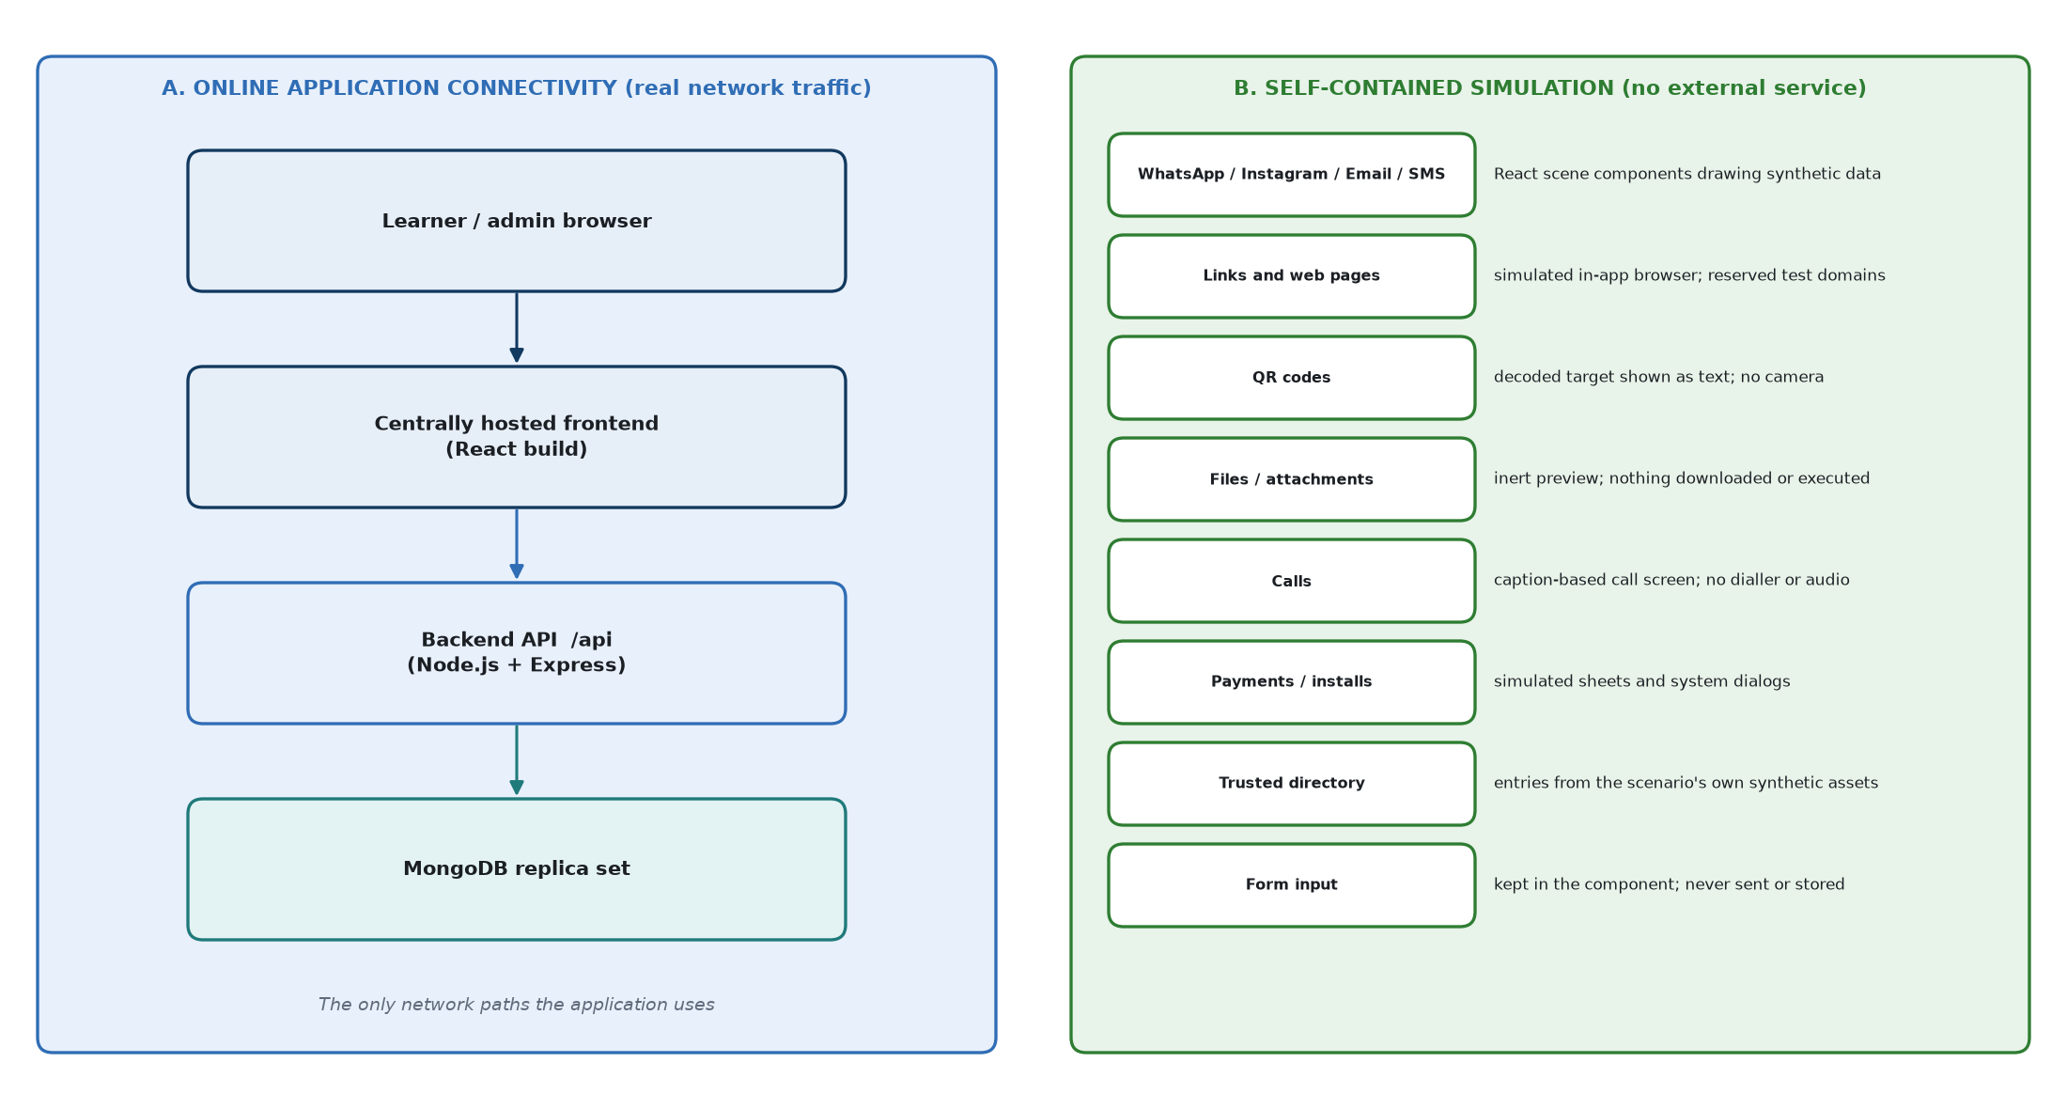
Figure 14. Online application connectivity (A) versus the self-contained simulation (B)

35.1 A - Online application connectivity
Connection | Current implementation
Browser → frontend | The browser loads the built React application (static files) from the hosted environment.
Browser → backend API | All data calls go through apiClient.request() to VITE_API_BASE_URL (default /api) with credentials: include, carrying the httpOnly session cookie. CORS on the API allows exactly the configured CORS_ORIGIN.
Backend → MongoDB | Mongoose connection from MONGO_URI; replica set required for transactions.
Backend → server file system | Writes export files to EXPORT_DIR; reads the learner-action maps at start-up.
Outbound calls to third parties | None. The backend has no HTTP client dependency and makes no outbound requests; the frontend loads no external fonts, scripts or images; the PDF writer embeds nothing and fetches nothing.

35.2 B - Self-contained simulated services
Simulated element | How it behaves (no real service involved)
WhatsApp simulation | Chat, contact/group info, settings and linked-devices screens drawn by WhatsAppScene; does not connect to WhatsApp.
Instagram simulation | Profiles, posts, stories, DMs, follower lists and account history drawn by InstagramScene; does not connect to Instagram.
Email simulation | Inbox, message details, "Show original", folders and compose sheets drawn by EmailScene; no mail server, no email is sent.
SMS simulation | Threads and conversation details drawn by SmsScene; no SMS provider; replies are recorded as "simulated_reply_sent".
Browser / external links | BrowserSurface: read-only address bar showing the host the message pointed at, an authored page graph, in-page navigation and Back, a CSS-only loading strip. Links use reserved hostnames only (.example, example.com/.net/.org, .invalid, .test, localhost, training.local - RESERVED_HOST_PATTERN), enforced by the importer (validateOfflineSafety) and by the scenario manager before publication. Nothing is loaded from the internet.
QR codes | The decoded target is shown as text in the viewer; the camera is never used and nothing is opened.
Files / attachments | Inert preview of synthetic metadata and content; no file exists, nothing is downloaded or executed.
Calls | CallSurface shows ringing / connected / ended states with captions and a timer; no dialler, no audio, no telephony.
Payments | PaySheetSurface shows a summary and a synthetic PIN step; no payment instrument or gateway exists.
Installs / permissions | InstallerSurface system dialogs; nothing is installed or granted.
Trusted Directory | Overlay whose results come only from the scenario's trusted_directory_entry assets (and approved scene entries). The message's own contact details are shown separately and can never become a trusted result; typing only filters.
Forms inside scenarios | SceneForm is a fieldset, not a form: typed values live in the component, are discarded on leaving the screen and are never sent to the API, logs or storage; autocomplete="off"; masking by CSS so password managers do not engage.
Consequences of risky actions | The engine returns an inert rendering instruction (e.g. simulated_browser_open, simulated_payment) with inert: true, executes: false; the page opens the matching simulated surface.
Authentication inside scenarios | Look-alike sign-in pages are simulated surfaces; no external identity provider is contacted. The application's own login is its own API.

35.3 Consequence for deployment
The application requires connectivity between the learner's browser and the centrally hosted frontend and API, and between the API and MongoDB. It does not require access to any real messaging, email, SMS, payment, QR, telephony, file-hosting or third-party authentication service, and none is configured anywhere in the code.

35.4 Remaining "offline" wording in the current code
Current implementation behaviour
Some text in the current code still uses "offline" wording from the earlier deployment context. It is documented here because it is what users currently see; this documentation task did not change it.
- Learner Rules dialog (SupportDialogs.jsx): "The simulation runs offline. Links open an offline viewer…".
- Simulated browser chrome title "Offline browser" (LocalSurfaces.jsx) and the consequence text "The link opened in the offline browser on the phone." (constants/simulation.js). Here "offline" describes the simulated browser, which indeed loads nothing from the internet.
- Simulated phone status for screen readers: "Simulated carrier …, offline" (DeviceFrame.jsx).
- Export reports and panel: marker "OFFLINE", notice "produced offline on the local training machine", PDF producer "(offline)", panel text "An offline report, written on this machine" (Section 27).
- Some scenario content uses "offline copy" as part of the fictional story (e.g. I11, I13, I17, I24); this is scenario narrative, not a system statement.

36. Testing Architecture
Suite | Runner / location | What it protects
Backend unit tests | node --test "tests/**/*.test.js" (npm test) | Scoring table and clamp, engine transitions, selection solver rules and determinism, demo selection, learner-action maps and codes, projections (no leaks), result classification, review rules, CSV/PDF writers, password hashing, audit validation, timers, synthetic content safety, full schema validation of all 100 definitions, scene affordance maps (sceneAffordance.test.js).
Backend DB-backed integration tests | npm run test:engine - starts a throwaway single-node replica set on port 27018 with its own data directory and runs 15 suites, each in its own database | Transactions, idempotency, concurrency, attempt API, results API, audit API, scenario manager API, viewer API, export API, instructor controls, profile API, progress API, timer/expiry, admin completion, dashboard, demo assessment.
Frontend tests | Vitest + jsdom + Testing Library (npm test in frontend), stubbed fetch | Login, briefing, dashboard orchestration and attempt state, simulation page, timer, demo skip, result and review pages, admin area and pagination, every scene pack per platform (SceneScenarios*.test.jsx), scene model rules (sceneModel.test.js), forms containment, neutrality helpers.
Bundle neutrality check | npm run check:bundle after npm run build | No canonical intents, scoring codes or verification sources in the production bundle.
Release validation | npm run release:validate (read-only) and release:smoke (against a disposable copy) | 12 invariants of the release database (collections, indexes, clean operational state, bank ids, schema, distribution, taxonomy, stages, source alignment, learner-action maps, selection).

36.1 Results confirmed while preparing this document (26 Sep 2026)
Run | Result
Backend npm test (no DB URI set) | 1,130 tests: 680 passed, 0 failed, 450 skipped (the DB-backed tests skip without a test database).
Backend npm run test:engine (throwaway replica set, port 27018) | 15 suites, 376 tests, all passed, 0 failed.
Frontend vitest run | 46 test files, 3,967 tests, all passed on the confirming run. An earlier run in the same session reported 1 failed test out of 3,967 that did not reproduce on re-run (an intermittent failure; the failing test was not captured).
Release database validation | Recorded in backend/deploy/migration-001/...validation.json (22 Sep 2026): PASS 12/12, including 200 simulated selections covering all 100 scenarios. Not re-run for this document (it reads the release database).

No test in this preparation wrote to the development or release database. Browser/manual verification notes exist in the project docs (e.g. docs/ACCEPTANCE_MATRIX.md, docs/ACCEPTANCE_OFFLINE.md) but were not re-performed for this document.

37. 100-Scenario Content Architecture
Source: backend/data/scenarios/v1 (client specification v1.0, 2 Sep 2026) imported through scenarioDefinitionImportService with taxonomy v1.0.0 and synthetic content v1. The statistics below were recomputed from the source data for this document and match the release manifest.
Dimension | Distribution
Total | 100 (W01-W25, I01-I25, E01-E25, S01-S25); all version 1, all active
Platform | WhatsApp 25, Instagram 25, Email 25, SMS 25
Disposition | Malicious 80 (20 per platform), Legitimate 20 (5 per platform)
Difficulty | Easy 32, Medium 36, Hard 32 (8/9/8 per platform)
Difficulty × disposition | Easy 24 malicious + 8 legitimate; Medium 28 + 8; Hard 28 + 4
Military context | 35 (WhatsApp 10, Instagram 12, Email 8, SMS 5; 27 malicious, 8 legitimate)
Six stages | All 100 have exactly six stages (notify … resolve) with learner flow, UI to build, expected safe behaviour and scoring text
Scoring sets | 80 malicious share one scoring set; 20 legitimate share the legitimate set (Section 16)
Synthetic assets | Every scenario has 4-7 assets (20 have 4, 52 have 5, 25 have 6, 3 have 7)
Learner-action maps | 1,986 scene controls (17-24 per scenario) + 37 generic controls
Raw client families | 99 distinct family strings mapped to 19 canonical families

37.1 Canonical families (taxonomy 1.0.0)
Canonical family | Scenarios | Canonical family | Scenarios
operational_elicitation | 10 | investment_and_task_fraud | 5
financial_credential_phishing | 9 | malware_delivery | 5
legit_system_confirmation | 7 | qr_code_phishing | 5
payment_diversion | 7 | unsolicited_payment_lure | 5
account_takeover_authorisation_abuse | 6 | coercion_and_extortion | 4
credential_phishing | 6 | impersonation_emergency_payment | 3
legit_coordination_request | 6 | relationship_grooming_fraud | 3
legit_routine_broadcast | 6 | disinformation_amplification | 1
tech_support_and_callback_fraud | 6 | legit_verified_high_risk_change | 1
identity_data_harvesting | 5

37.2 Canonical triggers (taxonomy 1.0.0; a scenario can carry several)
Trigger | Mentions | Trigger | Mentions
authority | 40 | isolation_secrecy | 5
urgency | 27 | pride | 5
routine | 19 | flattery | 4
fear | 18 | duty_compliance | 3
greed | 11 | helpfulness | 3
curiosity | 10 | reciprocity | 3
empathy | 9 | commitment | 2
familiarity | 8 | expert_status | 2
scarcity | 6 | shame_embarrassment | 2
trust | 6 | social_proof | 2
convenience | 5 | confusion | 1

37.3 Versioning and active state
(scenario_id, version) is unique; at most one version per scenario is active (the importer and the scenario manager both enforce this, and the selection pool refuses a bank with two active versions of one id). Runs pin the version they started on, so republishing never changes a scenario in flight. The 100 imported definitions have no stored lifecycle_state; they are treated as published because they are active. Every attempt stores content_version, taxonomy_version and trigger_taxonomy_version, which gate result comparisons.

38. Complete End-to-End Example
A learner, "Asha Rao", service number "IC-45872H", takes her first assessment. Values are illustrative; every behaviour is the implemented one.
# | A. What the learner sees | B. What the system does internally
1 Online access + login | Opens the hosted application in a browser; enters "Asha Rao" and "IC-45872H", presses Continue. | POST /candidates → normalises to IC45872H → no match → creates Candidate (masked ••••872H) → sets candidate_session → 201 created: true.
2 Profile / briefing | Briefing page; ticks "I have read this briefing"; Continue to Dashboard. | POST /candidates/me/briefing {version:1} → stores briefing_version: 1 + timestamp.
3 Start | Dashboard shows "Start Assessment", 0 of 10. | GET /attempts/current → null. Press Start → POST /attempts.
4 Attempt created | Navigates to the simulation; a phone home screen appears. | Not demo → createAttempt: pool 100, history empty, attempt index 0 → quota W3/I3/E2/S2, new seed; solver picks 8 malicious + 2 legitimate, 3/4/3, 2-4 military; transaction writes Attempt (expires_at = now + 90 min) and 10 runs at notify.
5 Scenario selected | "Scenario 1 of 10"; 1-4 s later a WhatsApp toast arrives. | GET current-run → run ordinal 1 (e.g. W01), candidate-safe scenario and one action code per allowed control (37 generic + 19 W01 scene controls). Delay = hash of run id.
6 Notify | Taps the toast. | Code for gen-c01 → open_item → event 1 NOTIFY_SEEN 0 → stage open.
7 Open | Opens the chat. | read → event 2 ITEM_OPEN 0 → inspect.
8 Inspect | Opens Contact info: unknown number, no groups in common. | inspect_sender → event 3 INSPECT_CONTEXT +2 → branch; the system code bubble appears (beat since branch).
9 Branch | Chooses "Do not reply, and open Account settings instead". | safe_pivot → SAFE_PIVOT +3 (malicious scenario) → verify.
10 Verify | Settings > Account > Linked devices. | verify_known_app → TRUSTED_VERIFY +3, verify_source: known_app → resolve.
11 Resolve | "Report and close the chat". Card: "Scenario 1 recorded - You reported it." | POST …/resolve → RESOLVE_CORRECT +2 → run resolved, score_running 10 → score_0_10 = 10, outcome resolve_report. Feedback held (timing on_completion).
12 Event stored / score updated | - | Six events (sequence 1-6) in scenarioevents; each committed with the run update in one transaction.
13 Next scenario | Continue → "Scenario 2 of 10" toast (e.g. Email). | GET current-run → lowest unresolved ordinal (2).
14 … Scenario 10 | Plays the remaining nine; on one legitimate item reports it by mistake. | That run: FALSE_REPORT_BLOCK -4 and CONTRADICTORY_UNSAFE_FINAL -4 → score 0 → later classified false_positive.
15 Attempt complete | "All scenarios resolved" → View results. | POST /complete → 10 resolved → total = Σ (e.g. 78) → attempt completed, end_reason: learner_completed → ProgressSnapshot rebuilt.
16 Result | Score 78/100; 7 handled safely, 1 missed threat, 1 false positive, 1 unsafe handling; review cards; breakdowns; "no previous attempt"; 2-3 practice areas. | buildAttemptResult verifies the total, classifies each run, builds reviews and breakdowns, remediation from the weakest families.
17 Admin view | Instructor opens Attempts → the attempt → sees scores, difficulty, military flag, disposition, family, path and feedback per scenario; exports a PDF. | GET /admin/attempts/:id (same result + classification); POST /admin/exports/attempts/:id {format:"pdf"} → file written to the export directory on the server and downloaded through the browser, EXPORT_CREATED audited. The dashboard now counts the attempt.

39. Error and Edge-Case Behaviour
Case | HTTP / code | Behaviour
Invalid login (empty) | 422 MISSING_FIELDS | Shown on form (browser validation usually prevents it).
Over-long name / number | 422 VALIDATION_ERROR | Schema limits 60 / 20.
Archived profile login | 403 PROFILE_ARCHIVED | "This profile is not available for training. Please speak to your instructor."
Duplicate login (second device) | 200 | Allowed; same profile and same attempt.
Expired session / no cookie | 401 NO_SESSION | Frontend clears state and returns to login.
Expired attempt, action sent | 409 ATTEMPT_EXPIRED (result_available: true) | Expired screen; result available.
Refresh / interrupted attempt | - | State re-read from server; interrupted notice with Resume.
Duplicate action | 200 duplicate: true | Original outcome replayed; scored once.
Invalid / tampered action code | 422 INVALID_ACTION | Inline "That action is not available here."
Client-supplied authoritative field | 422 FORBIDDEN_FIELD | Rejected, lists the field names.
Wrong stage | 409 STALE_STATE | Auto-resync.
Wrong run / attempt of another learner | 404 | Not found (never 403).
Action on a resolved run | 409 RUN_NOT_ACTIVE | Recoverable message.
Action on a reset/completed attempt | 409 ATTEMPT_NOT_IN_PROGRESS | Attempt no longer active.
Complete before 10 resolved | 409 SCENARIOS_OUTSTANDING | Lists outstanding ordinals.
Result of an unfinished attempt | 409 ATTEMPT_NOT_COMPLETE | -
Result integrity mismatch | 500 RESULT_INTEGRITY | Surfaced, never repaired silently.
Unauthorized admin request | 401 NO_ADMIN_SESSION | Redirect to admin login.
Too many admin login failures | 429 TOO_MANY_ATTEMPTS | Lockout message with seconds remaining.
Unknown admin filter | 422 FORBIDDEN_FILTER | -
Demo skip by a normal learner | 404 | Indistinguishable from a missing route.
Demo skip of a non-current run | 409 RUN_NOT_CURRENT | Resync.
Selection impossible | 409 SELECTION_CONSTRAINT_UNSATISFIABLE / SELECTION_POOL_INSUFFICIENT | No attempt created.
Two active versions of a scenario | 409 SELECTION_INVALID_CONTENT_VERSION | Attempt creation refused.
MongoDB standalone (no replica set) | 503 TRANSACTION_UNAVAILABLE | Authoritative writes refused; no partial writes.
Transaction failure | retry ×3 transient, else error | Aborted as a whole.
Server unavailable / network interruption | status 0 NETWORK_ERROR | Login: "record store unreachable" Retry panel. Simulation: recoverable inline message; retrying the same action reuses its intent key, so it cannot score twice.
Assessment timeout while browser closed | - | Sweeper/startup finalises; result ready on return.
Learner never presses View results after 10 | - | Attempt stays in progress until completed or until the deadline; expiry then finalises it (end_reason expired, 0 unresolved runs) with the same total.

40. Data Lifecycle
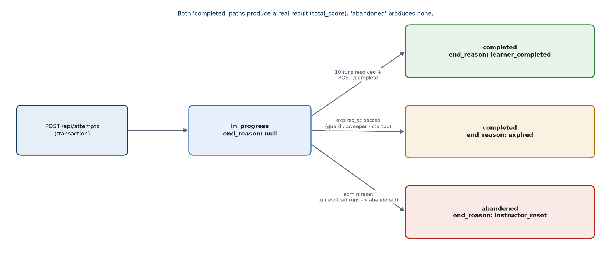
Figure 15. Attempt lifecycle (status and end_reason)
Stage | What is persisted
Learner enters the system | Candidate created (name, identifier, normalised key, mask, last_seen_at) or updated (name, last_seen_at).
Briefing | briefing_version, briefing_acknowledged_at.
Attempt created | Attempt (frozen sequence, seed, selection, versions, deadline) + 10 ScenarioRuns at notify.
Events generated | One ScenarioEvent per accepted action; run stage, last_sequence, score_running updated.
Scenario completed | Run resolved: score_0_10, outcome_code, resolved_at, optional rationale.
Attempt completed / expired | status completed, completed_at, total_score, end_reason (+ expired_at, unresolved_at_expiry); ProgressSnapshot rebuilt.
Attempt reset by instructor | status abandoned, end_reason instructor_reset, unresolved runs abandoned; AuditEvent.
Results generated | Nothing - computed on read.
Admin reads | Nothing (reads are not audited).
Admin exports | File in the export directory + AuditEvent EXPORT_CREATED.
Profile archived | archived flags + AuditEvent. No data is deleted anywhere in the application.

41. Current Implementation Boundaries
This section states precisely what the delivered application does and does not do. It describes the current scope; it is not a list of proposals.

41.1 The system does
- Run as a centrally hosted online web application: a React frontend delivered to the browser, a Node.js/Express API and a MongoDB replica set, configured through environment variables (hosting configuration is not part of the repository).
- Keep every simulated communication channel self-contained: no real messaging, email, SMS, payment, QR, telephony, file or third-party authentication service is used.
- Identify learners by name + personal/service number without passwords; authenticate instructors by username/password.
- Build each assessment of exactly 10 scenarios from 100, server-side, with fixed composition rules and recent-history exclusion.
- Simulate WhatsApp, Instagram, Email and SMS with authored scenes for all 100 scenarios, all inert and synthetic.
- Score every action server-side from stored scenario data through an append-only event ledger, with idempotency and transactions.
- Enforce a 90-minute limit server-side and finalise expired attempts automatically.
- Produce a detailed learner result and review, a learner progress snapshot and history.
- Provide an instructor dashboard, attempt viewer, CSV/PDF exports, scenario version management, attempt reset, profile archive, feedback-timing setting and an append-only audit log.
- Provide a separate Demo User with a fixed set and a skip function, excluded from dashboard statistics.

41.2 The system does not
- Adapt difficulty or scenario choice to a learner's previous performance (difficulty is always 3/4/3; see Section 10).
- Offer a learner-facing way to start "training" mode: the mode exists in the data model and API but the learner UI always starts an assessment.
- Enforce the briefing acknowledgement on the server before an attempt can start.
- Let a learner restart, abandon or skip a scenario (only instructor reset; skip only for the Demo User).
- Show per-action points or a running score during an assessment.
- Delete any learner, attempt, run, event or audit record through the application (archive and reset only).
- Provide unarchive, an admin-creation web page, multiple-admin management through the UI, or XLSX export.
- Let an export be written to a client-chosen path; files are written to the server's export directory and downloaded through the browser.
- Contact any external third-party service from the simulation, open real links, execute files, or use the camera, microphone or clipboard.
- Use the legacy 40-scenario quiz in the current learner journey (its routes remain mounted; the release database contains none of its scenarios).
- Restrict a learner to one concurrent browser session.

42. Technical Glossary
Term | Meaning in this system
LearnerProfile | The learner record, implemented by the Candidate model/collection; identified by the normalised personal/service number.
Attempt | One assessment of exactly 10 scenarios with a frozen order, seed and 90-minute deadline.
ScenarioDefinition | One versioned scenario of the 100-scenario bank, including server-only evaluation data.
ScenarioRun | One scenario being played inside an attempt; pinned to a definition version; holds stage and score.
Event / ScenarioEvent | One accepted learner action (or system closure) with a server-decided code and points - the ledger.
ProgressSnapshot | Derived per-learner progress summary, rebuilt from completed attempts.
Disposition | Whether a scenario is malicious or legitimate.
Difficulty (level) | easy, medium or hard.
Canonical family | One of 19 normalised attack/case families (taxonomy 1.0.0) mapped from the client's family text.
Trigger / canonical trigger | The psychological lever(s) a scenario uses (22 canonical values).
Military flag | Scenario set in a fictional military context (35 of 100).
Scenario stage | notify, open, inspect, branch, verify, resolve.
Intent | Server-side name of what a control means (e.g. safe_pivot). Never sent by the browser.
Neutral learner action / action code | The browser's only way to name an action: a neutral control id mapped to an opaque per-run HMAC code.
intent_key | Client-generated idempotency key per action; unique in the ledger.
Demo User | The configured demonstration profile with a fixed scenario set and skip ability.
Scenario seed / selection seed | Random 16-byte value stored on each attempt; with the pool and history it reproduces the selection.
Attempt index | Number of attempts the learner started before this one; rotates the platform quota.
Recent exclusion / relaxation | Avoiding the learner's last 20 scenario ids; re-admitting the minimum number if otherwise impossible.
Trusted verification | Checking via the trusted directory, a known app or a number already held (TRUSTED_VERIFY +3).
Safe pivot / correct use | Declining or using the official path at the branch stage (+3), named per disposition.
Missed threat | Malicious item not correctly closed, or passed through a critical unsafe action.
False positive | Legitimate item closed with a wrong (reject/report/block/ignore) action.
Unsafe handling | Legitimate item kept, but after a critical unsafe action.
Critical event | RISKY_OPEN_REPLY, UNSAFE_EXTERNAL_ACTION, CONTRADICTORY_UNSAFE_FINAL, SECRET_PAYMENT_INSTALL_DATA_RELEASE.
Pinned definition | The exact (scenario_id, version) a run uses for its whole life.
Clamp | Limiting a scenario score to 0-10 at resolution.
Feedback timing | Instructor setting: immediate (feedback card after each scenario) or on_completion (result only).
Scene pack | Frontend data module describing how one scenario looks and where each control sits.
Replica set | MongoDB deployment mode required for transactions (single node rs0).

Appendix A - Current Project Structure
Social Engineering Fraud Training PDS/
├─ backend/
│ ├─ src/
│ │ ├─ server.js, app.js
│ │ ├─ config/ env.js, database.js, demo.js
│ │ ├─ constants/ scenarioDefinition, scenarioEngine, scenarioSelection, attemptTiming,
│ │ │ learnerAction, resultProjection, scenarioReview, demoAssessment,
│ │ │ adminDashboard, attemptViewer, export, instructorControls, auditLog,
│ │ │ scenarioLifecycle, learnerProfile, assessment (legacy)
│ │ ├─ models/ Candidate, Attempt, ScenarioRun, ScenarioEvent, ScenarioDefinition,
│ │ │ ProgressSnapshot, AdminUser, AuditEvent, Configuration,
│ │ │ Assessment + Scenario (legacy)
│ │ ├─ routes/ index, candidate, attempt, progress, admin, health, scenario, assessment
│ │ ├─ controllers/ candidate, attempt, progress, admin, adminDashboard, attemptViewer,
│ │ │ export, instructorControl, scenarioManager, audit, health, scenario,
│ │ │ assessment (legacy)
│ │ ├─ services/ (see Section 4.5)
│ │ ├─ middleware/ session, adminSession, adminThrottle, errorHandler, notFound
│ │ └─ utils/ transactions, seededRandom, ApiError, asyncHandler, password,
│ │ serviceNumber, csvWriter, pdfWriter
│ ├─ data/ scenarios/v1, synthetic/v1, taxonomy, learner-actions/v1 (+ legacy samples)
│ ├─ scripts/ admin, import, generate, verify, backfill, dev tools, release/*
│ ├─ tests/ Node test runner suites (+ fixtures, helpers)
│ ├─ deploy/ migration-001 release archive and reports
│ └─ exports/ generated CSV/PDF reports
├─ frontend/
│ ├─ src/
│ │ ├─ main.jsx, App.jsx, routes/, context/, hooks/, state/, services/, utils/, constants/
│ │ ├─ pages/ Login, Briefing, Dashboard, Simulation, Result, History, Admin*, legacy
│ │ ├─ components/ simulation/ (whatsapp, instagram, email, sms, surfaces), result/,
│ │ │ admin/, assessment/ (renderers), auth/, layout/, ui/, common/
│ │ ├─ simulation/ sceneModel, sceneRegistry, useSceneNavigation, localForm,
│ │ │ scenes/{whatsapp,instagram,email,sms}/<id>.js (100 packs)
│ │ ├─ styles/index.css
│ │ └─ test/ fixtures and harness
│ └─ scripts/checkNeutralBundle.mjs
└─ docs/ design notes, research per scenario batch, acceptance and release docs

Appendix B - API Endpoint Reference
Method | Route (under /api) | Auth | Controller function | Purpose
GET | /health | - | getHealth | Liveness + DB state
GET | /scenarios/summary | - | getScenarioSummary | Legacy pool counts
POST | /candidates | - | createCandidate | Sign in / register learner
POST | /candidates/logout | - | logout | Clear learner cookie
GET | /candidates/me | Learner | getCurrentCandidate | Current learner
POST | /candidates/me/briefing | Learner | acknowledgeBriefingVersion | Record briefing acknowledgement
GET | /progress | Learner | getMyProgress | Own progress snapshot
POST | /attempts | Learner | startAttempt | Start or return in-progress attempt
GET | /attempts | Learner | listCompletedAttempts | Completed attempts (history)
GET | /attempts/current | Learner | getCurrentAttempt | In-progress (or last expired) attempt
GET | /attempts/:attemptId | Learner | getAttempt | Attempt state
GET | /attempts/:attemptId/current-run | Learner | getCurrentRun | Current run + scenario + action codes
POST | /attempts/:attemptId/runs/:runId/events | Learner | submitRunEvent | One learner action
POST | /attempts/:attemptId/runs/:runId/resolve | Learner | resolveRun | Final action of a scenario
POST | /attempts/:attemptId/runs/:runId/demo-skip | Learner (Demo User only) | skipDemoScenario | Skip in demo attempt
POST | /attempts/:attemptId/complete | Learner | finishAttempt | Complete attempt, return result
GET | /attempts/:attemptId/result | Learner | getAttemptResult | Result projection
POST | /assessments … (6 routes) | Learner | assessmentController.* | Legacy quiz
POST | /admin/login | - (throttled) | login | Admin sign-in
POST | /admin/logout | - | logout | Clear admin cookie
GET | /admin/me | Admin | getCurrentAdmin | Current admin
GET | /admin/dashboard | Admin | getDashboard | Aggregate statistics
GET | /admin/audit | Admin | getAuditLog | Audit log page
GET | /admin/scenarios | Admin | listScenarioDefinitions | Scenario list
POST | /admin/scenarios | Admin | postScenario | Create scenario draft
GET | /admin/scenarios/:scenarioId | Admin | getScenario | All versions
GET | /admin/scenarios/:scenarioId/versions/:version | Admin | getScenarioAtVersion | One version
PATCH | /admin/scenarios/:scenarioId/versions/:version | Admin | patchScenarioVersion | Edit draft / branch new draft
POST | /admin/scenarios/:scenarioId/versions/:version/clone | Admin | postScenarioClone | Clone to next version / new id
POST | /admin/scenarios/:scenarioId/versions/:version/publish | Admin | postScenarioPublish | Publish (audited)
POST | /admin/scenarios/:scenarioId/versions/:version/deactivate | Admin | postScenarioDeactivate | Deactivate (audited)
GET | /admin/attempts | Admin | listAttemptsForAdmin | Attempt list
GET | /admin/attempts/:attemptId | Admin | getAttemptDetailForAdmin | Attempt detail
GET | /admin/learners | Admin | lookupLearnersForAdmin | Learner lookup
POST | /admin/exports/attempts/:attemptId | Admin | postAttemptExport | Attempt CSV/PDF
POST | /admin/exports/learners/:profileId | Admin | postLearnerExport | Learner CSV/PDF
GET | /admin/exports/:filename | Admin | getExportArtifact | Download artifact
POST | /admin/attempts/:attemptId/reset | Admin | postAttemptReset | Reset in-progress attempt
POST | /admin/learners/:profileId/archive | Admin | postProfileArchive | Archive profile
GET | /admin/config/feedback | Admin | getFeedbackTimingConfig | Read feedback timing
PATCH | /admin/config/feedback | Admin | patchFeedbackTimingConfig | Change feedback timing

Appendix C - Database Collection / Model Reference
Fields, indexes and lifecycles are described in Sections 7, 17 and 28. Summary of model-level invariants:
Model | Invariants enforced in the model
Candidate | identifierNormalised unique; mask recomputed on validate; name <= 60; identifier <= 20.
Attempt | Exactly 10 sequence items, ordinals 1-10, no repeated scenario; completed ⇒ completed_at; time_limit_ms and expires_at set together and equal started_at + limit at creation; expired ⇒ completed + expired_at; in_progress ⇒ no end_reason; sequence, seed, selection, expires_at and time_limit_ms frozen after creation; total_score 0-100.
ScenarioRun | Resolved ⇒ score_0_10, resolved_at and outcome_code present; only resolved runs may hold score_0_10; unique (attempt_id, ordinal); rationale <= 250.
ScenarioEvent | event_code enum; points_delta -10..10; unique intent_key; unique (run_id, sequence); metadata allowlist and enums.
ScenarioDefinition | ID pattern and prefix/platform agreement; disposition ⇔ canonical family (legit_*) ⇔ legitimate_control; military_flag ⇔ trigger suffix; exactly six stages in order in both halves; transitions/events legal per stage; asset refs resolve; min <= max points; unique (scenario_id, version).
ProgressSnapshot | profile_id unique; scores 0-100.
AdminUser | usernameNormalised unique; passwordHash select:false.
AuditEvent | All fields immutable; saves other than inserts and all update/delete queries throw; strict schema.
Configuration | Single row (scope enum + unique); timings enum; strict schema.

Appendix D - Scenario Distribution
Platform | Malicious E/M/H | Legitimate E/M/H | Military (mal / legit)
WhatsApp | 6 / 7 / 7 | 2 / 2 / 1 | 7 / 3
Instagram | 6 / 7 / 7 | 2 / 2 / 1 | 8 / 4
Email | 6 / 7 / 7 | 2 / 2 / 1 | 7 / 1
SMS | 6 / 7 / 7 | 2 / 2 / 1 | 5 / 0

Difficulty | Malicious | Legitimate | Total
Easy | 24 | 8 | 32
Medium | 28 | 8 | 36
Hard | 28 | 4 | 32
Total | 80 | 20 | 100

Appendix E - Complete Scenario Catalogue
Confidential - answer key
This catalogue lists each scenario's disposition, difficulty, family and trigger - information the application deliberately withholds from learners. Titles are the client's authoring titles (server-side evaluation data). All 100 definitions are version 1 and active.

ID | Title | Disp. | Level | Canonical family | Canonical triggers | Mil. | Ver
E01 | Password Expires Today | Mal | Easy | credential_phishing | urgency, authority | - | 1
E02 | Invoice Spreadsheet Macro | Mal | Easy | malware_delivery | routine, urgency | - | 1
E03 | Authenticated Internal Newsletter | Legit | Easy | legit_routine_broadcast | routine | - | 1
E04 | Customs Parcel Hold | Mal | Easy | financial_credential_phishing | fear, curiosity | - | 1
E05 | Mandatory HR Policy Login | Mal | Easy | credential_phishing | authority, duty_compliance | - | 1
E06 | Adjutant Roster Request | Mal | Easy | identity_data_harvesting | authority | Yes | 1
E07 | Expected Training Calendar Invite | Legit | Easy | legit_coordination_request | routine, authority | Yes | 1
E08 | Instant Tax Refund | Mal | Easy | financial_credential_phishing | greed, urgency | - | 1
E09 | Executive Gift-Card Request | Mal | Medium | payment_diversion | authority, urgency, isolation_secrecy | Yes | 1
E10 | Vendor Changes Bank Details | Mal | Medium | payment_diversion | routine, urgency | - | 1
E11 | Leave Approval in Known Portal | Legit | Medium | legit_system_confirmation | authority, routine | - | 1
E12 | Shared Document Sign-In | Mal | Medium | credential_phishing | curiosity, routine | Yes | 1
E13 | Password-Protected ZIP | Mal | Medium | malware_delivery | curiosity, routine | - | 1
E14 | Revised Movement Order | Mal | Medium | qr_code_phishing | authority, urgency | Yes | 1
E15 | OAuth Consent for Mail Review | Mal | Medium | account_takeover_authorisation_abuse | convenience, authority | - | 1
E16 | Signed Maintenance Notice | Legit | Medium | legit_routine_broadcast | authority, routine | - | 1
E17 | Invoice Callback Trap | Mal | Medium | tech_support_and_callback_fraud | fear, urgency | - | 1
E18 | Hijacked Reply-Chain Invoice | Mal | Hard | payment_diversion | trust, routine | - | 1
E19 | Academic Interview on Readiness | Mal | Hard | operational_elicitation | expert_status, flattery | Yes | 1
E20 | Legal Notice and Secrecy Order | Mal | Hard | coercion_and_extortion | fear, authority, isolation_secrecy | - | 1
E21 | Verified Vendor Master Change | Legit | Hard | legit_verified_high_risk_change | routine, authority | - | 1
E22 | Senior Voice Memo Transfer | Mal | Hard | payment_diversion | authority, urgency | Yes | 1
E23 | DLP Alert HTML Attachment | Mal | Hard | malware_delivery | fear, duty_compliance | - | 1
E24 | QR Code in Policy PDF | Mal | Hard | qr_code_phishing | authority, convenience | - | 1
E25 | Payroll Direct-Deposit Redirect | Mal | Hard | payment_diversion | authority, routine | Yes | 1
I01 | Flash Giveaway Winner | Mal | Easy | unsolicited_payment_lure | greed, scarcity | - | 1
I02 | Copyright Appeal Countdown | Mal | Easy | credential_phishing | fear, urgency | - | 1
I03 | Published Blood-Donation Drive | Legit | Easy | legit_routine_broadcast | empathy | Yes | 1
I04 | Cloned Friend in Distress | Mal | Easy | impersonation_emergency_payment | empathy, urgency | - | 1
I05 | Friendly New Follower Questionnaire | Mal | Easy | operational_elicitation | flattery, curiosity | Yes | 1
I06 | Where Was This Exercise? | Mal | Easy | operational_elicitation | pride | Yes | 1
I07 | Known Friend Shares a Reel | Legit | Easy | legit_routine_broadcast | familiarity | - | 1
I08 | Verification Badge Agent | Mal | Easy | unsolicited_payment_lure | pride, scarcity | - | 1
I09 | Deepfake Trading Advertisement | Mal | Medium | investment_and_task_fraud | greed, authority | - | 1
I10 | Brand Collaboration Shipping Fee | Mal | Medium | unsolicited_payment_lure | flattery, reciprocity | - | 1
I11 | Official Welfare Helpline Update | Legit | Medium | legit_routine_broadcast | authority, empathy | Yes | 1
I12 | Account Recovery Backup Code | Mal | Medium | account_takeover_authorisation_abuse | fear, authority | - | 1
I13 | Deployed Officer Romance Profile | Mal | Medium | relationship_grooming_fraud | trust, empathy | Yes | 1
I14 | Commendation Page Requests Documents | Mal | Medium | identity_data_harvesting | pride, authority | Yes | 1
I15 | You Are in This Video | Mal | Medium | credential_phishing | curiosity, shame_embarrassment | - | 1
I16 | Approved Photo Release Request | Legit | Medium | legit_coordination_request | authority, pride | Yes | 1
I17 | Morphed-Photo Blackmail | Mal | Medium | coercion_and_extortion | fear, shame_embarrassment, isolation_secrecy | - | 1
I18 | High-Fidelity Teammate Clone | Mal | Hard | operational_elicitation | familiarity, urgency | Yes | 1
I19 | Urgent Unit Incident Repost | Mal | Hard | disinformation_amplification | fear, duty_compliance | Yes | 1
I20 | Researcher Asks Capability Questions | Mal | Hard | operational_elicitation | expert_status, flattery | Yes | 1
I21 | Post-Event Teammate Tag | Legit | Hard | legit_coordination_request | familiarity, pride | Yes | 1
I22 | Live Support Video Call | Mal | Hard | tech_support_and_callback_fraud | authority, fear | - | 1
I23 | Compromised Charity Influencer | Mal | Hard | unsolicited_payment_lure | empathy, social_proof | - | 1
I24 | Institutional Trading App | Mal | Hard | investment_and_task_fraud | authority, greed | - | 1
I25 | Canteen Coupon Reel QR | Mal | Hard | qr_code_phishing | familiarity, scarcity | Yes | 1
S01 | Bank KYC Suspension | Mal | Easy | financial_credential_phishing | fear, urgency | - | 1
S02 | Electricity Disconnect Tonight | Mal | Easy | tech_support_and_callback_fraud | fear, urgency | - | 1
S03 | Matching Debit Alert | Legit | Easy | legit_system_confirmation | routine | - | 1
S04 | Unpaid E-Challan Link | Mal | Easy | financial_credential_phishing | fear, urgency | - | 1
S05 | Parcel Address Fee | Mal | Easy | financial_credential_phishing | curiosity, urgency | - | 1
S06 | Service-Number Confirmation | Mal | Easy | identity_data_harvesting | authority | Yes | 1
S07 | Expected Recharge Confirmation | Legit | Easy | legit_system_confirmation | routine | - | 1
S08 | Lottery Claim Text | Mal | Easy | unsolicited_payment_lure | greed, scarcity | - | 1
S09 | Wrong Number Becomes an Investment Pitch | Mal | Medium | relationship_grooming_fraud | curiosity, trust | - | 1
S10 | eSIM Upgrade OTP | Mal | Medium | account_takeover_authorisation_abuse | authority, convenience | - | 1
S11 | Expected Clinic Reminder | Legit | Medium | legit_system_confirmation | routine, empathy | - | 1
S12 | Income-Tax Refund Form | Mal | Medium | financial_credential_phishing | greed, authority | - | 1
S13 | Rating-Task Recruiter | Mal | Medium | investment_and_task_fraud | greed, commitment | - | 1
S14 | Emergency Recall Location Link | Mal | Medium | operational_elicitation | authority, urgency | Yes | 1
S15 | Canteen Subsidy MMS QR | Mal | Medium | qr_code_phishing | familiarity, scarcity | Yes | 1
S16 | Learner-Initiated Login Code | Legit | Medium | legit_system_confirmation | routine | - | 1
S17 | New-Phone Family Emergency | Mal | Medium | impersonation_emergency_payment | empathy, urgency | - | 1
S18 | Bank Header Thread Hijack | Mal | Hard | tech_support_and_callback_fraud | trust, fear | - | 1
S19 | Network Survey Requests IMEI | Mal | Hard | operational_elicitation | authority, helpfulness | Yes | 1
S20 | Parcel Text Plus Callback | Mal | Hard | tech_support_and_callback_fraud | curiosity, urgency | - | 1
S21 | Matching New-Login Alert | Legit | Hard | legit_system_confirmation | fear, routine | - | 1
S22 | Synthetic Voice-Mail Link | Mal | Hard | credential_phishing | authority, curiosity | Yes | 1
S23 | UPI Refund Collect Request | Mal | Hard | financial_credential_phishing | greed, confusion | - | 1
S24 | Fake Cybercrime Case Fee | Mal | Hard | coercion_and_extortion | fear, authority | - | 1
S25 | FASTag Update APK | Mal | Hard | malware_delivery | convenience, urgency | - | 1
W01 | The Accidental Login Code | Mal | Easy | account_takeover_authorisation_abuse | helpfulness, urgency | - | 1
W02 | Parcel Redelivery Fee | Mal | Easy | financial_credential_phishing | urgency, curiosity | - | 1
W03 | Known Sports Meet Group | Legit | Easy | legit_coordination_request | familiarity | Yes | 1
W04 | Friend on a New Number | Mal | Easy | impersonation_emergency_payment | empathy, urgency | - | 1
W05 | KYC Suspension Warning | Mal | Easy | financial_credential_phishing | fear, urgency | - | 1
W06 | Unit Clerk ID Photo Request | Mal | Easy | identity_data_harvesting | authority | Yes | 1
W07 | Expected Family Document | Legit | Easy | legit_coordination_request | familiarity | - | 1
W08 | Festival Reward QR | Mal | Easy | qr_code_phishing | greed, scarcity | - | 1
W09 | Compromised Colleague Gift Cards | Mal | Medium | payment_diversion | authority, urgency | Yes | 1
W10 | Survey Device-Link QR | Mal | Medium | account_takeover_authorisation_abuse | convenience, authority | - | 1
W11 | Expected Welfare Appointment | Legit | Medium | legit_system_confirmation | authority, routine | - | 1
W12 | Digital Arrest Escalation | Mal | Medium | coercion_and_extortion | fear, authority, isolation_secrecy | - | 1
W13 | Guaranteed IPO Group | Mal | Medium | investment_and_task_fraud | greed, social_proof | - | 1
W14 | Movement Order APK | Mal | Medium | malware_delivery | authority, urgency | Yes | 1
W15 | Senior's Urgent Voice Note | Mal | Medium | operational_elicitation | authority, familiarity | Yes | 1
W16 | Verified Vehicle-Pool Change | Legit | Medium | legit_coordination_request | authority, urgency | Yes | 1
W17 | Part-Time Rating Tasks | Mal | Medium | investment_and_task_fraud | greed, commitment | - | 1
W18 | Hijacked Group Admin Roster Link | Mal | Hard | identity_data_harvesting | authority, routine | Yes | 1
W19 | Commander Clone Requests Location | Mal | Hard | operational_elicitation | authority, isolation_secrecy | Yes | 1
W20 | Supplier Bank-Detail Change | Mal | Hard | payment_diversion | routine, urgency | - | 1
W21 | Verified Senior Requests Secure Follow-Up | Legit | Hard | legit_routine_broadcast | authority | Yes | 1
W22 | Long-Game Online Friendship | Mal | Hard | relationship_grooming_fraud | trust, reciprocity | - | 1
W23 | Family Welfare Pretext | Mal | Hard | operational_elicitation | empathy, authority | Yes | 1
W24 | Remote Support Screen Share | Mal | Hard | tech_support_and_callback_fraud | fear, helpfulness | - | 1
W25 | Known Contact Sends a Linking Code | Mal | Hard | account_takeover_authorisation_abuse | trust, reciprocity | - | 1

Client "Attack / case family" and "Primary trigger" texts are stored verbatim beside the canonical values in each definition (family, trigger).

Appendix F - Scoring Event Reference by Stage and Disposition
Stage | Malicious scenarios (80) - declared codes | Legitimate scenarios (20) - declared codes
Notify | NOTIFY_SEEN 0 | NOTIFY_SEEN 0
Open | ITEM_OPEN 0; PREMATURE_REPLY -1 | ITEM_OPEN 0; PREMATURE_REPLY -1
Inspect | INSPECT_CONTEXT +2 (skip: STAGE_SKIPPED 0) | INSPECT_CONTEXT +2 (skip: STAGE_SKIPPED 0)
Branch | SAFE_PIVOT +3; RISKY_OPEN_REPLY -3; SECRET_PAYMENT_INSTALL_DATA_RELEASE -8 | CORRECT_USE +3; NEEDLESS_REJECT_IGNORE -2; UNSAFE_EXTERNAL_ACTION -4*
Verify | TRUSTED_VERIFY +3; REPORT_ONLY_WITHOUT_CHECK +1; VERIFY_THROUGH_MESSAGE 0 | TRUSTED_VERIFY +3; FALSE_REPORT_BLOCK -4; VERIFY_THROUGH_MESSAGE 0
Resolve | RESOLVE_CORRECT +2 (report/block); CONTRADICTORY_UNSAFE_FINAL -4* (continue/retain/ignore) | RESOLVE_CORRECT +2 (continue/retain); CONTRADICTORY_UNSAFE_FINAL -4* (report/block/ignore)
Max / min per scenario | 10 / 0 after clamp | 10 / 0 after clamp

* critical. Telemetry codes with 0 points: notification_dismissed, STAGE_SKIPPED, RUN_ABANDONED, RUN_EXPIRED, RUN_DEMO_SKIPPED.

Appendix G - State-Machine Reference (engine rules)
Stage | Intent | Candidate codes (first declared wins) | Next | Notes
notify | open_item | NOTIFY_SEEN | open
notify | dismiss | notification_dismissed (telemetry) | notify
open | read | ITEM_OPEN | inspect
open | reply, open_link, submit_data, attempt_payment, attempt_install, call_number | PREMATURE_REPLY | branch | metadata premature
inspect | inspect_sender, inspect_profile, inspect_link, preview_file, inspect_qr, read_thread | INSPECT_CONTEXT | branch
inspect | skip_inspection | STAGE_SKIPPED (telemetry) | branch
branch | safe_pivot | SAFE_PIVOT, CORRECT_USE | verify
branch | reject_ignore | NEEDLESS_REJECT_IGNORE | verify | legit only
branch | open_link, open_file, scan_qr, reply, call_number | RISKY_OPEN_REPLY, UNSAFE_EXTERNAL_ACTION | verify | inert consequence
branch | submit_data, attempt_payment, attempt_install, approve_device_link, share_secret, share_location | SECRET_PAYMENT_INSTALL_DATA_RELEASE, UNSAFE_EXTERNAL_ACTION | verify | inert consequence
verify | verify_trusted_directory, verify_known_app, verify_known_number | TRUSTED_VERIFY | resolve | verify_source recorded
verify | verify_in_message_contact | VERIFY_THROUGH_MESSAGE | resolve
verify | report, block | FALSE_REPORT_BLOCK, REPORT_ONLY_WITHOUT_CHECK | resolve
resolve | resolve_report, resolve_block, resolve_continue, resolve_retain | RESOLVE_CORRECT or CONTRADICTORY_UNSAFE_FINAL by disposition | end | run resolved
resolve | resolve_ignore | CONTRADICTORY_UNSAFE_FINAL | end | run resolved
resolve | abandon | RUN_ABANDONED (telemetry) | resolve (run abandoned) | no learner control

Appendix H - Configuration and Environment Variables
Backend variables are read from backend/.env (template backend/.env.example). Values are not reproduced here.
Variable | Default | Meaning
NODE_ENV | development | production enables secure cookies and hides error details.
PORT | 5000 | API port; set per deployment.
HOST | 127.0.0.1 | Address the API listens on; set per deployment.
MONGO_URI | mongodb://127.0.0.1:27017/cyber_awareness_training | MongoDB connection (development default shown); must reach a replica set.
CORS_ORIGIN | http://localhost:5173 | The single browser origin allowed to call the API with credentials (the hosted frontend origin in a deployment).
SESSION_SECRET | development fallback | Signs the learner cookie; also the fallback key source for action codes.
SESSION_MAX_AGE_MS | 28,800,000 (8 h) | Learner cookie lifetime.
ADMIN_SESSION_SECRET | none - required | Signs the admin cookie; must differ from SESSION_SECRET.
ADMIN_SESSION_MAX_AGE_MS | 3,600,000 (1 h) | Admin cookie lifetime.
ADMIN_LOGIN_MAX_ATTEMPTS / _WINDOW_MS / _LOCKOUT_MS | 5 / 15 min / 15 min | Admin login throttle.
EXPORT_DIR | backend/exports | Server directory where exports are written.
LEARNER_ACTION_SECRET | derived from SESSION_SECRET | Key for per-run action codes.
DEMO_DISPLAY_NAME | demo user | Demo User display name (informational).
DEMO_SERVICE_NUMBER | 1223334444 | Demo User service number; empty disables the demo.
ENGINE_TEST_MONGO_URI / ENGINE_TEST_PORT | unset / 27018 | Test-only: DB-backed test target.
VITE_API_BASE_URL (frontend) | /api | API base URL compiled into the frontend build (/api = same origin). The repository's development .env points to a local API.

Fixed constant (code, not environment) | Value
Assessment time limit | 90 minutes
Scenarios per attempt | 10 (8 malicious + 2 legitimate; 3/4/3)
Recent exclusion window | 20 scenario ids
Expiry sweeper | every 30 s, batch 50
Briefing version | 1
Selection algorithm version | 1.0.0 (demo: demo-fixed-1.0.0)
Taxonomy versions | family 1.0.0, trigger 1.0.0
Action-code version | 1
Feedback timing defaults | on_completion (training and assessment)
Admin UI page size | 10

