CLIENT HANDOVER DOCUMENT
SOCIAL ENGINEERING TRAINING &
CYBER FRAUD ASSESSMENT SYSTEM
System Design, Technical Architecture & Functional Workflow Guide
Version | 1.0 (final)
Date | 29 September 2026
Project type | Web-based training and assessment application - custom development
Prepared for | The client and its project stakeholders
Prepared by | The development team
Basis | Current source code of the project repository, inspected on 29 September 2026

All scenario content, names, numbers, links and organisations shown by the system are synthetic and exist only for training. The simulated applications do not connect to any real service.

About this guide
This guide explains the Social Engineering Training & Cyber Fraud Assessment System as it is built today: what it is for, how a learner moves through it, how the assessment is selected, run and scored, what the administrator sees, and how the frontend, backend and database work together.
It is written for two kinds of reader. Every major topic opens with a plain-language explanation that needs no technical background. Where it helps, a technical explanation follows, with the exact source files, functions, API endpoints and database collections involved.
If you are... | Start with | Then read
A stakeholder who wants to understand the product | Sections 1, 2 and 10 | Sections 13, 15, 16, 18, 23, 24 and 30, and the FAQ in Section 31
A reviewer checking how the assessment is decided and scored | Sections 11, 12 and 18 | Sections 13, 14, 17, 19, 20 and 21
A developer or technical auditor | Sections 3 to 9 | Sections 21 to 29, especially the file map in Section 28

How this document was prepared
Every statement about behaviour was checked against the current source code in the repository (backend backend/src, frontend frontend/src, data under backend/data). Where older project documents describe something differently, this guide follows the code. Anything that could not be confirmed from the code is marked Not confirmed in the current implementation. Nothing in this guide describes a planned or future feature as if it exists.
File paths are shown in monospace and are relative to the repository root. Secrets, passwords and production configuration values are deliberately left out.

Contents
1 Executive Overview 4
2 The System at a Glance 5
3 Technology Stack 6
4 High-Level System Design 8
5 Frontend Architecture 9
6 Backend Architecture 12
7 Database Design 14
8 API Communication 16
9 Real-Time Updates: WebSockets and Polling 17
10 The Complete Learner Flow 18
11 What Happens When the Learner Clicks Start Assessment 21
12 Scenario Selection 23
13 Is the Assessment Adaptive? 25
14 Second and Later Attempts 25
15 The Simulated Applications 26
16 The Six-Stage Scenario Flow 27
17 Learner Actions and the Behaviour Flow 29
18 Scoring 30
19 Behaviour Telemetry 32
20 Result Calculation 33
21 Transactions and Data Consistency 35
22 Refresh, Close and Failure Behaviour 36
23 The Admin System 37
24 The Demo User 39
25 Security Design 40
26 Online Architecture and Deployment 41
27 End-to-End Technical Example 43
28 Where Each Major Feature Lives 44
29 Testing and Quality Assurance 47
30 How to Explain the System Without Technical Terms 48
31 Client FAQ 49
32 One-Page System Map 52
Appendix A Source Basis and Verification Notes 53

PART A · UNDERSTANDING THE SYSTEM

1 Executive Overview

What the system is
The system is a browser-based training and assessment tool that measures how well a person handles fraudulent and manipulative digital messages - the kind of social engineering that arrives through WhatsApp, Instagram, email and SMS. Instead of answering quiz questions about fraud, the learner works through realistic situations on a simulated phone and decides what to do, one step at a time.

The problem it addresses
Most people can recognise a scam when they are told they are looking at one. The harder skill is recognising it in the flow of an ordinary day, when a message looks like it comes from a colleague, a bank or a commanding officer and asks for something that feels routine or urgent. The system tests that skill in context: a notification arrives, the learner opens it, can look more closely at the sender or the link, decides how to respond, may verify through an independent channel, and finally reports, blocks, keeps or carries on.
Equally important, not every message is a threat. Two of the ten scenarios in every assessment are genuine. A learner who reports or blocks everything is not handling communication safely either, and the scoring treats needless rejection as a mistake.

Who uses it
User | What they do
Learner | Signs in with their name and personal / service number, reads the briefing, takes a 10-scenario assessment on the simulated phone, and sees a result with a learning review.
Administrator (instructor) | Signs in to a separate console with a username and password. Sees aggregate statistics, every attempt and its detail, manages the scenario bank, exports reports, resets stuck attempts, archives profiles and reads the audit log.
Demo User | A normal learner login recognised by a configured service number. Receives a fixed, repeatable set of ten scenarios for demonstrations and can skip scenarios.

What the system measures
For every scenario, the server records each decision the learner takes and scores it against the rules defined for that scenario: did they look at the evidence, did they refuse a risky request or use the official route, did they verify through a trusted source, and was their final action the right one for what the message really was. Each scenario is worth 0 to 10 points and ten scenarios make a score out of 100.
Beyond the number, the result shows how many threats were handled safely, how many were missed, how many genuine messages were wrongly rejected, and how the learner performed by platform, by attack type, by psychological trigger and by stage of the decision.

What the administrator can see
The administrator sees everything the learner sees about a completed attempt, plus what the learner is never shown: which scenarios were malicious or genuine, their difficulty, attack family and triggers. A dashboard summarises completed assessments across all learners, and any attempt can be exported as CSV or PDF.

Why simulated applications, and why synthetic content
People meet fraud inside familiar apps, so that is where the assessment takes place. The system draws its own versions of a WhatsApp-style messenger, an Instagram-style social app, a mail client and a phone's SMS app, inside a simulated handset in the browser. They look and behave like the real thing closely enough that the learner's habits show, but they are drawings: every conversation, profile, link, attachment, call and payment screen is generated content stored with the scenario.
Nothing leaves the simulation
The simulated WhatsApp, Instagram, Email and SMS screens do not connect to the real services, send messages, place calls, open websites or move money. Links point at reserved training addresses (such as .example or training.local) and open a drawn browser page inside the phone. Anything a learner types into a simulated form stays on their screen and is never sent to the server.

Where it runs
The system is a centrally hosted web application. Learners and administrators need only a web browser; all processing and storage happen on the hosted server and database. Section 26 describes the online architecture and what the repository does and does not contain for hosting.

2 The System at a Glance
The whole system has four layers. The browser shows the screens, the frontend application draws them, the backend makes every decision that matters, and the database keeps the record.
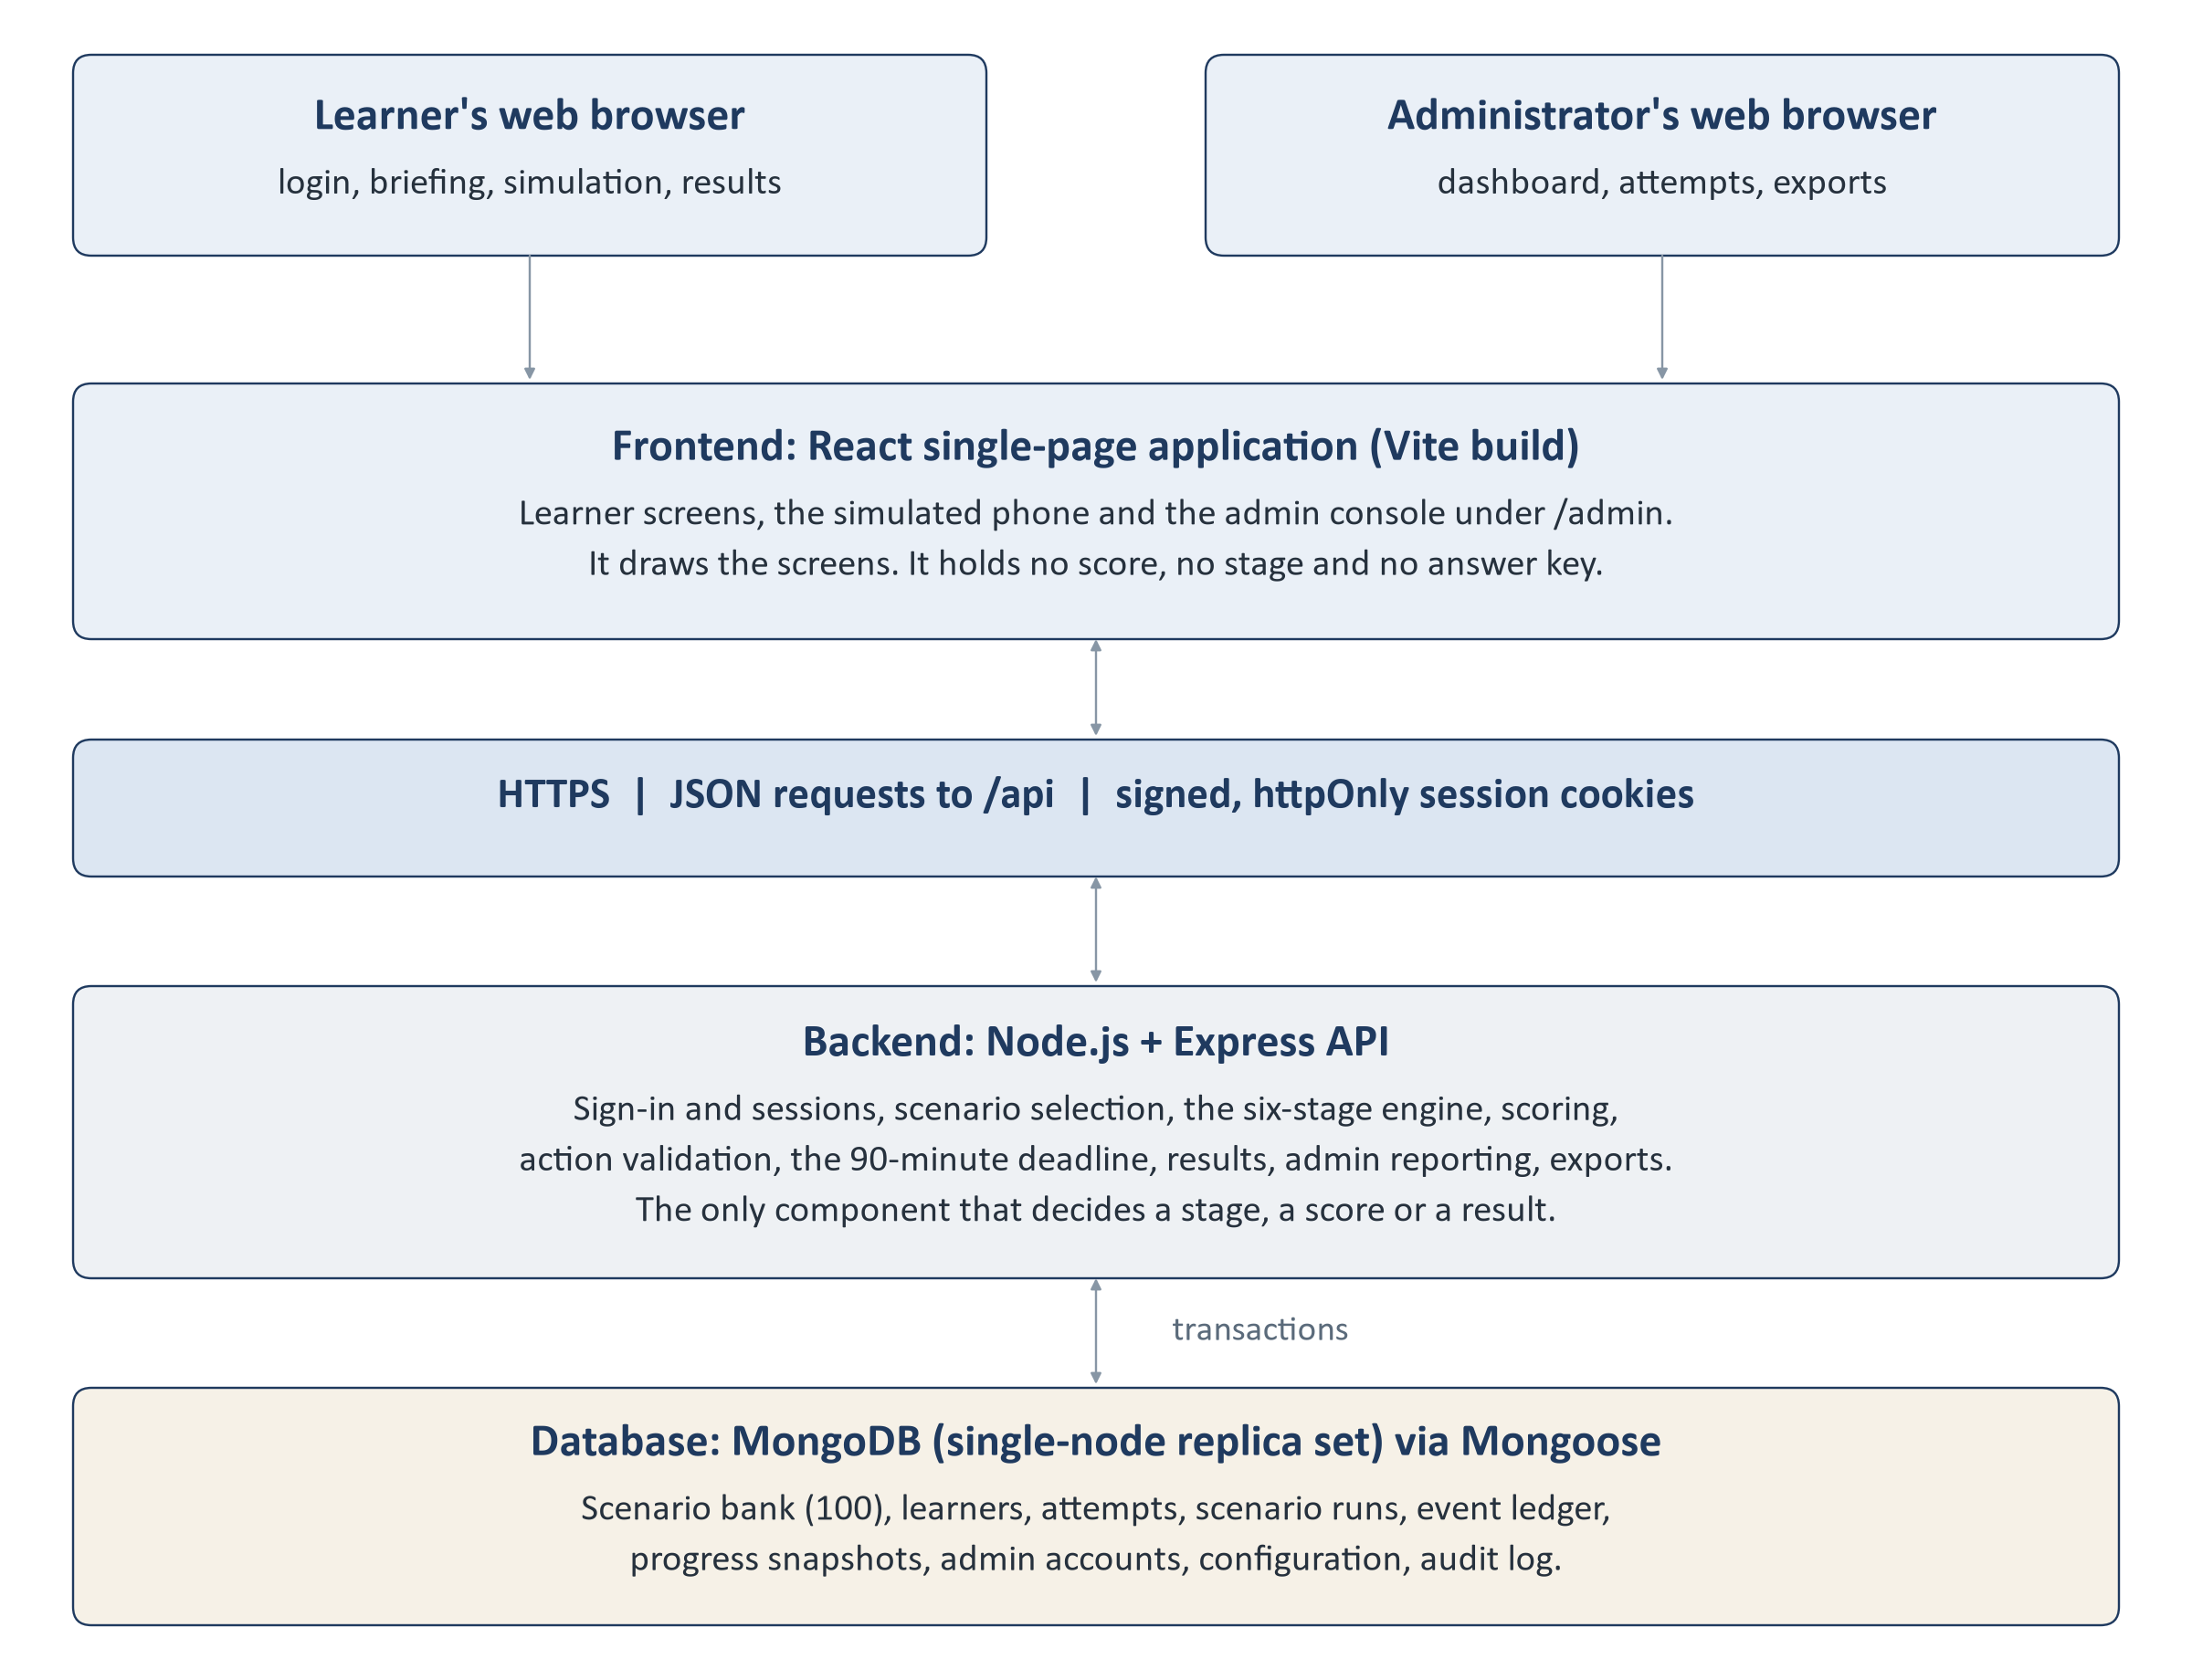
Figure 1. The four layers of the system and how they connect.
Layer | In plain terms | Technically
Browser | The window the learner or administrator uses. Nothing is installed. | Any modern browser. Holds only a signed session cookie it cannot read.
Frontend | The screens: login, briefing, dashboard, the simulated phone, results and the admin console. It shows what the server says and sends the learner's choices back. | React 19 single-page application built with Vite 8. Source in frontend/​src.
HTTPS / REST API | The conversation between the screens and the server. Each click that matters becomes one request and one answer. | JSON over HTTPS under the /​api path; fetch with credentials. No WebSockets or polling.
Backend | The rule keeper. It chooses the scenarios, checks every action, keeps time, keeps score and builds results. | Node.js 24 with Express 5. Source in backend/​src.
Database | The permanent record: the scenario bank, learners, attempts, every recorded action and the admin audit log. | MongoDB running as a replica set, accessed through Mongoose 9.

A short way to hold the whole design in mind: the browser asks, the server decides, the database remembers. The browser never calculates a score, never chooses the next scenario and never learns in advance which answer is correct.
PART B · ARCHITECTURE

3 Technology Stack
The table lists the technologies actually used, taken from backend/package.json, frontend/package.json and the source. The dependency list is deliberately short: the backend has six runtime packages, and things such as password hashing, PDF generation and request throttling are built on Node.js itself rather than on extra libraries.

Frontend
Technology | Purpose | Where used | Why it is used
React 19 (react, react-dom) | Builds the user interface from components | All screens in frontend/​src | Component model suits a screen made of many small, stateful parts such as the simulated phone
JavaScript + JSX | Language of the frontend | .js / .jsx files | No TypeScript source; @types/​react is present only for editor hints
Vite 8 | Development server and production build | frontend/​vite.config.js | Fast builds; produces static files for hosting
React Router 7 (react-router-dom) | Maps URLs to screens and guards them | src/​routes/​AppRoutes.jsx | Separate learner and admin route trees with guards
React state: useReducer + Context | Holds screen state | src/​state/​attemptMachine.js, src/​context/​CandidateProvider.jsx | Enough for this app; no Redux or Redux Toolkit is used
Tailwind CSS 4 (@tailwindcss/​vite) | Styling via utility classes and design tokens | src/​styles/​index.css and components | Consistent look without a separate CSS framework
lucide-react | Icon set | Across components | Single, consistent icon library
Browser fetch | HTTP calls to the API | src/​services/​apiClient.js | No HTTP library needed; one wrapper handles cookies and errors
Vitest 5 + Testing Library + jsdom | Component and logic tests | *.test.js(x) under src | Tests run without a browser or server
oxlint | Static code checks (lint) | frontend/​.oxlintrc.json | Fast linter; npm run lint

Backend
Technology | Purpose | Where used | Why it is used
Node.js 24 | Runs the server-side JavaScript | backend/​src/​server.js | Version 24 is required: admin password hashing uses the built-in crypto.argon2
Express 5 | HTTP server, routing and middleware | backend/​src/​app.js, src/​routes/​ | Small, well-understood web framework
Mongoose 9 | Schemas, validation and queries for MongoDB | backend/​src/​models/​ | Validation rules live next to the data definitions
cookie-parser, cookie-signature | Signed session cookies | src/​middleware/​session.js, src/​middleware/​adminSession.js | Sessions without a session store; separate secrets for learner and admin
cors | Allows the configured frontend origin to call the API with cookies | src/​app.js | Required when frontend and API are on different origins
dotenv | Loads configuration from backend/​.env | src/​config/​env.js | Keeps secrets out of code
Node crypto (Argon2id, HMAC) | Admin password hashing; learner action codes | src/​utils/​password.js, src/​services/​learnerActionService.js | Platform cryptography; no native add-ons to install
Built-in PDF and CSV writers | Admin exports | src/​utils/​pdfWriter.js, src/​utils/​csvWriter.js | No third-party PDF dependency
node:test | Backend test runner | backend/​tests/​ | Built into Node.js

Validation is written in the application rather than with a validation library: Mongoose schema rules check stored data, and controllers and services check request bodies explicitly (for example, by refusing any field the client is not allowed to send). No helmet, express-validator, JWT or rate-limit package is used; the admin login throttle is a small module of its own (src/middleware/adminThrottle.js).

Database
Technology | Purpose | Notes
MongoDB (8.3 used to build the release database) | Stores all persistent data | Must run as a replica set. A single-node replica set is enough.
Multi-document transactions | Keep related writes together | Used for attempt creation, every learner action, completion, expiry, demo skip and admin changes. The server refuses to run the engine on a standalone MongoDB rather than write non-atomically (src/​utils/​transactions.js).
Indexes | Speed and uniqueness | Declared in the Mongoose models; for example a unique index on intent_key makes every learner action idempotent. See Section 7.

Infrastructure and configuration
Item | Current implementation
Environment configuration | backend/​.env (template backend/​.env.example) read by src/​config/​env.js; frontend build variable VITE_API_BASE_URL (template frontend/​.env.example).
Process model | One Node.js process started with npm start (node src/​server.js). A PM2 or cluster setup is not part of the repository.
Web server / reverse proxy | Not confirmed in the current implementation. No Nginx or similar configuration is held in the repository.
HTTPS | Required in production because the session cookies are marked Secure when NODE_ENV=production. Certificate handling belongs to the hosting layer and is not in the repository.

4 High-Level System Design
Figure 2, at the end of this section, shows the main building blocks inside the frontend and backend and how a request travels through them. The pattern is the same everywhere: a screen calls a function in the frontend API layer; the request reaches an Express route; a controller translates it into a call to a service; the service applies the rules and reads or writes the database through a model.

Who talks to whom, and what moves between them
From | To | What moves
Learner browser | Frontend | Clicks and taps. Text typed into simulated forms stays here.
Frontend | Backend /​api/​candidates | Name and service number at sign-in; briefing acknowledgement.
Frontend | Backend /​api/​attempts | Start request; opaque action codes with an idempotency key; optional one-line rationale at resolution; completion request.
Backend | Frontend | The current scenario's learner-safe content, the action codes for this run, the committed stage, and after completion the full result. Never the answer key.
Backend | MongoDB | Reads of the scenario bank and learner history; transactional writes of attempts, runs and ledger events; derived progress snapshots.
Admin browser | Backend /​api/​admin | Username and password at sign-in; filters, paging, publish / reset / archive / export requests.
Backend | Admin browser | Aggregated dashboard figures, attempt lists and details including scenario classification, export files, audit entries.
Backend | File system | Export files written into the configured export directory (EXPORT_DIR, default backend/​exports).

The design principles behind it
- The server is authoritative. Stage, score, outcome, scenario order and the deadline are decided and stored by the backend. The frontend renders what the backend committed.
- The answer key stays on the server. Each scenario's evaluation block (expected actions and points) is excluded from normal queries and never included in anything sent to a learner.
- Everything that counts is recorded. Each accepted learner action becomes an event in an ordered, append-only ledger, and the score can be recomputed from that ledger at any time.
- Related writes happen together. Recording an action and advancing the scenario are one database transaction, so the record can never show half of a step.
- Content is fixed per attempt. An attempt pins the exact version of each scenario it uses, so later edits to the scenario bank never change an attempt already running or already scored.
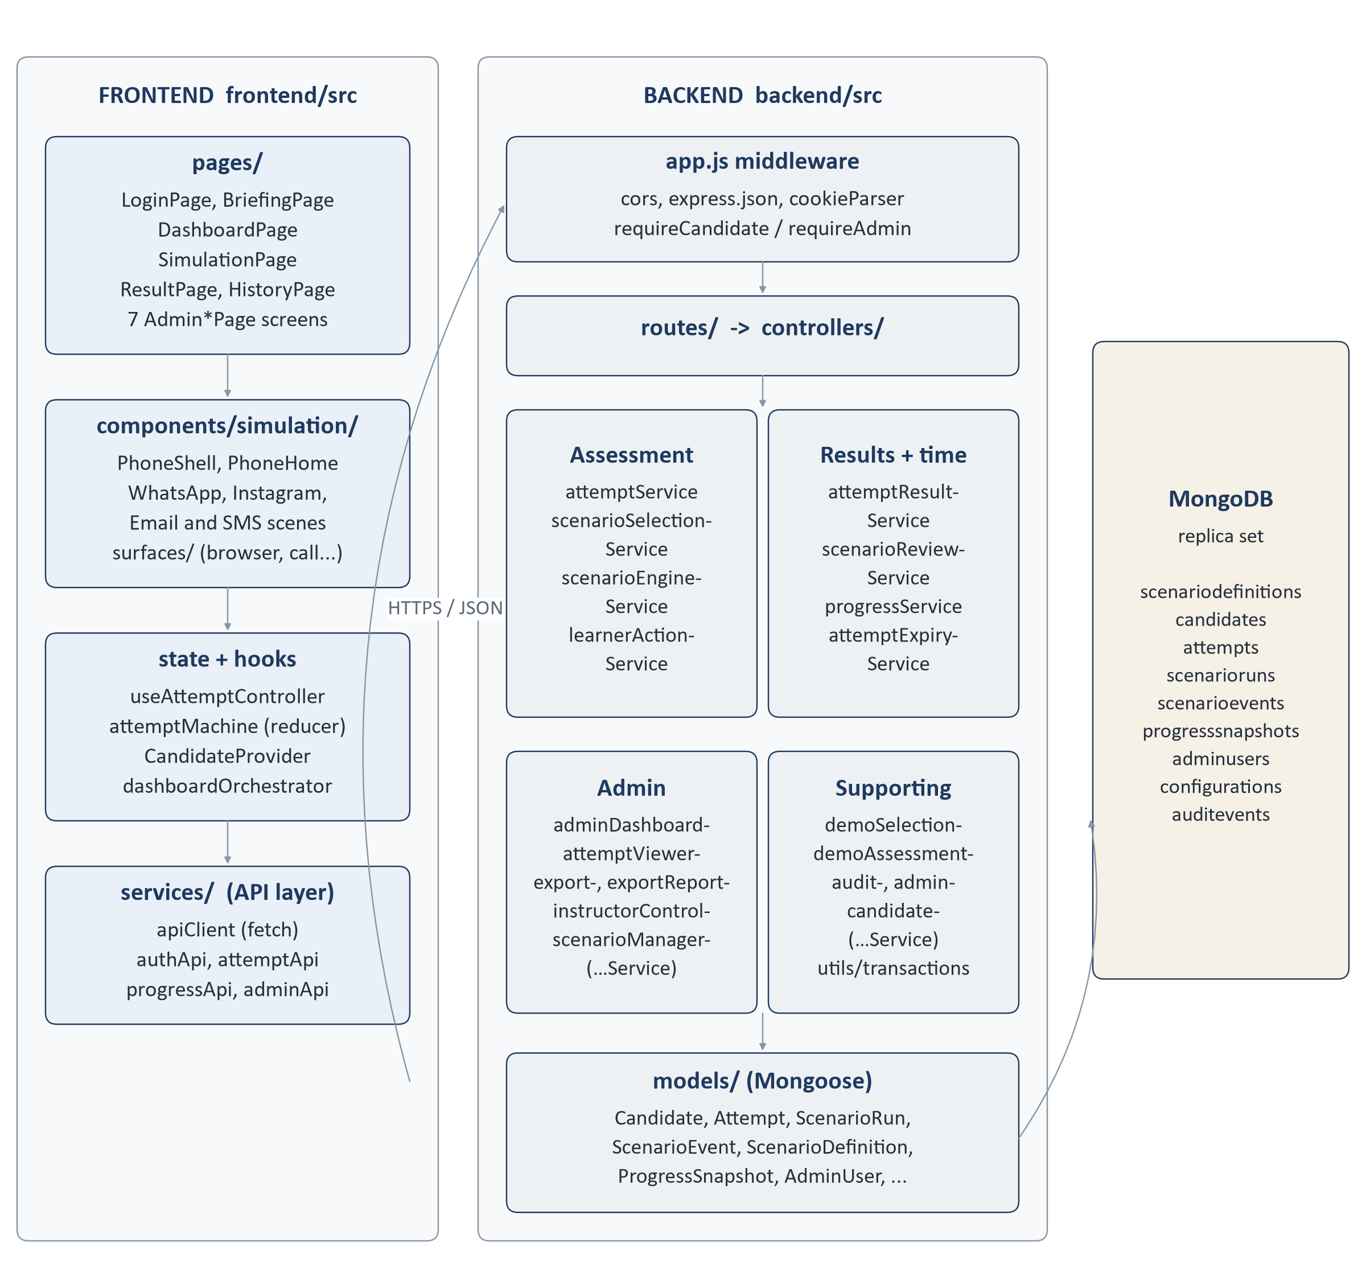
Figure 2. Component view: frontend modules, backend layers and database collections.

5 Frontend Architecture
IN PLAIN TERMS
The frontend is the part of the system the learner and administrator see and use in the browser. It is loaded once, then moves between screens without reloading the page. It knows how to draw the phone, the apps and the results, but it does not know the rules of the assessment - it asks the server.
TECHNICAL DETAIL
A React single-page application. frontend/src/main.jsx mounts App.jsx, which wraps the routes in BrowserRouter, ScrollToTop and CandidateProvider (the learner session context). All code uses the @/ alias for frontend/src.

Routing and guards
URL | Screen | Guard
/​login | LoginPage | Public
/​briefing | BriefingPage | RequireCandidate
/​dashboard | DashboardPage | RequireCandidate
/​assessment | SimulationPage - the six-stage simulation | RequireCandidate
/​result/​:attemptId | ResultPage | RequireCandidate (+ server ownership check)
/​history | HistoryPage | RequireCandidate
/​assessment/​legacy | AssessmentPage - older 40-question journey, kept but not linked | RequireCandidate
/​admin/​login | AdminLoginPage | Public
/​admin, /​admin/​scenarios, /​admin/​scenarios/​:scenarioId, /​admin/​attempts, /​admin/​attempts/​:attemptId, /​admin/​settings, /​admin/​audit | Admin console pages inside AdminLayout | RequireAdmin

The guards (src/routes/RequireCandidate.jsx, src/routes/RequireAdmin.jsx) only decide what to show. The backend enforces the same boundary independently on every API route, so a guard being bypassed in the browser gives access to nothing.

Authentication and session in the browser
CandidateProvider calls GET /api/candidates/me on load to discover whether a session exists, and exposes signIn, signOut and acknowledgeBriefing to the pages. The session itself is an httpOnly cookie set by the server; the frontend cannot read or store it, and no assessment state is kept in localStorage or sessionStorage.

The simulation screen
SimulationPage is the centre of the learner experience. It uses the useAttemptController hook, which is the only code that talks to the attempt API during an assessment. The hook feeds server responses into a reducer (src/state/attemptMachine.js) with phases such as loading, ready, submitting, completed, expired and error. Nothing on screen changes until the server has accepted an action - there is no optimistic update that could show a step the server refused.
The device is drawn by PhoneShell. At the Notify stage it shows the home screen (PhoneHome) with a notification; after that it shows the scenario inside the right app. Each of the 100 scenarios has an authored scene in src/simulation/scenes/<platform>/, registered in src/simulation/sceneRegistry.js. A scene is data: which conversation is open, which screens can be reached and which controls appear at each stage. The platform components draw it: whatsapp/WhatsAppScene.jsx, instagram/InstagramScene.jsx, email/EmailScene.jsx and sms/SmsScene.jsx. Screens the learner can push on top - a browser page, contact details, a call, a payment sheet, an installer, a file viewer, another app - live in components/simulation/surfaces/. For any scenario without a scene the page falls back to the platform renderers in components/assessment/channels/ and the generic ActionSheet.
Moving between screens on the phone (opening a contact card, going back, walking pages in the simulated browser) is local navigation handled by useSceneNavigation. It records nothing. Only controls that carry a server-issued action code are submitted.

Key frontend files
File | Responsibility
src/​App.jsx, src/​main.jsx | Application entry; router, scroll handling and session provider.
src/​routes/​AppRoutes.jsx | Every URL and which screen and guard it uses.
src/​context/​CandidateProvider.jsx | Learner session: who is signed in, sign-in, sign-out, briefing acknowledgement.
src/​pages/​LoginPage.jsx | Learner entry form (name + personal / service number), support dialogs.
src/​pages/​BriefingPage.jsx | Explains the six stages and records the learner's acknowledgement.
src/​pages/​DashboardPage.jsx | Start or resume the assessment; completed-assessment count, last and best score.
src/​pages/​SimulationPage.jsx | The assessment screen: phone, side panel, header, timer, outcome, skip (demo).
src/​hooks/​useAttemptController.js | All attempt API calls during an assessment; retries, stale-state recovery, expiry handling.
src/​state/​attemptMachine.js | Pure reducer holding the server's committed state.
src/​state/​dashboardOrchestrator.js, src/​hooks/​useActivityDelivery.js | When the notification appears (1-4 s after the phone is idle), the toast tray (max three), app tiles.
src/​components/​simulation/​PhoneShell.jsx | The simulated handset; chooses home screen, scene or fallback renderer.
src/​simulation/​sceneRegistry.js, src/​simulation/​sceneModel.js | Scene lookup for all 100 scenarios and the scene vocabulary.
src/​components/​simulation/​TrustedDirectory.jsx | The Trusted Directory used to verify independently.
src/​components/​simulation/​ScenarioOutcome.jsx | "Scenario n recorded" screen after each resolution.
src/​components/​simulation/​TimeRemaining.jsx, AttemptHeader.jsx | Progress, elapsed time and the 90-minute countdown (display only).
src/​components/​simulation/​DemoSkip.jsx | Skip button, rendered only when the server marks the attempt as a demo.
src/​pages/​ResultPage.jsx and src/​components/​result/​* | Score, outcome mix, comparison, behaviour breakdown, per-scenario review, practice areas.
src/​pages/​HistoryPage.jsx | The learner's completed assessments.
src/​services/​apiClient.js | One fetch wrapper: base URL, cookies, JSON, error shapes, network failure.
src/​services/​authApi.js, attemptApi.js, progressApi.js, adminApi.js | One small module per API area.
src/​components/​admin/​*, src/​pages/​Admin*Page.jsx | The administrator console (Section 23).

Loading and error handling
apiClient turns every failure into one error shape with an HTTP status and a stable code. A status of 0 means the server could not be reached; 401 means the session has ended, and the pages send the learner back to login. During an assessment, useAttemptController treats three codes specially: STALE_STATE (re-read the current scenario from the server), ATTEMPT_EXPIRED (go to the time-up screen) and a lost response on retry (the same idempotency key is reused, so the server replays rather than rescoring). Whole-screen states cover loading, no attempt in progress, and an error with a Retry button.

6 Backend Architecture
IN PLAIN TERMS
The backend is the part of the system that makes decisions. It checks who is asking, whether the request is allowed, what it means in the current scenario and what it is worth, then saves the result and sends back what the screen should show next.
TECHNICAL DETAIL
An Express 5 application created in backend/src/app.js and started by backend/src/server.js. On start-up the server connects to MongoDB, finalises any attempt whose deadline passed while it was down, starts listening, and starts a 30-second background sweep for overdue attempts.

Layers
Layer | Folder | What it does
Middleware | src/​middleware/​ | Parses JSON (1 MB limit) and cookies; resolves the learner (requireCandidate) or administrator (requireAdmin) from a signed cookie; throttles admin login; converts errors to JSON.
Routes | src/​routes/​ | Map URLs and HTTP methods to controller functions. index.js mounts them under /​api.
Controllers | src/​controllers/​ | Translate HTTP into service calls. They check ownership and refuse forbidden fields, but never compute a score or choose a scenario.
Services | src/​services/​ | The business rules: selection, the engine, scoring, results, expiry, demo, admin reporting, exports, instructor controls, auditing.
Models | src/​models/​ | Mongoose schemas with validation, indexes and learner-safe projections.
Constants | src/​constants/​ | The fixed vocabularies and rules (stages, intents, scoring codes, selection quotas, time limit).
Utilities | src/​utils/​ | Transactions, seeded random numbers, password hashing, CSV and PDF writers, error type, service-number masking.

Important call chains
Learner action. The chain for every scored click:
POST /api/attempts/:attemptId/runs/:runId/events
routes/attemptRoutes.js requireCandidate (middleware/session.js)
controllers/attemptController.js submitRunEvent
rejectAuthoritativeFields, findOwnAttempt, assertAttemptLive, findOwnRun
submitLearnerAction
services/learnerActionService.js translateActionCode -> { stage, intent }
services/scenarioEngineService.js submitIntent -> one transaction:
read ScenarioRun, check stage, resolveIntent,
insert ScenarioEvent, save ScenarioRun
controllers/attemptController.js attemptStateFor -> JSON response

Start assessment. POST /api/attempts -> attemptController.startAttempt -> attemptService.createAttempt (or demoAssessmentService.createDemoAttempt) -> scenarioSelectionService.selectAttemptScenarios -> one transaction that writes the Attempt and ten ScenarioRun documents. Section 11 walks through it.
Complete and result. POST /api/attempts/:id/complete -> attemptService.completeAttempt (sums the ten scenario scores inside a transaction) -> progressService.refreshProgressAfterCompletion -> attemptResultService.buildAttemptResult for the response.

Key backend files
File | Responsibility
src/​server.js | Start-up: database, expiry recovery, listener on HOST:PORT, sweeper, shutdown.
src/​app.js | Express app: CORS, JSON body parser, cookie parser, /​api routes, 404 and error handler.
src/​config/​env.js | Reads and checks configuration; refuses to start without ADMIN_SESSION_SECRET or with a default session secret in production.
src/​config/​demo.js | The Demo User identity (configurable through .env).
src/​middleware/​session.js | Learner cookie candidate_session; requireCandidate; archived profiles refused.
src/​middleware/​adminSession.js | Admin cookie admin_session with its own secret; requireAdmin.
src/​middleware/​adminThrottle.js | Locks admin sign-in after repeated failures.
src/​middleware/​errorHandler.js | Consistent JSON errors; hides internal detail in production.
src/​controllers/​attemptController.js | All learner assessment endpoints, including demo skip.
src/​services/​attemptService.js | Creates attempts and runs, finds the current run, completes attempts.
src/​services/​scenarioSelectionService.js | The 10-scenario selection solver and its independent validator.
src/​services/​scenarioEngineService.js | The six-stage state machine, scoring and the event ledger.
src/​services/​learnerActionService.js | Issues and translates the per-run action codes.
src/​services/​attemptExpiryService.js | The 90-minute deadline: route guard, sweeper, start-up recovery.
src/​services/​attemptResultService.js | Builds the result: outcome classes, breakdowns, comparison, practice areas.
src/​services/​scenarioReviewService.js | The per-scenario learning review (what you did, what to remember).
src/​services/​progressService.js | Rebuilds the learner's progress snapshot.
src/​services/​demoSelectionService.js, demoAssessmentService.js | Demo recognition, fixed set, skip, dashboard exclusion.
src/​services/​adminDashboardService.js | Aggregate figures for the admin dashboard.
src/​services/​attemptViewerService.js | Admin attempt list, learner lookup and attempt detail.
src/​services/​exportService.js, exportReportService.js | CSV and PDF exports for an attempt or a learner.
src/​services/​instructorControlService.js | Reset attempt, archive profile, feedback timing.
src/​services/​scenarioManagerService.js | Scenario bank: list, create, edit draft, clone, publish, deactivate.
src/​services/​auditService.js | Append-only audit log writes and reads.
src/​utils/​transactions.js | Transaction helper with bounded retries; replica-set check.

Error handling
errorHandler.js returns every error as { error: { code, message, details } }. Domain decisions such as STALE_STATE or RUN_NOT_ACTIVE keep their intended status (409, 422 and so on) so that the frontend can tell a superseded request from a fault. Malformed JSON returns 400, an oversize body 413, a Mongoose validation failure 422 and a duplicate key 409. Anything unexpected returns 500 with a generic message; the internal message is included only outside production.

7 Database Design
IN PLAIN TERMS
The database is the system's permanent memory. It holds the bank of 100 scenarios, one profile per learner, one record per assessment attempt, one record per scenario played inside that attempt, and a step-by-step log of every action the learner took. The admin side adds accounts, one settings record and an audit log of administrative changes.
Four words that matter
ScenarioDefinition - the master copy of a scenario in the bank: its content, its classification and its answer key.
Attempt - one sitting of the assessment by one learner: which ten scenarios, in which order, when it started, when it must end and the final total.
ScenarioRun - one scenario being played inside an attempt: which stage it has reached and what it scored. Ten per attempt.
ScenarioEvent - one recorded action inside a run, with the points it earned or lost. The ordered list of events is the evidence behind every score.

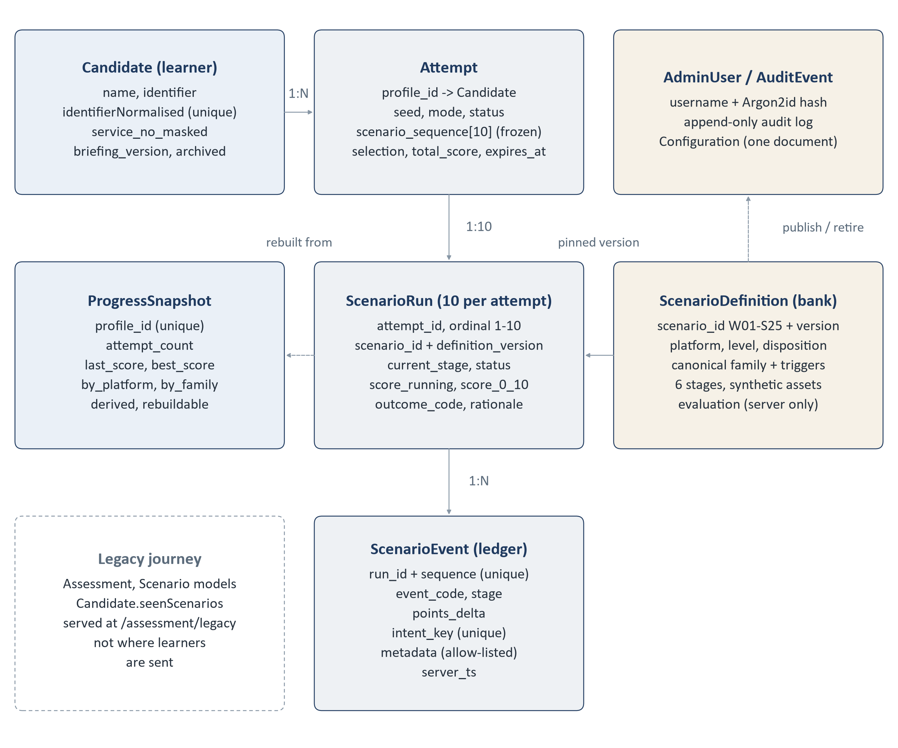
Figure 3. Main collections and their relationships.

Collections
Model (collection) | Purpose and important fields | Created / updated | Relationships
ScenarioDefinition (scenariodefinitions) | The scenario bank. scenario_id (W01-W25, I01-I25, E01-E25, S01-S25), version, active, lifecycle_state, platform, level, disposition (malicious / legitimate), canonical_family, canonical_triggers, military_flag, synthetic assets, six stages, and evaluation (hidden answer key and per-stage points). | Imported once (npm run import:definitions); new versions via the admin scenario manager. | Referenced by runs through scenario_id + definition_version.
Candidate (candidates) | The learner profile. name, identifier, identifierNormalised (unique), service_no_masked, last_seen_at, briefing_version, briefing_acknowledged_at, archived. | First sign-in creates it; later sign-ins update last_seen_at only. | One candidate has many attempts.
Attempt (attempts) | One assessment sitting. profile_id, seed, mode, status (in_progress / completed / abandoned), frozen scenario_sequence of 10, selection metadata, content_version, total_score, started_at, time_limit_ms, expires_at, end_reason. | Created at Start; completed, expired or reset once. Sequence, seed and deadline cannot change. | Belongs to a candidate; owns ten runs.
ScenarioRun (scenarioruns) | One scenario inside an attempt. attempt_id, ordinal 1-10, scenario_id, definition_version, platform, status, current_stage, last_sequence, score_running, score_0_10, outcome_code, rationale. | All ten created with the attempt; updated by every accepted action. | Belongs to an attempt; owns its events; pinned to one definition version.
ScenarioEvent (scenarioevents) | The event ledger. run_id, sequence, event_code, stage, points_delta, intent_key, client_ts, elapsed_ms, server_ts, allow-listed metadata. | Inserted by the engine, expiry or demo skip. Never updated or deleted by the application. | Belongs to a run.
ProgressSnapshot (progresssnapshots) | Derived learner progress: attempt_count, scenarios_completed, last_score, best_score, by_platform, by_family, mixed_versions. | Rebuilt from completed attempts after each completion or expiry, and on read if missing. | One per candidate; never used to decide a score.
AdminUser (adminusers) | username, usernameNormalised (unique), passwordHash (Argon2id, hidden from queries). | Created only from the command line (npm run admin:create). | Actor on audit entries.
Configuration (configurations) | Single document: assessment_feedback_timing, training_feedback_timing, config_version. | Created on first read; changed from Admin > Settings. | -
AuditEvent (auditevents) | Append-only log: action (e.g. SCENARIO_PUBLISHED, ATTEMPT_RESET, PROFILE_ARCHIVED, EXPORT_CREATED, CONFIG_CHANGED), actor, resource, time, sanitised metadata. | Written in the same transaction as the change it records. Updates and deletes are refused. | Refers to an admin and a resource.
Assessment, Scenario (legacy) | The earlier 40-scenario question journey. | Still in the code behind /​api/​assessments and /​assessment/​legacy; the release database carries these collections empty. | Not used by the current assessment.

Indexes that matter
- scenarioevents: unique intent_key (a retried action cannot be recorded twice) and unique (run_id, sequence) (two actions cannot claim the same step).
- scenarioruns: unique (attempt_id, ordinal) - exactly one run per position.
- scenariodefinitions: unique (scenario_id, version), plus indexes on active with platform, level, disposition, family, triggers and military flag for selection and the admin list.
- attempts: (profile_id, status), (profile_id, started_at), (started_at, _id) for the admin list, and (status, expires_at) for the expiry sweep.
- candidates: unique identifierNormalised, so one service number is one profile however it is typed.

Definition, run, event, attempt - the difference
A ScenarioDefinition is the script. An Attempt is one performance of ten scripts chosen for one learner. A ScenarioRun is one of those ten being performed, and it remembers where it has got to. A ScenarioEvent is one line in the record of that performance - "inspected the sender, +2". The definition never changes because someone played it; the attempt, run and events are the learner's own record.

8 API Communication
IN PLAIN TERMS
The frontend and backend talk through a set of web addresses (endpoints). Each one does one job - sign in, start an assessment, submit an action, get a result. The frontend sends a request, waits for the answer and draws the screen from it.
TECHNICAL DETAIL
REST-style JSON over HTTP(S). All paths are under /api. The frontend's apiClient sends every request with credentials: 'include' so the session cookie travels with it. The base URL is VITE_API_BASE_URL, or /api on the same origin when it is not set. Route files: backend/src/routes/.

Learner endpoints
Method | Endpoint | Purpose | Caller | Database
POST | /​api/​candidates | Sign in or register; starts the session | LoginPage (CandidateProvider) | Reads / creates Candidate
GET | /​api/​candidates/​me | Who is signed in | CandidateProvider | Reads Candidate; may update last_seen_at
POST | /​api/​candidates/​me/​briefing | Record briefing acknowledgement | BriefingPage | Updates Candidate
POST | /​api/​candidates/​logout | Clear the session cookie | Header menus | None
POST | /​api/​attempts | Start, or return the attempt already running | DashboardPage | Transaction: Attempt + 10 ScenarioRuns
GET | /​api/​attempts | Completed attempts (history) | HistoryPage | Reads Attempt
GET | /​api/​attempts/​current | The resumable (or just-expired) attempt | useAttemptController, DashboardPage | Reads; may finalise expiry
GET | /​api/​attempts/​:attemptId | One attempt's state | - | Reads; may finalise expiry
GET | /​api/​attempts/​:attemptId/​current-run | Current scenario, its content and action codes | useAttemptController | Reads Run + Definition
POST | /​api/​attempts/​:attemptId/​runs/​:runId/​events | Submit one action | useAttemptController | Transaction: Event + Run
POST | /​api/​attempts/​:attemptId/​runs/​:runId/​resolve | Final action of a scenario (+ rationale) | useAttemptController | Transaction: Event + Run
POST | /​api/​attempts/​:attemptId/​runs/​:runId/​demo-skip | Demo User skip; 404 for anyone else | useAttemptController | Transaction: Event + Run
POST | /​api/​attempts/​:attemptId/​complete | Finish after ten resolutions | useAttemptController | Transaction: Attempt; rebuild snapshot
GET | /​api/​attempts/​:attemptId/​result | Full learner-safe result | ResultPage | Reads Attempt, Runs, Events, Definitions
GET | /​api/​progress | Learner's progress snapshot | DashboardPage, ResultPage, in-assessment history panel | Reads / rebuilds ProgressSnapshot

Administrator endpoints
All of these except login and logout require the admin session (requireAdmin).
Method | Endpoint | Purpose | Database
POST | /​api/​admin/​login, /​api/​admin/​logout | Admin sign-in (throttled) and sign-out | Reads AdminUser
GET | /​api/​admin/​me | Current administrator | Reads AdminUser
GET | /​api/​admin/​dashboard | Aggregate statistics (no parameters) | Reads Candidates, Attempts, Runs, Definitions, Events
GET | /​api/​admin/​attempts, /​api/​admin/​attempts/​:attemptId | Attempt list (filters, paging) and detail | Reads
GET | /​api/​admin/​learners | Learner lookup for the filter | Reads Candidate
POST | /​api/​admin/​attempts/​:attemptId/​reset | Reset an in-progress attempt | Transaction + audit entry
POST | /​api/​admin/​learners/​:profileId/​archive | Archive a learner profile | Transaction + audit entry
POST | /​api/​admin/​exports/​attempts/​:attemptId, /​api/​admin/​exports/​learners/​:profileId | Create CSV or PDF export | Reads; writes file + audit entry
GET | /​api/​admin/​exports/​:filename | Download an export already written | File read
GET / PATCH | /​api/​admin/​config/​feedback | Read or change feedback timing | Configuration + audit entry
GET / POST | /​api/​admin/​scenarios | List the bank; create a draft | ScenarioDefinition
GET | /​api/​admin/​scenarios/​:scenarioId, .../​versions/​:version | Versions of a scenario | ScenarioDefinition
PATCH / POST | .../​versions/​:version, .../​clone, .../​publish, .../​deactivate | Edit draft, clone, publish, retire | Transactions + audit entries
GET | /​api/​admin/​audit | Read the audit log | Reads AuditEvent

Other endpoints
Method | Endpoint | Purpose
GET | /​api/​health | Server up time and database connection state; 503 when the database is not connected. No session needed.
GET | /​api/​scenarios/​summary | Counts from the legacy question bank. No session needed.
various | /​api/​assessments/​* | The legacy 40-scenario journey. Session required. Not used by the current assessment.

9 Real-Time Updates: WebSockets and Polling
The system does not use WebSockets, Socket.IO or Server-Sent Events, and it does not poll the server. This was checked across backend/src, frontend/src and both package.json files: none of these libraries is installed and no WebSocket or EventSource is created anywhere.
Communication is plain request and response. The browser sends a request when the learner does something (or when a screen loads), the server answers, and the screen is redrawn from the answer. Nothing is pushed from the server.

Timers that do exist, and why they are not polling
Where | What it does | Talks to the server?
backend/​src/​services/​attemptExpiryService.js | Every 30 seconds, finalises attempts whose deadline has passed (server-side job). | Runs inside the server
frontend/​src/​components/​simulation/​TimeRemaining.jsx, AttemptHeader.jsx | Update the on-screen clock every second. | No
frontend/​src/​components/​simulation/​DeviceFrame.jsx, TrainingRail.jsx | Refresh the phone's status-bar clock every 30 seconds. | No
frontend/​src/​components/​simulation/​AssessmentSessionPanels.jsx | Counts down the time shown in the logout confirmation. | No
frontend/​src/​components/​simulation/​surfaces/​CallSurface.jsx | Counts up the duration of a simulated call. | No
frontend/​src/​hooks/​useActivityDelivery.js | Waits 1-4 seconds before showing the next notification. | No

When the on-screen countdown reaches zero it does not end anything. It asks the server once for the current attempt (GET /api/attempts/current), and the server decides whether the attempt has expired.
PART C · HOW AN ASSESSMENT WORKS

10 The Complete Learner Flow
This section follows one learner from the login screen to the final result. Each stage has a short plain-language description followed by the technical detail.
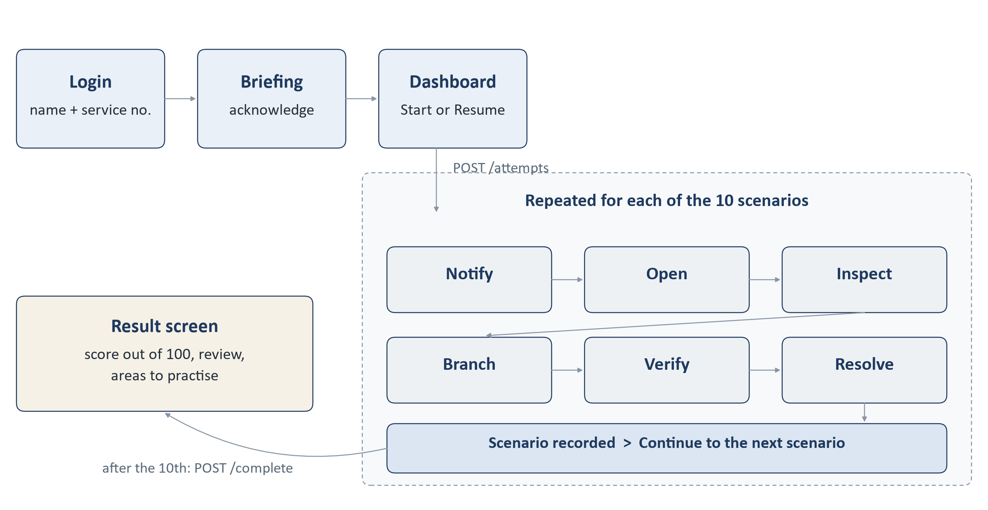
Figure 4. The learner journey. The inner loop runs once for each of the ten scenarios.

10.1 Login
The learner types their name and personal / service number. There is no password. If the number is new, a profile is created; if it is known, the learner continues with the existing profile and its history.
Technical | findOrCreateCandidate normalises the number (upper case; spaces, hyphens and slashes removed) and looks it up. A returning sign-in never changes the stored name. An archived profile is refused with 403. A signed, httpOnly cookie candidate_session (8 hours by default) is set.
Files | frontend/​src/​pages/​LoginPage.jsx, frontend/​src/​context/​CandidateProvider.jsx, backend/​src/​controllers/​candidateController.js, backend/​src/​services/​candidateService.js, backend/​src/​middleware/​session.js
API | POST /​api/​candidates
Database | Reads or creates a Candidate; updates last_seen_at.

10.2 Briefing
The briefing explains the six stages of a scenario and the rules. The learner ticks a box and continues; the acknowledgement is recorded with its version and time.
Technical | The server returns the briefing version it requires with the profile. The page sends that version back; any other value is refused. The acknowledgement is recorded on the profile. The start-assessment endpoint does not itself check it - the briefing is enforced by the screen flow (login always leads to the briefing).
Files | frontend/​src/​pages/​BriefingPage.jsx, backend/​src/​services/​candidateService.js (acknowledgeBriefing), backend/​src/​constants/​learnerProfile.js
API | POST /​api/​candidates/​me/​briefing
Database | Updates briefing_version and briefing_acknowledged_at on the Candidate.

10.3 Dashboard
The dashboard shows whether an assessment is waiting to be resumed and how many have been completed, with the last and best score. The learner presses Start (or Resume).
Technical | Two independent reads: the current attempt and the progress snapshot. Only an attempt the server reports as in_progress is offered for resume; an expired one falls back to Start.
Files | frontend/​src/​pages/​DashboardPage.jsx, backend/​src/​services/​progressService.js
API | GET /​api/​attempts/​current, GET /​api/​progress
Database | Reads Attempt; reads or rebuilds ProgressSnapshot.

10.4 Start assessment and scenario selection
The server chooses ten scenarios for this learner, fixes their order, sets a 90-minute deadline and saves the whole plan before the first scenario is shown.
Technical | startAttempt returns the running attempt if there is one; otherwise createAttempt runs the selection solver and writes the attempt and ten runs in one transaction. Section 11 has the full sequence; Section 12 explains the selection rules.
Files | backend/​src/​controllers/​attemptController.js, backend/​src/​services/​attemptService.js, backend/​src/​services/​scenarioSelectionService.js
API | POST /​api/​attempts
Database | Creates one Attempt and ten ScenarioRun documents.

10.5 Playing a scenario
A notification arrives on the simulated phone. The learner opens it, can look more closely at the sender, link or attachment, decides how to respond, may verify through a trusted route, and chooses a final action. Each of these is one step in the six-stage flow described in Section 16.
Technical | The page loads the current run with its learner-safe content and a set of opaque action codes. Each scored control submits its code; the engine validates it, records an event, applies the points and moves the run to the next stage, all in one transaction.
Files | frontend/​src/​pages/​SimulationPage.jsx, frontend/​src/​hooks/​useAttemptController.js, frontend/​src/​components/​simulation/​*, backend/​src/​services/​scenarioEngineService.js, backend/​src/​services/​learnerActionService.js
API | GET .../​current-run, POST .../​runs/​:runId/​events, POST .../​runs/​:runId/​resolve
Database | Reads ScenarioRun and the pinned ScenarioDefinition; inserts ScenarioEvent; updates ScenarioRun.

10.6 Scenario recorded
After the final action the learner sees "Scenario n recorded" and a sentence describing what they chose. In assessment mode the points for the scenario are not shown here, and the scenario's feedback appears only if the administrator has set feedback to "immediate".
Technical | The resolve response carries the run's final state. The feedback card is attached only when the configured timing for the attempt's mode is immediate (default: on_completion).
Files | frontend/​src/​components/​simulation/​ScenarioOutcome.jsx, backend/​src/​services/​instructorControlService.js (effectiveFeedbackTiming)
API | Response of POST .../​resolve
Database | Reads Configuration.

10.7 Next scenario, up to scenario 10
Continue loads the next scenario. The order was fixed at the start; nothing the learner did changes what comes next.
Technical | The frontend asks for the current run again; the server returns the lowest-numbered run that is not yet resolved. After the tenth, it returns run: null, which tells the page to complete.
Files | useAttemptController.advance, attemptService.findCurrentRun
API | GET /​api/​attempts/​:attemptId/​current-run
Database | Reads ScenarioRun.

10.8 Completion and final result
After the tenth scenario the learner presses Finish and sees the result: a score out of 100, how many threats were handled safely or missed, how many genuine messages were rejected, a review of each scenario and up to three areas to practise.
Technical | completeAttempt refuses unless all ten runs are resolved, sums their scores inside a transaction, marks the attempt completed and then rebuilds the progress snapshot. The result is built by buildAttemptResult on every read.
Files | attemptService.completeAttempt, attemptResultService.buildAttemptResult, frontend/​src/​pages/​ResultPage.jsx, frontend/​src/​components/​result/​*
API | POST /​api/​attempts/​:attemptId/​complete, GET /​api/​attempts/​:attemptId/​result
Database | Updates Attempt; upserts ProgressSnapshot; reads runs, events and definitions.

11 What Happens When the Learner Clicks Start Assessment
This is the moment the assessment is decided. Everything about which scenarios the learner will see, and in what order, is fixed here on the server and saved before the first notification appears.
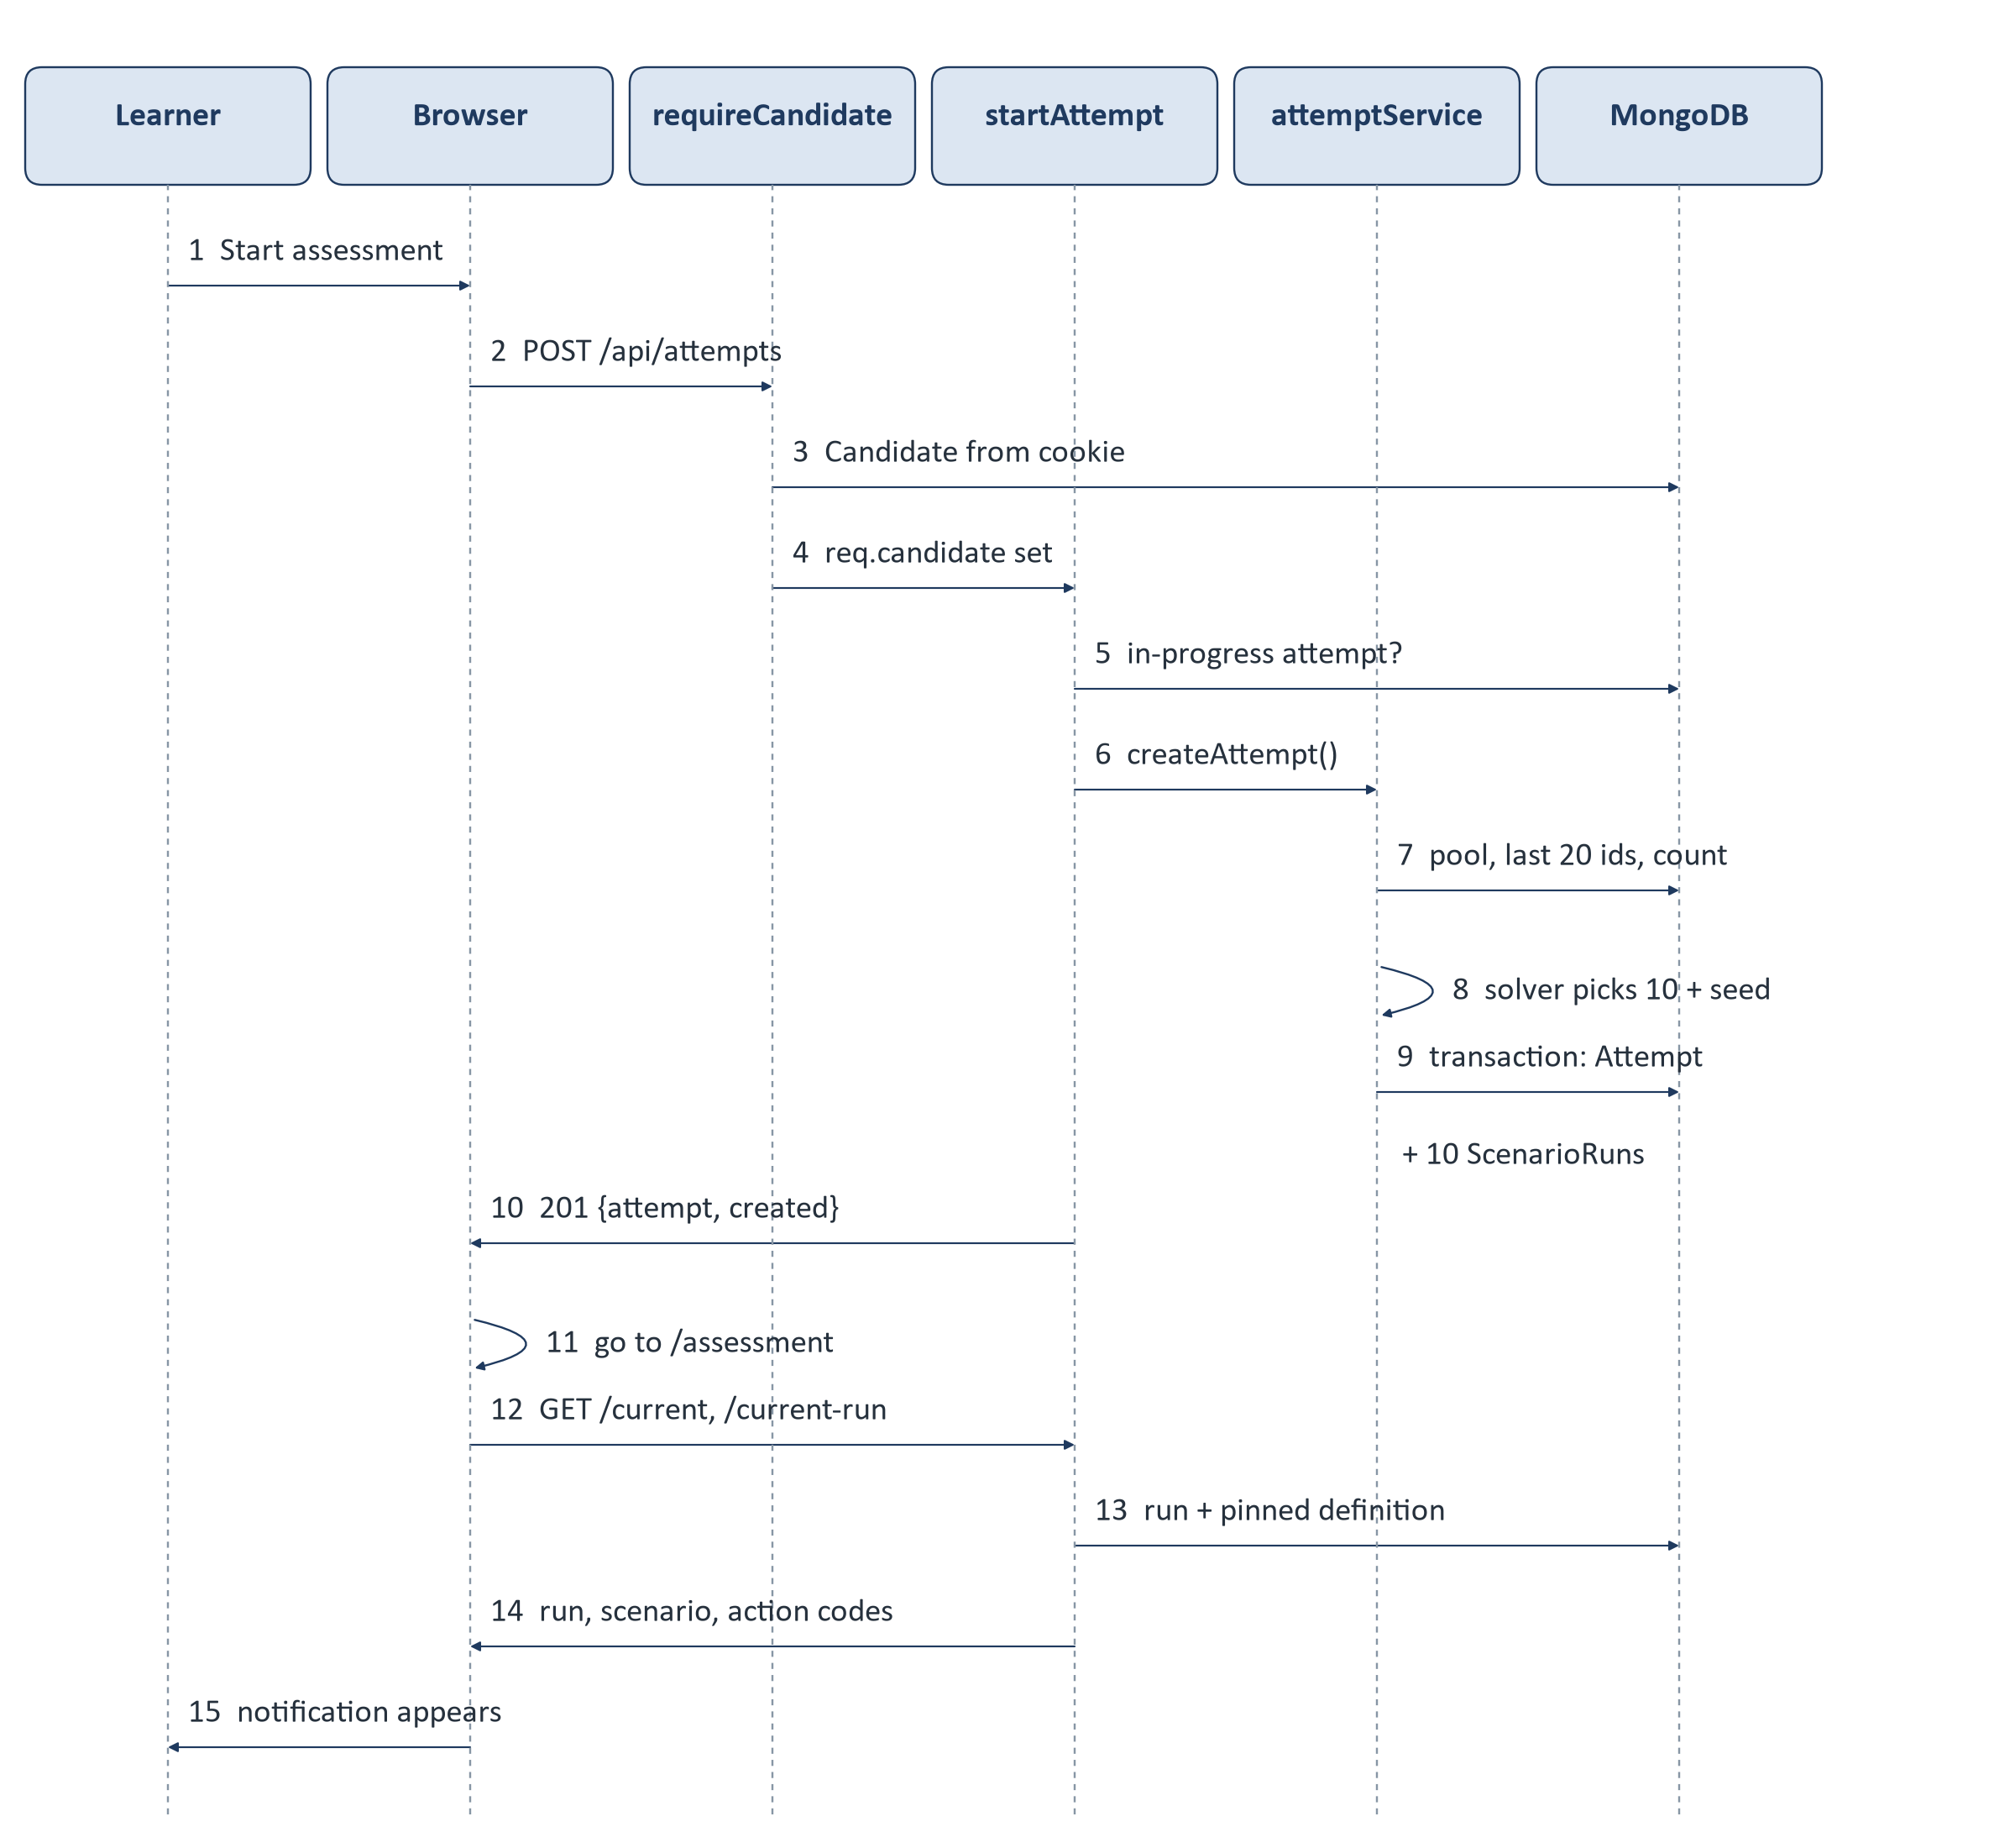
Figure 5. Sequence of calls when Start assessment is pressed.

Step by step
1. Frontend click. On the dashboard, the Start button calls handleStart in frontend/src/pages/DashboardPage.jsx, which calls attemptApi.start() (frontend/src/services/attemptApi.js). No mode is sent, so the server uses assessment.
2. API request. apiClient sends POST /api/attempts with the session cookie.
3. Learner identification. requireCandidate (backend/src/middleware/session.js) reads the signed candidate_session cookie, loads the Candidate, refuses archived profiles and attaches req.candidate. The learner is never identified from the request body.
4. Validation. startAttempt (backend/src/controllers/attemptController.js) refuses the request if the body contains any server-owned field - seed, scenario ids, composition, score, stage, deadline and more.
5. Active attempt check. findActiveAttempt looks for an in_progress attempt. If one exists and its deadline has not passed, it is returned with created: false - pressing Start twice never creates a second attempt. If its deadline has passed, it is finalised first and a new attempt is created.
6. Demo check. isDemoCandidate compares the profile's normalised service number with the configured Demo number. The Demo User goes to createDemoAttempt; everyone else to createAttempt. Both persist through the same code.
7. Scenario selection. createAttempt (backend/src/services/attemptService.js) confirms MongoDB supports transactions, loads the active scenario bank (classification fields only - never the answer key), the learner's 20 most recent scenario ids and their attempt count, creates a random seed and calls selectAttemptScenarios (Section 12).
8. Attempt creation. Inside one transaction the server re-checks that no attempt is in progress, updates the learner's last_seen_at (this serialises two concurrent Starts), and inserts the Attempt with the frozen scenario_sequence, the seed, the selection metadata, started_at, time_limit_ms (90 minutes) and expires_at.
9. Scenario run creation. In the same transaction it inserts ten ScenarioRun documents, ordinals 1 to 10, each pinned to a scenario id and content version, starting at stage notify with a score of 0.
10. Response. 201 Created with the learner-safe attempt state: id, status, 10 scenarios, start time, deadline, the server's current time, progress 0/10 and a pointer to the first run (its id, platform and stage). No scenario content and no list of scenario ids is included.
11. Frontend rendering. The dashboard navigates to /assessment. SimulationPage asks GET /api/attempts/current, then GET /api/attempts/:attemptId/current-run, which returns the first run, its scenario content (learner-safe projection) and the action codes for this run. One to four seconds after the phone becomes idle, the notification appears.

Questions this answers
Question | Answer
Are all 100 scenarios loaded? | Not into the browser. The server reads the classification fields of the active bank to run selection, but the browser never receives the bank or a list of chosen ids.
Are only the selected scenarios loaded? | Yes, and one at a time. The browser receives the content of the current scenario only, when it becomes current.
Is selection performed in the backend? | Yes, entirely, in scenarioSelectionService.js. The request may not contain any selection input.
Is the sequence persisted? | Yes, in Attempt.scenario_sequence, and as ten ScenarioRun records, committed together.
Can the sequence change? | No. A model hook refuses any later change to the sequence, the seed or the selection metadata. Learner behaviour, refresh, reconnect or restart cannot alter it.
Does the frontend request each scenario separately? | Yes. After each resolution it calls current-run and the server returns the next unresolved run in order.

12 Scenario Selection
Two things are easy to confuse here. The scenario bank is the full set of 100 scenarios stored in the scenariodefinitions collection, 25 per platform. The assessment sequence is the ten scenarios chosen from that bank for one attempt, stored on that attempt only. The bank is shared by everyone; each sequence belongs to one learner and one attempt.
Platform | Scenarios | Malicious | Genuine | Easy | Medium | Hard | Military context
WhatsApp | 25 | 20 | 5 | 8 | 9 | 8 | 10
Instagram | 25 | 20 | 5 | 8 | 9 | 8 | 12
Email | 25 | 20 | 5 | 8 | 9 | 8 | 8
SMS | 25 | 20 | 5 | 8 | 9 | 8 | 5
Total | 100 | 80 | 20 | 32 | 36 | 32 | 35

Composition of the release bank as recorded in docs/PRODUCTION_RELEASE_MANIFEST.md (all 100 active, content version 1).
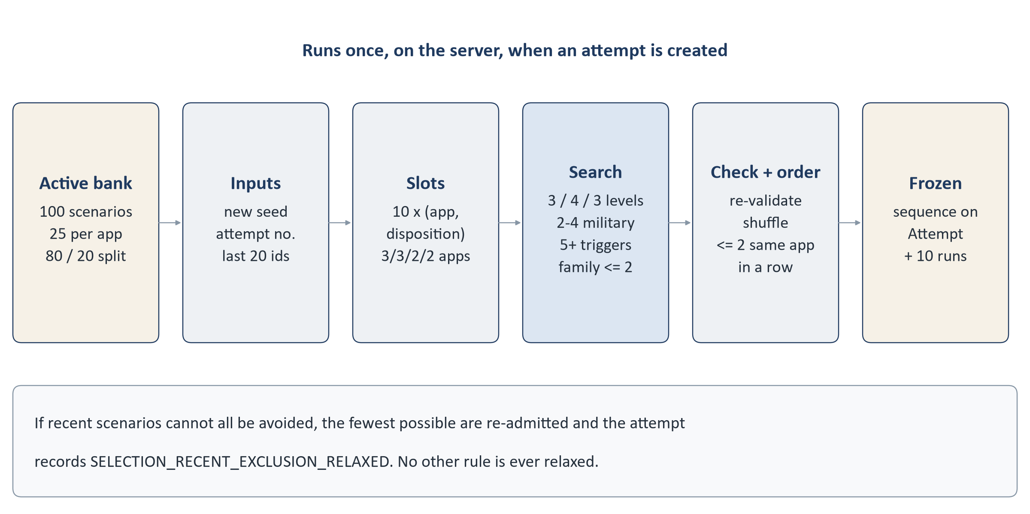
Figure 6. How ten scenarios are chosen for an attempt.

The rules every normal attempt satisfies
Rule | Value | Where defined
Scenarios per attempt | Exactly 10, no repeats | ATTEMPT_SCENARIO_COUNT
Malicious vs genuine | 8 malicious, 2 genuine; the two genuine ones from different platforms | DISPOSITION_QUOTA
Difficulty | 3 easy, 4 medium, 3 hard | DIFFICULTY_QUOTA
Platforms | A 3 / 3 / 2 / 2 split that rotates with each attempt (table below) | PLATFORM_PATTERN, platformQuotaFor
Military-context cases | Between 2 and 4 | MILITARY_RANGE
Psychological triggers | At least 5 distinct canonical triggers across the ten | MIN_DISTINCT_TRIGGERS
Attack families | No canonical family more than twice | MAX_PER_CANONICAL_FAMILY
Recent scenarios | Avoid the learner's 20 most recent scenario ids where possible | RECENT_EXCLUSION_WINDOW
Presentation order | Shuffled; never more than two scenarios from the same app in a row | MAX_CONSECUTIVE_SAME_PLATFORM

All values are in backend/src/constants/scenarioSelection.js.

Platform rotation
The platform split is driven by how many attempts the learner has started before (all statuses, including reset attempts), so that over any four consecutive attempts each platform contributes exactly ten scenarios.
Learner's attempt | WhatsApp | Instagram | Email | SMS
1st, 5th, 9th ... | 3 | 3 | 2 | 2
2nd, 6th, ... | 3 | 2 | 2 | 3
3rd, 7th, ... | 2 | 2 | 3 | 3
4th, 8th, ... | 2 | 3 | 3 | 2

How the solver works
Picking ten at random and checking them would rarely satisfy every rule, so the solver builds a valid set directly. It lays out ten slots of (platform, malicious or genuine), fills the hardest slots first (genuine scenarios are scarce: five per platform) and, after each choice, checks that the remaining slots can still meet the difficulty, military, trigger and family rules. Any dead end is abandoned early. The result is then checked again by a separate validator (validateSelection) that shares no logic with the solver; if the two ever disagreed the attempt would not be created.

Deterministic, but different for every attempt
The only randomness is a 16-byte seed created for each new attempt (createSeed in backend/src/utils/seededRandom.js). Every choice the solver makes comes from that seed through a deterministic generator, and candidate lists are ordered by scenario id rather than database order. The seed is stored on the attempt, so the same seed, bank and history always reproduce the same ten scenarios in the same order - which makes every attempt auditable. Because each attempt gets a new seed, two attempts normally receive different sequences.

Relaxation
If the rules cannot be met while avoiding all 20 recent scenarios, the solver re-admits recent scenarios one at a time and stops at the smallest number that works. The attempt records SELECTION_RECENT_EXCLUSION_RELAXED and which ids were re-admitted. No other rule is ever relaxed: if the bank could not produce a valid attempt, the start request would fail with an error rather than produce a weaker assessment.

The Demo User's fixed sequence
The Demo User does not go through the solver. selectDemoScenarios returns the same ten scenarios in the same order every time (backend/src/constants/demoAssessment.js), after checking they are all active and still split 6 malicious / 4 genuine. See Section 24.

13 Is the Assessment Adaptive?
No. The current system does not adapt to the learner's performance. The ten scenarios and their order are fixed when the attempt starts, before the learner has done anything, and they do not change while the attempt runs. There is no difficulty model, no levelling and no prediction.
Question | Current behaviour
Does the score affect the next scenario? | No. The next scenario is simply the next run in the frozen sequence.
Does good performance increase difficulty? | No. Every normal attempt has 3 easy, 4 medium and 3 hard scenarios.
Does poor performance decrease difficulty? | No.
Does the assessment "level up"? | No. There are no levels beyond each scenario's fixed difficulty label.
Does the second attempt become harder? | No. It has the same difficulty mix. It uses different scenarios where possible.
Does one mistake affect future selection? | No. Selection reads only the learner's recent scenario ids and attempt count - never scores, outcomes or events.

What does influence selection
- A new random seed for each attempt.
- The learner's attempt count, which rotates the platform split.
- The learner's 20 most recent scenario ids, which are avoided where possible.
- Which scenarios are active in the bank when the attempt starts.
A note on "training" mode
The data model allows two modes, assessment and training (ATTEMPT_MODES). The learner screens always start assessment attempts. A training-mode attempt could only be created by calling the API directly; it would be selected by the same solver and differ only in feedback timing and in showing each scenario's points on the outcome screen. No adaptive behaviour exists in either mode.

14 Second and Later Attempts
A learner can take the assessment again once their previous attempt has ended (completed, timed out or reset by an administrator). Only one attempt can be in progress at a time.
Attempt 1 (in_progress) -> 10 runs resolved -> POST /complete
-> completed, total_score written, ProgressSnapshot rebuilt
Dashboard -> Start -> POST /api/attempts
-> Attempt 2: new seed, new sequence, 10 new runs

Aspect | What happens
New records | A new Attempt, ten new ScenarioRun documents and, as the learner plays, new ScenarioEvent records. Nothing from attempt 1 is reused or modified.
Scenario rotation | The platform split moves to the next step of the rotation (Section 12).
Recent exclusion | The 20 most recent scenario ids are avoided where possible. With ten scenarios per attempt this in practice means the previous two attempts. A third attempt may therefore meet scenarios from the first.
Difficulty | Unchanged: 3 easy, 4 medium, 3 hard.
Influence of earlier behaviour | None. Earlier scores, mistakes and outcomes are not read by selection.
Score comparison | The result compares with the learner's previous completed attempt, but only when both share the same mode, content version and taxonomy versions. Otherwise it says a comparison is not available and why.
Progress | The dashboard shows the number of completed assessments with the last and best score. If completed attempts span different content versions, the snapshot flags it.
History | The History page lists every completed attempt with its date and score, each linking to its full result.

Can scenarios repeat? Never within an attempt. Across attempts they are avoided for the last 20 scenario ids, and may return after that; if a learner took so many attempts that avoidance became impossible, the minimal relaxation in Section 12 applies and is recorded.

15 The Simulated Applications
Each scenario takes place in one of four simulated apps on a simulated handset drawn in the browser (frontend/src/components/simulation/DeviceFrame.jsx, PhoneShell.jsx). The home screen shows the four app tiles and a notification tray of at most three items. All four apps are synthetic training simulations: they are drawn from the scenario's stored content, contain no real accounts, and do not connect to WhatsApp, Instagram, any mail server or any mobile network.

15.1 WhatsApp
Purpose | Tests trust in personal and group messaging: impersonated contacts, forwarded login codes, payment requests, device-link QR codes, fake support.
What the learner sees | A chat list with the unread conversation among ordinary ones; message bubbles with ticks and times, system notices, polls, link previews, payment request cards, voice and call screens.
Evidence to inspect | Contact and group information with tabs (for example groups in common), link and attachment detail, the payment sheet before a PIN.
Files | components/​simulation/​whatsapp/​WhatsAppScene.jsx, ChatBlocks.jsx, AttachmentTile.jsx

15.2 Instagram
Purpose | Tests social-media lures: cloned friend accounts, fake giveaways and investment offers, message requests from strangers, false official pages.
What the learner sees | Notifications list or message-requests inbox, posts with captions and comments, stories, DM threads, profiles with a grid, followers and "About this account".
Evidence to inspect | The profile's age, follower pattern and "About this account" page, the post and its comments, where a link really goes.
Files | components/​simulation/​instagram/​InstagramScene.jsx, IgBlocks.jsx, surfaces/​SocialSurface.jsx

15.3 Email
Purpose | Tests phishing and business email fraud: password-expiry links, invoice and bank-change requests, QR-code documents, malicious attachments.
What the learner sees | A mailbox with folders; a message opened from its row; sender line, body with buttons and attachments, quoted history, reply and forward sheets.
Evidence to inspect | Expanded sender details (From, Reply-To, To and an authentication summary), "Show original", the real target of each link, attachment preview.
Files | components/​simulation/​email/​EmailScene.jsx, MailBlocks.jsx, surfaces/​MailSurface.jsx

15.4 SMS
Purpose | Tests text-message fraud: delivery and toll scams, fake bank alerts, APK "updates", one-time codes.
What the learner sees | The phone's Messages app with category tabs (Personal, Transactions, Promotions, Spam), grey and blue bubbles, carrier system lines, link preview cards and warning bars.
Evidence to inspect | The real sending number, whether it is a registered sender header or an ordinary mobile, which SIM received it, where a shortened link expands to, what else the sender has sent.
Files | components/​simulation/​sms/​SmsScene.jsx, SmsBubbles.jsx, surfaces/​SmsSurface.jsx

15.5 What is common to all four
- Notification. Each scenario starts with a notification on the home screen, delivered one to four seconds after the phone becomes idle. Opening it opens the right app at the right item; dismissing it is recorded but the scenario remains.
- Interaction. Scored decisions are made with the controls a person would really use - tapping the conversation, the sender's name, a link, a payment card, a menu item. A list of the available actions is also shown beside the phone for anyone who prefers to read the options.
- Safe and unsafe actions. Safe choices include refusing the request, using the official route instead, verifying independently and reporting. Unsafe choices include opening the link, replying, calling the number in the message, entering details, paying, installing, approving a device link or sharing a secret or location. Unsafe choices are allowed so that they can be measured; their consequence is drawn on the phone as an inert screen.
- Verification. The Trusted Directory (TrustedDirectory.jsx) lists only entries stored with the scenario as trusted sources; numbers or links from the suspicious message can never appear in it. Scenarios may also offer the known official app (drawn as a separate app) or a known number. Using contact details from the message itself is recorded as verification through the message, which is not a trusted check.
- Resolution. The learner ends the scenario by reporting, blocking, keeping, continuing with the request, or ignoring it, and can add an optional one-line reason of up to 250 characters. The reason is stored but never scored.
- Containment. The simulated browser shows only reserved training addresses; forms accept typing but the values live only in that screen and are discarded when it closes; calls use no microphone or camera; nothing opens a real link, file or app.

16 The Six-Stage Scenario Flow
Every scenario is played through the same six stages. The stage a scenario is in is held on the server (ScenarioRun.current_stage), and each stage accepts one scored step that moves it forward. The legal moves are defined in STAGE_INTENTS in backend/src/constants/scenarioEngine.js.
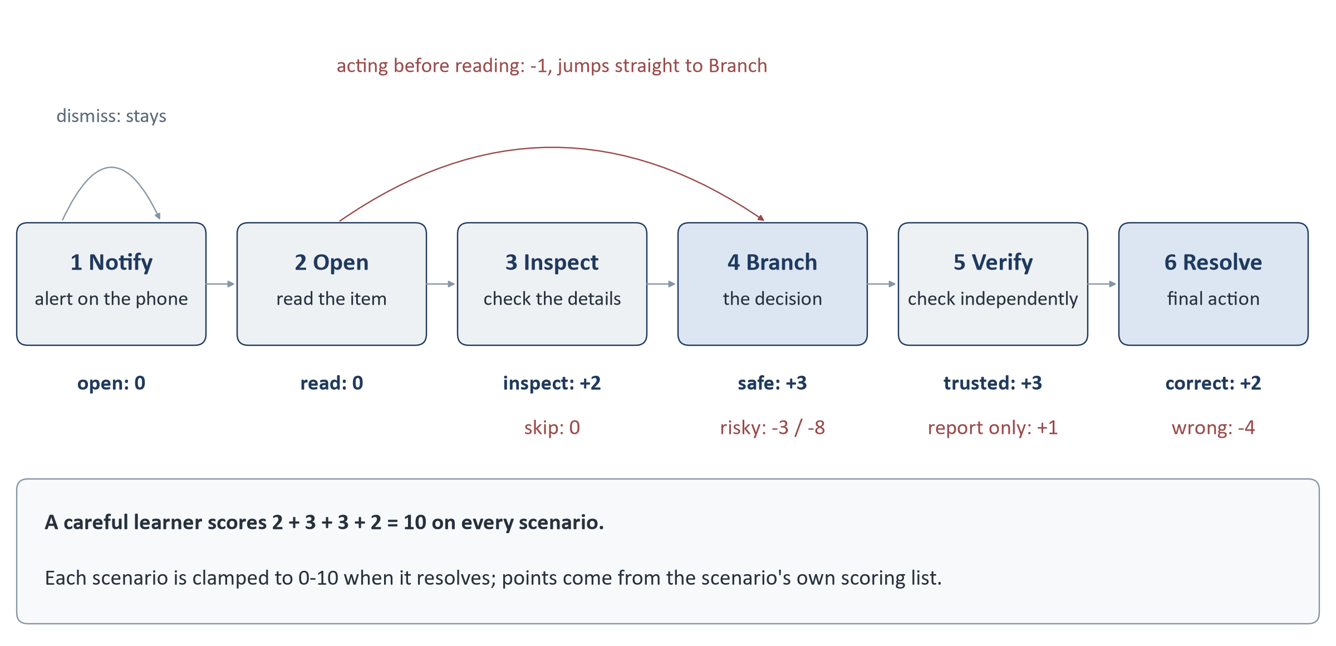
Figure 7. The six stages, the usual path and the points each step can carry.
Stage | Learner sees | Learner can | Recorded / scored
1 Notify | Home screen with the notification. | Open it, or dismiss it. | Open: NOTIFY_SEEN, 0 points, moves to Open. Dismiss: notification_dismissed, 0, stays at Notify. Time before opening is recorded.
2 Open | The message, post, email or text in its app. | Read it properly, or act on it straight away (reply, open the link, submit, pay, install, call). | Read: ITEM_OPEN, 0, moves to Inspect. Acting first: PREMATURE_REPLY, -1, jumps to Branch. Time on screen is recorded.
3 Inspect | The item plus ways to look closer. | Inspect the sender, profile, link, file, QR code or thread; or skip. | Inspect: INSPECT_CONTEXT, +2. Skip: STAGE_SKIPPED, 0. Both move to Branch.
4 Branch | The request itself - what the message wants. | Take the safe route, reject it, or do what it asks. | Safe route: SAFE_PIVOT (malicious) or CORRECT_USE (genuine), +3. Needless rejection: NEEDLESS_REJECT_IGNORE, -2. Risky open or reply: RISKY_OPEN_REPLY -3 or UNSAFE_EXTERNAL_ACTION -4. Giving away data, money, a code, an install or a device link: SECRET_PAYMENT_INSTALL_DATA_RELEASE -8 or UNSAFE_EXTERNAL_ACTION -4. Moves to Verify; a risky action also shows its simulated consequence.
5 Verify | Ways to check. | Use the Trusted Directory, the known app or a known number; use the contact in the message; or report / block without checking. | Trusted check: TRUSTED_VERIFY, +3. Message contact: VERIFY_THROUGH_MESSAGE, 0. Report or block: REPORT_ONLY_WITHOUT_CHECK +1 on a malicious item, FALSE_REPORT_BLOCK -4 on a genuine one. Moves to Resolve.
6 Resolve | Final choices and an optional reason. | Report, block, keep, continue, or ignore. | Correct for what the item really was (report / block a malicious item; keep / continue a genuine one): RESOLVE_CORRECT, +2. Anything else, including ignore: CONTRADICTORY_UNSAFE_FINAL, -4. The run is resolved and its score fixed.

How one intent can mean different things
Each scenario's definition lists which scoring codes apply at each stage. When the engine receives an action it takes the first code in that action's preference list that the scenario declares. This is how the same "take the safe route" choice scores SAFE_PIVOT on a malicious scenario and CORRECT_USE on a genuine one, and how "report" at the Verify stage is +1 on a scam but -4 on a genuine message - without the engine containing any scenario-specific code. An action the scenario does not declare at that stage is refused.

Components involved
Stage | Frontend | Backend
All | SimulationPage, useAttemptController, PhoneShell, the platform scene | attemptController.submitRunEvent / resolveRun, learnerActionService, scenarioEngineService
Notify | PhoneHome, NotificationTray, useActivityDelivery | -
Inspect | Scene surfaces (details, mail, SMS, social), InspectSheet | View key returned after commit
Branch | surfaces/​* for consequences (browser, payment sheet, installer, call, viewer) | Consequence returned as an inert rendering instruction
Verify | TrustedDirectory, surfaces/​AppSurface.jsx | verify_source recorded in event metadata
Resolve | Scene resolve controls, rationale field, ScenarioOutcome | Run resolved, score clamped, optional feedback attached

17 Learner Actions and the Behaviour Flow
Every scored click follows the same path from the screen to the database and back.
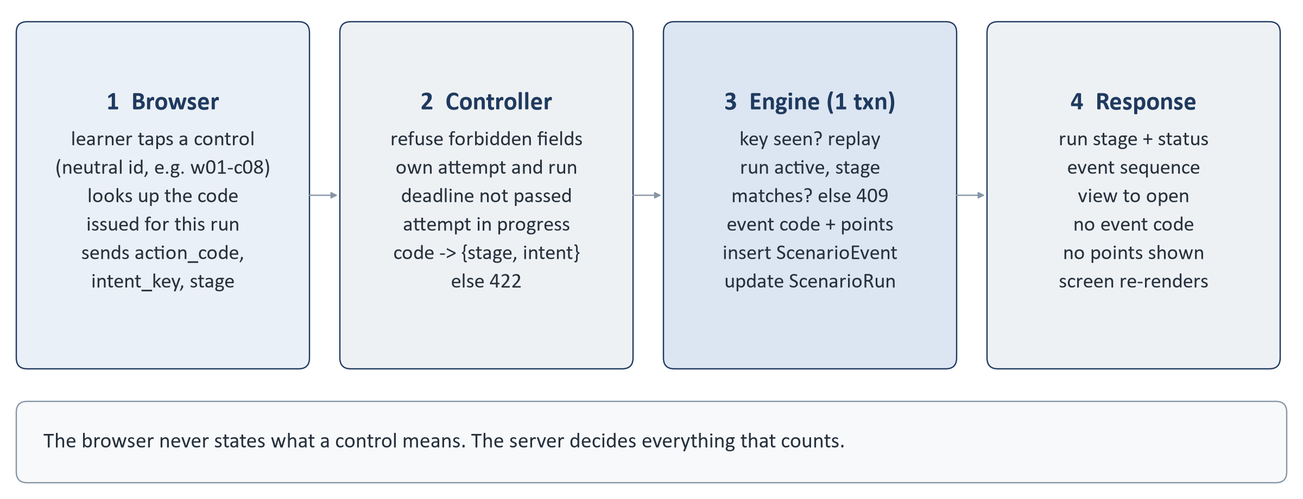
Figure 8. What happens to one learner action.

Why action codes are neutral
If the browser sent "share_secret" or "verify_trusted_directory", anyone could open the browser's developer tools, read the names and work out which button is safe. So the browser never holds those names. Each control on screen has a neutral position-style id such as w01-c08, and for each run the server issues an opaque code for every control, for example ac_ followed by 20 hexadecimal characters. The browser sends the code; the server translates it back.
- Codes are an HMAC of the run id, scenario id, content version and control id, keyed by a server secret (LEARNER_ACTION_SECRET, or one derived from SESSION_SECRET). They are deterministic, so a reload returns the same codes.
- A code works only on the run it was issued for. The same control has a different code on every run, and a code copied from another run, attempt or learner matches nothing.
- The mapping from control ids to engine actions lives only on the server, in backend/data/learner-actions/v1/*.json (a generic sheet plus 25 scenes per platform).
- Every wrong code - malformed, unknown, foreign - receives the same neutral 422 INVALID_ACTION, so a refusal reveals nothing.
- A release check (frontend/scripts/checkNeutralBundle.mjs) scans the built frontend for any engine action name or scoring code and fails if one is found.

How the backend validates an action
1. The body may not contain server-owned fields (score, points, stage, event code, intent, deadline and others). If it does, the request is refused with 422 FORBIDDEN_FIELD - not silently ignored.
2. The attempt must belong to the signed-in learner and the run must belong to the attempt; otherwise 404.
3. The deadline is enforced (ATTEMPT_EXPIRED if passed) and the attempt must still be in progress.
4. The action code is translated for this run into a stage and an engine action.
5. Inside the transaction: an already-recorded idempotency key replays the original answer; a resolved run is refused (RUN_NOT_ACTIVE); a stage that no longer matches is refused (STALE_STATE); an action the scenario does not allow at this stage is refused.
6. The engine decides the event code and points from the pinned scenario definition, writes the event, updates the run and commits.
The frontend is not trusted
Nothing the browser sends can set a stage, a score, an outcome, the scenario order or the deadline. The only client-supplied values stored with an event are timing measurements (the time before opening, time on screen, a client timestamp and elapsed time), and those are recorded as telemetry only - they never decide a transition or a score.

18 Scoring
IN PLAIN TERMS
Each scenario is worth up to 10 points. Looking at the evidence, taking the safe route, checking through a trusted source and ending with the right action earn points. Acting too quickly, rejecting something genuine, engaging with a scam and - above all - handing over money, codes, data or access lose points. A scenario never scores below 0 or above 10, and ten scenarios give a score out of 100.
TECHNICAL DETAIL
Point values are part of each scenario's definition (evaluation.stages[].scoring), imported from the client's scenario catalogue. The canonical values are listed in SCORING_EVENTS in backend/src/constants/scenarioDefinition.js, and the importer only accepts these exact clauses.
Event code | Meaning | Points
INSPECT_CONTEXT | Looked at the sender, profile, link, file, QR code or thread before deciding | +2
SAFE_PIVOT | Refused a malicious request or moved to the safe route | +3
CORRECT_USE | Used a genuine item through the correct, official route | +3
TRUSTED_VERIFY | Verified through an independent trusted source | +3
RESOLVE_CORRECT | Final action matches what the item really was | +2
REPORT_ONLY_WITHOUT_CHECK | Reported or blocked a malicious item without verifying first | +1
NOTIFY_SEEN, ITEM_OPEN | Opened the notification; read the item | 0
VERIFY_THROUGH_MESSAGE | "Verified" using contact details from the suspect message | 0
PREMATURE_REPLY | Acted on the item before reading it | -1
NEEDLESS_REJECT_IGNORE | Rejected or ignored a genuine request without checking | -2
RISKY_OPEN_REPLY | Opened the link or file, scanned the QR, replied or called the number | -3
FALSE_REPORT_BLOCK | Reported or blocked a genuine item | -4
UNSAFE_EXTERNAL_ACTION | Took an unsafe action outside the conversation (where the scenario defines it) | -4
CONTRADICTORY_UNSAFE_FINAL | Final action contradicts what the item was (including ignoring it) | -4
SECRET_PAYMENT_INSTALL_DATA_RELEASE | Shared a secret or location, paid, installed, submitted data or approved a device link | -8
STAGE_SKIPPED, notification_dismissed, RUN_ABANDONED, RUN_EXPIRED, RUN_DEMO_SKIPPED | Engine records with no scoring meaning | 0

Four codes are treated as critical unsafe actions: RISKY_OPEN_REPLY, UNSAFE_EXTERNAL_ACTION, CONTRADICTORY_UNSAFE_FINAL and SECRET_PAYMENT_INSTALL_DATA_RELEASE. They matter for how a scenario's outcome is classified (Section 20).

Scenario score, limits and total
- While a scenario is being played, the run keeps an unclamped running total (score_running).
- When it resolves, the score is fixed at score_0_10 = clamp(score_running, 0, 10).
- The safe path always adds up to exactly 10: +2 inspect, +3 safe route, +3 trusted check, +2 correct end.
- The attempt total (total_score) is the sum of the ten scenario scores, 0 to 100, written when the attempt completes or expires.
- The score can always be recomputed from the event ledger (recomputeScoreFromEvents); the stored figures are a cache of that record.

Worked example
Three scenarios from one attempt:
Scenario | What the learner did | Points | Score
A malicious email asking to reset a password | Opened (0), read (0), checked the real link target (+2), declined (+3), checked the Trusted Directory (+3), reported (+2) | 10 | 10
A malicious WhatsApp message asking for a login code | Opened (0), read (0), skipped inspection (0), sent the code (-8), reported without checking (+1), reported (+2) | -5 | 0
A genuine SMS login code the learner requested | Opened (0), read (0), inspected the sender (+2), used it normally (+3), reported it at Verify (-4), blocked the sender (-4) | -3 | 0

If the other seven scenarios scored 10, 8, 10, 7, 10, 5 and 10, the attempt total would be 10 + 0 + 0 + 10 + 8 + 10 + 7 + 10 + 5 + 10 = 70 out of 100.

Where the score is calculated
What | Where
Points for each action | resolveIntent in backend/​src/​services/​scenarioEngineService.js
Running score and the 0-10 clamp | submitIntent in the same file
Attempt total | completeAttempt in backend/​src/​services/​attemptService.js; expireAttempt in attemptExpiryService.js for a timed-out attempt
Check that the total matches | assertResultIntegrity in backend/​src/​services/​attemptResultService.js

In assessment mode the learner does not see a running score or per-scenario points during the assessment; they appear on the result screen.

19 Behaviour Telemetry
"Telemetry" here simply means the record of the learner's assessment actions. The system records what the learner did inside each scenario so that it can score the scenario, explain the result and let an instructor see how each decision was made. It does not record anything outside the assessment and it does not analyse the learner as a person.

The event ledger
Each accepted action becomes one ScenarioEvent. Events are numbered 1, 2, 3 ... within a run, with no gaps and no duplicates, and the application never edits or deletes them.
Field | What it holds
run_id, sequence | Which scenario run, and the position of this step in it.
stage | The stage the run was in when the action was accepted (notify ... resolve).
event_code | What the server decided happened, e.g. INSPECT_CONTEXT or RISKY_OPEN_REPLY.
points_delta | Points this step earned or lost.
metadata | Allow-listed only: the engine action, the stage transition, a simulated consequence, the resolution, the verification source, and the timing values below.
open_latency_ms, dwell_ms | Time before opening the notification; time spent on the Open and Inspect stages (sent by the browser, telemetry only).
client_ts, elapsed_ms, server_ts | Browser time and time since the scenario began (telemetry); server time, which is the authoritative timestamp.
intent_key | The one-per-action idempotency key.

The platform and scenario are known from the run the event belongs to. The optional one-line rationale is stored on the run, not in the ledger.

What is not recorded
- Anything typed into a simulated form - card numbers, passwords, codes. These values stay in the screen and are never sent.
- Keystrokes, mouse movement, screen recordings, camera, microphone or location.
- Local navigation that is not a decision, such as switching tabs in a contact card or going back a page in the simulated browser.

From events to behaviour summaries
When the result is built, each resolved scenario is classified from three facts: what the item really was, the learner's final action, and whether any critical unsafe event is in its ledger.
Outcome class | Meaning
Handled safely | A malicious item ended correctly with no critical unsafe step, or a genuine item was kept or used correctly without an unsafe step.
Missed threat | A malicious item was not correctly reported / blocked, or was reported only after a critical unsafe step such as sending a code.
False positive | A genuine item was reported, blocked or ignored.
Unsafe handling | A genuine item ended correctly, but a critical unsafe step happened along the way.
Not resolved | The 90-minute limit closed the scenario before a final action, or (Demo only) it was skipped.

These classes are then counted by platform, attack family, psychological trigger and stage, and the ledger is turned into a short path replay ("inspected the details", "declined the request", "verified independently" ...).

What the administrator sees
- For each attempt: every scenario's score, outcome class, the learner's final action, the path replay, timing, and the scenario's real classification (malicious or genuine, difficulty, family, triggers, military context).
- The behaviour breakdown and practice recommendations the learner received.
- On the dashboard: counts and rates across all completed assessments, such as the share of malicious scenarios where the threat was missed, per platform.
The raw event rows themselves are not shown in the admin screens or exports; they remain in the database as the audit record behind the scores.
No AI or prediction
Behaviour summaries are counts and ratios of recorded events and outcome classes. The system contains no machine-learning model, risk prediction, profiling or scoring of the learner as a person.

20 Result Calculation
A result is built in layers. The lower layers are stored when they happen; the upper layers are calculated each time a result is requested, from the stored layers.
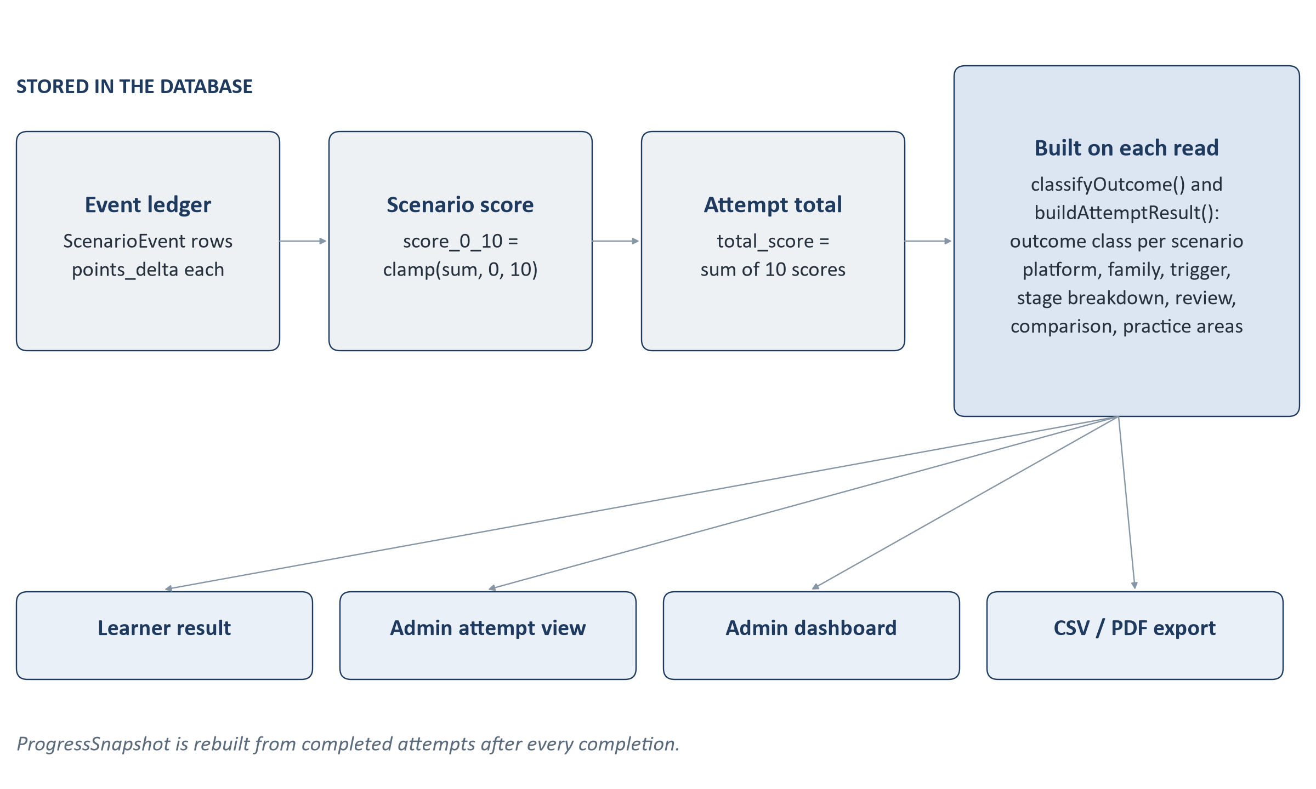
Figure 9. From recorded actions to the result screens.
Layer | Stored or calculated | Source
Event points | Stored when each action is accepted | ScenarioEvent.points_delta
Scenario score (0-10) | Stored when the scenario resolves | ScenarioRun.score_0_10
Attempt score (0-100) | Stored when the attempt completes or expires | Attempt.total_score
Outcome class per scenario | Calculated on read | classifyOutcome (attemptResultService.js)
Platform / family / trigger / stage breakdown | Calculated on read | behaviourBreakdown
Learning review per scenario | Calculated on read | buildScenarioReview (scenarioReviewService.js)
Comparison with previous attempt | Calculated on read | comparisonFor
Practice areas (up to three families) | Calculated on read | remediationFor
Progress across attempts | Stored as a derived snapshot, rebuilt after each completion | ProgressSnapshot (progressService.js)

Exactly where the result comes from
GET /api/attempts/:attemptId/result and POST /api/attempts/:attemptId/complete both call buildAttemptResult(attempt) in backend/src/services/attemptResultService.js. It:
1. refuses unless the attempt is completed;
2. loads the ten runs and checks their integrity - ten runs, positions 1 to 10, all resolved, each score a whole number from 0 to 10, and a stored total equal to their sum. If any check fails it returns an error rather than a wrong result;
3. loads the pinned scenario definitions (the only learner-facing place allowed to read the answer key, and only the authored feedback leaves it) and the ledger events;
4. classifies each scenario, builds its path replay and learning review;
5. builds the breakdowns, the comparison and the practice recommendations.
The practice recommendations name attack families, never scenario ids, so a learner is not handed part of the answer key for scenarios they may meet again. Only families that still have active scenarios in the bank are recommended, worst first (missed threats, then false positives, then points lost).
The administrator's attempt detail, the dashboard and the exports use the same classification function and the same stored scores, so a learner, an instructor and an exported report always agree.

Feedback timing
By default (on_completion), each scenario's authored feedback is shown only on the result screen. An administrator can set assessment feedback to immediate in Admin > Settings, in which case the feedback card is included with the response that resolves each scenario and shown on the outcome screen.
PART D · RELIABILITY, ADMINISTRATION AND SECURITY

21 Transactions and Data Consistency
IN PLAIN TERMS
Some operations have to change several records at once. When a learner takes an action, the system must both write down the action and move the scenario forward. If only one of those happened - for example because the server stopped half-way - the record would no longer match the score. A database transaction groups the changes so that either all of them are saved or none of them are.
TECHNICAL DETAIL
MongoDB supports multi-document transactions only on a replica set, so the system requires one (a single node is enough). withEngineTransaction in backend/src/utils/transactions.js runs each unit of work in a session with write concern { w: 1, j: true } (the commit is written to the on-disk journal before it is acknowledged). Transient database errors are retried a small, fixed number of times with a short back-off; business refusals such as STALE_STATE are never retried. If the database is running standalone, assertTransactionSupport refuses to proceed rather than fall back to separate writes.

What is written together
Operation | Records written in one transaction
Start assessment | The learner's last_seen_at, the Attempt and all ten ScenarioRun records.
Learner action | One ScenarioEvent and the updated ScenarioRun (stage, sequence, running score).
Resolution | The final ScenarioEvent, and the ScenarioRun marked resolved with its clamped score, outcome and optional rationale.
Completion | The Attempt status, completion time, end_reason and total_score.
Expiry | A RUN_EXPIRED event and a resolved run for every unfinished scenario, and the finalised Attempt with its total.
Demo skip | A RUN_DEMO_SKIPPED event and the resolved run.
Admin reset / archive / settings / publish / retire | The change and its AuditEvent together.

The learner's ProgressSnapshot is rebuilt after a completion commits, deliberately outside the transaction. It is a recalculation from completed attempts, so a failure there cannot undo a completion, and the next read repairs it.

Failure, duplicates, concurrency and stale requests
Situation | What the implementation does
Something fails part-way through an action | The transaction is aborted and nothing is saved. The learner sees an error and can retry.
The same action is submitted twice (retry after a lost response, double submit) | Each action carries an intent_key created once in the browser and reused on retry. If the key is already recorded, the server returns the original outcome, marked duplicate, and scores nothing new. A unique index on intent_key backs this up if two copies arrive at the same moment.
Two different actions for the same scenario arrive together | Only one can take the next sequence number: a unique index on (run_id, sequence) rejects the other, which receives 409 STALE_STATE.
An action prepared for an earlier stage (for example from a second tab) | Each request states the stage it was prepared for. If the run has moved on, it is refused with 409 STALE_STATE and the page reloads the current state.
Action on a scenario that has already resolved | 409 RUN_NOT_ACTIVE - a resolved run never reopens.
Start pressed twice or in two tabs | Both requests write the learner's profile inside their transactions, so they cannot both commit. The second sees the attempt the first created and returns it with created: false.
Two completion requests | The attempt is re-read inside the transaction; only one can move it from in progress to completed. The other returns the completed attempt.
Expiry and a learner action at the same moment | Expiry re-reads the attempt inside its transaction and uses a fixed key per run for its events, so it runs once; the action is refused as expired.

In the browser, the controller also ignores a second click while a request is in flight, so most double clicks never reach the server.

22 Refresh, Close and Failure Behaviour
Because the server holds all the state that matters, recovery nearly always means one thing: ask the server what is current and draw it.
If... | What the learner experiences | What happens underneath
The page is refreshed | The same scenario reappears at the same stage. Any sub-screen that was open (a contact card, a browser page) closes. | useAttemptController reloads the current attempt and run. Nothing is kept in browser storage; local navigation is not persisted and records nothing, so nothing is lost.
The browser is closed | On return (and sign-in, if the 8-hour session has ended) the dashboard offers Resume. If 90 minutes have passed, the learner is told time ran out and can open the saved result. | The attempt stays in progress on the server and its deadline keeps running. A background sweep finalises it at the deadline even if nobody is looking.
The learner signs out mid-assessment | A confirmation explains that the timer keeps running. | Logout only clears the cookie; the attempt is untouched.
The API cannot be reached | "Cannot reach the training server" with a Retry option. Nothing moves on screen. | No request arrived, so nothing changed.
MongoDB is unavailable | Requests fail with an error. | The server will not start without a database connection. While running, database errors abort the transaction, so no partial record is written. GET /​api/​health reports 503.
An action request fails | An error message; the screen stays where it was. | Retrying reuses the same intent_key, so if the first request had in fact committed, the retry replays its outcome instead of scoring twice.
The learner double-clicks | One action is taken. | The UI ignores clicks while submitting; the server's idempotency key and sequence index cover the rest.
A stale action is submitted | The screen refreshes to the current step. | 409 STALE_STATE; the controller reloads the current run.
The scenario has already resolved | No change. | 409 RUN_NOT_ACTIVE.
The assessment expires | Warnings at 10 and 2 minutes left; at zero a "time is up" screen with a link to the result. | See below.
An administrator resets the attempt | The attempt can no longer be continued; the learner can start a new one. | Status abandoned; later actions receive ATTEMPT_NOT_IN_PROGRESS.
An administrator archives the profile | The learner is signed out at the next request and cannot sign in again. | requireCandidate refuses archived profiles; sign-in returns 403.

The 90-minute limit
Each attempt has a fixed deadline, expires_at, set from the server clock when the attempt is created and frozen afterwards. The browser shows a countdown corrected against the server's time, but the countdown decides nothing. Three layers enforce the deadline on the server (backend/src/services/attemptExpiryService.js):
- Route guard - every attempt endpoint checks the deadline first. This alone guarantees no action is accepted after time is up.
- Sweeper - every 30 seconds the server finalises overdue attempts nobody is looking at.
- Start-up recovery - when the server starts, it finalises attempts whose deadline passed while it was down. Downtime is not credited back.
At expiry, every unfinished scenario is closed with a RUN_EXPIRED event worth 0 points and the outcome resolve_expired. Points already earned in those scenarios are kept; nothing further is awarded and no decision is invented. The attempt becomes completed with end_reason: expired, its total is calculated, and the result is available immediately. The result screen states that time ran out and how many scenarios were unfinished; those scenarios are classed as "not resolved", not as mistakes.

23 The Admin System
The admin console is a separate area of the same application, under /admin, with its own sign-in. It is used to follow learner performance, look into individual attempts, manage the scenario bank, produce reports and handle the few administrative actions the system allows.

Sign-in
- Username and password. Passwords are stored only as Argon2id hashes (backend/src/utils/password.js).
- Accounts are created from the server command line with npm run admin:create; there is no registration page, no password-reset page and no API route that creates an administrator.
- Repeated failures from the same address and username lock sign-in: by default 5 failures within 15 minutes cause a 15-minute lockout (src/middleware/adminThrottle.js, configurable in .env).
- The admin session is a separate signed cookie, admin_session, lasting one hour by default.

Screens
Screen | What it shows or does | Data source
Dashboard (AdminDashboardPage) | Learners (total, archived, with attempts, with a completed attempt); attempts by status and completion rate; how completed attempts ended (finished vs timed out); score summaries and 10-point score bands for all attempts and for each learner's latest; per-platform average score, attack success rate (missed threats among malicious scenarios decided), safe-handling rate and false-positive rate, with the highest and lowest platform; the overall outcome mix; completions per day for the last 14 days.  Assessment-mode attempts only; the Demo User is excluded. | GET /​api/​admin/​dashboard -> adminDashboardService.buildDashboard
Attempts (AdminAttemptsPage) | Paged list (10 per page), newest first, filterable by learner (name or service number lookup), status and start date range. (The API also accepts a mode filter; the screen does not offer one.) | GET /​api/​admin/​attempts, /​api/​admin/​learners
Attempt detail (AdminAttemptDetailPage) | Learner (name and masked service number), timings, total and outcome counts, platform coverage; for each scenario: score, outcome class, final action, path replay, feedback and the real classification (malicious or genuine, difficulty, family, triggers, military context); behaviour breakdown, practice areas and comparison.  Controls: reset (in-progress attempts only), archive learner, export. | GET /​api/​admin/​attempts/​:attemptId -> attemptViewerService
Exports (panel on attempt detail) | CSV or PDF for one attempt, or for all completed attempts of a learner. The server writes the file to its export directory and the browser can download a copy. Every export is audited. | exportService, exportReportService
Scenarios (AdminScenariosPage, AdminScenarioDetailPage) | The bank, filterable by id, platform, level, disposition, family, lifecycle, active and military flag. Each scenario's versions; create or edit a draft, clone, publish (after validation, including a check that every link uses a reserved training host) or retire. Publishing retires the previously live version, so one version is active at a time. | scenarioManagerService
Settings (AdminSettingsPage) | Feedback timing for assessment mode (and the unused training mode): immediate or on completion. | instructorControlService
Audit log (AdminAuditPage) | Every publication, retirement, reset, archive, export and settings change, with who and when; filterable and paged. Read-only. | auditService

Where the admin data comes from
The admin screens calculate nothing themselves. Every figure comes from the backend, which reads the stored scores and ledger and applies the same classification the learner's result uses. Opening a screen never changes data. Only four kinds of admin request change anything - scenario lifecycle changes, attempt reset, profile archive and settings - plus the export audit entry, and each of these is recorded in the audit log in the same transaction.
Reset and archive are deliberately conservative: a reset moves an in-progress attempt to abandoned without deleting anything or inventing a score, and archiving blocks a profile from further use while keeping every attempt, run and event. There is no delete function anywhere in the admin console.

Admin files
File | Responsibility
frontend/​src/​components/​admin/​AdminLayout.jsx | Console shell: sidebar navigation, header, sign-out.
frontend/​src/​components/​admin/​DashboardCharts.jsx | Bars, columns and strips drawn in HTML and CSS (no chart library).
frontend/​src/​components/​admin/​AttemptControls.jsx, ConfirmDialog.jsx | Reset and archive with confirmation.
frontend/​src/​components/​admin/​AttemptExportPanel.jsx | CSV / PDF export and download.
frontend/​src/​services/​adminApi.js | All admin API calls.
backend/​src/​routes/​adminRoutes.js | Every admin endpoint and its guard.
backend/​src/​controllers/​admin*.js, attemptViewerController.js, exportController.js, instructorControlController.js, scenarioManagerController.js, auditController.js | Admin request handling.

24 The Demo User
The Demo User exists so the system can be demonstrated quickly and the same way every time. It is a learner account, not a special mode: it signs in on the normal login page and takes a real assessment, but always the same ten scenarios in the same order, and it can skip scenarios.

Identity
The Demo User is identified on the server by a configured service number (DEMO_SERVICE_NUMBER, with a display name DEMO_DISPLAY_NAME, both in backend/.env; defaults in backend/src/config/demo.js). The check compares the signed-in profile's normalised number with the configured one (isDemoCandidate). The browser cannot claim to be the Demo User. Setting DEMO_SERVICE_NUMBER to an empty value disables the feature. The actual demo credentials are provided to the client separately and are not reproduced here.

The fixed sequence
# | Scenario | App | Level | Type | What it demonstrates
1 | W01 | WhatsApp | Easy | Malicious | Account takeover - a login code sent "by mistake"
2 | E01 | Email | Easy | Malicious | Credential phishing - password-expiry link and form
3 | S16 | SMS | Medium | Genuine | A login code the learner requested
4 | I04 | Instagram | Easy | Malicious | Impersonation - a cloned friend asks for money
5 | E21 | Email | Hard | Genuine | A verified vendor bank-detail change
6 | W24 | WhatsApp | Hard | Malicious | Tech-support fraud - remote screen share
7 | E14 | Email | Medium | Malicious | QR phishing in a revised movement order (military)
8 | I11 | Instagram | Medium | Genuine | Official welfare helpline broadcast (military)
9 | S25 | SMS | Hard | Malicious | Malware - a toll-tag "update" app install
10 | W16 | WhatsApp | Medium | Genuine | Verified vehicle-pool change (military)

The set is 6 malicious and 4 genuine (a normal attempt is 8 and 2), with 3 WhatsApp, 3 Email, 2 Instagram and 2 SMS, difficulty 3 / 4 / 3 and three military-context cases. It is defined in backend/src/constants/demoAssessment.js; attempt creation refuses to proceed if any of the ten is missing or inactive, or if the split is no longer 6 / 4.

Demo Skip
On a demo attempt only, a small Skip button with an inline confirmation appears under the scenario. It calls POST /api/attempts/:attemptId/runs/:runId/demo-skip, which answers 404 - exactly like an unknown address - to anyone who is not the Demo User or for any attempt not built from the demo set. A skip records a RUN_DEMO_SKIPPED event worth 0 points and resolves the scenario with the outcome resolve_demo_skipped; points already earned in that scenario are kept. On the result screen the scenario is shown as skipped, without feedback or the correct path, and it is left out of the behaviour breakdown and the practice recommendations. Instructor screens class it as "not resolved".

How the Demo User differs from a normal learner
Aspect | Normal learner | Demo User
Scenario choice | Solver, new random seed each attempt | Fixed list of ten, fixed order
Composition | 8 malicious / 2 genuine | 6 malicious / 4 genuine
Recent-scenario avoidance | Yes | No (recorded as not applied)
Skip | Not available (endpoint returns 404) | Available on every scenario
Scoring, stages, deadline, resume, reset | Standard | Identical
Storage | Attempt, runs and events | Same collections; the attempt is marked by its selection version demo-fixed-1.0.0
Admin attempt list, detail and exports | Shown | Shown
Admin dashboard statistics | Included | Excluded (by profile and by selection version)

25 Security Design
This section lists the security controls that exist in the code today, in plain terms, followed by the things the application deliberately leaves to the hosting environment.
Area | What is implemented
Learner sign-in | Name plus personal / service number, with no password, as the product specification requires. The normalised number is the identity; the stored name is never changed by a later sign-in. Archived profiles cannot sign in.
Administrator sign-in | Username and password (minimum 12 characters) hashed with Argon2id (64 MiB memory, 3 passes) and compared in constant time. Failed attempts are throttled and locked out.
Sessions | Signed, httpOnly cookies that page scripts cannot read, SameSite=Lax, and Secure in production. Learner and admin cookies have different names, different signing secrets and resolve against different collections, so one can never be turned into the other. The server will not start without an admin secret, refuses an admin secret equal to the learner secret, and in production refuses the published development secret.
Learner / admin separation | Every admin endpoint requires requireAdmin; a learner session is refused, not upgraded. Admin accounts live in their own collection and can only be created from the command line.
Ownership | An attempt is always looked up by its id and the session's learner together; a run by its id and its attempt. Another learner's attempt returns 404, not 403, so ids cannot be probed.
Action validation | Opaque per-run action codes; server-owned fields in a request are refused; stage and scenario rules are checked inside the transaction (Section 17).
Replay and stale protection | Idempotency keys, unique sequence numbers and stage checks (Section 21).
Resolved-run protection | A resolved run never accepts another action and never reopens.
Deadline | Server-held and frozen; any attempt to send a deadline field is refused (Section 22).
Input validation | 1 MB request limit; malformed JSON refused; rationale limited to one line of 250 characters with no markup; event metadata limited to an allow-list; unknown query parameters on admin lists refused; schema validation on every stored document.
Answer-key protection | The scenario evaluation block is excluded from queries by default and every learner response is built from an allow-list. The built frontend is scanned for engine vocabulary before release.
Simulated external services | Scenario links must use reserved training hosts (checked at import and at publication). Simulated browsers, calls, payments and installs are drawings; form input is never transmitted.
Data minimisation | No phone number, e-mail address, rank or password is collected from learners. Learner screens receive a masked service number and never the internal profile id; the admin console shows masked service numbers.
Audit logging | Administrative changes and exports are appended to an audit log in the same transaction as the change. The application refuses to update or delete audit entries.
Network boundary | The API listens on 127.0.0.1 by default (HOST), and CORS allows only the configured frontend origin. Export files can only be written to the server's configured directory with server-generated names.
Error hygiene | In production, unexpected errors return a generic message without internal detail.

What the application leaves to the hosting environment
- HTTPS certificates and termination, and any reverse proxy - not held in the repository.
- HTTP security headers (for example a Content Security Policy) - not set by the application; not confirmed in the current implementation.
- Database access control and backups - configured on the MongoDB server.
- Keeping backend/.env secret and choosing strong values for SESSION_SECRET and ADMIN_SESSION_SECRET.

Known limits, stated plainly
- Because learner sign-in has no password (by specification), anyone who knows a learner's service number can sign in as that learner.
- The admin login throttle is held in memory and resets if the server restarts.
- The audit log is protected at the application level; someone with direct database access could still alter it.

26 Online Architecture and Deployment
The system is intended to be centrally hosted so that learners and administrators use it through a web browser. This section describes the parts that exist in the code and the configuration they expect. It is not an installation manual.
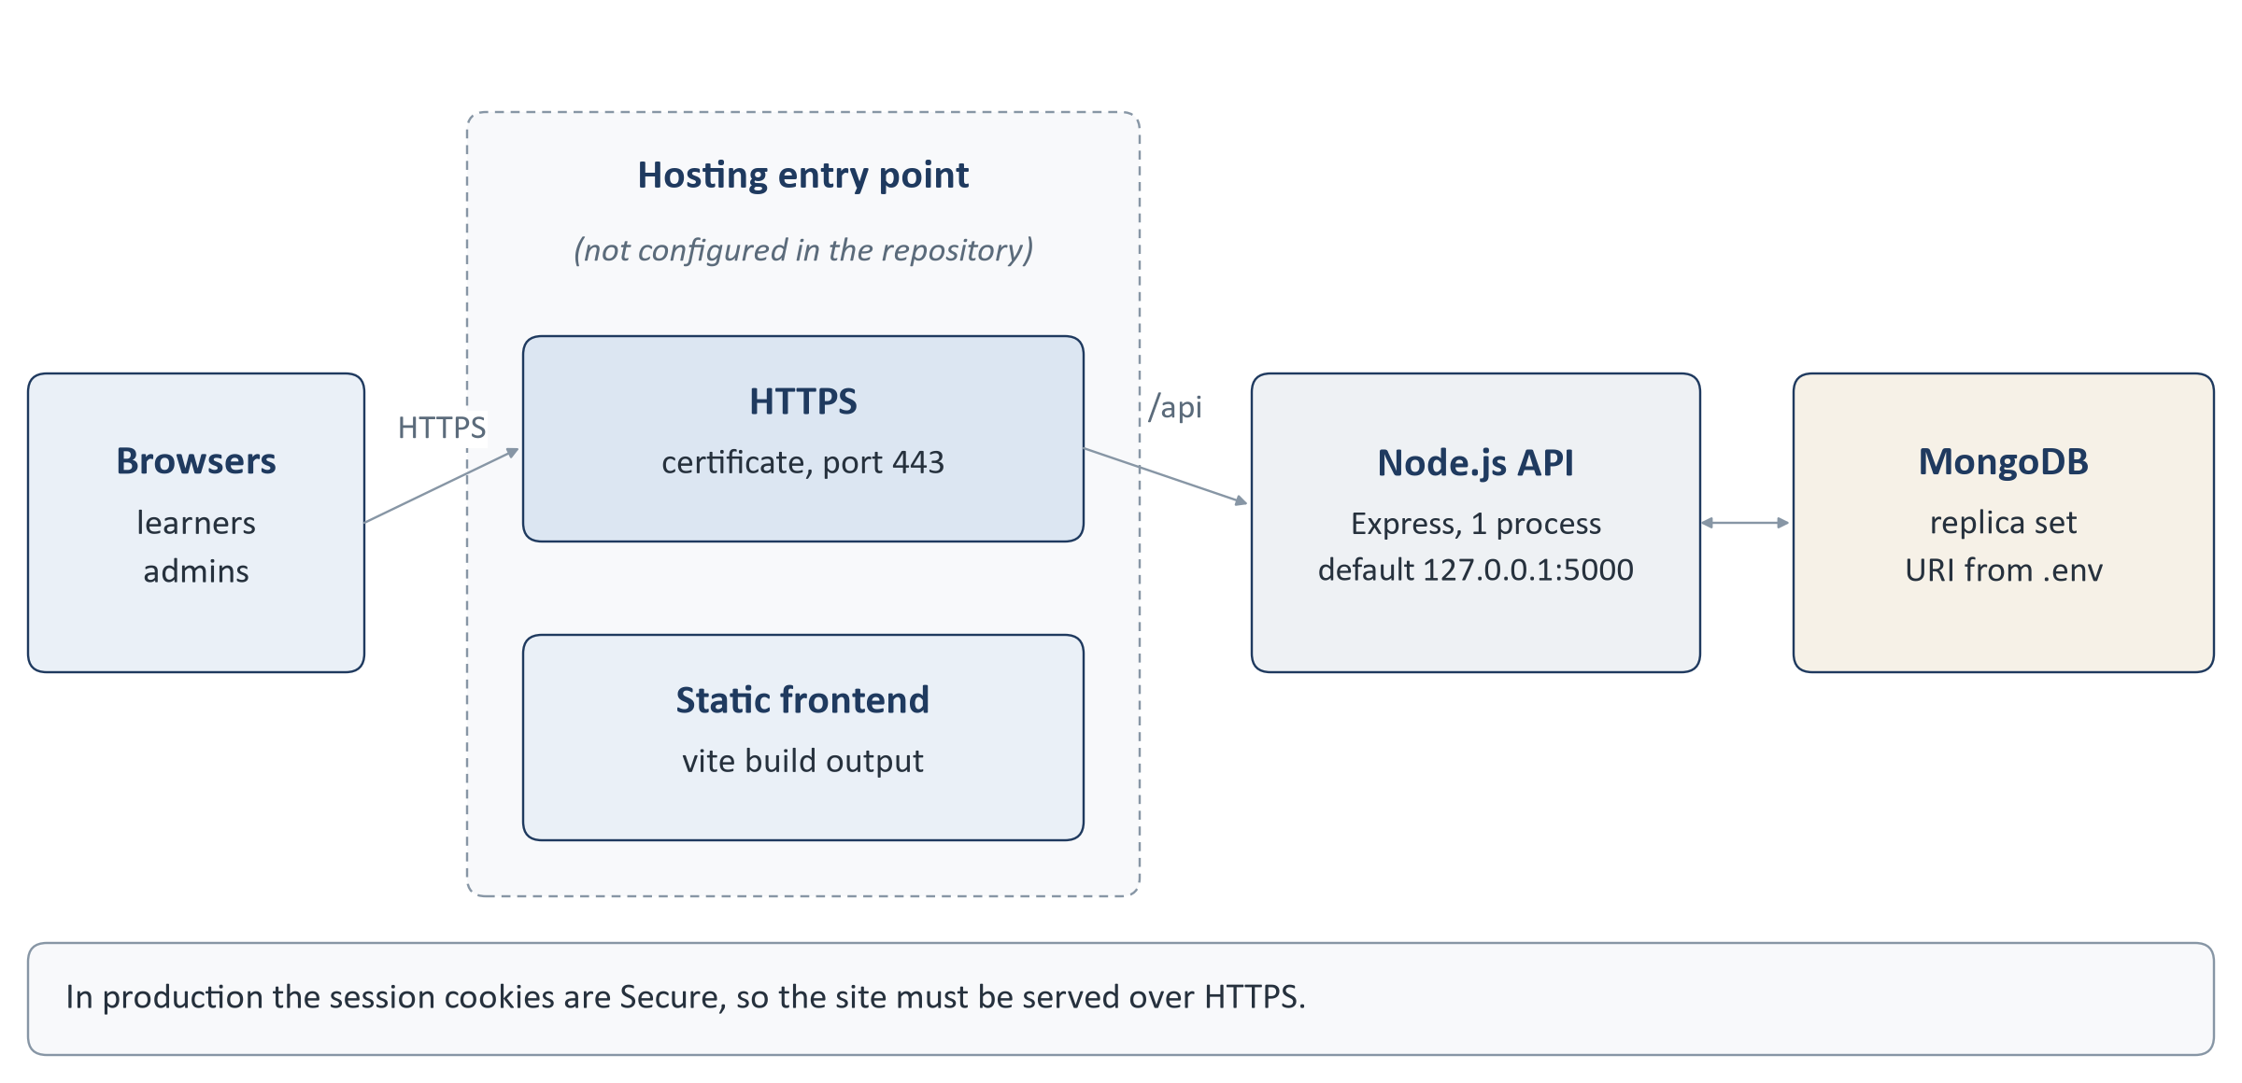
Figure 10. Online architecture. The dashed area is provided by the hosting environment.

Responsibilities
Component | Responsibility
Hosting entry point | Serves the built frontend (npm run build produces static files in frontend/​dist), terminates HTTPS and forwards /​api requests to the Node.js process. The Express application only serves /​api; it does not serve the frontend files. This layer's configuration is not part of the repository.
Node.js API | npm start in backend runs one process that listens on HOST:PORT (default 127.0.0.1:5000), runs the expiry sweeper and exits cleanly on SIGINT / SIGTERM.
MongoDB | A replica set reachable at MONGO_URI. The release database (cyber_awareness_training_release) holds the 100-scenario bank and empty, fully indexed collections; its build and validation are recorded in docs/​PRODUCTION_RELEASE_MANIFEST.md.

Frontend and API on one site
The frontend calls the API at VITE_API_BASE_URL, fixed when the frontend is built. If it is not set, the frontend calls /api on its own origin, which is the simplest arrangement behind one web entry point. The API can also be on a different origin, in which case CORS_ORIGIN must name the frontend's origin. Because the session cookies are SameSite=Lax, the frontend and API should be served from the same site (the same origin, or subdomains of the same domain).

Configuration
Variable | Purpose
NODE_ENV | production enables Secure cookies, hides internal error detail and rejects the development secret.
HOST, PORT | Where the API listens (default 127.0.0.1 and 5000).
MONGO_URI | MongoDB connection string, including the replica-set name.
CORS_ORIGIN | The one browser origin allowed to call the API with cookies.
SESSION_SECRET, SESSION_MAX_AGE_MS | Learner cookie signing secret and lifetime (default 8 hours).
ADMIN_SESSION_SECRET, ADMIN_SESSION_MAX_AGE_MS | Admin cookie secret (required) and lifetime (default 1 hour).
ADMIN_LOGIN_MAX_ATTEMPTS, ADMIN_LOGIN_WINDOW_MS, ADMIN_LOGIN_LOCKOUT_MS | Admin sign-in throttling.
LEARNER_ACTION_SECRET | Optional key for action codes; derived from SESSION_SECRET when not set.
EXPORT_DIR | Where export files are written (default backend/​exports).
DEMO_SERVICE_NUMBER, DEMO_DISPLAY_NAME | The Demo User identity; empty number disables it.
VITE_API_BASE_URL (frontend build) | API base URL used by the browser.

Templates are backend/.env.example and frontend/.env.example. Real values are held on the server and are not reproduced in this document.

Operational scripts
Command (in `backend`) | Use
npm run admin:create | Create an administrator account.
npm run import:definitions | Import the 100-scenario bank from backend/​data/​scenarios/​v1.
npm run verify:replicaset | Check that MongoDB supports transactions.
npm run release:build, release:validate, release:inventory, release:smoke | Build, validate, inventory and smoke-test the release database.

PART E · REFERENCE

27 End-to-End Technical Example
One learner, one attempt, from sign-in to the administrator's dashboard. The scenario played in steps 6 to 11 is a malicious email handled perfectly.
Step | User and frontend | API | Backend | Database
1 Sign in | Types name and service number; LoginPage -> CandidateProvider.signIn | POST /​api/​candidates | candidateController.createCandidate -> findOrCreateCandidate; cookie set | candidates: find or insert
2 Briefing | Ticks and continues; BriefingPage | POST /​api/​candidates/​me/​briefing | acknowledgeBriefing checks the version | candidates: briefing fields
3 Dashboard | DashboardPage loads | GET /​api/​attempts/​current, GET /​api/​progress | findActiveAttempt; getProgressSnapshot | Reads attempts, progresssnapshots
4 Start | Presses Start; attemptApi.start() | POST /​api/​attempts | startAttempt -> createAttempt -> selectAttemptScenarios | Transaction: 1 attempt + 10 runs
5 First scenario | SimulationPage -> useAttemptController.resume | GET .../​current-run | findCurrentRun, runPayloadFor, actionCodesForRun | Reads run 1 and its pinned definition
6 Open notification | Taps the toast; submits its action code | POST .../​runs/​:runId/​events | translateActionCode -> submitIntent: NOTIFY_SEEN, 0 | Event #1; run -> open
7 Read | Opens the email | same | ITEM_OPEN, 0 | Event #2; run -> inspect
8 Inspect | Expands the sender details | same | INSPECT_CONTEXT, +2; view sender returned | Event #3; run -> branch, running 2
9 Decide | Declines to follow the link | same | SAFE_PIVOT, +3 | Event #4; run -> verify, running 5
10 Verify | Looks up the service desk in the Trusted Directory | same | TRUSTED_VERIFY, +3 | Event #5; run -> resolve, running 8
11 Resolve | Chooses Report, adds a short reason | POST .../​runs/​:runId/​resolve | RESOLVE_CORRECT, +2; run resolved, score_0_10 = 10 | Event #6; run resolved
12 Next | "Scenario 1 recorded" -> Continue | GET .../​current-run | Returns run 2 | Reads run 2 + definition
13 Last scenario | Scenario 10 resolved -> Continue | GET .../​current-run | No unresolved run: run: null | Reads runs
14 Finish | Presses Finish | POST /​api/​attempts/​:id/​complete | completeAttempt sums ten scores; refreshProgressAfterCompletion; buildAttemptResult | Transaction: attempt completed; snapshot upserted
15 Result | ResultPage shows score, review, breakdown | GET /​api/​attempts/​:id/​result, GET /​api/​progress | buildAttemptResult | Reads attempt, runs, events, definitions
16 Admin dashboard | Instructor opens /​admin | GET /​api/​admin/​dashboard | buildDashboard counts completed assessment attempts (Demo excluded) | Reads candidates, attempts, runs, definitions, events
17 Admin detail | Opens the attempt | GET /​api/​admin/​attempts/​:attemptId | getAttemptForAdmin reuses the result projection and adds classification | Reads attempt, runs, definitions, profile

At every step the direction is the same: the user acts, the frontend sends a request, the backend decides and writes, the database commits, and the frontend draws the committed state.

28 Where Each Major Feature Lives
A reference for developers. Paths are relative to the repository root; every file listed was checked to exist in the current source.

Frontend (frontend/src)
File path | Feature | Responsibility | Main functions / components
main.jsx, App.jsx | Entry | Mount React; router, scroll, session provider | App
routes/​AppRoutes.jsx | Routing | Learner and admin route trees | AppRoutes
routes/​RequireCandidate.jsx, routes/​RequireAdmin.jsx | Guards | Redirect when no session | RequireCandidate, RequireAdmin
context/​CandidateProvider.jsx | Session | Current learner; sign-in / out; briefing | CandidateProvider, signIn, signOut, acknowledgeBriefing
services/​apiClient.js | API layer | fetch wrapper, cookies, errors | apiClient, ApiError, isInfrastructureError
services/​attemptApi.js | API layer | Attempt endpoints | start, current, currentRun, submitEvent, resolveRun, demoSkip, complete, result, history
services/​authApi.js, progressApi.js, adminApi.js | API layer | Sign-in, progress, admin endpoints | signIn, me, mine, getDashboard ...
pages/​LoginPage.jsx | Login | Entry form and support dialogs | LoginPage
pages/​BriefingPage.jsx | Briefing | Six-stage explanation, acknowledgement | BriefingPage
pages/​DashboardPage.jsx | Dashboard | Start / resume, progress line | DashboardPage, handleStart
pages/​SimulationPage.jsx | Assessment | Phone, side panel, outcome, skip, finish | SimulationPage, act, nextScenario, finish
hooks/​useAttemptController.js | Assessment | All attempt calls; retry, stale and expiry handling | useAttemptController, submit, advance, complete, skip, syncDeadline
state/​attemptMachine.js | Assessment state | Reducer of committed server state | attemptReducer, PHASE, scoreVisible
state/​dashboardOrchestrator.js, hooks/​useActivityDelivery.js | Notifications | Delivery delay, tray, tiles, interruption | deliveryDelayMs, trayFor, tilesFor, useActivityDelivery
simulation/​sceneRegistry.js | Scenes | Scene for each of the 100 scenarios | sceneFor, AUTHORED_SCENARIO_IDS
simulation/​sceneModel.js, useSceneNavigation.js, localForm.js | Scenes | Scene vocabulary, local navigation, local-only form state | affordancesFor, useSceneNavigation, useLocalForm
simulation/​scenes/​{whatsapp,instagram,email,sms}/​*.js | Scenes | One authored scene per scenario | one builder per scenario
components/​simulation/​PhoneShell.jsx, PhoneHome.jsx, DeviceFrame.jsx | Device | Handset, home screen, screen selection | PhoneShell
components/​simulation/​{whatsapp,instagram,email,sms}/​* | Apps | The four simulated apps | WhatsAppScene, InstagramScene, EmailScene, SmsScene
components/​simulation/​surfaces/​* | Apps | Browser, call, payment, installer, viewer, details, other app | BrowserSurface, CallSurface, ...
components/​simulation/​TrustedDirectory.jsx | Verify | Trusted sources only | TrustedDirectory
components/​simulation/​ScenarioOutcome.jsx, DemoSkip.jsx, TimeRemaining.jsx | Assessment UI | Outcome, demo skip, countdown | ScenarioOutcome, DemoSkip
pages/​ResultPage.jsx, components/​result/​* | Result | Score, review, breakdown, practice areas | ResultSummary, ScenarioReview, BehaviourBreakdown
pages/​Admin*Page.jsx, components/​admin/​* | Admin | Console screens | AdminLayout, AdminDashboardPage ...

Backend (backend/src)
File path | Feature | Responsibility | Main functions
server.js, app.js | Start-up | Connect, recover, listen, sweep; Express app | start, createApp
routes/​*.js | Routing | URL -> controller; guards | apiRoutes, attemptRoutes, adminRoutes ...
middleware/​session.js | Learner auth | Cookie session, archive check | startSession, requireCandidate
middleware/​adminSession.js, adminThrottle.js | Admin auth | Admin cookie, login lockout | requireAdmin, adminLoginThrottle
middleware/​errorHandler.js | Errors | JSON error responses | errorHandler
controllers/​candidateController.js | Login | Sign-in, me, briefing, logout | createCandidate, acknowledgeBriefingVersion
controllers/​attemptController.js | Assessment | Start, run, events, resolve, skip, complete, result | startAttempt, submitRunEvent, resolveRun, skipDemoScenario, finishAttempt
services/​candidateService.js | Login | Find or create profile | findOrCreateCandidate, touchLastSeen, acknowledgeBriefing
services/​attemptService.js | Attempts | Create, current run, complete | createAttempt, findCurrentRun, runPayloadFor, completeAttempt
services/​scenarioSelectionService.js | Selection | Solver and validator | selectAttemptScenarios, platformQuotaFor, validateSelection
services/​scenarioEngineService.js | Engine, scoring | Stages, events, points | submitIntent, resolveIntent, recomputeScoreFromEvents
services/​learnerActionService.js | Action codes | Issue and translate codes | actionCodesForRun, translateActionCode
services/​attemptExpiryService.js | Deadline | Guard, sweeper, recovery | enforceDeadline, assertAttemptLive, expireAttempt, startExpirySweeper
services/​attemptResultService.js | Result | Result projection | buildAttemptResult, classifyOutcome, behaviourBreakdown
services/​scenarioReviewService.js | Result | Learning review | buildScenarioReview, reviewSummary
services/​progressService.js | Progress | Snapshot rebuild | rebuildProgressSnapshot, refreshProgressAfterCompletion
services/​demoSelectionService.js, demoAssessmentService.js | Demo | Recognition, fixed set, skip, exclusion | isDemoCandidate, selectDemoScenarios, skipDemoRun, excludeDemoAttempts
services/​adminDashboardService.js | Admin | Dashboard figures | buildDashboard, platformPerformance
services/​attemptViewerService.js | Admin | Attempt list and detail | listAttempts, getAttemptForAdmin, lookupLearners
services/​exportService.js, exportReportService.js | Admin | CSV / PDF exports | createAttemptExport, createLearnerExport, buildAttemptReport
services/​instructorControlService.js | Admin | Reset, archive, feedback timing | resetAttempt, archiveProfile, updateFeedbackConfig
services/​scenarioManagerService.js | Admin | Scenario lifecycle | createScenario, publishScenarioVersion, deactivateScenarioVersion
services/​auditService.js, adminService.js | Admin | Audit log; admin accounts | append, listAuditEvents, authenticateAdmin
utils/​transactions.js | Consistency | Transactions and retry | withEngineTransaction, assertTransactionSupport
utils/​seededRandom.js, password.js, pdfWriter.js, csvWriter.js | Utilities | Seeded PRNG, Argon2id, file writers | createSeed, seededRandom, hashPassword

Database models (backend/src/models)
File | Model | Notable methods / rules
ScenarioDefinition.js | ScenarioDefinition | toCandidateJSON (allow-list); evaluation hidden by default
Candidate.js | Candidate | normaliseIdentifier, toPublicJSON, briefingState
Attempt.js | Attempt | Frozen sequence / seed / deadline hooks; toCandidateJSON
ScenarioRun.js | ScenarioRun | Resolved-run invariants; toCandidateJSON
ScenarioEvent.js | ScenarioEvent | Unique intent_key and (run_id, sequence); toLedgerJSON
ProgressSnapshot.js | ProgressSnapshot | toCandidateJSON
AdminUser.js, Configuration.js, AuditEvent.js | Admin data | Hidden password hash; single settings row; append-only log
Assessment.js, Scenario.js | Legacy | Earlier 40-scenario journey

Configuration and data
Path | Purpose
backend/​.env.example, frontend/​.env.example | Configuration templates
backend/​src/​config/​env.js, database.js, demo.js | Configuration loading, database connection, Demo identity
backend/​src/​constants/​*.js | Rules: selection quotas, stages and intents, scoring codes, time limit, demo set
backend/​data/​scenarios/​v1/​ | The 100-scenario source catalogue (import input)
backend/​data/​synthetic/​v1/​ | Synthetic scenario content (threads, profiles, pages, directory entries)
backend/​data/​taxonomy/​ | Attack-family and trigger taxonomies
backend/​data/​learner-actions/​v1/​ | Server-only map from neutral control ids to engine actions
frontend/​vite.config.js, frontend/​.oxlintrc.json | Build, test and lint configuration
.claude/​launch.json | Local development launch profiles

Tests
Path | Covers
backend/​tests/​scenarioSelection.test.js, demoSelection.test.js | Selection rules, rotation, relaxation, demo set
backend/​tests/​scenarioEngine.test.js, scenarioEngineTransaction.test.js | Stage machine, scoring, idempotency, concurrency
backend/​tests/​attemptCreation.test.js, attemptApi.test.js | Attempt creation, concurrent Start, API contract
backend/​tests/​attemptTimer.test.js | 90-minute deadline, sweeper, recovery
backend/​tests/​learnerAction*.test.js, sceneAffordance.test.js, sceneProjection.test.js | Action codes, scene controls, learner-safe content
backend/​tests/​email*Engine.test.js, sms*Engine.test.js | Scenario-by-scenario engine walks
backend/​tests/​admin*.test.js, export*.test.js, instructorControls*.test.js, auditLog*.test.js, scenarioManager*.test.js | Admin features
backend/​scripts/​testEngine.js | Runs the database suites against a temporary replica set
frontend/​src/​pages/​SceneScenarios*.test.jsx | Every authored scene walked in the UI
frontend/​src/​pages/​*.test.jsx, components/​**/​*.test.jsx, state/​*.test.js | Screens, controller, timer, demo skip, admin area
frontend/​scripts/​checkNeutralBundle.mjs | Release scan of the built bundle

Documentation
Path | Content
docs/​SCENARIO_ENGINE.md, docs/​SCENARIO_SELECTION.md | Engine and selection design notes
docs/​NEUTRAL_LEARNER_ACTION_CONTRACT.md | Action-code contract
docs/​ATTEMPT_API.md, docs/​RESULT_API.md | API contracts
docs/​ADMIN_*.md | Admin dashboard, viewer, exports, controls, audit, scenario manager
docs/​DEMO_USER.md | Demo User
docs/​DEPLOYMENT_AND_TRANSACTION_STRATEGY.md, docs/​LOCAL_MONGODB_REPLICA_SET.md | Transactions and replica-set setup
docs/​PRODUCTION_RELEASE_MANIFEST.md | Release database contents and validation
docs/​*_REAL_WORLD_RESEARCH.md | Research behind each batch of scenarios
PROJECT_MASTER_PLAN.md | Project plan and decision record

29 Testing and Quality Assurance
All the automated checks below were run against the current source on 29 September 2026 while this guide was prepared. The figures are the actual output of those runs.
Check | Command | Result on 29 Sep 2026
Backend unit and API tests | npm test (backend) | 1146 tests: 683 passed, 0 failed, 463 skipped. The skipped tests need a replica set and are run by the next line.
Backend database tests | npm run test:engine (temporary replica set on port 27018) | 23 suites, 463 tests: all passed, 0 failed.
Frontend tests | npm test (frontend, Vitest) | 46 test files, 3974 tests: all passed.
Frontend lint | npm run lint (oxlint) | No findings (exit code 0).
Production build | vite build (to a temporary folder) | Succeeded. One advisory: the main bundle is larger than 500 kB after minification.
Bundle neutrality scan | checkNeutralBundle.mjs | Passed: no engine action names or scoring codes in the built files.

What the suites cover
- Scenario validation. All 100 scenario definitions are checked against the schema, the taxonomies and the offline-safety rules (reserved hosts only); synthetic content is checked against its manifest.
- Selection. Every composition rule, the platform rotation, recent-scenario exclusion and relaxation, determinism from the seed, and the independent validator.
- Engine and scoring. Legal and illegal transitions per stage, point values, clamping, replay of the ledger, idempotent retries and stale-state refusal.
- Concurrency. Concurrent Start requests, concurrent actions on one run, concurrent completion, expiry racing an action, and concurrent first sign-in, against a real replica set.
- Expiry. The deadline guard, the sweeper, start-up recovery, preserved points and the result of an expired attempt.
- Demo. Recognition, the fixed set and its checks, skip permissions (404 for others), scoring of skipped scenarios and exclusion from the dashboard.
- Neutral action contract. Codes bound to one run, neutral refusals, and no engine vocabulary in any learner response or in the bundle.
- Frontend. Each authored scene is walked through in the UI; the controller, reducer, timer, demo skip, result screens and admin screens are tested against stubbed API responses.
- Admin. Dashboard aggregation, attempt viewer filters and paging, exports in both formats, reset, archive, settings, audit immutability and login throttling.
Manual browser and responsive-layout checks are not part of the automated suites and were not repeated for this document.

30 How to Explain the System Without Technical Terms
A useful way to describe the system to someone new is as a practical examination held on a simulated phone, with a strict examiner.
System term | Everyday comparison
Scenario bank / ScenarioDefinition | The locked cabinet of exam questions. Each question card has the situation on the front and the marking scheme on the back. Candidates only ever see the front.
Attempt | One sitting of the exam. The paper - ten questions in a fixed order - is printed and sealed before the candidate starts, and cannot be swapped halfway.
ScenarioRun | One question on that paper, with a bookmark showing how far the candidate has got.
ScenarioEvent | A line in the invigilator's log: "checked the sender's number", "sent the code".
Score | The marks the marking scheme gives for the lines in the log, with each question marked out of 10.
Backend / server | The examiner, who keeps the marking scheme, the log and the clock.
Frontend / browser | The candidate's desk and the phone they are handed. It shows the situation and passes their choices to the examiner.
Action code | Answer boxes that are simply numbered. Only the examiner's key says what box 8 means, so reading the answer sheet reveals nothing.
Transaction | The invigilator writing the log line and moving the bookmark in one movement, so the two can never disagree.
Deadline | The exam-hall clock. The candidate's own watch is shown for convenience but does not decide when time is up.
Telemetry | The invigilator's log - what was done, in order, and when. Nothing about the person beyond that.
Demo User | A rehearsal paper that is always the same, used to show the exam to visitors.
Admin console | The examinations office: results for every sitting, the question cabinet and a register of every change the office makes.

The system in one minute
A learner signs in and is handed a simulated phone. Ten situations arrive one by one - messages, posts, emails and texts, most of them scams and a couple genuine. For each, the learner decides what to do, step by step, exactly as they would on their own phone. The server writes down every step and marks it against a fixed scheme, so the result shows not only a score out of 100 but where the learner was careful and where they were caught out. Nothing on the phone is real, and nothing the learner types into it is sent anywhere. Instructors see every result and a summary across all learners.

31 Client FAQ
What happens when Start Assessment is clicked?
The server checks who is signed in, returns the attempt already running if there is one, and otherwise chooses ten scenarios, fixes their order and a 90-minute deadline, and saves the attempt and its ten scenario records in one transaction. The first scenario is then loaded. See Section 11.
Are all scenarios loaded at once?
No. The browser never receives the bank or the list of chosen scenarios. It receives one scenario at a time, when that scenario becomes current.
How are scenarios selected?
By a solver on the server that meets fixed rules: 8 malicious and 2 genuine, 3 easy / 4 medium / 3 hard, a rotating 3/3/2/2 platform split, 2-4 military-context cases, at least five psychological triggers, no attack family more than twice, and avoiding the learner's 20 most recent scenarios where possible. See Section 12.
Does the sequence change after every scenario?
No. It is frozen when the attempt is created and the database refuses any change to it.
Does the system adapt difficulty?
No. Every normal attempt has the same difficulty mix and nothing about performance changes what comes next. See Section 13.
Does good performance make the next scenario harder?
No.
Does the second attempt become harder?
No. It has the same difficulty mix, uses different scenarios where possible and rotates the platform split.
Can scenarios repeat?
Never within one attempt. Across attempts the last 20 scenarios are avoided where possible; after that a scenario can return.
How does the system score a learner?
Each step of each scenario earns or loses points according to that scenario's scoring rules; each scenario is limited to 0-10 and the ten are added up to a score out of 100. See Section 18.
Where is the score calculated?
Only on the server, in the scenario engine as each action is accepted, and in the attempt service at completion.
Can the score be manipulated from the browser?
The browser cannot send a score, points, stage, scenario order or deadline - requests containing them are refused. It sends only an opaque code for the control used, valid for one scenario run, and the server decides what it means and what it is worth. A learner can of course choose the actions they like; what they cannot do is change how those actions are marked.
How are learner actions stored?
As ordered events in the scenarioevents collection, one per accepted action, each with its stage, event code, points and server time. They are never edited or deleted by the application.
What is telemetry?
The record of the learner's assessment actions and a few timings, such as how long before a notification was opened. It is used to score and explain the result. See Section 19.
Does the system use AI?
No. There is no machine-learning model, AI service or prediction. Scoring and classification are fixed rules.
Does the system use WebSockets?
No. It uses ordinary HTTPS requests and responses.
Does it poll the server?
No. Requests are made when the learner acts or a screen loads. The only repeating job is a server-side 30-second check for overdue attempts.
What happens if the user refreshes?
They return to the same scenario and stage. Nothing is lost, because nothing important is held in the browser.
What happens if the internet disconnects?
The request fails, the screen stays where it was and the learner can retry once connected. If the failed request had in fact reached the server, the retry is recognised and not scored twice. The 90-minute deadline keeps running on the server.
What happens if two actions are clicked quickly?
The screen ignores clicks while an action is being sent. If two requests still arrive, only one can be recorded for that step; the other is refused as stale and the screen refreshes.
What happens if the same action is submitted twice?
The second copy carries the same idempotency key, so the server returns the original result and scores nothing new.
How does Admin get the result?
From the same stored scores and the same classification the learner's result uses, read through the admin endpoints. The admin screens calculate nothing themselves.
How does Demo work?
A configured service number is recognised on the server and given a fixed set of ten scenarios (6 malicious, 4 genuine) and a Skip button. Demo attempts are real attempts, visible to administrators, but left out of the dashboard statistics. See Section 24.
How is data protected?
Signed, httpOnly session cookies; separate learner and admin sessions; Argon2id admin passwords; ownership checks on every attempt; allow-listed responses that never include the answer key; minimal personal data; audited admin changes. HTTPS and database access controls are provided by the hosting environment. See Section 25.
What happens when an assessment expires?
At 90 minutes the server closes all unfinished scenarios without awarding further points, keeps the points already earned, completes the attempt and makes the result available. Unfinished scenarios are reported as "not resolved", not as mistakes.
How are previous attempts handled?
They are kept unchanged. The History page lists them, the dashboard shows the count with the last and best score, and each new result is compared with the previous one when the two are comparable.
Can an administrator change or delete a learner's result?
No. There is no edit or delete function. An administrator can reset an attempt that is still in progress (it is marked abandoned, nothing is deleted) and can archive a profile to stop further use.
Does anything connect to the real WhatsApp, Instagram, email or SMS?
No. All four apps are drawings inside the browser, driven by synthetic content stored with each scenario.

32 One-Page System Map
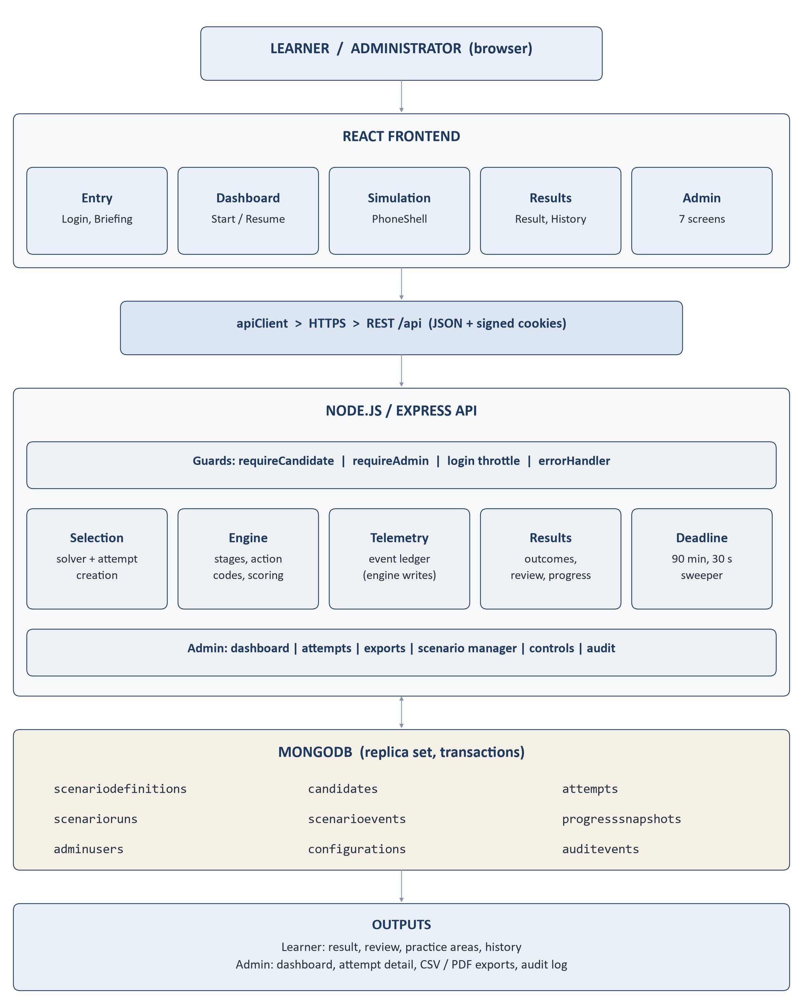
Figure 11. The whole system on one page.

Appendix A Source Basis and Verification Notes

What was inspected
The repository working tree on 29 September 2026 (commit ab41199 plus the uncommitted changes present in the working tree). This covered every file under backend/src (routes, controllers, middleware, services, models, constants, utilities, configuration), the frontend routing, pages, hooks, state, services and simulation components under frontend/src, both package.json files, the environment templates, the learner-action maps, the scenario catalogue headers, the release manifest and the existing project documents in docs/ and the repository root.

Where older material differs from the current code
These differences were found while preparing the guide. In each case this guide follows the code.
Item | Older description | Current implementation
Deployment model | Several design documents and code comments (for example docs/​DEPLOYMENT_AND_TRANSACTION_STRATEGY.md and comments in config/​env.js, adminThrottle.js, password.js) describe a standalone offline machine. | The product is hosted online. The code's defaults (API on 127.0.0.1, one process) remain and suit an API behind a web entry point on the same host.
Authored scenes | Some component comments (for example in PhoneShell.jsx) say only W01-W05 have authored scenes. | sceneRegistry.js registers a scene for all 100 scenarios.
Admin write routes | The header comment of routes/​adminRoutes.js says the admin namespace has no write endpoint. | Scenario lifecycle, reset, archive, settings and export are writes; each is audited.
Practice recommendations | Some comments say "two or three". | Up to three families; fewer when fewer are weak.
Legacy journey | Earlier documents describe a 40-question assessment. | Still in the code (/​api/​assessments, /​assessment/​legacy) but learners are sent to the six-stage simulation.
Training mode | Described as a separate practice mode. | Exists in the data model and settings; not reachable from the learner screens; not adaptive.

Not confirmed in the current implementation
- Web server / reverse proxy configuration, HTTPS certificate handling and process supervision (for example Nginx or PM2) - not in the repository.
- HTTP security headers such as a Content Security Policy - not set by the application.
- Database backup schedule and access-control settings - managed outside the application.

Not included in this guide
Secrets, passwords, production connection strings, the Demo User's service number and the production administrator account are deliberately omitted.

