CLIENT DOCUMENT
System Design and Flow
Social Engineering Fraud Training & Assessment System

This document explains, in plain language, how the implemented system is built and how it works from start to finish: what the learner does, how scenarios are presented, how actions are recorded and scored, how results are produced, and how the administrator reviews them.
Document type | System design and workflow overview
System | Centrally hosted online assessment system
Version | 1.0
Date | 29 September 2026

Synthetic, self-contained simulation
All communication shown in the system — messages, emails, profiles, web pages, files, QR codes, calls, payment and login screens — is synthetic. It is created for training and runs entirely inside the application. Nothing connects to real WhatsApp, Instagram, email, SMS, banking or other external services.

Contents
1. Executive Overview 3
2. High-Level System Design 3
3. User / Learner Flow 4
4. Assessment Flow – The Six Stages 5
5. Scenario Design 5
6. Simulated Application Design 6
7. Learner Action and Behaviour Flow 6
8. Scoring Flow 7
9. Data / Telemetry Flow 7
10. Result Flow 8
11. Admin Flow 8
12. Demo User Flow 9
13. Online and Security Design 9
14. End-to-End Flow Diagram 10
15. Component Responsibility Summary 11
16. Final Summary 11

How to read this document
Sections | Answer the question
1 – 2 | What is the system, and what is it made of?
3 – 4 | What does the learner do, step by step?
5 – 6 | Which scenarios and simulated apps are used?
7 – 10 | How are actions recorded, scored and turned into results?
11 – 12 | How do the administrator and the Demo User work?
13 – 16 | How is the system protected, and how does it all fit together?

Key terms
Term | Meaning in this document
Learner | The person taking the assessment.
Administrator | The instructor or reviewer who views results and manages the system.
Scenario | One simulated communication (for example a WhatsApp message) that the learner works through from notification to final decision.
Assessment (attempt) | One sitting of 10 scenarios, with a 90-minute time limit.
Malicious / legitimate | A scenario is either a fraud attempt (malicious or deceptive) or a genuine message (legitimate) that should be kept.
Synthetic | Invented for training. No real people, organisations or services are involved.

1. Executive Overview
The Social Engineering Fraud Training & Assessment System is a centrally hosted online application. It provides a controlled environment in which learners practise identifying suspicious digital communication and making safe decisions. All communication shown during the assessment is synthetic and contained within the training environment.
- The problem it addresses. Fraudsters use messaging apps, social media, email and SMS to pressure people into sharing codes, paying money, installing apps or revealing information. The system lets learners practise recognising these attempts safely — and recognising genuine messages that should not be rejected.
- What the learner does. Works through 10 interactive scenarios on a simulated phone: opens each message, inspects the details, decides, verifies and chooses a final action.
- What the system records. Every action the learner takes, in order, with the points it earns or loses and the outcome of each scenario.
- What the administrator can review. Dashboard statistics, every attempt in detail, and downloadable CSV or PDF reports.
Key fact | Value
Scenario library | 100 scenarios across WhatsApp, Instagram, Email and SMS (25 each)
One assessment | 10 scenarios, each played through six stages
Scoring | 0–10 points per scenario; 0–100 for the whole assessment
Time limit | 90 minutes per assessment, timed by the server

2. High-Level System Design
The system has four main parts. The learner and the administrator use an ordinary web browser; everything else runs on the hosted system.
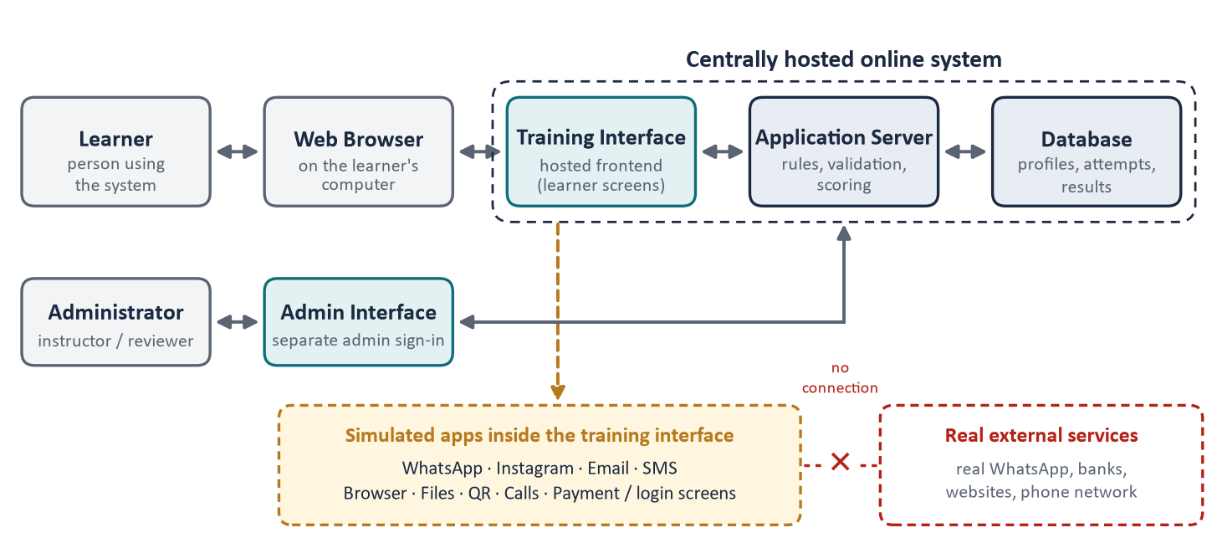
Figure 1 – Main components and how they connect
When the learner takes an action, the training interface sends it to the application server. The server checks it, applies the rules, saves it in the database and sends back what the screen should show next.

2.1 Learner Interface
Everything the learner sees and uses: the login page, the briefing, the dashboard with a simulated phone, the four simulated apps, and the results and history pages. The interface displays the scenario and passes on the learner's choices. It does not decide scores.

2.2 Application Server
The central “brain” of the system. It identifies learners, starts assessments, selects the scenarios, checks that every action is allowed at that moment, applies the scoring rules, enforces the 90-minute time limit, builds results and reports, and handles administrator requests.

2.3 Database
The permanent store. It holds learner profiles, the scenario library, assessment attempts, the recorded actions for every scenario, progress summaries, administrator settings and the administrator audit log.

2.4 Admin Interface
A separate area of the same hosted system with its own sign-in. Administrators use it to view statistics, review attempts, download reports and manage settings (see Section 11).

2.5 Technology Overview
Part | Technology used
Learner and admin interface | React web application (JavaScript), opened in a web browser
Application server | Node.js with the Express framework, providing the system's APIs (the defined requests the interface can send)
Database | MongoDB
Reports | CSV and PDF files generated by the server

3. User / Learner Flow
The complete learner journey, from opening the system to receiving results:
1. Learner opens the online system in a web browser. The login page appears; nothing needs to be installed.
2. Enters name and service number (“Full Name” and “Personal / Service Number”). Learners do not use a password.
3. System validates the details on the server. If the number already has a profile, the learner continues with it; otherwise a new profile is created. A secure sign-in session starts.
4. Reads the briefing — the rules and the notice that all content is simulated — and confirms it. The confirmation is stored.
5. Enters the dashboard — a simulated phone home screen with WhatsApp, Instagram, Email and SMS tiles, a Start / Resume button, progress and history.
6. Starts an assessment. The 90-minute limit begins. An unfinished assessment can be resumed while time remains.
7. System prepares the assessment by selecting 10 scenarios under fixed rules (Section 5). The set is locked for this attempt.
8. A simulated notification appears on the phone, for example a new WhatsApp message or email.
9. Learner opens and investigates the communication inside the simulated app — sender, links, files, QR codes, profile.
10. Learner makes decisions using the on-screen controls: actions, verification options, report, block or keep.
11. System records each action on the server, in order, with the points it earns or loses.
12. Learner completes the scenario by choosing a final action, such as report, block or keep.
13. Feedback is displayed. A confirmation shows the recorded final action. Detailed feedback appears on the results screen, or straight after each scenario if the administrator selects that setting. The running score is hidden.
14. The next scenario is presented with a new notification.
15. After 10 scenarios, the assessment is completed. If the time limit ends first, the assessment closes and unfinished scenarios are marked “Not reached in time”.
16. Results are generated — overall score, scenario results, behaviour summary and feedback (Section 10).

4. Assessment Flow – The Six Stages
Every scenario is played through the same six stages. The learner moves forward by making choices; the server decides which choices are available at each stage.
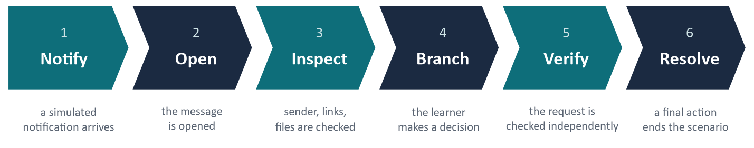
Stage | What the learner sees | What the learner can do | What the system records
1. Notify | A simulated notification on the phone. | Open it, or dismiss it for now. | That the notification was seen or dismissed.
2. Open | The full message, email, post or SMS inside the simulated app. | Read it — or act at once (reply, tap a link) before reading. | That it was opened; acting before reading is recorded as premature.
3. Inspect | Details that can be checked: sender, profile, link address, file preview, QR destination, earlier messages. | Examine one or more details, or skip checking. | Whether the context was inspected.
4. Branch | The choices the scenario offers — safe ones and risky ones. | Decline or use the official route; or open, reply, call, pay, install, share or submit. | The decision. A risky choice shows a simulated consequence only.
5. Verify | Ways to check the request: Trusted Directory, official app, known number, or contact details given in the message. | Verify independently, rely on the message's own details, or report / block. | Which route was used. Only independent sources count as trusted.
6. Resolve | The final actions: report, block, keep, continue or ignore. | Choose the final action. | The final decision, whether it was correct, and the scenario score.

5. Scenario Design
The system contains a library of 100 scenarios, spread evenly across the four platforms.
Platform | Scenarios | Malicious / deceptive | Legitimate | Easy | Medium | Hard
WhatsApp | 25 | 20 | 5 | 8 | 9 | 8
Instagram | 25 | 20 | 5 | 8 | 9 | 8
Email | 25 | 20 | 5 | 8 | 9 | 8
SMS | 25 | 20 | 5 | 8 | 9 | 8
Total | 100 | 80 | 20 | 32 | 36 | 32

- Synthetic and fictional. All people, organisations, numbers, links, logos and documents are invented. 35 of the 100 scenarios use a fictional military context, such as movement orders, welfare notices or unit coordination.
- Realistic variety. The malicious scenarios cover 15 fraud types (for example credential phishing, payment diversion, account takeover, QR-code phishing, malicious files and apps, impersonated emergencies and relationship grooming). Each uses persuasion techniques such as authority, urgency, fear or reward.
- Judgement, not memorisation. Genuine messages are included, so reporting everything does not score well. The same action can be right in one scenario and wrong in another.
- Interactive, not multiple-choice. Each scenario is a sequence of screens and actions. The score comes from the path the learner actually follows.

How the 10 scenarios are selected
- 8 malicious and 2 legitimate scenarios; the 2 legitimate ones come from different platforms.
- 3 Easy, 4 Medium and 3 Hard; all four platforms appear (a rotating 3 / 3 / 2 / 2 split).
- 2 to 4 military-context scenarios, at least 5 different persuasion techniques, and no fraud type more than twice.
- The learner's 20 most recently seen scenarios are avoided where possible.
- The order is mixed, with no more than two scenarios in a row from the same app. Once the assessment starts the set is fixed, so resuming shows the same scenarios.

6. Simulated Application Design
The four platforms are recreated inside the training interface on a simulated phone. They look and behave like familiar apps so the experience is realistic, but they are simulations built into the system.
Platform | What the learner experiences
WhatsApp | Chat list, individual and group chats, forwarded messages, contact details, voice notes and call screens.
Instagram | Feed, posts, stories, profiles and direct messages, with profile details (followers, badges, account history) to inspect.
Email | An inbox with categories, full sender addresses, attachments and links.
SMS | A message list with sender names, short codes and links inside texts.

Supporting surface | Purpose
Browser | Shows the simulated web page a link leads to, including fake login or payment pages. The address can be inspected.
File viewer | Previews attachments such as PDFs, documents and app installers.
QR inspection | Shows where a QR code would lead.
Call simulation | Incoming and outgoing call screens with accept, decline, end, verify and report.
Trusted Directory | A built-in list of official contacts, used to verify a request independently of the message.
Action menu | Reply, forward, delete, mark safe, verify, report and block / restrict.
Payment, login and  device-linking screens | Simulated forms. Anything typed stays on the learner's screen; the system records only that the action was taken.

Important
No real connection is ever made. Opening a link, previewing a file, scanning a QR code, placing a call, paying, logging in or linking a device only opens another simulated screen. No message is sent, no call is placed, no payment is made and nothing is installed.

7. Learner Action and Behaviour Flow
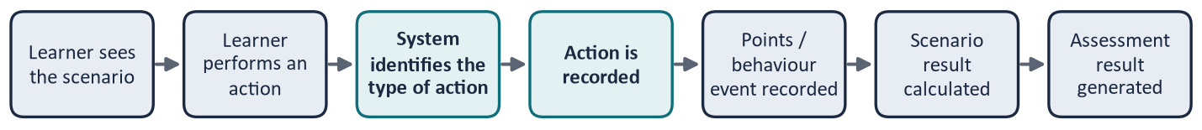
Figure 2 – From a learner's action to the assessment result
When the learner taps a control, the interface tells the server only which option was chosen. The server decides what that option means in this scenario, whether it is allowed at this stage, and what it is worth. Examples of what is recorded:
Behaviour recorded | Example | Effect
Inspecting information | Checking the sender, link address or profile | Positive
Verifying through a trusted source | Using the Trusted Directory or the official app | Positive
Taking a safe action | Declining the request; using the official route | Positive
Replying prematurely | Replying or tapping before reading the message | Negative
Opening risky content | Opening a suspicious link or file, scanning a QR code | Negative
Reporting / blocking incorrectly | Reporting a genuine message | Negative
Releasing sensitive information | Entering a code or password, paying, installing an app, approving a device link | Strongly negative
Resolving the scenario correctly | Reporting a malicious message; keeping a genuine one | Positive

8. Scoring Flow
Each scenario can earn up to 10 points. Points are added or taken away as the learner moves through the stages:
Scoring principle | Points
Context inspection | +2
Safe pivot / correct use (safe decision, or correct use of a genuine message) | +3
Trusted verification | +3
Correct resolution | +2
Premature reply (acting before reading) | −1
Risky open / reply | −3
Sensitive information, payment, install or data release | −8
False report / block of a genuine message | −4
Needless rejection / ignoring of a genuine message | −2

Other rules defined in the scenarios: reporting a malicious message without checking it first earns +1; checking through contact details given inside the message earns 0; a wrong final decision (such as continuing with a malicious request) is −4; and in some scenarios a risky action is scored as an unsafe external action (−4).
- The safe path adds up to exactly 10: inspect (+2), safe decision (+3), trusted verification (+3), correct resolution (+2).
- Each scenario score is kept within 0–10 — it never goes below 0 or above 10.
- The 10 scenario scores are added together to give the overall result of 0–100.
Example 1 (safe). The learner inspects the sender (+2), declines the request (+3), verifies through the Trusted Directory (+3) and reports the message (+2): 10 / 10.
Example 2 (unsafe). The learner opens the link without checking (−3), calls the number given in the message (0) and then reports it (+2). The total of −1 is kept at 0 / 10, and the scenario is shown as a missed threat.

9. Data / Telemetry Flow
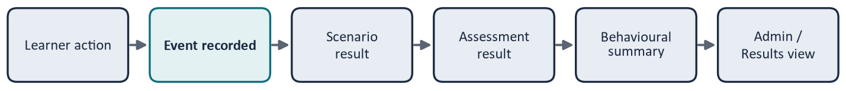
Figure 3 – How recorded actions become reviewable results
The system keeps the learner's full interaction history so that a completed assessment can be reviewed. Results are always calculated from the recorded actions, so the learner's results screen, the admin view and the exported reports show the same figures.
Information area | What it holds
Learner profile | Name, service number (shown masked to administrators), briefing confirmation and last sign-in.
Assessment attempt | The 10 selected scenarios and their order, start time, deadline, status and total score.
Scenario run | One per scenario in the attempt: current stage, final action and scenario score.
Scenario events | The ordered record of every action: stage, type of action, points and time.
Progress information | A per-learner summary across completed assessments, such as scenarios seen and the score trend.
Results | Built from the above when the assessment is completed.

Anything a learner types into a simulated form — for example a password on a fake login page — stays on the learner's screen. It is not sent to or stored by the server.

10. Result Flow
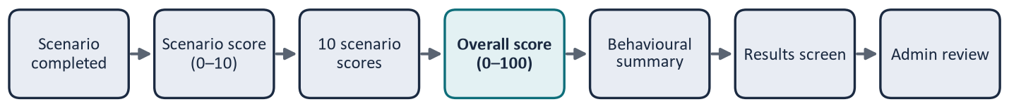
Figure 4 – From scenario scores to review
Each scenario is classified as Handled safely, Missed threat (a malicious message not stopped, or stopped only after an unsafe action), False positive (a genuine message rejected, reported or blocked), Unsafe handling (a genuine message kept, but after an unsafe action) or Not reached in time. The results screen then shows:
Result information | What it shows
Overall score | The assessment result out of 100, with a summary of outcomes.
Scenario-level results | For each scenario: app, score out of 10, outcome and final action.
Action / path information | The step-by-step path the learner followed in each scenario.
Behaviour by platform | Points, missed threats and false positives per app.
Behaviour by attack family | The same, grouped by type of fraud (“case type”).
Behaviour by trigger | The same, grouped by persuasion technique.
Behaviour by decision stage | How often the learner inspected, decided safely, verified and resolved correctly.
Missed threats / false positives | Counted overall and in every breakdown.
Feedback | For each scenario: what it was, the warning signs, the safe response, the likely impact and one habit to remember — plus 2 to 3 recommended areas to practise where points were lost.
Progress | Comparison with the learner's previous comparable assessment, where one exists.

The administrator sees the same result for every attempt, plus each scenario's classification (malicious or genuine, fraud type and persuasion technique). The Admin Dashboard summarises all learners by score, completion and platform; breakdowns by fraud type and trigger are shown per attempt and in exports, not as dashboard-wide totals.

11. Admin Flow
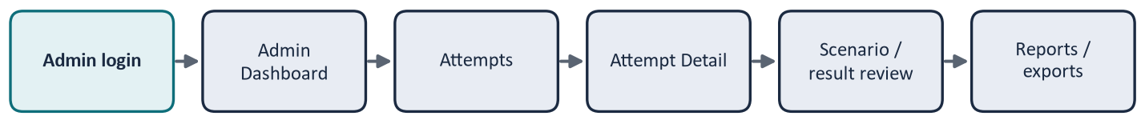
Figure 5 – Administrator journey
Admin area | What the administrator can do
Admin login | Separate username and password. Repeated failed sign-ins temporarily block further attempts, and admin sessions expire sooner than learner sessions.
Dashboard | Number of learners; attempts by status and completion rate; average score and score range; score distribution; platform performance (average score, share of malicious scenarios not stopped, safe-handling and genuine-rejected rates); outcome mix by platform; completions in the last 14 days.
Attempts | All attempts, completed and in progress. Search by learner name and filter by status and date.
Attempt Detail | Learner (masked service number), overall score, each scenario's classification, score, outcome and path, the behaviour breakdowns and recommendations. Controls to reset an unfinished attempt or archive a learner profile.
Reports / exports | CSV or PDF for one attempt, or for all completed attempts of one learner. Marked as training data with a version, and downloaded through the browser.
Scenarios | View the scenario library and its versions, and manage them (edit, clone, publish, deactivate). Answer details are hidden unless opened.
Settings | Choose when detailed feedback is shown: after each scenario, or at the end.
Audit log | A permanent record of administrator changes — scenario publication, resets, archiving, exports and settings changes — showing who did what, and when.

12. Demo User Flow
A Demo User lets the system be demonstrated quickly and consistently. It signs in through the normal login page using a fixed, pre-configured Demo identity (provided separately). The server recognises it; no special option is shown to other learners.
# | App | Level | Type | What it demonstrates
1 | WhatsApp | Easy | Malicious | Forwarded login code (account takeover)
2 | Email | Easy | Malicious | Password-expiry link and credential form
3 | SMS | Medium | Legitimate | A login code the learner requested
4 | Instagram | Easy | Malicious | Cloned friend asks for money
5 | Email | Hard | Legitimate | Verified vendor bank-detail change
6 | WhatsApp | Hard | Malicious | Remote-support screen share
7 | Email | Medium | Malicious | QR code in a revised movement order (military)
8 | Instagram | Medium | Legitimate | Official welfare helpline update (military)
9 | SMS | Hard | Malicious | Toll-tag “update” app install
10 | WhatsApp | Medium | Legitimate | Verified vehicle-pool change (military)

- Fixed sequence. Every Demo assessment uses these 10 scenarios in this order: 6 malicious and 4 legitimate, across all four apps and all three levels.
- Demo Skip. Only the Demo User sees a Skip button, with a confirmation step. A skipped scenario gains and loses nothing further (points already earned in it are kept), is shown as “Skipped (Demo)”, and does not reveal its feedback or correct path. The server refuses a skip from anyone else.
- Demo results. A normal results screen is produced. Skipped scenarios are left out of the behaviour breakdowns and recommendations.
- Kept separate. Demo attempts are excluded from Admin Dashboard statistics, but remain visible in Attempts, Attempt Detail and exports. The same stages, scoring and 90-minute limit apply.

13. Online and Security Design
- Centrally hosted. Learners and administrators need only a web browser. All processing and data storage take place on the hosted application server and database.
- The server validates every request. It confirms who is signed in, that the attempt belongs to them, that the action is for the current scenario and stage, and that time remains.
- Scoring stays on the server. The scoring rules and correct answers are not sent to the learner's browser during the assessment; the screen receives only what it needs to display.
- Learner and admin access are separate. Each has its own sign-in and session. Learners cannot reach admin functions.
- Simulated interactions are contained. Links, files, QR codes, calls, payments, logins and device linking open simulated screens only. All scenario images, logos and documents are synthetic files that are part of the application.
- Changes are traceable. Administrator changes are written to the audit log, and admin tools do not delete assessment records.
- Security details are not exposed. Keys, passwords and server settings are held on the server and are not shown to learners or included in this document.

14. End-to-End Flow Diagram
The complete journey on one page — from the learner's first login to administrator review.
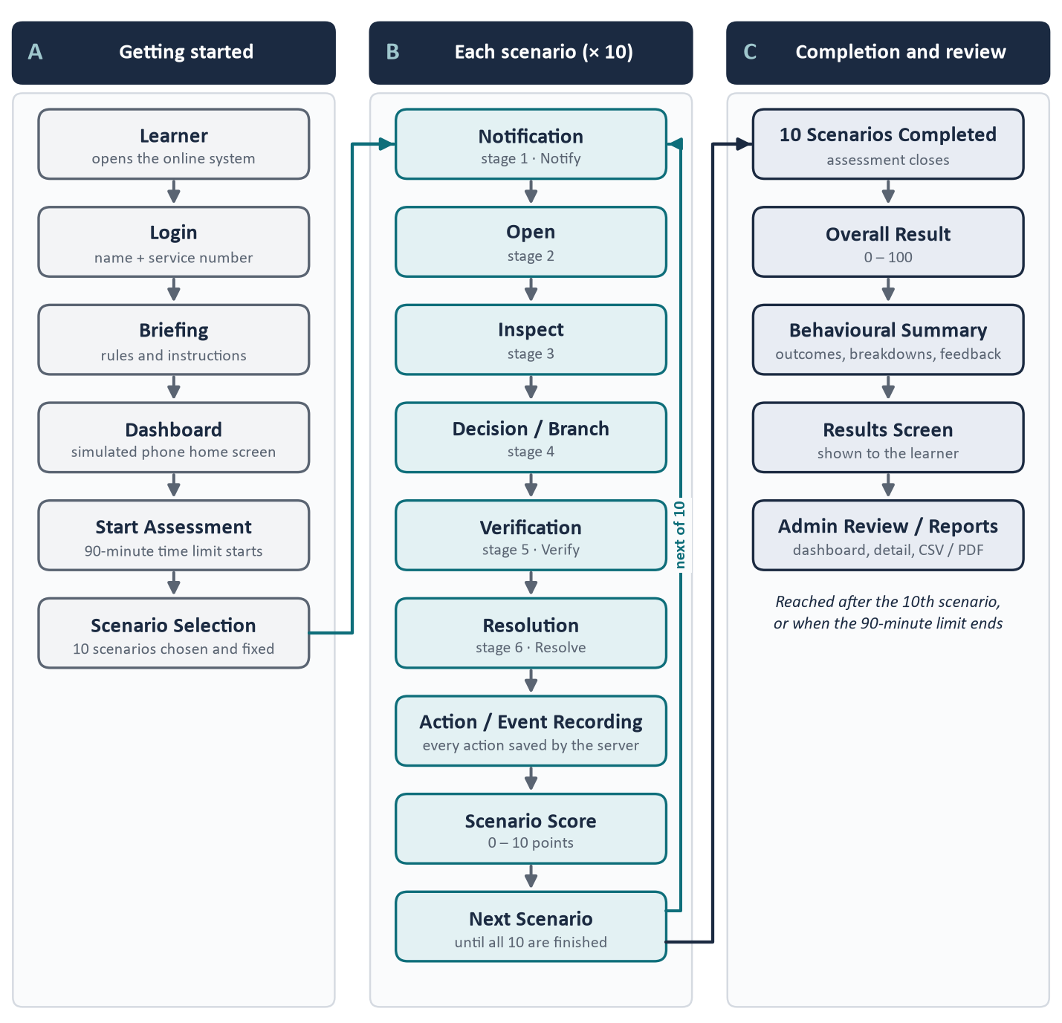
Figure 6 – End-to-end system flow

15. Component Responsibility Summary
Component | Main responsibility
Learner Interface | User interaction and simulation — shows the phone, the apps and the scenario screens, and passes on the learner's choices.
Backend / API | Processing and validation — checks every request and applies the rules.
Database | Storing learner and assessment data — profiles, attempts, recorded actions and results.
Scenario Engine | Providing scenario flow and content — moves each scenario through the six stages.
Scoring | Calculating scenario and assessment points — 0–10 per scenario, 0–100 overall.
Admin Interface | Reviewing assessment information — dashboard, attempts, settings and audit log.
Export / Reporting | Producing assessment reports — CSV and PDF, per attempt or per learner.

16. Final Summary
The system provides a centrally hosted online assessment environment where learners interact with controlled, simulated communication scenarios. Their actions are recorded and evaluated by the server, results are generated from that record, and administrators can review every completed assessment in detail and export it as a report.
Controlled | Synthetic | Self-contained | Online | Measurable | Reviewable

