Case 1: When LLM classifies the query as ‘News’ and NewsAPI fetches the related news articles. The fact_check agent flags 1 article which comes from a potentially unreliable source.

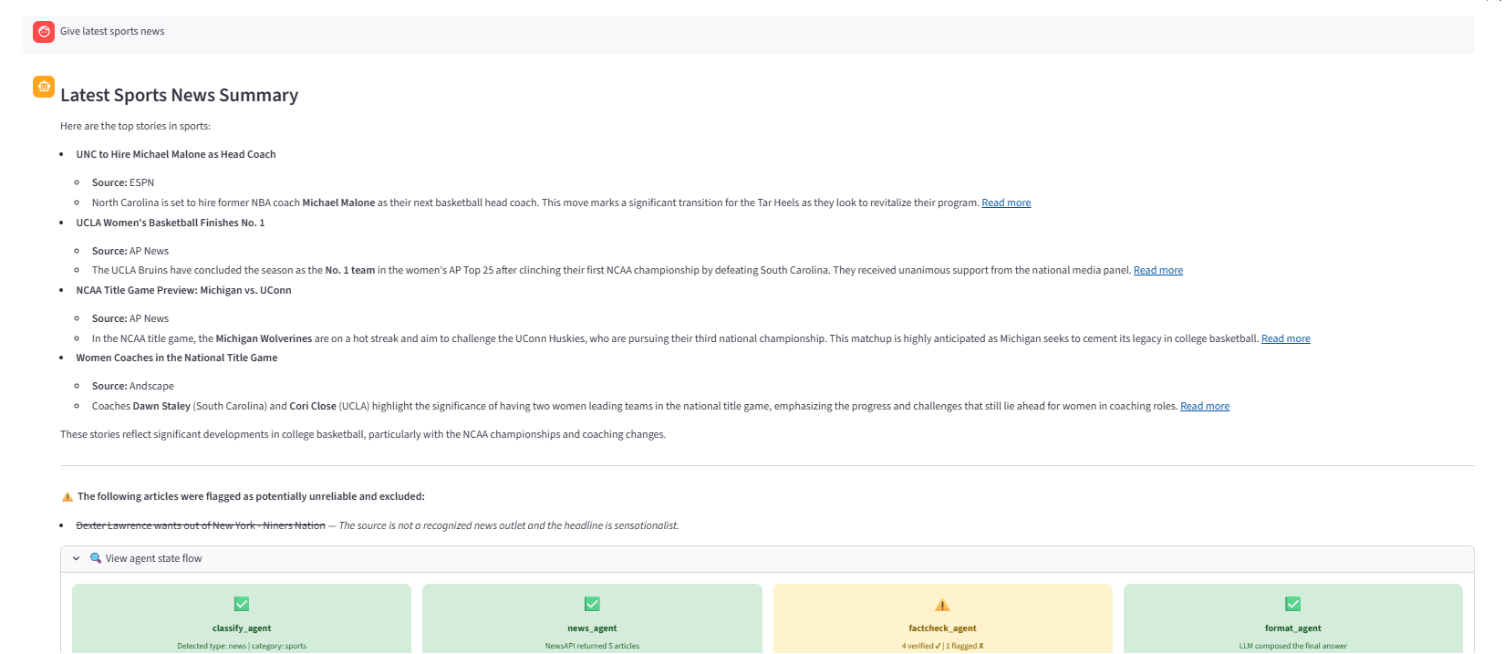

Case 2: When the LLM classifies the query as ‘News’ but no related news is available in the NewsAPI so it falls back and returns output through the SerpAPI.
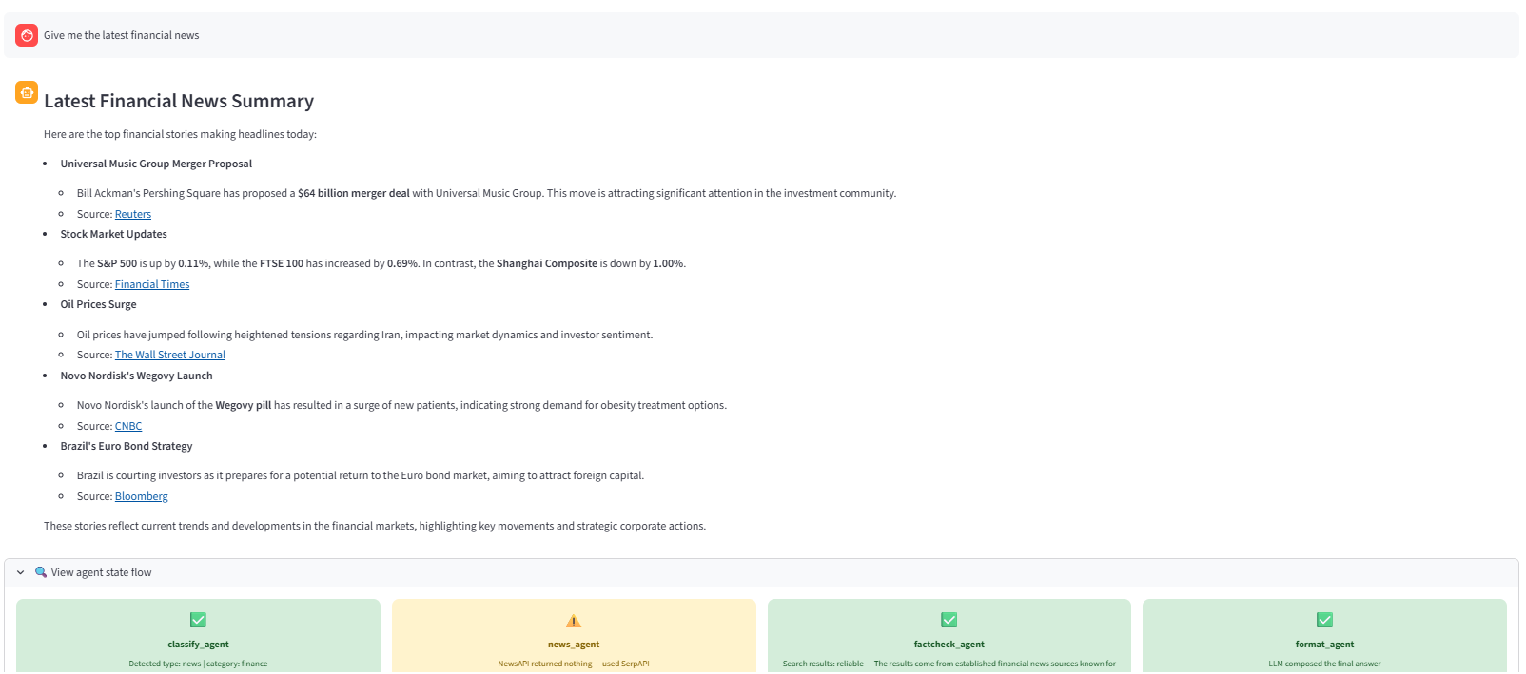

Case 3: When the LLM classifies the query as ‘General’ and SerpAPI returns corresponding output
