Title of Article  The Rise of Wealth, Private Property, and Income Inequality in China | Source of article  Stanford University | Date the commentary was written  July, 28, 2024
Word count of commentary  799 | Unit of syllabus to which the article relates  Macroeconomics | Key Concept  equity

commentary
The article discusses the issue of growing inequalities in outcomes in China compared to other countries. While income inequality refers to the unequal distribution of income within a population, outcomes inequality refers to disparities in wealth and income. This essay will discuss the key concept of equity, the notion that everyone should be given equal opportunity to succeed.

China's inequality of income has been increasing, as the article states. The data from the article's diagram is extracted to plot the point on the Lorenz Curve diagram to illustrate the income inequality of China in 1978 and 2014.

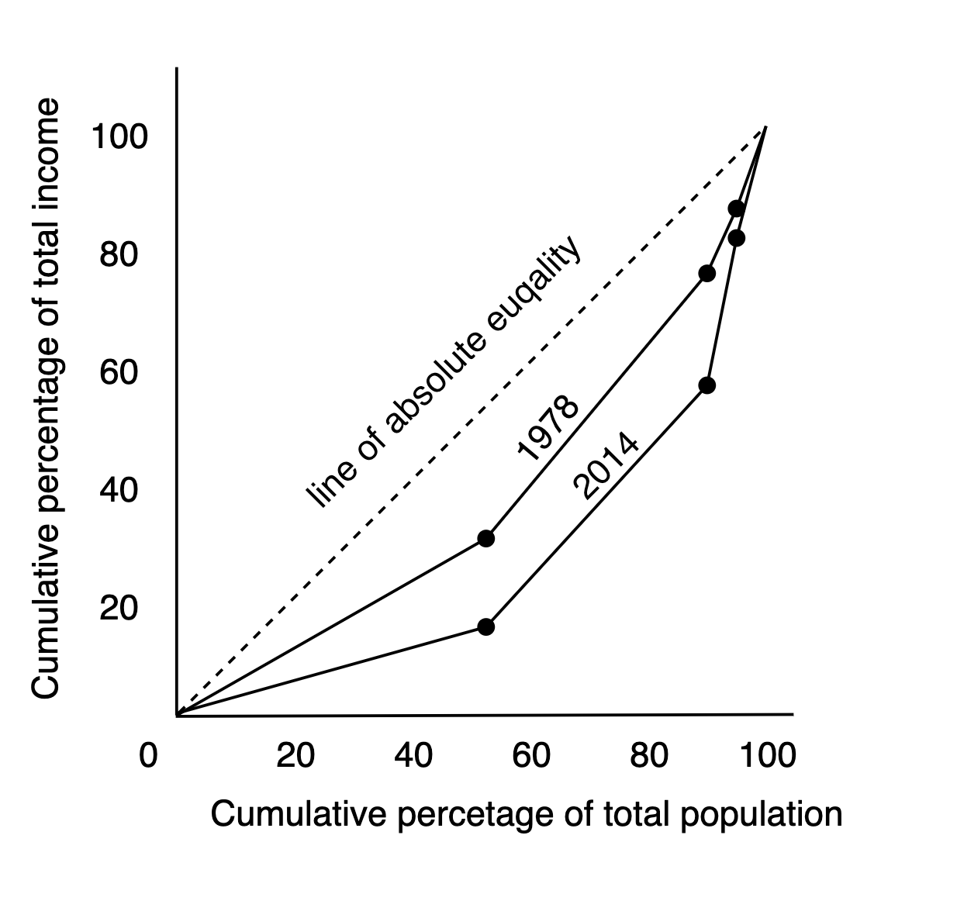
The x-axis of the diagram shows the cumulative percentage of the total population divided up in the quintiles. The y-axis shows the cumulative percentage of total income earned by the quintiles. The green dotted line represents absolute equality, which means that income is evenly distributed over the population, where the lowest 50% of the population has 50% of the national income. Whereas the Curve shows China's actual income distribution. According to the report, the wealthiest 10% of China's population received 27% of the national income in 1978 and 41% in 2015, while the lowest 50% earned 27% and 15%, respectively. This difference is shown as the orange curve is further away from the line of absolute equality than the blue curve, which means that the income is more unequally distributed.
Although income inequality and inequity are different, there is often a connection between them. According to the article, wealth is far more concentrated than income; the poorest 50% of the population owns 5.8% of China's total wealth, which is about equal to that of the top 0.0001%. Households in poverty have access to fewer opportunities. For example, children from poor households are less likely to have access to quality education. Even if they perform well, they may struggle to afford the cost of tutoring or private schooling. However, children in wealthy households get better educations and become more skilled to succeed. A lack of equity is reflected in the growing levels of income, wealth, and opportunity inequality.

The article expresses a need to design adequate policy responses to reduce inequalities. One possible policy is progressive tax, meaning the tax rate will increase for higher income. However, wealth is frequently concentrated in the hands of a small number of people. By imposing a property tax or "wealth" tax on individuals based on the value of their financial assets, the government could more effectively raise money to lower taxes on low-income individuals and fund public services like healthcare and education, which would lessen inequality in long run. Another way is transfer payments, which are the financial assistance that the government takes from other people’s income to a certain group.
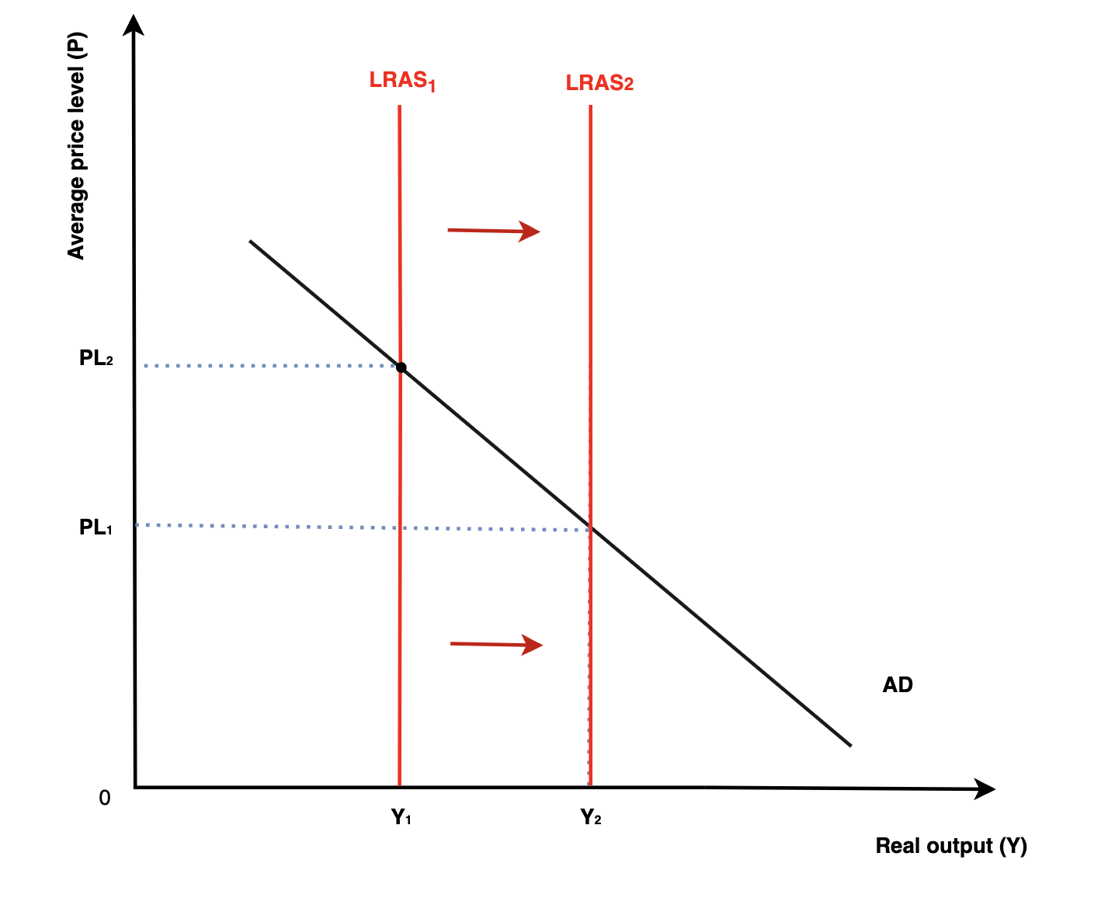
Improving public services like education and healthcare can increase long-term economic growth and improve equity. Because it can help improve human capital and, therefore, labour productivity in the country, leading the LRAS to shift right and reach a higher real GDP from Y₁ to Y₂ and causing the price level to drop from PL₂ to PL₁ as well. For example, improving public education provides equal access to quality schooling for all segments of society. Therefore, labour productivity increases due to higher cognitive skills. Furthermore, when public services are funded and improved, wealthier families' advantage over poor ones is reduced, ensuring children from disadvantaged backgrounds have more opportunities to succeed.
On the other hand, the Chinese government uses social security to redistribute income from the well-compensated to the poorly compensated. It also gives financial aid to people who can meet their living needs. This would be a quicker and more specific way of improving equality rather than improving public services.
There are also disadvantages to the policies. A more progressive tax system or overpromoting transfer payments can have a negative impact on economic growth; the incentive for investment will be reduced because the return on investment will be lower due to a higher tax rate. Moreover, the incentive for work and entrepreneurship will be reduced since people would benefit less from hard work due to more tax on higher income, and they get benefits from the government even if they are not pursuing employment due to social security. This could lead the LRAS to shift back to the left. Nevertheless, excessive and inefficient investments can lead to a budget deficit, threatening the long-term financial future of the country.
All things considered, policies that advance equity will help lower-income groups of people while having a detrimental effect on higher-income households. Transfer payments have the potential to reduce inequality in the short run. China needs to find the correct balance between fostering equity and preserving the incentives required for economic expansion. Last but not least, investing in human capital is essential and will eventually foster equity and growth.

Bibliography:
Mazzocco, I. (2022) ‘How Inequality Is Undermining China’s Prosperity’. Available at: https://www.csis.org/analysis/how-inequality-undermining-chinas-prosperity (Accessed: 21 November 2024).
University, © Stanford, Stanford and California 94305 (2023) The Rise of Wealth, Private Property, and Income Inequality in China. Available at: https://sccei.fsi.stanford.edu/china-briefs/rise-wealth-private-property-and-income-inequality-china (Accessed: 9 September 2024).

