SYNOPSIS

CO_HEALTH is a website to provide the information related to the municipality ,health also covid related information to the public. It will maintain complete covid reports of people in a municipality ward based.

The public can also view the covid general information and vaccination details and also TPR and WPR rate as well as they can know the micro­­­­­-containment zone.

Also they can have the option to provide their concern for organ donation.

The system consist of 5 modules:

ADMIN

Admin is the main module and this module have the overall control of the website. Admin can view and verify the registrations.

DEPARTMENT

Department is the another module where the registration of staffs and they can login after approving by admin.

TEST CENTRE/LAB

Test centre can register and they can update the covid information.

USERS

There are 2 categories of users. One is primary users and secondary users. The primary users have the direct interaction with the health department. The others are secondary users. The public users can view the details in graphical as well as text format. Also they can submit their complaints. Also they can submit their concern for organ donation.

VACCINATION

This module consist of all the vaccination details, like vaccination type, location, ward, etc

HEALTH INSPECTOR

The health inspector can add and edit vaccination drive. He can view all the vaccination details.

HARDWARE AND SOFTWARE REQUIREMENTS

Processor :i3

RAM :Minimum 4gb

Hard Disk :500gb

Front-End :Python-Django

Back-End :Python

Database :SQL

TABLES

Table no:1 Primary key:User_id

Table name: User

|  |  |  |
| --- | --- | --- |
| FIELD | DATATYPE | DESCRIPTION |
| User_id | Int(5) | User id |
| Name | varchar(20) | Name |
| User type | varchar(20) | Type of user |
| State | varchar(20) | State |
| District | varchar(20) | District |
| City | varchar(20) | City |
| Pincode | Int(10) | Pincode |
| Email | varchar(20) | Email |
| Username | varchar(20) | Username |
| Password | varchar(20) | Password |

Table no:2 Primary key:Org_id

Table name: Organ_donation Foreign key :User_id

|  |  |  |
| --- | --- | --- |
| FIELD | DATATYPE | DESCRIPTION |
| Org_id | Int(5) | Organ id |
| User_id | Int(5) | User id |
| Name | varchar(20) | Name |
| State | varchar(20) | State |
| District | varchar(20) | District |
| City | varchar(20) | City |
| D_organ | varchar(20) | Donating organ |
| Weight | Int | Weight |
| Height | Int | Height |
| H_status | varchar(20) | Health_status |
| Phone | Int(10) | Phone |
| Email | varchar(20) | Email |

Table no:3 Primary key:Admin_id

Table name: login

|  |  |  |
| --- | --- | --- |
| FIELD | DATATYPE | DESCRIPTION |
| Login_id | Int(5) | Login id |
| Username | varchar(20) | Username |
| Type | Varchar(20) | Type of user |
| Password | varchar(20) | Password |

Table no:4 Primary key :Co_id

Table name:complaint Forign key :User_id

|  |  |  |
| --- | --- | --- |
| FIELD | DATATYPE | DESCRIPTION |
| Co_id | Int | Complaint id |
| User_id | Int(5) | User id |
| Name | varchar(20) | Name |
| Phone | Int(10) | Phone |
| Email | varchar(20) | Email |
| Complaint | varchar(50) | Complaint |

Table no:5 Primary key :Dep_id

Table name: Department

|  |  |  |
| --- | --- | --- |
| FIELD | DATATYPE | DECRIPTION |
| Dep_id | Int(5) | Department id |
| Dep_name | varchar(25) | Department name |
| Staff_name | varchar(25) | Staff name |
| State | varchar(25) | State |
| District | varchar(25) | District |
| City | varchar(25) | City |
| Pincode | Int(10) | Pincode |
| Phone | Int(10) | Phone |
| Designtion | varchar(25) | Designation |
| Email | varchar(25) | Email |
| Staff_username | varchar(25) | Staff username |
| Staff_password | varchar(25) | Staff password |

Table no:6 Primary key :Tl_id

Table name: testlab_registration

|  |  |  |
| --- | --- | --- |
| FIELD | DATATYPE | DESCRIPTION |
| Tl_id | Int(5) | Test lab id |
| Name | varchar(20) | Name of test/lab |
| Location | varchar(20) | Location |
| State | varchar(20) | State |
| District | varchar(20) | District |
| Proof | varchar(20) | Proof |
| Licenseno | varchar(20) | License number |
| Email | varchar(20) | Email |
| Tl_username | varchar(20) | Test lab username |
| Tl_password | varchar(20) | Test lab password |
| Working_days | varchar(20) | Working days |
| Working_time | varchar(20) | Working time |

Table no:7 Primary key :Vacc_id

Table name: vaccine_drive

|  |  |  |
| --- | --- | --- |
| FIELD | DATATYPE | DESCRIPTION |
| Vacc_id | Int(5) | Vaccination id |
| Vacc_type | varchar(20) | Vaccination type |
| Vacc_location | varchar(20) | Vaccination location |
| Date | date | Date of vaccination |
| Time | varchar(20) | Time of vaccination |
| Ward | varchar(20) | Ward |
| Max_vaccno | varchar(20) | Maximum vaccination number |
| Dr incharge | varchar(20) | Doctor incharge of drive |
| Nurse Asst | varchar(20) | Nurse assistant |

Table no:8 Primary key :Cd_id

Table name: covid_info Forign key :Tl_id

|  |  |  |
| --- | --- | --- |
| FIELD | DATATYPE | DESCRIPTION |
| Cd_id | Int(5) | Covid id |
| Tl_id | Int(5) | Test lab id |
| Patient_name | varchar(25) | Patient name |
| Patient_status | varchar(25) | Patient status |
| Patient_location | varchar(25) | Patient location |
| Patient_phc | varchar(25) | Patient phc |
| Patient_ward | varchar(25) | Patient ward |
| Panchayath/municipality | varchar(25) | Panchayath/ municipality |
| Contact-no | Int(10) | Phone number |
| Email | varchar(25) | Email |

Table no:9 Primary key :User_id

Table name: vacc_info

|  |  |  |
| --- | --- | --- |
| FIELD | DATATYPE | DESCRIPTION |
| User_id | Int(5) | User id |
| Name | varchar(25) | Name |
| Vaccine_type | varchar(25) | Type of vaccination |
| Ward | Int(3) | Ward number |
| Contact_no | Int(10) | Contact number |
| Have you ever covid +ve?  (yes/no) | varchar(25) | Covid status |

Table no:10 Primary key :Ward_no

Table name: dashboard

|  |  |  |
| --- | --- | --- |
| FIELD | DATATYPE | DESCRIPTION |
| Ward-no | Int(3) | Ward number |
| No_of_positive | Int(5) | Total positive |
| No_of_women | int(5) | Total no of women |
| No_of_men | Int(5) | Total no of men |
| No_of_children | Int(5) | Total no of children |
| TPR | Double | TPR rate |
| WPR | Double | WPR rate |
| Home_quarantine | varchar(20) | Total home quarantine |
| Total_death | Int(5) | Total death |

DFD

LEVEL 0

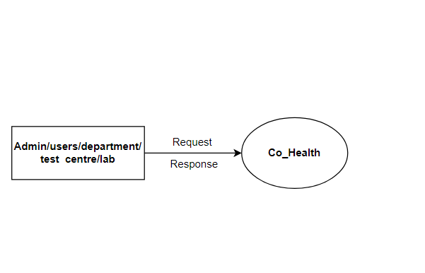

LEVEL 1: Admin

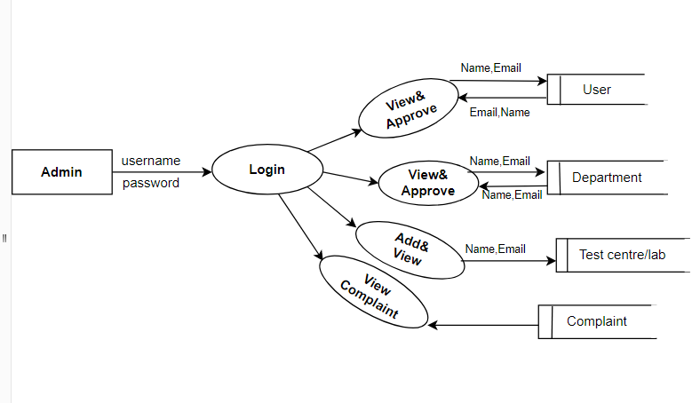

LEVEL 1:Test centre/lab

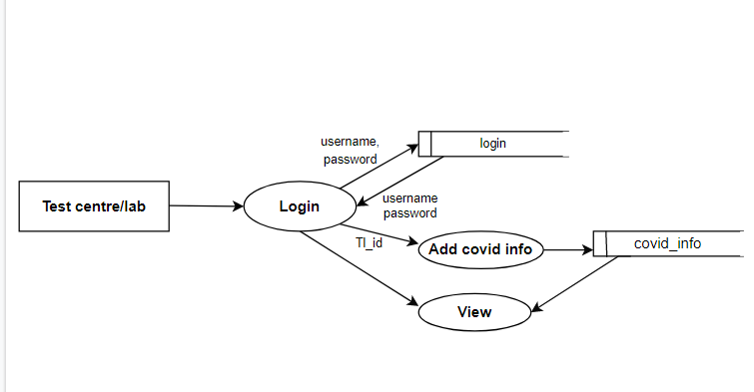

LEVEL 1:Users

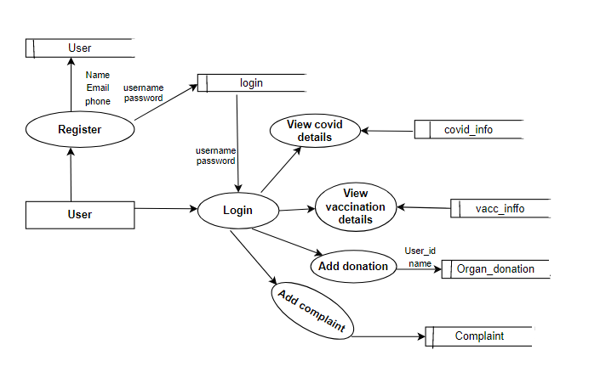

LEVEL 1:Department

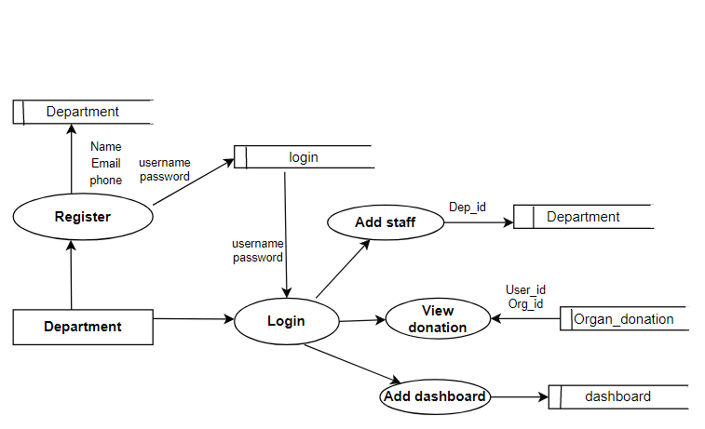

LEVEL 1:Health inspector

