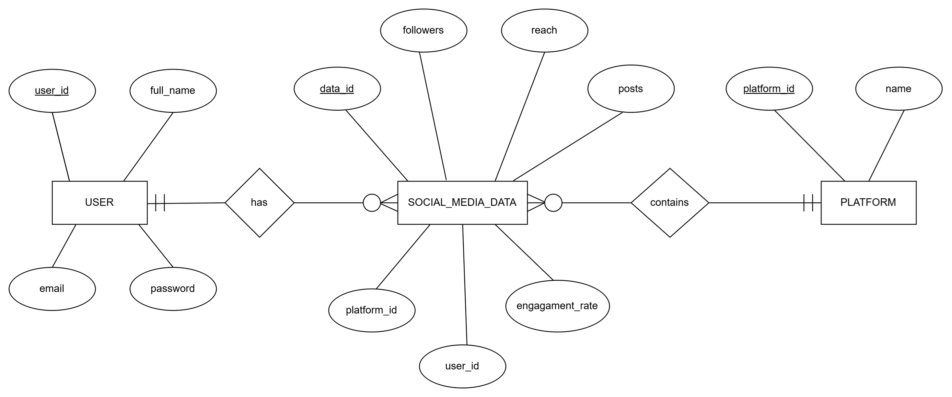

` **Social Media Analytics Dashboard**

**ER-Diagram**