Department of Veterans Affairs
Pharmacy Reengineering (PRE)
Medication Order Check Healthcare Application
(MOCHA) Server v3.0
Requirements Specification Document



December 2014
Version 2.3

Revision History
Note: The revision history cycle begins once changes or enhancements are requested after the Requirements Specification Document has been baselined.
Date | Version | Description | Author
12/29/2014 | 2.3 | Technical Edit
12/09/2014 | 2.2 | Updates for PBM review to the following sections: 1 – Introduction; 1.2 Scope; 1.3.1 Acronyms; 1.4 References; 2.4 Disaster Recovery Specification; 6 Purchased Components; 2.6.1 – Updated numbering and FR 2.6.1.1 and FR 2.6.1.3.2.1.
11/13/2014 | 2.1 | Technical edit
11/10/2014 | 2.0 | Document updated to reflect MOCHA Server v3.0 changes only.
08/20/2014 | 1.7 | Moved New VistA XML message schema for Drug Name Search (CR 6846) under MOCHA Server v4.0.
02/20/2014 | 1.6 | Update FP Estimation
01/21/2014 | 1.5 | Updates
01/14/2014 | 1.3 | Updated RSD for  MOCHA Server v 3.0 functionalities required for MOCHA VistA 2.1.  MOCHA Server v4.0 functionalities required for MOCHA VistA 2.2  MOCHA Server v 5.0 functionalities required for MOCHA VistA 2.3  Added definitions. Minor text edits.

Artifact Rationale
The Requirements Specification Document (RSD) records the results of the specification gathering processes carried out during the Requirements phase. The RSD is generally written by the functional analyst(s) and should provide the bulk of the information used to create the test plan and test scripts. It should be updated for each increment.
The level of detail contained in this RSD should be consistent with the size and scope of the project. It is not necessary to fill out any sections of this document that do not apply to the project. The resources necessary to create and maintain this document during the life cycle of a large project should be acknowledged and clearly reflected in project schedules. Do not duplicate data that is already defined in another document or a section in this document; note in the section where the information can be found.
Table of Contents
1 Introduction 1
1.1 Purpose 1
1.2 Scope 1
1.3 Acronyms and Definitions 2
1.3.1 Acronyms 2
1.3.2 Definitions 3
1.4 References 4
2 Overall Description 4
2.1 Accessibility Specifications 4
2.2 Business Rules Specification 4
2.3 Design Constraints Specification 5
2.4 Disaster Recovery Specification 5
2.5 Documentation Specifications 5
2.6 Functional Specifications 5
2.6.1 MOCHA Server v3.0 5
2.7 Graphical User Interface (GUI) Specifications 6
2.8 Multi-divisional Specifications 6
2.9 Performance Specifications 6
2.10 Quality Attributes Specification 6
2.11 Reliability Specifications 7
2.12 Scope Integration 7
2.13 Security Specifications 7
2.14 System Features 7
2.15 Usability Specifications 7
3 Applicable Standards 7
4 Interfaces 7
4.1 Communications Interfaces 7
4.2 Hardware Interfaces 7
4.3 Software Interfaces 7
4.4 User Interfaces 7
5 Legal, Copyright, and Other Notices 7
6 Purchased Components 8
7 User Class Characteristics 8
8 Estimation 8
9 Approval Signatures 10
Appendix Summary 11

Introduction
Medication Order Check Healthcare Application (MOCHA) Server is a Java 2 Enterprise Edition (J2EE) utility which is used by the MOCHA Veterans Health Information Systems and Technology Architecture (VistA) Pharmacy Application to conduct enhanced order checks using First Databank’s (FDB) MedKnowledge Framework. FDB’s MedKnowledge Framework is a drug data product that provides the latest identification and safety information on medications. Additionally, FDB provides the latest algorithms used to perform order checks. The order checks and drug information retrieval performed by MOCHA Server include:
- Enhanced Drug-Drug Interactions Order Check – provides the clinician with more information by displaying a short description of the clinical effects of the drug interaction and providing an optional view of a detailed professional drug interaction monograph. It checks interactions between two or more drugs, including interaction monographs.
- Enhanced Duplicate Therapy Order Check – uses FDB’s Enhanced Therapeutic Classification (ETC) System, which allows checking for duplicated drug classifications between two or more drugs.
- Drug Dose Order Check – determines if the prescribed dose for an ordered drug within the proper dosing parameters based on the patient’s age, weight, and body surface area. This includes both maximum single dose checking and daily dose range checking with a max daily dose limit. General dosing information for a drug will be provided when the other dosing checks cannot be performed.
- Drug Dose Information – Compilation of dose route, dose unit, and whether weight or body surface area (BSA) is required for a specific age range, dose type and dose route combinations. The information retrieved from a drug’s dosing records is used for viewing through a VistA Pharmacy Data Management (PDM) option.

Purpose
The purpose of this Requirements Specification Document (RSD) is to articulate the required changes to MOCHA Server for version 3.0. MOCHA v2.1 requires MOCHA Server v3.0.
The target audience of this RSD includes Pharmacy Benefits Management (PBM), Integrated Project Team (IPT) members, the MOCHA Server project team, and test site users.

Scope
This RSD captures the functional and technical requirement specifications for MOCHA Server v3.0.
MOCHA Server v3.0 adds fields to the Drug-Dose order check response back to VistA. The Dose Units, Dose Routes, and Dose Types tables will be updated to match what is in the current FDB database. Several software upgrades will be made to MOCHA Server to remain Technical Reference Model (TRM) compliant.

Acronyms and Definitions
This subsection should provide the definitions of all terms, acronyms, and abbreviations required to properly interpret the RSD.

Acronyms
Term | Definition
ACP | Application Contingency Plan
AITC | Austin Information Technology Center
API | Application Program Interface
BSA | Body Surface Area
COTS | Commercial-Off-The-Shelf
DR | Disaster Recovery
ESB | Enterprise Service Bus
ETC | Enhanced Therapeutic Classification
FDB | First Databank
FTP | File Transfer Protocol
GCN | Generic Code Number
ICD | Interface Control Document
IPT | Integrated Program/Project Team
J2EE | Java 2 Enterprise Edition
JDBC | Java Database Connect
MOCHA | Medication Order Check Healthcare Application
PBM | Pharmacy Benefits Management
PDM | Pharmacy Data Management
PECS | Pharmacy Enterprise Customization System
PITC | Philadelphia Information Technology Center
PMAS | Program Management Accountability System
PRE | Pharmacy Reengineering
RSD | Requirements Specification Document
SDD | System Design Document
SSH | Secure Shell
SSP | System Security Plan
SE | Standard Edition
SwRI | Southwest Research Institute
TRM | Technical Reference Model
TSPR | Technical Services Project Repository (deprecated)
VA | Department of Veterans Affairs
VistA | Veterans Health Information Systems and Technology Architecture

Definitions
Term | Definition
Body Surface Area | A measured or calculated surface of a human body.
Dose Route | A term which represents the method of administering the drug.
Dose Type | A term which identifies the purpose for which the dose is given (for example, loading dose, maintenance dose).
Dose Unit | A unit of measure commonly reported in the medical literature and reference sources, such as ‘MG’, ‘TABLET’.
Enhanced Order Checks | Drug-Drug Interaction, Duplicate Therapy, and Dosing order checks that are executed utilizing FDB’s MedKnowledge Framework (formerly known as Drug Information Framework) APIs and database.
GCNSEQNO | A numeric value that represents a generic formulation. It is specific to the generic ingredient(s), route of administration, dosage form, and strength. The Formulation ID (GCN), in some cases, may have the same value for different dosage forms, strengths, or non-active ingredient list differences and therefore may be linked to more than one GCNSENO. But a GCNSEQNO is unique in its association with each combination of factors.
Java Database Connect | The industry standard for database-independent connections between the Java programming language and a wide range of databases.
Java Platform, Enterprise Edition | A platform for a large scale server programming in the Java Programming language. Java EE differs from the Standard Edition (SE) of Java in that it adds additional libraries that provide functionality to deploy fault-tolerant, distributed, multi-tier Java software, based largely on modular components running on an application server. It is also a reference implementation of the Java EE specification.
Weblogic Server | A Java Enterprise Edition application server platform designed to host distributed applications written using Java and the Java Enterprise Edition frameworks. Weblogic Server has Enterprise Service Bus (ESB) capabilities that can be configured to provide system connectivity and data transformation spanning IT environments.

References
- VA Handbook 6500 – Information Security Program
- PMAS Portal
- ProPath Site
This manual contains references to several other documents. These documents can be found on following sites:
- PRE SharePoint Site:
- MOCHA Server IPT Review Portal:
- MOCHA Server v3.0 SharePoint Site:
- PRE Technical Services Project Notebook (TSPR) Site:
- One-VA TRM Home Page:
Note: | Due to policy constraints, active links cannot be included in this document. Please copy and paste the URLs into your browser.

The following documents are referenced within this document:
- MOCHA Server v3.0 SDD
- MOCHA Server v3.0 ICD
- Austin Information Technology Center (AITC)’s Application Contingency Plan document
- J2EE Component of PRE version 0.5 Software Requirements document (produced by Southwest Research Institute (SwRI))
If you cannot find a specific document, please advise the Program Manager found on the TSPR site.

Overall Description
This section describes the general factors that affect the product and its specifications.

Accessibility Specifications
Not applicable.

Business Rules Specification
This section lists the design constraints specifications:
- The system shall provide the ability to utilize services provided by a commercial drug database to support VistA order check process.
- When a VistA package requests a check on one or more drugs, the system shall receive and evaluate the request, triage the request, interact with the Commercial-Off-The-Shelf (COTS) data source to perform the requested check, and return the requested order check information.
- The link between the VistA drug concept and FDB drug concept shall be the Generic Code Number (GCN) Sequence Number.
- Only the drugs that are successfully mapped to a FDB drug concept will participate in the order check.

Design Constraints Specification
Design Constraints Specifications are described in the MOCHA Server v3.0 SDD.

Disaster Recovery Specification
No specific requirements for Disaster Recovery (DR). Disaster Recovery is implemented by the AITC, PITC and Regional Data Center as part of hosting services.

Documentation Specifications
The project shall follow VA-required PMAS and ProPath documentation standards for VA projects.

Functional Specifications
This section describes the software modifications for MOCHA Server v3.0. MOCHA Server v3.0 will be implemented with MOCHA v2.1.
FDB’s MedKnowledge Framework v3.3 Application Program Interfaces (APIs), business logic and database will be utilized.

MOCHA Server v3.0
This section documents the requirements that will be delivered in MOCHA Server v3.0.
RTC Story ID# 32517 – New clinical route added – 114 INTRAVARICEAL shall be addressed by Functional Requirement 2.6.1.1.2.

Functional Requirement 1
Three tables within MOCHA Server shall be updated to match what is in the FDB database.

Functional Requirement 1
The Dose Units table shall be updated.

Functional Requirement 2
The Dose Routes table shall be updated.

Functional Requirement 3
The Dose Types table shall be updated.

Functional Requirement 2
The system shall return the MaxDailyDose, MaxDailyDoseUnit, MaxDailyDoseForm, and MaxDailyDoseFormUnit fields in the response back to VistA when performing a Drug-Dose order check.

Functional Requirement 3
Several software upgrades shall be made to stay Technical Reference Model (TRM) compliant.

Functional Requirement 1
WebLogic Server shall be upgraded from 10.3.6 to 12c.

Functional Requirement 2
The platform shall be upgraded from Java 6 to Java 7.

Functional Requirement 1
The following jars shall be upgraded to newer versions:
- Jaxb-xjc-2.2.7.jar
- Jaxb-core.jar
- Jaxb-impl.jar

Functional Requirement 3
The Java Database Connect (JDBC) driver shall be upgraded from version 6 to 7.

Graphical User Interface (GUI) Specifications
Not applicable.

Multi-divisional Specifications
Not applicable.

Performance Specifications
SwRI provides performance measures for the MOCHA Server, previously known as PRE V 0.5 system (i.e., the J2EE component). SwRI interprets these requirements to mean round-trip time to complete a requested order check, from the time the request message arrives at MOCHA Server, through the time the order check is performed, to the time the response message is returned to VistA. VistA-side processing is not considered for the overall order check response time requirements.
Details can be found in the J2EE Component of PRE V 0.5 Software Requirements document produced by SwRI.
The system shall support the 5-second performance measures for the J2EE component defined for the execution of order checks.

Quality Attributes Specification
Not applicable.

Reliability Specifications
The system shall be available 24/7, with exception made for required system maintenance activities. Required maintenance activities shall be scheduled for known periods of decreased system utilization.

Scope Integration
Not applicable.

Security Specifications
Users can not directly log into MOCHA servers via SSH (Secure Shell), Telnet or FTP (File Transfer Protocol) because there are no user accounts. Additional details can be found in the PRE-PECS_SSP_2011 document in ClearCase.

System Features
System features are described in the MOCHA Server SDD.

Usability Specifications
Not applicable.

Applicable Standards
Applicable standards are described in the MOCHA Server v3.0 SDD.

Interfaces
Interfaces are described in the MOCHA Server v3.0 ICD.

Communications Interfaces
Communication interfaces are described in the MOCHA Server v3.0 SDD.

Hardware Interfaces
Hardware interfaces are described in the MOCHA Server v3.0 SDD.

Software Interfaces
Software interfaces are described in the MOCHA Server v3.0 SDD.

User Interfaces
MOCHA Server is a stand-alone utility without any user interface.

Legal, Copyright, and Other Notices
Not Applicable.

Purchased Components
The MOCHA Server Java utility is hosted by AITC, PITC, and Regional Data Centers; all the purchased components are listed in AITC’s and PITC’s Application Contingency Plan (ACP) documents.

User Class Characteristics
MOCHA Server is a stand-alone Java utility without any user interface.

Estimation
Project Software Functional Size and Size-Based Effort and Duration Estimate
Application
Item | MOCHA Server | Total
Counted Function Points | 62 | 62
Estimated Scope Growth
Estimated Size at Release

Size-Based Effort Estimates | Labor Hours | Probability
Low-Effort Estimate – With indicated probability, project will consume no more than: | 1010 | 50
High-Effort Estimate – With indicated probability, project will consume no more than: | 1890 | 75

Size-Based Duration Estimates | Work Days | Probability
Low-Duration Estimate – With indicated probability, project will consume no more than: | 69 | 50
High-Duration Estimate -- With indicated probability, project will consume no more than: | 116 | 75

Figure 1: Cumulative Probability (“S-curve”) Chart for MOCHA Server v3.0
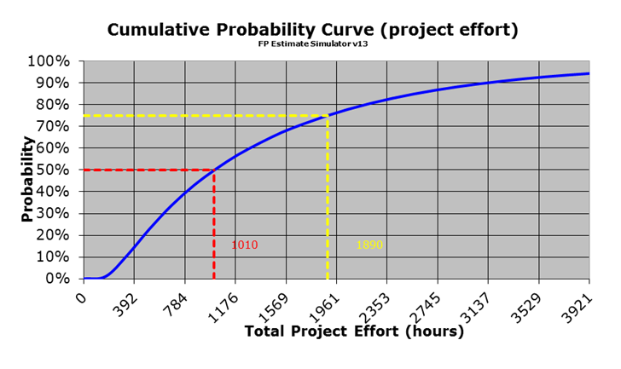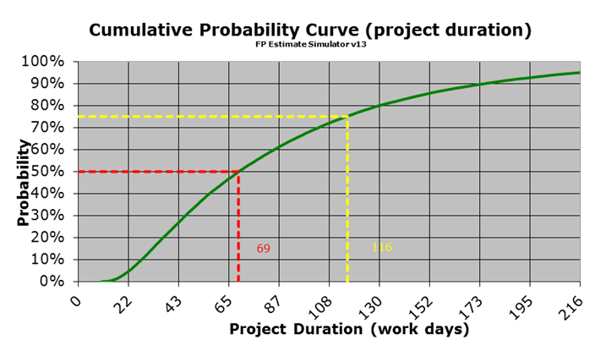

Approval Signatures
This section is used to document the approval of the Requirements Specification Document during the Formal Review.
The Chair of the governing Integrated Project Team (IPT), Business Sponsor, IT Program Manager, and the Project Manager are required to sign. Please annotate signature blocks accordingly.

REVIEW DATE:
SCRIBE:

____________________________________________________________
Signed:
, Project Manager, Pharmacy Reengineering - MOCHA

____________________________________________________________
Signed:
, Program Manager, Pharmacy Reengineering
Integrated Project Team (IPT) Chair & IT Program Manager

____________________________________________________________
Signed:
, PBM, Associate Chief Consultant, Clinical Informatics/Reengineering
Business Sponsor

Appendix Summary
This appendix contains the link for the original RSD for MOCHA Server 1.0, which was created by SwRI. It is for reference only:

