Pharmacy Reengineering
Medication Order Check Healthcare Application (MOCHA) Server
Installation Guide



Version 3.0

January 2015

Department of Veterans Affairs
Product Development
Revision History
Date | Description | Author
01/12/2015 | Format/technical edit.
01/08/2015 | Initial draft of the Pharmacy Reengineering (PRE) Installation Guide for MOCHA SERVER 3.0 build deployment on WebLogic Application Server; modified MOCHA Server 2.0 Installation Guide.
ProPath template version 1.3 April 2014

Table of Contents
1. Introduction 1
1.1. Overview of PRE MOCHA Server 1
1.2. Scope of this Document 1
2. Installation Prerequisites 2
3. Database Tier Overview 3
4. WebLogic Application Server Configuration 4
4.1. Un-Deploy Old MOCHA Server Build 4
4.2. Deploy New MOCHA Server Build 8

List of Figures
Figure 4-1: Domain Structure 4
Figure 4-2: Change Center 5
Figure 4-3: Summary of Deployments – Stopping MOCHA 5
Figure 4-4: Force Stop Application Assistant 6
Figure 4-5: Summary of Deployments – MOCHA Deployment Prepared 6
Figure 4-6: Delete Application Assistant 7
Figure 4-7: Summary of Deployments – MOCHA Deployment Deleted 7
Figure 4-8: Activate Changes 8
Figure 4-9: Domain Structure 8
Figure 4-10: Change Center 9
Figure 4-11: Deployments 9
Figure 4-12: Install Application Assistant 10
Figure 4-13: Choose Targeting Style 11
Figure 4-14: Select Deployment Targets 12
Figure 4-15: Optional Settings 13
Figure 4-16: Review Your Choices and Click Finish 14
Figure 4-17: Settings for MOCHA 15
Figure 4-18: Activate Changes 16
Figure 4-19: Domain Structure 16
Figure 4-20: Summary of Deployments 17
Figure 4-21: Start Application Assistant 17
Figure 4-22: Summary of Deployments – MOCHA Deployment Active 18

Introduction

Overview of PRE MOCHA Server
MOCHA (Medication Order Check Healthcare Application) Server is a J2EE Application which is used by the VistA MOCHA Pharmacy Application to conduct enhanced order checks using First Databank’s (FDB) MedKnowledge Framework. FDB is a drug data product that provides the latest identification and safety information on medications. Additionally, FDB provides the latest algorithms used to perform order checks. The order checks performed by MOCHA include:
- Enhanced Drug-Drug Interactions Order Checks –provides the clinician with more information by displaying a short description of the clinical effects of the drug interaction and providing an optional view of a detailed professional drug interaction monograph. It checks interactions between two or more drugs.
- Enhanced Duplicate Therapy Order Checks –uses FDB’s Enhanced Therapeutic Classification (ETC) System, which allows checking for duplicated drug classifications between two or more drugs.
- Drug Dose Order Check –checks if the prescribed dose for an ordered drug is within the proper dosing parameters based on the patient’s age, weight, and body surface area. This includes both maximum single dose checking and daily dose range checking. General dosing information for a drug will be provided when the other dosing checks cannot be performed.

Scope of this Document
MOCHA Server is comprised of four logical deployment components: Application Server, Database Server, Failover Server, and Legacy Interface.
The purpose of this Installation Guide is to provide instructions for the deployment of the PRE MOCHA Server application build on a WebLogic (application) Server and provide an overview of the Database Server component.

Installation Prerequisites
For successful deployment of the MOCHA Server software at a site, the following assumptions must be met:
- The Deployment Server is configured and running.
- WebLogic 12c is configured to run with the Java™ Standard Edition Development Kit, Version 1.7.
- Access to the WebLogic console is by means of any valid administrative user name and password.
- The proper Caché database driver libraries for the chosen deployment environment are present on the class path for the respective Deployment Servers.
- Red Hat Enterprise Linux 5.x operating system is properly installed.
- Domain Name Server (DNS) resolution is configured for the Deployment server for MOCHA Server.
- The installation instructions are followed in the order that the sections are presented within this Installation Guide.
- FDB-DIF v3.3 database is installed on the Database Server. Installation instructions are provided in FDB-DIF Installation/Migration guide. Contact the PRE Configuration Manager who should be identified on the project’s Technical Services Project Repository (TSPR) site for a copy of the guide and installations/migration scripts.

Database Tier Overview
The FDB-DIF database used by MOCHA Server requires Caché to be successfully installed. The Caché database has specific installation procedures and files for each operating system. Red Hat Linux must be successfully installed prior to installing the Caché database. A successful installation of a Caché database instance is one in which the installation guide procedures are followed, resulting in an error-free installation.
The installation of the Caché database is described in the Caché Installation Guide, Version 2008.2, Section 4, Installing Caché on UNIX and Linux. The standard installation should be used to install the Caché database server software.
For successful deployment of the MOCHA Server 3.0 software at a site, the FDB-DIF v3.3 database must be installed. Installation instructions are provided in FDB-DIF Installation/Migration guide. Contact the PRE Configuration Manager who should be identified on the project’s Technical Services Project Repository (TSPR) site for a copy of the guide and installations/migration scripts.

WebLogic Application Server Configuration
The following instructions detail the steps required to perform an installation of a release for the MOCHA software when an existing release is already deployed. These steps assume a fresh installation has been completed, and there is an existing MOCHA Server Application up and running which will be replaced by the WebLogic Build.
This is a two-step process: first, remove the old release (build), and then deploy the new PRE MOCHA Server application build. The server must not be in-use while this operation is taking place.

Un-Deploy Old MOCHA Server Build
The following steps detail how to un-deploy the MOCHA Server build:
- Open and log into the WebLogic console. This is located at: http://<Deployment Machine>:PORT/console.
- Within the Domain Structure panel in the left column of the WebLogic console, click the Deployments node. For reference, see Figure 4-1.

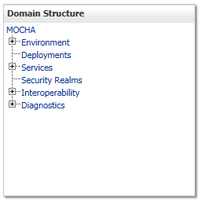
Figure 4-1: Domain Structure
- Within the Change Center panel in the left column of the WebLogic console, click Lock & Edit. For reference, see Figure 4-2.
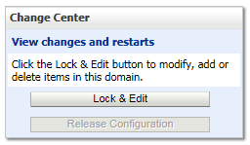
Figure 4-2: Change Center
- WebLogic will now display the panel Summary of Deployments in the right column of the console, where all deployments for the WebLogic domain are listed. For reference, see Figure 4-3.
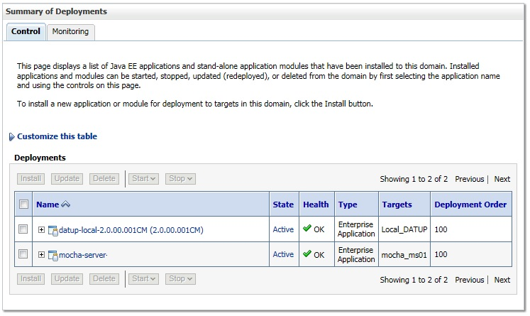
Figure 4-3: Summary of Deployments – Stopping MOCHA
- Select the previously deployed MOCHA (Server) deployment, click Stop, and then select Force Stop Now from the drop-down list box.
- WebLogic will now display the panel Force Stop Application Assistant in the right column of the console for confirmation to start servicing requests. For reference, see Figure 4-4.
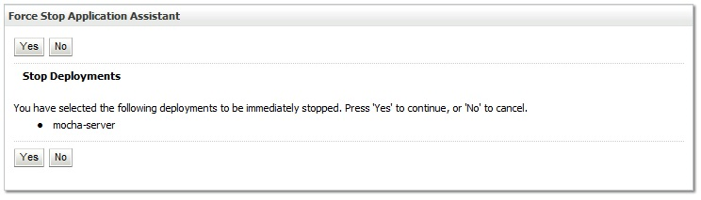
Figure 4-4: Force Stop Application Assistant
- Click Yes in the Force Stop Application Assistant panel in the right column of the WebLogic console.
- WebLogic now returns to the Summary of Deployments panel in the right column of the console. For reference, see Figure 4-5.
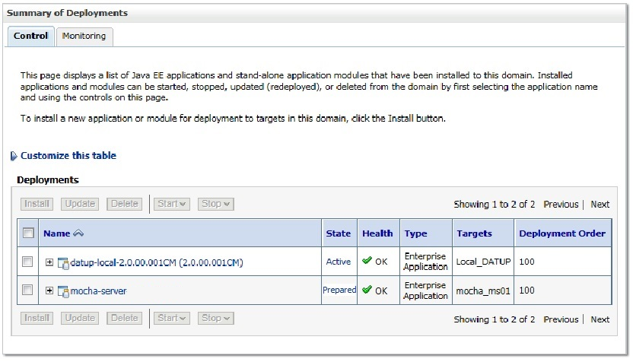
Figure 4-5: Summary of Deployments – MOCHA Deployment Prepared
- Verify that the State of the MOCHA deployment is Prepared.
- Select the previously deployed MOCHA deployment, and then click Delete.
- WebLogic will now display the panel Delete Application Assistant in the right column of the console for confirmation to start servicing requests. For reference, see Figure 4-6.
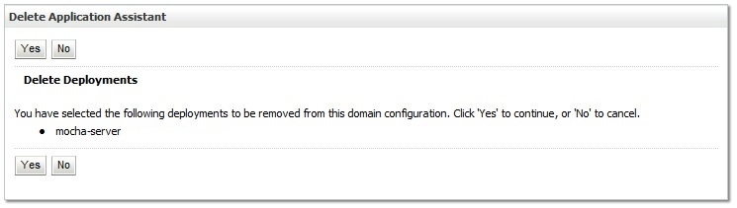
Figure 4-6: Delete Application Assistant
- Click Yes in the Delete Application Assistant panel in the right column of the WebLogic console.
- WebLogic now returns to the Summary of Deployments panel in the right column of the console. For reference, see Figure 4-7.
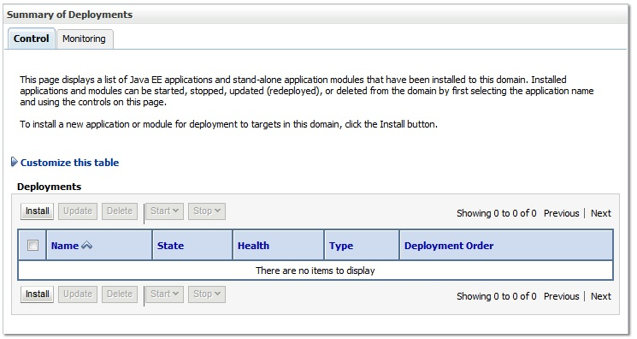
Figure 4-7: Summary of Deployments – MOCHA Deployment Deleted
- Verify that the MOCHA deployment is deleted and no longer present.
- Within the Change Center panel in the left column of the WebLogic console, click Activate Changes. For reference, see Figure 4-8.
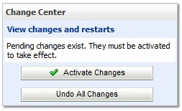
Figure 4-8: Activate Changes

Deploy New MOCHA Server Build
The following steps detail the deployment of the MOCHA Server application Build on WebLogic application Server.
- Open and log into the WebLogic console. This is located at: http://<Deployment Machine>:PORT/console.
- Within the Domain Structure panel in the left column of the WebLogic console, click the Deployments node. For reference, see Figure 4-9.
Figure 4-9: Domain Structure
- Within the Change Center panel in the left column of the WebLogic console, click Lock & Edit. For reference, see Figure 4-10.
Figure 4-10: Change Center
- Click Install found in the Deployments panel in the right column of the WebLogic console. For reference, see Figure 4-11.
Figure 4-11: Deployments
- WebLogic will now display the panel Install Application Assistant in the right column of the console, where the location of the MOCHA Server deployment will be found. For reference, see Figure 4-12.

IMAGE REDACTED

Figure 4-12: Install Application Assistant
- If the MOCHA Server build for deployment has already been transferred to the Deployment Machine, navigate to the deployment file location using the links and file structure displayed within the Install Application Assistant window.
- Select the mocha-server-X.X.XX.XXXX.ear file. (Version number will depend on the current MOCHA Server version. For example, for MOCHA Server 3.0 build 73, the ear file is mocha-server-3.0.00.0073).
- Once the MOCHA Server build for deployment is located and selected, click Next.
- WebLogic will now display the panel Choose targeting style within the Install Application Assistant in the right column of the console. Leave the default value selected, Install this deployment as an application, and click Next. For reference, see Figure 4-133.
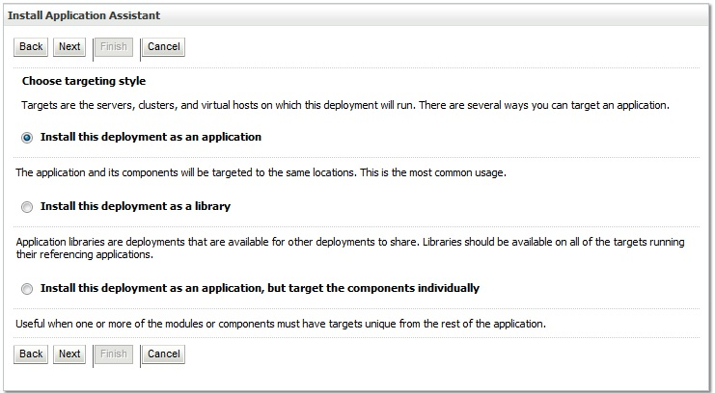
Figure 4-133: Choose Targeting Style
- Within the Install Application Assistant in the right column of the console, WebLogic will now display the panel Select deployment targets, where the Deployment Server will be selected as the target in the next step. For reference, see Figure 4-144.
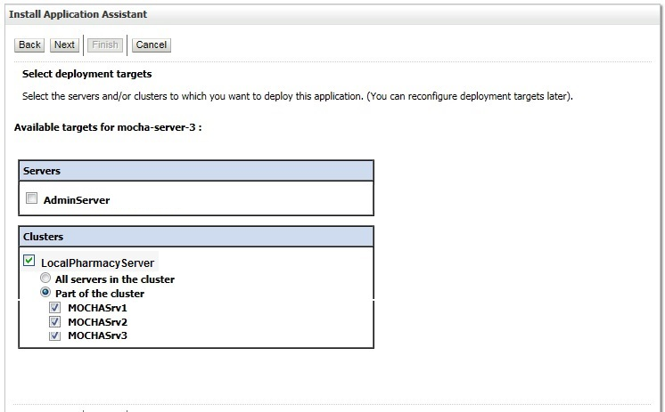
Figure 4-144: Select Deployment Targets
- For the Target, select the Deployment Server. For example, LocalPharmacyServer.
- Select Part of the cluster, and select mocha1, mocha1, and mocha3.
- Click Next.
- Within the Install Application Assistant, WebLogic will now display the panel Optional Settings in the right column of the console, where the name of the deployment and the copy behavior are chosen. For reference, see Figure 4-155.
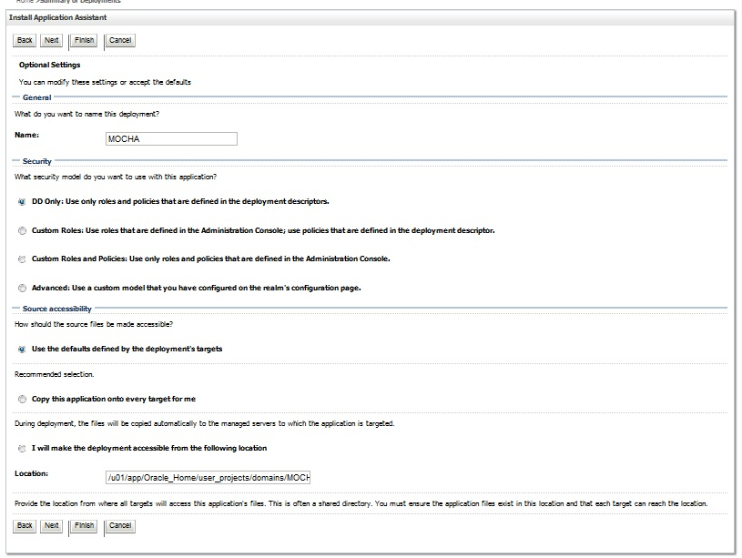
Figure 4-155: Optional Settings
- Enter the Name for the deployment. For example, MOCHA.
- Verify that the following default option for Security is selected:
DD Only: Use only roles and policies that are defined in the deployment descriptors.
- Verify that the following default option for Source accessibility is selected:
Use the defaults defined by the deployment's targets.
- Click Next.
- Within the Install Application Assistant in the right column of the console WebLogic will now display the panel Review your choices and click Finish, which summarizes the steps completed above. For reference, see Figure 4-166. (Version number will depend on the current MOCHA Server version. For example, for MOCHA Server 3.0 build 73, the ear file is mocha-server-3.0.00.0073).
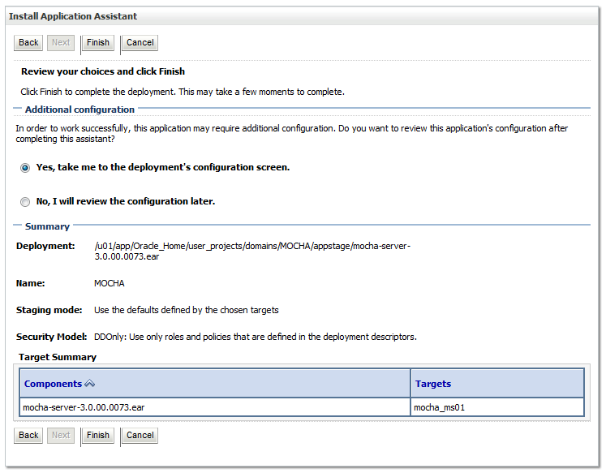
Figure 4-166: Review Your Choices and Click Finish
- Verify that the values match those entered in Steps 7 through 19 and click Finish.
- WebLogic will now display the panel Settings for MOCHA, in the right column of the console, where the values previously entered are available as well as a setting to change the deployment order. For reference, see Figure 4-177.
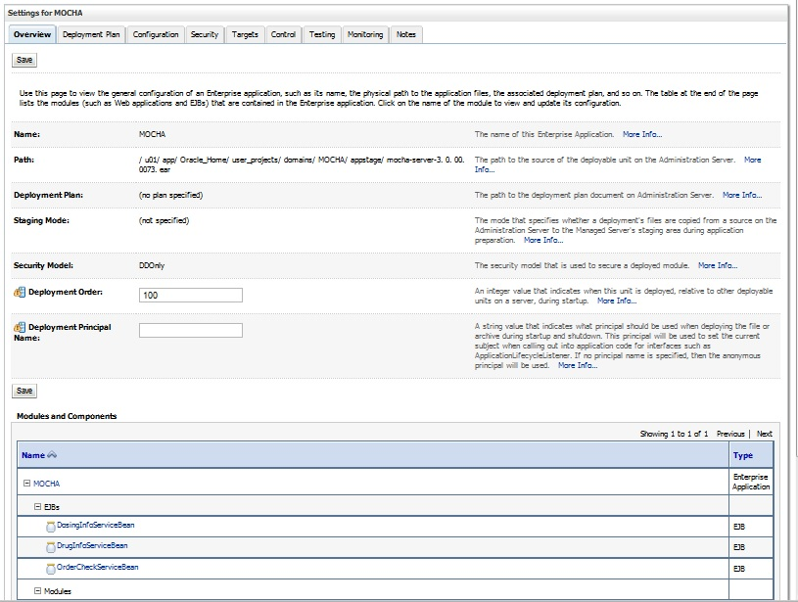
Figure 4-177: Settings for MOCHA
- Leave all the values as defaulted by WebLogic and click Save.
- Within the Change Center panel in the left column of the WebLogic console, click Activate Changes. For reference, see Error: Reference source not found18.
Figure 4-18: Activate Changes
- Within the Domain Structure panel in the left column of the WebLogic console, click the PRE > Deployments node. For reference, see Error: Reference source not found.
Figure 4-19: Domain Structure
- WebLogic will now display the panel Summary of Deployments in the right column of the console, where all deployments for the WebLogic domain are listed. For reference, see Figure 4-200.
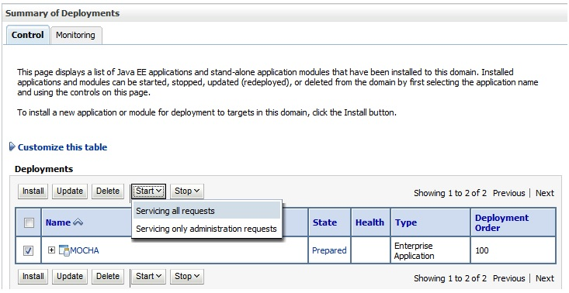
Figure 4-200: Summary of Deployments
- Select the previously deployed MOCHA deployment, click Start, and then select Servicing all requests from the drop-down list box.
- WebLogic will now display the panel Start Application Assistant in the right column of the console for confirmation to start servicing requests. For reference, see Figure 4-211.
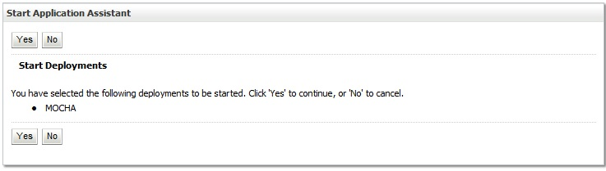
Figure 4-211: Start Application Assistant
- Click Yes in the Start Application Assistant panel in the right column of the WebLogic console.
- WebLogic now returns to the Summary of Deployments panel in the right column of the console. For reference, see Figure 4-222.
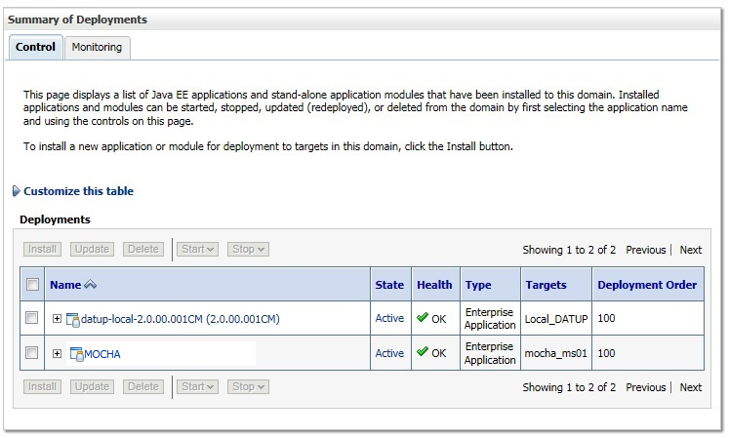
Figure 4-22: Summary of Deployments – MOCHA Deployment Active
- Verify that the State of the MOCHA deployment is Active.

At the time of development, this product was known as FDB Drug Information Framework (commonly abbreviated as FDB-DIF). The references to FDB-DIF in this manual are necessary due to previously completed code and instructions that could not be changed to match the new product name.

