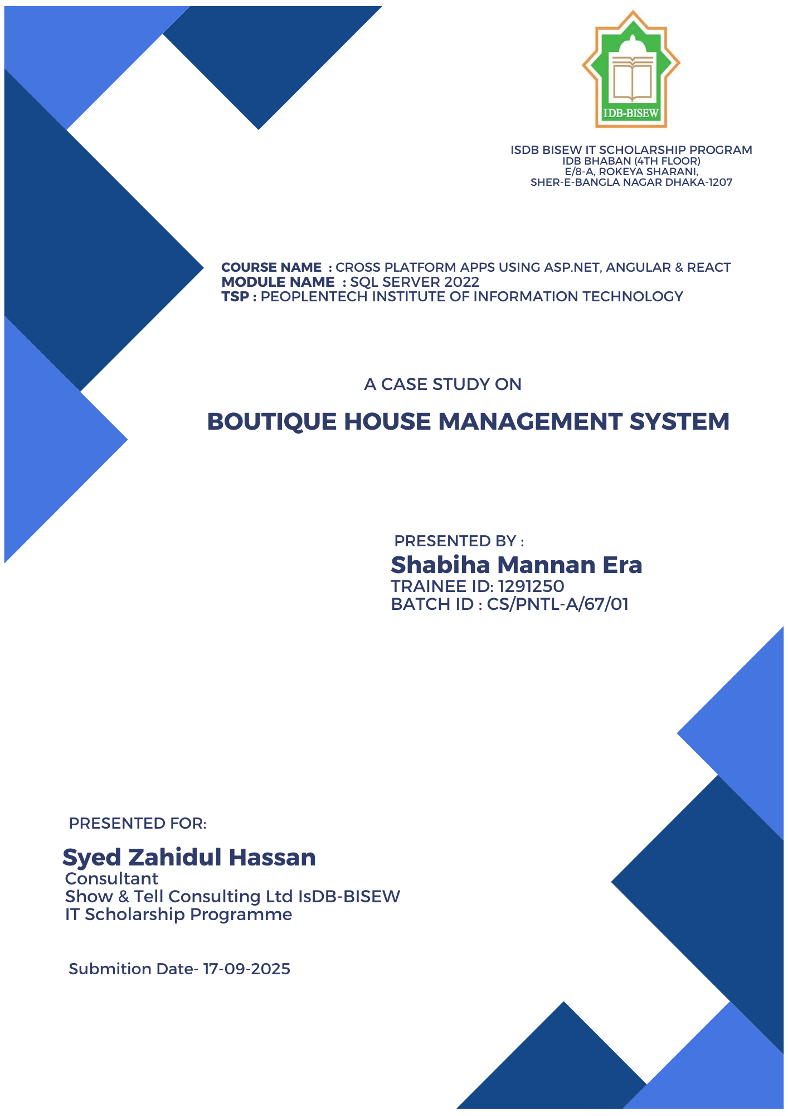

Boutique House Management System
(BHMS)





CASE STUDY
Shabhiha Mannan Era
The Project on Boutique House Management System
(BHMS)

Summary:
BHMS is a database-driven system designed to digitize and automate the core operations of a small or medium-sized boutique/hosiery business (e.g., Burqa, Hijab, or clothing outlets). The project includes modules such as product, size, color, stock, order, payment, sales, and rating. Using SQL Server, the system models a complete business workflow through tables, constraints, views, stored procedures, functions, triggers, sequences, indexes, and various queries.

Introduction:
In retail/boutique businesses, managing product variations (size/color), inventory synchronization, order processing, and sales reporting can be complex. The BHMS project provides a database-centric solution to reduce this complexity and enhance operational efficiency. The DDL scripts define schema and constraints, while the DML scripts include dummy data, test queries, and functionality validation.

Objectives:
- To systematically model, products and their variations (size/color).
- To automate stock and cost tracking (stock-in/stock-out records).
- To ensure end-to-end data flow from order processing to payment and sales recording.
- To generate quick and accurate reporting (daily/monthly sales, profit, stock status).
- To maintain data integrity through relationships, constraints, and triggers.

Database Design:
Key Entities: Products, Stocks, product Size, product Color, product Details (variants), Customer, Orders, Payment Type, Payment, Sales, Rating.

Core Relationships:
- Each product may have multiple variants (size + color).
- Stocks table maintains cost and inventory per Product ID.
- Orders and Payment tables connect customers and products to track transactions.

Integrity Features: Primary keys, composite primary keys (product Details), foreign keys, unique and check constraints (e.g., valid contact numbers, price > 0).

Automation & Performance: Views (v_profit, v_Products), stored procedures (insert/update/delete), functions (scalar and table-valued), sequences (seqNum), indexes (clustered/non-clustered), and triggers for insert/update automation.

Key Modules & Functionalities
1. Product Management: Add, update, delete products; configure pricing and identity.
2. Variant Management: Define size/color variations using product Size and product Color, store in product Details with composite key.

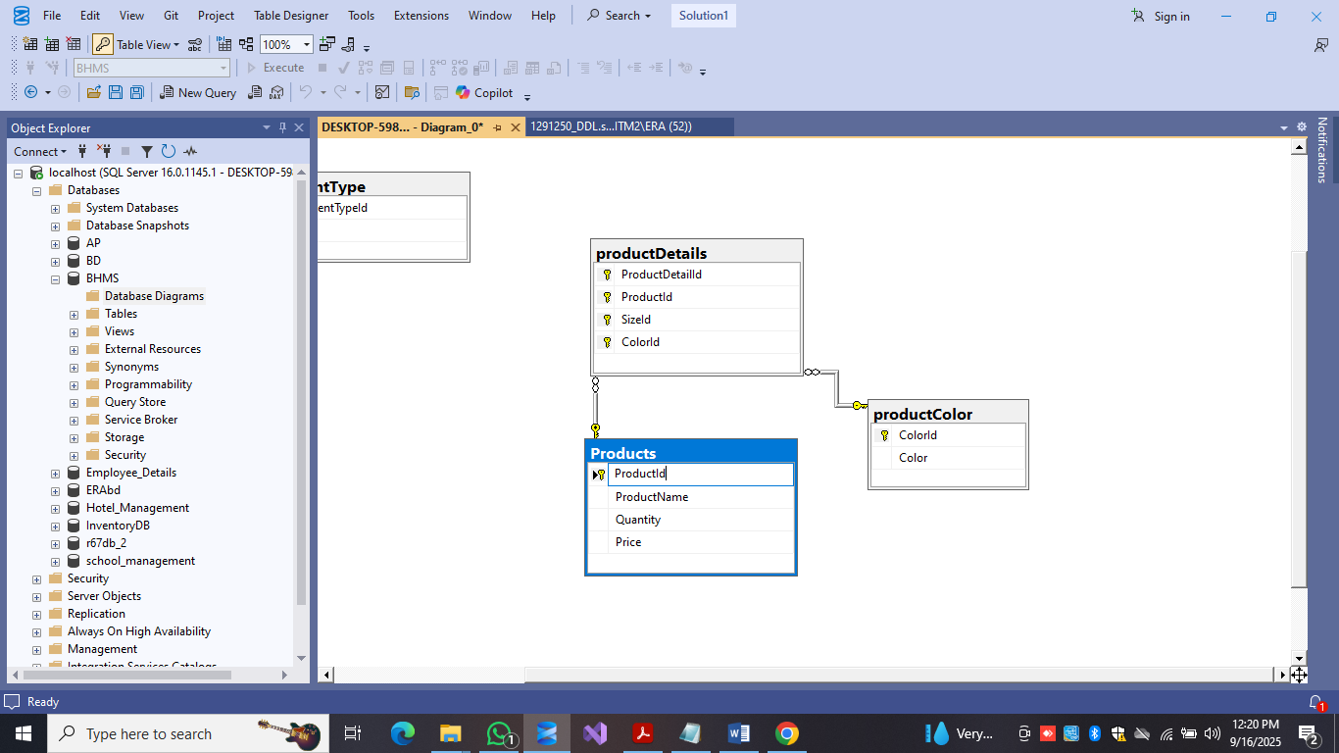

3. Order & Payment Processing: Orders table logs customer orders, Payment records transactions/discounts, and Sales records sales.
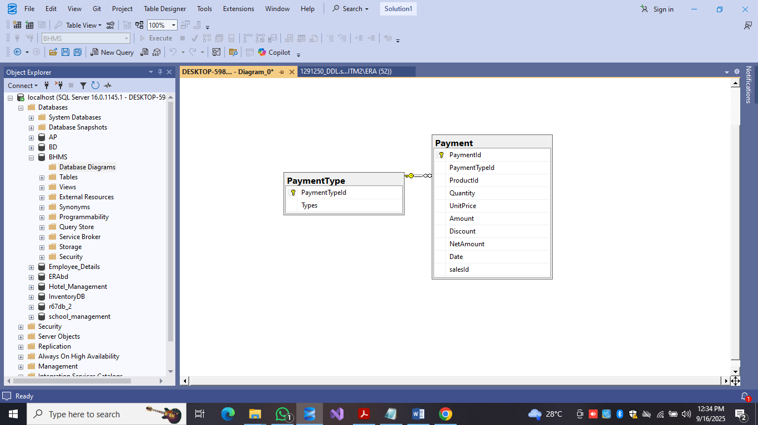
4. Inventory/Stock Management: Maintain cost, stock, and date in the Stocks table; triggers/procedures keep stock aligned with sales/payments.
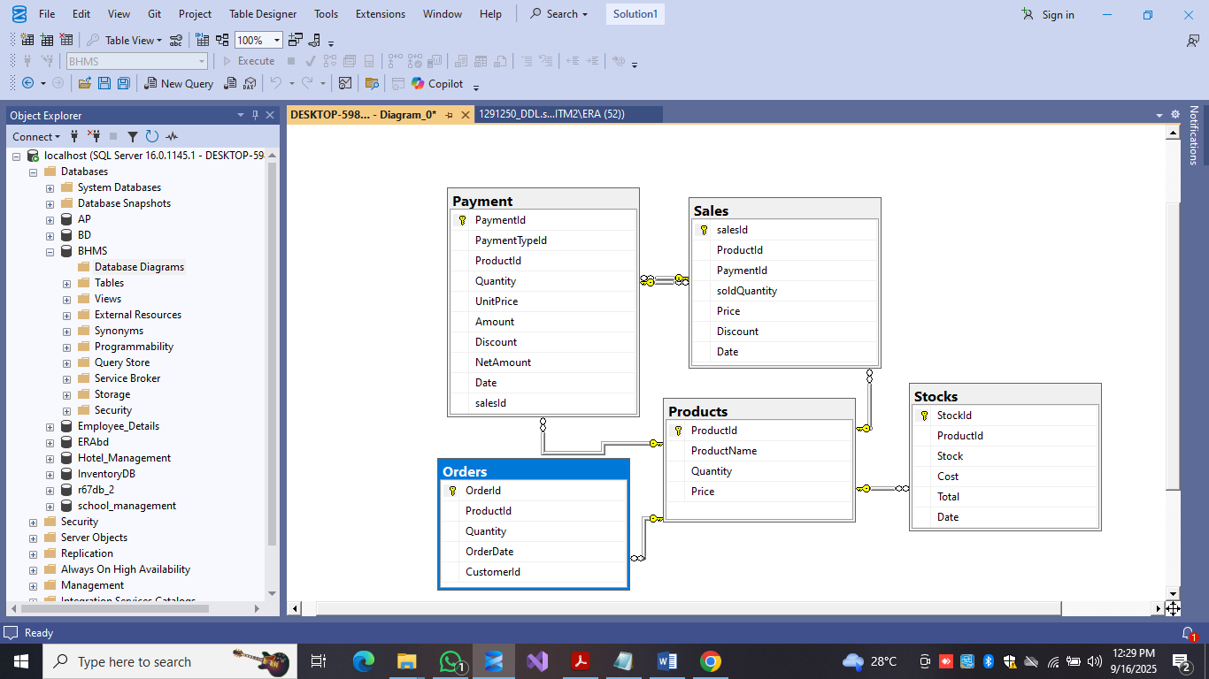

5. Reporting & Analytics: v_profit view and functions (fn_SalesOfMonth, fn_Profit) generate profit/sales reports.

6. Automation & Validation: Custom constraints (e.g., ContactNo), triggers (e.g., tr_payWiseStock), and TRY-CATCH logic ensure data protection.

Challenges & Solutions:

Stock & Payment Synchronization: Without proper reflection, payment inserts may cause sales mismatches → solved using tr_payWiseStock trigger and MERGE.

Complex Variation Modeling: Multiple variations risk redundancy → solved with productDetails junction table + composite PK.

Data Integrity & Validation: Errors like invalid contact/email prevented with CHECK & UNIQUE constraints.

Reporting Performance: Large aggregations may slow queries → views, indexes, and materialized views recommended.

Reports & Analytics:

Daily/Monthly Sales Reports: fn_SalesOfMonth and fn_salesPerDay summarize sales.

Product-wise Profit Reports: v_profit view analyzes net profit.

Stock Reports: Stocks table identifies low-stock items for reordering.

Customer Order Reports: Orders and Payment JOIN extracts top customers and best-selling products.
Benefits:

- Centralized data management across all operations.
- Automated stock updates and reporting through triggers/procedures.
- Easy handling of size and color-based inventory variations.
- Scalable and extendable for future integration with POS/e-commerce.

Conclusion:

This project demonstrates how a well-designed SQL Server database can effectively manage all aspects of a small-to-medium boutique or apparel business—products, variations, stock, orders, payments, and reporting. With constraints, triggers, views, functions, and stored procedures, the system ensures accuracy, automation, and reporting efficiency. With UI integration and backup strategies, BHMS can evolve into a complete production-ready solution.

