**Project Overview**

This project involves the implementation of a clustering technique using Object-Oriented Programming (OOP) concepts. The main objective is to process input data sets in a specific format and transform them into the required format for clustering analysis.

**Purpose of the Project**

The purpose of the project is to implement a clustering technique using Object-Oriented Programming (OOP) concepts. The project involves processing input data sets in a specific format and transforming them into the required format for clustering analysis. The main objectives of the project are to:

* Calculate a correlation matrix using Pearson's correlation coefficient from the data matrix.
* Discretize the correlation matrix by setting values above the mean to 1 and the rest to 0.
* Visualize the discretized matrix by converting it into a bitmap and providing zoom functionality.
* Permute the data matrix by shuffling individual rows in the dataset.
* Recover image clusters using the Signature technique, which involves summing values in a row, calculating the mean, multiplying the sum by the mean, rearranging the similarity matrix based on the signature values, and applying Task 1 on the rearranged matrix.
* The project aims to provide a comprehensive understanding of data manipulation, correlation analysis, visualization, and clustering techniques through the implementation of the mentioned tasks.

**Libraries**

The code utilizes various libraries for different functionalities:

* fmx.h: Header file for FireMonkey framework.
* iostream: Input/output stream handling.
* fstream: File stream handling.
* string: String manipulation.
* cmath: Math functions.
* FMX.Graphics.hpp: Graphics handling in FireMonkey.
* ctime: Time functions.
* random: Random number generation.

**Code Analysis and Explanation**

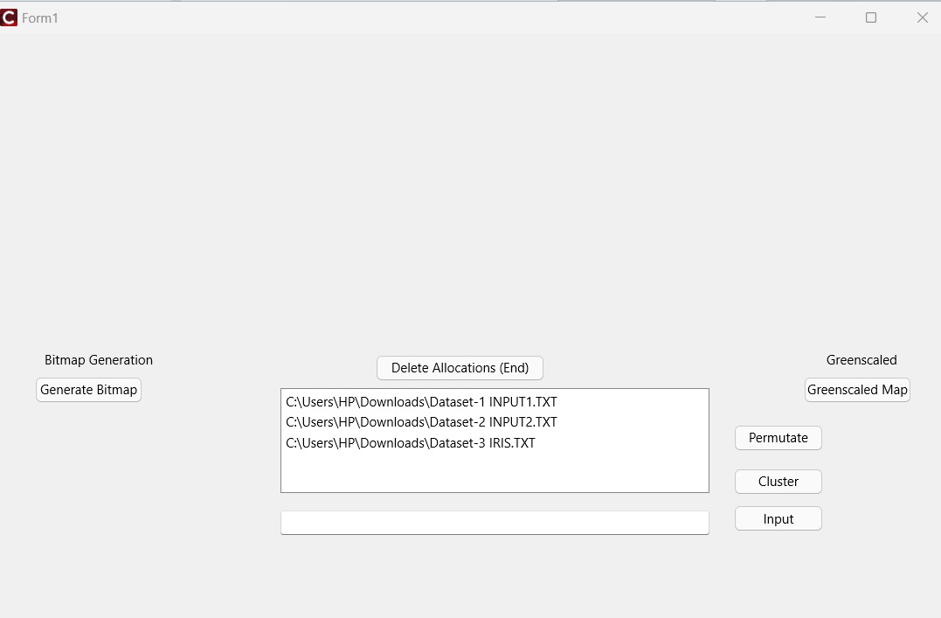

The code consists of several functions and components for different tasks:

**Task 1:**

* Calculate Correlation Matrix: Pearson's correlation coefficient is computed between each pair of rows in the data matrix, resulting in an NxN correlation matrix.
* Discretize Correlation Matrix: The correlation matrix is discretized by setting values above the mean to 1 and the rest to 0.
* Visualize Discretized Matrix: The discretized matrix is converted into a bitmap for visualization, allowing zoom functionality.

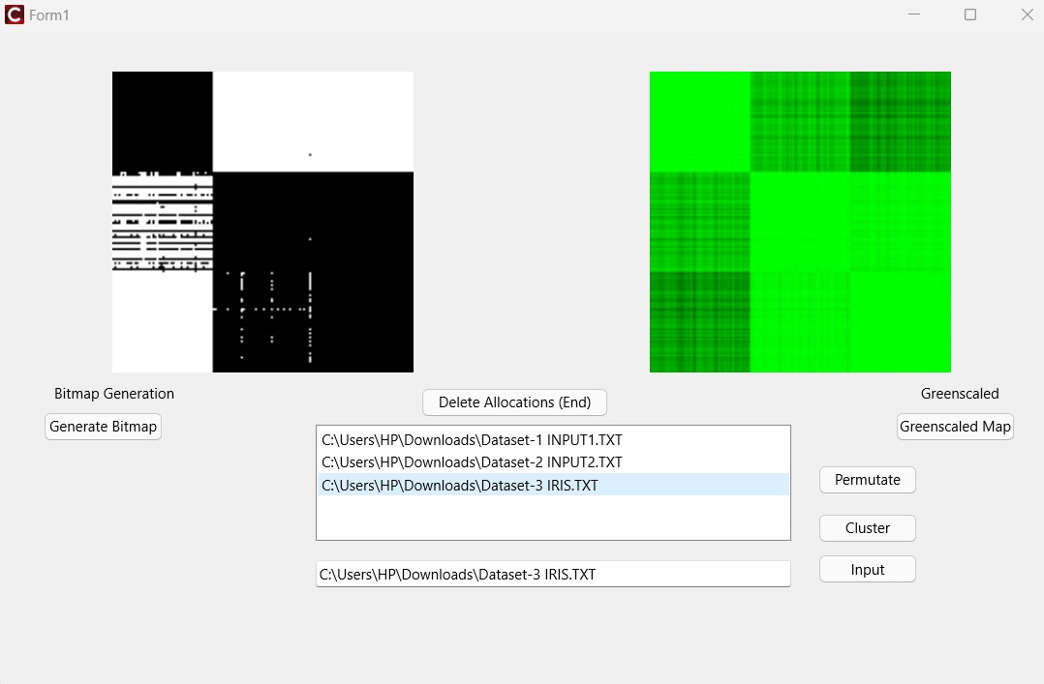

**Task 2:**

* Permute Data Matrix: Rows in the data matrix are shuffled randomly.
* Display Permuted Matrix: The permuted data matrix is displayed as a color-coded image.
* Recover Image Clusters: Signature technique is used to recover clusters by:
* Summing all values in a row.
* Calculating the mean of the row.
* Multiplying the sum by the mean to generate a signature value.
* Rearranging the similarity matrix based on the signature values.
* Apply Task 1 on Rearranged Matrix: The rearranged matrix is processed as in Task 1.
* Display Color-Coded Image: The final color-coded image is displayed.

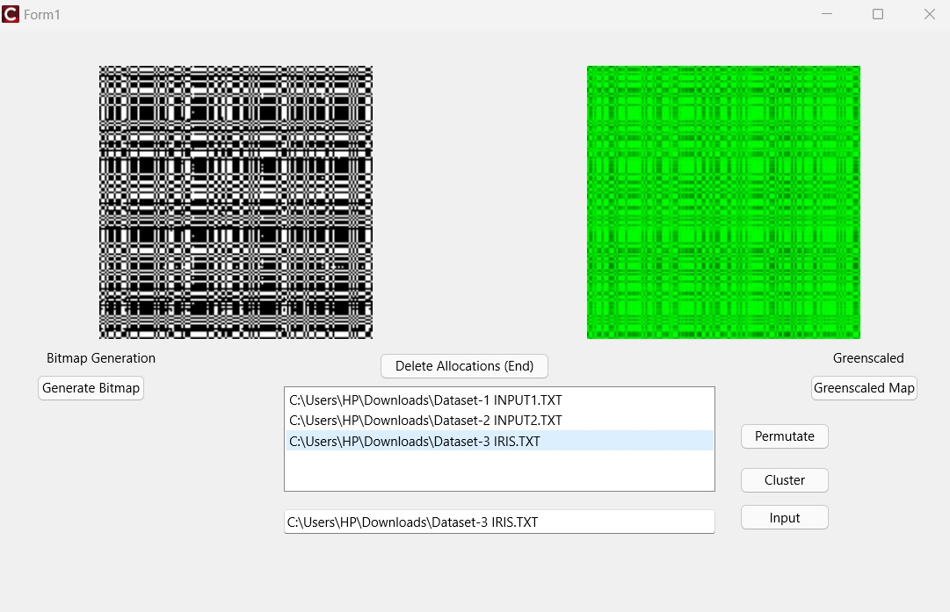

Permuted ^

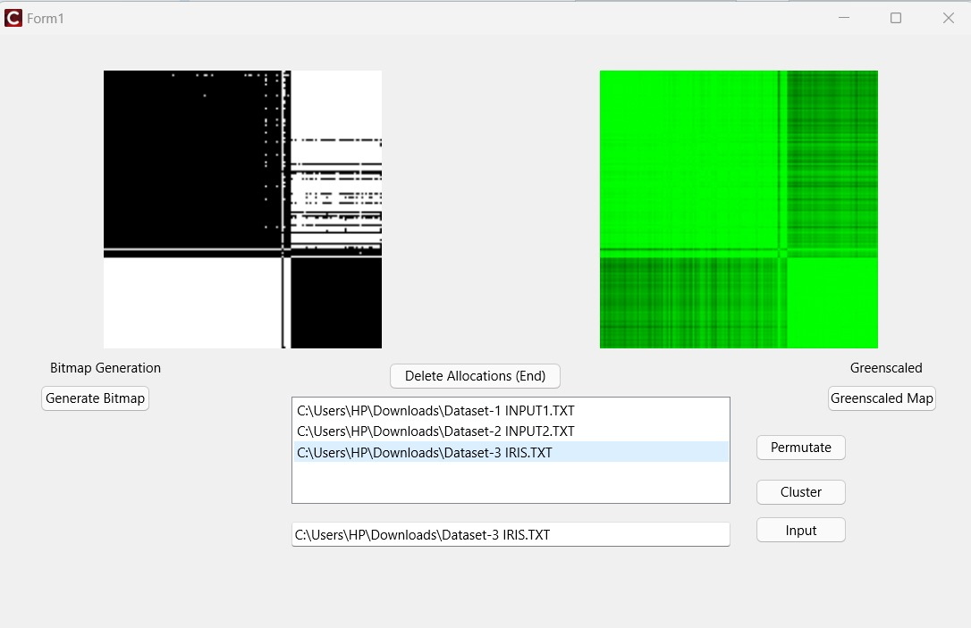

Clustered ^

**Additional Information:**

* Memory Management: Dynamically allocated memory is properly cleaned up at the end of the program execution.
* This project involves complex data processing, correlation analysis, visualization, and clustering techniques, providing a comprehensive understanding of data manipulation and clustering methodologies.

**Task Division Between Members:**

Muhammad Shabih Ul Hassan Raja:

- GUI implementation

- Front-End Work

Syed Ghazi Abbas:

- Base code

- Backend work

