VTAhorz

VTA

eTimeManagement

Functional Specifications

October 13, 2014

# Table of Contents

Table of Contents 2

Revision and Signoff Sheet 4

Change Record 4

Approvals 4

Document Overview 5

Project Summary 5

eTime SharePoint Site 6

Process Flow 7

1- Pay Exception Approval Request Flow (PEAR) 7

2- TimeSheet Approval Request Flow (TSAR) 8

3- Work Out Of Class Request Flow (WOOC) 9

4- FMLA Request Flow 10

5- Lead/Training Pay Request Flow 11

Functional Specifications 12

1 – eTimeManagement Security 12

**1.1 Security Access for Module based access of Application** 12

2 – Pay Exception Request 13

**2.1 Create New or Revise Pay Exception Approval Request** 15

**2.2 Approve Pay Approval Exception Request – Supervisor Review** 16

**2.3 Work Out of Class Request – WOOC Review** 17

**2.4 FMLA Request – FMLA Review** 18

**2.5 Lead/Training Pay Request – Lead/Training Pay Review** 20

3 – TimeSheet Approval Request 21

**3.1 Employee Request – eTimeSheet Review** 23

**3.2 Supervisor Review – eTimeSheet Review** 24

**3.3 TimeKeeper Review – eTimeSheet Verification** 25

4 - Reporting / Dashboard/ Admin 26

**4.1 eTime Report** 26

**4.2 My eTime Pending Requests** 26

**4.3 Approved by Me (eTime Requests)** 27

**4.4 PEAR Report** 27

**4.5 My PEAR Pending Requests** 28

**4.6 Approved by Me (PEAR Requests)** 28

**4.7 Administration** 28

**4.8 Help** 29

5 – Interface with SAP 30

Database Schema 32

Assumptions 33

Appendices 33

# Revision and Signoff Sheet

## Change Record

|  |  |  |  |
| --- | --- | --- | --- |
| Date | Author | Version | Change reference |
| 04/01/2014 | Shabina Mirajkar | 1.0 | Initial Creation |
| 04/08/2014 | Shabina Mirajkar | 1.1 | Modified with feedback from Business |
| 04/09/2014 | Shabina Mirajkar | 1.2 | Modified with feedback from Business |
| 04/11/2014 | Shabina Mirajkar | 1.3 | Modified with feedback from Business to include FMLA, WOOC |
| 04/16/2014 | Shabina Mirajkar | 1.4 | Modified with feedback from Business with details & include Lead Pay |
| 04/17/2014 | Shabina Mirajkar | 1.5 | Modified with feedback from Business, include Payroll as an Approval Role for WOOC, Lead Pay and TimeSheet Approval Processes, provide Help button/menu option |
| 04/18/2014 | Shabina Mirajkar | 1.6 | Modified with feedback from Business |
| 04/21/2014 | Shabina Mirajkar | 1.7 | Modified with feedback from Business |

## Approvals

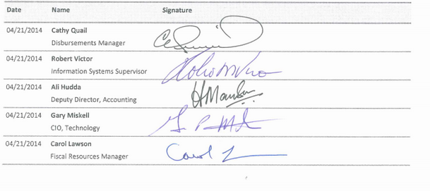

# 

# Document Overview

This document details the functional requirements which will be used to design the eTimeManagement application. The information listed covers the specific requirement for each feature listed.

## Project Summary

The main objective of this project is to automate the eTimeManagement process for non-ATU VTA employees. It will enable the organization to create, track, approve and manage leave, overtime, lead/training pay, work out of class & timesheet requests and also to integrate and automate data flow from and to the SAP system. Currently the process is managed with a manual paper-based process.

Key aspects of the project:

* Impacts all VTA employees except ATU members , staff (hourly and salaried)
* Tracks time and attendance electronically
* Maintains time off accruals and advanced requests replacing manual and exception processes
* Maintains work and time off schedules
* Offer flexibility and timeliness
* Improves communication and employee experience
* Reduces duplicative and manual processes
* Streamlines and improves processes
* Supports sustainability

# eTime SharePoint Site

Snapshot of proposed user interface for eTime:

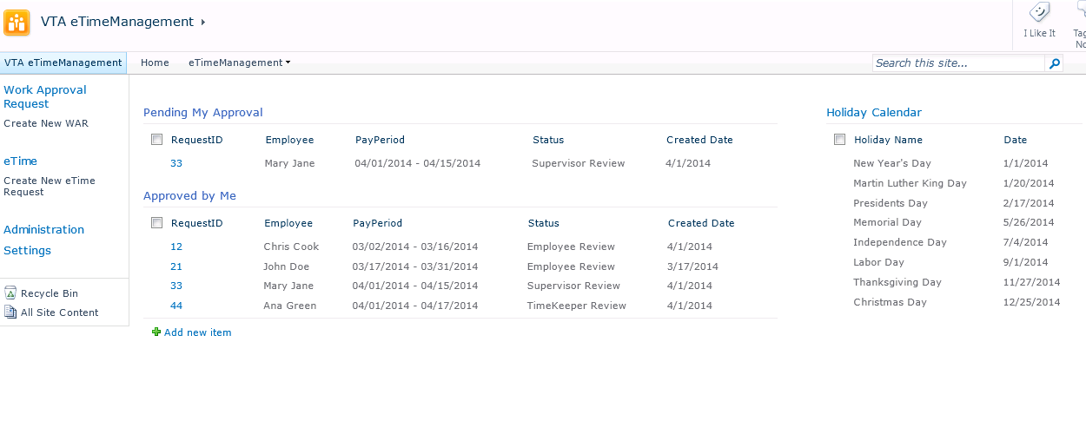

# Process Flow

## Pay Exception Approval Request Flow (PEAR)



## TimeSheet Approval Request Flow (TSAR)



## Work Out Of Class Request Flow (WOOC)

Work Out of Class Process will be addressed in this scope. WOOC Assignment Form will be initiated online and filled by the Supervisor and routed. All other forms will be electronically scanned and attached to the request and routed appropriately. Comments will be used to guide the employee/timekeeper for entering pay codes.



## FMLA Request Flow

FMLA Process scope will be included in this requirement. The various applicable forms like FMLA Request, Notice of Eligibility and Rights & Responsibility will be electronically scanned and attached to the request and routed appropriately. Comments will be used to guide the employee/timekeeper for entering pay codes



## Lead/Training Pay Request Flow

Lead/Training Pay Process scope will be included in this requirement. Lead/Training Pay Request Form, Supervisor Review, Chief Review & HR Review Form will be initiated & filled online and routed. All other forms will be electronically scanned and attached to the request and routed appropriately. Comments will be used to guide the employee/timekeeper for entering pay codes



# Functional Specifications

## 1 – eTimeManagement Security

|  |  |  |  |
| --- | --- | --- | --- |
| Feature | **1.1 Security Access for Module based access of Application** | | |
| Priority | **01 - Critical** | **Est. Effort** | Click here to enter text. Hours |
| Description | Create Role based access for the eTimeManagement implementation. | | |
| Requirement | Customize security based access for the following roles:   1. Employee (Access to their own accounts only) 2. Supervisor (Access to their accounts and employees reporting to them) 3. TimeKeeper (Full Access to all accounts associated supervisor has access to) | | |
| Technical Details | * Employees will have access to Create New Pay Exception Requests, Create New TimeSheets, Modify TimeSheets, their Worklist and Reports for their respective accounts, * Supervisor will have all the same access rights as employees. In addition they will have access to review, modify and/or approve their direct reports Pay Exception and TimeSheet Requests. They cannot approve their own time. * Supervisor will have access to Create New Pay Exception Requests, Create New TimeSheets, Supervisor Review (Modify TimeSheets), Worklist & Reports * TimeKeeper will have access to Create New TimeSheets for associated Employees, TimeKeeper Review (Modify TimeSheets), Worklist & Reports | | |
| Assumptions | * Employee, Supervisor & TimeKeeper roles * Employee or Supervisor can initiate New Pay Exception Requests * Employee, Supervisor or TimeKeeper can initiate New TimeSheet Requests | | |

## 2 – Pay Exception Request

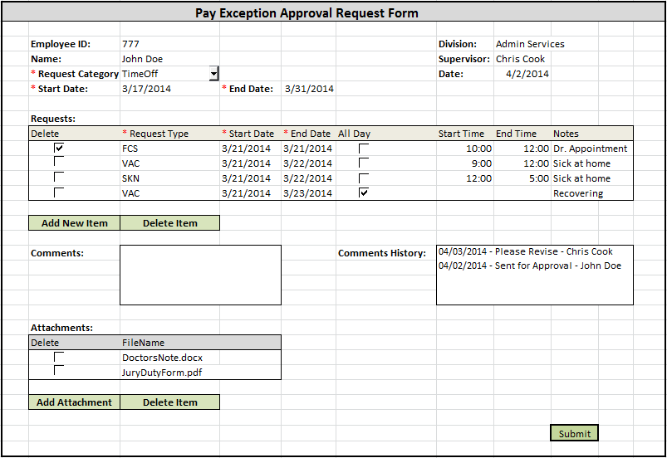

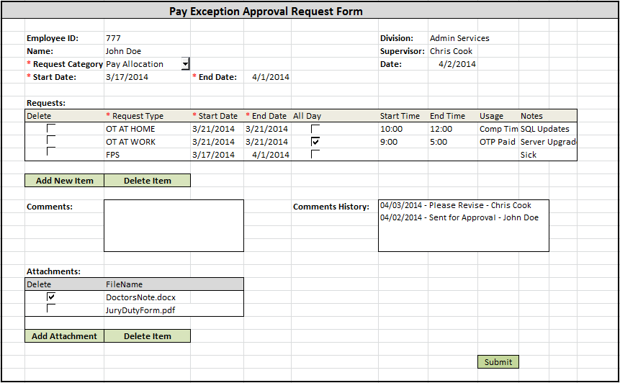

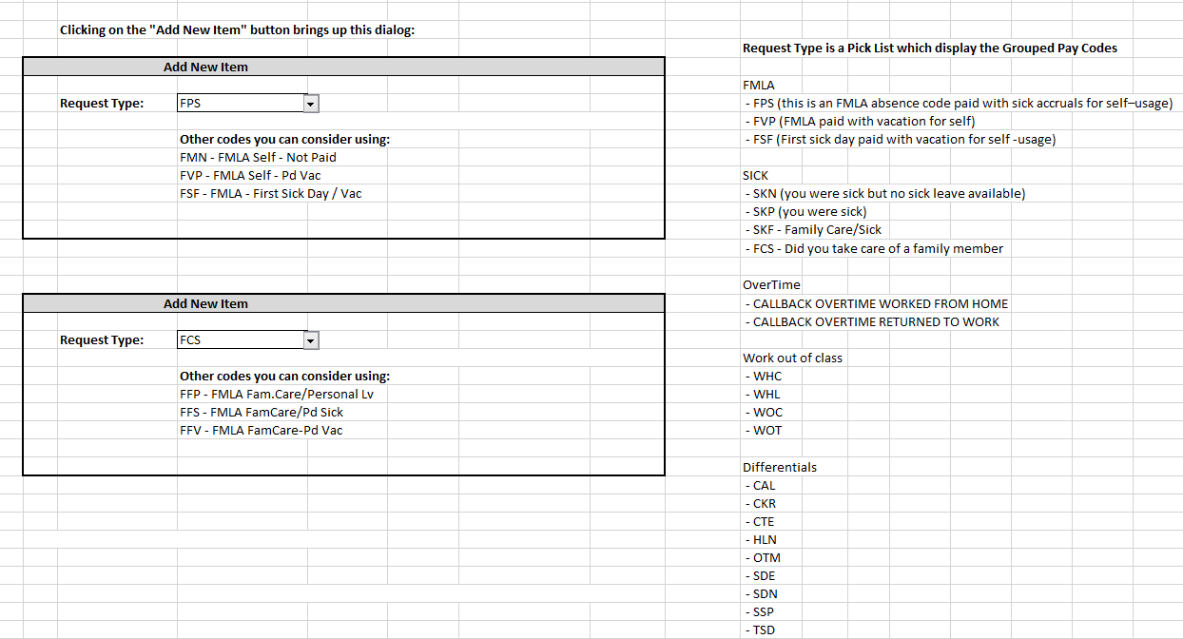

|  |  |  |  |
| --- | --- | --- | --- |
| Feature | **2.1 Create New or Revise Pay Exception Approval Request** | | |
| Priority | **01 - Critical** | **Est. Effort** | Click here to enter text. Hours |
| Description | New Pay Approval Exception Request which will go through Supervisor approval process | | |
| User Interface | * Header data like Employee Name, Supervisor Name, Date is auto-populated * Employee selects the category for Pay Exception Request: TimeOff or Pay Allocation Request (Mandatory) * TimeOff handles Pay Codes for Leave Requests like Sick, Vacation, etc * Pay Allocation handles Pay Codes for Overtime, Work Out of Class, Differentials, Lead/Training Pay * Employee enters time-period for the Request. Time Period can be in the past or future (Mandatory) * Past Time Period cannot be beyond 6 months * Future Time Period cannot be beyond 1 year * Employee can enter multiple types of Request with a unique Type, Date & Time combination * Request Type, Date is mandatory. If All Day is not checked, Start & End Times are mandatory * Validate Date against Holiday Calendar & Employee Union Code * Hours Requested will be calculated * Employee can open only one PEAR for a Pay Period. A PEAR already submitted for Review can be modified in 2 ways: Supervisor requests employee for Revision or Employee cancels the current PEAR and submits a new one for the Pay Period * Validations for TimeOff like no. of hours cannot exceed 8 for a particular date * OverTime Request hours range will not be validated * Request Items can be edited, deleted or a new item can be added * Comments can be entered for each request | | |
| Workflow Process/ Security | * Only Employee/Supervisor can initiate a work approval request * If Supervisor initiates a PEAR, an Employee selection is made (for who to initiate the PEAR) * Once Employee submits a Request, it gets routed to Supervisor for Review * The Request will be pending approval with ‘Pending Supervisor Review’ status * Each Request may have multiple items with varying Request types/Date/Time combinations for a particular category. The approval for each request will be treated as a single unit comprising of the multiple items. | | |
| Technical Details | * PayPeriod for the year is calculated based on the time-period selected to generate a request * Employee Name, Supervisor Name, Division fields will be auto-populated with values from the SAP * Data is persisted in the TimeManagement Database in SQL Server * If CB2 worked from Home – minimum hours charged: 2 * If CB4 worked from Office – minimum hours charged: 4 * Overtime can be used towards Comp Time Earned – rule for usage can be defined and used by TimeSheet Approval Process * If Pay Period is closed, On Demand eTimeSheet will be created for employee for the Retro Pay Period | | |
| Notifications | * A confirmation email is sent to Employee when an Employee Request is submitted * Supervisor is notified when an Employee Request is submitted | | |
| Assumptions | * Risk Management Approval for PayCodes like FMLA will not be addressed in this scope * OverTime Meal Allowance will not be addressed in this scope * Work Out of Class requests will get Supervisor Approval. Payroll and HR approval process will remain manual for this scope | | |
| SAP Interfaces | * **Input to K2**:   User Profile (EmpID, Name, Division, Exempt Status, Union affiliation, Supervisor)  Holiday Calendar per Union  Pay Periods | | |
| |  |  |  |  | | --- | --- | --- | --- | | Feature | **2.2 Approve Pay Approval Exception Request – Supervisor Review** | | | | Priority | **01 - Critical** | **Est. Effort** | Click here to enter text. Hours | | Description | Supervisor Approves or Rejects the Pay Approval Exception Request | | | | User Interface | * Header data like Employee Name, Supervisor Name, Date is auto-populated * Data on the form presented to Supervisor is read-only and for review purposes only. * There will be a comments field, which Supervisor must use for feedback in case a Revise action (mandatory in case of a revise). | | | | Workflow Process/ Security | * Supervisor reviews the Request * Supervisor can Approve, Reject, Revise or Cancel the request * If Approved, the workflow stands completed * If Revised, the workflow item goes back to the employee with ‘Pending Employee Revision’ status * If Cancelled, the workflow is Cancelled, database is updated. | | | | Technical Details | * Employee Name, Supervisor Name, Division fields will be auto-populated with values from SAP * Data is updated in the TimeManagement Database in SQL Server | | | | Notifications | * A confirmation email is sent to the Supervisor when an Employee Request is actioned * A notification email is sent to Employee when an Employee Request is completed/cancelled/revised * A notification email is sent to TimeKeeper when a Request is approved | | | | | | |
| Feature | **2.3 Work Out of Class Request – WOOC Review** | | |
| Priority | **02 - Major** | **Est. Effort** | Click here to enter text. Hours |
| Description | WOOC Process Flow | | |
| User Interface | * WOOC Assignment Form (as seen above) will be initiated by the Supervisor and will be routed for Approval. * All other applicable forms will be electronically scanned & attached to the workflow process * WOOC Payroll Form will be electronically scanned/attached to the e-TimeSheet Form (*Optional Feature: AutoGenerate the Form and route to Supervisor for Approval) * Links will be provided to find forms to be attached | | |
| Workflow Process/ Security | * Employee initiates the WOOC using Pay Exception Form * Supervisor receives the request and will need to fill the WOOC Assignment form for other approvals * Request is routed to Chief, HR, Payroll for Approval * Chief/HR will see the Temporary WOOC Assignment Form snapshot before they make a decision. * Payroll receives notification along-with attachments for manual approval * If Approved, the PEAR workflow moves to the next step * If Rejected, the PEAR workflow goes back to Employee Revise step | | |
| Technical Details | * Approval Process updates database with stamped PDF of WOOC Assignment Form. Attached forms will be saved as well * The HR calculations and code assignments are on record in Notes or Attachments and will be used as a reference in the TimeSheet fill-in process by TimeKeeper | | |
| Notifications | * Notifications will be sent | | |

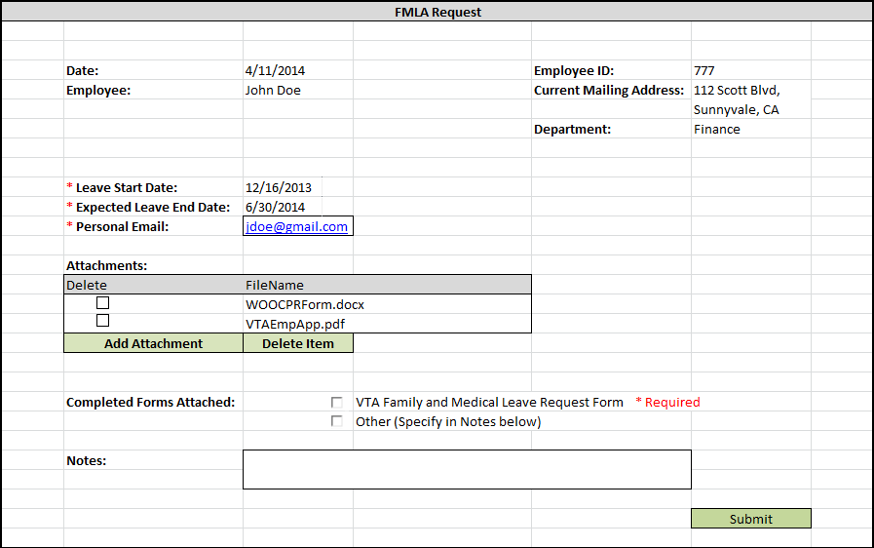

|  |  |  |  |
| --- | --- | --- | --- |
| Feature | **2.4 FMLA Request – FMLA Review** | | |
| Priority | **02 - Major** | **Est. Effort** | Click here to enter text. Hours |
| Description | FMLA Process Flow | | |
| User Interface | * Employee uses the form above to submit FMLA request * All other applicable forms will be electronically scanned & attached to the workflow process * Links will be provided to find forms to be attached | | |
| Workflow Process/ Security | * Employee submits the FMLA Request Form using the screen above. The form is filled/scanned and attached to the above screen and the request is submitted * Supervisor reviews the FMLA request. If any other information is needed, it is sent back to the Employee with a Pending status with appropriate forms attached * Risk Management reviews the FMLA request. If any other information (example: note correction) is needed, it is sent back to the Employee with a Pending status with appropriate forms attached. The employee is sent the communications via email & postal mail. * Once Risk Management approves the request, the Supervisor can Approve or Decline the request * The Employee is notified via email & postal mail with the Designation letter | | |
| Technical Details | * Approval Process updates database with attached forms and Request Details * The RM calculations and code assignments are on record in Notes or Attachments and will be used as a reference in the TimeSheet fill-in process by TimeKeeper | | |
| Notifications | * Notifications will be sent | | |

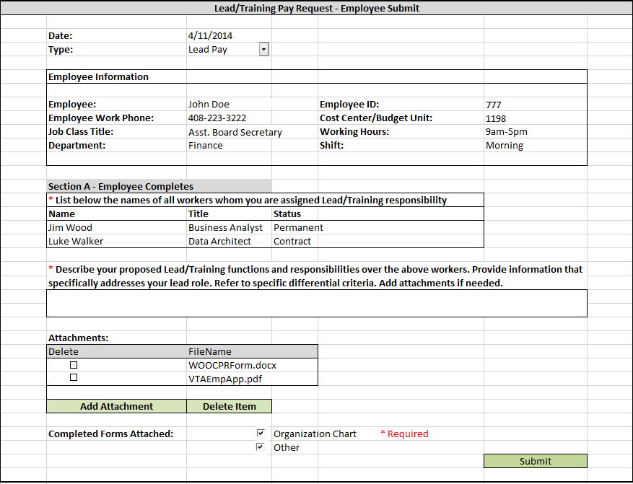

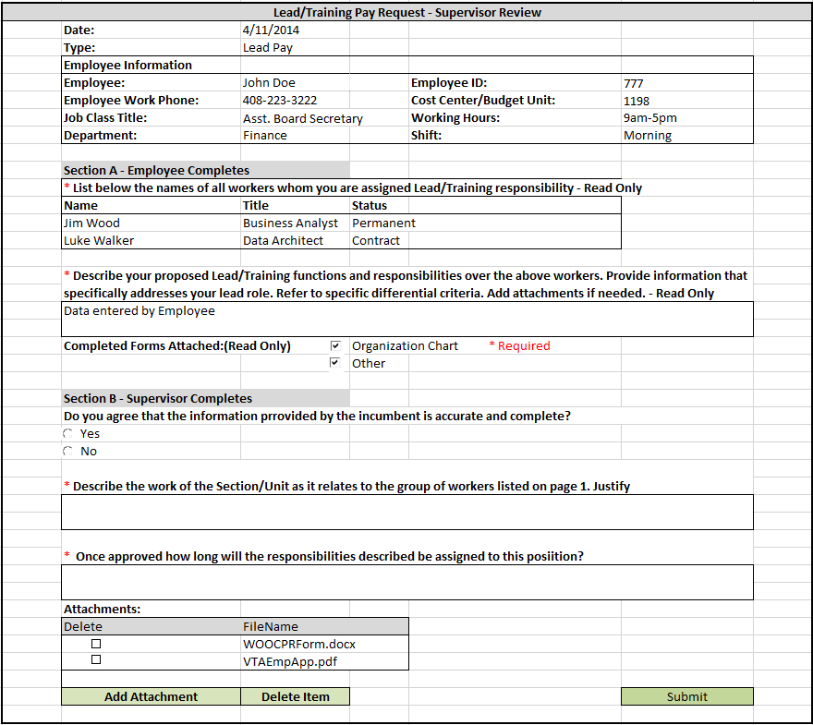

|  |  |  |  |
| --- | --- | --- | --- |
| Feature | **2.5 Lead/Training Pay Request – Lead/Training Pay Review** | | |
| Priority | **02 - Major** | **Est. Effort** | Click here to enter text. Hours |
| Description | Lead/Training Pay Process Flow | | |
| User Interface | * Employee uses the form above to submit Lead/Training Pay request * Links will be provided to find forms to be attached * Supervisor uses the form above to review the Lead/Training Pay request * Chief/HR/Payroll will review a read-only supervisor view of the form * Employee can select the list of people who they have Lead/Training responsibility over using a people picker OR * Optionally, employee can select from a dropdown list, personnel who report to their supervisor * In case the personnel is a contractor, they will have to be manually typed in | | |
| Workflow Process/ Security | * Employee submits the Lead/Training Pay Request Form using the screen above. The form is completed and the request is submitted * Supervisor reviews the Lead/Training Pay Request. If any other information is needed, it is sent back to the Employee with a Review status * Chief reviews the Lead/Training Pay request. If any other information is needed, it is sent back to the Employee with a Review status. * The Chief can Approve or Decline the request * The approved request is routed to 3 levels of HR approval (Analyst, Manager & Director) & Payroll | | |
| Technical Details | * Approval Process updates database with attached forms and Request Details * The HR calculations and code assignments are on record in Notes or Attachments and will be used as a reference in the TimeSheet fill-in process by TimeKeeper | | |
| Notifications | * Notifications will be sent | | |

## 3 – TimeSheet Approval Request

Sample 1:

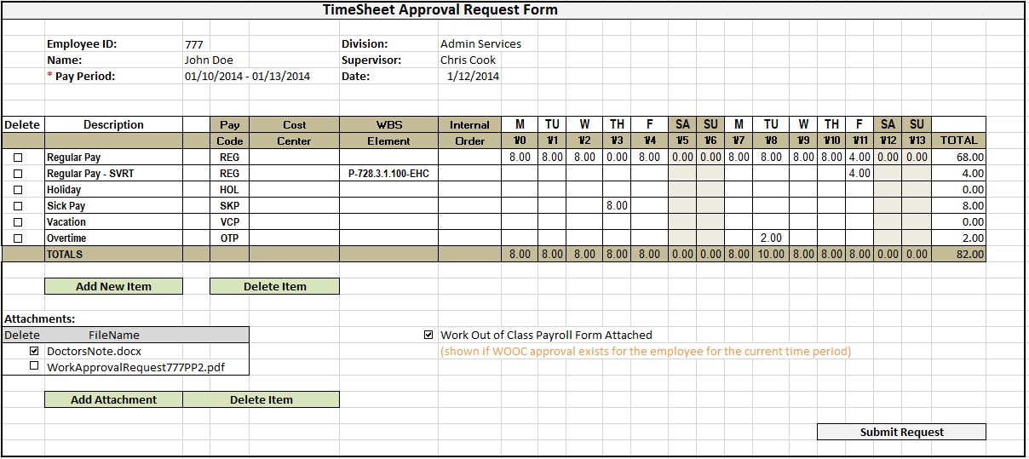

Sample 2:

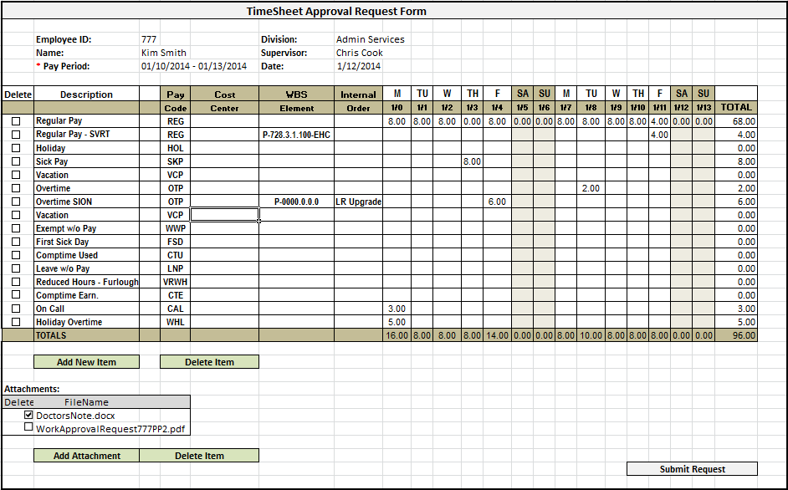

Sample 3:

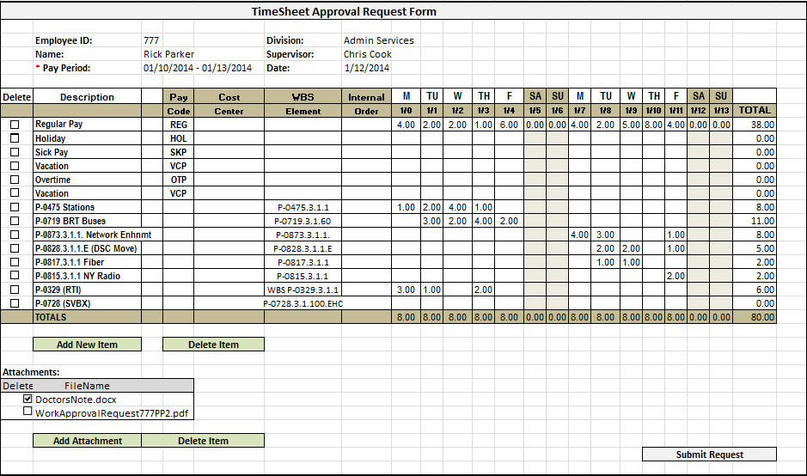

|  |  |  |  |
| --- | --- | --- | --- |
| Feature | **3.1 Employee Request – eTimeSheet Review** | | |
| Priority | **01 - Critical** | **Est. Effort** | Click here to enter text. Hours |
| Description | New eTimeSheet request which will go through Supervisor & TimeKeeper Approval process | | |
| User Interface | * A TSAR is automatically generated at the start of every Pay Period * TSAR can be manually initiated as well * Employee will select either ‘Current’ Pay Period or an On Demand (RETRO or future) pay period to start a new TSAR * If Supervisor or TimeKeeper is initiating the TSAR, Employee selection will be required. The default user selection will be the Supervisor or TimeKeeper credentials. * Header data like EmployeeID, Employee Name, Supervisor Name, Division and Pay Period are auto-populated using SAP data * Holidays will be pre-populated using the Holiday Calendar & Employee Union Code * Future TimeSheets can be created upto 6 months ahead * Validations for Leave Request and OverTime will be performed against the PEAR entries for the particular Pay Period & Date * TimeOff/Comp Time will be validated against SAP available hours * WBS/SION will be validated against SAP * Error Notifications will be displayed if WBS codes are inactive or locked. * Error Notifications/Validations could be pop-ups or on-screen messages. * Request Items can be edited, deleted or a new item can be added * User can enter Notes for each hours entry on the TimeSheet * Employee’s eTime Profile will be used to determine the items displayed for Description/Pay Codes/Internal Order/WBS elements on the new TimeSheet * Timesheet will be archived and saved as a stamped PDF in SharePoint Library * Attachments can be added to support the TSAR * If a Pay Approval Exception Request exists for the employee, for the same time period, it will show as an attachment on the TSAR * WBS/SION Warning Message / Validation will occur if the Project Hours exceed Work Hours (Example: Project Hours > 80 – PEAR hours). The user will be allowed to continue, but after they are notified. * If a Work Out of Class approval exists for the employee for the current time period, a checkbox will be shown mandating a Work Out of Class Payroll Form attachment to the timesheet | | |
| Workflow Process/ Security | * There will be an automated process to initiate timesheets for each employee every Pay Period * Employees/Supervisors/TimeKeepers can manually initiate an eTimeSheet request for current/past/future Pay Periods * TimeKeeper can manually initiate an eTimeSheet request for all employees with a Supervisor associated with the TK * Supervisor can manually initiate an eTimeSheet request for all employees reporting to them * Employee/s will receive a WorkItem to action. They will fill in their timesheet in the form and submit the request. * Once Employee submits a Request, it gets routed to Supervisor for Review * If Employee does not action the TSAR for a pre-configuredno. of days, the TSAR expires and the worklist item gets assigned to Supervisor * Supervisor Reviews the TSAR. Supervisor can Approve or Request for Revsion * If Supervisor does not action the TSAR for a pre-configured no. of days, the TSAR expires and the worklist item gets assigned to TimeKeeper * TimeKeeper worklist item is assigned to a group of timekeepers associated with the Supervisor * TimeKeeper picks employees for whom they have been assigned TimeKeeping * This role requires only 1 approval to complete the worklist item action * If Supervisor has approved, the item can be updated into SAP * The workflow does not complete unless the Employee has completed the ‘Employee Submit’ action * Supervisor or TimeKeeper can request Employee for Revision of the TSAR * If any of the PayCodes are of FMLA type, the request will also need Risk Management Approval * If any of the PayCodes are of WOOC or Lead/Training Pay type, the request will also need Payroll Approval * Escalation: If pending for Employee Review, send a reminder notification to Employee at a designated interval | | |
| Technical Details | * PayPeriod/ Year in the header is needed to generate a request * Employee Name, Division, ID, Pay Period fields will be auto-populated with values from the SAP * Future timeline TSAR’s cannot be submitted by TimeKeeper, until the timeline becomes current * Automatically initiated TimeSheets will not be created for an Employee, if a future TSAR exists for the employee * Notify about 2 timesheets need to be submitted for year end * 2 Timesheets may need to be generated for the Year End. Need to discuss this some more – will need to check for feasibility based on system load capabilities | | |
| Notifications | * A confirmation email is sent to Employee when an Employee Request is submitted * Supervisor is notified when an Employee Request is submitted * Employee and TimeKeeper are notified at every step once the flow reaches the TimeKeeper. Supervisor Notifications will be at key points which need to be firmed up. * Budget Analyst Role will be notified if a change is made to an On Demand Timesheet which is beyond past 6 weeks. Details sent in the email notification will include the following: Employee Name and details, Pay Period for the change and a link to the reports section, where one can filter the timesheet entry and view a read only copy of the changed timesheet | | |
| SAP Interfaces | **Input to K2:**   1. User Profile (EmpID, Display Name, Division, Exempt Status, Union affiliation, Supervisor) - SAP will return a list of all non-ATU employees (All Employees for whom TimeSheets need to be created) with this information 2. List of Employees at Supervisor Level to identify Manager’s in the organization 3. List of Employees identified as TimeKeeper associated with Supervisor’s in the organization 4. Project Code & Labor WBS - SAP will return a list 5. Leave Balance Actuals/ Vacation Time Available/ Comp Time Available per Employee   - K2 will give EmpID as parameter  - SAP will return the balances   1. PayCodes, Internal Order and Cost Centers 2. Holiday Calendar per Union 3. Pay Periods   **Update to SAP from K2:**   1. Timesheet Data entry by PayPeriod for each Day for each PayCode/CC/WBS/Internal Code entered (may be multiple calls are needed here)  * K2 will input: EmpID, Pay Period, Date, Codes (PayCode or WBS or Internal Order or Cost Center) for date, hours for the Code * SAP will validate this data. If Validation passes, data will be updated, otherwise a validation error will be returned to K2 | | |

|  |  |  |  |
| --- | --- | --- | --- |
| Feature | **3.2 Supervisor Review – eTimeSheet Review** | | |
| Priority | **01 - Critical** | **Est. Effort** | Click here to enter text. Hours |
| Description | eTimeSheet request at Supervisor level for approval | | |
| User Interface | * Similar to 3.1 | | |
| Workflow Process/Security | * Supervisor Reviews the TSAR. Supervisor can Approve or Request for Revsion * If Supervisor does not action the TSAR for n no. of days, the TSAR expires and the worklist item gets assigned to TimeKeeper * Supervisor can route request back to Employee to Revise using the ‘Revise’ option * If Supervisor approves, the request is routed to TimeKeeper for review * Supervisor can manually initiate an eTimeSheet request for all employees reporting to them * Escalation: If pending for Supervisor, send a reminder notification to Supervisor every 8 hours | | |
| Technical Details | * Employee Name, Division, ID, Pay Period fields will be auto-populated with values from the SAP | | |
| Notifications | * Supervisor Incoming Notification will include Employee Name, PayPeriod and few other header level details * The notification will also include the source of the request (Employee Request or Revise) | | |

|  |  |  |  |
| --- | --- | --- | --- |
| Feature | **3.3 TimeKeeper Review – eTimeSheet Verification** | | |
| Priority | **01 - Critical** | **Est. Effort** | Click here to enter text. Hours |
| Description | eTimeSheet Request at TimeKeeper level for approval | | |
| User Interface | * Similar to section 3.1 * TimeKeeper can see requests from all employees reporting to their associated Supervisor. They will approve requests for Employees who are assigned to them * After TimeKeeper approval, if there is no Supervisor Approval, the request gets routed to a Supervisor, 1 level above the existing Supervisor | | |
| Workflow Process/Security | * TimeKeeper routes request to Employee and asks for revision * TimeKeeper completes the request and data is updated to SAP * TimeKeeper send to Supervisor, if Supervisor Approval not present | | |
| Technical Details | * Employee Name, Division, ID, PayPeriods fields will be auto-populated with values from the Employee Request submission. * TimeKeeper assignment will be to a group. Any 1 approval will complete the request | | |
| Notifications | * TimeKeeper Incoming Notification will include Employee Name, PayPeriod and few other header level details * The notification will also include the source of the request (Employee Request or Revise) | | |

## 4 - Reporting / Dashboard/ Admin

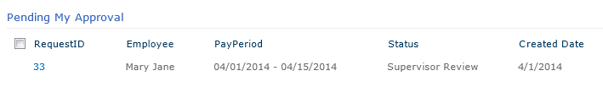

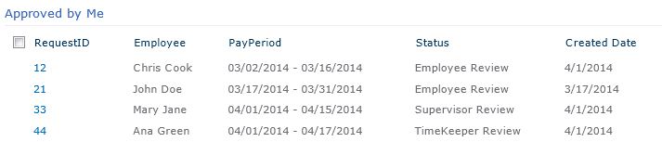

|  |  |  |  |
| --- | --- | --- | --- |
| Feature | **4.1 eTime Report** | | |
| Priority | **02 - Major** | **Est. Effort** | Click here to enter text. Hours |
| Description | Create a Report to display all eTime Requests. Employee, Supervisor or TimeKeeper will have access to this Report | | |
| User Interface | * Report will display requests data as per the security/org structure. * The report lists a summary of all requests for the user in Employee, Supervisor or TimeKeeper role with data security access * Employee can see any requests that were created by them or assigned to them * Supervisor can see any requests assigned to them or all requests created by employees in their Org structure * TimeKeeper can see any requests assigned to them or all requests created by employees in their Org structure * When the user clicks on the individual request, they see a read-only version of the request item details screen * Date Range or Pay Period filter can be applied | | |
| Technical Details | **Status Options:** Employee Review, SupervisorReview, TimeKeeper Review, Complete, Cancelled | | |
| Security Roles | Employee, Supervisor and TimeKeeper can view the Report. | | |

|  |  |  |  |
| --- | --- | --- | --- |
| Feature | **4.2 My eTime Pending Requests** | | |
| Priority | **02 - Major** | **Est. Effort** | Click here to enter text. Hours |
| Description | Lists all requests assigned to the logged in user in various stage. This is the worklist for logged in user, which are pending and need to be actioned. | | |
| User Interface | * Displays all requests assigned to the logged in user. Logged in user can action pending requests * When the user clicks on the individual request, they see the request item details screen. They can modify the items and action them on this screen | | |
| Technical Details | * Employee can see all requests pending for their review * RequestNo, Employee Name, PayPeriod, Status, Created Date fields will be displayed | | |
| Security Roles | Any user with a role that is part of the approval flow is able to see the worklist view. Employee, Supervisor and TimeKeeper can view their respective WorkList | | |

|  |  |  |  |
| --- | --- | --- | --- |
| Feature | **4.3 Approved by Me (eTime Requests)** | | |
| Priority | **02 - Major** | **Est. Effort** | Click here to enter text. Hours |
| Description | Lists all requests approved by the user. | | |
| User Interface | * Displays all requests which the user has approved. The requests can be in various stages, the logged in user has approved it at some stage. * Once completed or cancelled, they will be removed from this list * When the user clicks on the individual request, they see a read-only version of the request item details screen | | |
| Technical Details | * RequestNo, Employee Name, PayPeriod, Status, Created Date fields will be displayed | | |
| Security Roles | Employee, Supervisor and TimeKeeper can view the Report. | | |

|  |  |  |  |
| --- | --- | --- | --- |
| Feature | **4.4 PEAR Report** | | |
| Priority | **02 - Major** | **Est. Effort** | Click here to enter text. Hours |
| Description | Create a Report to display all PEAR Requests. Employee, Supervisor or will have access to this Report | | |
| User Interface | * Report will display requests data as per the security/org structure. * The report lists a summary of all requests for the user in Employee, Supervisor or TimeKeeper role with data security access * Employee can see any requests that were created by them or assigned to them * Supervisor can see any requests assigned to them or all requests created by employees in their Org structure * TimeKeeper can see any requests assigned to them or all requests created by employees in their Org structure * When the user clicks on the individual request, they see a read-only version of the request item details screen * User can cancel a PEAR request using a link provided * Date Range or Pay Period filter can be applied | | |
| Workflow Process/ Security | * Employee/Supervisor/TimeKeeper can view this report or Cancel items * On Cancelling an item, if request is Pending, workflow will be cancelled and database will be updated to reflect the change * On Cancelling an item, if request is Completed, only database will be updated to reflect the change | | |
| Technical Details | * Data is retrieved and or updated in the TimeManagement Database in SQL Server * RequestNo, Employee Name, PayPeriod, Status, Created Date fields will be displayed * **Status Options:** Employee Open, Employee Revise, SupervisorReview, Complete, Cancelled | | |
| Notifications | * A notification email is sent to Employee & Supervisor when an Employee Request is cancelled. The TimeKeeper is also notified if the cancelled request item was Approved. | | |

|  |  |  |  |
| --- | --- | --- | --- |
| Feature | **4.5 My PEAR Pending Requests** | | |
| Priority | **02 - Major** | **Est. Effort** | Click here to enter text. Hours |
| Description | Lists all requests assigned to the logged in user in various stage. This is the worklist for logged in user, which are pending and need to be actioned. | | |
| User Interface | * Displays all requests assigned to the logged in user. Logged in user can action pending requests * When the user clicks on the individual request, they see the request item details screen. They can modify the items and action them on this screen | | |
| Technical Details | * Employee can see all requests pending for their review * RequestNo, Employee Name, PayPeriod, Status, Created Date fields will be displayed | | |
| Security Roles | Any user with a role that is part of the approval flow is able to see the worklist view. Employee, Supervisor and TimeKeeper can view their respective WorkList | | |

|  |  |  |  |
| --- | --- | --- | --- |
| Feature | **4.6 Approved by Me (PEAR Requests)** | | |
| Priority | **02 - Major** | **Est. Effort** | Click here to enter text. Hours |
| Description | Lists all requests approved by the user. | | |
| User Interface | * Displays all requests which the user has approved. The requests can be in various stages, the logged in user has approved it at some stage. * When the user clicks on the individual request, they see a read-only version of the request item details screen * User can cancel a PEAR request using a link provided | | |
| Workflow Process/ Security | * Employee/Supervisor/TimeKeeper can view this report or Cancel items * On Cancelling an item, if request is Pending, workflow will be cancelled and database will be updated to reflect the change * On Cancelling an item, if request is Completed, only database will be updated to reflect the change | | |
| Technical Details | * Data is retrieved and or updated in the TimeManagement Database in SQL Server * RequestNo, Employee Name, PayPeriod, Status, Created Date fields will be displayed | | |
| Notifications | * A notification email is sent to Employee & Supervisor when an Employee Request is cancelled. The TimeKeeper is also notified if the cancelled request item was Approved. | | |

|  |  |  |  |
| --- | --- | --- | --- |
| Feature | **4.7 Administration** | | |
| Priority | **02 - Major** | **Est. Effort** | Click here to enter text. Hours |
| Description | A list of TimeKeepers associated with Supervisors will be maintained in a SQL table. This correlation will be manually maintained by TimeKeeper.  Employee Timekeeper association will be established in SQL table which the workflow will reference. | | |
| User Interface | * Every Supervisor can have 1 or more TimeKeeper designated for eTimeSheet approval * Each employee will have 1 TimeKeeper associated | | |
| Security Roles | Only Supervisor will have access to this feature | | |
| Assumption | Needed if this association does not exist or cannot be maintained in SAP | | |

|  |  |  |  |
| --- | --- | --- | --- |
| Feature | **4.8 Help** | | |
| Priority | **02 - Major** | **Est. Effort** | Click here to enter text. Hours |
| Description | Help will be provided on an application-wide level as well as on forms when applicable. | | |
| User Interface | * On Clicking the Help menu option a page will be displayed with information/FAQs | | |
| Security Roles | Everyone will have access to this feature | | |

## 5 – Interface with SAP

**Mode 1 (Preferred)**

1. SAP Master tables (Employee Profile, Supervisor List, TimeKeeper List) updated to SQL Server periodically –

daily (night)

1. SAP Master tables (PayCodes – WBS, Internal Order, Cost Center) updated to SQL Server periodically –

daily (night)

1. SAP Master tables (Hoilday Calendar by Union, Pay Periods) updated to SQL Server periodically –

Every 6 months (after mid-Dec & 6 months from then)

1. SAP Transactional tables (Vac, Leave Balance Accruals) updated to SQL Server periodically –

twice every week (Tue & Thu night)

OR Read SAP Transactional tables live – using K2 Connect & custom BAPIs

1. Final step - Validate against SAP Transactional tables live – using K2 Connect & custom BAPIs
2. Final step - Write to SAP – Updates live – using K2 Connect & custom BAPIs

**Mode 2**

1. SAP Master tables (Employee Profile, Supervisor List, TimeKeeper List) updated to SQL Server periodically –

twice every week (Tue & Thu night)

1. SAP Master tables (PayCodes – WBS, Internal Order, Cost Center) updated to SQL Server periodically –

weekly ( Thu night)

1. SAP Master tables (Hoilday Calendar by Union, Pay Periods) updated to SQL Server periodically –

Every 6 months ( after mid-Dec & 6 months from then)

1. SAP Transactional tables (Vac, Leave Balance Accruals) updated to SQL Server periodically –

twice every week (Tue & Thu night) **OR**

Validate against Business logic developed in K2/SQL Server (duplicated logic)

1. Write to SAP – Updates – daily in batches – using XML or text files with data generated by K2. Will be consumed by SAP. Logic for the file consumption will be in SAP **OR**

Write to SAP – Updates – daily in batches – using SQL Server tables with data generated by K2. Will be consumed by SAP. Logic for the file consumption will be in SAP

**Details (Need to be worked on):**

|  |
| --- |
| **Custom BAPI's – Identified so far - Input from SAP**  We need to see sample data which K2 will be able to consume for the below: |
| 1. User Profile (EmpID, Display Name, Division/Department, Exempt Status, Union affiliation, Supervisor, Cost Center/Budget Unit, Working Hours, Shift, Job Class Title, Work Phone)  * SAP will return a list of all non-ATU employees (All Employees for whom TimeSheets need to be created) with this information |
| 1. Leave Balance Actuals/ Vacation Time Available/ Comp Time Available per Employee  * K2 will give EmpID as parameter * SAP will return the balances |
| **Custom BAPI's – Identified so far - Update from K2 to SAP**   1. Timesheet Data entry by PayPeriod for each Day for each PayCode/CC/WBS/Internal Code entered (may be multiple calls are needed here)  * K2 will input: EmpID, Pay Period, Date, Codes (PayCode or WBS or Internal Order or Cost Center) for date, hours for the Code * SAP will validate this data. If Validation passes, data will be updated, otherwise a validation error will be returned to K2   **Areas that need clarification** |
| In places where data exists, we would like to see sample data to determine how K2 will process this data: |
| * Leave Types - Grouped by – Are there descriptions for them in SAP? * Are Overtime types defined in SAP? |
| * Employee - WorkUnit Data - need to Analyze what is available * TimeKeepers - what access level do they have to modify data in SAP, is there a role defined for them? * Hierarchy of Employees/Supervisor/Chiefs based on Class level? * Is that role reflected in the Employee User Profile, so we can categorize them as TimeKeepers? * Are we able to associate TimeKeepers with Supervisors or Employees? Need to determine the hierarchy associated with TimeKeepers and Supervisory in a Department * SAP Delegate - Alternate table - verify the table, how it is used and what information is saved in it. How often is it updated? * Are we able to determine Supervisor level employees from SAP * Working Hours for Employees? Different class of employees have different working hours set. Information maintained/available from SAP – Not available, confirm. * Description/Pay Codes/Internal Order/WBS Elements relationship & data entry– Analyze with SME * New Employee needs an ATRate assigned, if not activity type is allocated to employee, send email to Budget Sr. Mgmt Analyst with Employee ID requesting access * Error Notifications will be displayed if WBS codes are inactive or locked |

# Database Schema

**TimeManagement Database**

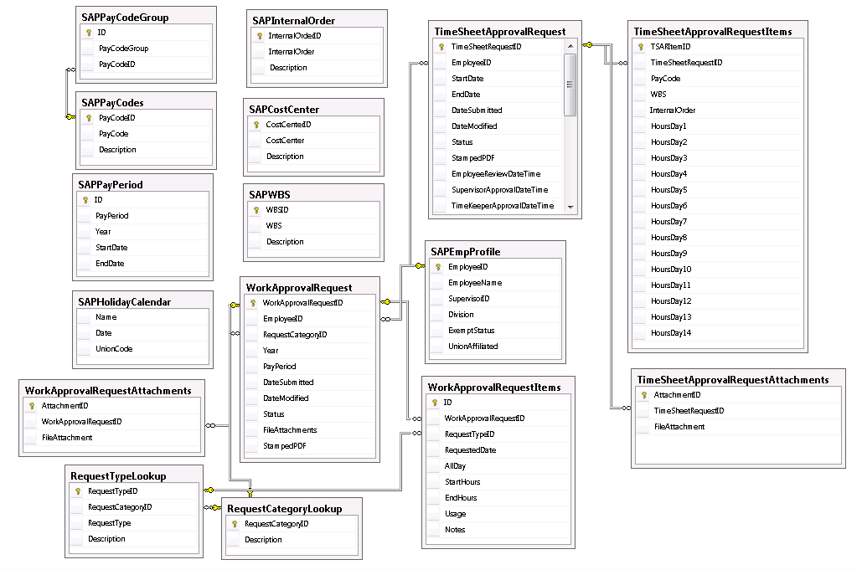

# Assumptions

K2 Environment – Dev, UAT & Prod

Upgrade to K2 BlackPearl 4.6.7 and K2 SmartForms 1.0.6

K2 Connect is configured

Visual Studio 2012 is installed on the server

SAP Interfaces defined and SME resource available to provide Business Logic & SAP related implementation

SharePoint Site will be available to host the eTime portal

# Appendices

| **Term** | **Definition** |
| --- | --- |
| PP | Pay Period |
| WBS | Work Breakdown Structure |
| SMO | SmartObject |
| WF | WorkFlow |
| DB | SQL Database |
| PEAR | Pay Approval Exception Request |
| TSAR | TimeSheet Approval Request |
| UI | User Interface |
| WOOC | Work Out Of Class |
| FMLA | Family and Medical Leave Act |
| RM | Risk Management |
| HR | Human Resources |

**Changes:**

Pay Exception Request (PayEx) has been renamed to Pay Exception Approval Process (PEAR). Some places in this document may not reflect this change.

**Additional Functionalities (Not in scope for this phase, not considered in Estimates):**

**Work Out of Class Process**

* Automate all Forms in K2
* Tie the codes/hr/payroll calculations at end of process to Pay Approval Exception Request
* WOOC Payroll Form will be autogenerated, attached to the e-TimeSheet Form and routed to Supervisor for Approval

**FMLA Process**

* Automate Forms in K2 with eSign
* Incorporate Payroll in K2 workflow process
* Tie the codes/hr/payroll calculations at end of process to Pay Approval Exception Request

**Custom Delegation in K2**

* SAP and other systems should be able to leverage this. SAP & other system integration delegation not included in estimate

**On Call Administration**

* Implement UI and tables to store the On Call List
* Allow surfacing the list via SharePoint Calendar List

**OverTime Meal Allowance**

* In some cases, related to working hours of employees, depending on their shift, Overtime Meal Allowance may be approved

**Differentials Approval Process**

* It may only be a timekeeping process or may be able to integrate this under the Lead Pay Process

**AT Rate Assign Process**

* New Employee needs an AT Rate assigned, if no activity type is allocated to employee.
* Check if the project is Locked or Open in SAP
* Send email to appropriate personnel Budget Sr. Mgmt Analyst (Christine Huynh currently performs this function) with Employee ID requesting access approval

**Changes to Original Requirements or scope beyond estimates**

1. **SAP Interface for Retro TimeSheet – 40 hrs**

* Design a new interface for a Retro TimeSheet, cell by cell entry.
* Data format – data is needed per date, not per line item. Cannot provide a PayPeriod & EmployeeID, need to provide each Date and EmployeeID
* Need to provide Action for each cell, Insert/Update/Delete, specifying action for each row is not sufficient
* In case of an Update, provide to SAP, original record as well as modified record

1. **Add Validity dates to SAPPayCodes – 16 hrs**

* PEAR form validations will need to take the PayCode Start and End Date’s into account
* TSAR form validations will need to take the PayCode Start and End Date’s into account

1. **Add HR Role for WOOC items to TimeSheet Request Approval Process – 4 hrs**

* HR will attach the WOOC Payroll sheet to the TSAR form with their calculations.
* Payroll reviews, makes modifications to the calculation sheet. Payroll also review the WOOC PayCode and changes it if needed
* When TimeKeeper submits time to SAP, WOOC related code is not passed to SAP
* Payroll will directly add this data to SAP, but K2 will have the correct code too, since Payroll has verified and made changes to the code if needed

1. **PEAR Item Cancel feature – 8 hrs**

Display a list of existing PEAR Approved items on Employee PEAR form

Add the ability to cancel PEAR individual items

1. **Project WBS – Cost Center validation – TBD hrs (Not included)**

* Per Carol, there needs to have a rule setup in K2 to determine whether the employee can charge to WBS based on the cost center
* Per the existing document list, the cost center's which are NOT highlighted are not chargeable to all available WBS Projects.
* This document list is could be updated any time and not maintained in SAP.  It needs to be maintained in K2

1. **Change**
2. SAP cannot give us PayCodes/Union affiliation. This validation will happen at the TSAR when employee submits eTime – Discussed & agreed on 07/01/2014 – Milestone 1 Demo meeting with Ali, Cathy, Belinda, Al, Liusan, Bob
3. **Change – Admin TimeKeeper tables will be batch updated from SAP**
4. **TimeKeeper Admin change – May need to maintain TK role for Execs in SAPEmployeeProfile table**
5. **WOOC – Allow TimeKeeper/SuperAdmin to initiate a new WOOC on behalf of Supervisors reporting to them**
6. **TSAR OnDemand – SuperAdmin feature – Allow TSAR to be created for all employees**
7. **Change of Add New PEAR item: Change 30 min increment to 1 min increment**
8. **PEAR – Cancel a WF in progress**