
BiG DATA and cloud security
Module - LD7081

Student Name - Shabina
Student ID - W21060994
Module Tutor - Dr Bilal Hassan

Table of Contents
Section A 3
Tasks 1: 3
Introduction of Big Data on The Cloud: 3
5V’s Big Data Principles: 4
Volume: 4
Velocity: 4
Variety: 4
Veracity: 4
Value: 4
How Big Data can be helpful for Ace Travel Company: 5
1.Increasing Revenue: 5
2. Improving Customer Experience: 6
3. Targeted Marketing 6
4.Managing Brand Reputation: For 6
5.Making Market Research and Strategy: 6
Task 2: Security risks within IAAS, PAAS and SAAS 7
Cloud Deployment Model: 7
IaaS: Infrastructure as a Service 7
PaaS: Platform as a Service 8
SaaS: Software as a Service 9
Comparison Table: SaaS vs Paas vs Iaas 11
Task 3: Big Data frameworks in the cloud: 13
Hadoop Distributed File System (HDFS) : 13
Hive: 13
Amazon Web Services (AWS): 14
Google Cloud Platform (GCP): 14
Yarn: 14
Map Reduce: 14
Pig: 14
Managing risk and reducing security threats associated with massive data for Ace Travel: 14
Standard Hadoop Security Procedures: 15
Screen, identify and resolve issues 15
Security concerns raised during AT investigations: 15
Task 4: Infrastructure diagram to support AT data migration project: 17
Section B: 18
Task 1 &Task 2: 18
AWS Step Configuration: 18
Task 3: Data Driven Dashboard 34
Tableau Dashboard 34
Task 4: Ace Travel to comply with relevant legal, ethical and social issues within the Cloud and Big data environment 38
Adhering to data privacy laws: 38
Implementing robust security measures: 38
Being transparent about data collection and use: 38
Being mindful of ethical considerations: 38
Ensuring compliance with relevant industry regulations: 38
References 40

Table of Figures
Fig 1: The 5 V’s of Big Data (Adapted from (“IBM big data platform - Bringing big data to the Enterprise,” 2014) 9
Fig 2: Increasing Revenue (Naveen Kumar, 2022) 11
Fig 3: Making Market Research and Strategy (Naveen Kumar, 2022) 12
Fig 4: IaaS Service Type Source: (Watts and Raza, 2019) 14
Fig 5: PaaS Service Type Source: (Watts and Raza, 2019) 15
Fig 6: SaaS Service Type Source: (Watts and Raza, 2019) 16
Fig 7: Apache Hadoop Ecosystem architecture (Abualkishik, 2019) 19
Fig 8: Risk management lifecycle and activities. Source (Fearnley, 2013) 21
Fig 9: Ace Travel Company AWS Cloud Infrastructure Deployment Diagram (created by author) 23
Fig. 10: Open a free account on the Amazon AWS website. 25
Fig 11: Create an account, then log in as the root user using your Credentials. 25
Fig 12: To create a virtual machine, sign in and start Ec2. 26
Fig 13: Choose the Ubuntu machine image from the list of icons in 26
Fig 14: Choose an instance type by scrolling down 27
Fig 15: Network settings configuration 27
Fig 16: Configure storage setting 28
Fig 17: Add key tags 28
Fig 18: Choose a key file format and create a new keypair. ppk for PuTTY use 29
Fig 19: You can get a summary after adjusting every setting on the right-hand side. After reviewing it, start an instance 29
Fig 20: Launch Successfully 30
Fig 21: Putty Connected 30
Fig 22: Successfully launched an Ubuntu instance 30
Fig 23: Create a bucket by typing "S3" into the Amazon Services search bar 31
Fig 24: Give a bucket a distinctive name to make one 31
Fig 25: Remove all public access restrictions 32
Fig 26: Bucket created 32
Fig 27: Edit Bucket properties 32
Fig 28: Enable Static web hosting 33
Fig 29: Files Uploaded Successfully 33
Fig 30: Make Status Public 34
Fig 31: Object uploaded and accessible 34
Fig 32: Access to Static Web Page by User (https://acetravelcompany.s3.amazonaws.com/index.html ) 34
Fig 33: Find IAM in the search bar, choose it, and begin establishing a user 35
Fig 34: Activate MFA 35
Fig 35: Set up virtual MFA device Using Microsoft Authenticator 35
Fig 36: Scan QR Code with Microsoft Authenticator App on mobile to get MFA Code 1 and MFA Code 1 36
Fig 37: MFA Is Activated in Root Account 36
Fig 38: The root account has now been successfully given multi-factor authentication 36
Fig 39: Add User AceTravel Company Root Account 37
Fig 40: Add Custom Password 37
Fig 41: Set Permission boundary only user can access 37
Fig 42: Add tags ace travel company 38
Fig 43: You may get the dataset here as well as review and create a user 38
Fig 44: Sign in As IAM User 39
Fig 45: IAM user successfully logged in. And you can see the IAM username and account ID in the top right corner 39
Fig 46: Tableau Welcome Screen 40
Fig 47: Selecting table for live connection or extracts 41
Fig 48: Data split into Dimensions and Measures 41
Fig 49: Creating different sheets for analysis of data (in this case distribution of customer age group) 42
Fig 50: Tableau Dashboard (developed for Ace travel by author) 42
Fig 51: Publish tableau dashboard on server for it to be accessible by employees 43
Fig 52: Publishing tableau dashboard on public server with link 43
List of tables
Table 1: SaaS vs Paas vs Iaas 14

Section A

Tasks 1:

Introduction of Big Data on The Cloud:
Big data is a built-in capability of the cloud and offers previously unheard-of possibilities for combining traditional, structured database information and corporate analytics with social networking, sensor network data, and far less structured multimedia. Big data applications need a data-centric computational architecture, and many solutions integrate cloud-based APIs with sophisticated columnar searches, machine learning techniques, and sophisticated analytics including computer vision, video analytics, and visualisation tools. These all are the reason Ace Travel Company(ATC) is migrating their system to cloud. (Sam B. Siewert, 2013)
My responsibility is to move the company's centralized databases to big data in the cloud and to discover security holes and any security dangers brought on by the data migration. In order for the regional managers to obtain real-time travel bookings information and fulfill their established bookings targets, it is important to improve the company's decision-making by utilizing vital information and insight from all current databases. I will also address all troubling problems brought up during the management investigations and offer sound advice on how to safeguard the business from these risks.
To fully appreciate the difficulties, we need to examine the most important characteristics of Big Data. Those characteristics are known as 5V’s principle, and it stand for Value, Velocity, Veracity, Variety and Volume and the clear definition is shown in the figure 1.
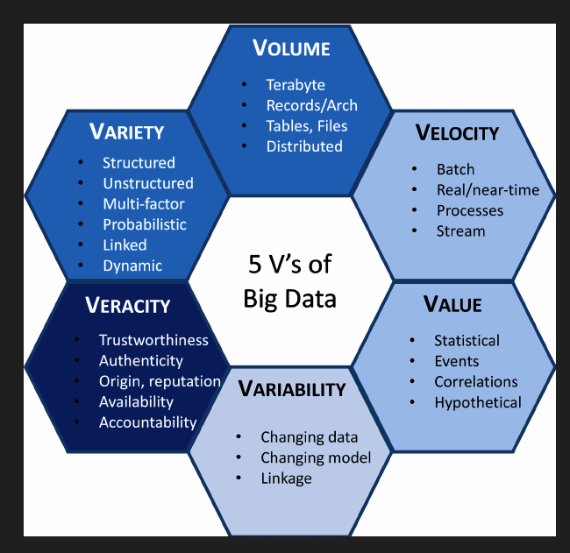
Fig 1: The 5 V’s of Big Data (Adapted from (“IBM big data platform - Bringing big data to the Enterprise,” 2014)

5V’s Big Data Principles:
Volume: Volume refers to the total amount of data. The central databases of Ace Travel (AT) in High Wycombe and other locations generate and retain a considerable amount of data. Bookings, packages, and consumer complaints are all included in this data. The volume of data has greatly expanded due to the company's expansion, making it challenging for management to make wise judgments. (Alexander S. Gillis, 2021)

Velocity: It describes the rate at which data is created and transferred. AT's data is updated daily, and regional managers manually distribute reports among one another. Due to the absence of real-time information caused by this lengthy procedure, it might be difficult to make decisions and meet goals for booking travel. With the use of big data on the cloud, data processing may happen more quickly, giving management access to real-time insights. (Alexander S. Gillis, 2021)

Variety: Diverse data types are referred to as variety. AT handles a variety of data types, including semi-structured data from the regional managers' reports, unstructured data from client complaints, and structured data from their centralized databases. The management faces difficulties in efficiently utilizing all the data to make educated judgments due to the variety of the data. (Alexander S. Gillis, 2021)
Veracity: Data accuracy and quality are discussed. The accuracy and reliability of the data are in doubt because the company's online database frequently goes down as a result of daily internal backups, cyberattacks, and server overload. The reliability of the data can be increased by assuring data integrity and security by transferring the data to the cloud and deploying big data solutions. (Alexander S. Gillis, 2021)

Value: This refers to the value that big data may offer and is directly related to what businesses can do with the information gathered. The organization can gain insightful knowledge from the vast amount of data they have by transferring it to the cloud and using big data solutions. This may result in better decision-making and the achievement of defined goals for travel bookings. By spotting patterns and trends in the data, the business can also address consumer complaints and enhance the entire customer experience. (Alexander S. Gillis, 2021)
As was previously said, Ace Travel Company adheres to all the principles. To ensure large financial revenue, Ace Travel Company must carefully balance the amount and pace of data collecting. In order for Ace Travel Company's overall operation to succeed, data must be acquired from a wide variety of trustworthy sources. The "Value" qualities of big data, as stated in the conclusion, include not only the "quantity and quality of structured information," but also the potential financial gains from marketing the information in question or from developing a new company plan.

How Big Data can be helpful for Ace Travel Company:
For Ace Travel (AT), big data can be very beneficial in several ways. First off, by transferring their centralized databases to big data on the cloud, AT may enhance its ability to make decisions by having immediate access to all their data. This will give regional managers complete access to information about recent trip bookings, enabling them to reach their predetermined bookings targets more effectively. Furthermore, big data technologies like Hadoop and Spark can quickly and effectively process enormous amounts of data, allowing AT to glean insights and see trends that would be challenging or impossible to spot with conventional data processing techniques.
Second, a company's ability to handle, recover from, and prevent future cyberattacks can be enhanced by a migration to the cloud and big data environments. Cloud service providers with strong security features and compliance certifications, such Amazon Web Services, Microsoft Azure, and Google Cloud Platform, can aid in protecting AT's data. Furthermore, security analytics and possible threats can be implemented using big data technologies, such as intrusion detection and anomaly detection. (Han, Kamber, & Pei, 2011)
Finally, by utilizing big data and cloud technology, AT can increase the availability and dependability of its online booking system, lowering delays and customer complaints. Cloud service providers give high availability and disaster recovery alternatives that can keep AT's system operational even in the case of interruptions or malfunctions (Amazon Web Services, n.d.). Big data technology can also assist AT in scaling their system to manage rising traffic and demand, lowering the possibility of server overloads.
Some of the most significant advantages and applications of big data for tourism and travel are listed below:
1.Increasing Revenue: Getting the right product in front of the right consumer at the right time and at the right price is one of the numerous difficulties the travel business faces. (Naveen Kumar, 2022)


Fig 2: Increasing Revenue (Naveen Kumar, 2022)
2. Improving Customer Experience: Customers are regularly and individually interacted with in the travel and tourism sector (Naveen Kumar, 2022)
3. Targeted Marketing: Every business groups its clients according to a variety of criteria, such as purchasing power, location, behaviour, and many more.
4.Managing Brand Reputation: For tourist places to remain profitable, reputation is crucial. (Naveen Kumar, 2022)
5.Making Market Research and Strategy: Big data analytics is also used by hotels and airlines to learn more about their primary rivals.

Fig 3: Making Market Research and Strategy (Naveen Kumar, 2022)

Task 2: Security risks within IAAS, PAAS and SAAS

Cloud Deployment Model:
The Ace Travel Company will require a cloud deployment methodology, which the business must choose before migrating. The phrase "deployment model" refers specifically to the service that has been selected and the degree of privacy that is provided by the hosting technique. Data sovereignty, the transfer of duties, and control are the top cyber security concerns and difficulties associated with cloud migration. Before migrating Ace Travel's centralized databases to Big Data in the Cloud, it is vital to evaluate and take into account the security concerns linked with each type of cloud service, including Infrastructure-as-a-Service (IAAS), Platform-as-a-Service (PAAS), and Software-as-a-Service (SAAS). (Stanislav Stella, 2017)

IaaS: Infrastructure as a Service
On-premises infrastructure can be substituted with infrastructure as a service, or IaaS. A third party provides you with cloud-based, internet-based infrastructure services as you need them, including storage and virtualization. It is a pay-as-you-go service.
IAAS give a business the resources and infrastructure it needs to run its own software and applications, like Amazon Web Services (AWS) and Microsoft Azure. Although this option offers the greatest degree of flexibility and control over security measures, it also necessitates the greatest amount of management and maintenance resources.
Because the provider does that, you don't need to update or manage your on-site datacenter. Instead, you access and control the infrastructure using a dashboard or an application programming interface (API).
You have the opportunity with IaaS to just purchase the components you actually require and scale them up or down as appropriate. Because it has no overhead and no maintenance fees, IaaS is a very affordable solution.
Testing and development environments might be quickly and easily set up and taken down using IaaS. Simply use the infrastructure you need to establish your development environment, scale it up or down as needed, and use it for however long you need to before ending so that you only pay for what you really use.
The main drawbacks of IaaS are the possibility of security issues with the provider, multi-tenant systems where the provider must share infrastructure resources with several clients, and service dependability. These drawbacks can be avoided by choosing a service with a strong track record and reputation. (RedHat, 2022)

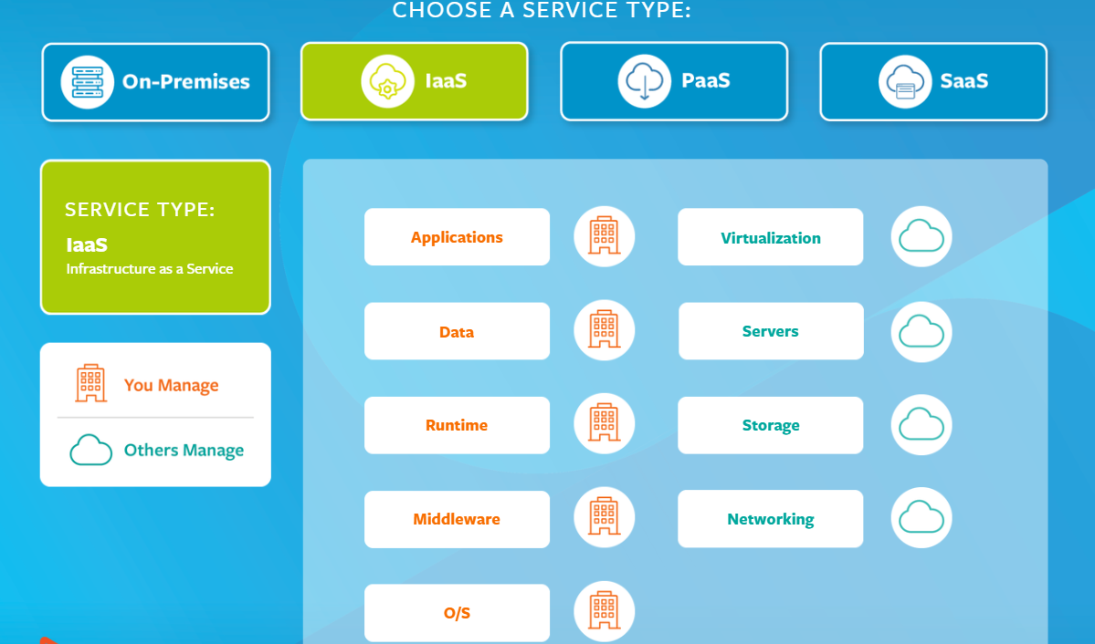
Fig 4: IaaS Service Type Source: (Watts and Raza, 2019)
The orange text in the above graphic denotes what the organisation, business, or user manages.

PaaS: Platform as a Service
Cloud platform services also go by the moniker Platform as a Service (PaaS), which provides cloud components to certain software while being mostly used for apps. When using PaaS, developers are given a framework on which to build specialized apps. While the corporation or a third-party supplier can handle all servers, storage, and networking, the developers can continue to handle the programs. (Watts and Raza, 2019)
PaaS is primarily advantageous for developers and programmers because it allows users to construct, run, and manage their own apps without having to build and maintain the infrastructure or platform frequently associated with the process.
By writing the code, you may design and manage your apps without worrying about hardware maintenance or software updates. You are provided with the ideal setting for developing and deploying.
Programmers can use the PaaS technique to create and modify a framework for their web-based applications. Developers can use pre-built software components in the design of their programs, which decreases the amount of original code they must produce.
AWS Elastic Beanstalk, Heroku, and Red Hat OpenShift are a few instances of PaaS.

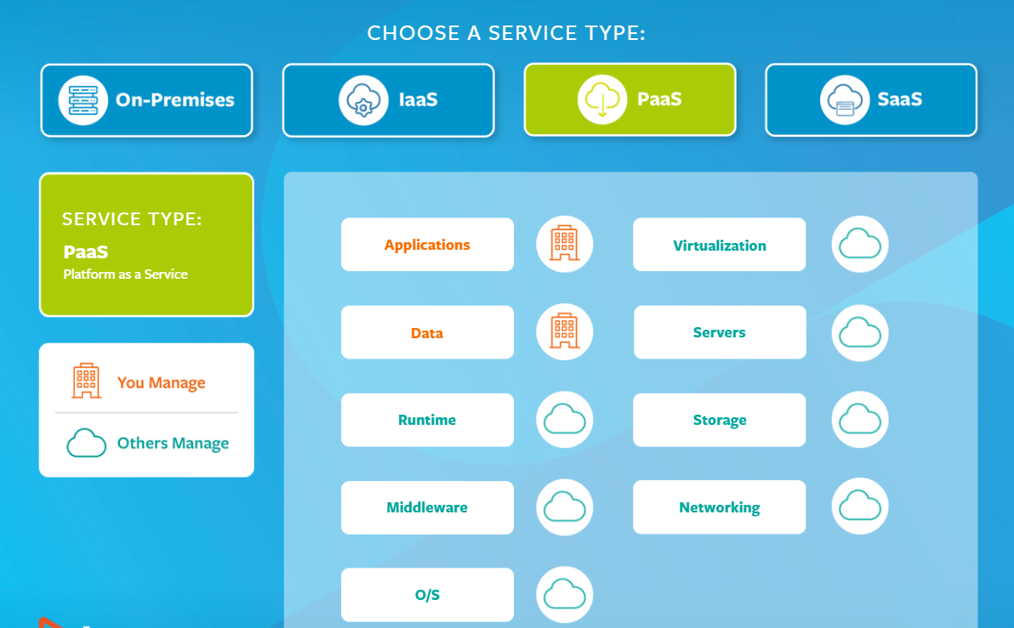Fig 5: PaaS Service Type Source: (Watts and Raza, 2019)

SaaS: Software as a Service
For businesses employing the cloud, software as a service—often referred to as cloud application services—is the most common option. SaaS uses the internet to give its consumers access to apps that are managed by a different supplier. Most SaaS apps are browser-based, which eliminates the requirement for client-side download or installation. 2019 (Watts and Raza)
Because you can log into your account and check your email from any computer, anytime, if you have an email account with a web-based service like Outlook or Gmail, you're already familiar with a sort of SaaS.
Selecting a reliable provider is essential since SaaS may save you time and money on maintenance but may also cost you in terms of control, security, and performance.
Red Hat Insights, Dropbox, Salesforce, and Google Apps are a few SaaS instances. (RedHat, 2022)

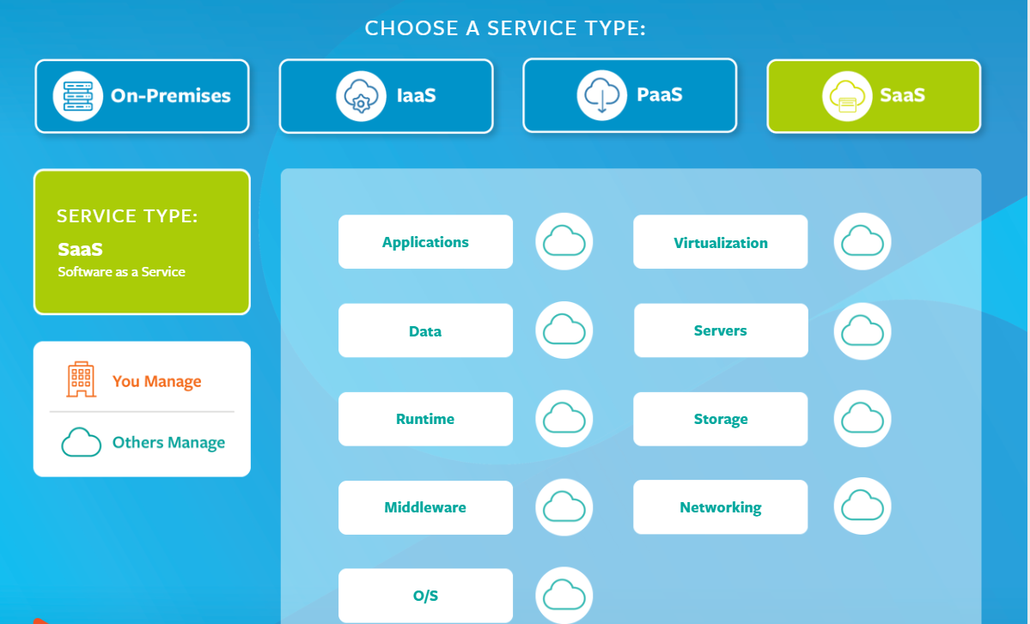Fig 6: SaaS Service Type Source: (Watts and Raza, 2019)

Comparison Table: SaaS vs Paas vs Iaas
The following are some ways that cloud services vary:
Table 1: SaaS vs Paas vs Iaas
In the instance of Ace Travel, they require control over both their infrastructure and data security. IAAS is the best choice for the firm as a result. To safeguard their data in the cloud, they could also deploy security measures like firewalls, intrusion detection systems, and encryption. (Stanislav & Stella, n.d.)
Cloud Security: A Practical Guide” by Mark Stanislav and Josh Stella, published by O'Reilly Media
IaaS has several benefits for Ace Travel Company, including:
1. The most flexible architecture for cloud computing
2. Server, networking, storage, and processing power deployment is straightforward and automated.
3. Hardware purchases could be influenced by consumption.
4. The infrastructure is entirely in the control of the customer.
5. Resources may be purchased as needed.
6. Exceptionally scalable
7. a lot of people utilizing the same equipment
8. The organization retains complete control of the infrastructure.
9. Flexible and versatile. 2019 (Watts and Raza)
It is also crucial to remember that the business should carry out careful due diligence and a complete risk analysis before moving its data to the cloud. They should also consider the regulatory compliance standards that apply to their sector and confirm that the cloud provider they select complies with those standards. (Mather,Kumaraswamy,latif, n.d.)

Task 3: Big Data frameworks in the cloud:
It is now possible to produce a large amount of data thanks to emerging, innovative technologies. It is essential that such a big volume of data be stored safely. Large volumes of data are stored using the Hadoop tool in insecure settings. This article has examined a variety of techniques for securing data storage in Hadoop. The Hadoop framework was developed with the intention of processing and storing Big Data in a distributed computing environment. The usage of big data has grown in importance since it can help firms increase their operating margin (Martis, Pai, Pragathi, Rakshatha, Dixit, 2019). The use of cloud computing technologies for data storage, processing, and analysis is referred to as "big data in the cloud." For this purpose, there are numerous Big Data frameworks available on the cloud, including:
Hadoop Distributed File System (HDFS) : One of the most popular open-source Big Data frameworks in the cloud is this one. Large volumes of data can be stored and processed using distributed computer clusters with this system. To analyse the data, Hadoop can be used in conjunction with other tools like Apache Hive. Data from every Hadoop cluster can be accessed by users thanks to a distributed file system called HDS. A group of linked computers is referred to as a cluster. Like other Hadoop-related technologies, HDFS is an essential tool for organizing and easing the analysis of extraordinarily large volumes of data, such as petabytes and zettabytes.
HDFS can be used without paying for licencing or support because it is open-source software. It is made to work with a standard PC.
MapReduce, a Hadoop data processing framework, may easily receive more than two terabytes of data per second, per computer, from HDFS.
Large data can be accessed by a standard file system, however problems with input and output to the disc are possible owing to many factors. (By Simplilearn, 2022)
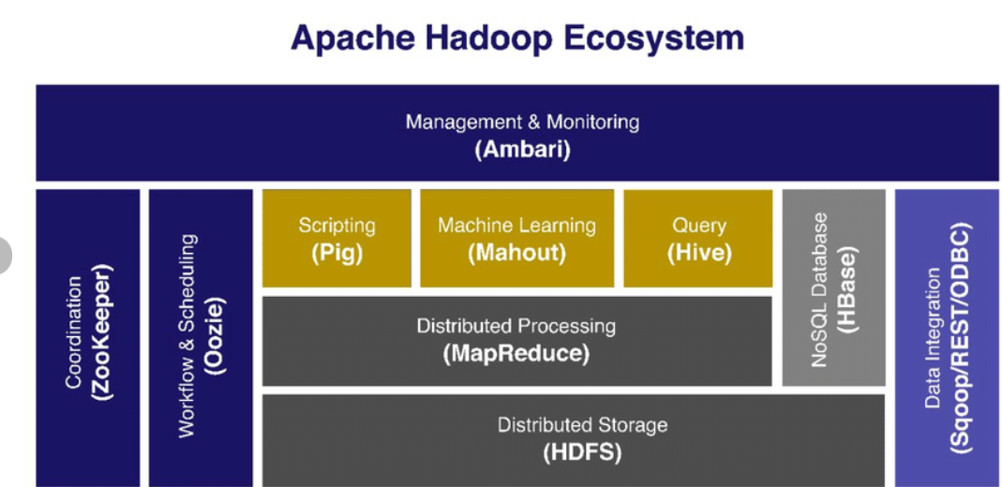
Fig 7: Apache Hadoop Ecosystem architecture (Abualkishik, 2019)
Hive: Apache Hive, a distributed, fault-tolerant data warehousing solution, enables massive-scale analytics. In order to enable decisions based on data, a data warehouse provides a consolidated store of data that can be swiftly examined. SQL can be used by Hive to read, write to, and manage petabytes of data. Hive is unique because it provides a SQL-like user interface and can use Apache Tez or MapReduce to query large datasets. (Aws, 2022)
Amazon Web Services (AWS): Storage, computation, and analytics are just a few of the capabilities offered by AWS, a cloud computing platform. AWS provides a range of Big Data services that may be used to store, process, and analyze enormous volumes of data in the cloud, including Amazon Elastic MapReduce (EMR) and Amazon Redshift. (Amazon Web Services, 2022)
Google Cloud Platform (GCP): GCP is a platform for cloud computing that offers a range of services, including analytics, processing, and storage. Google Cloud Platform (GCP) provides a range of Big Data services that may be used to store, process, and analyze huge volumes of data on the cloud, including Google BigQuery and Google Cloud Dataflow.(GCP, 2021)
Yarn: Isolating the daemons in charge of resource management, job scheduling, and monitoring is the fundamental idea underpinning YARN. The idea is to have an application master for each application as well as an overarching resource manager (RM) (AM). Applications can consist of a DAG of jobs or just one task.. (Apache Hadoop, 2022)
Map Reduce: is a product model for managing massive amounts of organised, unstructured, and coordinated data on enormous amounts of production equipment. (Hive, 2022)
Pig: It is a step of procedural language used to promote material for MapReduce tasks.
These Big Data frameworks in the cloud have various built-in security measures that can help to reduce security concerns brought up during the Ace Travel investigations. For example:
Using protocols like Kerberos and SSL, Hadoop and Spark both provide secure communication between cluster nodes.
Both AWS and GCP include a range of security capabilities, including access controls, security groups, and encryption both in transit and at rest.

AWS Guard Duty and GCP Security Command Centre are only two of the services that AWS and GCP provide to help defend against cyberattacks.
Overall, these cloud-based Big Data frameworks can offer a safe and dependable approach to handle, process, and analyse massive amounts of data. It's crucial to remember that these frameworks might not be sufficient on their own to properly address all security issues, thus it's crucial to have a thorough security strategy in place and to regularly monitor and improve it. (Amazon Web Services, 2022)

Managing risk and reducing security threats associated with massive data for Ace Travel:
Recognizing and analysing issue priority is part of risk management.
Risk management restricts screens and increases the possibility of disappointment or missing essential application information in terms of big data analytics. Ace Travel will benefit from improved risk management as a result of enhanced system architecture and data management.
Ace Travel needs a system to safeguard the data in order to stay up with and deal with the high amount of information that is accessed by an increased number of clients and since Hadoop has a high risk of information theft due to the lack of safety calculations included into Hadoop. (Fearnley, 2013)
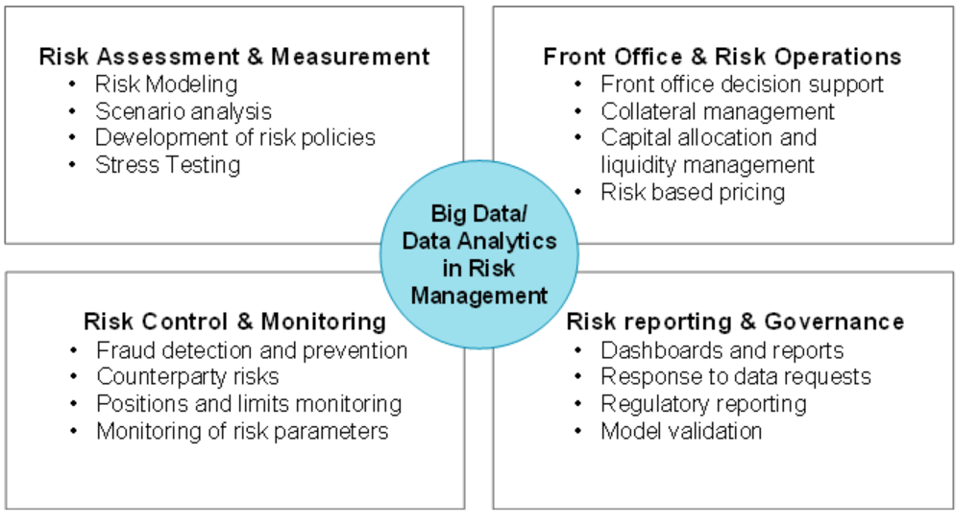
Fig 8: Risk management lifecycle and activities. Source (Fearnley, 2013)

Standard Hadoop Security Procedures:
• Apache Hadoop uses the Kerberos protocol, a traditional method that is also used for network security.
• The Apache Knox software is used to secure borders.
• The Apache Hadoop structure is obtained using ESS (Enterprise-scale security).
• The structure is checked and handled using Argus, an Apache Foundation product.
To sum up, current safety measures including web firewalls, information recording, checking, and reviewing plans, and putting up the board. (Krishnakumar, 2015)

Screen, identify and resolve issues - Infact, even the greatest security models will be seen as unreliable if they lack the capability to recognize common security infractions such as recurring errors in judgment and resistance. Associations must make sure that the finest effort is done to set up the checking and proofing cycles. (Aggarwal, 2015)

Security concerns raised during AT investigations:
Regardless of the cloud deployment architecture selected, Ace Travel Company will face numerous difficulties and cyber dangers, as demonstrated in this chapter. Ace Travel is advised to establish Security as a Service in light of this (SECaaS). In order to demonstrate both the deployment of such a service and the adaptability of cloud services, the following section of the document will provide an example of deployment using AWS Services..

Task 4: Infrastructure diagram to support AT data migration project:

The initial configuration for this project will be the Amazon S3 or Amazon Simple Storage Service. With this Amazon Web Services product, object storage is made available via a front-end web application. Amazon S3 makes use of the same adaptive storage technology that Amazon.com utilizes to power its Ace Travel Company.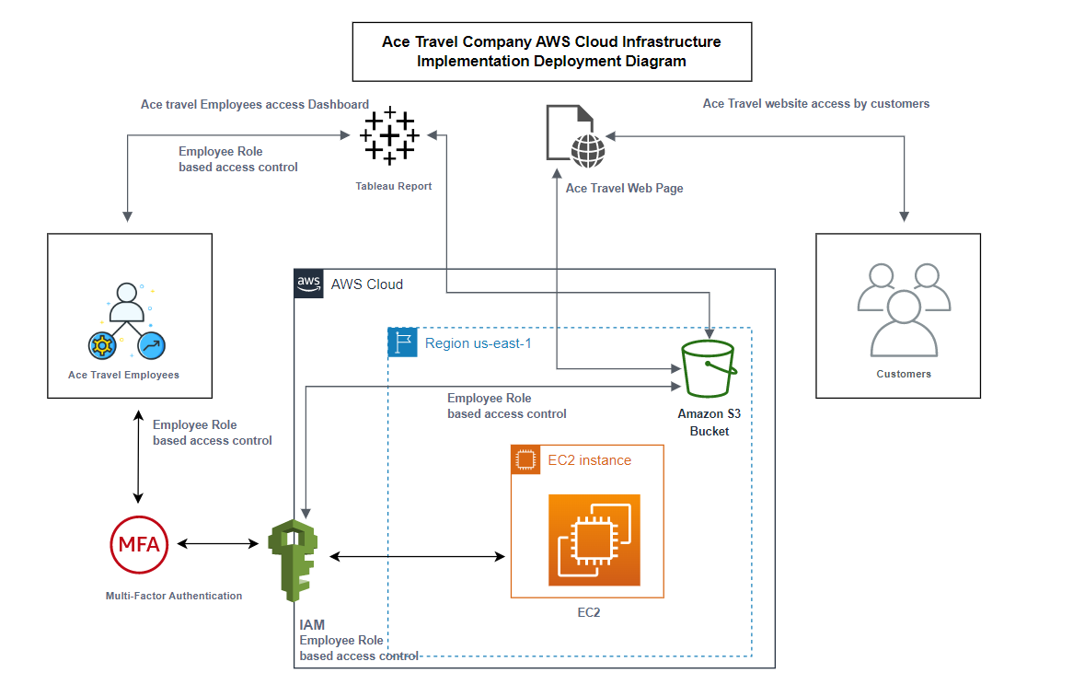
Fig 9: Ace Travel Company AWS Cloud Infrastructure Deployment Diagram (created by author)

Section B:

Task 1 &Task 2:
AWS Step Configuration: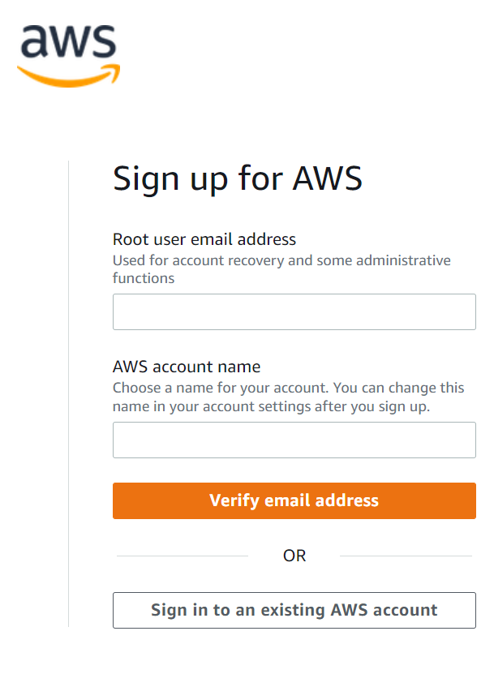

Fig. 10: Open a free account on the Amazon AWS website.
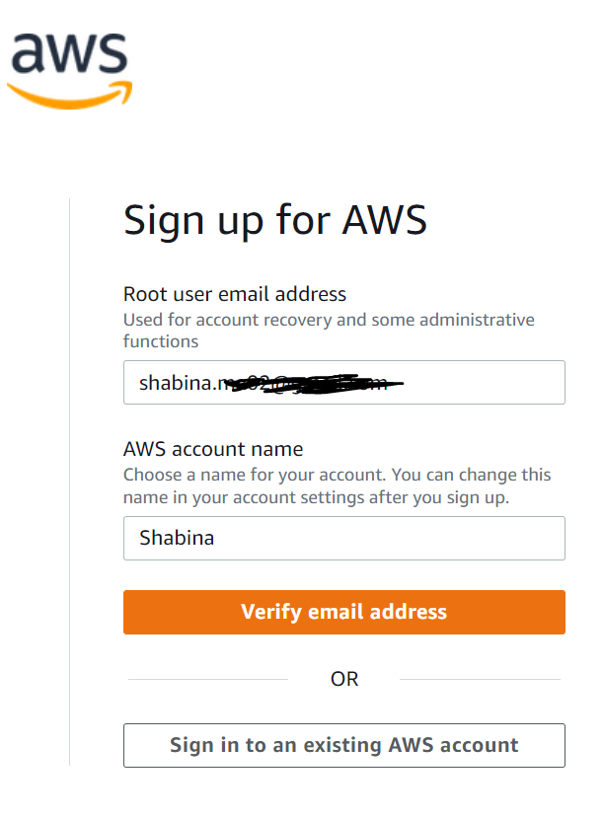Fig 11: Create an account, then log in as the root user using your Credentials.

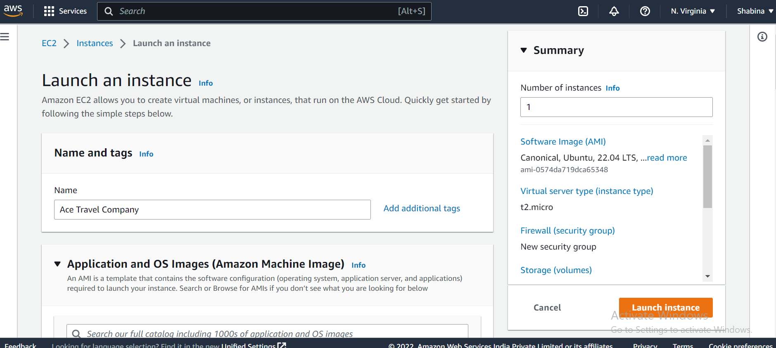
Fig 12: To create a virtual machine, sign in and start Ec2.
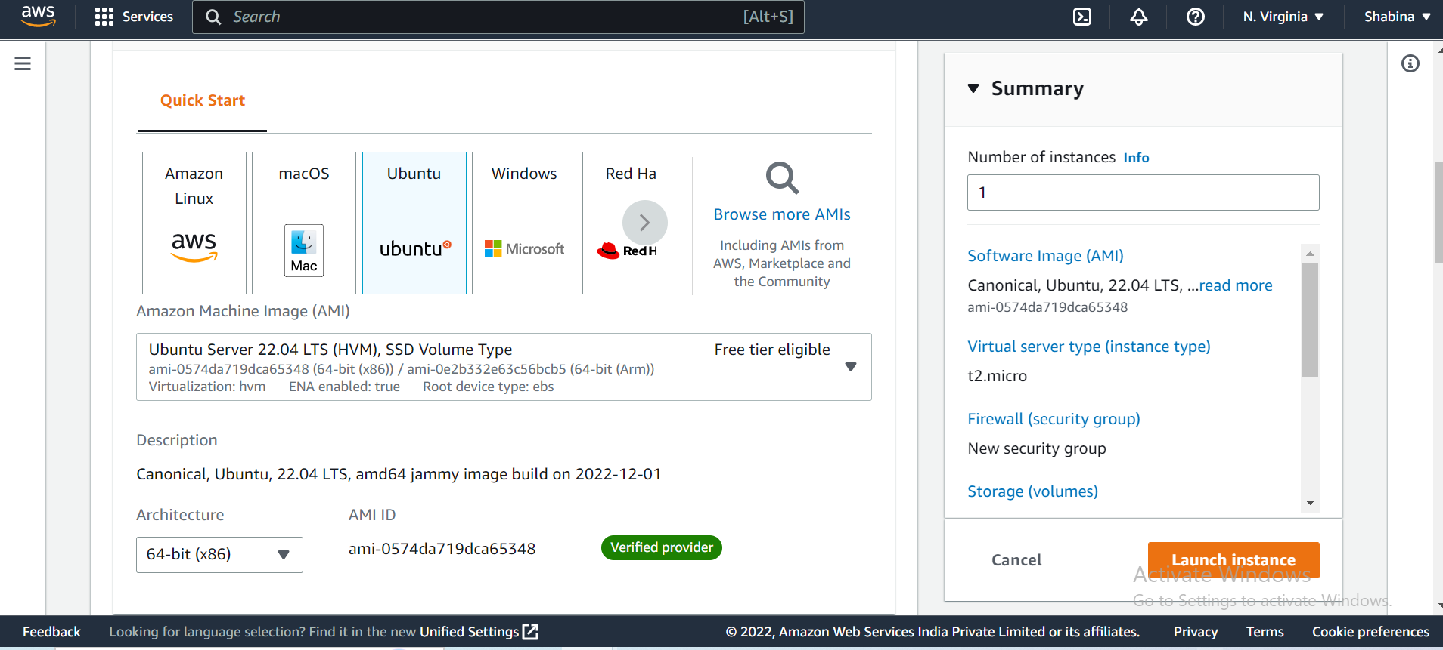
Fig 13: Choose the Ubuntu machine image from the list of icons in

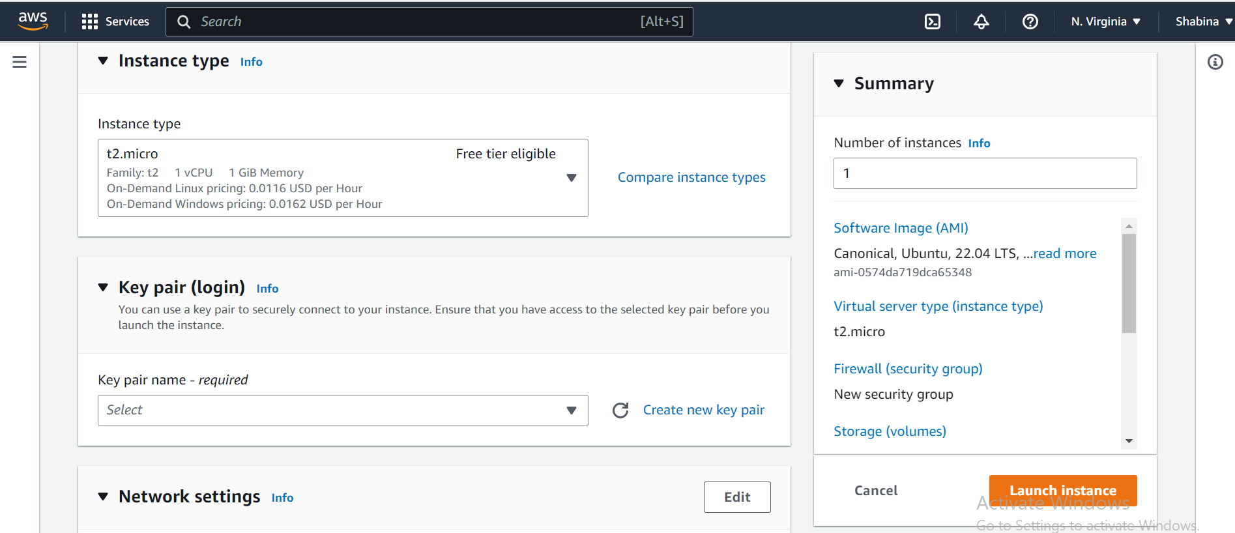 Fig 14: Choose an instance type by scrolling down

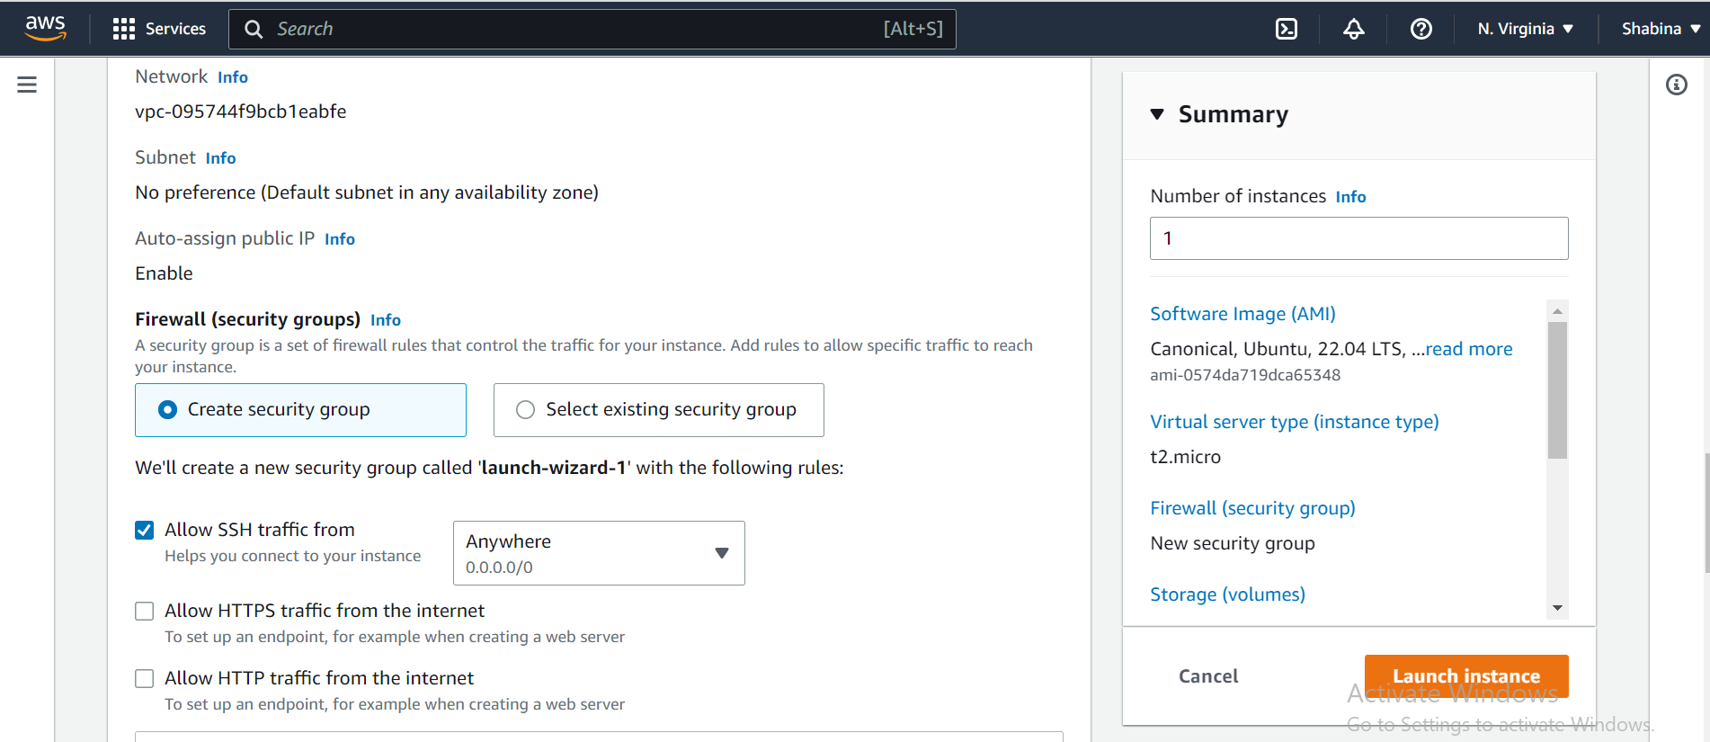
Fig 15: Network settings configuration

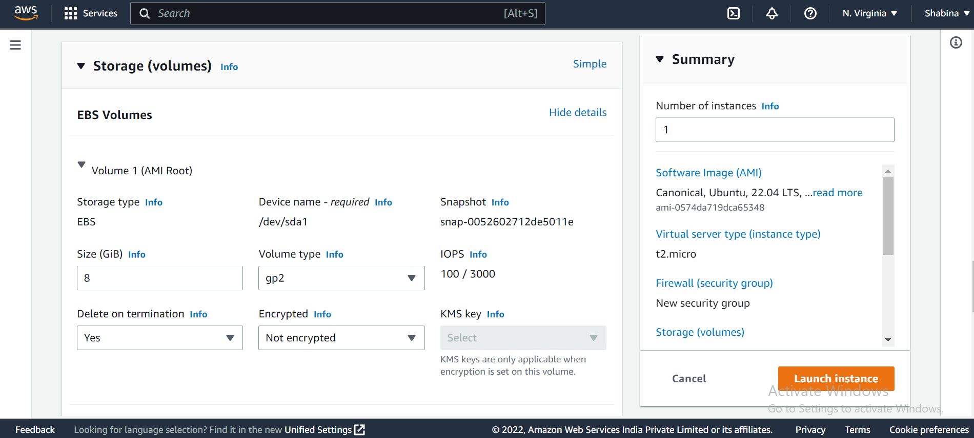
Fig 16: Configure storage setting

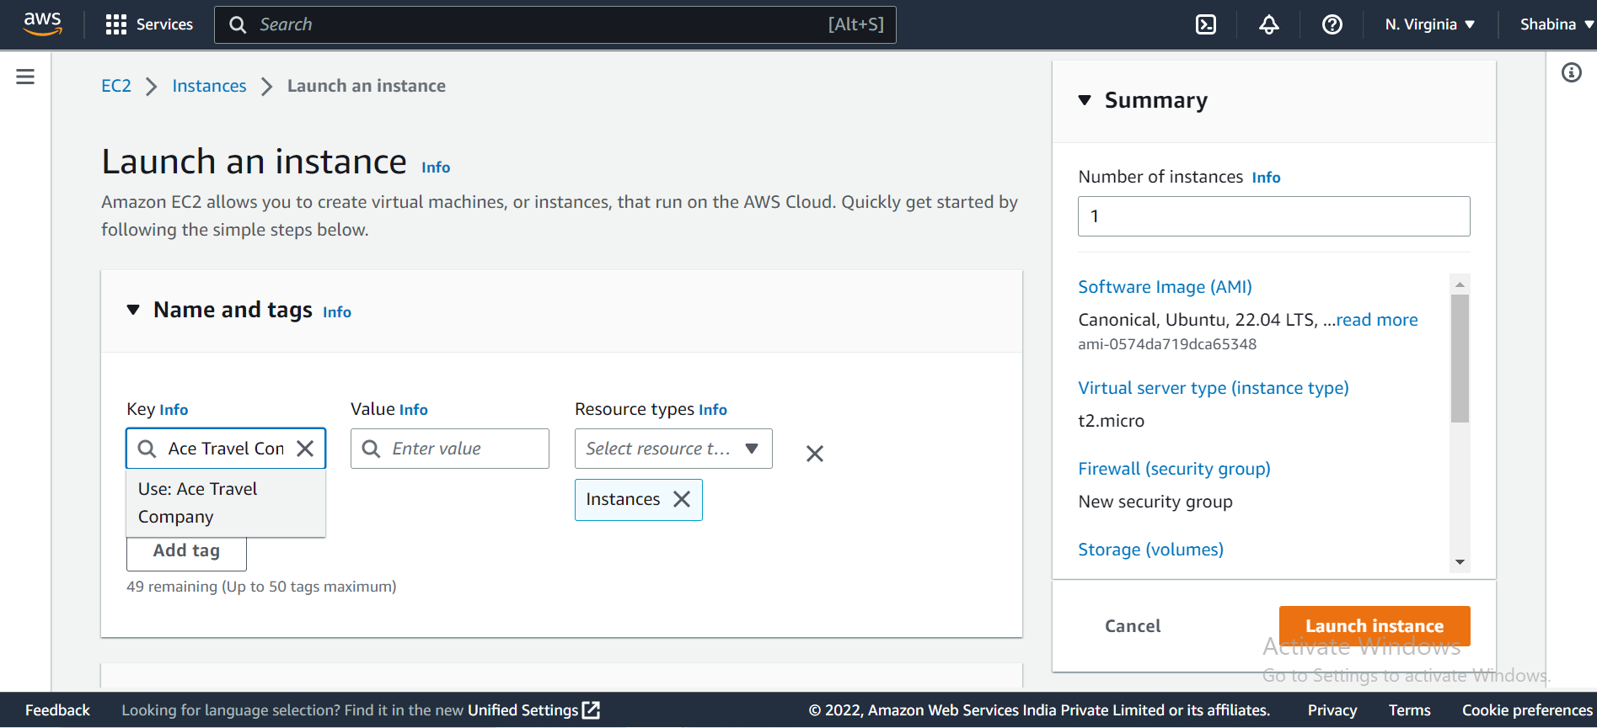
Fig 17: Add key tags

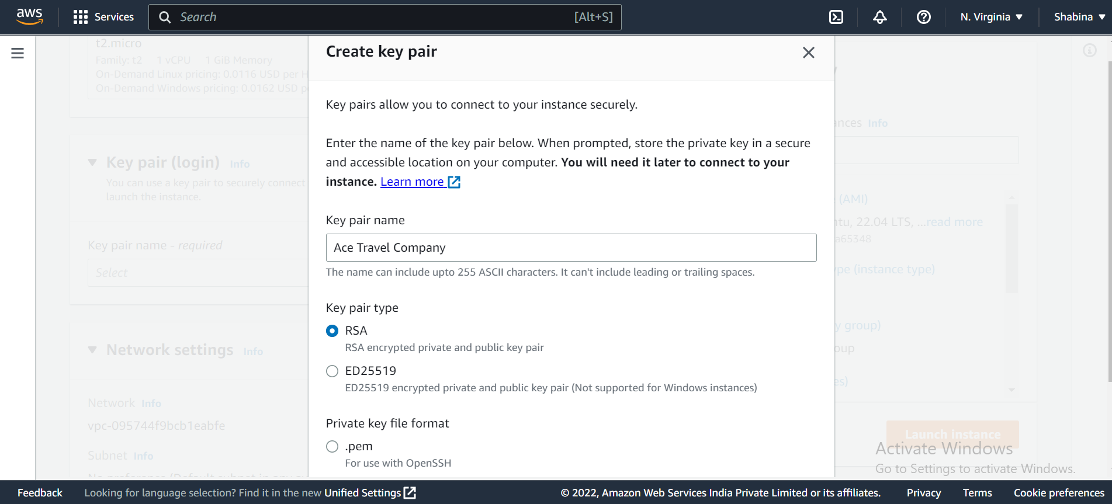
Fig 18: Choose a key file format and create a new keypair. ppk for PuTTY use

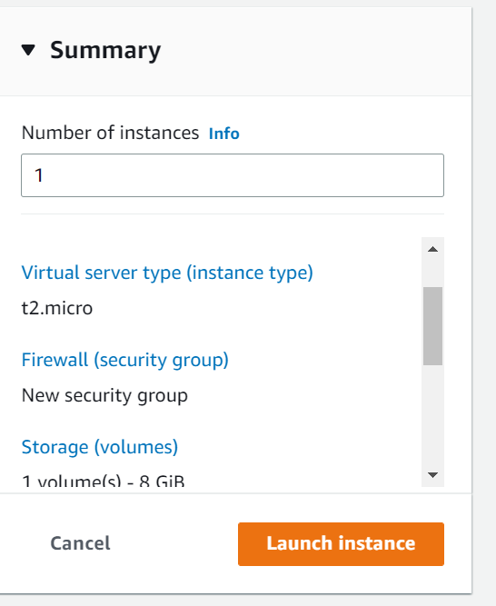
Fig 19: You can get a summary after adjusting every setting on the right-hand side. After reviewing it, start an instance

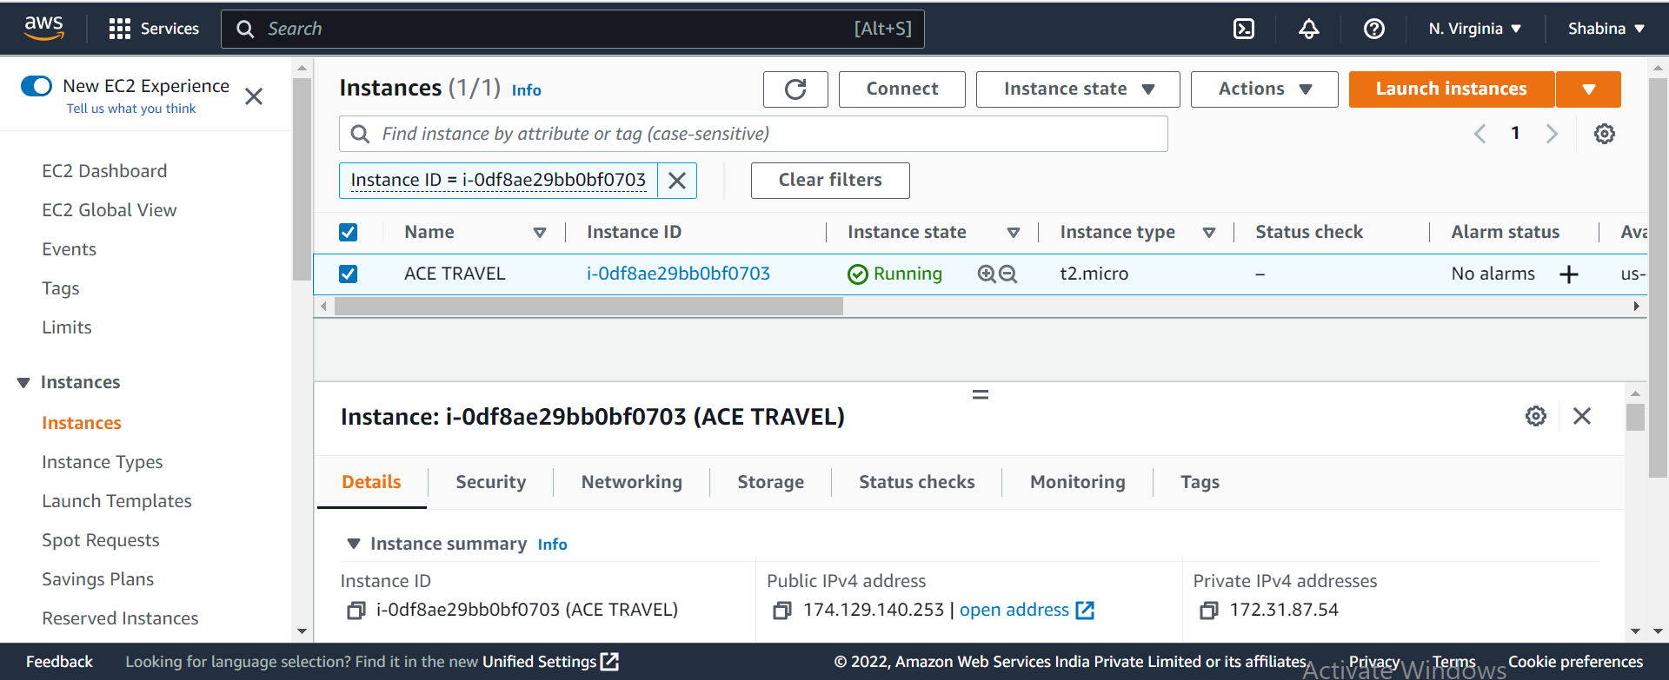
Fig 20: Launch Successfully

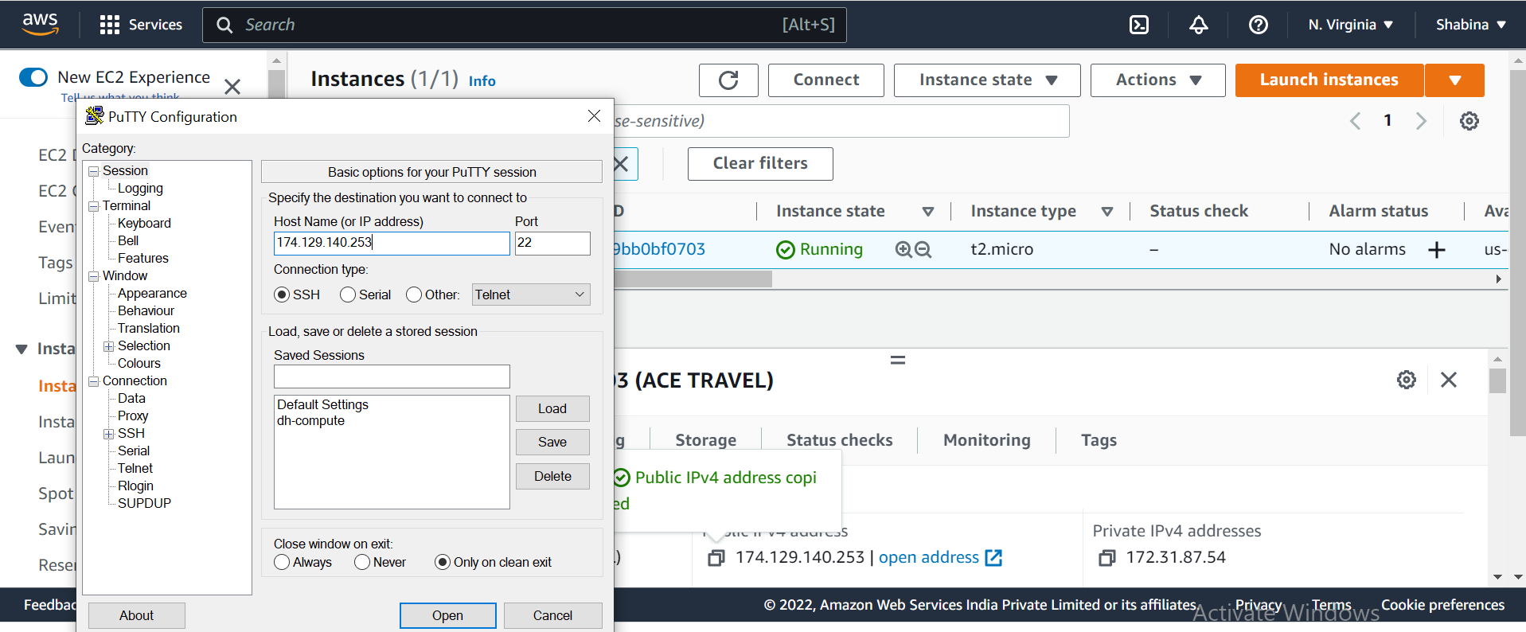
Fig 21: Putty Connected
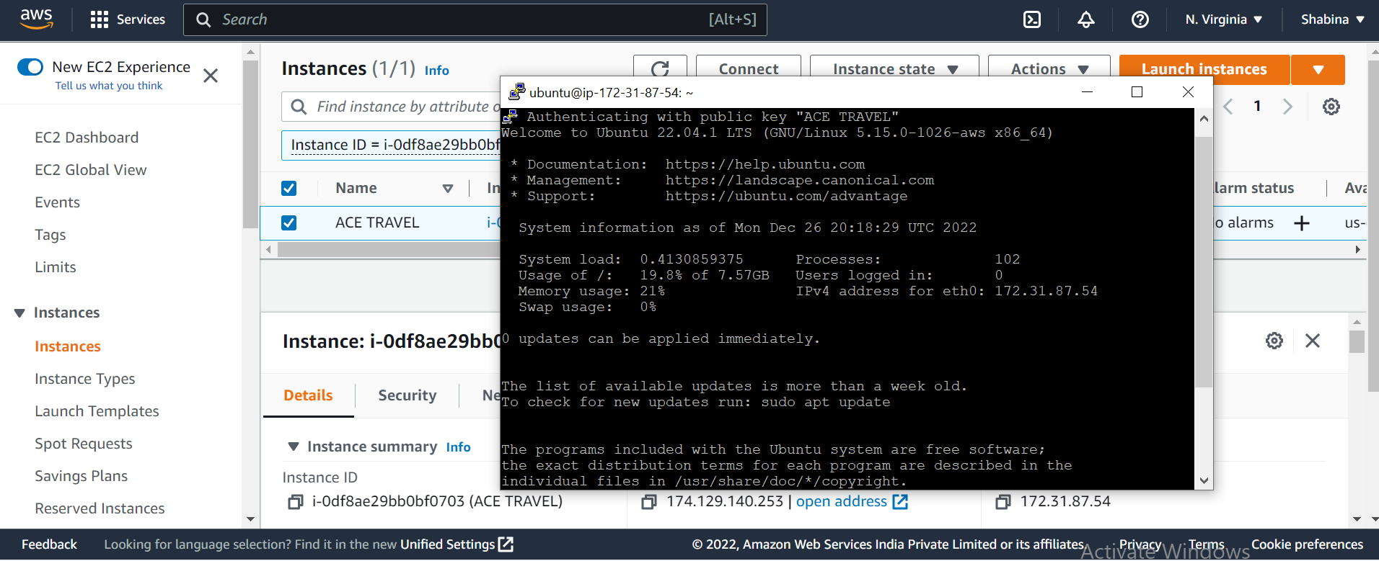
Fig 22: Successfully launched an Ubuntu instance
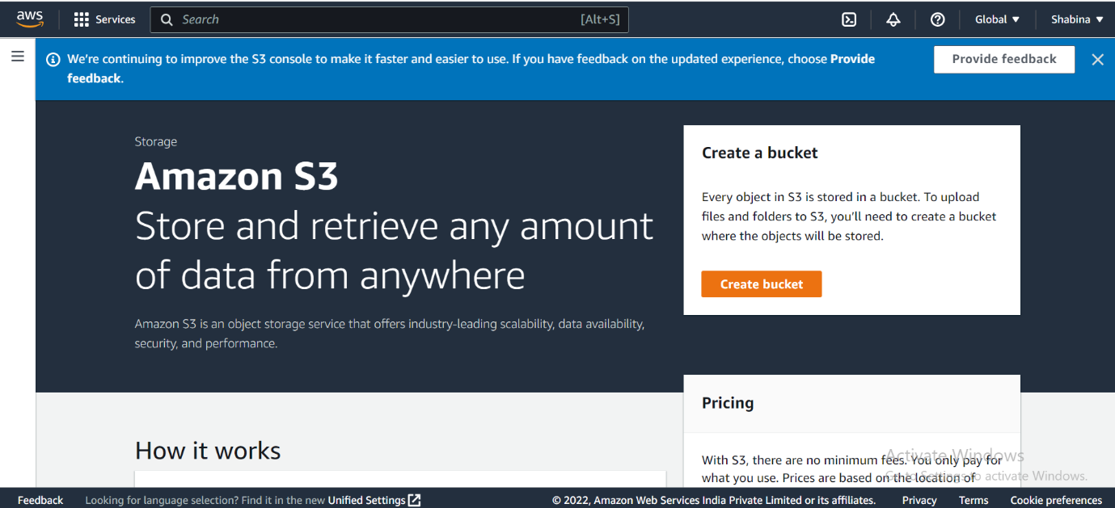
Fig 23: Create a bucket by typing "S3" into the Amazon Services search bar

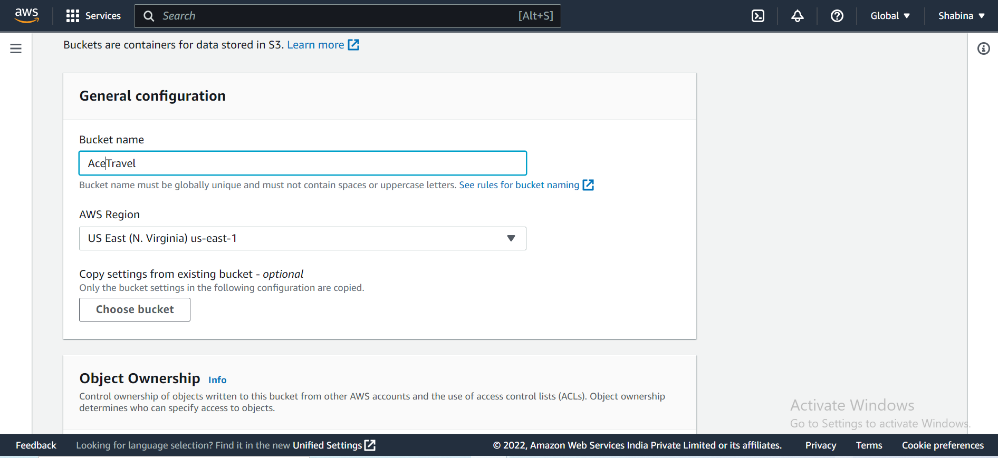
Fig 24: Give a bucket a distinctive name to make one

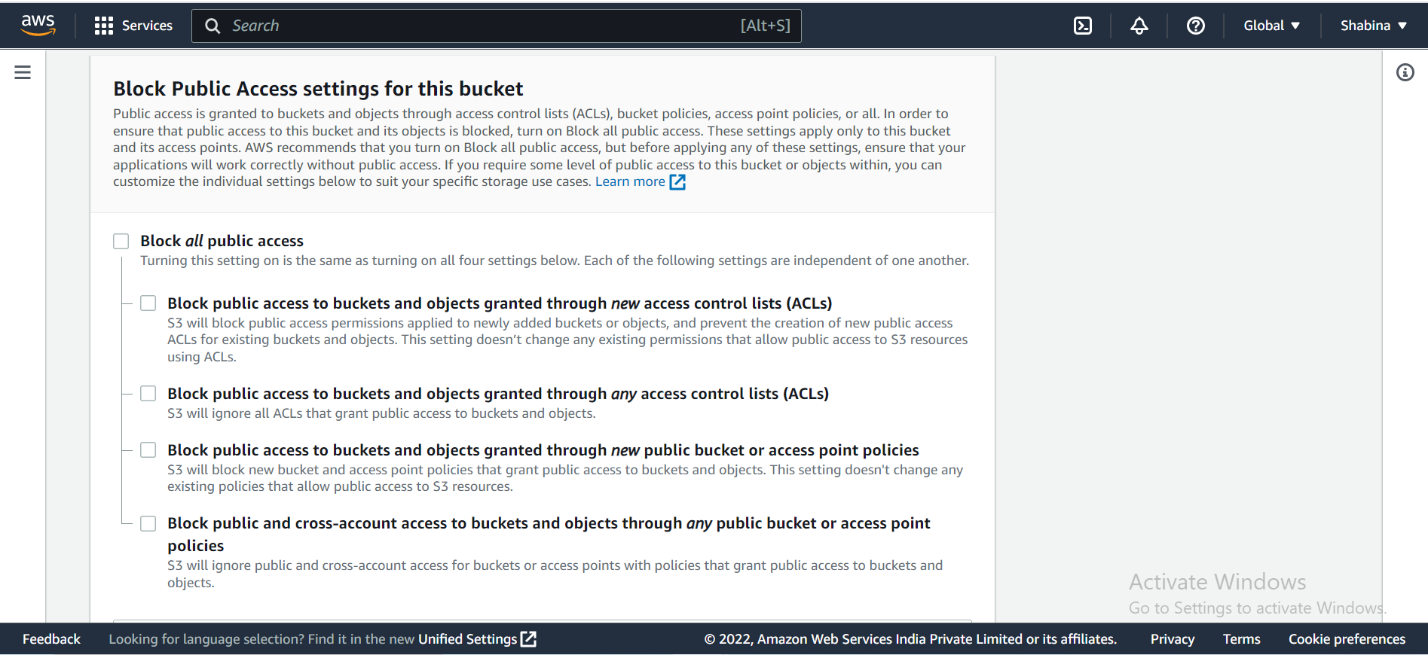
Fig 25: Remove all public access restrictions
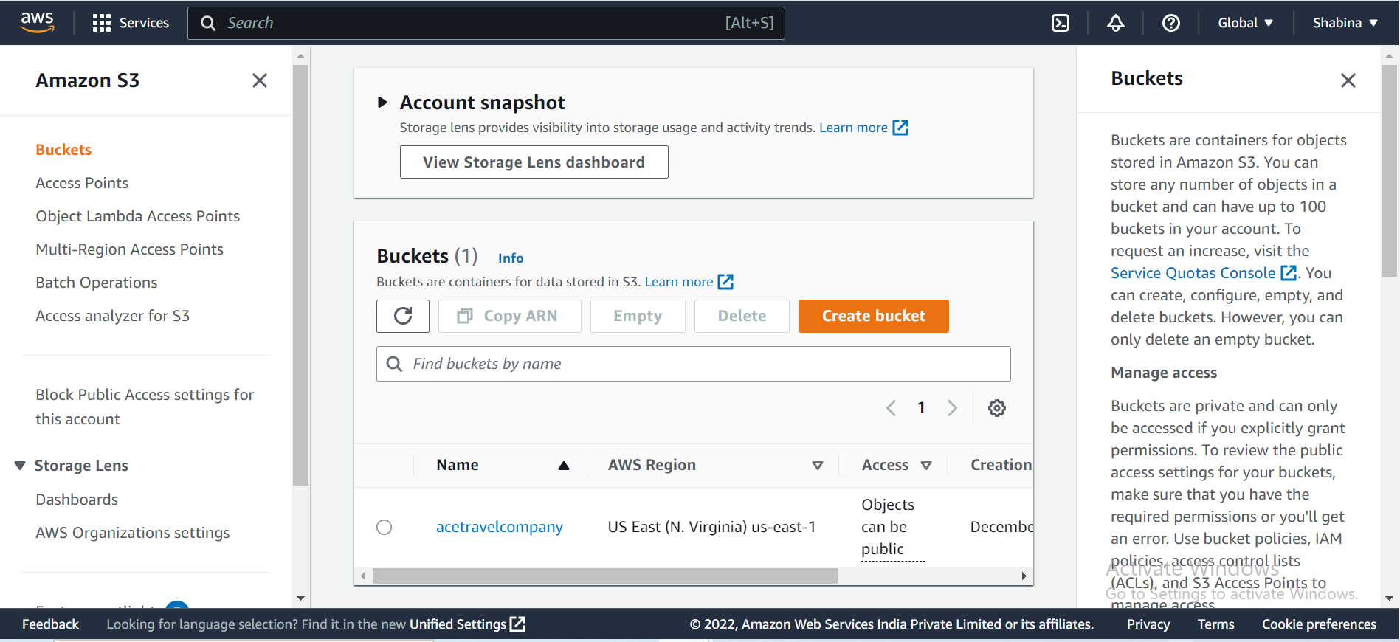
Fig 26: Bucket created
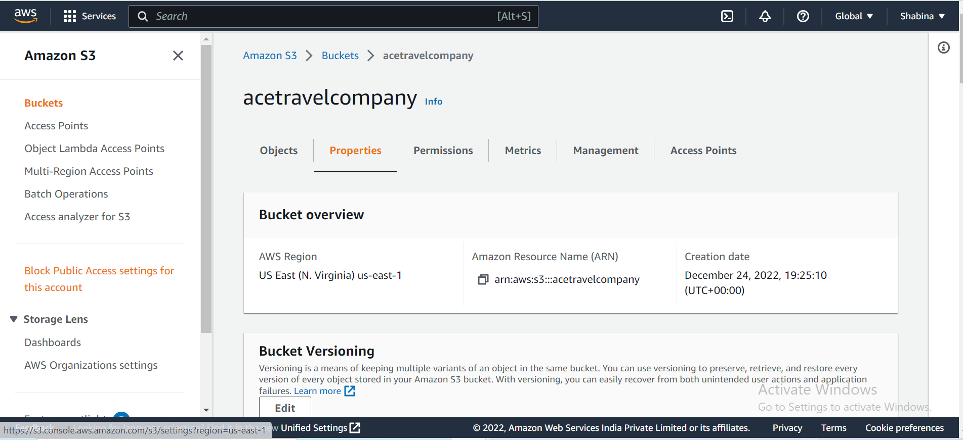Fig 27: Edit Bucket properties

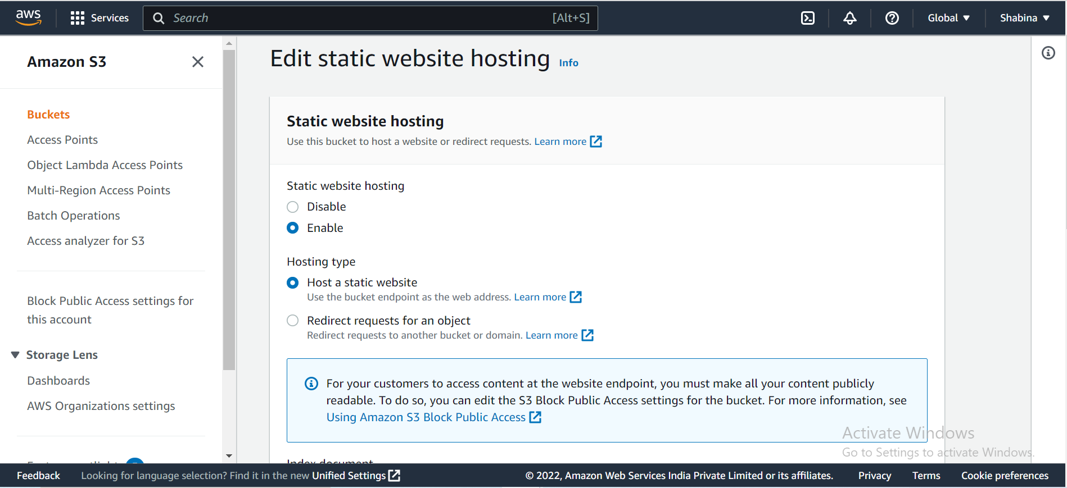Fig 28: Enable Static web hosting
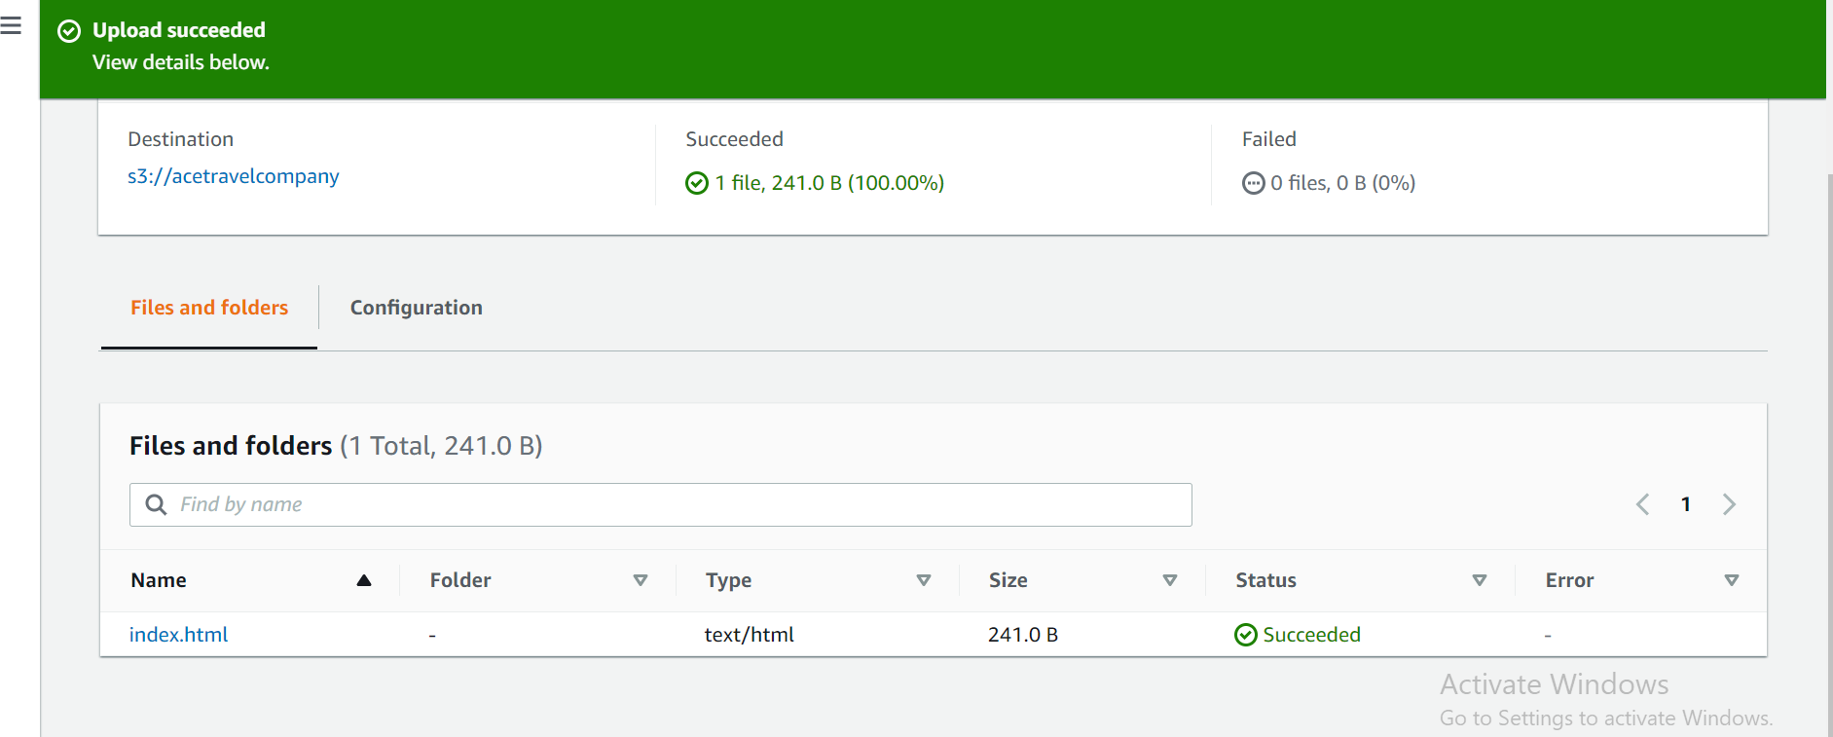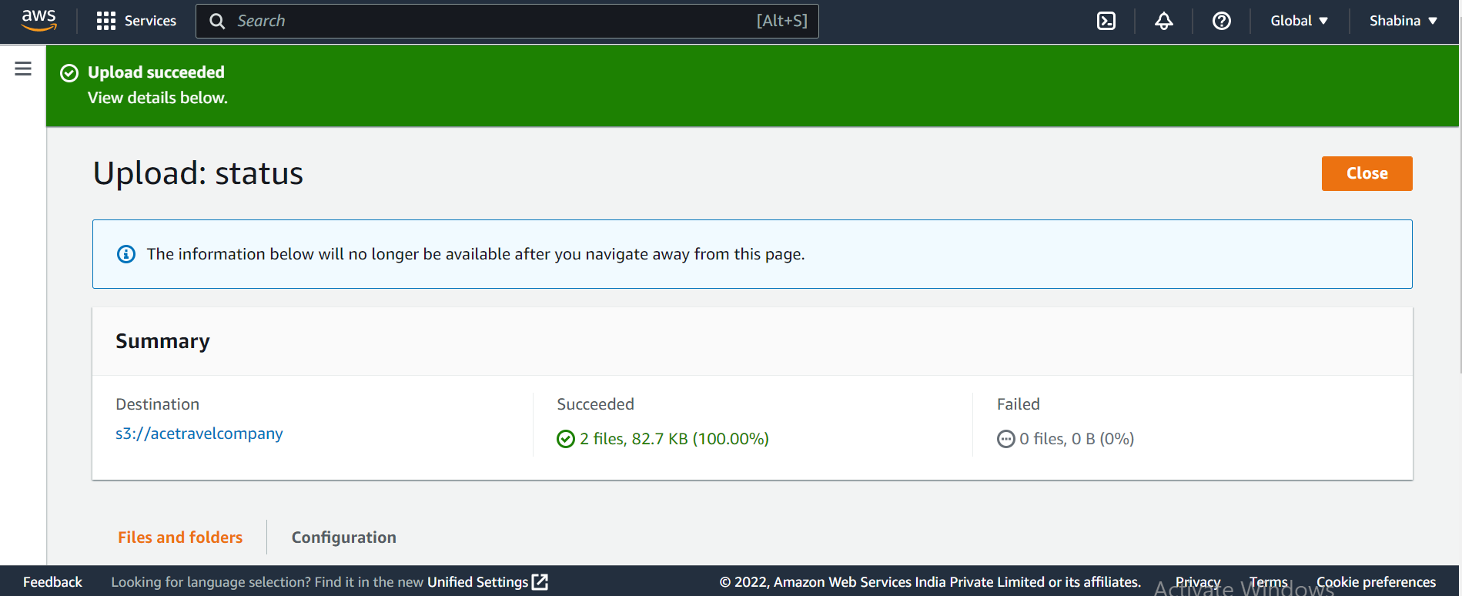
Fig 29: Files Uploaded Successfully
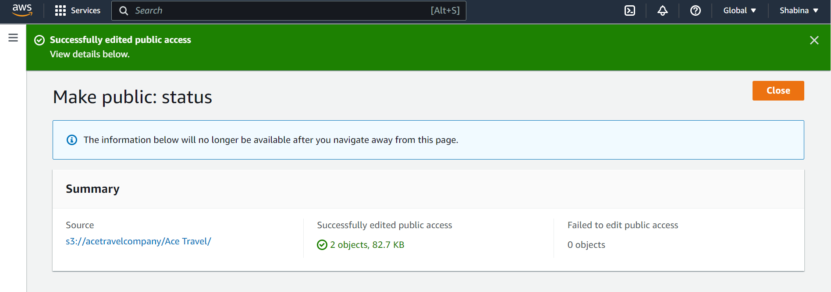
Fig 30: Make Status Public
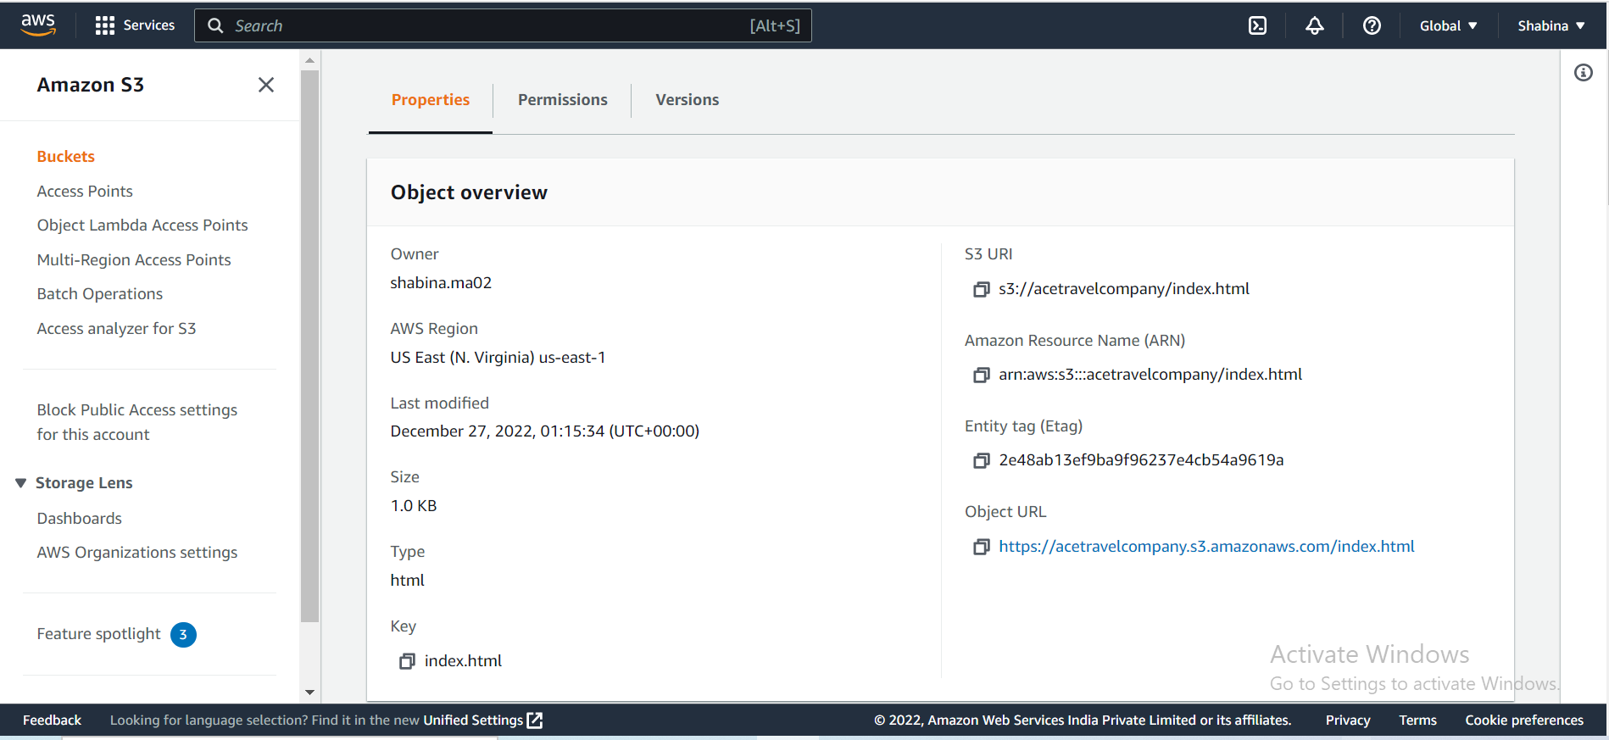
Fig 31: Object uploaded and accessible
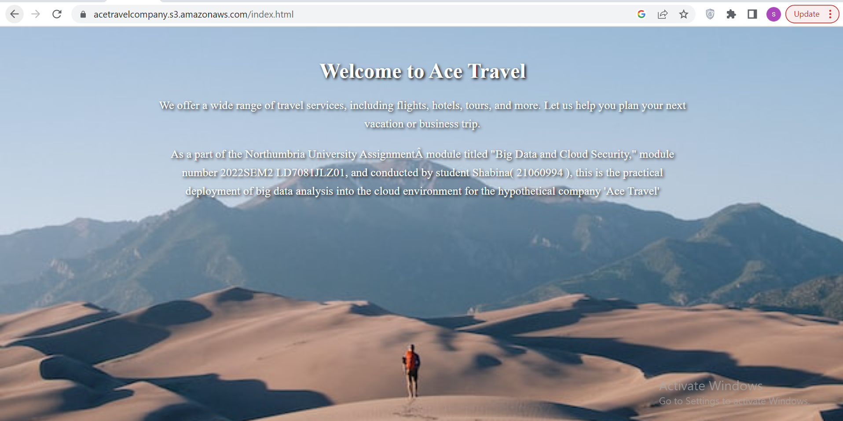
Fig 32: Access to Static Web Page by User
(https://acetravelcompany.s3.amazonaws.com/index.html )

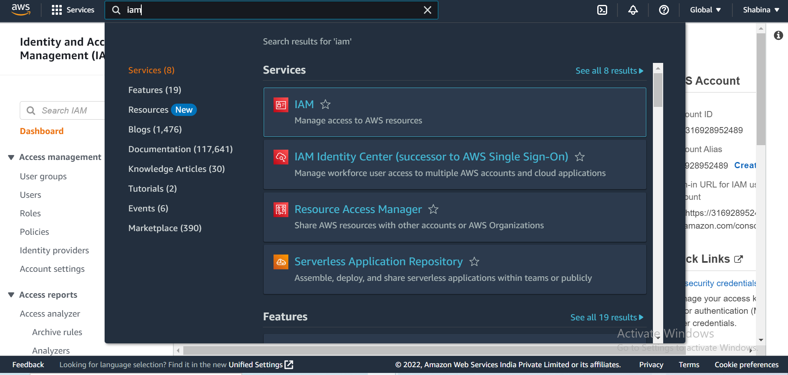
Fig 33: Find IAM in the search bar, choose it, and begin establishing a user

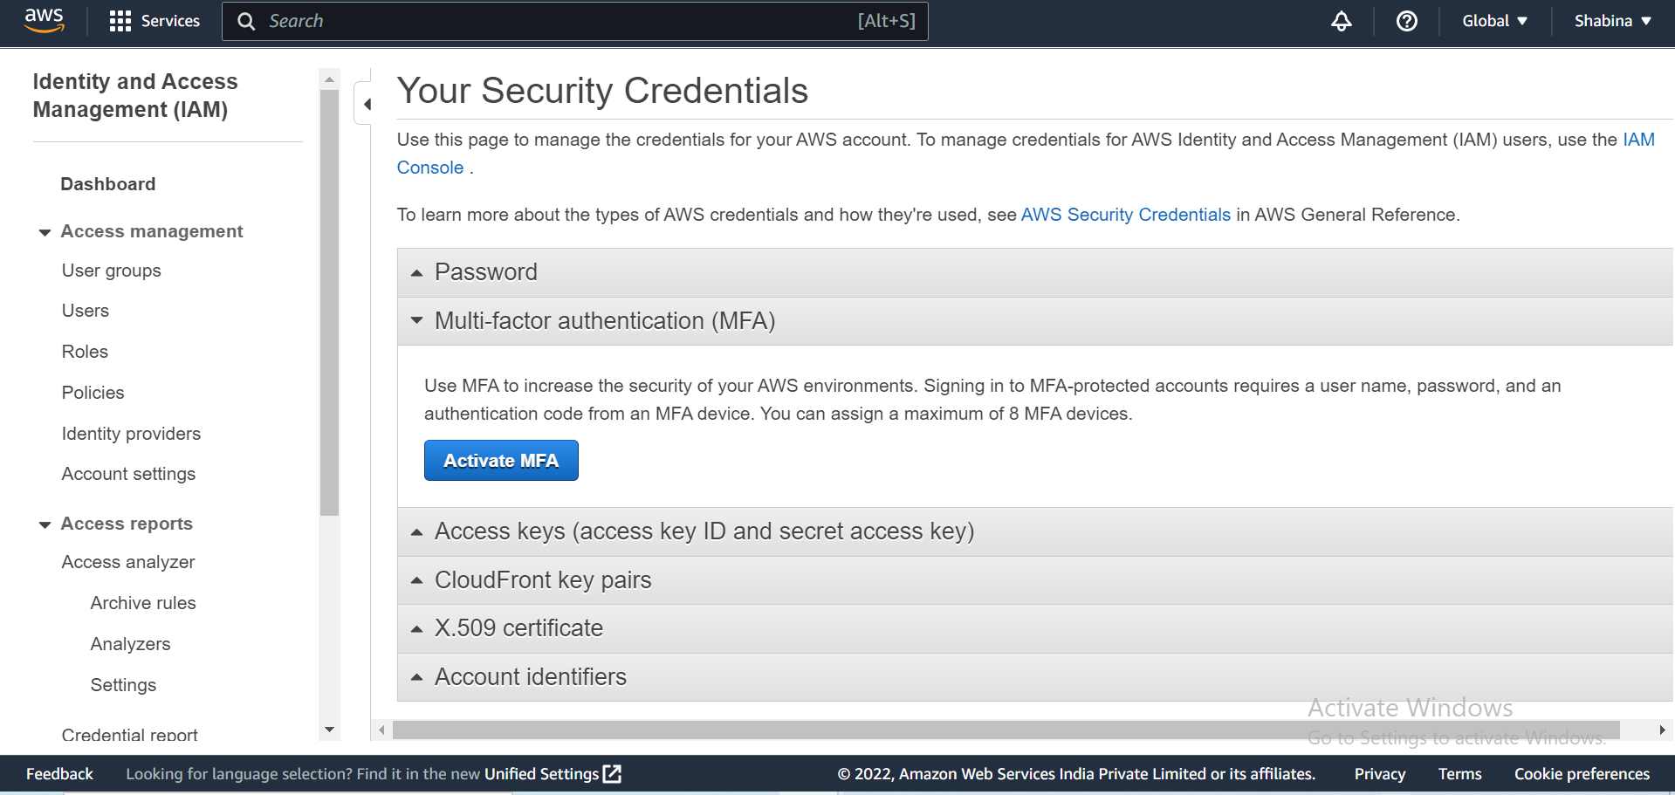
Fig 34: Activate MFA
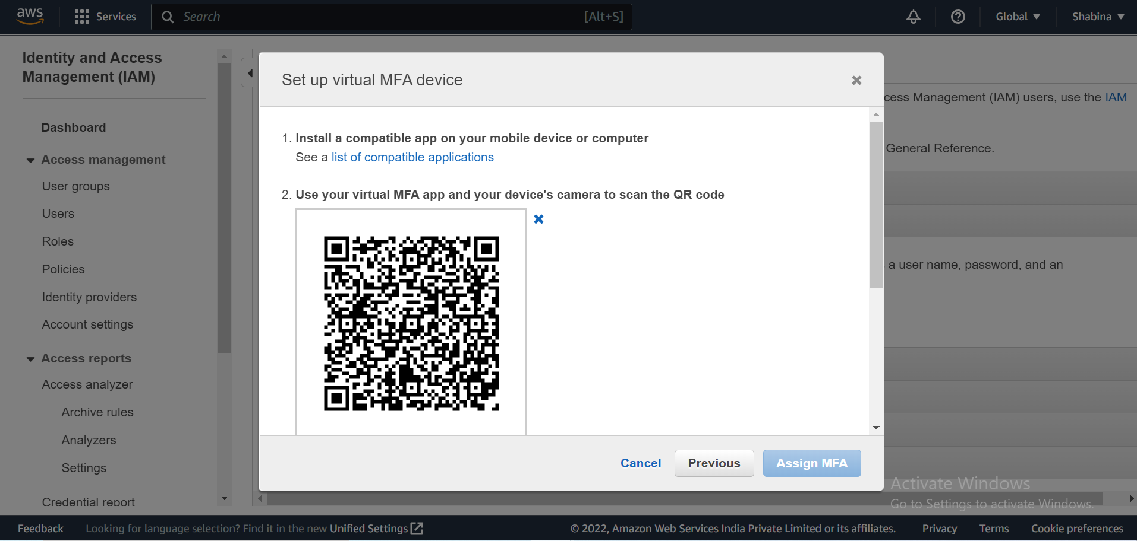
Fig 35: Set up virtual MFA device Using Microsoft Authenticator

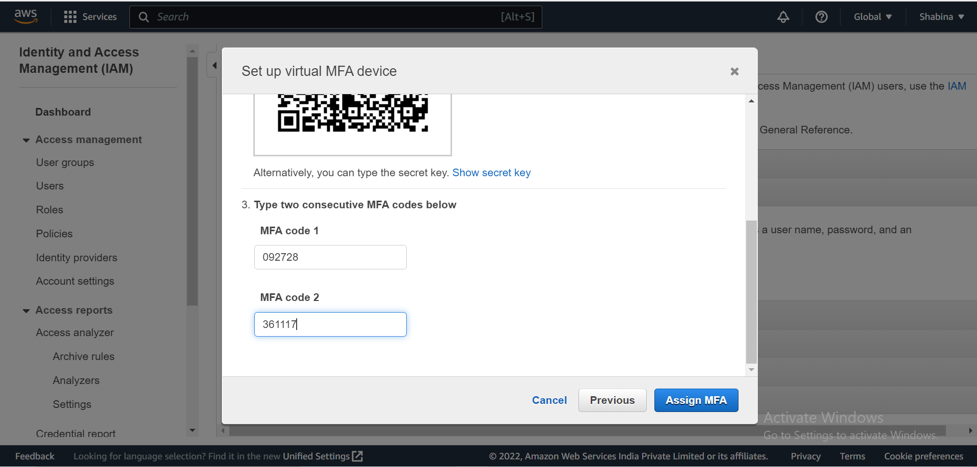
Fig 36: Scan QR Code with Microsoft Authenticator App on mobile to get MFA Code 1 and MFA Code 1

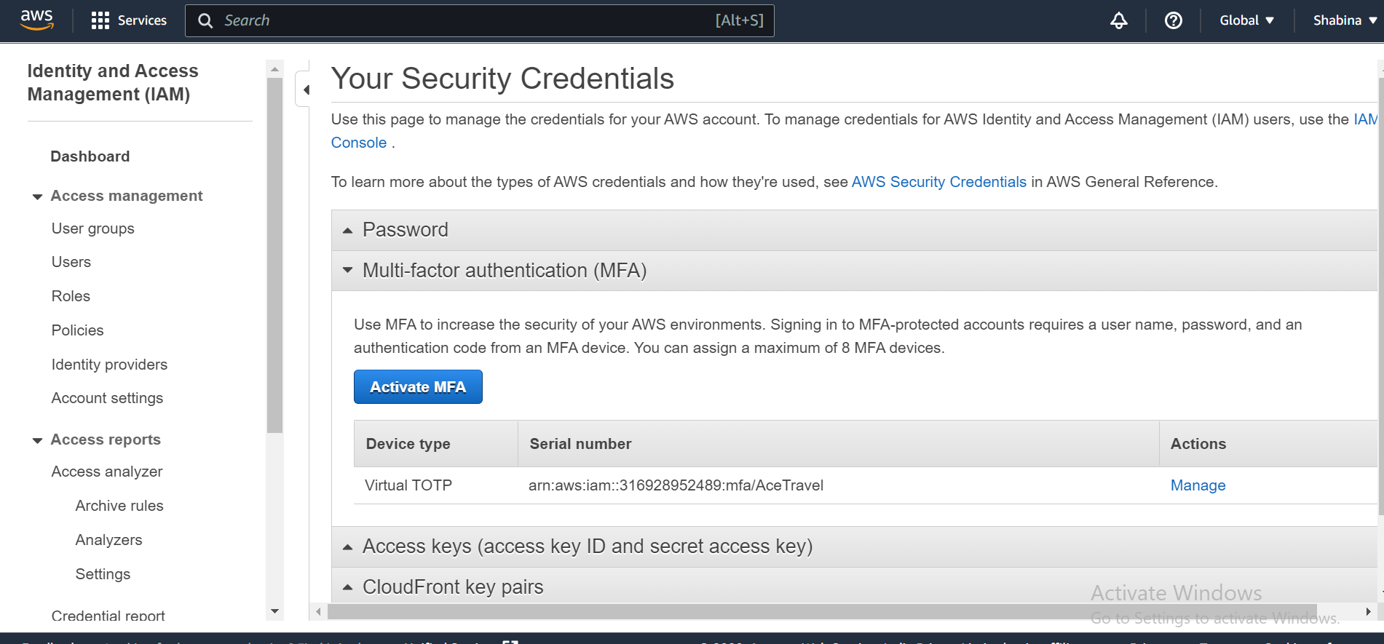
Fig 37: MFA Is Activated in Root Account
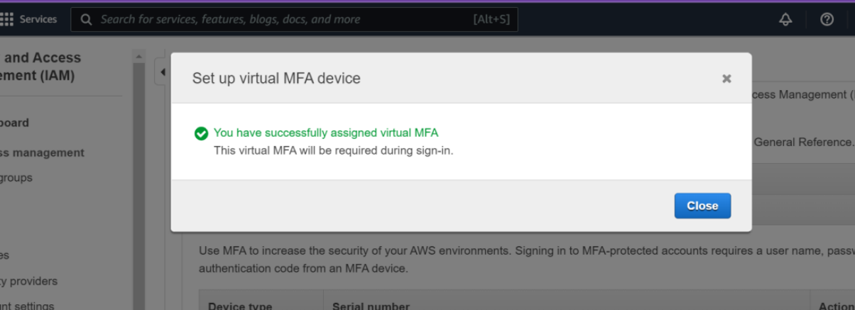
Fig 38: The root account has now been successfully given multi-factor authentication
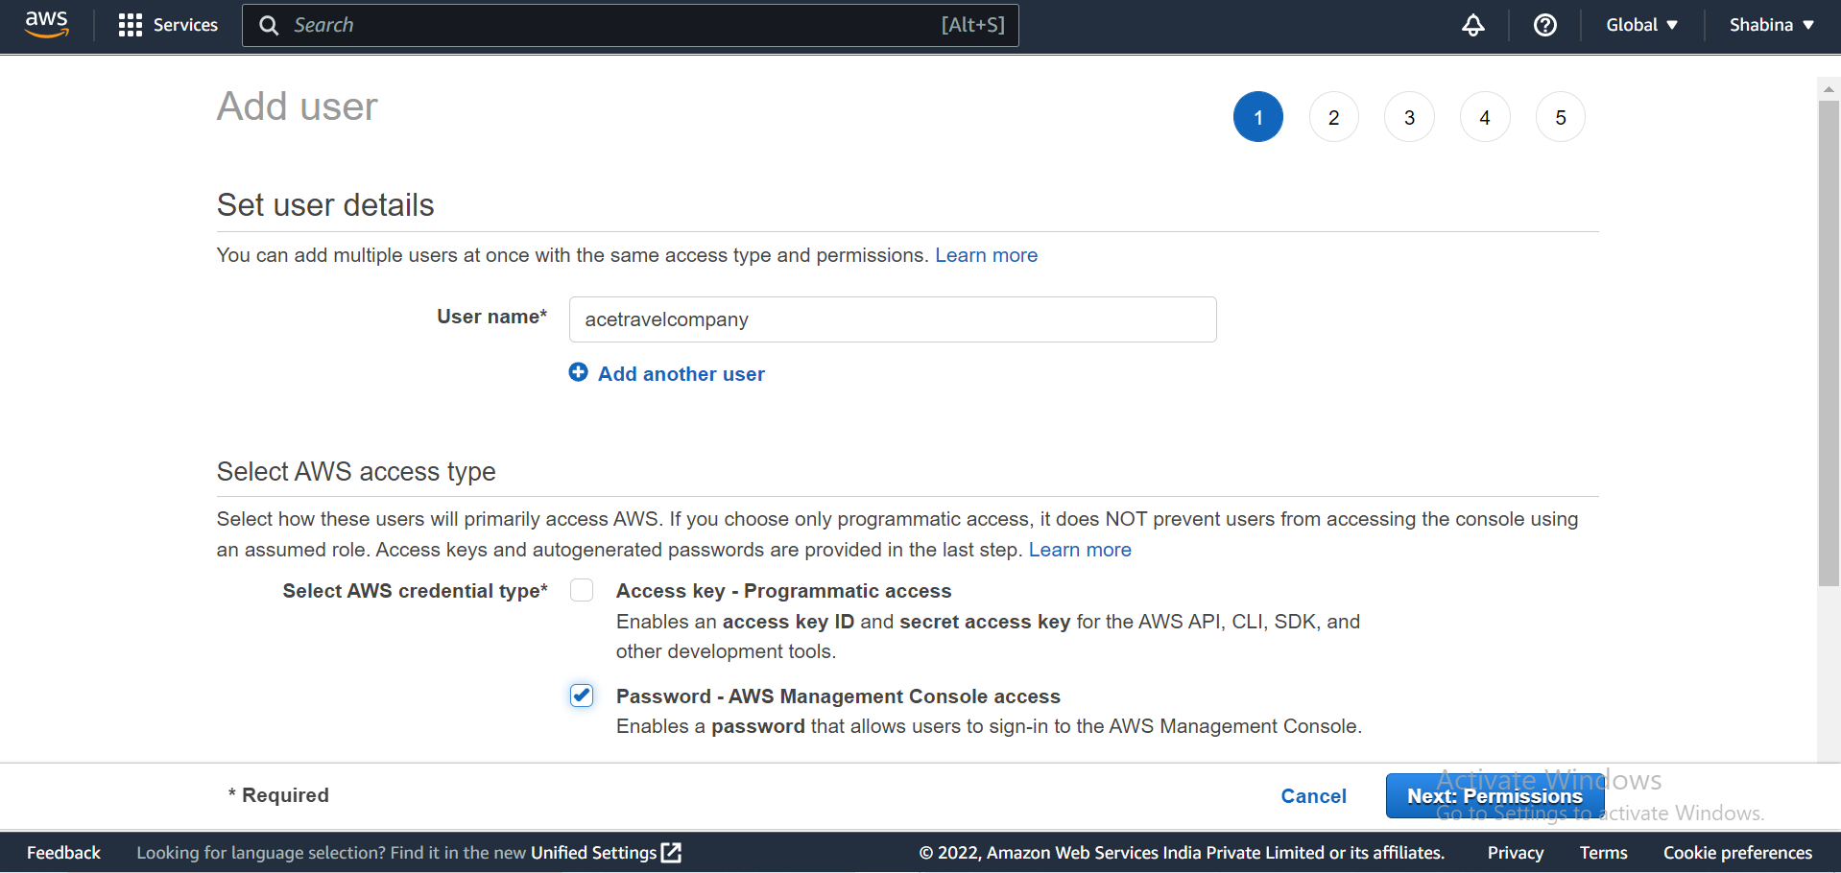
Fig 39: Add User AceTravel Company Root Account
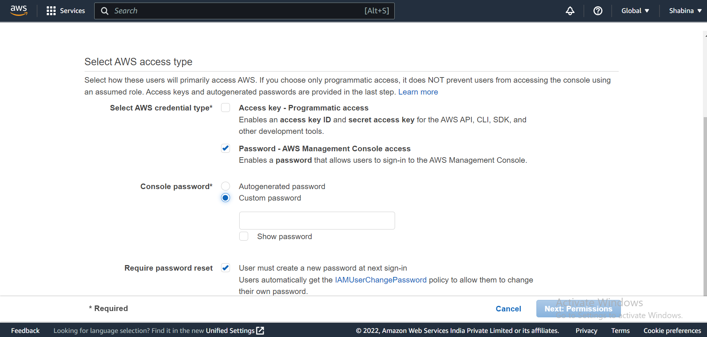
Fig 40: Add Custom Password
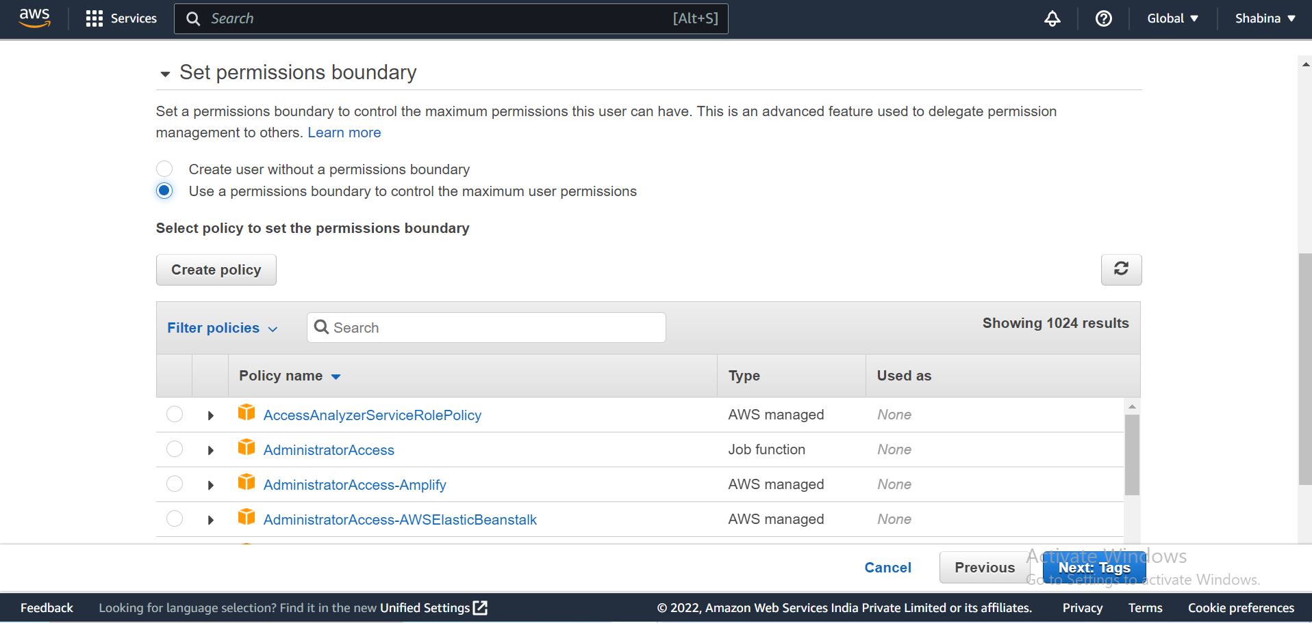
Fig 41: Set Permission boundary only user can access

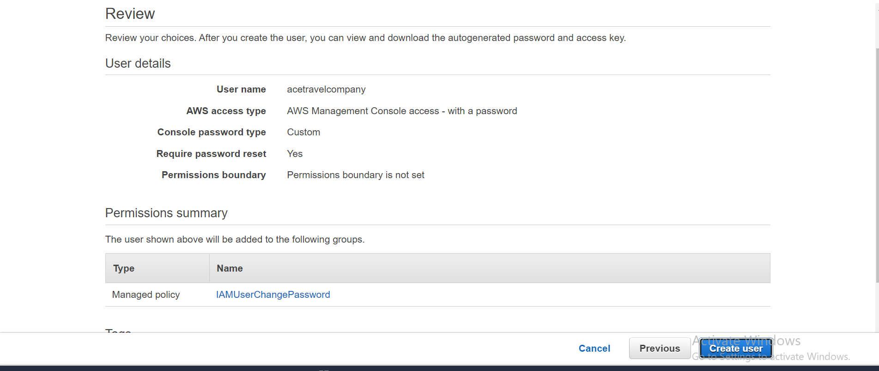
Fig 42: Add tags ace travel company
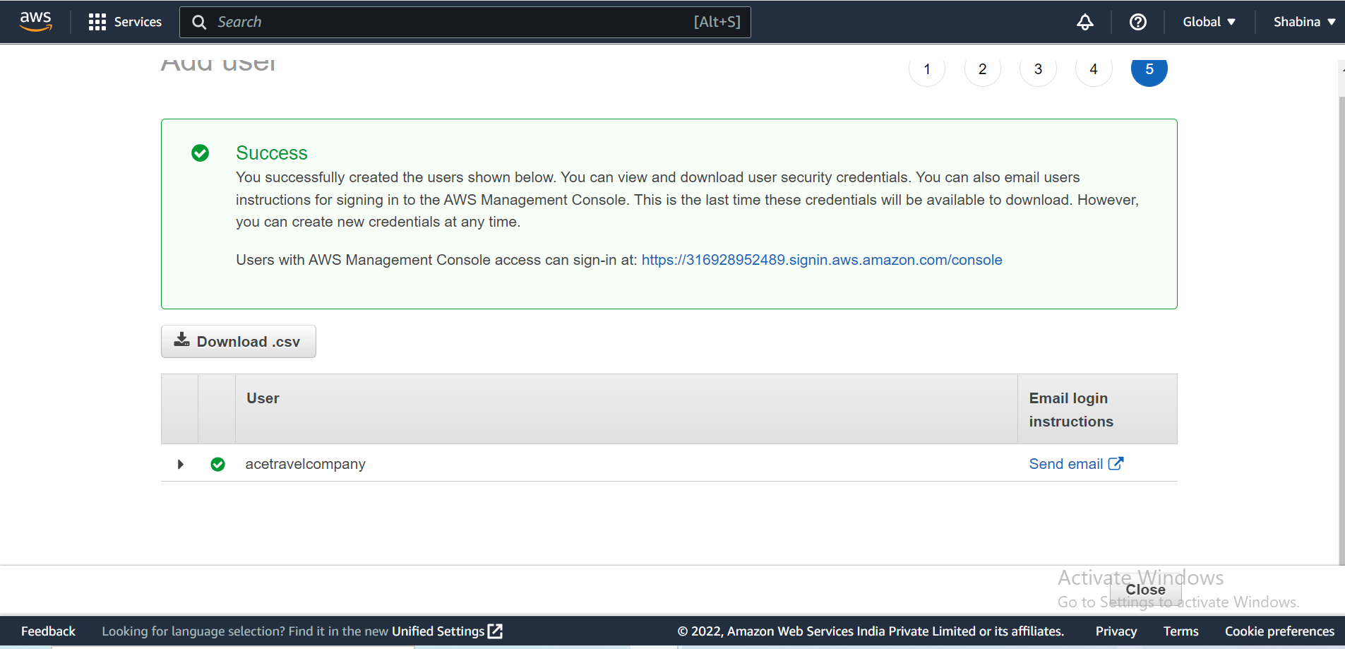
Fig 43: You may get the dataset here as well as review and create a user

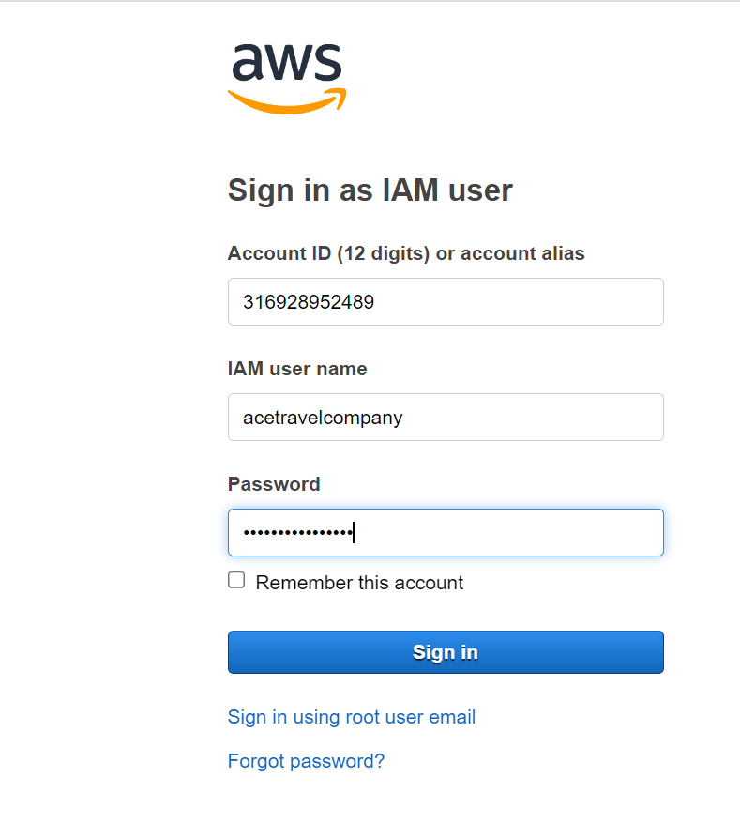
Fig 44: Sign in As IAM User

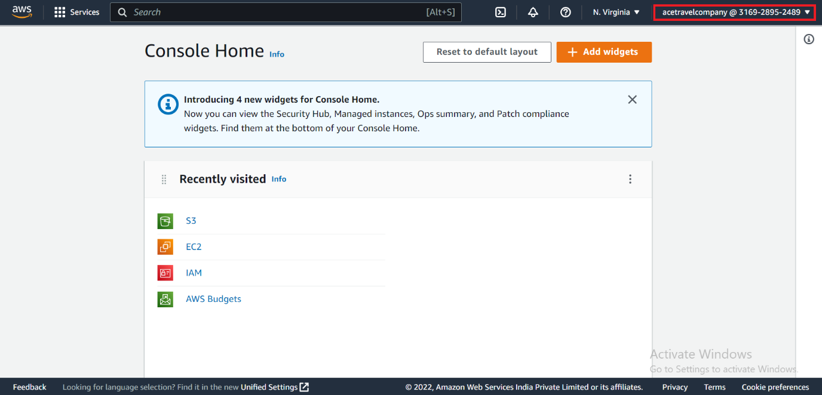
Fig 45: IAM user successfully logged in. And you can see the IAM username and account ID in the top right corner

Task 3: Data Driven Dashboard

Tableau Dashboard
Tableau is a powerful data visualisation platform that can be used to create interactive dashboards and visualisations for organizations, notably travel agencies like Ace Travel. Connecting to and analyzing data from numerous sources, including databases, spreadsheets, and cloud-based platforms, is made simple with Tableau. (Tableau, 2020)
Here are some ideas for improving Ace Travel's business decisions through the use of Tableau to visualize their data.
1.Create a dashboard to track key performance indicators (KPIs), including consumer demographics (age, monthly income, city tier, passport holder), products pitched, and preferred properties. This will help Ace Travel identify trends and areas for possible development.
2. Ace Travel uses Tableau to visualize consumer data, such as demographics and travel preferences, in order to better understand their target market and modify their products and services.
3. Construct a map visualization showing the locations of Ace Travel's top picks. The company will be able to maximize its marketing efforts as a result and discover new growth opportunities.
In order to improve business choices and streamline procedures, Ace Travel may gain from adopting Tableau to examine and analyze their data. (Tableau, 2020)
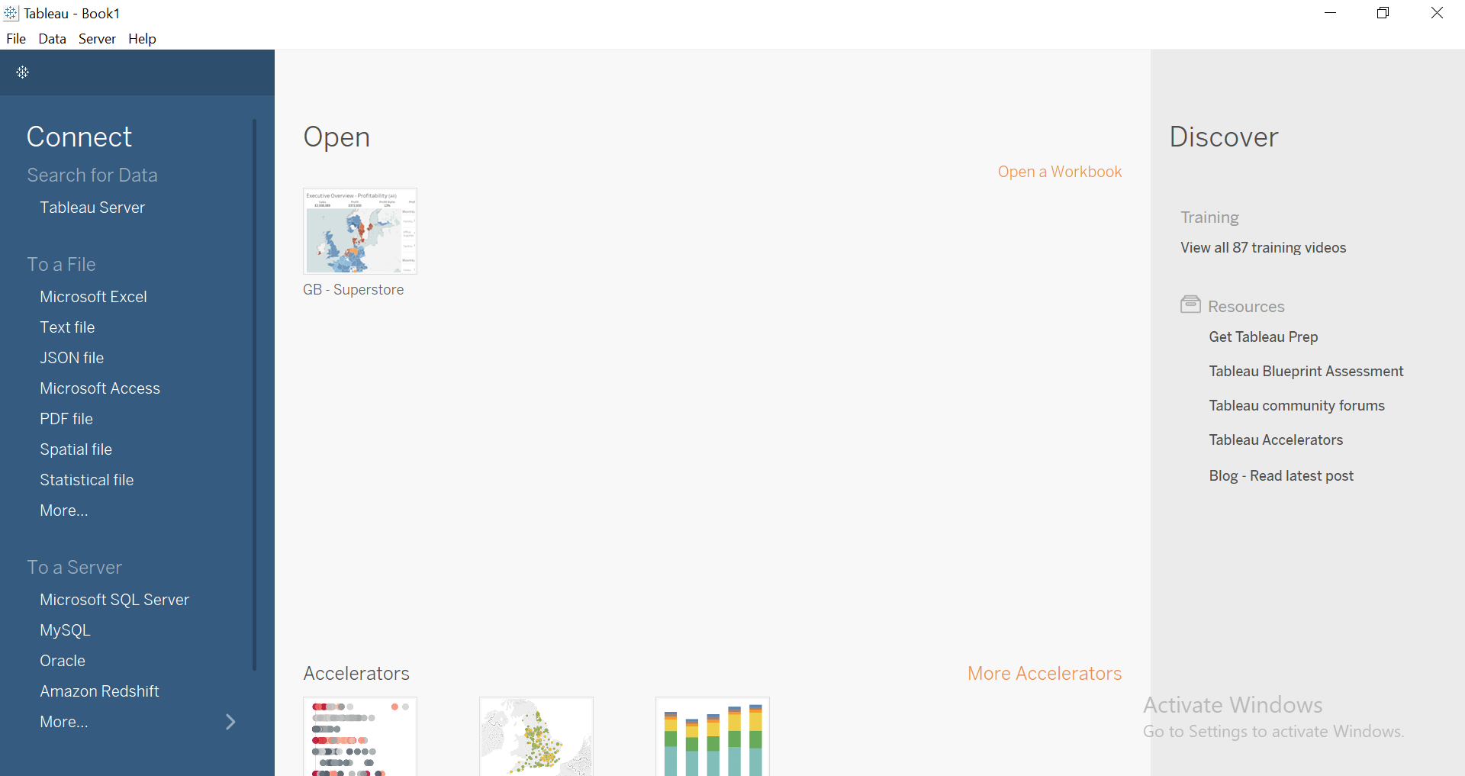
Fig 46: Tableau Welcome Screen
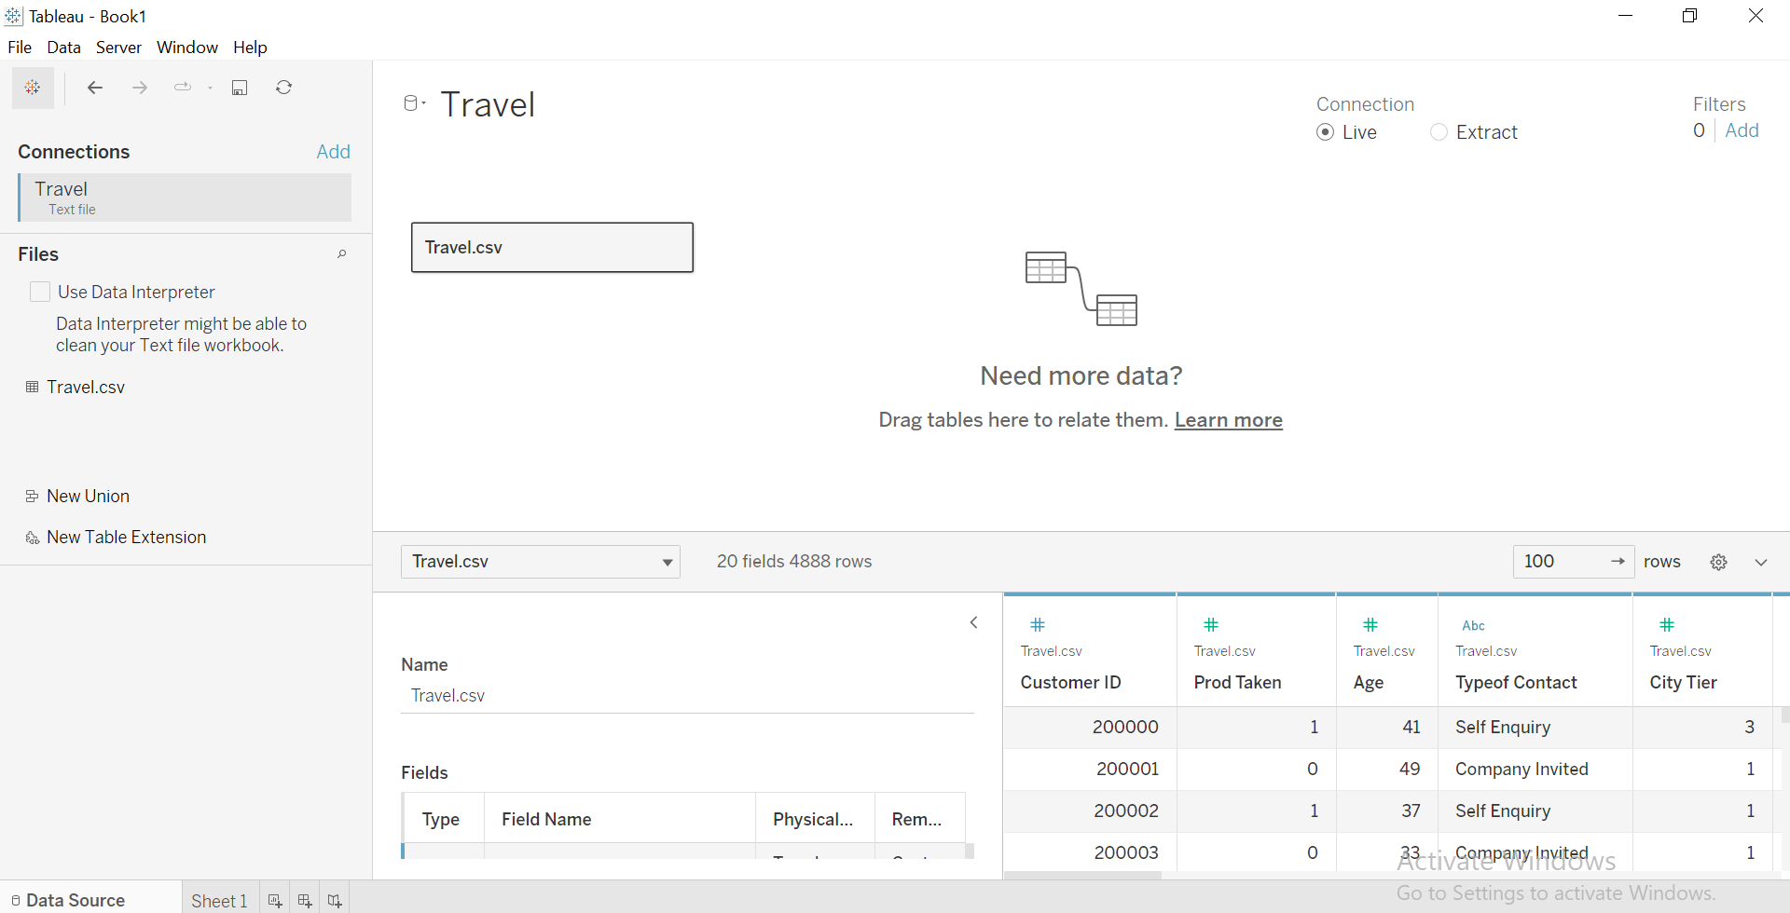
Fig 47: Selecting table for live connection or extracts
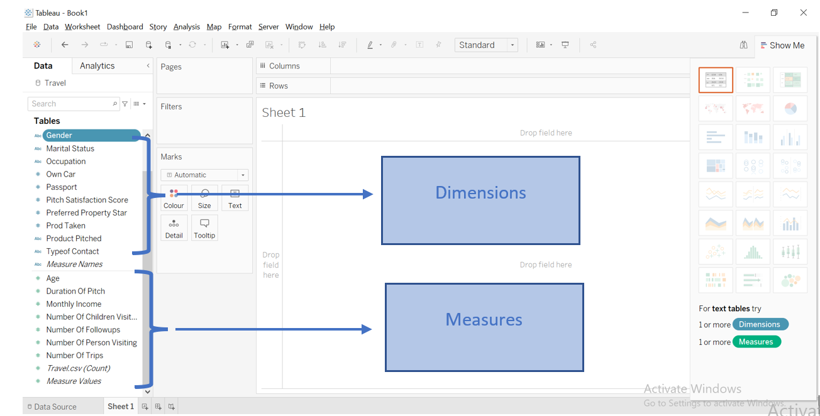
Fig 48: Data split into Dimensions and Measures

Note: When data is loaded into tableau, they need to be separated into two major factors as dimensions and measures. Dimensions are qualitative information of data (e.g. customer name,order number) and Measures is the quantative information of data(e.g. Age , price etc)

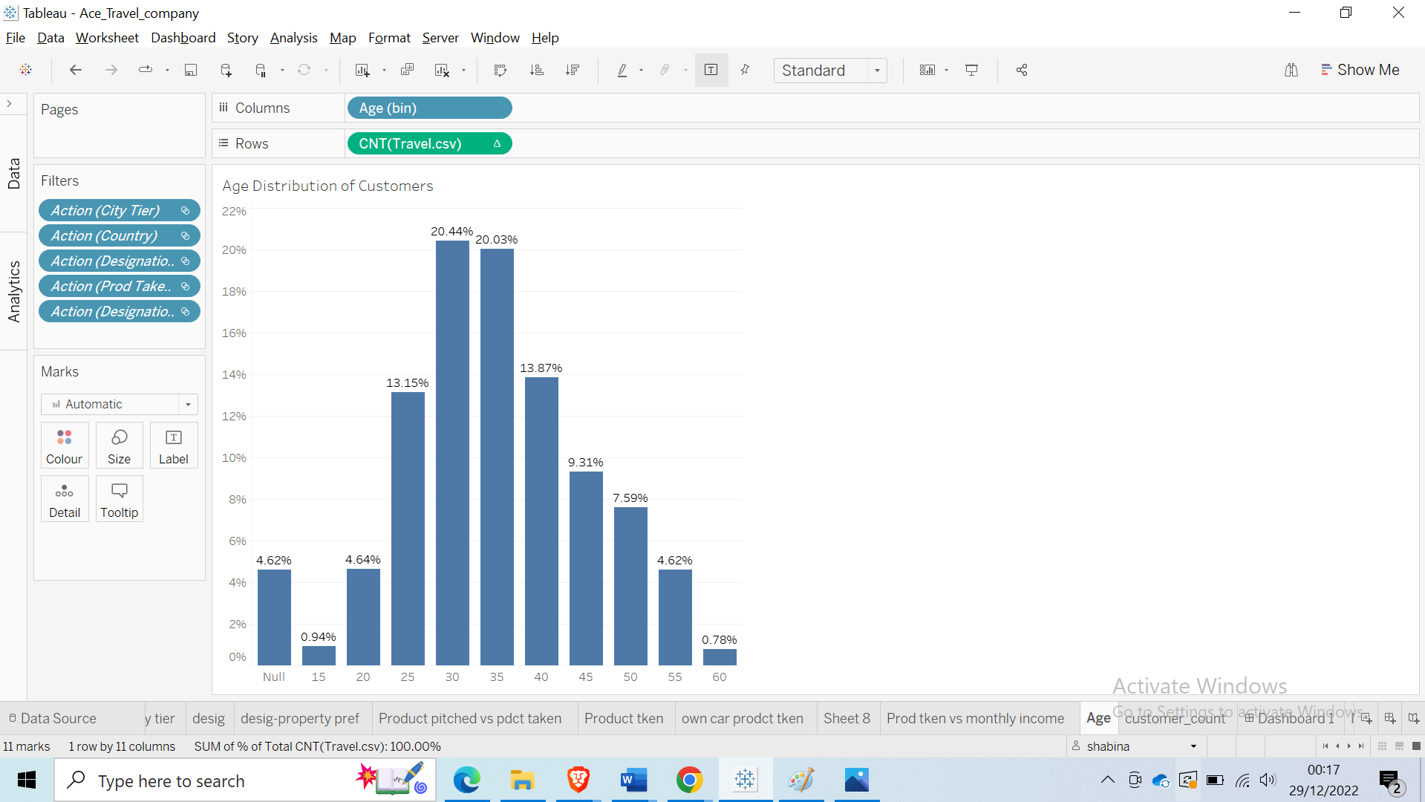
Fig 49: Creating different sheets for analysis of data (in this case distribution of customer age group)

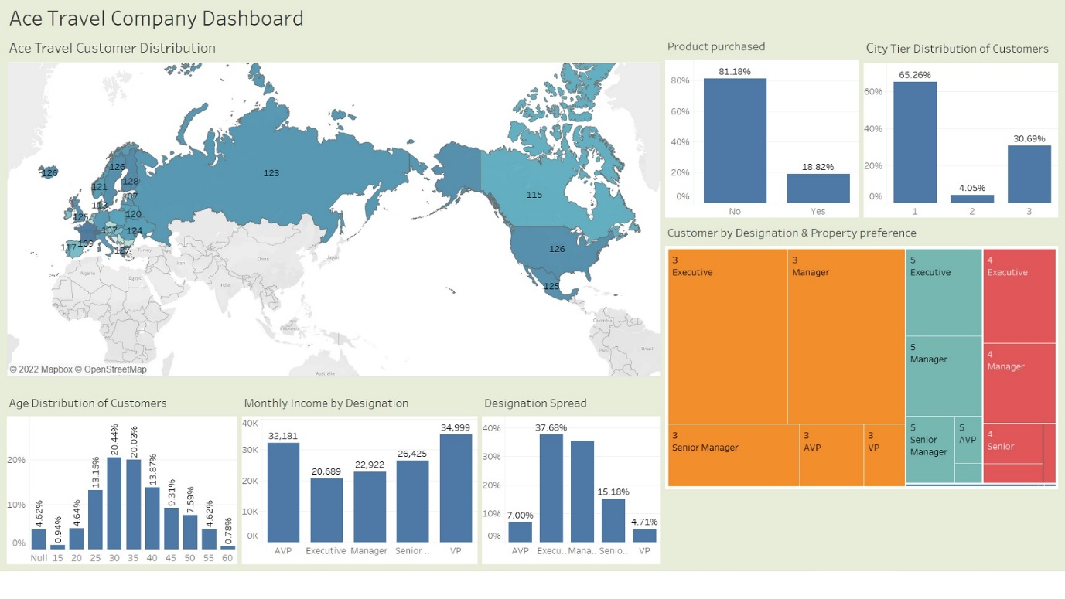Fig 50: Tableau Dashboard (developed for Ace travel by author)
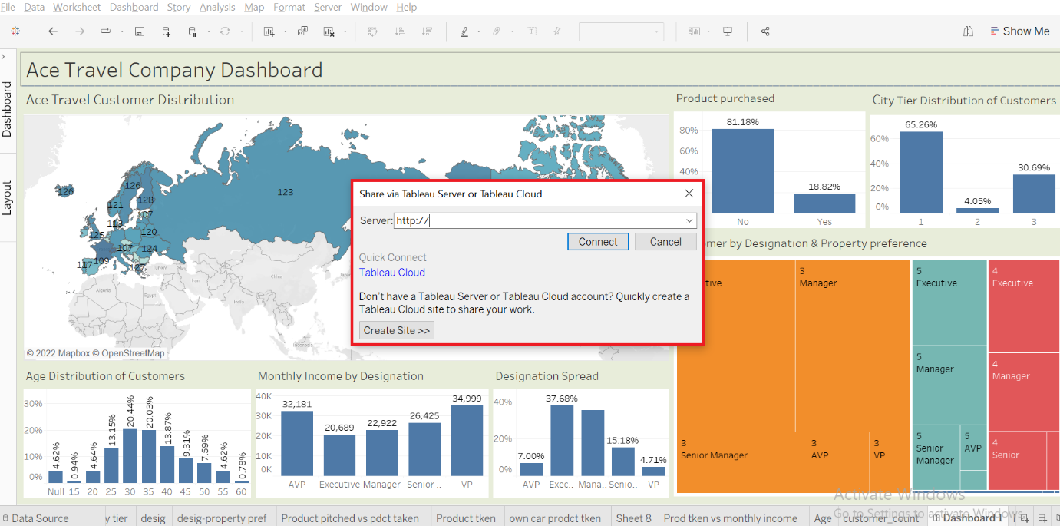
Fig 51: Publish tableau dashboard on server for it to be accessible by employees

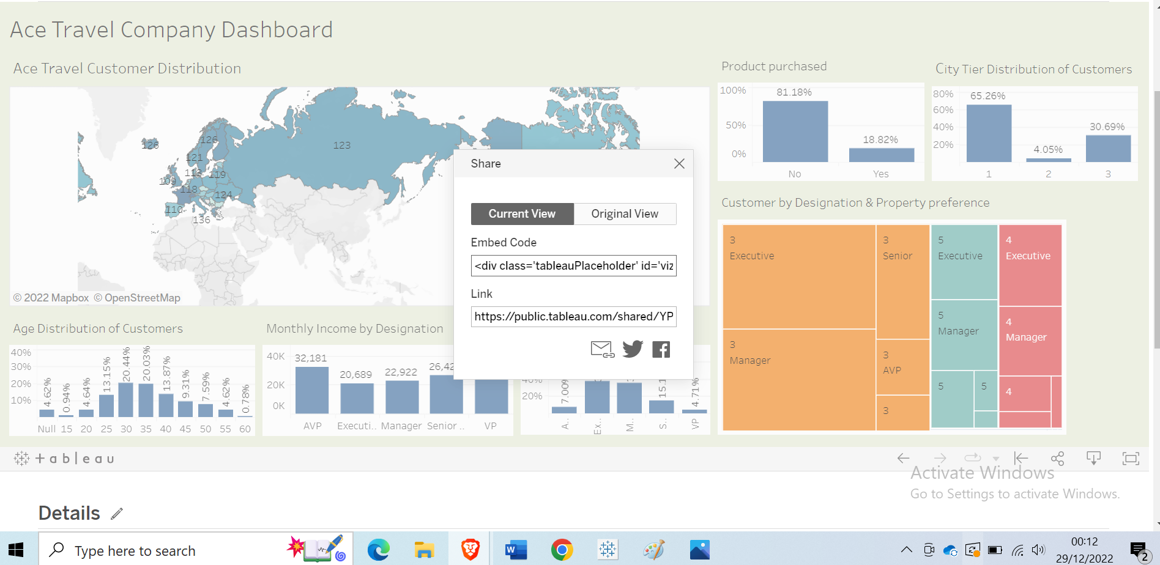
Fig 52: Publishing tableau dashboard on public server with link
https://public.tableau.com/shared/YP9X93FFJ?:display_count=n&:origin=viz_share_link
Note : The tableau dashboard was published on public server only for demonstration purpose in real world example this would be on a private server which is only accessible by company employees. Having data on public server increases Vulnerability Risks

Task 4: Ace Travel to comply with relevant legal, ethical and social issues within the Cloud and Big data environment
Ace Travel may comply with pertinent legal, moral, and social requirements in the cloud and big data environment by using a number of professional techniques. These techniques consist of:
Adhering to data privacy laws: The General Data Protection Regulation (GDPR) (European Union, 2016) and the California Consumer Privacy Act (CCPA) (State of California, 2020) are two examples of pertinent data privacy legislation that Ace Travel should make sure it adheres with. In order to do this, it is necessary to safeguard the personal information of both clients and staff members and to get their permission before collecting, using, or disclosing the information. Understanding the exact needs of these laws is crucial for Ace Travel, and the company must take the necessary action to guarantee compliance.(GDPR, 2022)
Implementing robust security measures: Ace Travel needs to put in place robust security measures to guard against hacker attacks and data breaches. To secure its systems and data, this includes putting in place encryption, firewalls, and access controls (National Institute of Standards and Technology, 2020). To keep its security measures effective, Ace Travel must also frequently review and upgrade them. Ensuring data accuracy and quality: Ace Travel should ensure that the data it collects and uses is accurate, relevant, and up-to-date (Wang, Song, & Li, 2018).
Regular data cleansing and verification procedures can help with this. Ace Travel must have procedures in place to find and fix any errors or inaccuracies in its data as well as to find and get rid of any information that is no longer necessary or pertinent.
Being transparent about data collection and use: When it comes to how it gathers and uses consumer and employee data, Ace Travel should be open and honest (Gandy, 2018). This entails articulating precise and explicit privacy policies and being open about the categories of data it gathers and the uses to which it will be put. In order to foster trust and preserve positive relationships with its stakeholders, Ace Travel must be forthright and honest with them regarding how it collects and uses data. (Gandy, 2018)
Being mindful of ethical considerations: When it comes to data collection and usage, Ace Travel should think about the moral implications of its conduct (Bryant, 2018). For instance, it should make sure that it is not using data in a way that could be damaging or discriminatory to specific people. Establishing ethical standards and educating staff members on ethical data practices may be necessary for this.
Ensuring compliance with relevant industry regulations: There may be certain industry regulations that Ace Travel must adhere to, depending on the industry in which it operates. For instance, there are many rules governing consumer protection and data privacy that apply to the travel business (International Air Transport Association, 2019). It is critical that Ace Travel is aware of these rules and takes action to assure compliance.
Ace Travel should think about putting policies in place to ensure the responsible use of big data in addition to these procedures (Manyika et al., 2011). Establishing policies and practices for the gathering, analyzing, and usage of big data, as well as making sure that all of the company's personnel are taught on them, may be part of this.
In order to safeguard its reputation and cultivate confidence with its clients and staff, Ace Travel must prioritize compliance with legal, ethical, and social issues. Ace Travel can demonstrate its dedication to responsible data management and make sure that it is utilizing data in a way that is open, moral, and complies with applicable laws and regulations by using these professional standards.

References
- Aggarwal, 2015. Keeping Big Data Safe: Common Hadoop Security Issues and Best Practices. [Online] Available at: https://www.qubole.com/blog/hadoop-security-issues
[Accessed 19 December 2022].
- Schaumann, 2022. Twitter. [Online]
Available at: https://twitter.com/jschauma/status/1220904655753969664
[Accessed 04 Jan 2023].
- Abualkishik, 2019. Journal of Theoretical and Applied Information Technology. HADOOP AND BIG DATA CHALLENGES , Volume 97.
- ACM Council, 2018. ACM Code of Ethics and Professional Conduct. [Online]
Available at: https://www.acm.org/code-of-ethics[Accessed )5 Jan 2023].
- Alexander S. Gillis, 2021. 5 V's of big data. [Online] Available at: https://www.techtarget.com/searchdatamanagement/definition/5-Vs-of-big-data[Accessed 13 December 2022].
- Amazon Web Services, 2022. [Online] Available at: https://aws.amazon.com/
[Accessed 15 Jan 2023].
- Amazon Web Services, n.d. Aws Cloud Adoption Framework Security. [Online]
Available at: https://aws.amazon.com/compliance/cloud-adoption-framework/security/
[Accessed 15 Jan 2023].
- Apache Hadoop, 2022. Apache Hadoop YARN. [Online]
Available at: https://hadoop.apache.org/docs/stable/hadoop-yarn/hadoop-yarn-site/YARN.html[Accessed 17 Dec 2022].
- Aws, 2022. What is Apache Hive?. [Online]
Available at: https://aws.amazon.com/big-data/what-is-hive/[Accessed 17 Dec 2022].
- Bhardwaj , 2021. SaaS vs PaaS vs IaaS: Understand the difference. [Online]
Available at: https://ipwithease.com/saas-vs-paas-vs-iaas/[Accessed 17 Dec 2022].
- Bulao, 2022. DREAD Threat Modeling: An Introduction to Qualitative Risk Analysis. [Online]
Available at: https://www.eccouncil.org/cybersecurity-exchange/threat-intelligence/dread-threat-modeling-intro[Accessed 05 Jan 2023].
- By Simplilearn, 2022. HDFS Tutorial. [Online] Available at: https://www.simplilearn.com/tutorials/hadoop-tutorial/hdfs[Accessed 17 Dec 2022].
- chowdhury, 2019. INTRODUCTION TO CYBER THREAT INTELLIGENCE (CTI): A DEFINITIVE GUIDE FOR THE BEGINNERS. [Online] Available at: https://hackersterminal.com/cyber-threat-intelligence-cti/[Accessed 04 jan 2023].
- EC-Council, 2022. Cyber Threat Modelling. [Online] Available at: https://www.eccouncil.org/threat-modeling/[Accessed 04 Jan 2023].
- Fearnley, 2013. BIG DATA IN RISK MANAGEMENT: TOOLS PROVIDING NEW INSIGHT, s.l.: Celent.
- Gaithersburg,MD, 2013. Satisfy NIST Cybersecurity Framework, DFARS, 800-171, Silicon valley: Beachhead Solution.
- GCP, 2021. GCP Security. [Online]
Available at: https://cloud.google.com/security/
[Accessed 15 Jan 2023].
- GDPR, 2022. General Data Protection Regulation (GDPR). European Commission. [Online]
Available at: https://ec.europa.eu/info/regulation/gdpr-general-data-protection-regulation
[Accessed 15 Jan 2023].
- Guru, 2021. What is COBIT Framework – Components, Structure & Advantages. [Online]
Available at: https://cybersecuritynews.com/what-is-cobit-framework/
[Accessed 05 Jan 2023].
- Han, Kamber, & Pei, 2011. Data mining. In: M. Kaufmann, ed. Data mining: concepts and techniques. s.l.:s.n.
- Hive, 2022. Hive - Introduction. [Online] Available at: https://www.tutorialspoint.com/hive/hive_introduction.htm
[Accessed 17 Dec 2022].
- IBM, 2021. Fuel your journey to AI with data science. [Online] Available at:https://www.ibm.com/analytics/data-science-ai?utm_content=SRCWW&p1=Search&p4=43700068083056031&p5=p&gclid=EAIaIQobChMIndfdvKDF_AIVSYjVCh1u4w_bEAAYASAAEgKroPD_BwE&gclsrc=aw.ds
[Accessed 13 Jan 2023].
- Jose Andre Moura, 2015. IGI Global. [Online] Available at: https://www.researchgate.net/figure/The-five-Vs-of-Big-Data-Adapted-from-IBM-big-data-platform-Bringing-big-data-to-the_fig1_281404634[Accessed 10 December 2022].
- Kaspersky, 2023. What is threat intelligence? Definition and explanation. [Online]
Available at: https://www.kaspersky.com/resource-center/definitions/threat-intelligence
[Accessed 04 Jan 2023].
- Kost, 2022. What is Threat Modelling? 10 Threat Identity Methods Explained. [Online]
Available at: https://www.upguard.com/blog/what-is-threat-modelling[Accessed 04 Jan2023].
- Krishnakumar, 2015. Handling risk management of data in hadoop. [Online] Available at: https://blog.eduonix.com/bigdata-and-hadoop/handling-risk-management-of-data-in-hadoop/[Accessed 19 December 2022].
- Martis, Pai, Pragathi,Rakshatha,Dixit, 2019. Comprehensive Survey on Hadoop Security. Singapore, Springer.
- Mather,Kumaraswamy,latif, n.d. Cloud Security and Privacy. In: An Enterprise Perspective on Risks and Compliance. s.l.:O'Reilly Media.
- Naveen Kumar, 2022. Six Examples “How Is Big Data Being Used in the Travel Industry?”. [Online] Available at: https://www.joomdev.com/six-examples-how-is-big-data-being-used-in-the-travel-industry/[Accessed 14 December 2022].
- NIST, 2021. Uses and Benefits of the Framework. [Online] Available at: https://www.nist.gov/cyberframework/online-learning/uses-and-benefits-framework[Accessed 05 Jan 2023].
- Reciprocity, 2022. Top Threat Modeling Methodologies. [Online] Available at: https://reciprocity.com/blog/top-threat-modeling-methodologies/
[Accessed 04 Jan 2023].
- RedHat, 2022. IaaS vs. PaaS vs. SaaS. [Online] Available at: https://www.redhat.com/en/topics/cloud-computing/iaas-vs-paas-vs-saas?sc_cid=7013a000002pgRZAAY&gclid=CjwKCAiAy_CcBhBeEiwAcoMRHD7gon6bKqbtpFM4FvH6jbrGbqxq-LB-_WjeTpdhHUMGmBcD-JbcmRoCXIEQAvD_BwE&gclsrc=aw.ds[Accessed 16 December 2022].
- River, 2022. What Is Threat Modelling. [Online]
Available at: https://www.windriver.com/solutions/learning/threat-modeling
[Accessed 04 jan 2023].
- Sam B. Siewert, 2013. Big data in the cloud.
- Sec, 2022. ISO-27001, ISA/IEC-62443, and NIST CSF: Selecting the right standard/framework for your OT cybersecurity program. [Online]
Available at: https://www.intechww.com/iso-27001-isa-iec-62443-and-nist-csf-selecting-the-right-standard-framework-for-your-ot-cybersecurity-program/[Accessed 05 Jan 2023].
- Seymour,Bosworth & Kebay, 2002. Computer Security Handbook. 4th ed. New York: s.n.
- Stanislav Stella, 2017. Cloud Security: A Practical Guide. In: O. Media, ed. s.l.:O'Reilly Media.
- Stanislav & Stella, n.d. Cloud Security. In: Cloud Security: A Practical Guide. s.l.:O' Reilly Media.
- Stanislav & Williams, 2014. Information Security. In: Principles and Practices. s.l.:syngress.
- Stolte,Hanrahan,Chabot, 2022. What is Tableau?. [Online] Available at: https://www.tableau.com/why-tableau/what-is-tableau[Accessed 27 Dec 2022].
- Tableau, 2020. Tableau. [Online] Available at: https://www.tableau.com/[Accessed 15 Jan 2023].
- Watts and Raza, 2019. SaaS vs PaaS vs IaaS: What’s The Difference & How To Choose. [Online] Available at: https://www.bmc.com/blogs/saas-vs-paas-vs-iaas-whats-the-difference-and-how-to-choose/[Accessed 16 December 2022].
- Bryant, C. (2018). The ethics of big data: A primer for policymakers. IEEE Technology and Society Magazine, 37(2), 6-13.
- Gandy, O. (2018). The data business:
- General Data Protection Regulation (GDPR). European Commission. https://ec.europa.eu/info/regulation/gdpr-general-data-protection-regulation
- Data Protection Act 2018. UK Government. https://www.legislation.gov.uk/ukpga/2018/12/contents/enacted
- Cloud Security Alliance. Cloud Control Matrix.https://cloudsecurityalliance.org/research/ccm/
- Bostrom, N. (2014). Superintelligence: Paths, Dangers, and Strategies. Oxford University Press.

