**Module: R0: The Missing Semester**

**Section:** Command Line Environment **Task:** 01

**Task:**

From what we have seen, we can use some ps aux | grep commands to get our jobs’ pids and then kill them, but there are better ways to do it. Start a sleep 10000 job in a terminal, background it with Ctrl-Z and continue its execution with bg. Now use pgrep to find its pid and pkill to kill it without ever typing the pid itself. (Hint: use the -af flags).

**Explanation:**

Firstly, I started a job of **‘sleep 10000’,**

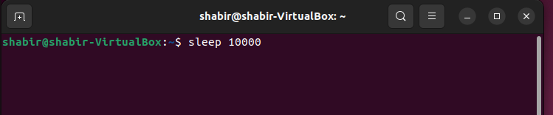

Then, background the job by using ‘^Z’,

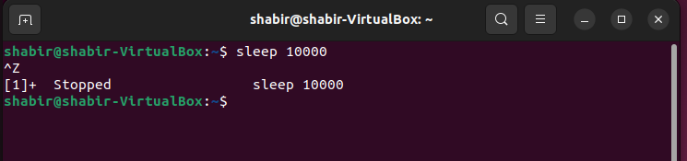

Then, use ***‘bg’*** command to resume again the job,

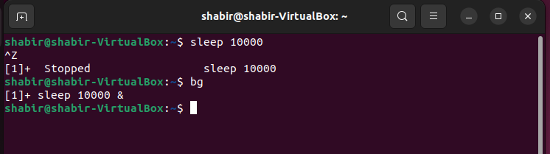

Then, use the command ***‘pgrep –af sleep’*** to get the process id of the job sleep.

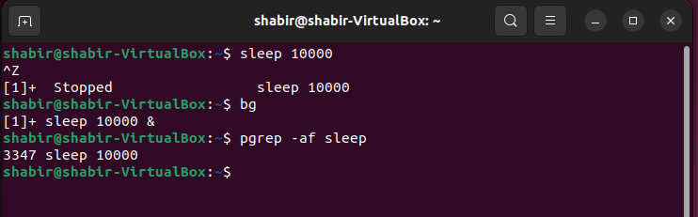

Then, I used the command ***‘pkill –f sleep’*** to terminate the ‘sleep 10000’ job,

can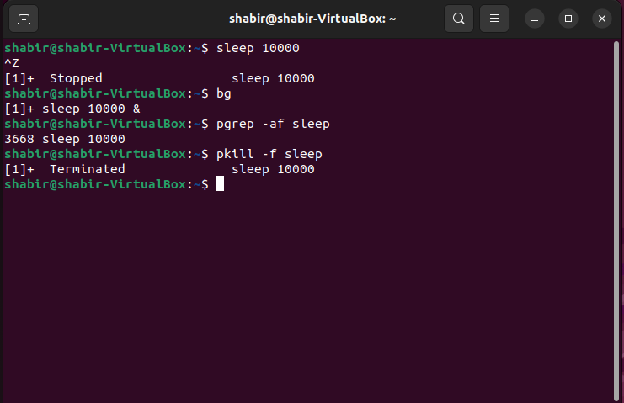

By using **pgrep** and **pkill**, I am able to get the PID of the job and kill that job respectively, without ever typing the PID itself.