Project Title: ONLINE JOB PORTAL

By

SHABITHA K.S

# Abstract

Job portal service was developed for creating an interactive job vacancy form for candidates. This web application manage updates both from the job seekers as well as the companies. It’s unique development methodology helps in acquiring the client and candidate information and separating them according to the job requirements and vacancies.

The online access to it provides details of the job. An employer being registered in the web site has the facility to use the services. Being an authorized user he can publish vacancy details and can search no of Employees on portal and also he can search candidates on basis of the key skill which employee provides on registration.

1. **Introduction:**

Online Job Portal Project which is a free portal where people seeking jobs can apply their resumes / CVs for different jobs and can get hired via our platform.

The Purpose of Application is to Provide Jobs portal for Job Seekers to submit their CV and apply for job posting and employer can select best employees from Available CV based on their payment option selection.This is basically a Job portal ,here job Seeker applies for jobs and employer post jobs and select prospective applicant.

There are 2 major modules that we can divide the project into

1. **Administration Module :** This module will be used to enter the recruiter’s records such as type of jobs, description of needed candidates, etc. The administration should manage the entire system as a whole. Admin will have some advanced features inaccessible to the users. For instance, the admin can make changes to the entire database which the user does not even have viewing access to.
2. **Employee :** They also have to log in using their email ID and password and should be able to create job posts with descriptions and a number of openings, etc.
3. **Jobseeker :** They will also have to log in using the credentials and will also have to update their profile and resume from time to time.
4. **User Stories:**

ADMIN: Admin can able to access all the information of the module where employee and company perform in the module.

EMPLOYEE: Employee can able to access all the information of the module where he can apply jobs in registered company.

COMPANY: company employee can able to access all the information of the employee where he can register new company in the module.

**SREENSHOT**:

Registration:

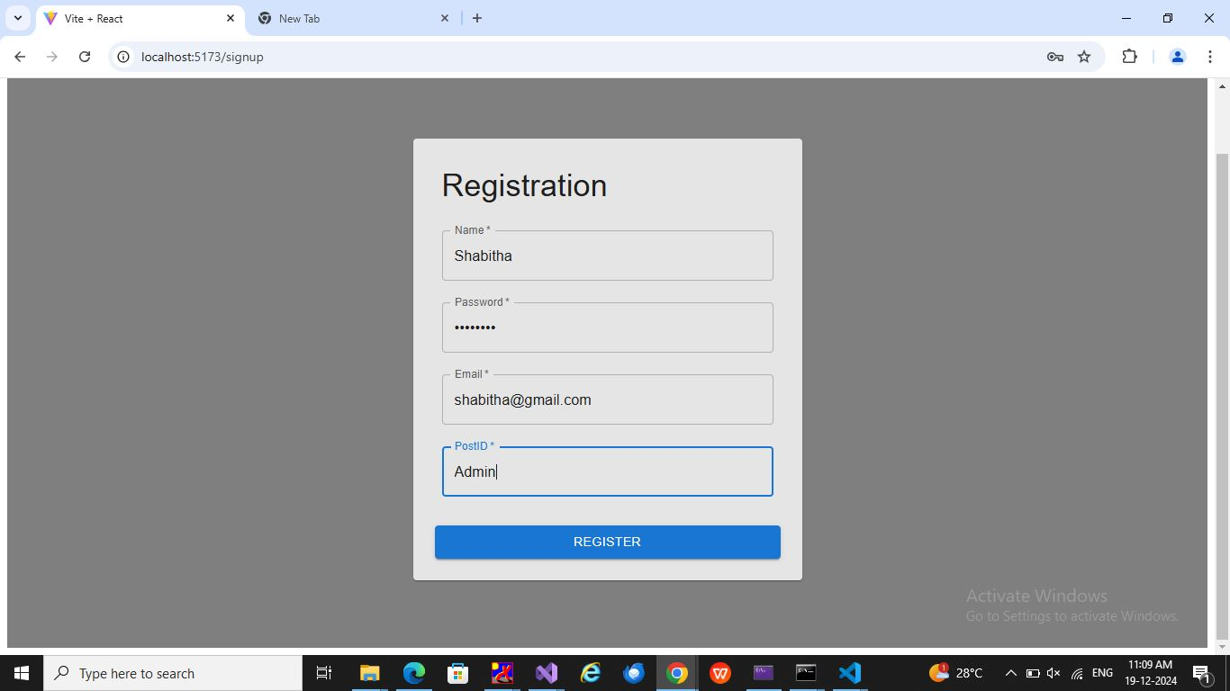

Login: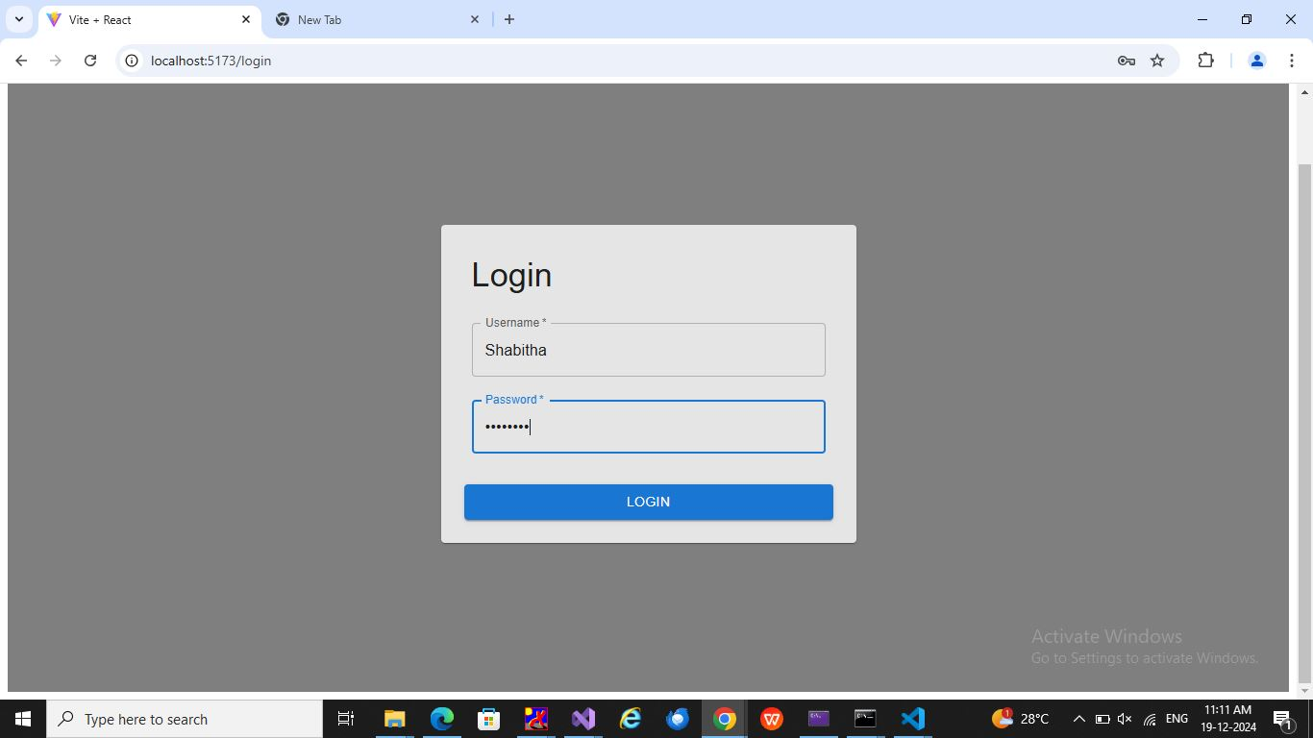

Admin -Company Employee Details :

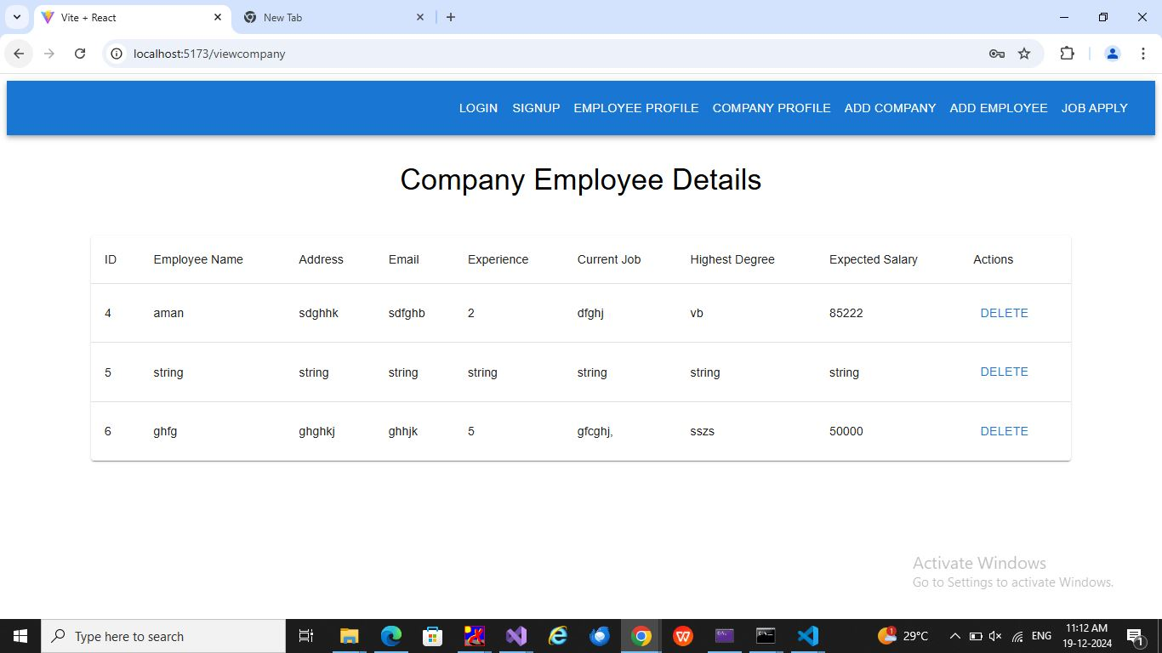

Admin -Company Employee Details (Delete):

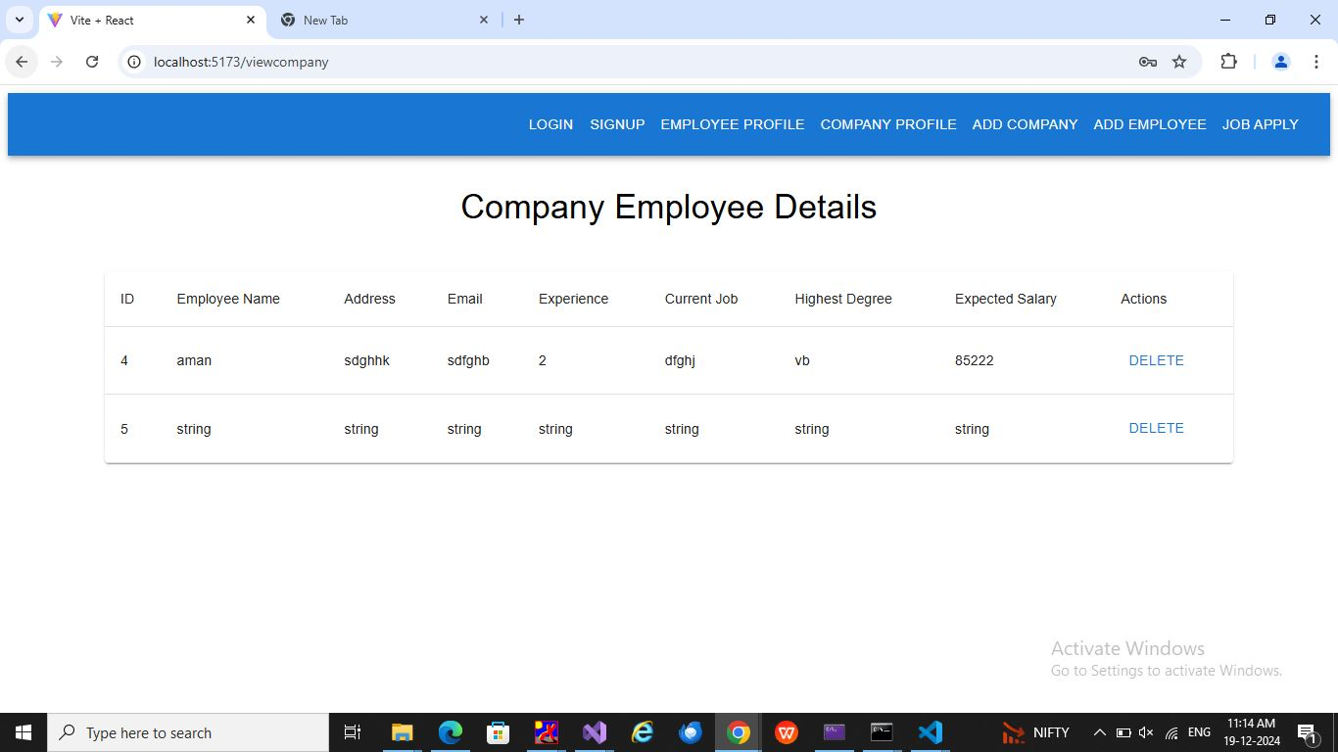

Admin -Company Details :

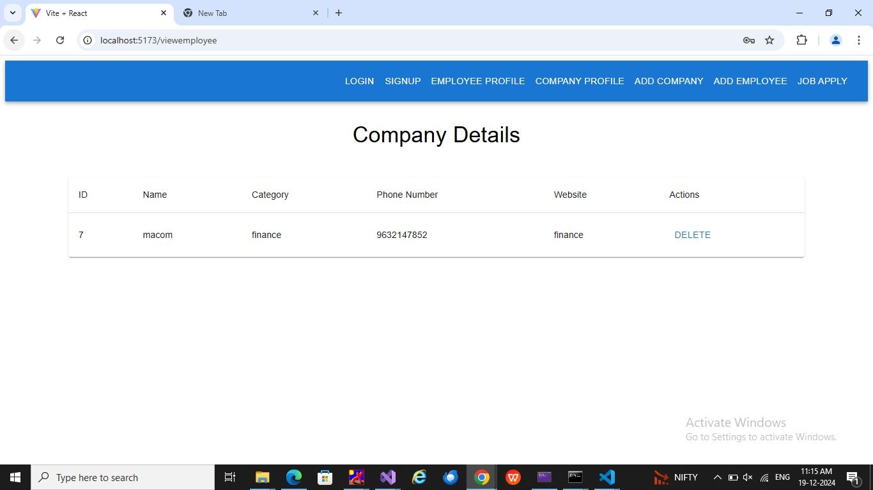

Admin - Register New Company :

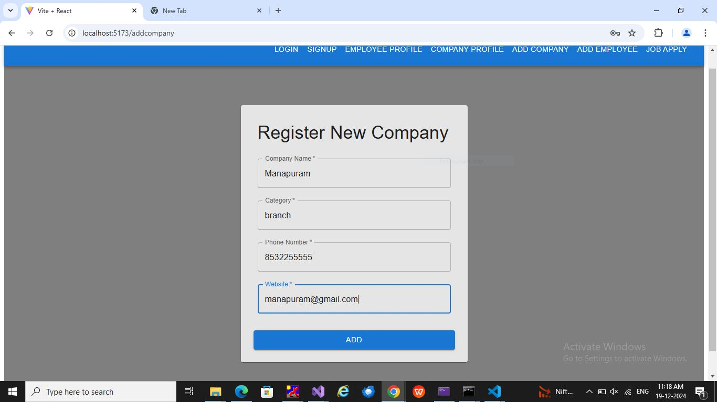

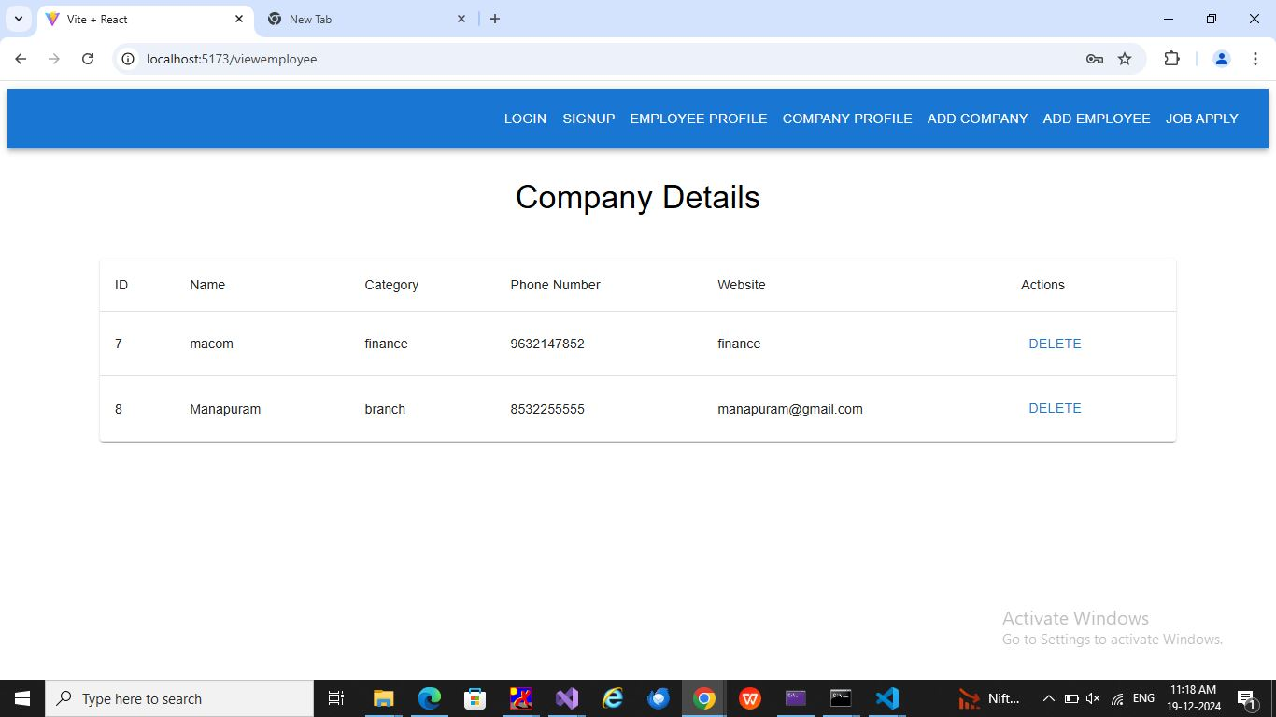

Admin - Register New Employee :

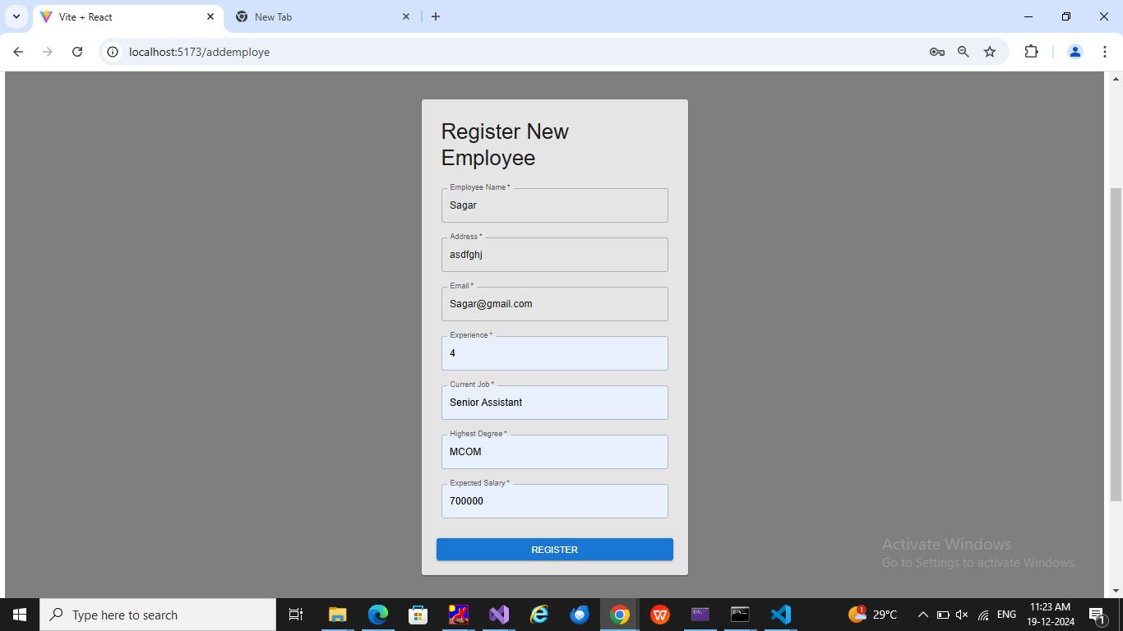

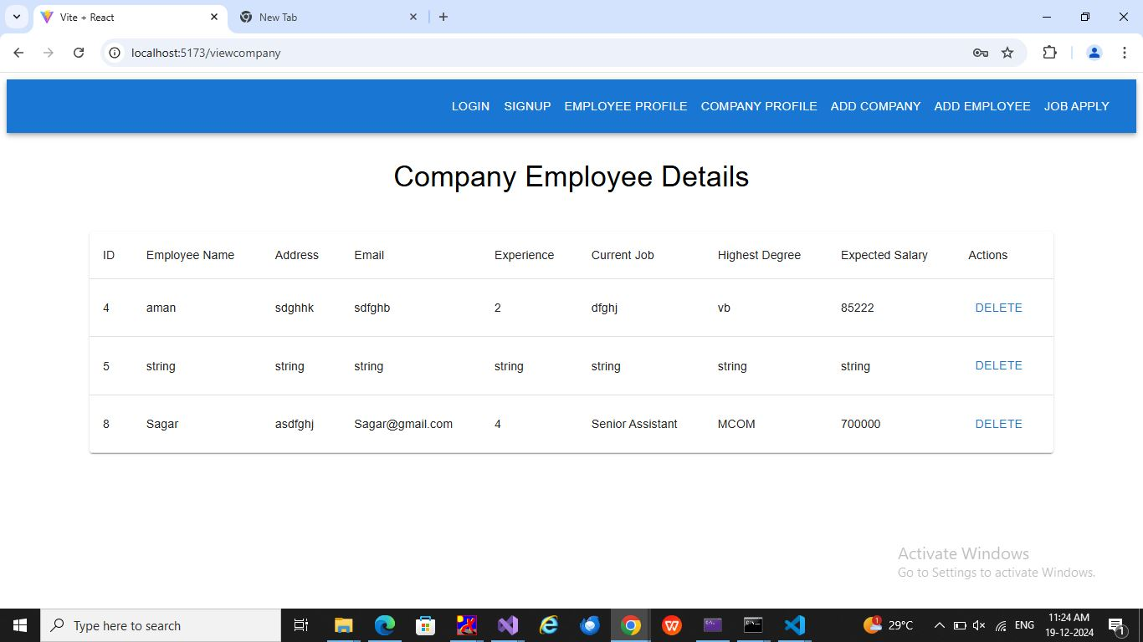

Employee - Registration :

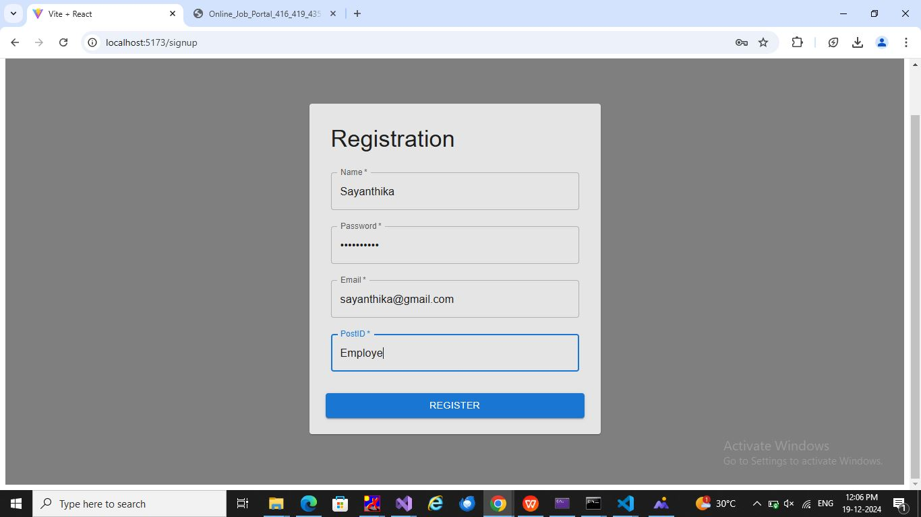

Employee - Job Application :

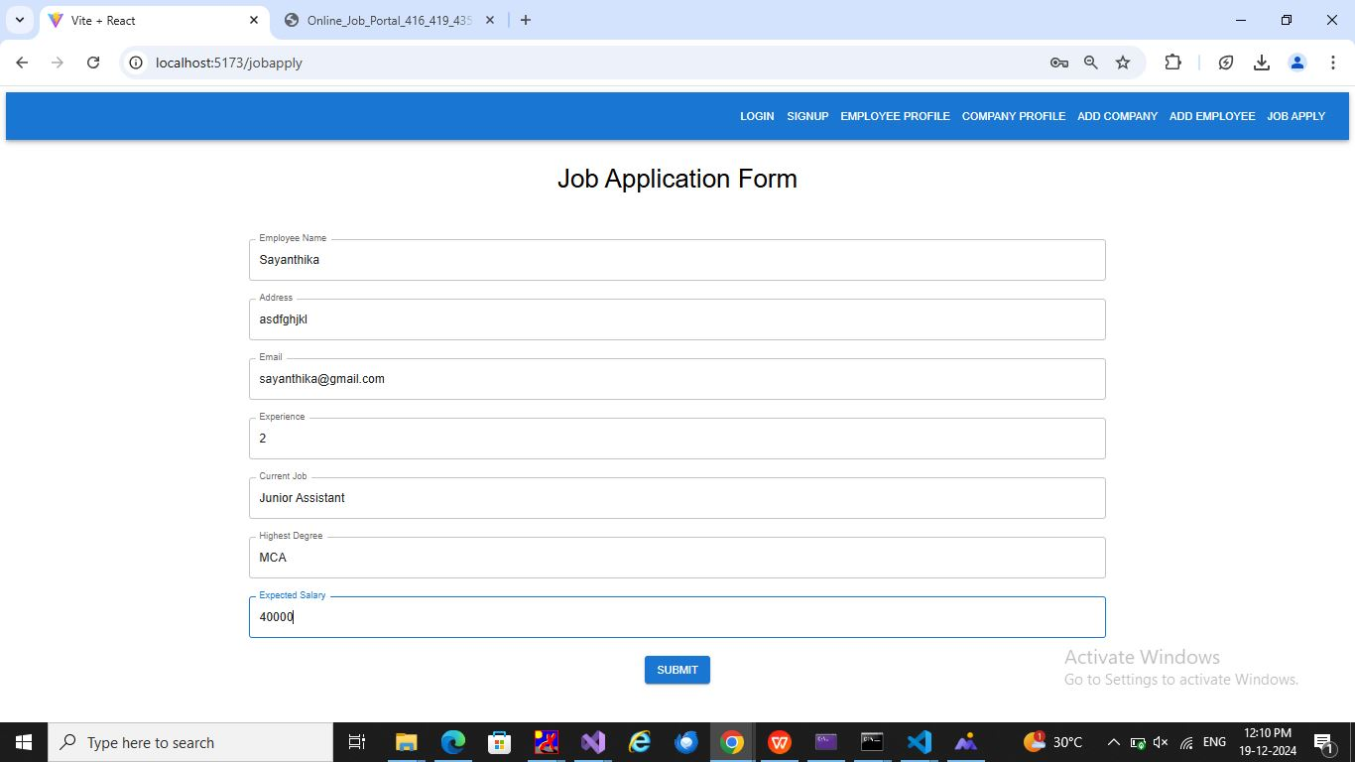



Company- Registration :

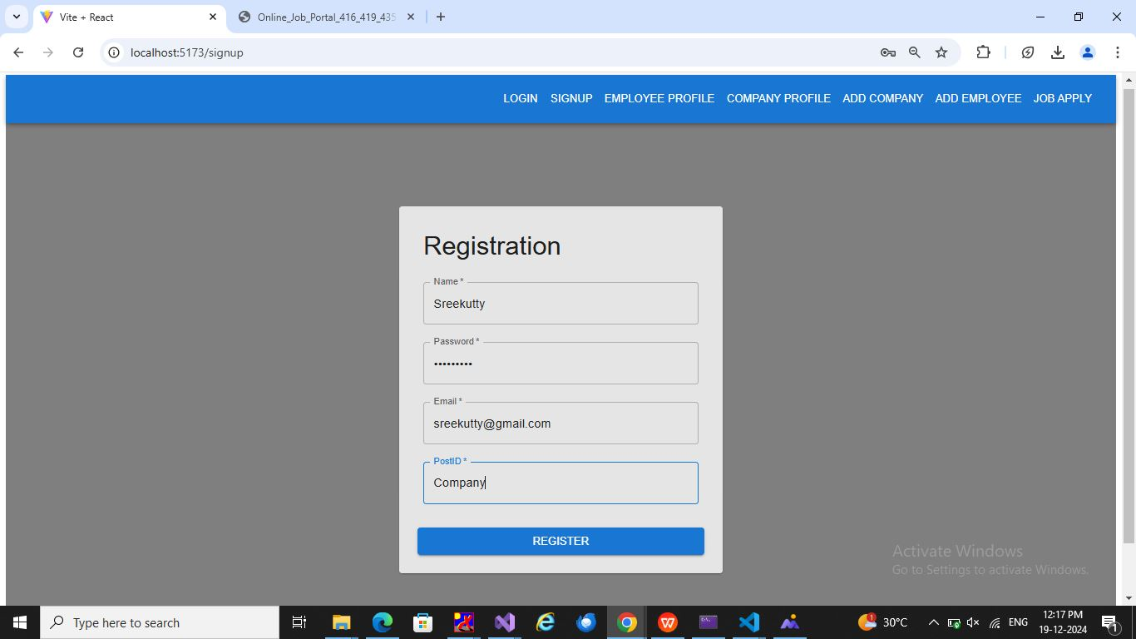







LogOut:

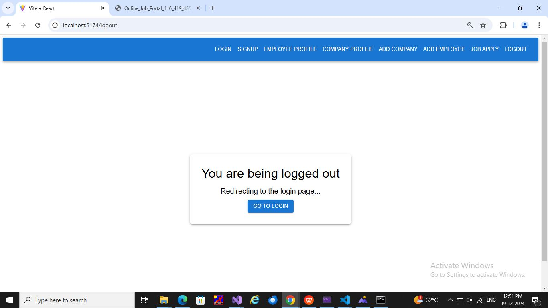

# Login Credentials:

**Admin:**

Username:Shabitha

Password:Shabitha

Employee:

Username:Lakshmi

Password:Lakshmi

Company:

Username:Abhirami

Password:Abhirami

**Repo Link: <https://github.com/shabithasagar/ReactExam>**