**BABY TOUCH – USER MANUAL**

**BUILDING & RUNNING iPAD Application (Developers Only):**

1. Download the zip file from Google Drive > UBC Project > September 19th > BabyTouch_19Sep.zip
2. Extract the zip file > Open folder > Open ic_v5iPad > Open ic_v5iPad.xcodeproj
3. Connect your iPad to your laptop using the USB port and keep it connected until STEP 8.
4. Once you open the file in Xcode, set your device by clicking on the highlighted button:

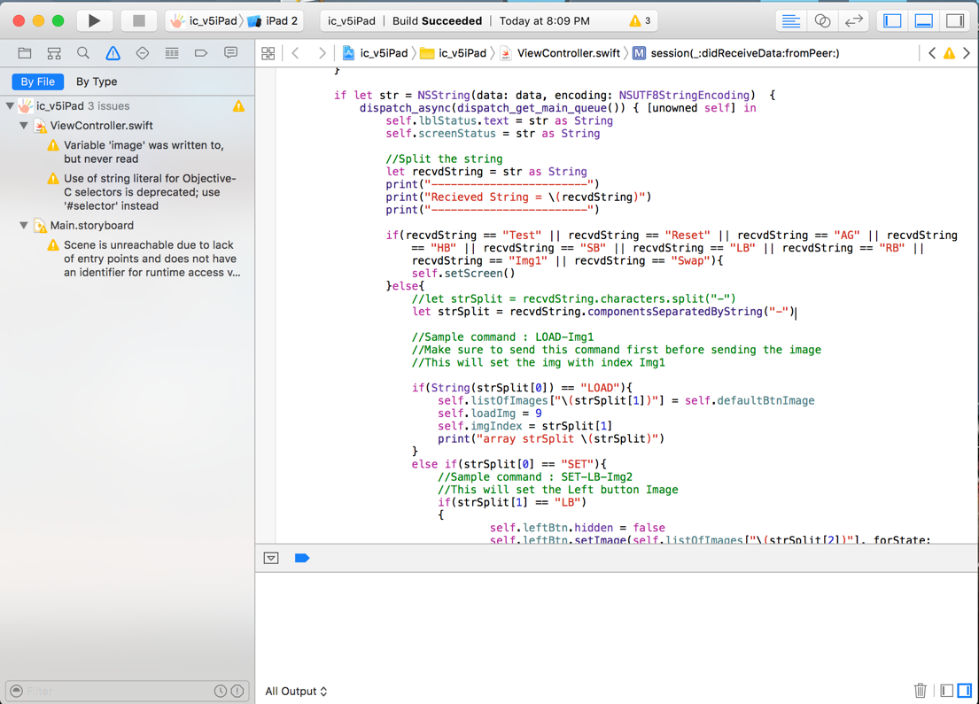

*Your initial screen should look like this image above*

1. The name of your device type should appear in the area signaled in the next picture if plugged correctly:

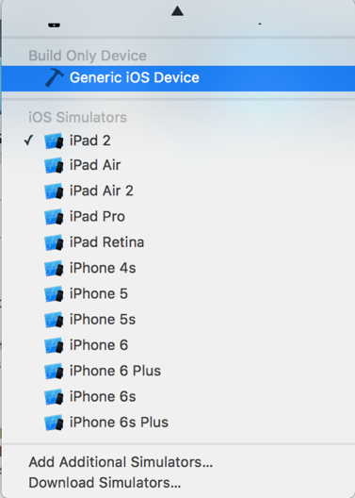

1. Then hit the “Play” button to build and run the iPAD application.

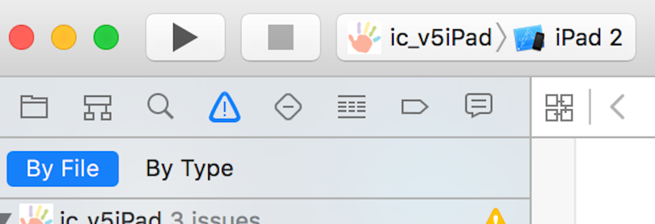

1. 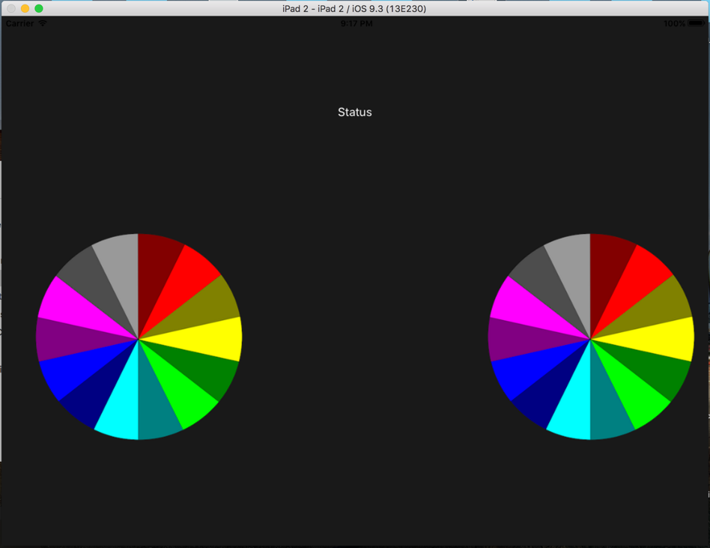The following image should appear on your iPad:
2. 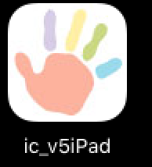Once this image appears, close the app, unplug the iPad from your laptop and restart the app by clicking on the icon.

*Now the iPad is ready to use*

**BUILDING & RUNNING MAC Application (Developers Only):**

1. For the admin application, Open folder > Open ic_v6Mac > Open ic_v6Mac.xcodeproj
2. Create a folder called Log on your desktop and update the path in AppDelegate.swift file in ic_v6Mac.xcodeproj

log.setup(.Debug, showLogLevel: true, showFileNames: true, showLineNumbers: true, showDate: true, writeToFile: "/Users/shabnam_suresh/Desktop/Log/\(logfile)")

with the new path.

1. 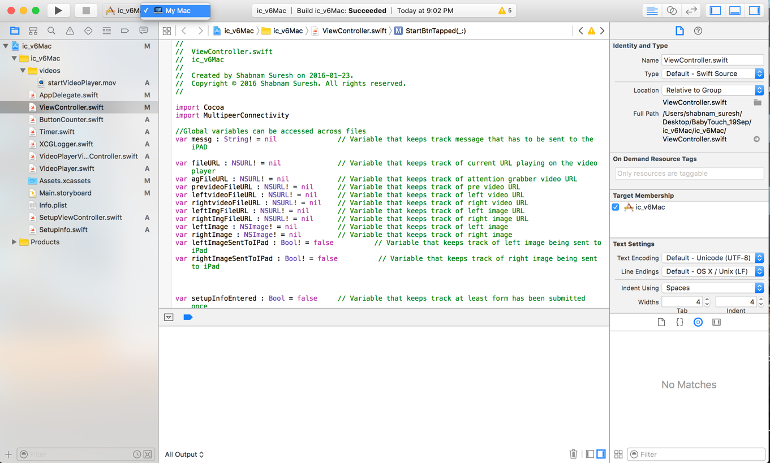 Set Mac as your device.
2. Hit the Play button



1. Baby Touch admin application window will appear. 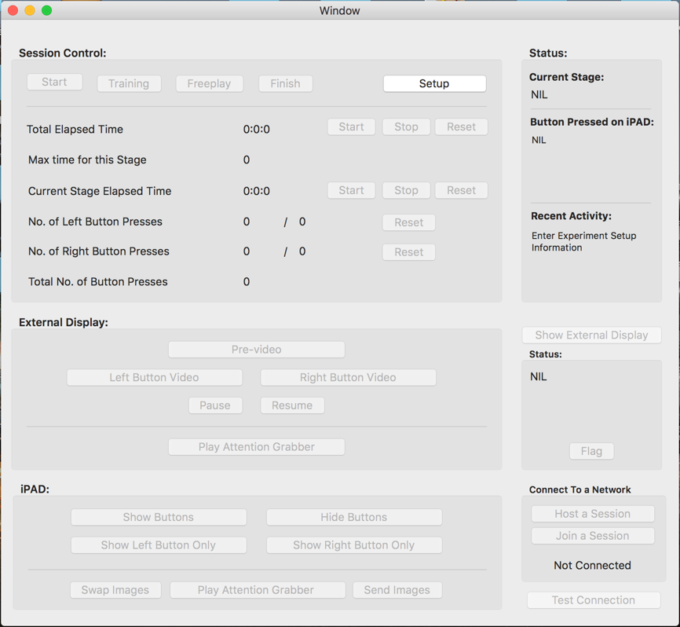
2. Click Setup button.
3. 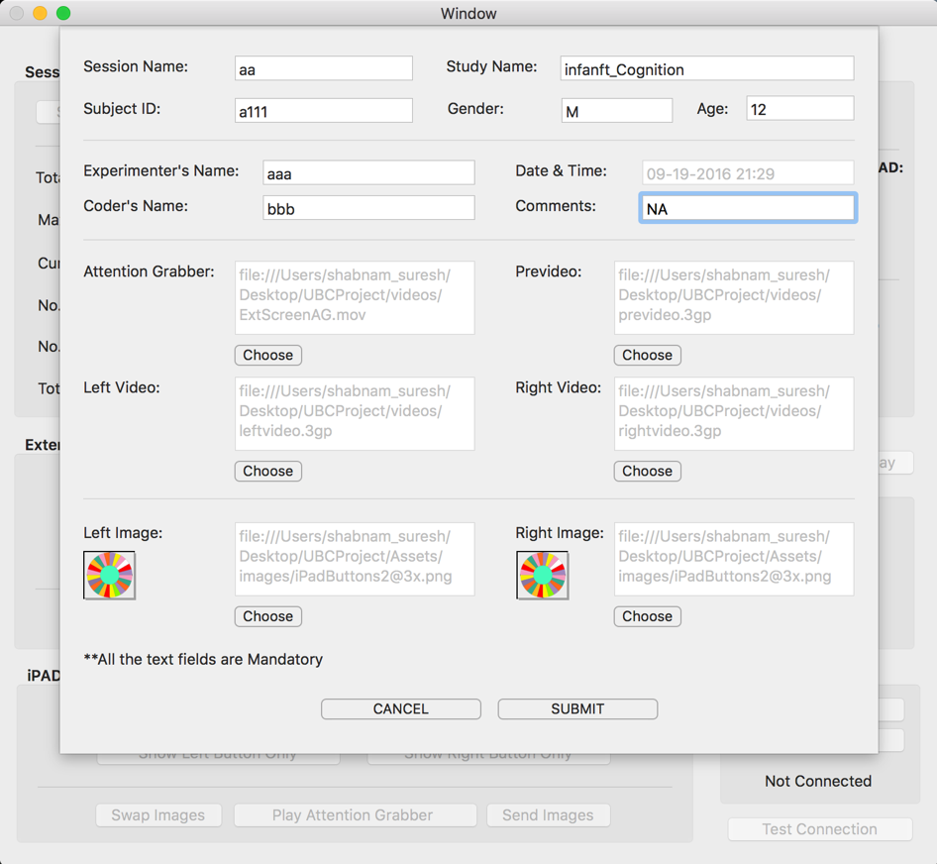 Write down the appropriate details for session name, study name, Subject ID, gender, age, experimenter’s name, coder’s name, and comments. The following image is an example:
4. Attention grabber, prevideo, left video, right video must correspond to their video files.

NOTE: Make sure the file format is .mp4, .mov or .3gp. The files names should not have spaces. *Ex. leftvideo.3gp*

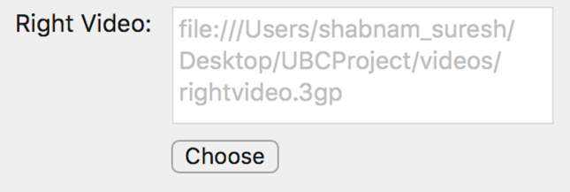

1. Next, choose the corresponding image for the iPad left and right buttons. NOTE: Make sure the file format is .jpeg, or .png. The files names should not have spaces. *Ex. iPadButtons.jpg*
2. 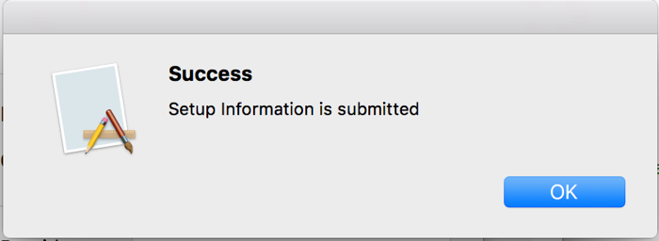 Click on Submit. Success window should appear once the button is clicked
3. Once you’re back to the main admin window, “Show External Display” and “Host a Session” buttons should be enabled.
4. Click on “Show external display” to open a video player in a new window. Resize this window as you see fit. NOTE: If this window is closed by mistake, click again on “Setup” > “Submit” button.

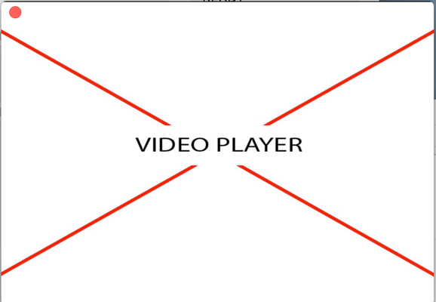

1. Drag the video player window to the external screen. NOTE: Make sure to connect the external screen to your MacBook via HDMI cable or VGA.
2. Now you can test the player by clicking on external display buttons that are enabled. *Ex. Click on prevideo button to play the prevideo. Pause button will pause the video currently being played. Resume will play the video from where it was previously paused. Attention Grabber button will play the Attention Grabber video on the screen.*
3. Next, to connect to the iPad, click on “Host a Session” button.
4. On the iPad, open the Baby Touch application. Tap on the top part of the screen to make the navigation bar visible. NOTE: To hide the navigation bar, tap on it again.

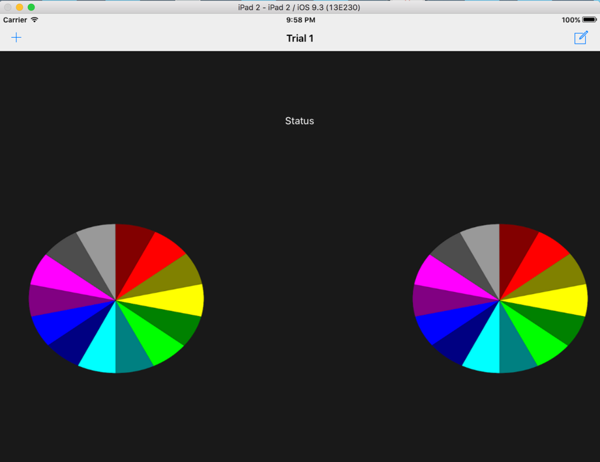

1. 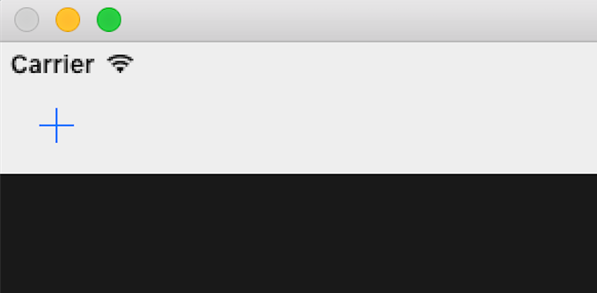Click on the + icon on top of the screen.
2. 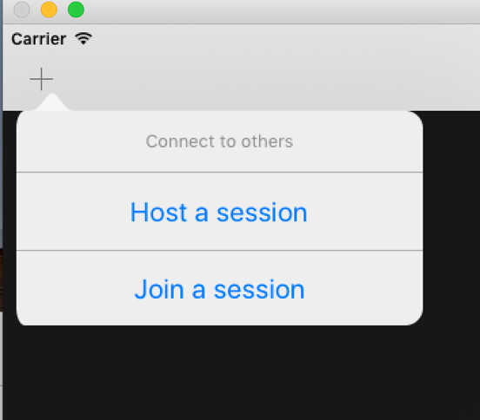You’ll see the next drop down menu. Click on Join a session.
3. Connect with your MacBook by clicking on the laptop’s name.

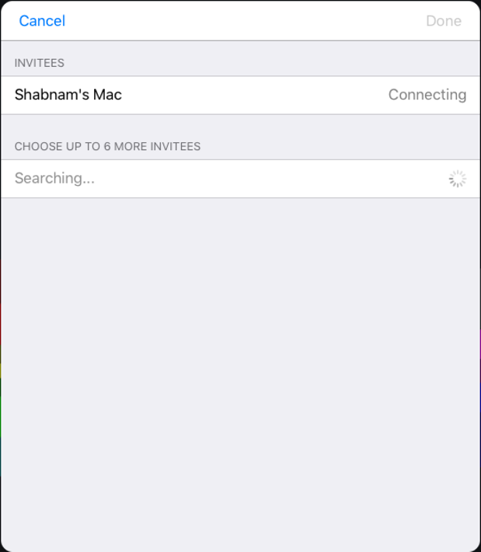

1. 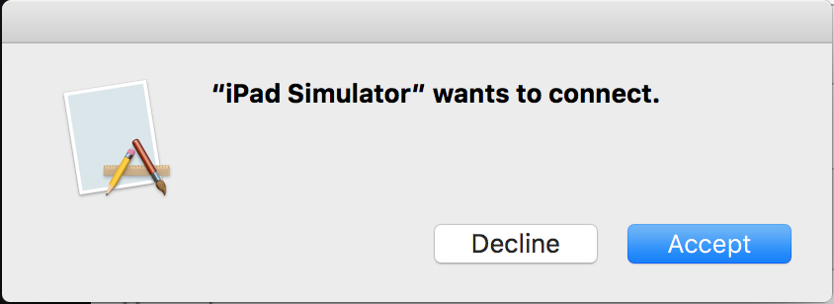Press accept from your MacBook to connect. When the screen shown below appears, click accept.
2. Once successfully connected, the state will be reflected on the iPad, click Done to close the window.
3. 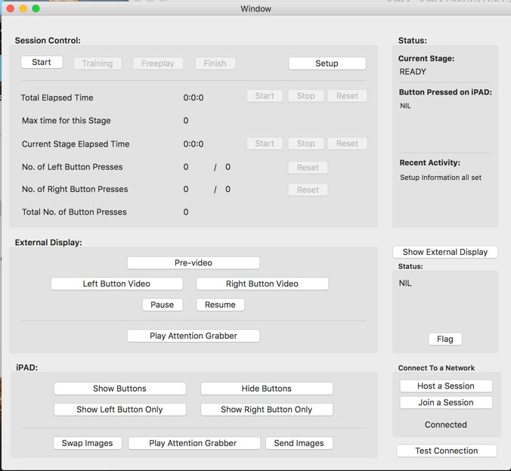 Now that both iPad and MacBook are connected to each other, test the connection by clicking on the “Test Connection” button.
4. Click on the “Send images” button to send the images selected from the Setup menu from your MacBook to your iPad.
5. iPad screen will reflect the new changes.
6. Hide buttons will disappear both buttons on the iPad and show buttons will bring them back. Show Left Button will display only left button on the iPad, the same is true for the right button.
7. Swap images button will change left image to right and vice versa.
8. Play attention grabber button will play its respective video on the iPad. NOTE: This video is programmed into the application and can only be changed if reprogrammed directly from the code.
9. Session control has 4 modes: Start, Training, Freeplay and Finish.
10. Clicking on start button will start running the timer for the total elapsed time of the test. This can be altered by clicking on the stop, reset and start button accordingly. Same goes for Current Stage Elapsed time.
11. The Training phase has a max time of 20 seconds. Once this time has elapsed, the color of the timer will change from blue to red to indicate the overtime. NOTE: To alter this effect, changes have to be made in the code of the program.
12. Freeplay mode has a max time of 50 seconds and has the same visual behavior as Training phase.
13. You may click the Setup button at any time during the experiment to modify the videos or images showed.