Tasks - 09/09/2023

Task 2:

Write Python code that prints your name, student number and email address usinginput and output functions

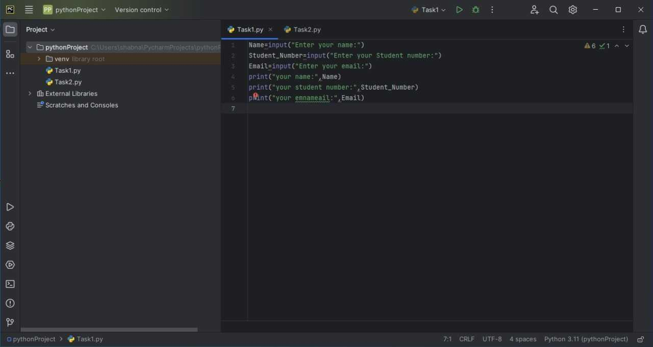

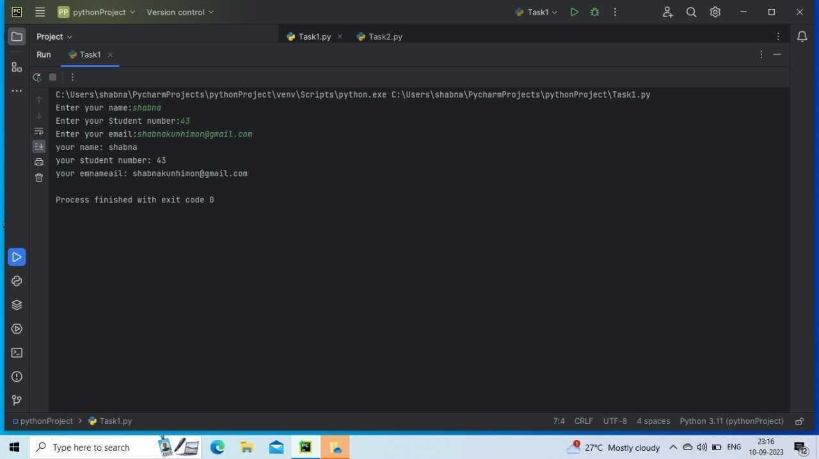

Task 3:

Write Python code that add, subtract, multiply and divide the two numbers. You can use the two numbers 14 and 7.

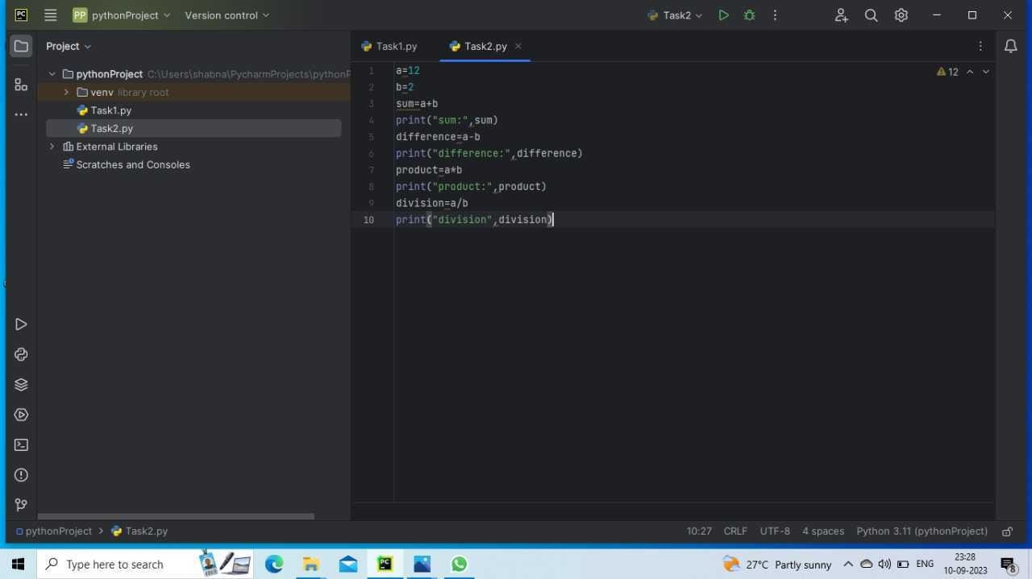

Tasks - 19/09/2023

Last date - 29/09/2023

1) A three-day festival is the official celebration.

There are two categories of tickets: individual cost is £68, under sixteen is £32.25. Write a program thatasks the user for total numbers in each category, calculate and display the breakdown of each and totalprices.

To get more idea please see the execution of the program below:

Doctor Who Festival - Price Calculator

Note: enter 0 if none

Enter total number of individuals : 3

Enter total number of under 16s: 2

Category Price Breakdown:

Price is £204 for 3 individuals

Price is £64.5 for 2 under 16s

2) Define the variables below. Print the types of each variable. What is the sum of your variables? (Hint:use a type conversion function.) What datatype is the sum?

num=23

textnum="57"

decimal=98.3

3) Name your file: MonthNames.py

Write a program that reads an integer value between 1 and 12 from the user and prints output the corresponding month of the year.

An example run of the program

Enter the month: 3

Month 3 is March

Name your file: EvenOddNumbers.py

4) Write a program that reads an integer value from the user and prints output whether it is odd or even.

An example run of the program (use modulus (%) operator)

Enter a number: 12

12 is “even”

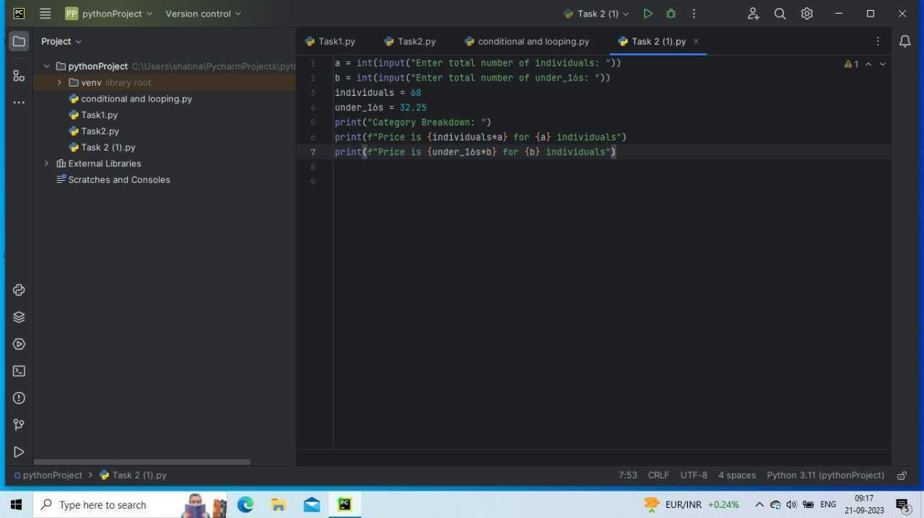

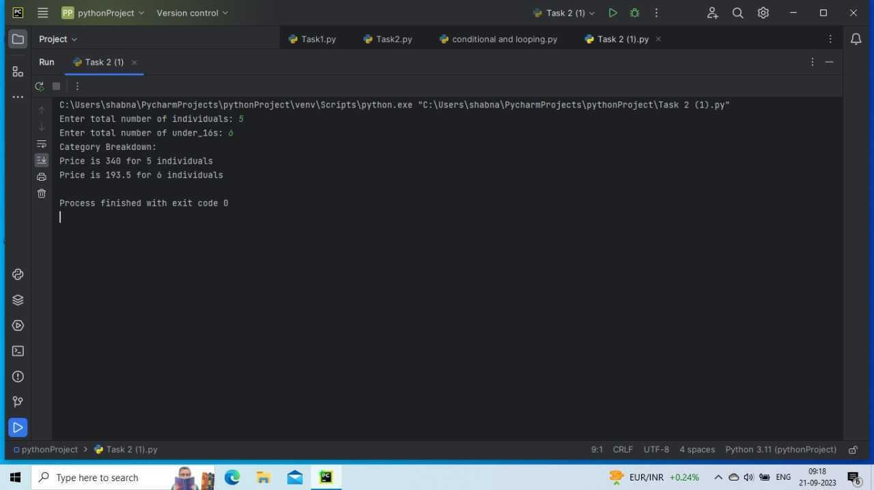

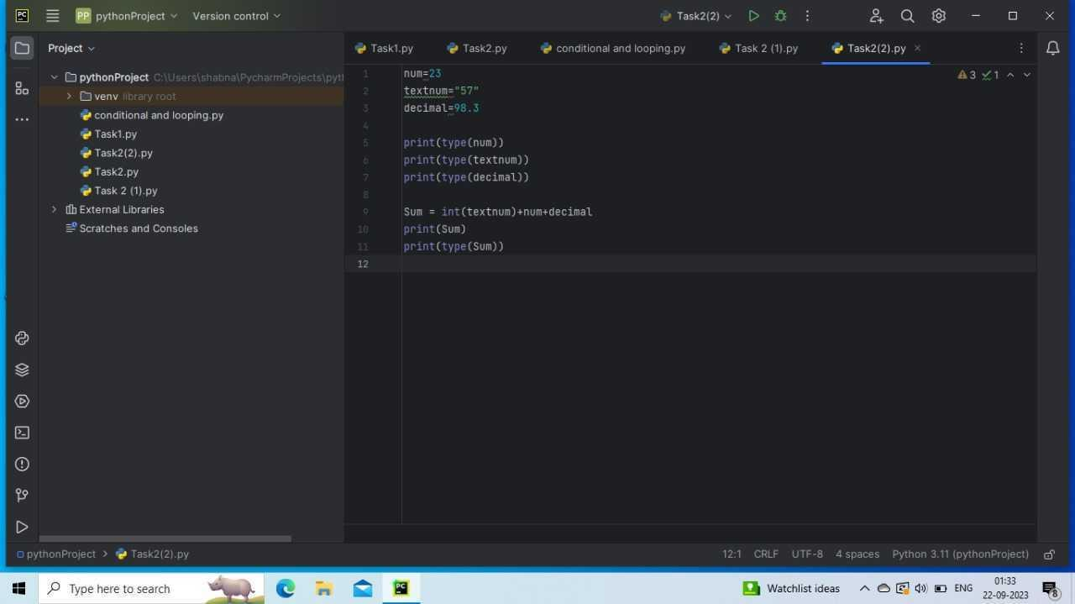

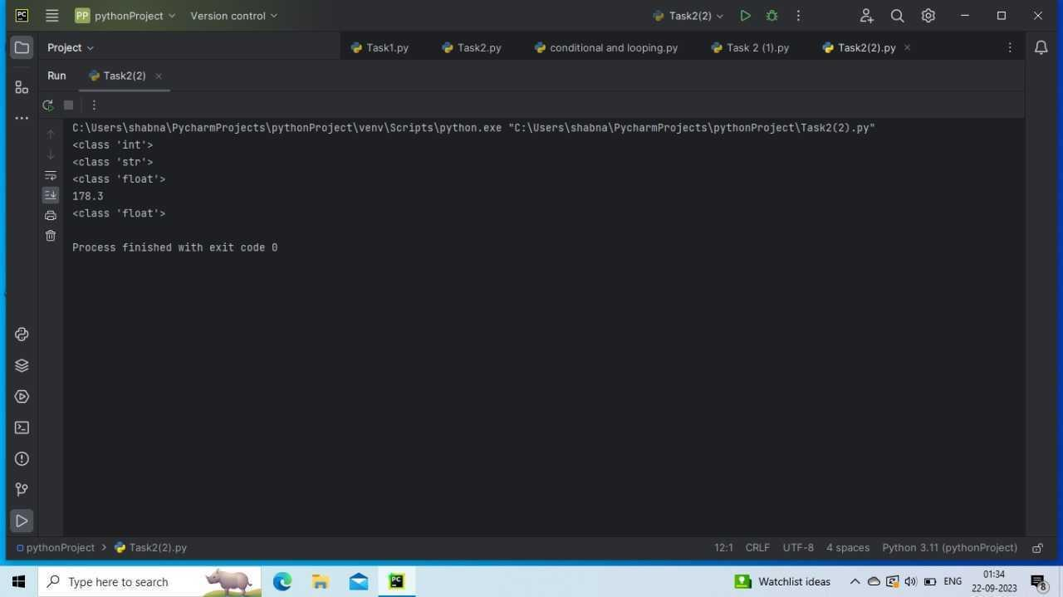

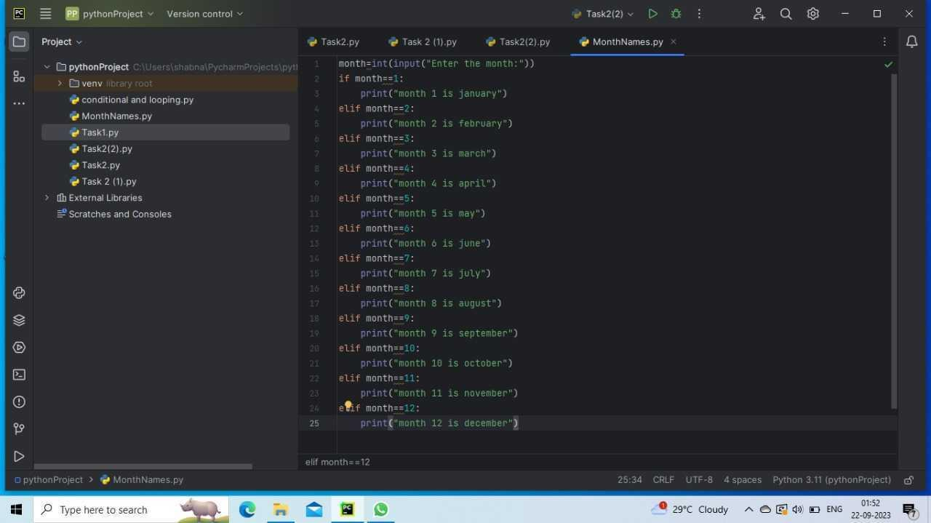

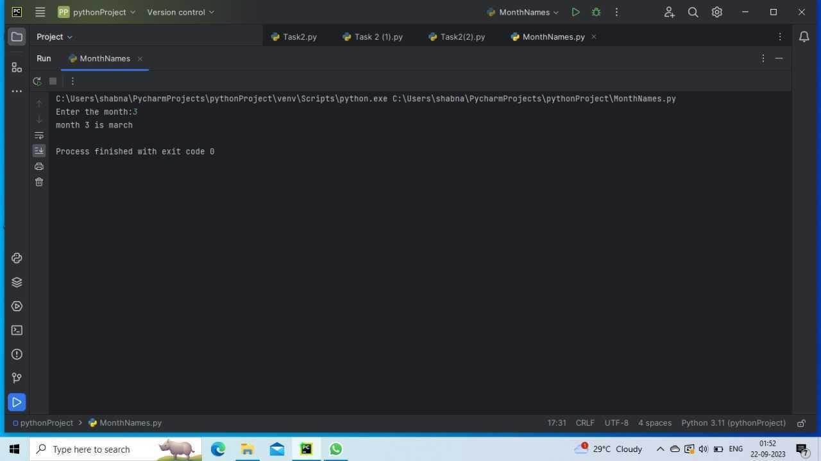

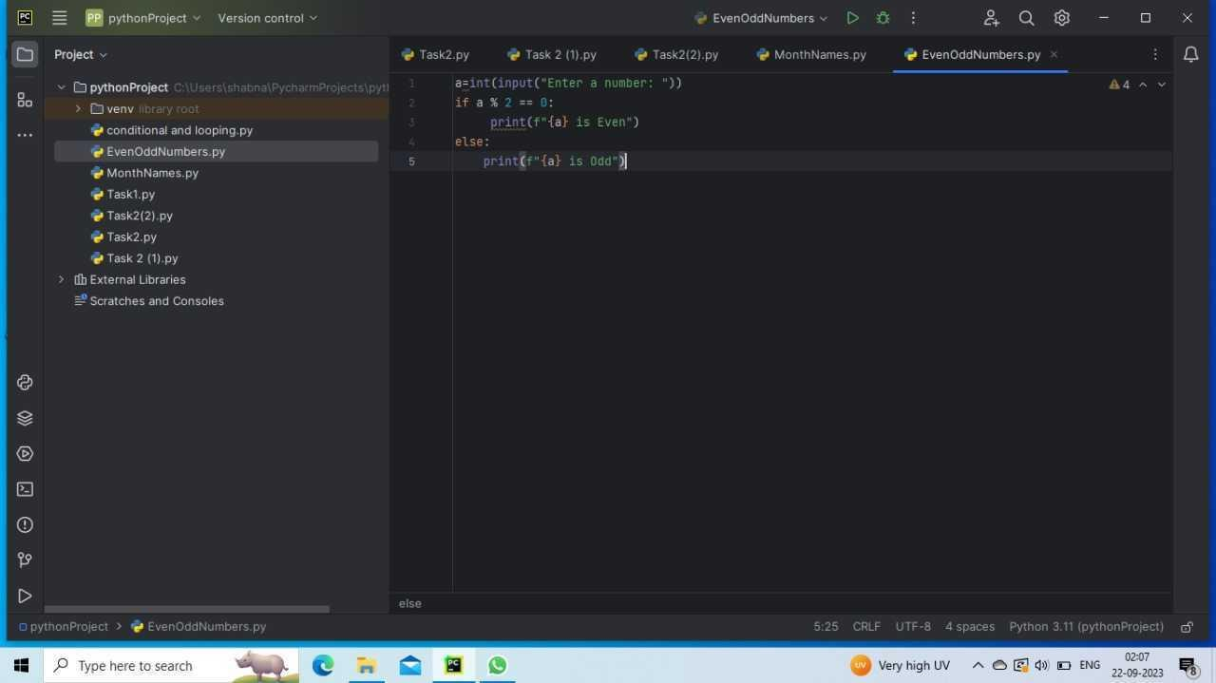

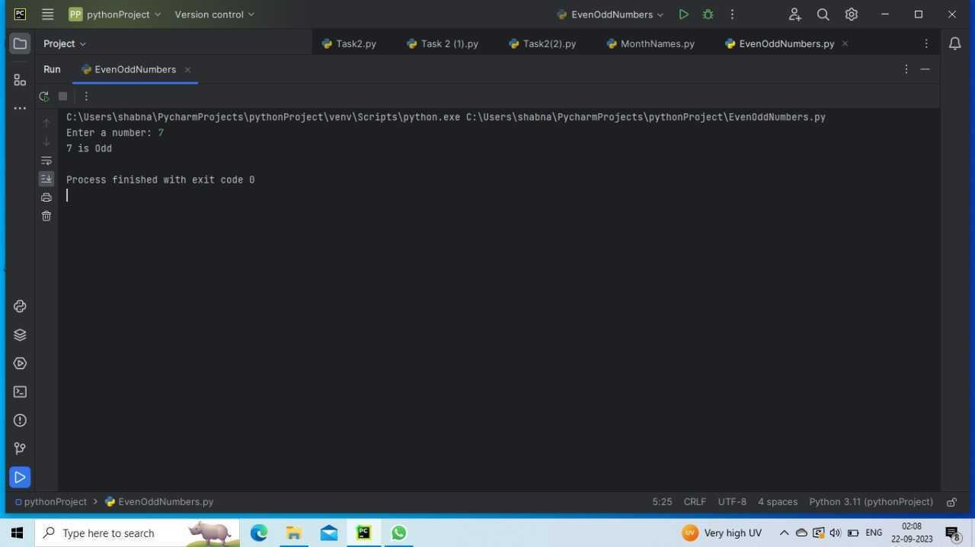

Task 26/09/2023

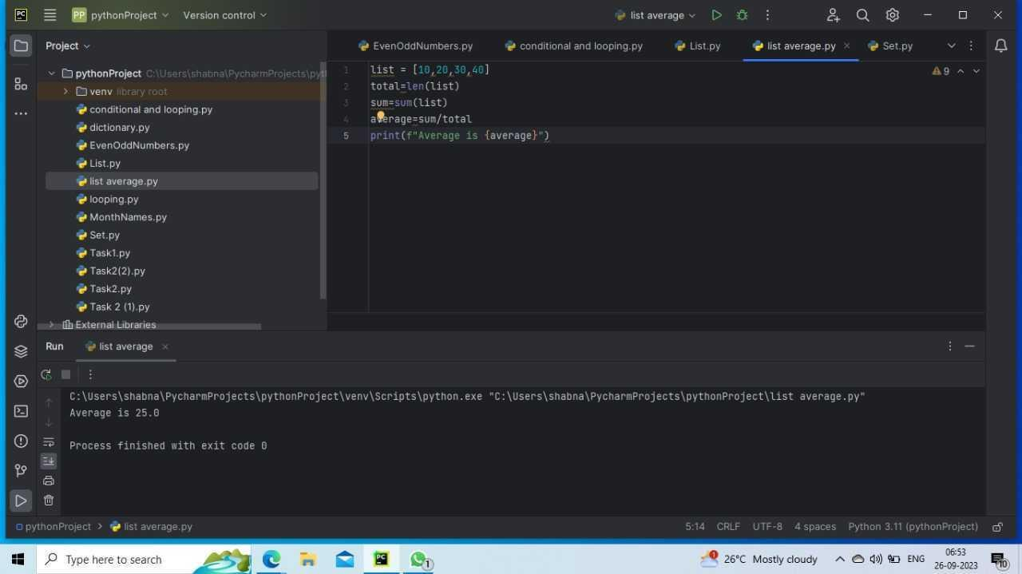

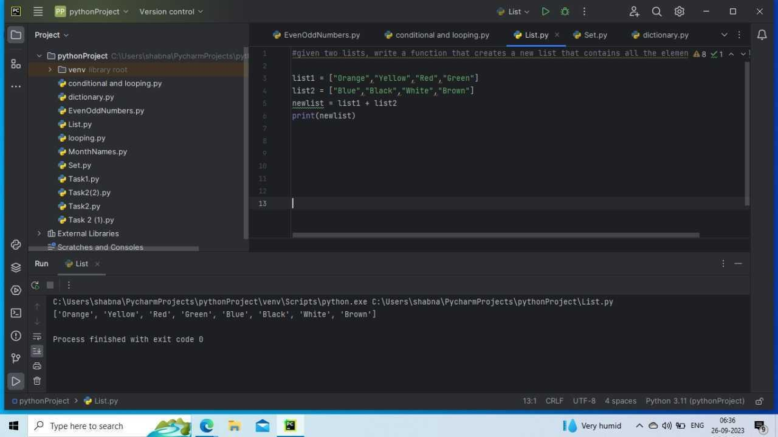

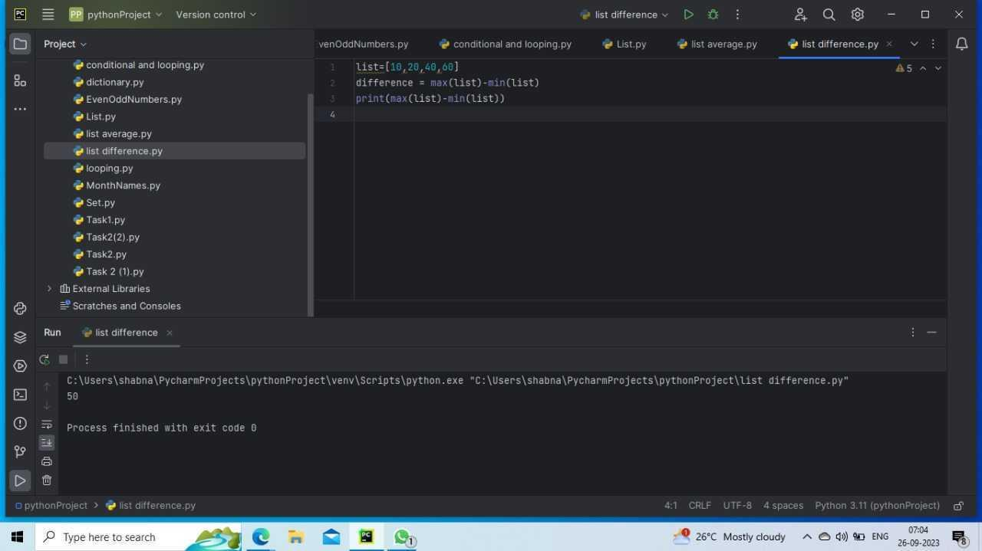

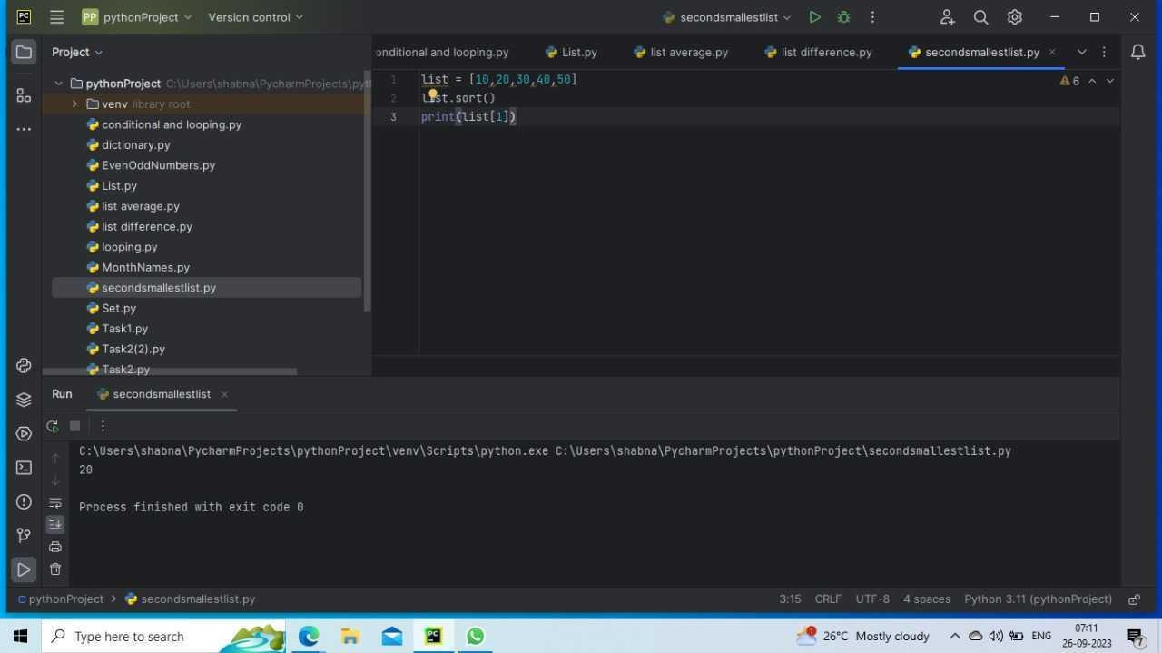

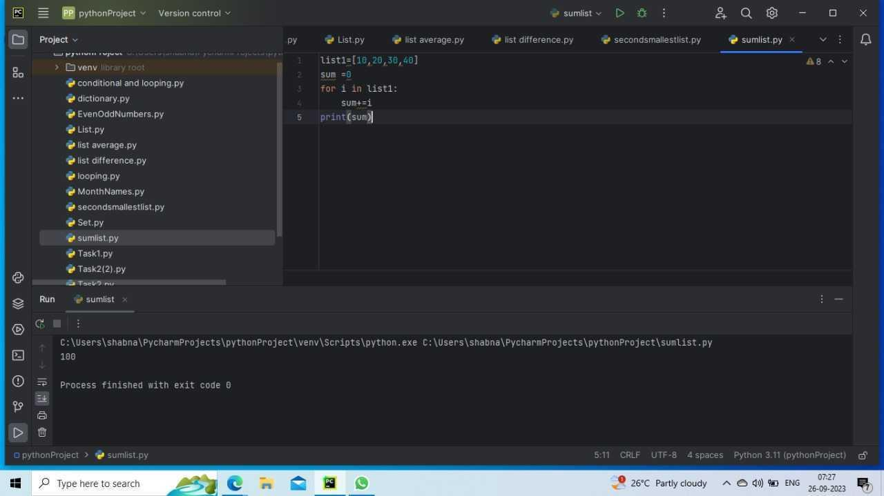

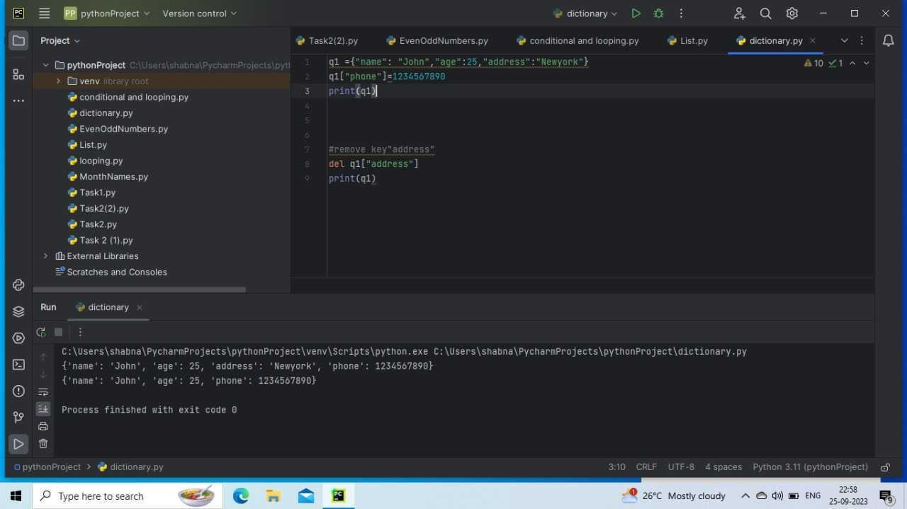

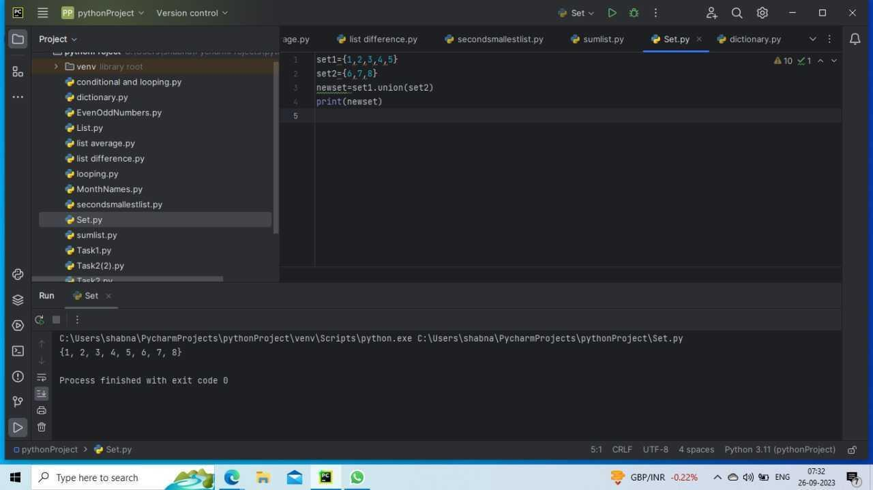

Task 06/10/23

Functions:

Exercises 1

Write a Python program to count the number of strings where the string length is 2 or more and the first and last character are same from a given list of strings

Sample List : ['abc', 'xyz', 'aba', '1221']

Expected Result : 2

Exercises 2

Write a Python program to multiply all the items in a list

Exercise 3

Create dictionary from a list where the keys are the elements of the list and value of the dictionary is result after dividing the element by 3

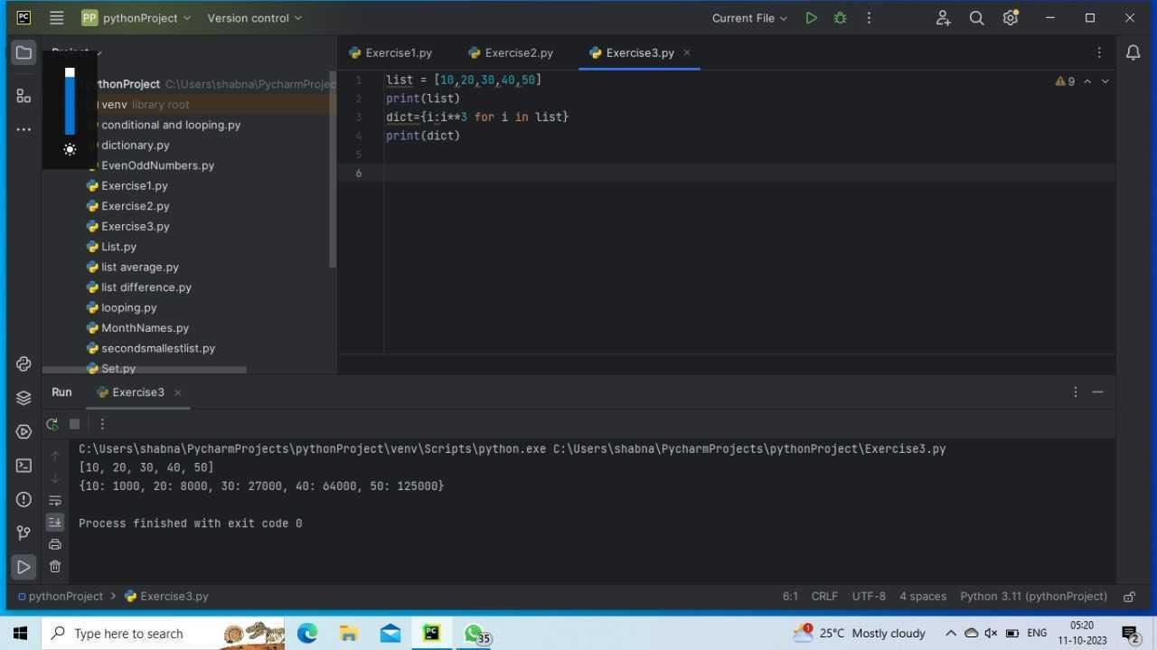

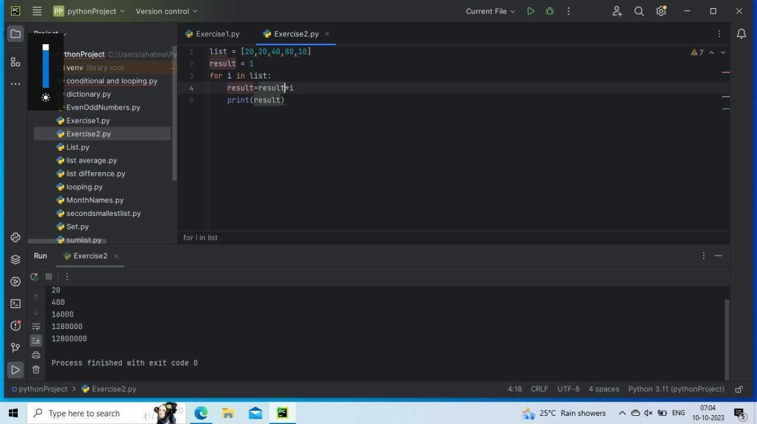

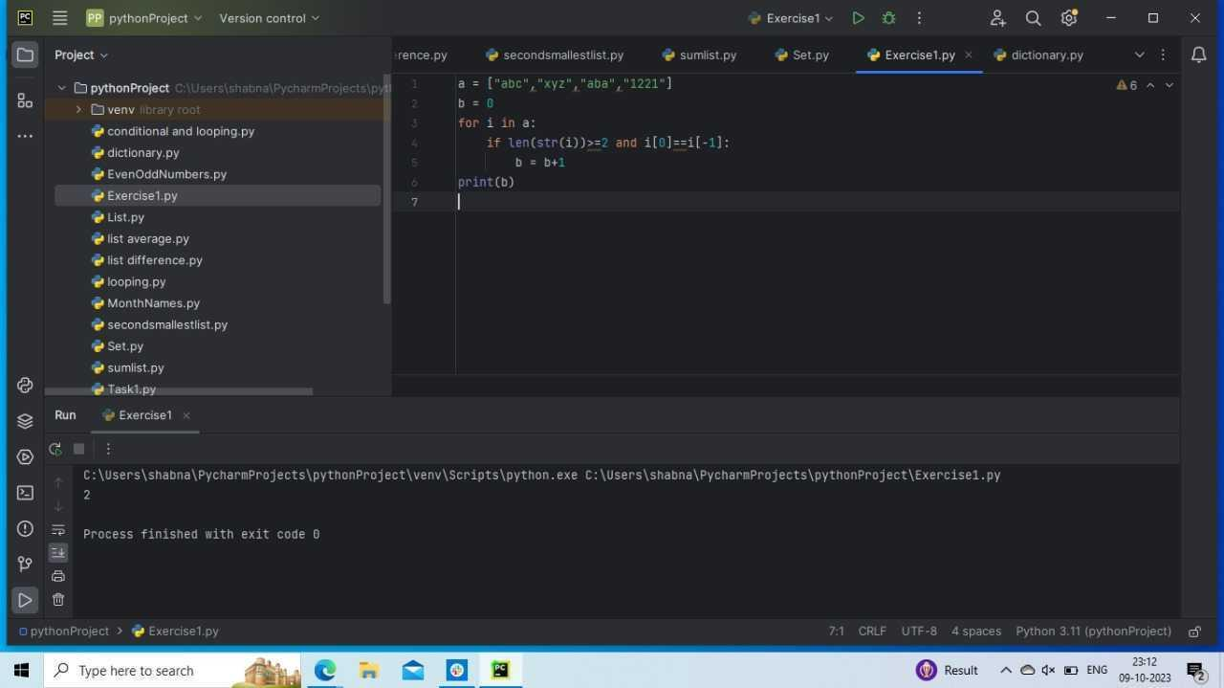

Task 09-10-2023

Functions:

Create a function that takes in an arbitrary number of arguments and prints the sum of all the even numbers. If no even numbers are provided, the function should print 0.

Create a function that takes in two required arguments, one optional keyword argument with a default value of 1, and one arbitrary argument. The function should print the product of the two required arguments, multiplied by the optional keyword argument, multiplied by the product of all the values in the arbitrary argument.

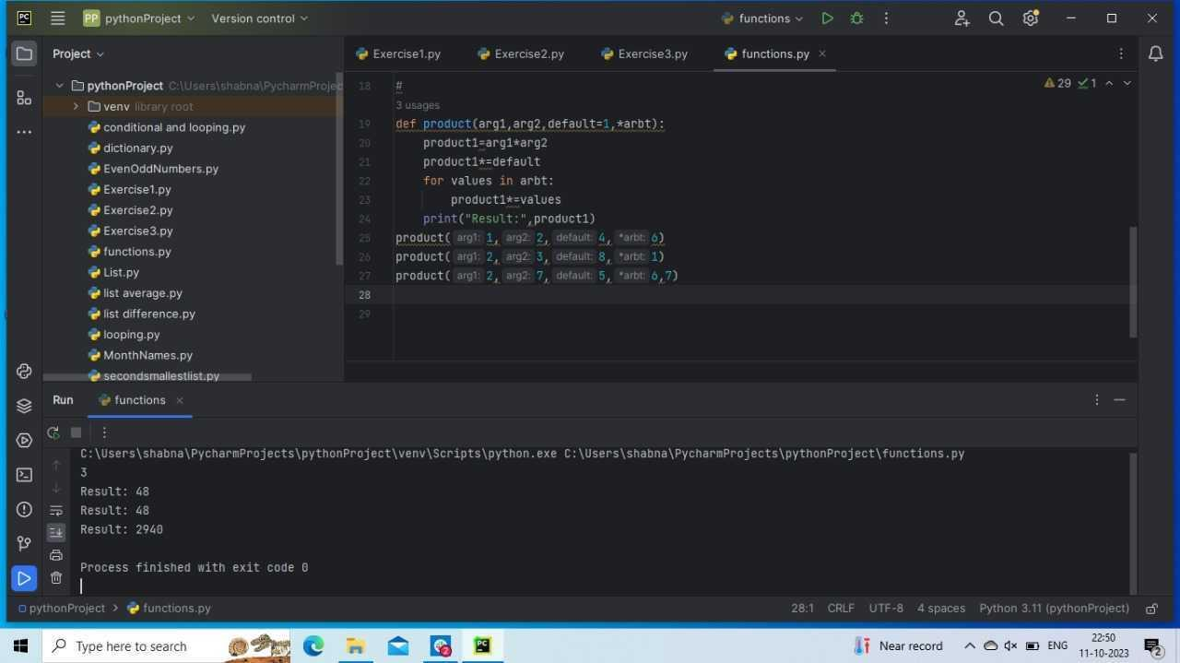

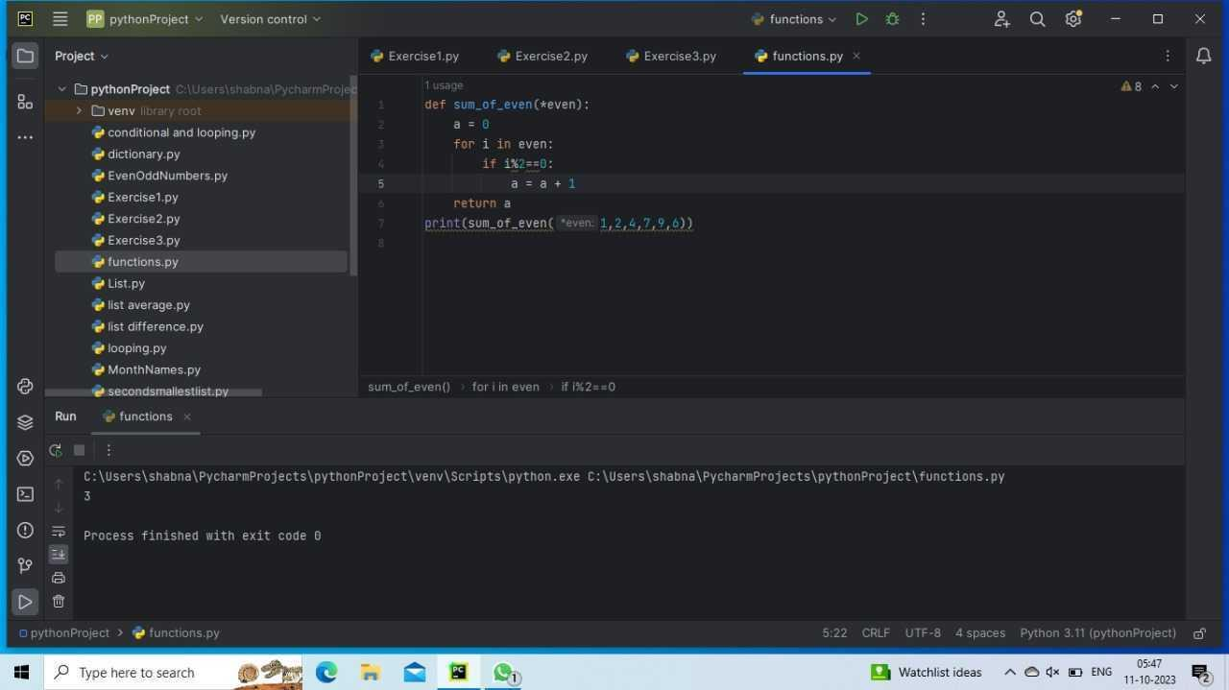

:Task 13-10-2023

Functions:

Write a function to implement calculator

Sample run:

Press 1 for addition

Press 2 for subtraction

Press 3 for Multiplication

Press 4 for Division

Enter your option: 1

Enter your first number: 23

Enter your second number: 10

Addition of 23 and 10 is : 33

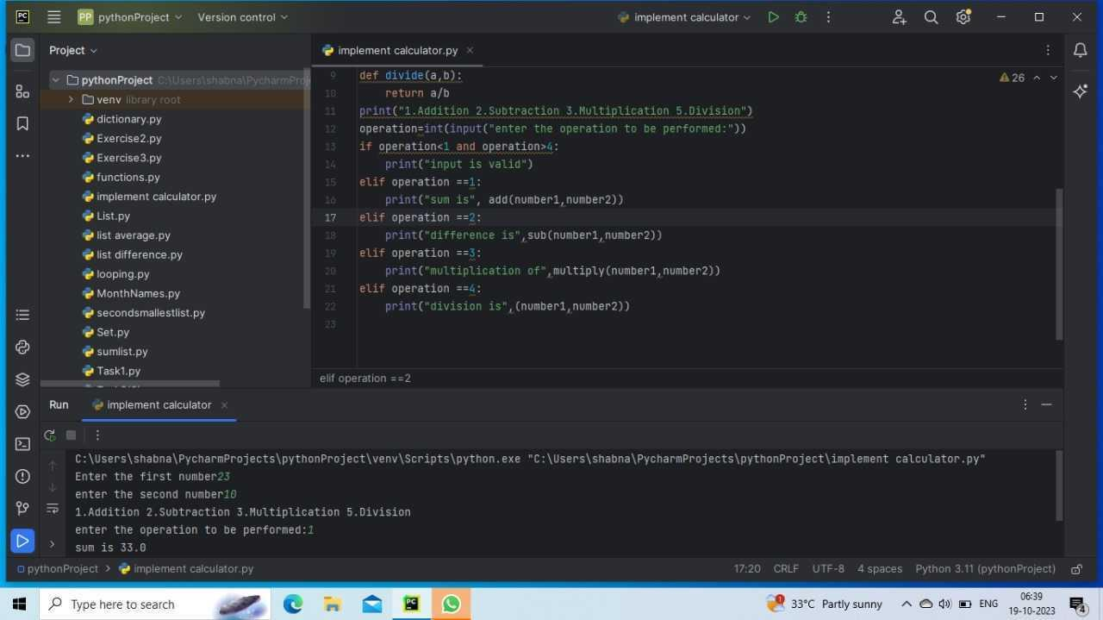

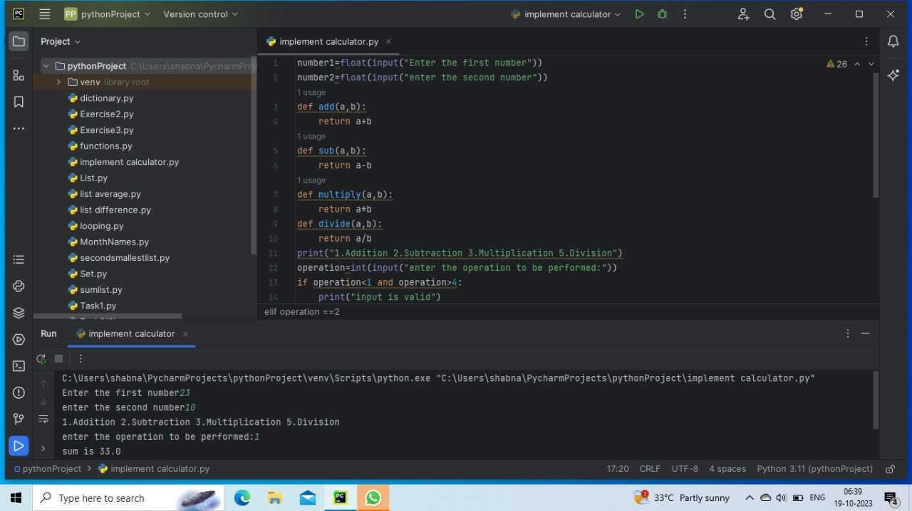

Task 16-10-2023:

1.Write a lambda function that takes in a parameter and returns True if the parameter is even and False otherwise.

2.Write a Python program to create a lambda function that adds 15 to a given number passed in as an argument, also create a lambda function that multiplies argument x with argument y and prints the result.

3.Write a Python program to evaluate a given mathematical expression using the eval() function.

expression = "3 \* 5 + 2"

4. Write a Python program to evaluate a given logical expression using the eval() function.

expression = "5 > 2 and 3 < 4"

5. Write a Python program to evaluate a given Python expression using the eval() function.

expression = "[x \* 2 for x in range(5)]"

6.Write a Python program to filter out the vowels from a given list of characters using the filter() function.

7.Write a Python program to filter out the prime numbers from a given list of integers using the filter() function.

8.Write a Python program to filter out the strings with length greater than 5 from a given list of strings using the filter() function

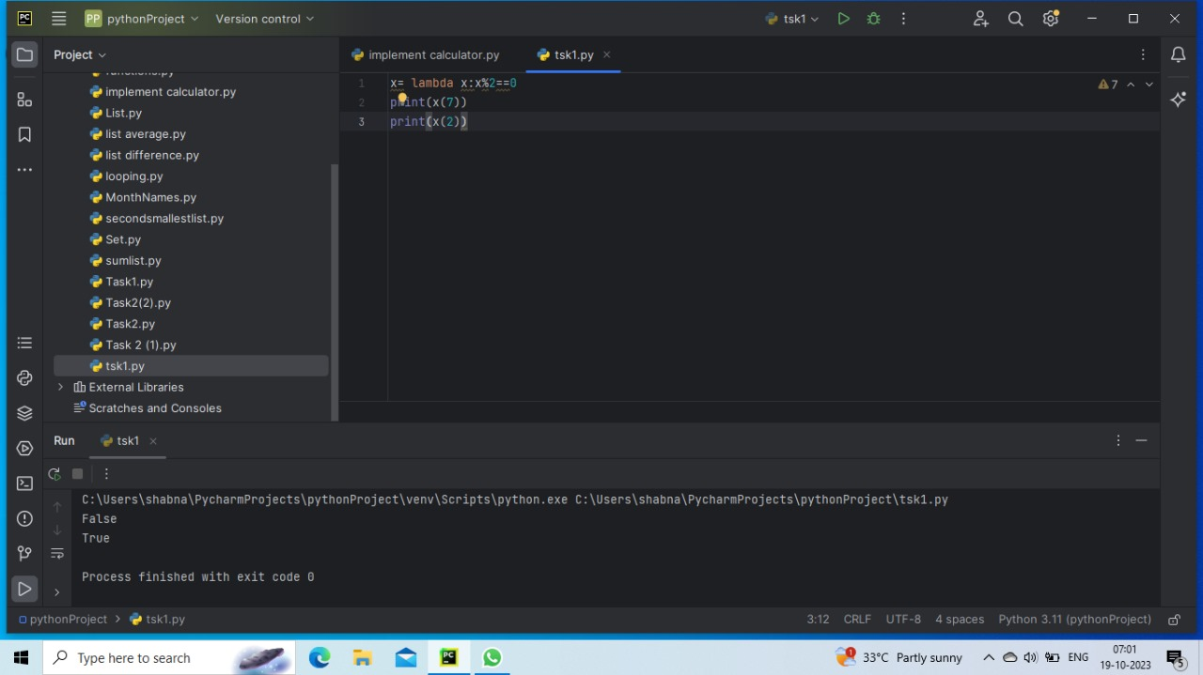

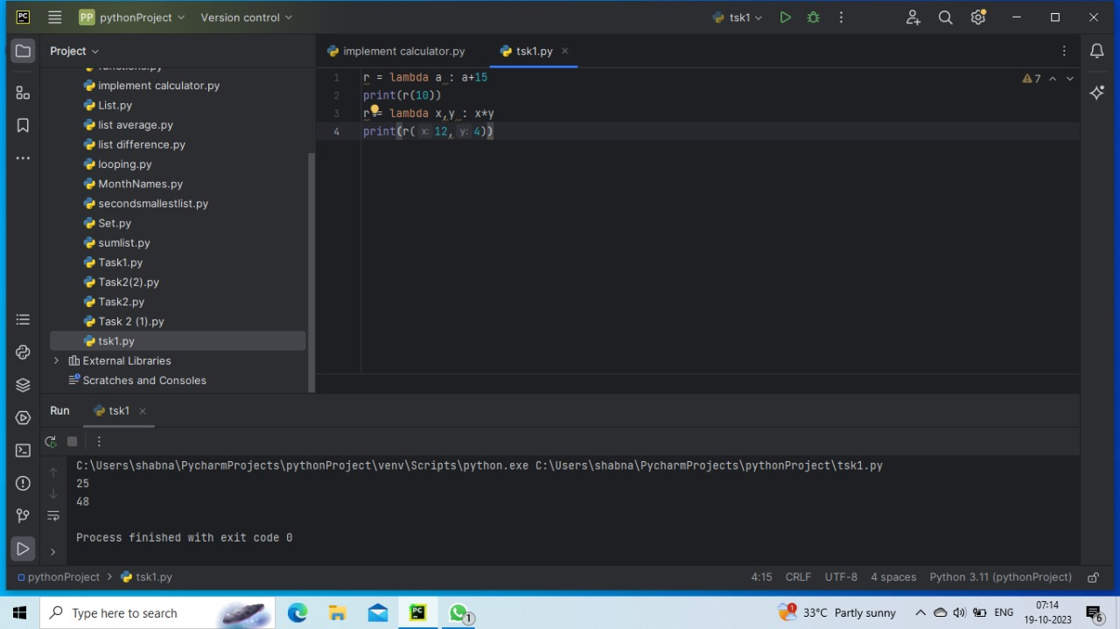

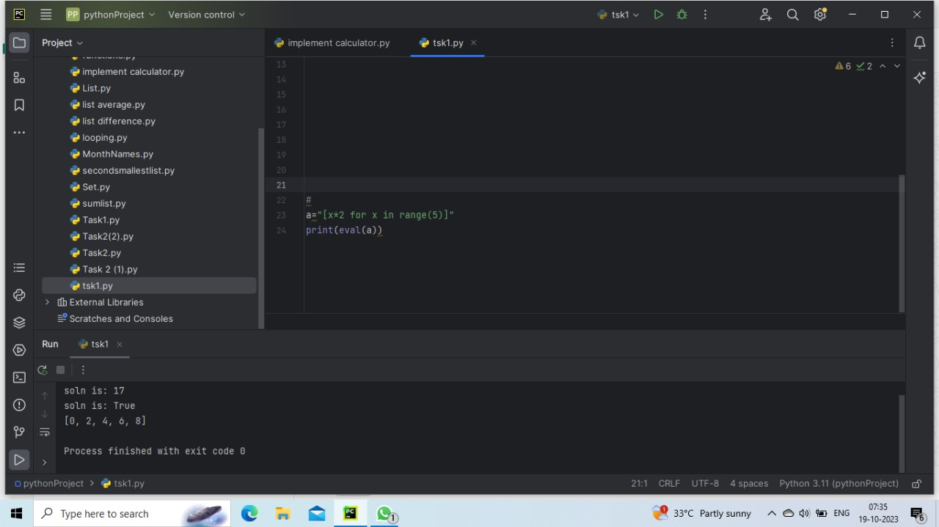

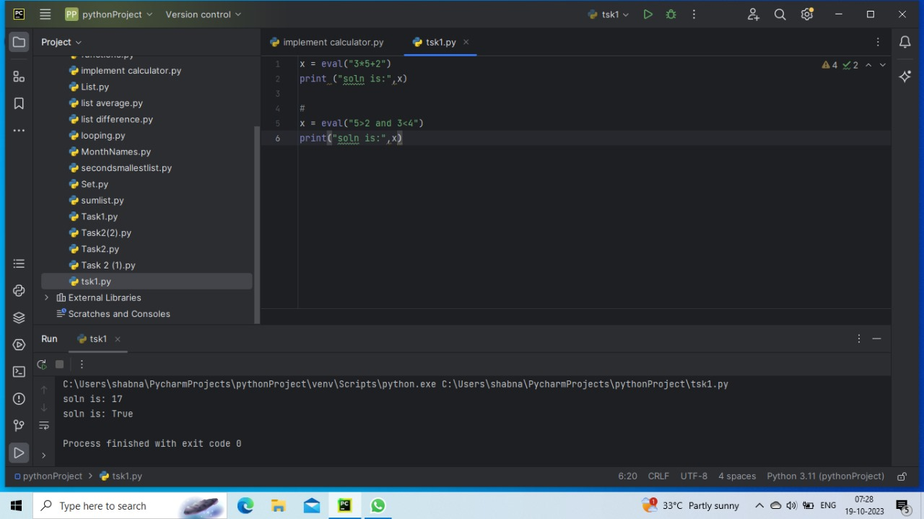

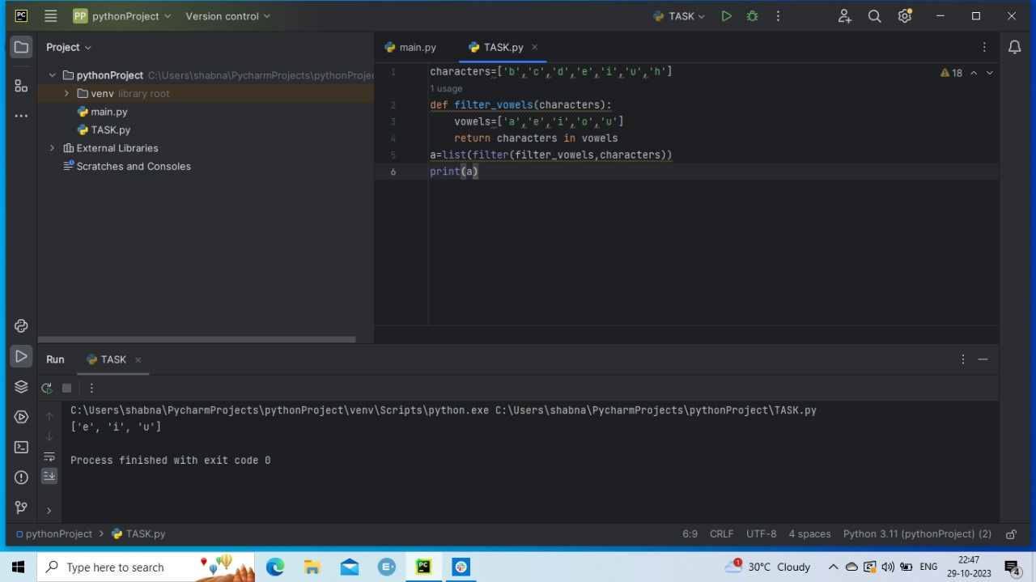

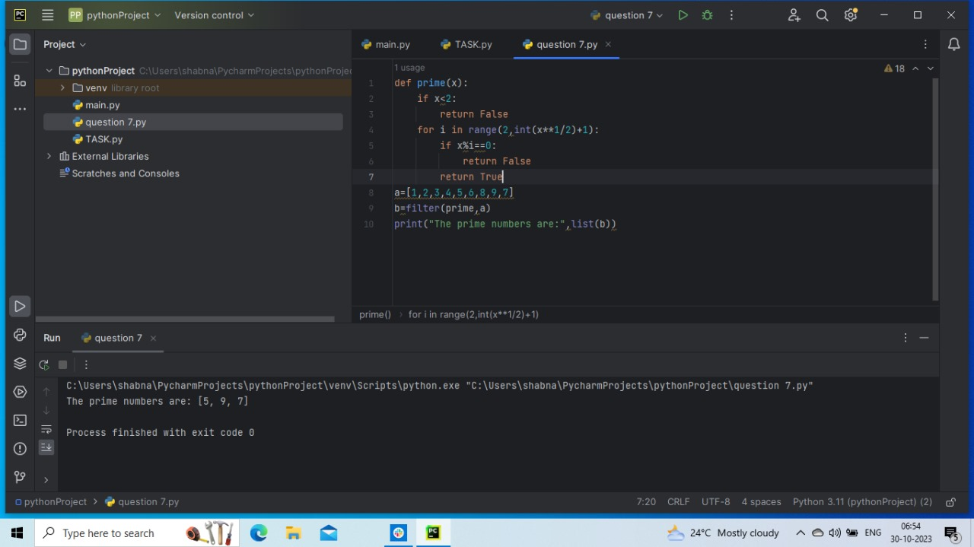

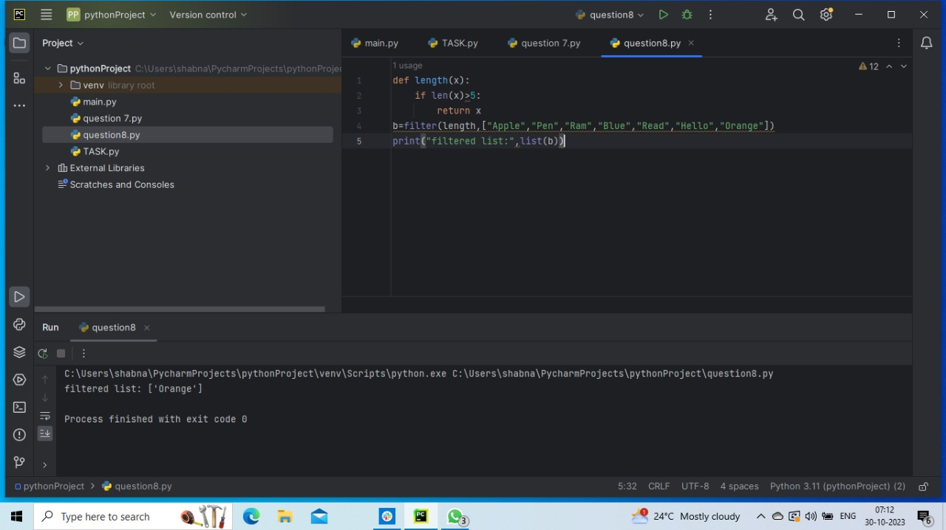

20-10-2023

Generators and Decorators:

Exercise 1:

Write a generator function that takes a string and yields each word in the string

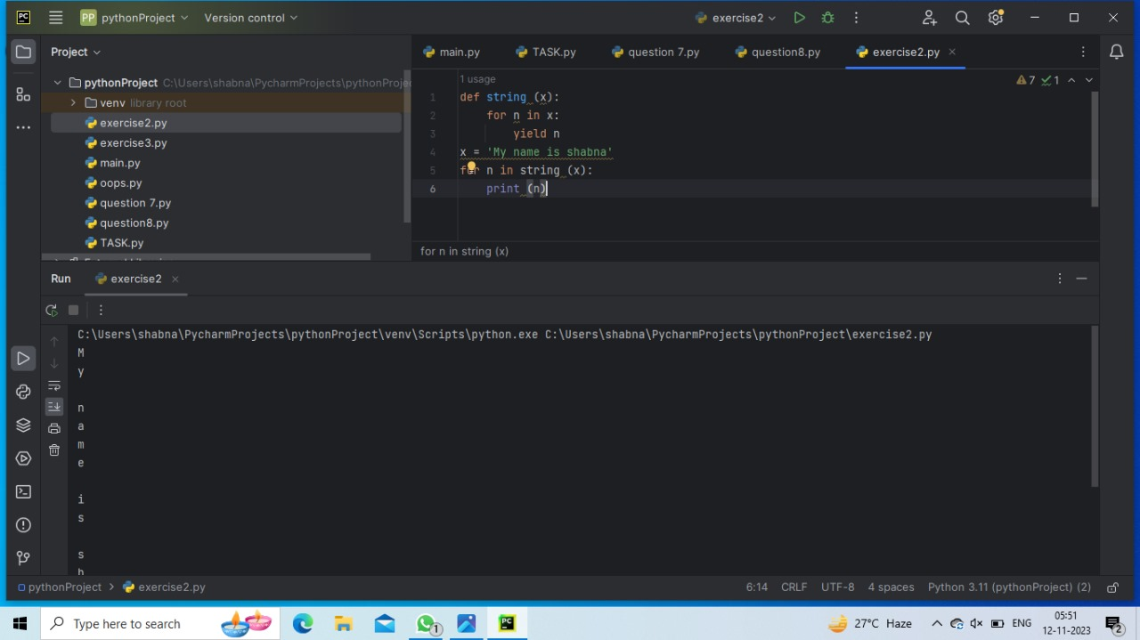

Exercise 2:

Write a generator function that takes a list of integers and yields only the even numbers

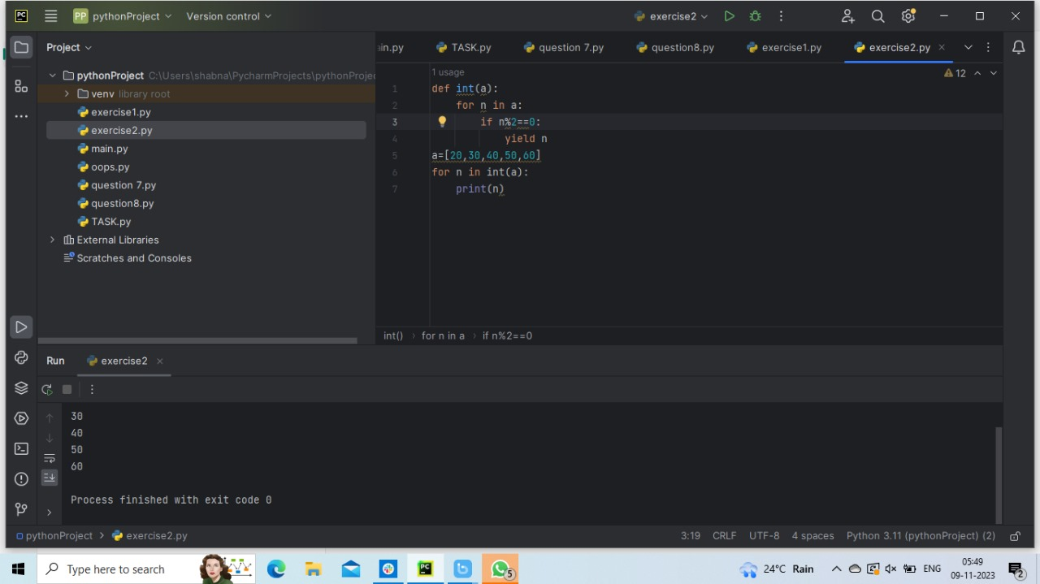

Exercise 3:

Write a generator function that takes a list of strings and yields only the strings that start with a vowel.

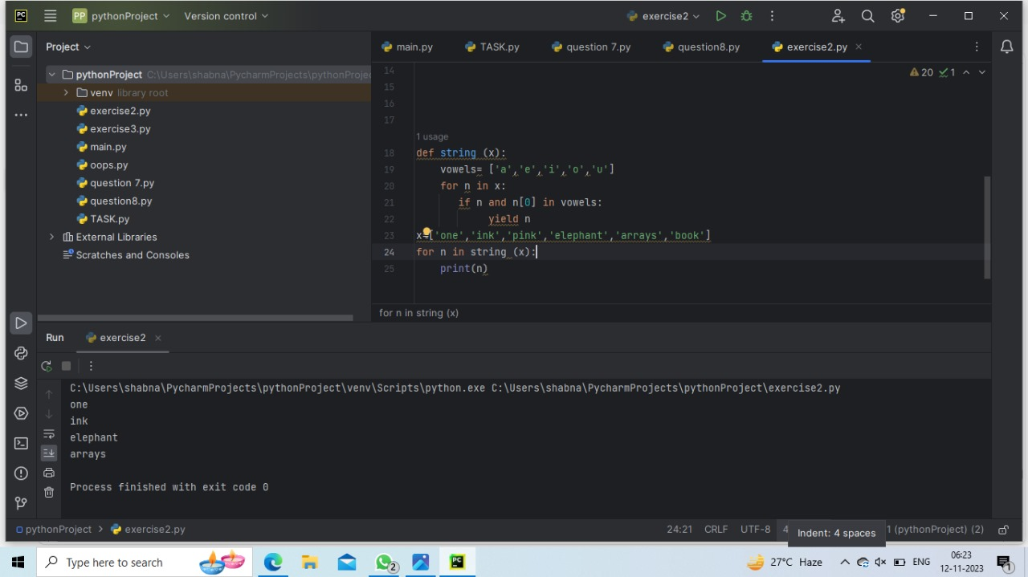

Exercise 4:

Write a decorator function that logs the arguments and return value of a function.

