**SYD366 – Individual Presentation – report**

**Shabnoor Sayed(133649194)**

**Professor Cindy Laurin**

|  |  |  |  |
| --- | --- | --- | --- |
| criteria | No | With some modifications | Yes |
| Able to classify customers according to the client’s requirements? |  |  | Checkmark |
| Able to record price lists as per the client’s requirements? | Checkmark |  |  |
| Classify Inventory? | Checkmark |  |  |
| Record Income? | Checkmark |  |  |
| Record Expenses? |  |  | Checkmark |
| Record Purchases? |  |  | Checkmark |
| Record Sales? |  |  | Checkmark |
| Allow for Scheduling? |  |  | Checkmark |
| Is the software affordable? |  |  | Checkmark |
| Is the software available through Open Source? | NO | | |
| What operating system will this run under? | Checkmark | | |

1. Able to classify customers according to the client’s requirements?  
   The software includes customers and pets tagging system which allows users to distinct the customers by giving them different colors of labels. Users can write anything within those labels also it allows user to add any additional details while creating a customer profile.

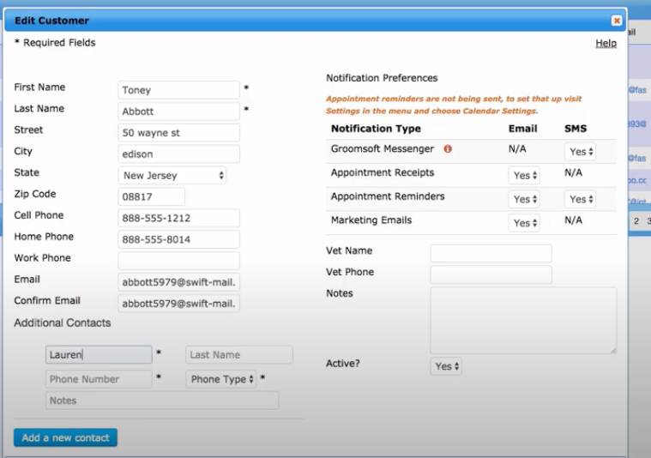 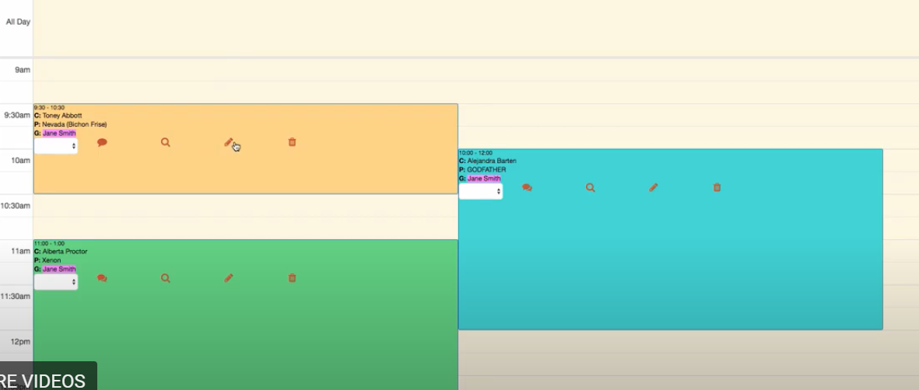

1. Record Expenses?

In their expense tracking system there are multiple categories and we can also add the custom category if we want, the category window allows us to enter further detail about the particular expense and also an option to edit or delete it later.

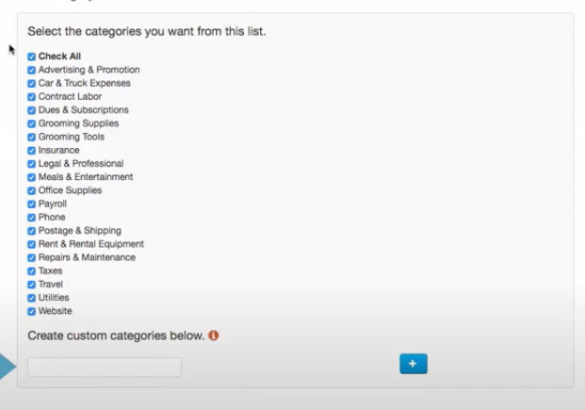

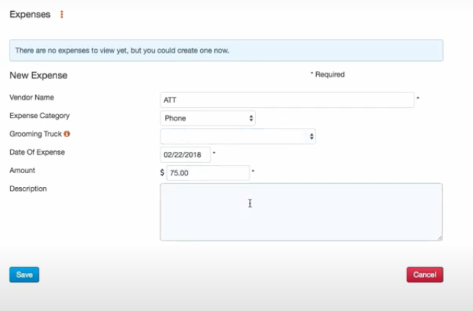



1. Record Purchases?

We can record purchase through the same expense tracking system and also categorize them according to the type of purchase.



1. Record Sales?

This software helps us to record our sales by date, month, year and also the zip code. The software also show the taxes along with that, the taxes include are the flat rate and does not include compounded taxes.

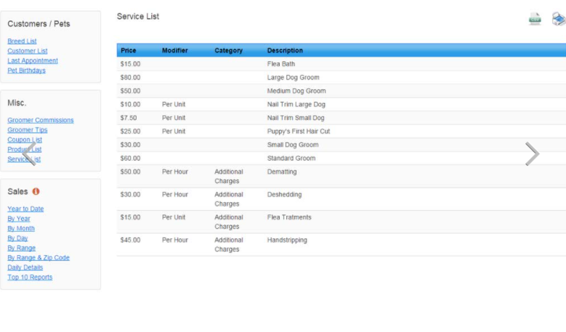

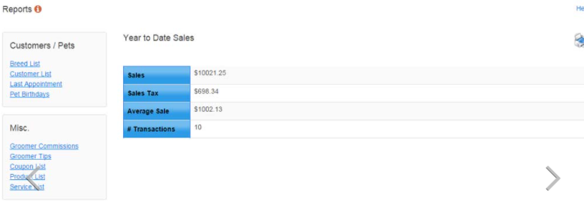

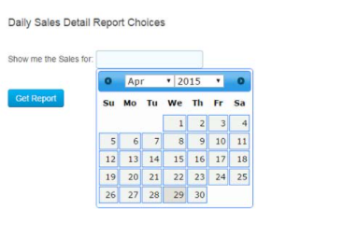 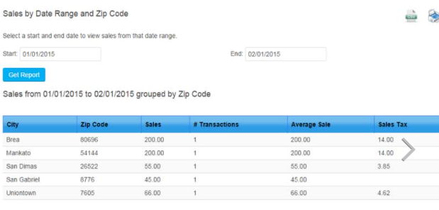

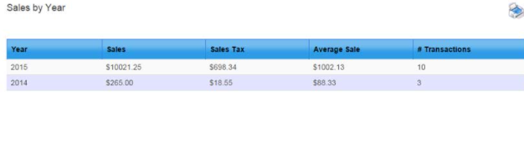 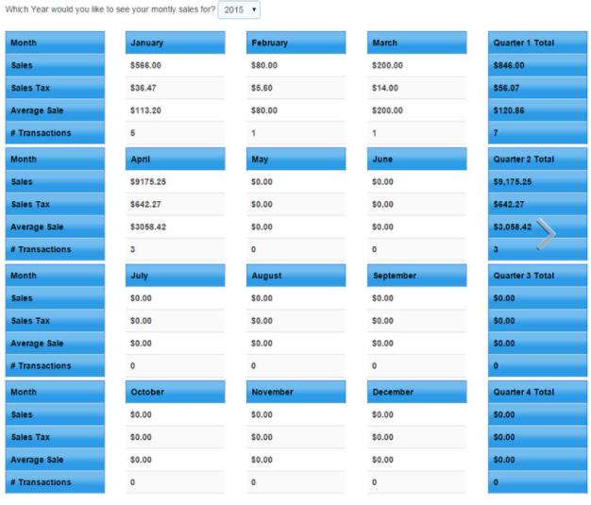

1. Allow for Scheduling?

Using Pet groom finder pet owners can search for the groomers and book themselves the appointment, the groomers can create a customer and schedule the appointment they also have an option to block some time slots and days during which they are not available so that no one can book them for that. The groomers have an option to accept or reject the appointment and If they are full they can also put the customers in the waitlist.

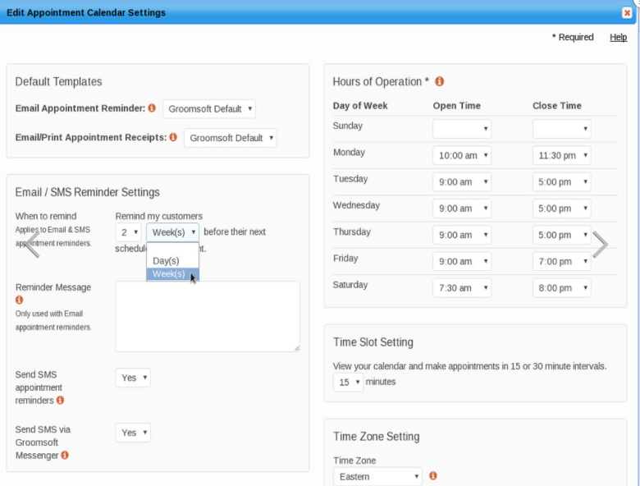

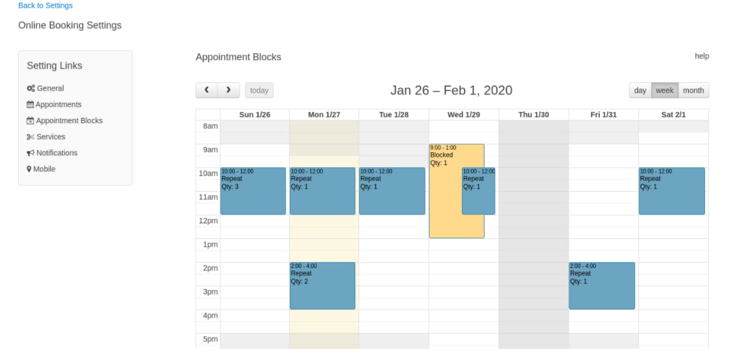

1. Is the software affordable?

Yes, according to many customer reviews it is affordable and have free 100 texts and free email reminder service with their package.

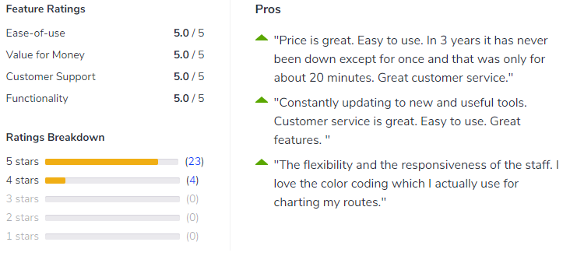

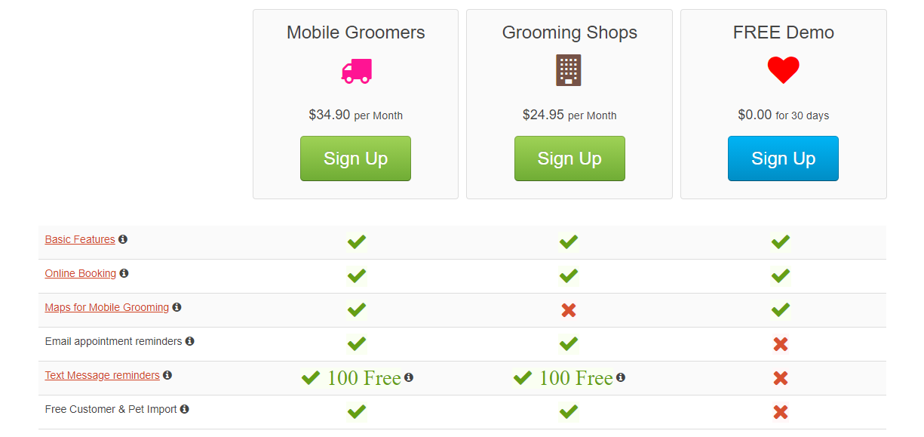

1. What operating system will this run under?

Since we are logging into your account via the internet there is no OS requirement. Groomsoft will work on any device (Mac, Windows, Android, Apple) that has an internet connection. Groomsoft has been tested on the most popular internet browsers such as Edge, Chrome, Firefox and Safari.

