Name: ____Shabnoor Sayed_______________________

Student ID: __133649194___________________________ Section: _NAA_

Please read the case study and answer the questions below. This document, in it’s .docx format, must be submitted to Blackboard before the due date. Please not that submitted work, in any other format will not be graded.

You are welcome to use additional tools (example Visual Paradigm) as long as you copy pictures of your work into this document. The pictures must be legible. Your professor will not grade any work that isn’t easy to read.

You are welcome to use outside sources in formulating your answers. Be sure to reference your work using APA format. ***Work not properly referenced will be passed to the Academic Integrity Committee for review.***

Case Study

Jenny Singh runs *Packing Supplies Ltd*, a small company that supplies packing materials including boxes, bubble wrap, packing ‘pop corn’. Her clients are Moving Companies throughout Canada.

Jenny employs a small team, including some office, sales, and warehouse staff. A few times a year, Jenny attends trade shows and visits manufacturers to learn about new products. Jenny uses an outside delivery service to deliver orders to her clients.

Your team has started looking at Jenny’s inventory records and found that Jenny records weights and measures for each of the products that she stocks, for proper placement in her warehouse and to aid in quick calculation of shipment costs. Jenny orders product from various suppliers through their online ordering portals, and must record her purchases so that she knows what she’s purchased and what’s arrived to stock in her warehouse.

Your team leader has written the following scenarios to capture Jenny’s requirements.

|  |  |  |  |
| --- | --- | --- | --- |
| Use Case Name | Create Product Information | | |
| Triggering Event | A new product of interest to the business | | |
| Brief Description | Allows the Owner to record a new product. | | |
| Actors | Owner | | |
| Related Use Cases |  | | |
| Preconditions | Owner has opened the Main Menu. | | |
| Post Conditions | Product is saved to the database and now can be purchased or used in a service. | | |
| Flow of activities | Actor | | System |
|  |  | Requests to add a new product | Displays a list of products currently recorded in the system and prompts to add a new product. |
|  |  | Enters the product name, description, weight, height, width, and depth of the new product. | Verifies that all of the data is entered. Displays the newly created product and requests to save. |
|  |  | Request to save | Saves the product and returns to the main menu |
| Exception Conditions | * Owner chooses to cancel adding the product | | |

|  |  |  |  |
| --- | --- | --- | --- |
| Use Case Name | Create Purchase | | |
| Triggering Event | Purchase of a product. | | |
| Brief Description | Allows the Owner to record a new purchase. | | |
| Actors | Owner | | |
| Related Use Cases |  | | |
| Preconditions | Owner has opened the Main Menu. | | |
| Post Conditions | Purchase is saved to the database and now can be queried. | | |
| Flow of activities | Actor | | System |
|  | 1. | Requests to add a new purchase | Displays a list of suppliers and prompts for selection. |
|  | 2. | Selects a supplier. | Verifies that a supplier was selected. Prompts for purchase date and selection of receipt file location. |
|  | 3. | Enters purchase date and receipt file selected. | Verifies that date was entered and receipt selected.  Creates a unique identifier for the purchase. Prompts to enter product details. |
|  | loop | Chooses new detail | Displays a list of product and prompts for selection. Prompts for price, quantity ordered, and quantity received |
|  | 4. | Selects a product and enters price and quantity. | Product must be selected.  Price and quantity must be entered  Data is valid  Weight of the purchase is calculated.  Displays purchase including weight, date and list of products.  Prompts to add another product |
|  | End | When all products selected | Displays purchase including totals, date and list of products.  Verifies that at least one product has been selected.  Prompts to save purchase |
|  | 5. | Chooses to save | Saves the purchase and returns to the main menu |
| Exception Conditions | * Owner chooses to cancel adding the purchase | | |

Question 1 (worth 10 marks)

Complete a class diagram to support what your team has learned so far about *Packing Supplies Ltd.*

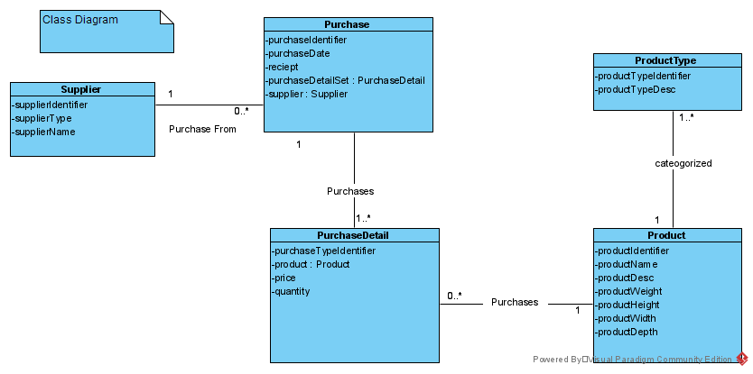

Question 2 (worth 20 marks)

Complete sequence diagrams to support the above scenarios.

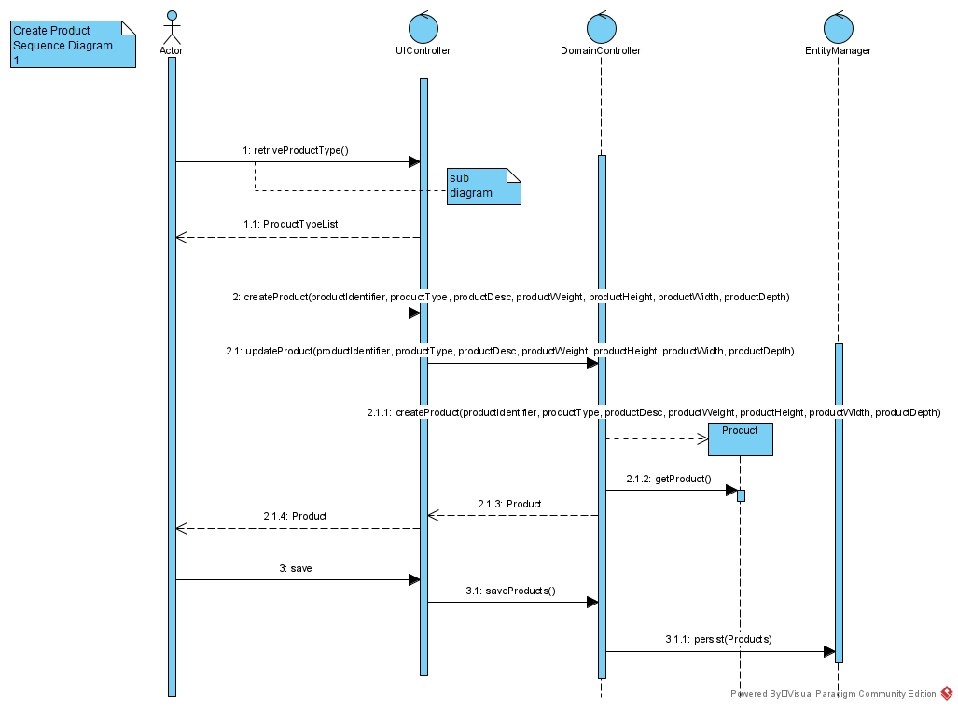

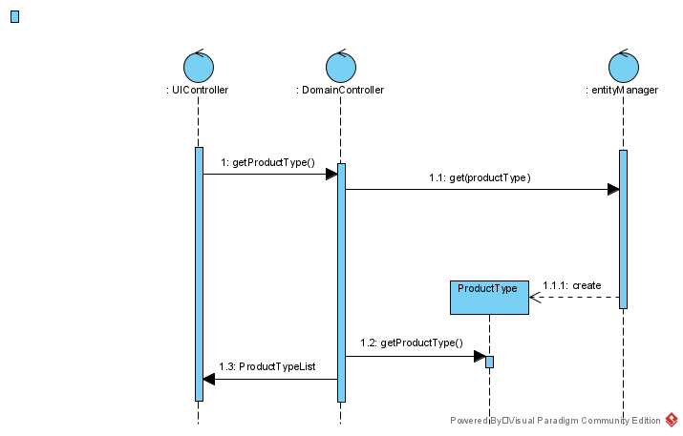

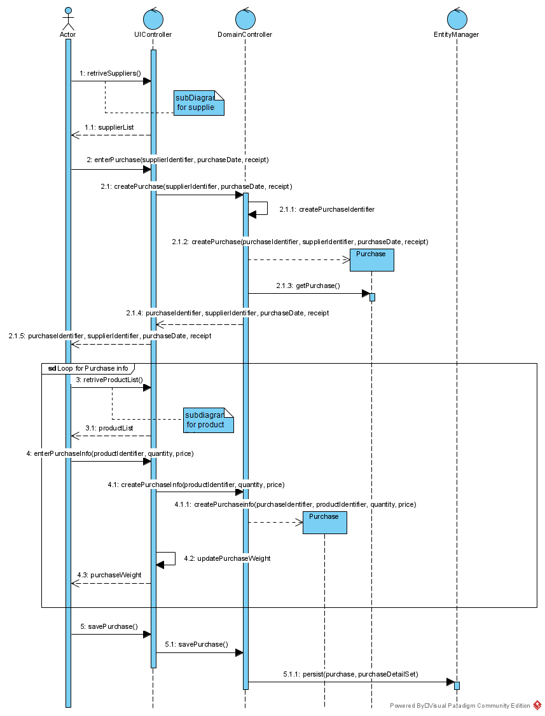

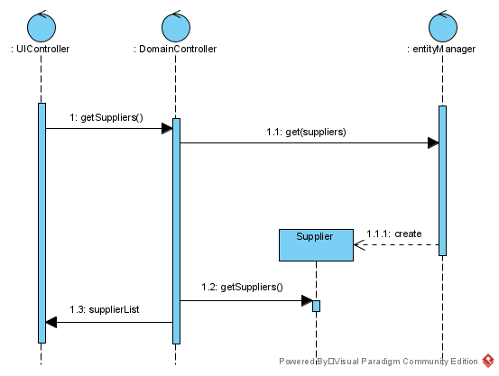

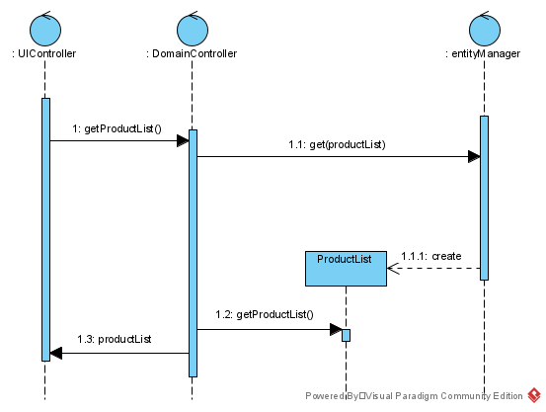

Question 3 (worth 5 marks)

Jenny would like the system to suggest where to store items in the warehouse. Different racks in her warehouse can hold different weights. How would you incorporate this change in your model? Please describe in English.

**ANSWER:** We could make an additional information about racks in the warehouse that would tell us the type of rack and the amount of maximum weight it can hold.

Question 4 (worth 5 marks)

What is WHMIS? Is this important to Jenny?

**ANSWER:** WHIMS is Workplace Hazardous Materials Information System and it is Canada’s national hazard communication standard, working with hazardous chemicals and elements can be harmful so therefore according to this standard it is the employer’s responsibility to provide proper training and information to the employees and others for precautions. If Jenny is working with any hazardous substance like any kind of adhesive or any other products then they need to be properly addressed and Jenny needs to follow WHIMS.

Question 5 (worth 5 marks)

Jenny finds a sale on packing tape and would like to buy six months worth of product. How would she use your model to figure out how many to buy?

**ANSWER:** She needs to see how much stock she is reordering and at what point in time and also need to measure her sales trends by those things she will be able to predict how much inventory it is needed.

Question 6 (worth 5 marks)

Jenny currently buys from local retailers and from Amazon. Should she buy from a wholesaler or distributor? What would be the advantages and disadvantages in doing so?

**ANSWER:** Buying from wholesalers and distributors will be a lot cheaper for Jenny and would be a good choice but she also would have to make sure that she knows the amount of quantity she needs to order. A disadvantage order from wholesale is that they do bulk orders and if there are any materials which jenny use and has a low expiry might have a chance of getting expired if she couldn’t use them all.

Question 7 (worth 5 marks)

Jenny had an idea: What about if the system could tell her when she will start to run out of a product? How would your model change to accommodate this?

**ANSWER:** She can use SKU to keep track of all her inventories and then can manage her inventories. SKU is short for Stock Keeping Unit and is a code which we can use to identify and search the stock which we have.