Name: __________Shabnoor Sayed ____________________________________________

Student ID: ________133649194___________________________ Section: _NAA_____

Please read the case study and answer the questions below. This document, in it’s .docx format, must be submitted to Blackboard before the due date. Please not that submitted work, in any other format will not be graded.

You are welcome to use additional tools (example Visual Paradigm) as long as you copy pictures of your work into this document. The pictures must be legible. Your professor will not grade any work that isn’t easy to read.

You are welcome to use outside sources in formulating your answers. Be sure to reference your work using APA format. ***Work not properly referenced will be passed to the Academic Integrity Committee for review.***

Case Study

Jenny Tourneaux runs *Auto Supplies Ltd*, a small company that supplies aftermarket auto mobile parts to local garages.

Jenny employs a small team, including some office, sales, and warehouse staff. A few times a year, Jenny attends trade shows and visits manufacturers to learn about new products. Jenny uses an outside delivery service to deliver orders to her customers.

Your team has been hired to document Jenny’s requirements and recommend software for Jenny to purchase.

Your team has started looking at Jenny’s financial records and found that Jenny allows for different payment methods and would like to categorize her income and expense transactions accordingly.

Your team leader has written the following scenarios to capture Jenny’s requirements.

|  |  |  |  |
| --- | --- | --- | --- |
| Use Case Name | Record Income Transaction | | |
| Triggering Event | Customer pays for work done | | |
| Brief Description | Allows the Owner to record an income transaction | | |
| Actors | Owner | | |
| Related Use Cases |  | | |
| Preconditions | Owner has opened the Main Menu. | | |
| Post Conditions | Income transaction is recorded | | |
| Flow of activities | Actor | | System |
|  | 1. | Requests to record an income transaction | Displays a list of payment methods and prompts for selection. Prompts for amount of transaction and transaction date (defaults to the system date) |
|  | 2. | Selects a payment method, enters date and amount | Displays the transaction and prompts for confirmation |
|  | 3 | Chooses to confirm | Saves the transaction. |
| Exception Conditions | * Owner chooses to cancel recording income transaction. | | |

|  |  |  |  |
| --- | --- | --- | --- |
| Use Case Name | Query Expense transactions | | |
| Triggering Event | Owner requires a list of expenses | | |
| Brief Description | Allows the Owner to review expense transactions | | |
| Actors | Owner | | |
| Related Use Cases |  | | |
| Preconditions | Owner has opened the Main Menu. | | |
| Post Conditions | Expense transactions retrieved | | |
| Flow of activities | Actor | | System |
|  | 1. | Requests to query expense transactions | Prompts for start and end date |
|  | 2. | Enters a start and end date | Retrieves expense transactions that meet the date requirements. Displays the list |
| Exception Conditions | * Owner chooses to cancel querying expense transactions. | | |

Question 1 (worth 10 marks)

Complete a class diagram to support what your team has learned so far about *Auto Supplies Ltd.*

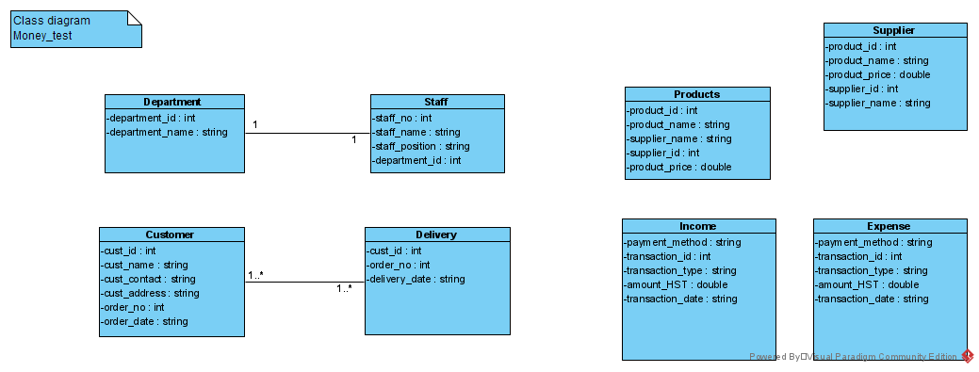

Question 2 (worth 20 marks)

Complete sequence diagrams to support the above scenarios.

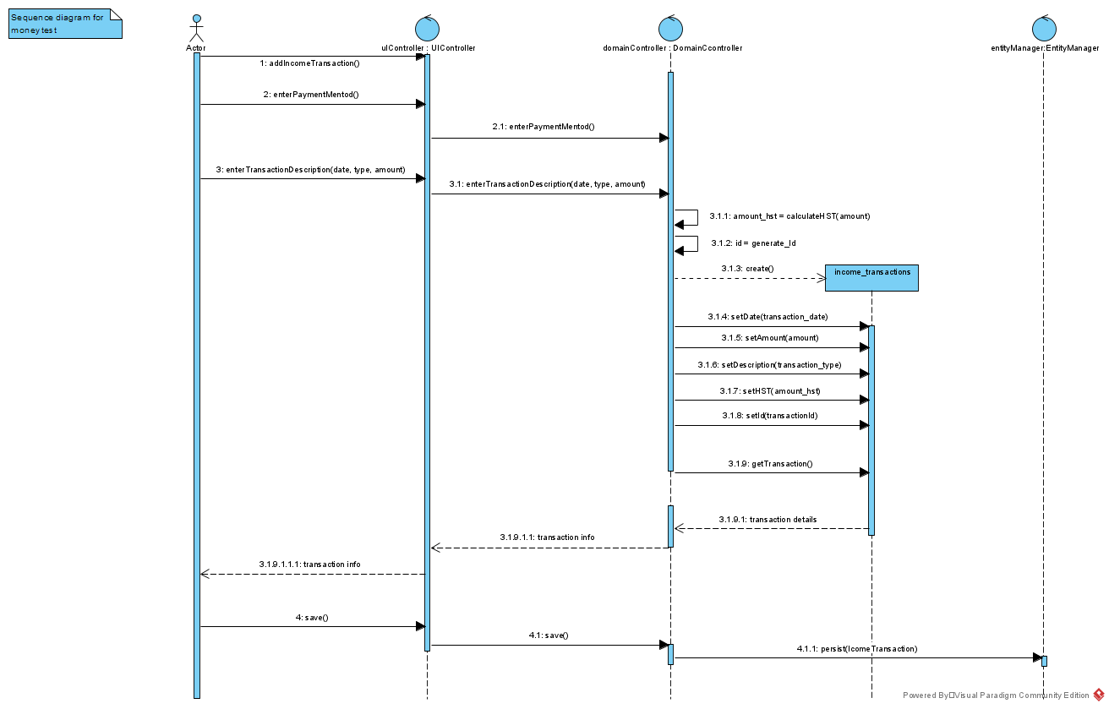

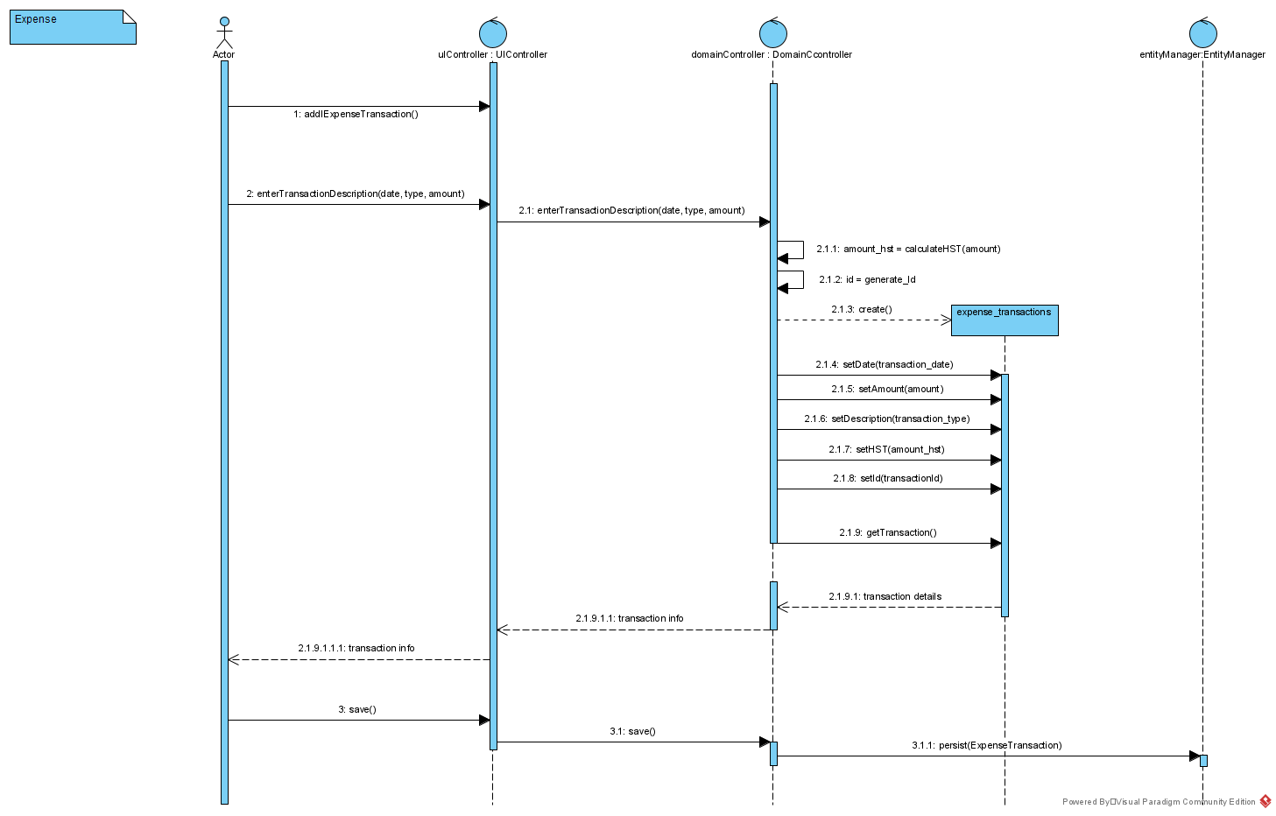

Question 3 (worth 5 marks)

Jenny is considering recording the customer related to each sale. How will this change your class diagram? How will this change the scenarios and sequence diagrams? Please describe in English.

**Answer:**

If she wishes to record each sale related to customer we would need an order class in which we will have the order number, what product is ordered and other customer and order details along with the price, quantity and dates of order and delivery. On our sequence diagram we have to categorize all the transactions according to the customer we can do it with customer id, in this way she can track her individual transactions.

Question 4 (worth 5 marks)

One of Jenny’s favorite suppliers offers points on purchases. Jenny like to include these points when summarizing her transactions. She would like to record when she uses points to buy products from these suppliers. From the government’s standpoint, these sales are HST exempt. How would you change the model that you created to support this change in requirements?

**Answer:**

So, the amount in our model will then be categorized into two the one to which HST applies and the second one to which HST doesn’t apply. We can check each time a transaction is entered that what type of payment method we are using and then check if the HST applies to that particular payment method, if it does then we will proceed s normal but if it doesn’t then we will put it in a category where we don’t need to calculate HST.

Question 5 (worth 5 marks)

Some goods and services are HST exempt? What are they? Would there be any benefits to Jenny’s auto supply business?

**Answer:**

If the business is a small business which means that the total revenue of 4 consecutive quarter is less than $30,000 then it is exempted.  
There are some supplies like milk, shampoo or other grocery items are considered as zero rated which means that the tax applied to them are at the rate of 0%.

If Jenny 4 consecutive quarterly revenue is less than $30,000 she will be exempted from the tax but if it is more than 30,000 for even a single she has to file for the tax on the supply that made her exceed. If she exceeds more then over a single quarter calendar then she has to pay tax on all her supplies.

Question 6 (worth 5 marks)

Jenny is a small business owner. Some of her clients have asked if they pay cash, can they avoid paying tax? Is this a good idea for Jenny? What about her clients?

**Answer:**

This type of method to avoid paying tax is considered as underground economy and the people or business doing it can face serious penalties and criminal offense, Jenny should absolutely avoid doing such acts and also advised about the government policies about such acts.

Question 7 (worth 5 marks)

*Auto Supplies Ltd’s* project is documenting the business’s requirements for a new system. We’ve looked at Agile and Waterfall (Predictive) Project Management methodologies. You are a team of 3 analysts and a Project Manager. If you were the Project Manager, what Project Management Methodology would you use for this project? And why?

**Answer:**

I would use Agile Methodology as it involves a lot of collaboration and I believe that more ideas can make the system more effective and diverse as when designing any system, we not just have to cover the base requirements but also make sure that every other part like it is equal for all (racial and other aspects). Agile Methodology also allow to focus on each step carefully to avoid any errors, as all the things are tested at the end.

**Reference:**

Canada Revenue Agency. (2020, October 2). General Information for GST/HST Registrants - Canada.ca. Retrieved October 16, 2020, from <https://www.canada.ca/en/revenue-agency/services/forms-publications/publications/rc4022/general-information-gst-hst-registrants.html#H1_106>

Canada Revenue Agency. (2019, April 15). Type of supply - Canada.ca. Retrieved October 16, 2020, from <https://www.canada.ca/en/revenue-agency/services/tax/businesses/topics/gst-hst-businesses/charge-collect-type-supply.html#examplezer>

(I have also referred class notes, discussions, money lab and other class labs, I tried to search how to cite those but couldn’t find)