Practice Plots

John Jacob Jingleheimer Schmidt

Janurary 25, 2019

*I guess we aren’t playing with this feature too much*

# leture05 Grafphics and plots with R  
  
# section 2a: line plot  
  
w <- read.table("bimm143_05_rstats/weight_chart.txt", header=TRUE)  
  
plot(w$Age, w$Weight, type="o", pch=15, col= c(1:20),   
 cex=1.5, lwd=2, ylim= c(2,10), xlab=("Age (months)"),   
 ylab="Weight (kg)", main= "baby weight plot")

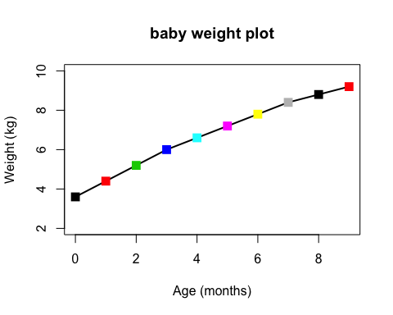

fc<- read.table("bimm143_05_rstats/feature_counts.txt", header=TRUE,   
 sep="\t")  
  
par(mar= c(5.1, 11.0, 4.1, 2.1))  
  
barplot(fc$Count, horiz = TRUE, ylab= "",   
 names.arg = fc$Feature, main= "babaganush", las=1, col=2:10)

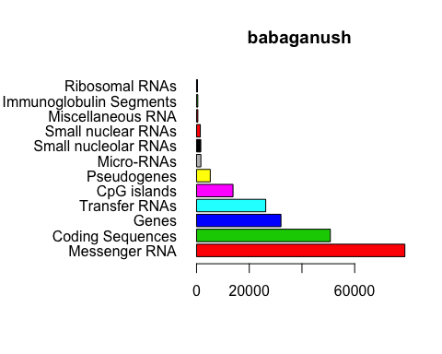

mfc<- read.table("bimm143_05_rstats/male_female_counts.txt", header=TRUE,  
 sep="\t")  
  
par(mar=c(8,5,4,4))  
  
barplot(mfc$Count, names.arg= mfc$Sample, las=2, ylab= "People",   
 main = "Those who have met Cathulhu", col=c("red2", "purple2"))

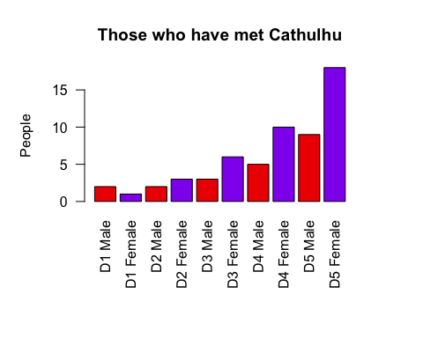

ud<- read.delim("bimm143_05_rstats/up_down_expression.txt")  
nrow(ud)

## [1] 5196

table(ud$State)

##   
## down unchanging up   
## 72 4997 127

palette(c("purple", "gray", "orange"))  
plot(ud$Condition1, ud$Condition2, col=ud$State,   
 xlab="Amount eaten", ylab= "The Gainz", main= "HULKING OUT")

