

**NAMA : SHABRINA QOTTRUNNADA**

**KELAS : 1G**

**ABSEN : 24**

**NIM : 2341760160**

**JOBSHEET 11**

**EXPERIMENT 3**

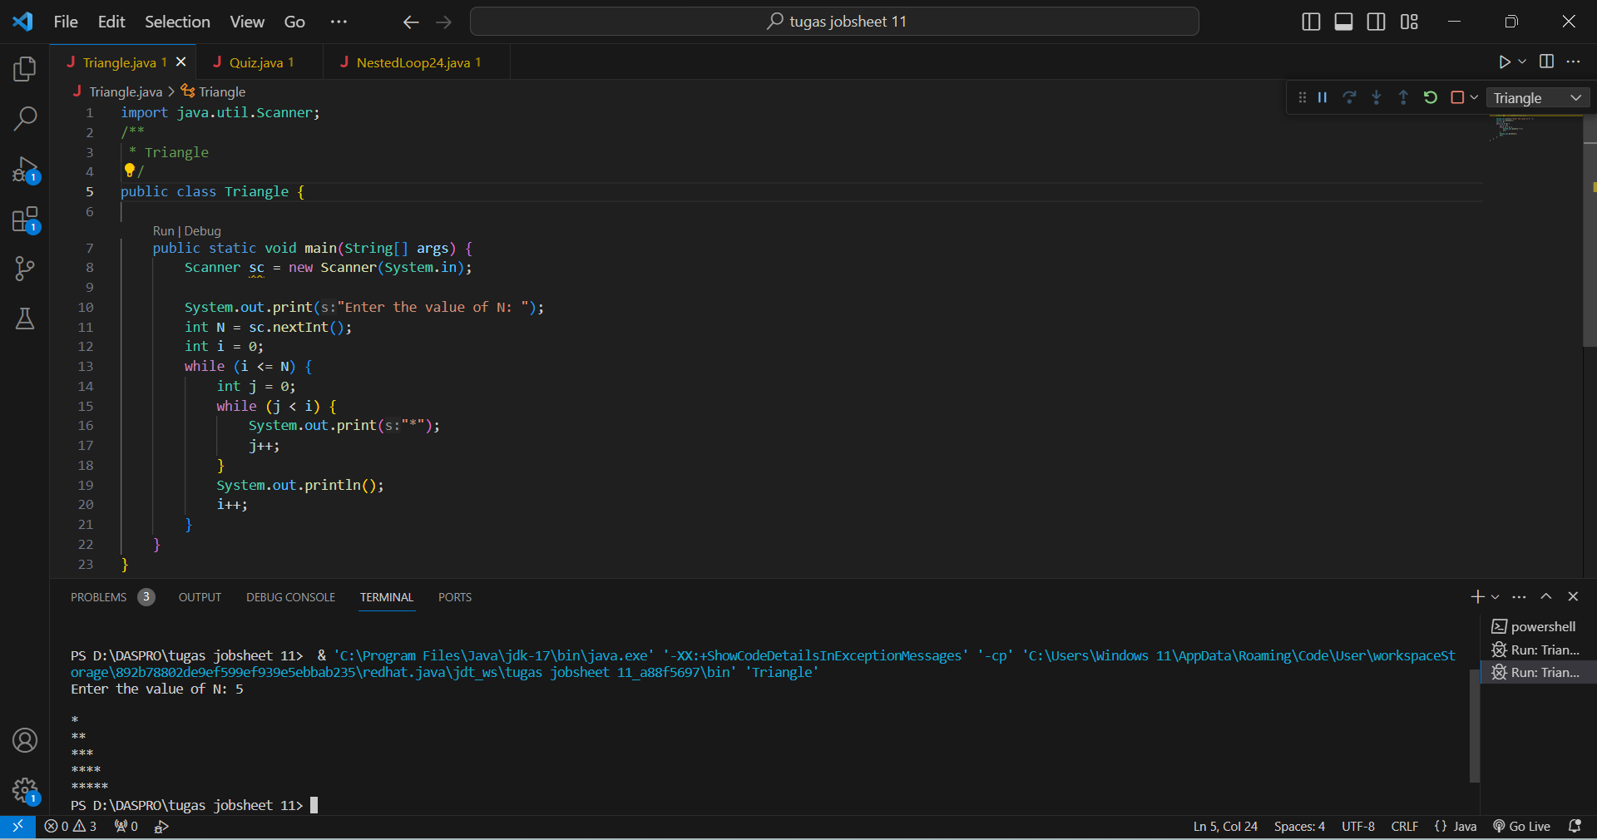

Questions!

1. Look at the results, does the output produced with a value of N = 5 match the following display?

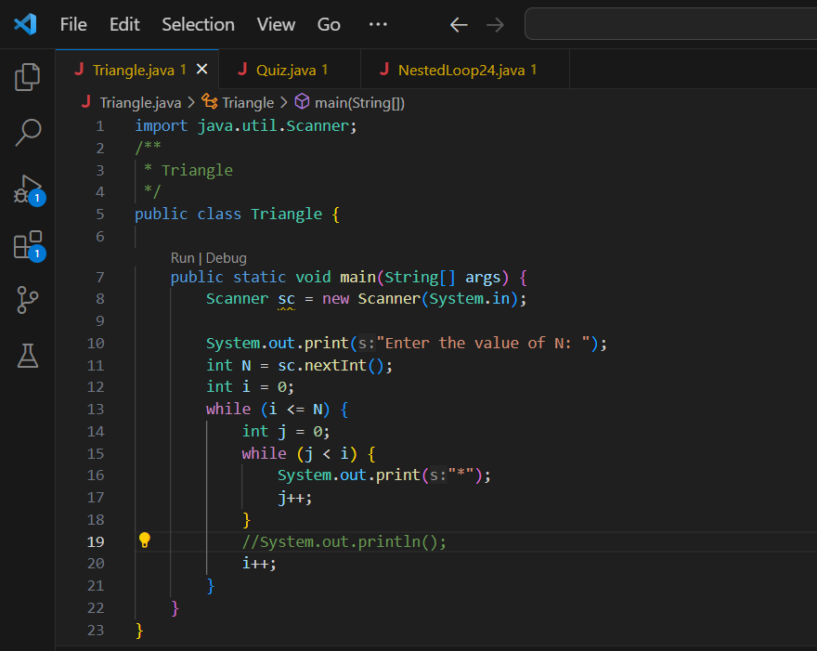



the output produced with a value of N = 5 above is not in accordance with what is displayed and the result is instead 1 row of stars, not a triangle of stars.

1. If not, which parts should be improved or added? Describe any parts that need to be improved or added!

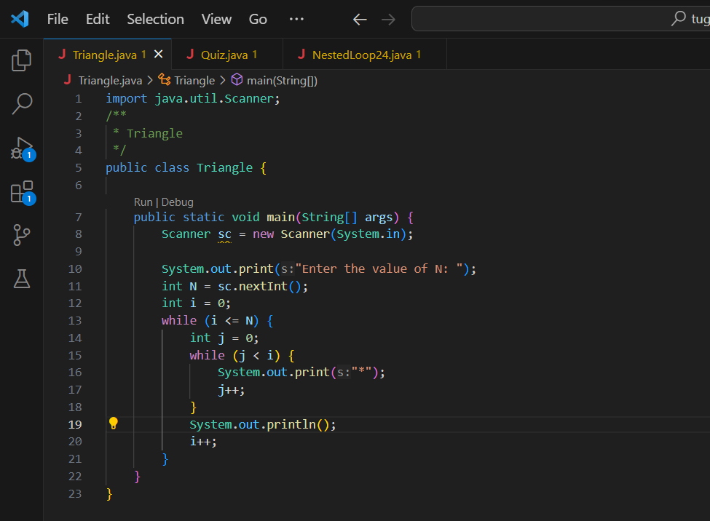

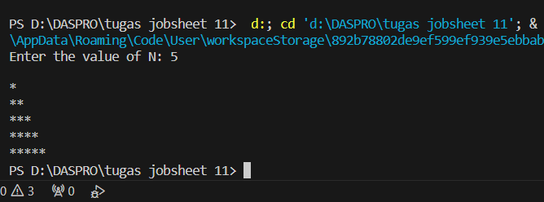

We only need to add the input System.out.println(); at the top of i++ and then the result will be as shown which is a star triangle.

**EXPERIMENT 4**

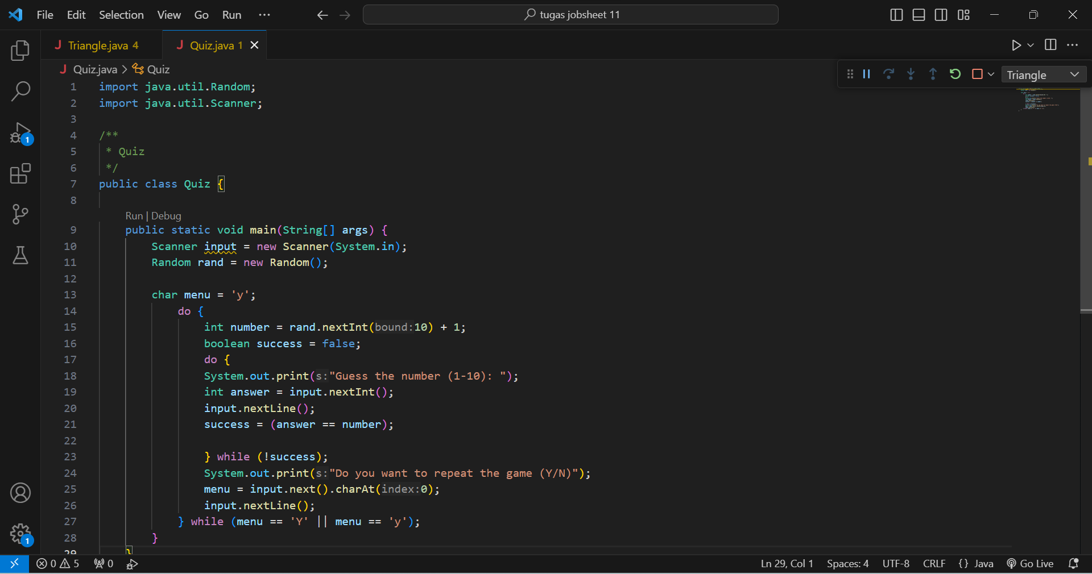

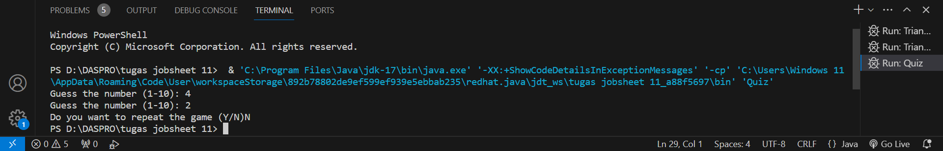

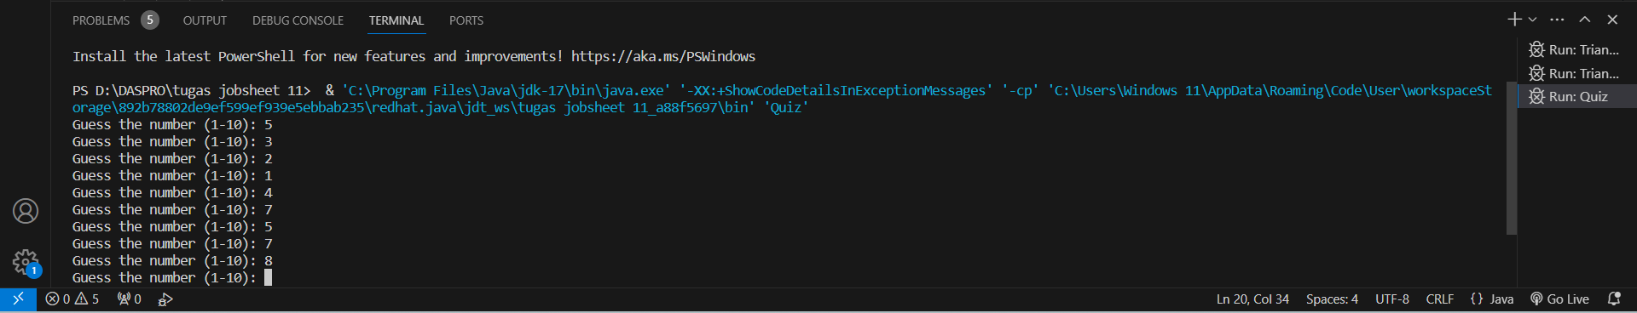

Questions!

1. Explain the program flow in Experiment 4!

When the program is run and we enter one of the numbers from 1-10, the program will continue to run without stopping if the guess of the number we entered is not correct.

1. What must be done to discontinue (not repeat) the game?

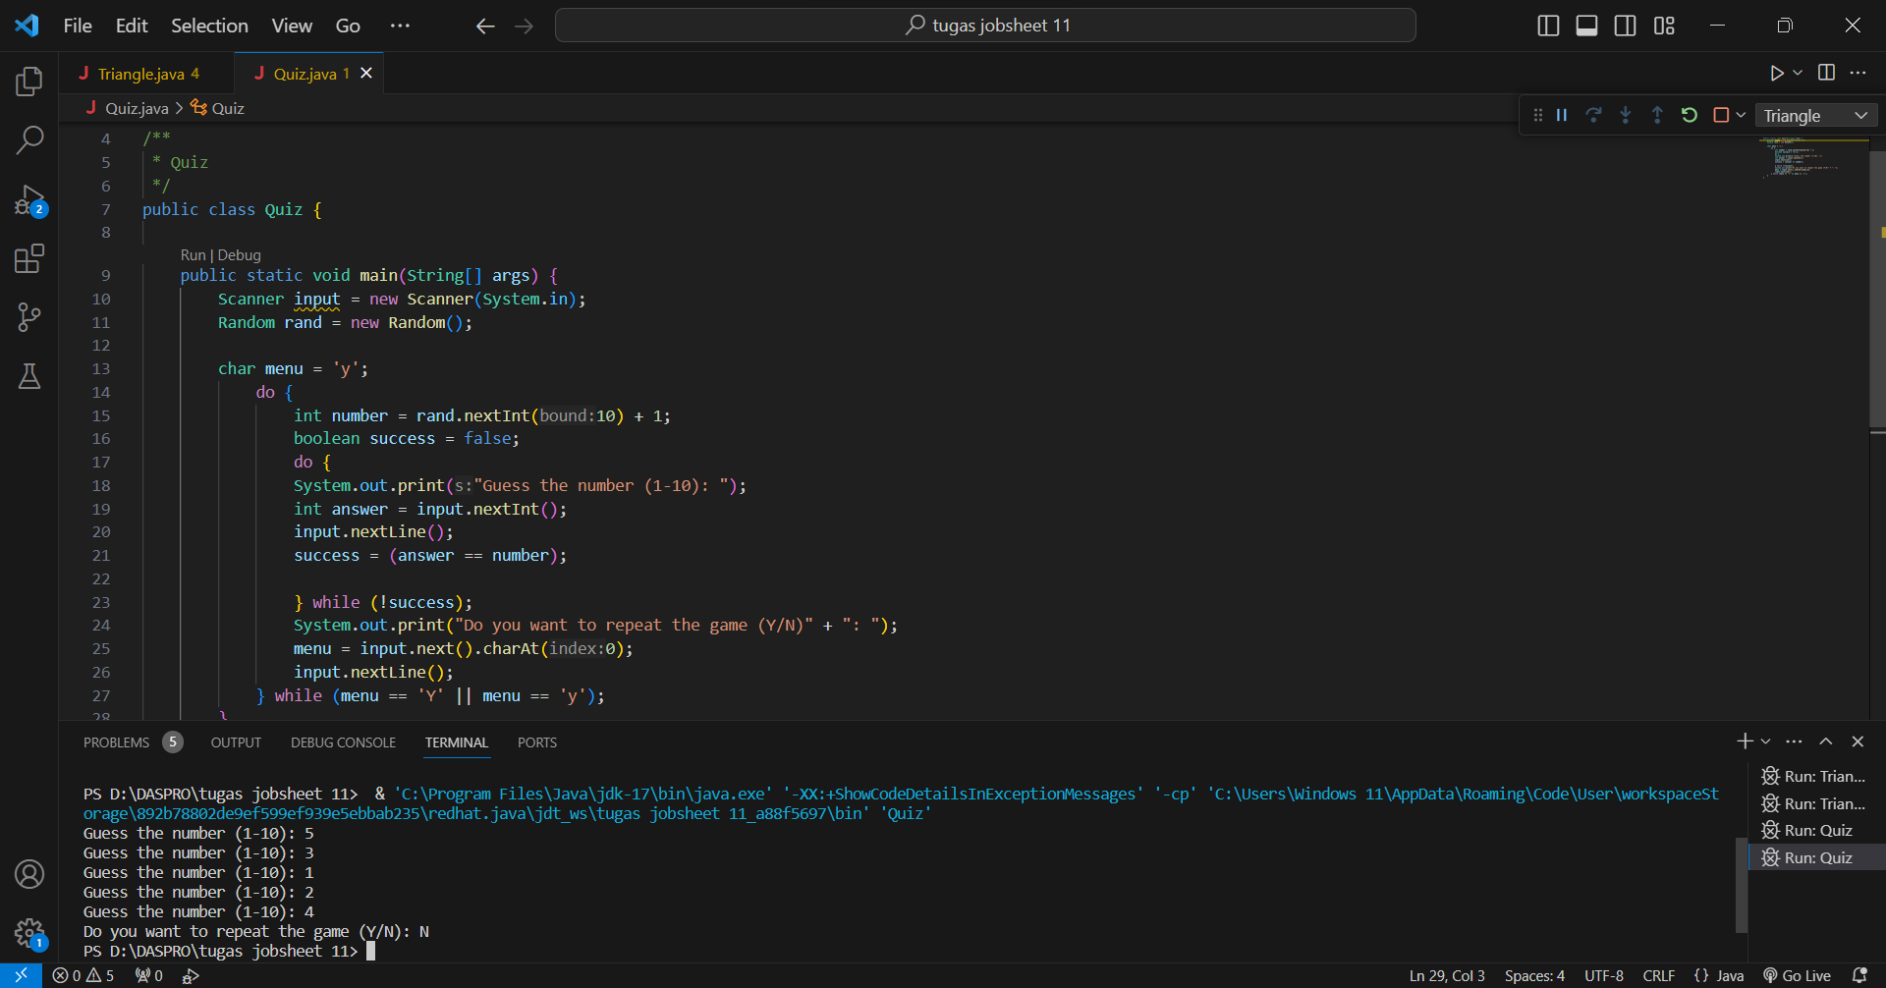

The way to stop the program is by adding ":" after System.out.print("Do you want to repoat the game (Y/N)"); and we write the input N to stop the game.

1. Modify the program above, so that it can display information about: input the guess value entered by the user, whether it is smaller or greater than the answer (number) randomly determined by the computer!

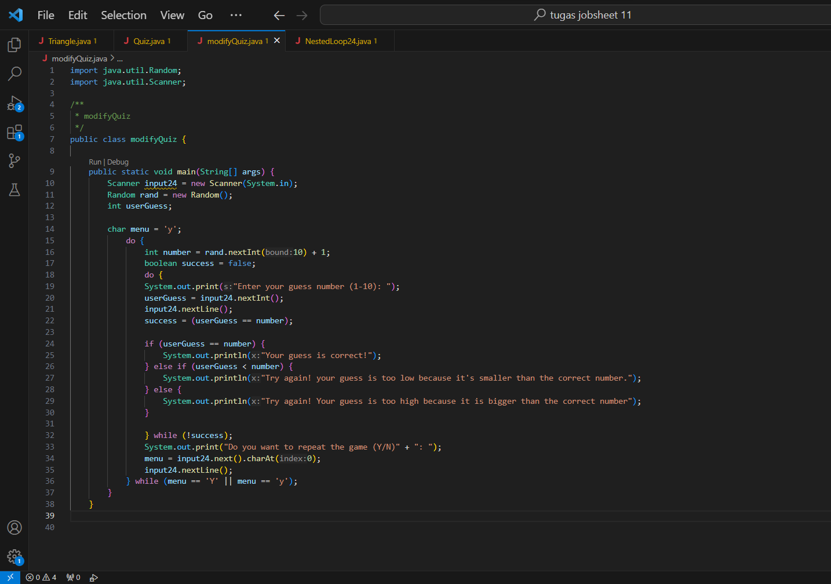

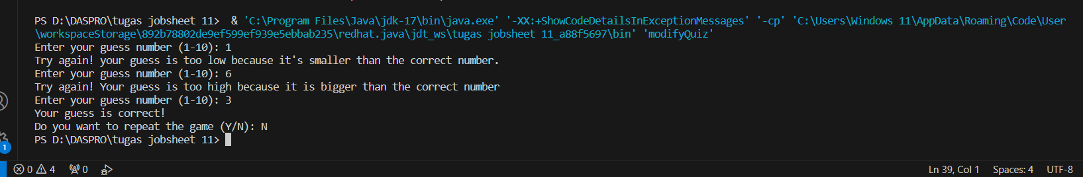

1. Commit and push the changes to GitHub

**EXPERIMENT 5**

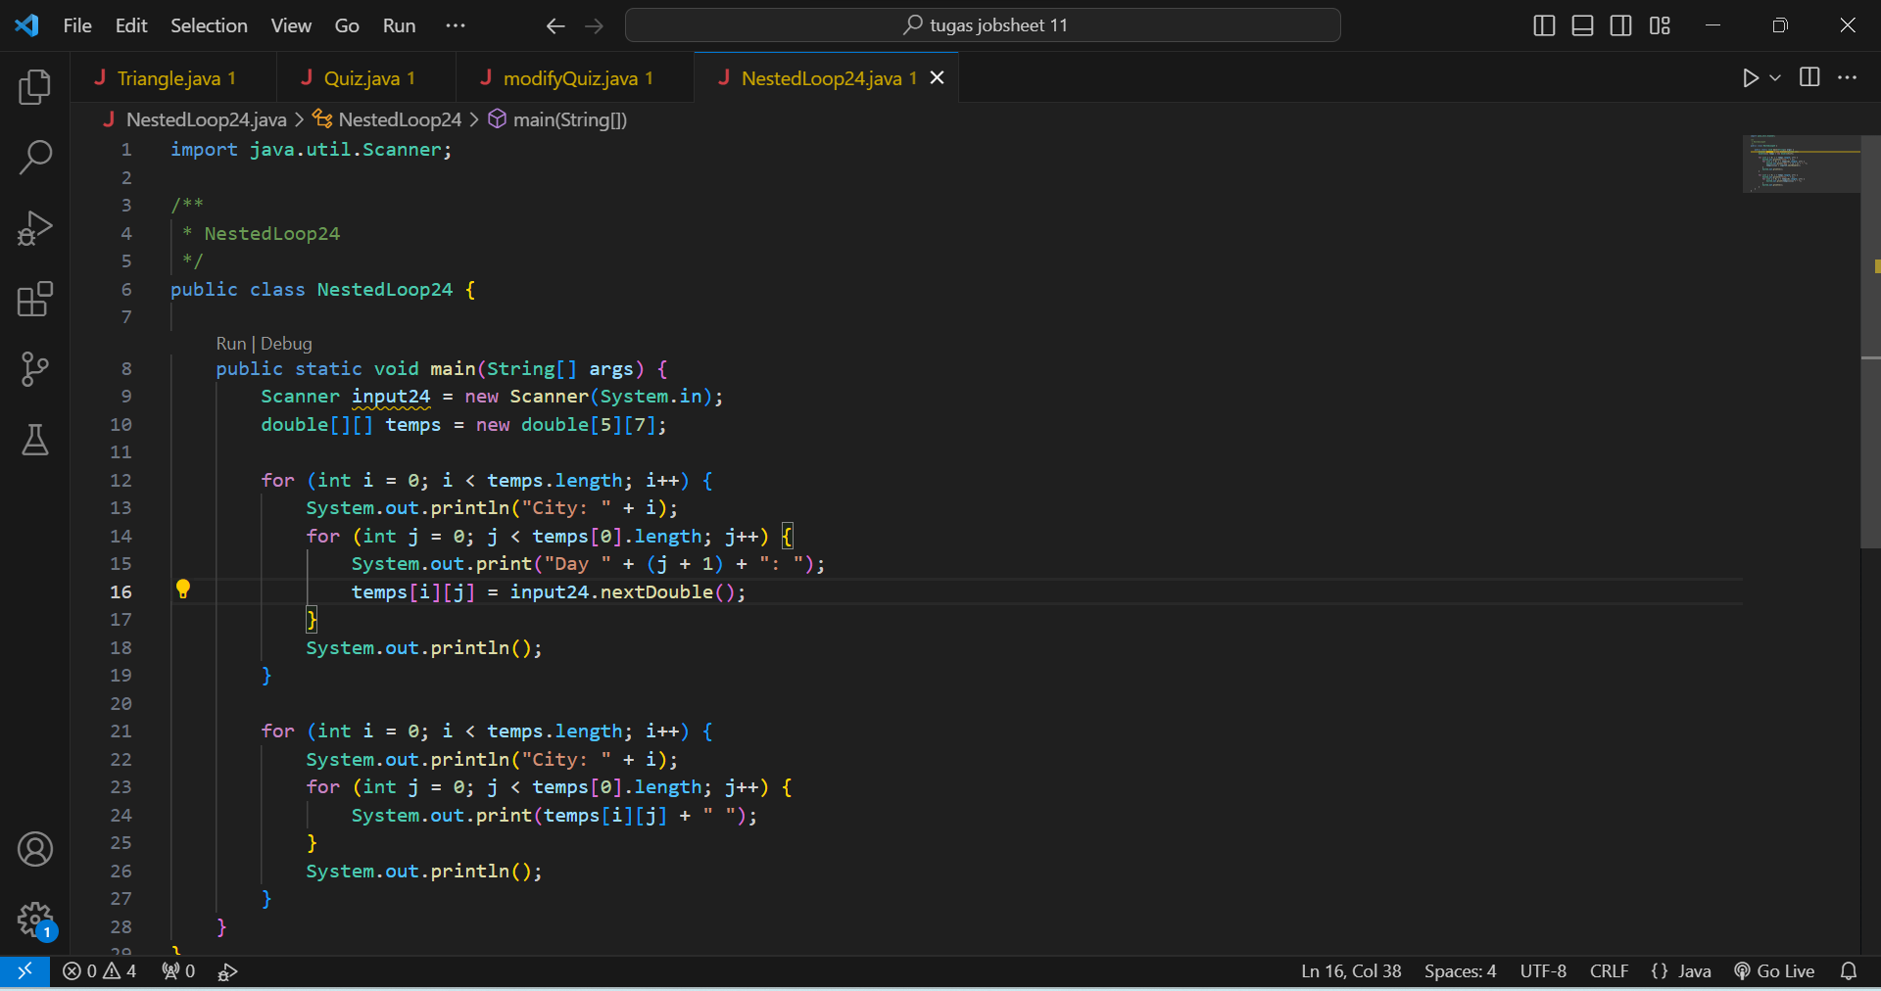

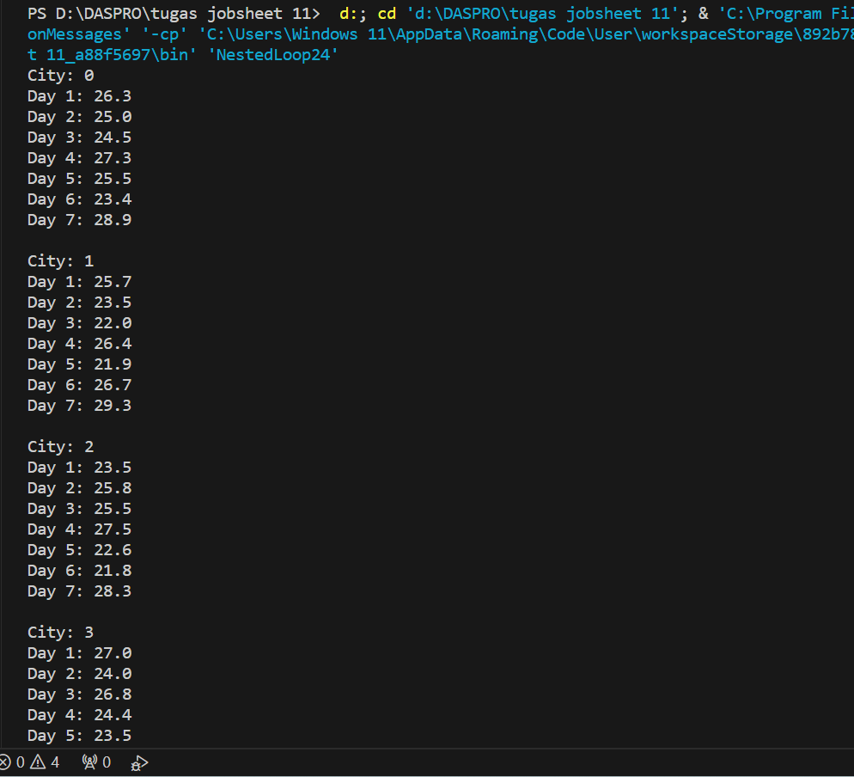

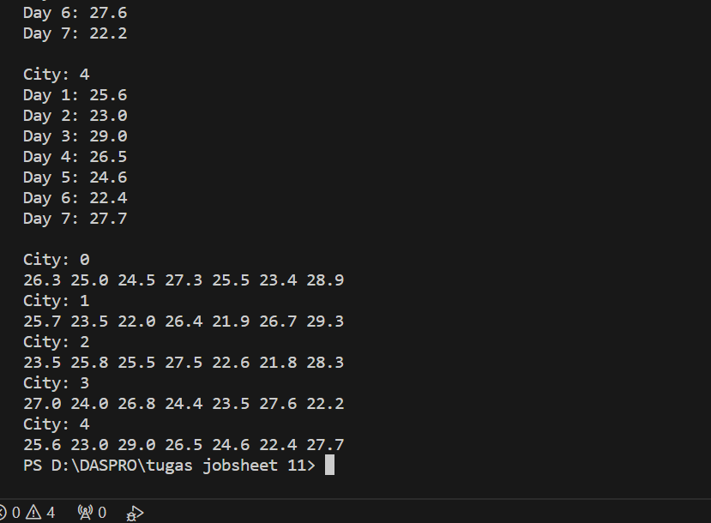

Questions!

1. Explain the program flow in Experiment 5!



It’s purpose is to take input from the user.



In the matrix for temperature storage, there are 5 rows (designated for a city) and 7 columns (designated for a day).



Used to display city numbers starting from 0 for users.



In the program we are instructed to enter the temperature number on each day (certain).



the use of the program code is to store the temperature number (input) that we write on the matrix.

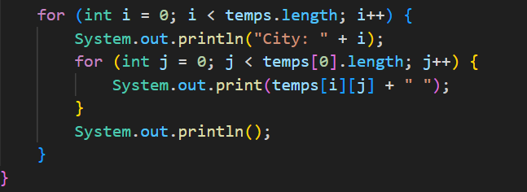

The use of the program code (input) above is to display the results of the matrix that we have created and of course in the matrix row (5) is used for the city, then column (7) is used for temperature.

1. Modify the program to display an array using foreach!

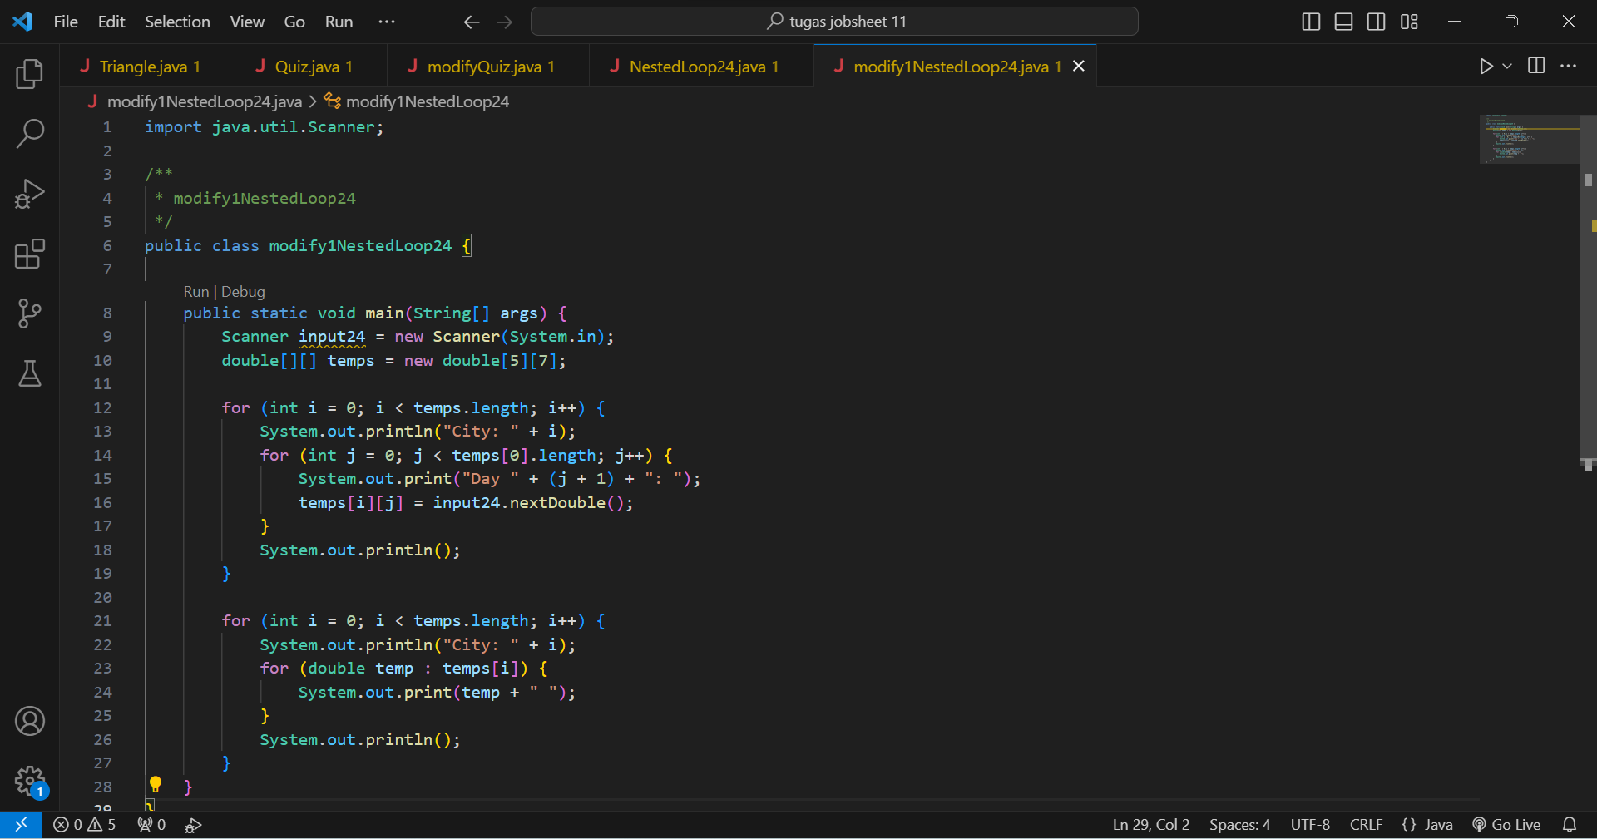

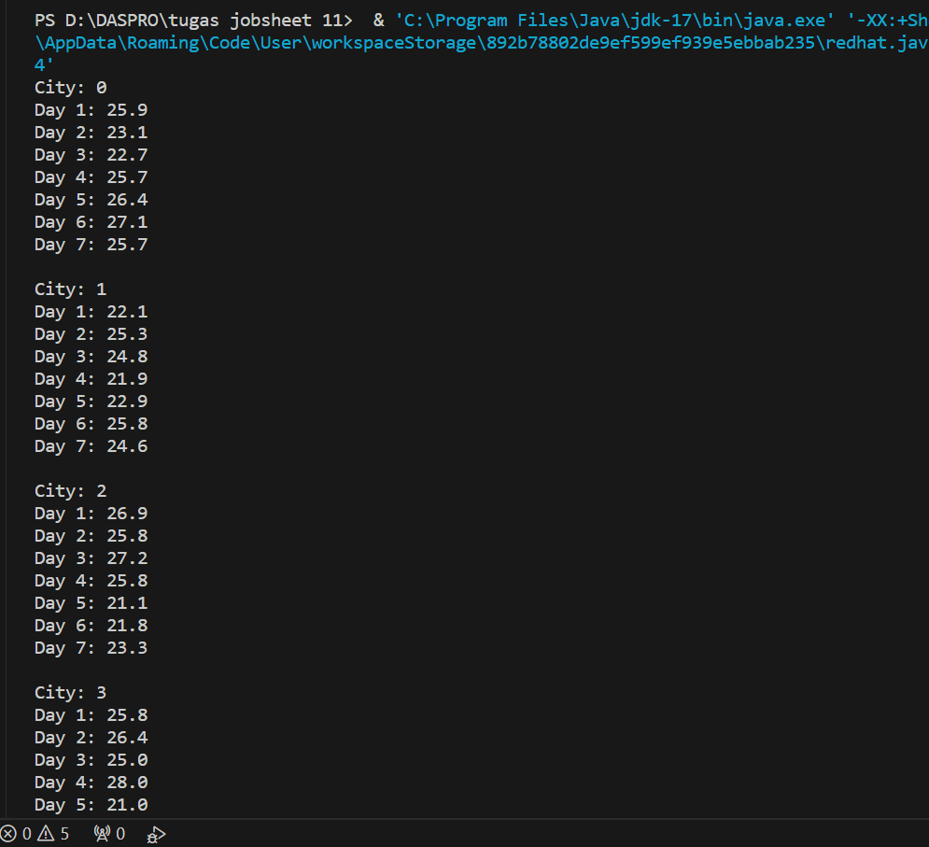

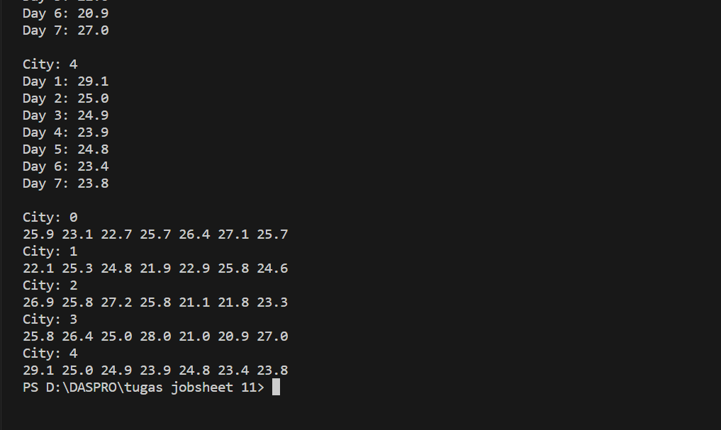

1. Modify the program so that it can display the average value for each city!

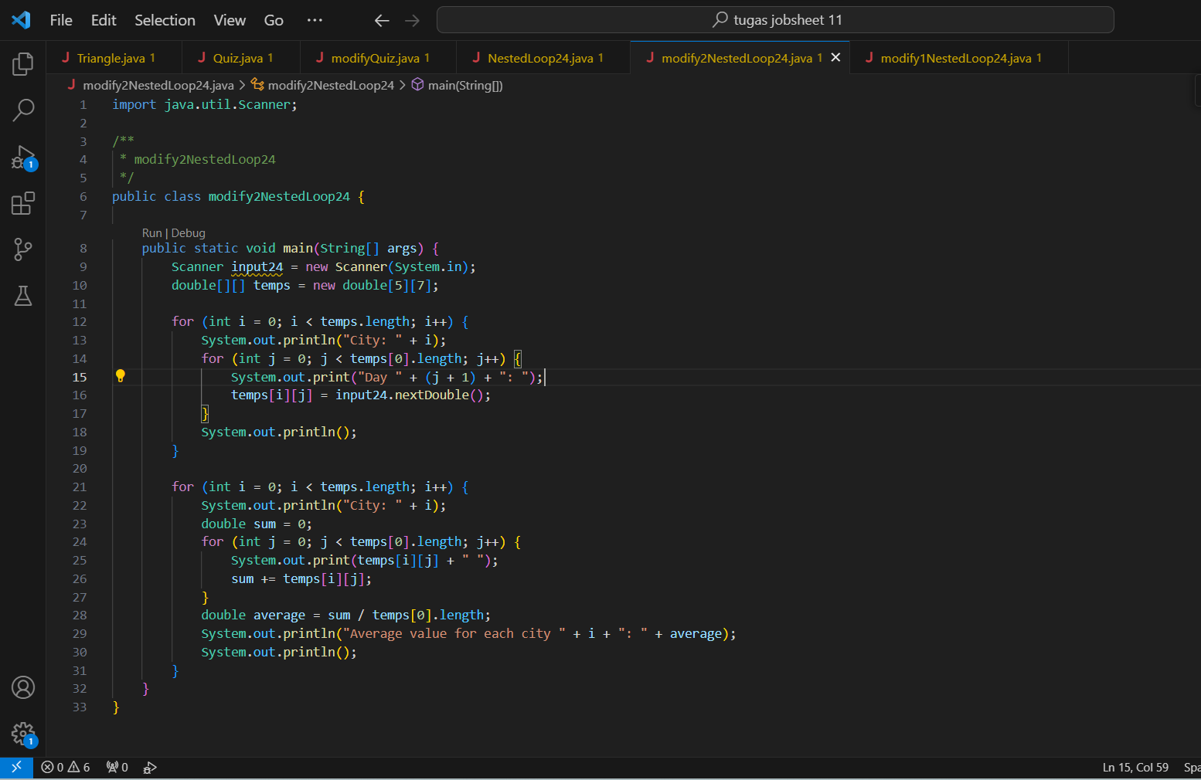

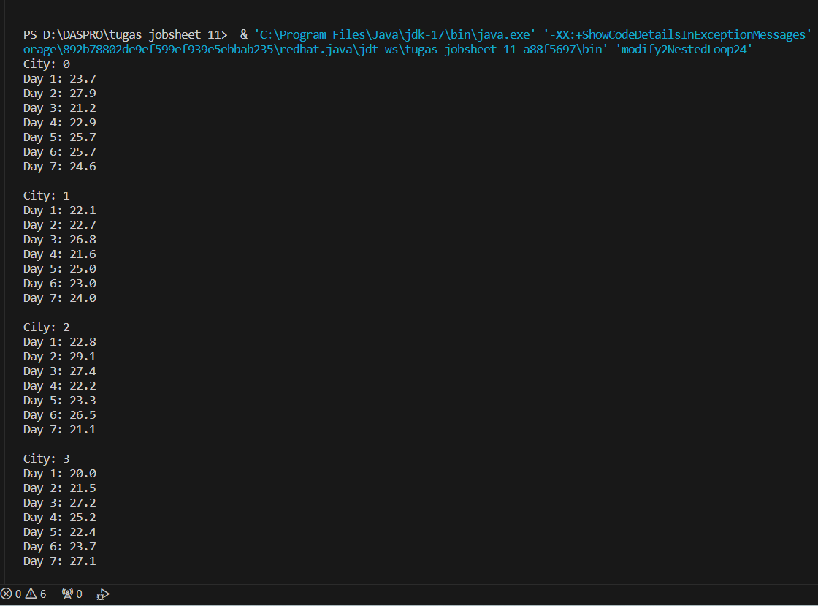

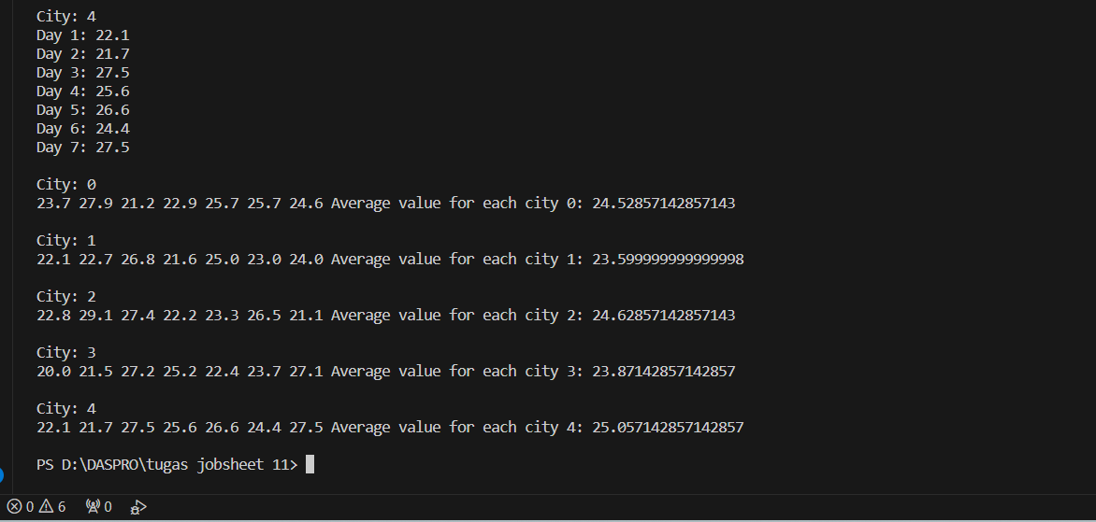

1. Commit and push the changes to GitHub