JOBSHEET VIII QUEUE

# Learning Objective

After finishing this topic, students must be able to:

1. Understand the basic concept of Queue
2. Understand the basic operation of Queue
3. Implement the Queue concept as well as the operation in a program by using Java

# Lab Activities #1

* + 1. **Steps**
       1. We will create a program based on this following class diagram

|  |
| --- |
| Queue |
| max: int size: int front: int rear: int  Q: int[] |
| Queue(max: int) create(): void isFull(): boolean isEmpty(): boolean  enqueue(data: int): void dequeue(): int  peek: void print(): void  clear(): void |

* + - 1. Create a new project named **Jobsheet8,** create a new package with name **practicum1.**

After that, create a new class **Queue**

* + - 1. Add max, size, front,rear and Q as its attributes based on the class diagram above.
      2. Add a constructor with parameter and method create as illustration below.

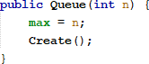

Within the constructor, there is a code to execute **create().** then we make the create function

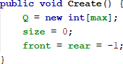

* + - 1. Create a method isEmpty with boolean as its return data type. We use this function to identify whether a queue is empty or not

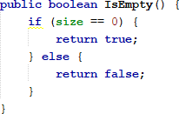

* + - 1. Create a method isFull with boolean as its return data type. We use this function to identify whether a queue is full or not

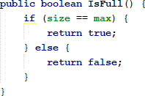

* + - 1. Create **peek()** with void as its return type to display the data at the beginning of the queue

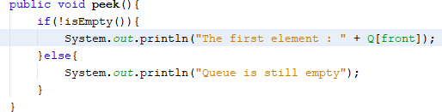

* + - 1. Create **print()** with void as its return type to display the data from the beginning until the end of the queue

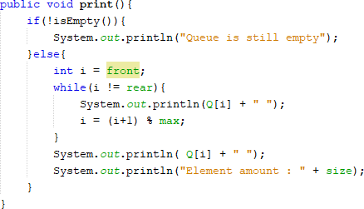

* + - 1. Create **clear()** with void as its return type to remove all data in a queue

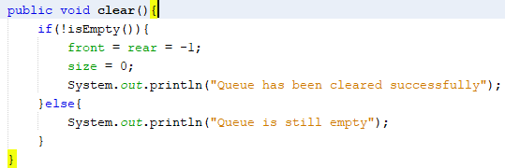

* + - 1. Next up, we make a new method **enqueue()** to insert a new data in a queue that has integer datatype as its parameter

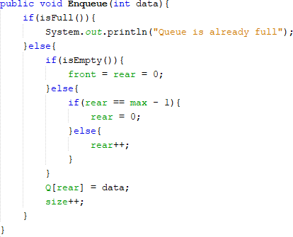

* + - 1. Create method **dequeue()** with integer as its return type. We will need this function whenever we want to remove the last data inside the queue

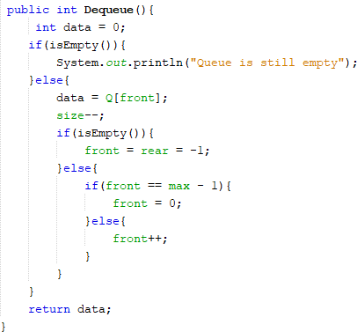

* + - 1. Next, we create a new class named **QueueMain** still at the same package **Practicum1.** To create a menu with void return type to allow user choose which function to be executed when the program runs

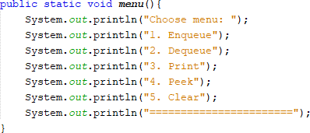

* + - 1. Create a main function, and declare the Scanner object with name **sc**
      2. Create **n** variable to store input of how many elements that can be stored within the queue
      3. Instantiate the Queue object with name **Q** and set the parameter **n** as its queue length



* + - 1. Declare the input of menu selected by user
      2. Loop with do-while to run the program based on the given input. Inside the loop, there is a switch case condition to manipulate queue based on the given input

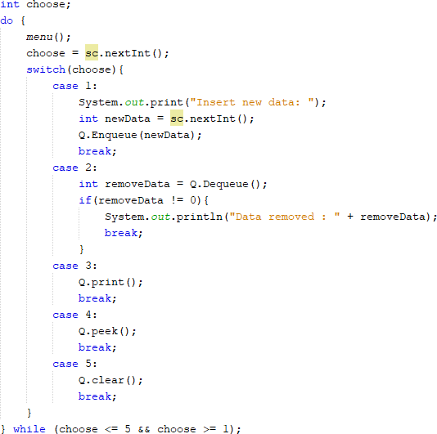

* + - 1. Compile the program and run the **QueueMain** class. And observe the result

# Result

Check if the result match with following image:

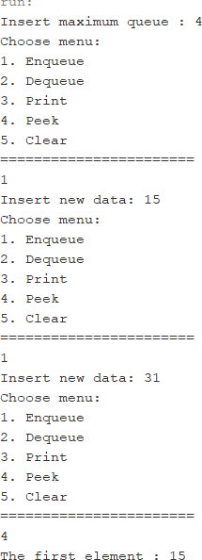

# Questions

* + - 1. In method create(), why is the front and rear attribute has initial value with 1 and not 0?
      2. In method enqueue(), please explain the usage of this following code



* + - 1. Observe enqueue() method, which line of code indicates that the new data will be stored in last position of the queue?
      2. Observe dequeue() method, which line of code indicates that the data is removed in the first position of the queue?
      3. In dequeue method(), explain the usage of these codes !



* + - 1. In method print(), why the loop process has **int i = 0** instead of **int i=front**?
      2. In method print(), please explain why we insert this code in our program?



# Lab Activities #2

In this lab activity, we will create a train ticket payment simple program with implementing the properties adjusted in railway stations environment

# Steps

|  |
| --- |
| Passengers |
| name: String cityOrigin: String cityDestination: String ticketAmount: int  price: int |
| Passengers(name: String, cityOrigin: String, cityDestination:  String, ticketAmount: int, price: int) |

* + - 1. Based on above class diagram, we will create a program written in Java
      2. Create a new package named **Practicum2** and create a new class named **Passengers**
      3. Add attributes for Passengers based on above class diagram, add the constructor as well
      4. Copy the program code written in **Queue** in 1st Lab Activities to be reused in this package. We will need to modify the class, since the stored value in 1st lab activity is in integer data type, but we need it to store an object
      5. Modify the class **Queue**, we change the data type **int[] Q** into **Passenger[] Q.** Since this case we will need to store Passenger object in the queue. In addition, we will need to modify **attributes, create(), enqueue(), and dequeue()**



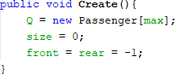

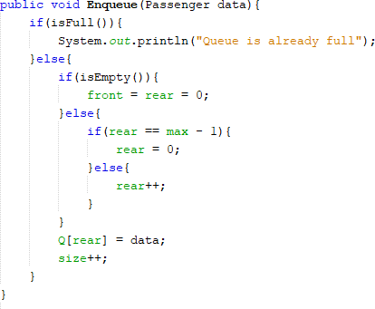

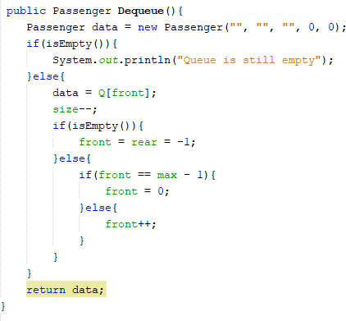

* + - 1. Because one element in queue holds some information (name, cityOrigin, cityDestination, ticketAmount, price), we are needed to display all of that information. This leads to modifying the **peek() and print()** as well

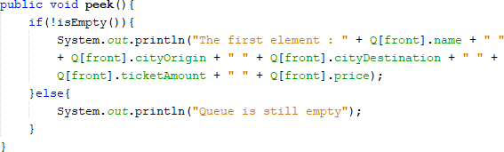

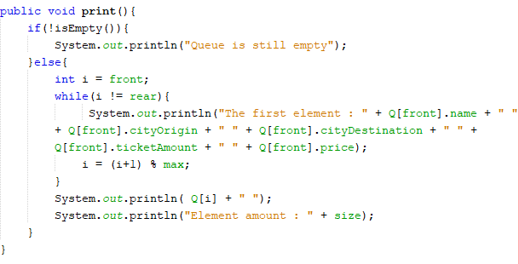

* + - 1. 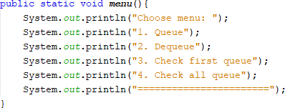Next, create a new class named **QueueMain** within the **Practicum2** package. Create **menu()** to provide menu options and allow the user to choose the menu when the program runs
      2. Create **main method** in the **QueueMain**, and declare the Scanner object with name

# sc

* + - 1. Create **max** variable to define the capacity of the queue. After that, instantiate queue object with name **queuePassenger** with its parameter is **max**
      2. Declare a variable named **choose** with integer as its datatype to get which option did the user choose.
      3. Add these following codes to loops menu options according to given input by the user.

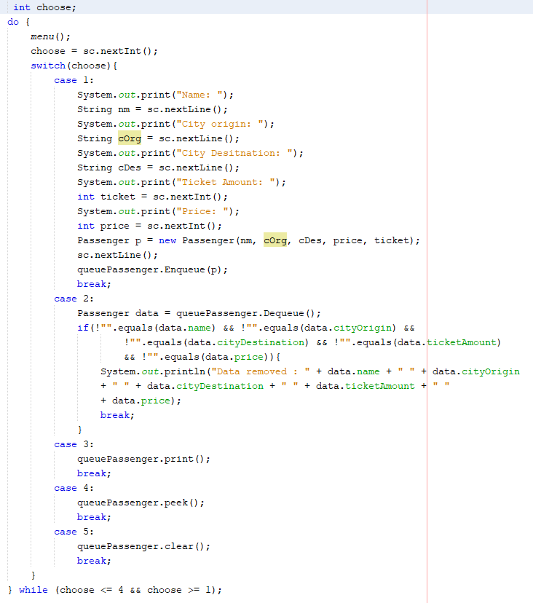

* + - 1. Compile the program and run the **QueueMain** class. And observe the result

# Result

Check if the result match with following image:

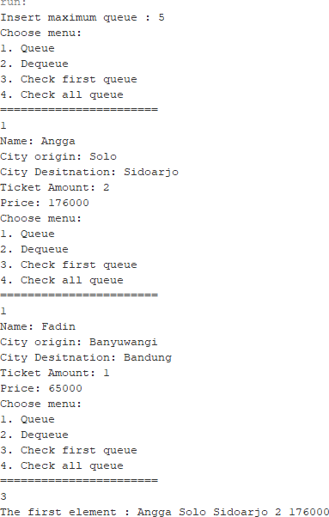

# Questions

* + - 1. In Queue Class, what’s the function of this program code in method Dequeue?



* + - 1. In previous number, if the program code changed to Passenger data = new Passenger()

What will happen?

* + - 1. Show the program code used for displaying the data retrieved / removed from the queue!
      2. Modify the program by adding a method named **peekRear()** in Queue class to check the last position within the queue. Add a menu for the user to perform and explore your program as well
      3. Ensure that the **peekRear**() function can be executed inside the program

# Assignments

1. Add these 2 methods in **Queue** class in 1st practicum
2. Make a queue program for students when they need the signs for their KRS by the DPA. If the student is in queue, they will be required to fill in some information as follows:

|  |
| --- |
| Student |
| nim: String name: String classNumber: int  gpa: double |
| Student (nim: String, name: String, classNumber: int,gpa:  double) |

Queue Class diagram:

|  |
| --- |
| Queue |
| max: int front: int rear: int size: int  stdQueue: Student[] |
| Queue(max: int) create(): void isEmpty(): boolean isFull(): boolean  enqueue(stdQueue: Student): void dequeue(): int  print(): void peek(): void peekRear(): void  peekPosition(nim: String): void  printStudents(position: int): void |

Notes:

* + The implementation of Create(), isEmpty(), isFull(), enqueue(), dequeue() and print() functions are similar with we’ve built in practicum
  + Peek() method is used for displaying students data in the first queue
  + peekRead() method is used for displaying students data in the last queue
  + peekPosition() method is used for displaying students data in the queue by their NIM
  + printStudents() method is used for displaying a student data in specified position in a queue