Analysis_log_To_DB

**The application collect log and give it by order**

**Highlights:**

* On the DB connect.mdb , at Table “log_RPA” have the grep that I use
* Get all the Fapi function that run on RecoverPoint , can add word at file fapi_filter.txt
* Time synchronizer .
* Support ESX splitter
* Can filter the result
* Option to run on-line

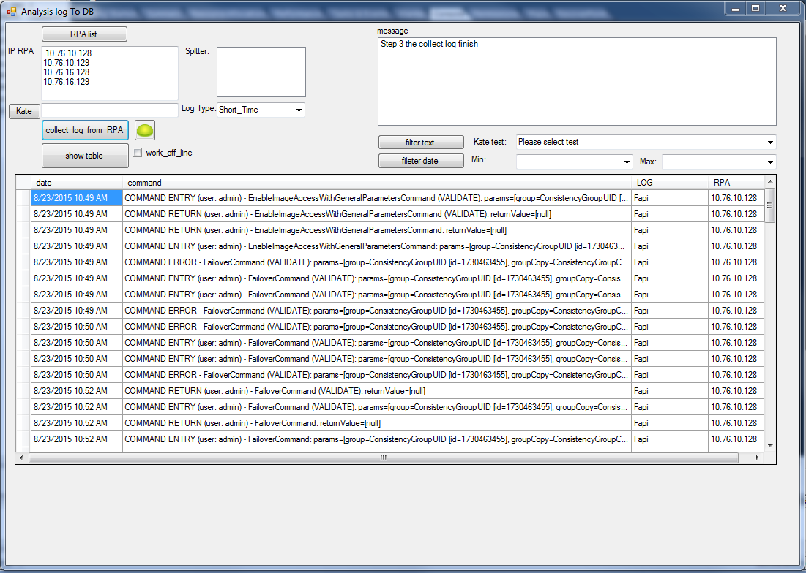

**What how need to run it :**

* You will have access DB install on the computer ( Microsoft office).
* Framework 4.5 sdk . (if you not have you will get link when you start the program )
* Can connect RPA by root with password q

**How to start :**

1. Copy to local computer : \\ISHZ1FS2\COE_Departments\QA\Tools\Analysis_log_To_DB\Analysis_log_To_DB
2. Press on ssh_to_DB.exe
3. Edit the RPA list by press on RPA list button.
4. Press on update time if not all the RPA , splitter on the same time zone
5. if you want to use it for kate press on kate button and choose the kate log , and after on “collect log” button
6. press on collect log from RPA , you have 5 option of collect
7. when on the message you get “Step 3 the collect log finish”
8. press on “show table” button , if not show the 3 hours before
9. you can filter it by test , date , and sql by press on filter text

all the data on access DB connect.mdb

**source file**

* if you want to see the code at : \\ISHZ1FS2\COE_Departments\QA\Tools\Analysis_log_To_DB\ssh_to_DB

**bug:**

if you see bug please send me mail of open bug at bugzilla 🡪 additional tools 🡪Mercury Assistance Tool

**Want I going to improve :**

1. open collect file , open kate file that collect
2. add splitter that have ssh connection

**if you have idea for help with the application I will thanks if you connect me**

Thanks

Shacham