**Final Project**

The project submission deliverables:

* 1. A PowerPoint presentation in English (including project title, IDs and names of the group participants in English, including the project flow and model architecture).
  2. A one-two pages report in English summarizing the process of the project study, the project flow, the obtained results, and conclusions.
  3. The source code files. Implementation of the solution in **Python Google Colab**, GUI is not a necessary attribute, but a possibility to evaluate and to control the input and the output has to be.

**General Scheme**

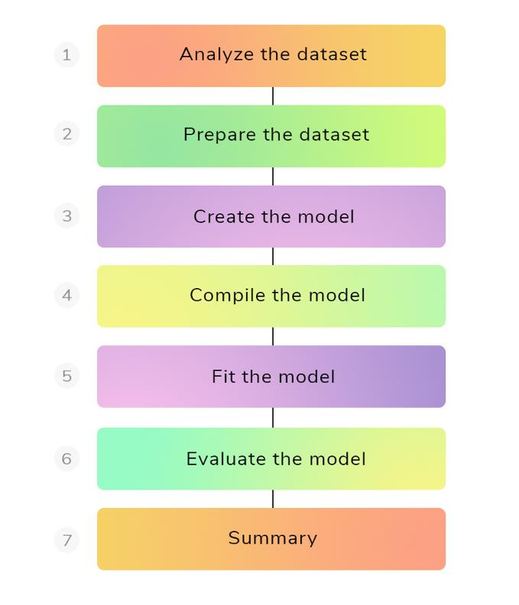

**Problem definition**

You need to understand the problem and come up with a rough idea of how you are going to use machine learning to solve it. (Look for research papers, open source projects, tutorials, and similar applications used by other companies.) Make sure your solution is realistic, and data is easily available.

**Data collection**

You will be collecting data from the article (or various sources), if need cleaning and labelling it. Make sure your data is not biased or contains sensitive information. Describe the chosen dataset.

**Data preparation**

Fill missing values, clean, and process data for data analysis. Use visualization tools to understand the distribution of data and how you can use features to improve the model performance. Feature scaling and data augmentation are used to transform data for a machine learning model.

**Build model and Train model**

Selecting neural networks and machine learning algorithms that are commonly used for specific problems. Build and Train the model. You should describe the model architecture and describe the layers in your model.

**Model evaluation**

Evaluating the model on the test dataset.

Make sure you are using the correct model evaluation metric for specific problems. Accuracy is not a valid metric for all kinds of problems.

Check the F1 or AUC score for classification. Visualize model feature importance to drop features that are not important. Evaluate performance metrics such as model training.

**Summary and Conclusion**