EXPERIMENT-3

AIM: TO ADD HEADER, FOOTER AND CSS TO EXISTING HOMEPAGE.

HEADER:

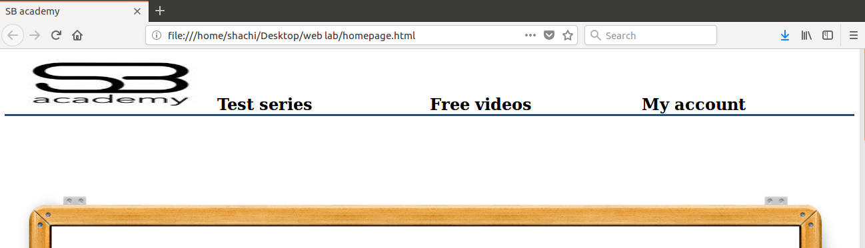

FOOTER:



CSS:





