EXPERIMENT-4

AIM: TO ADD LINKS AND LIST TO WEBPAGE.

LINKS:

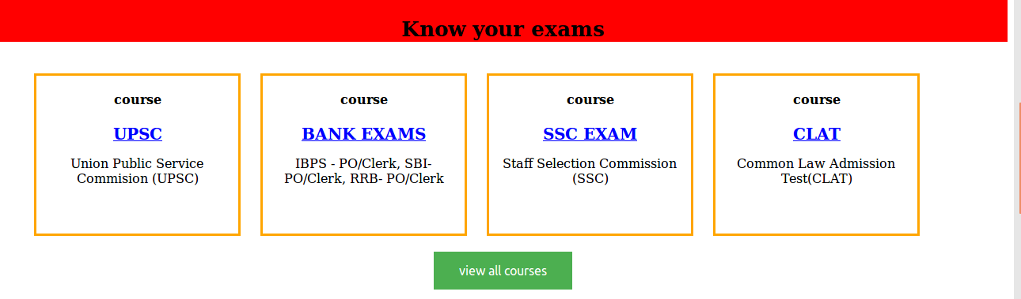

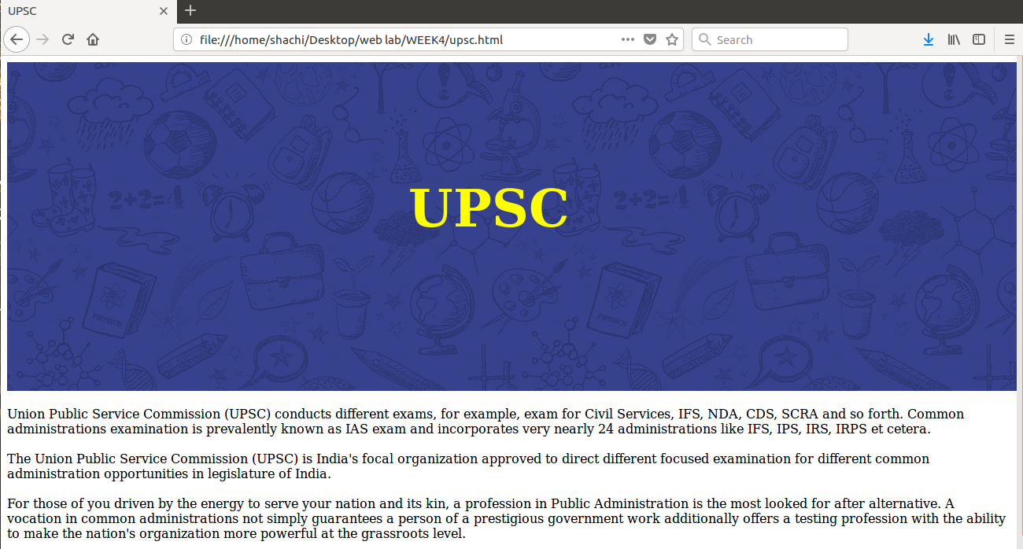

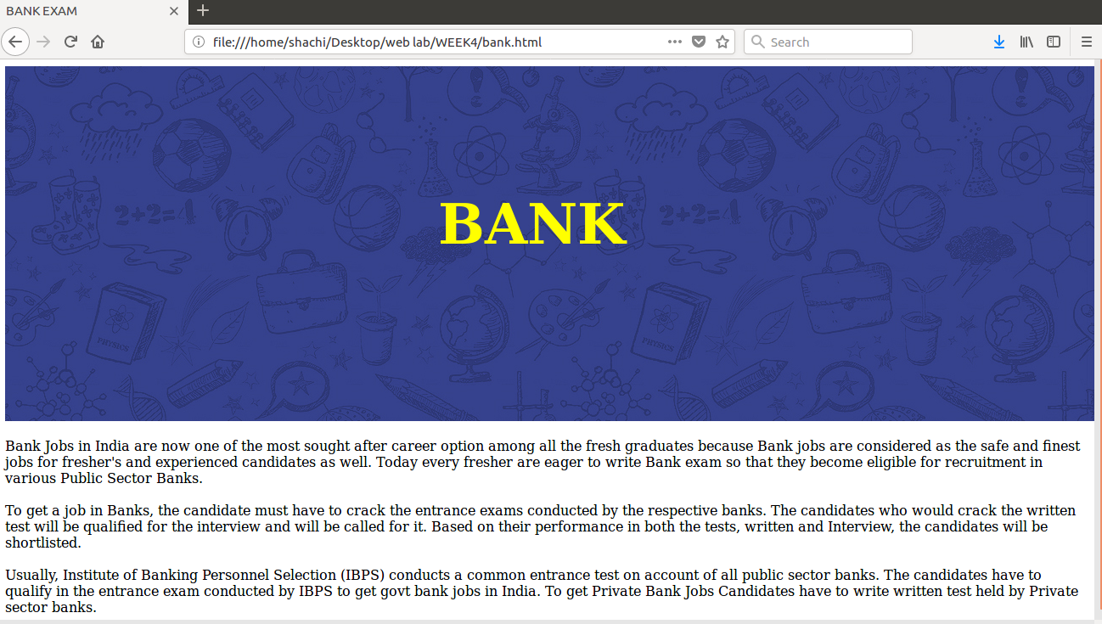
LIST-

- ORDERED LIST

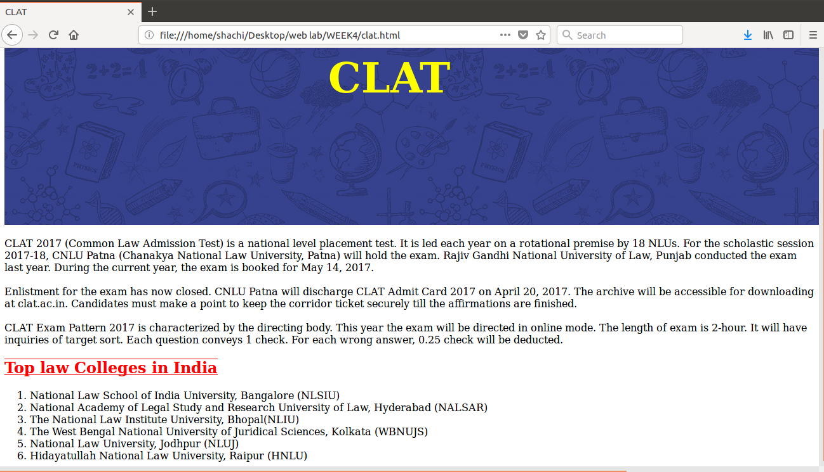

- UNORDERD LIST

