LinkedIn and other job portals often frustrate users with irrelevant recommendations, keyword spam, recruiter bias, reposted jobs, and lack of clear career guidance. Your Job Recommendation Engine can solve these by using graphs for skill-job mapping, tries for precise search, dynamic programming for career paths, and heaps for fair ranking.

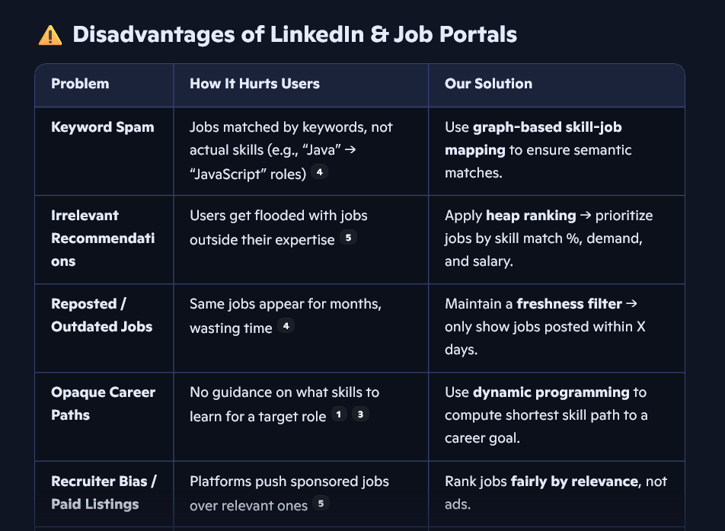

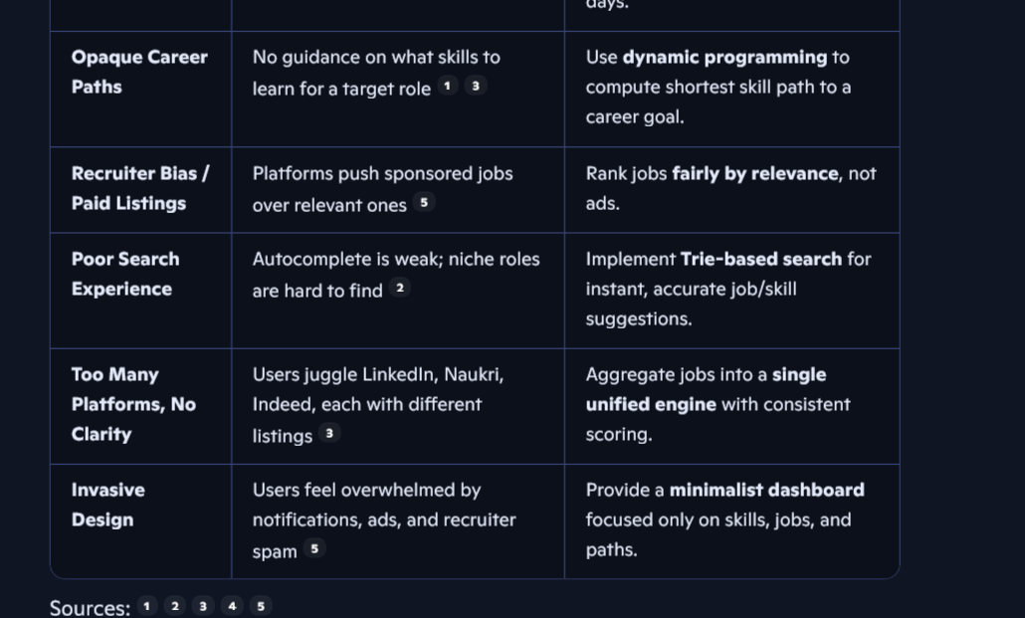

How Your Engine Fixes These
- Graph Algorithms → Replace keyword spam with skill-job semantic mapping.
- Trie Search → Autocomplete job titles and skills instantly.
- Dynamic Programming → Show transparent career paths (e.g., “Learn Python → Spark → Data Engineer”).
- Heap Ranking → Fairly prioritize jobs by relevance, not ads.
- Freshness Filter → Remove outdated/reposted jobs.
- Unified Dashboard → Aggregate jobs from multiple sources into one clean interface.

Purpose Statement (for Resume/Interviews)
“I built a Job Recommendation Engine that fixes the flaws of LinkedIn and Indeed by using graph algorithms, tries, and dynamic programming to recommend jobs based on actual skills, not just keywords. It also shows transparent career paths and filters out outdated or biased listings, giving candidates a fair and personalized job search experience.”

