Neural Networks and Deep Learning
End-Semester Project Report
P6. Intent-Classifying Help-Desk Chatbot
with Out-of-Scope Detection
Afzal (Member A, model lead)
Shachi (Member B, application lead)
Dataset: CLINC150 (small, imbalanced, plus) | Framework: PyTorch + NumPy

Abstract
We build a help-desk chatbot that classifies a user message into one of 150 intents from the CLINC150 dataset and recognises when a question is outside its scope. Messages are converted to TF-IDF features. A one-vs-rest multi-class perceptron written from scratch in NumPy serves as the baseline, and a PyTorch multilayer perceptron (MLP) with batch normalization and dropout is the main model. Out-of-scope (OOS) queries are detected by thresholding the softmax confidence, with the threshold chosen on the validation set. Trained on the plus configuration, the MLP reaches 90.13% in-scope test accuracy (the target was 85%) against 88.89% for the perceptron, and at the chosen threshold T = 0.555 it rejects 80.00% of OOS queries. We compare depth, width, batch normalization and dropout, study the effect of training size and class imbalance, and analyse the ten most confused intent pairs. The model is served through our own FastAPI endpoint behind a Gradio chat interface with a top-3 debug panel and per-turn logging.

1. Problem Statement
Real assistants must recognise what a user wants and admit when a question is outside their scope. A bot that confidently answers an unrelated question with the wrong action is worse than one that asks the user to rephrase. The task is therefore two-fold:
- Intent classification: map a short English query to one of 150 intents across 10 domains (banking, credit cards, travel, work, home, kitchen and dining, auto and commute, utility, small talk, meta).
- Out-of-scope detection: flag queries that belong to none of the 150 intents.
The project requires a from-scratch baseline (multi-class perceptron), an MLP with dropout and batch normalization on TF-IDF features, a threshold-based OOS mechanism with its trade-off curve, a comparison of the small, imbalanced and plus training configurations, an error analysis of the ten most confused intent pairs, and a working chatbot served behind our own API.

2. Dataset
CLINC150 (Larson et al., 2019) contains crowd-sourced queries for 150 intents plus an "oos" label. We use three training configurations. All three share the same validation set (3,000 in-scope + 100 OOS) and the same test set (4,500 in-scope + 1,000 OOS), which we verified in code, so differences between configurations are due to the training data alone.
Config | In-scope train | OOS train | Examples per intent
small | 7500 | 100 | 50
imbalanced | 10525 | 100 | 25 to 100
plus | 15000 | 250 | 100
Table 1. Training splits of the three configurations.
Queries are short (median 8 words). Two data-handling decisions matter:
- Label ids by name. In the Hugging Face ClassLabel list, "oos" is index 42, not the last index (150 is change_volume). We never hard-code ids: the 150 in-scope names are sorted alphabetically to get labels 0 to 149, and OOS rows get label -1.
- Train on in-scope only. The classifier sees only the 150 in-scope intents. OOS detection comes entirely from the confidence threshold, so it needs no OOS training data. (A 151-class alternative is evaluated in Section 5.6.)
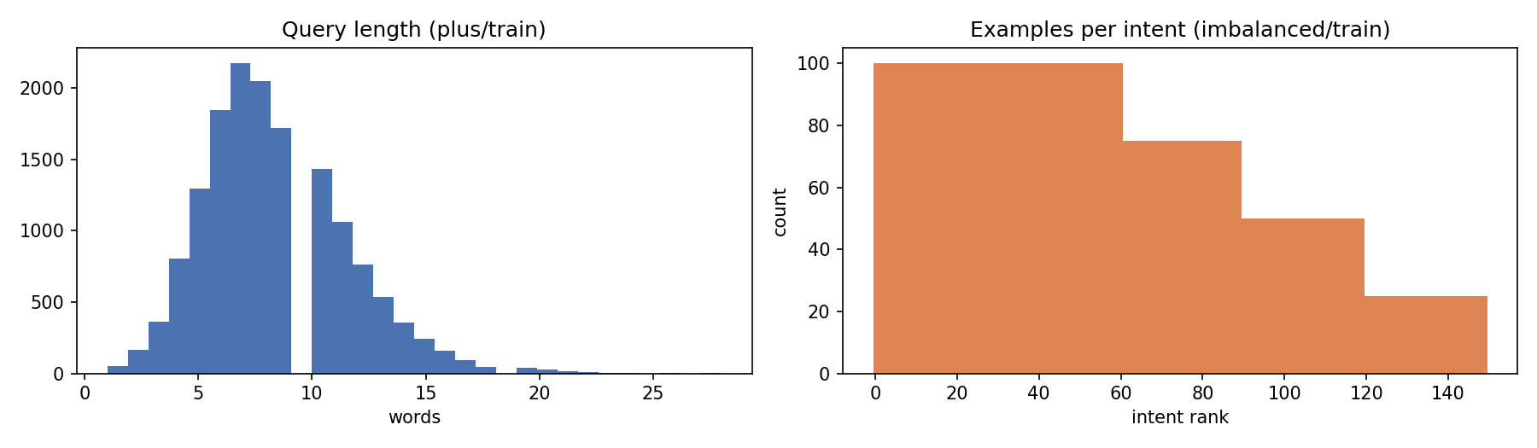
Figure 1. Query length distribution (left) and examples per intent in the imbalanced configuration (right).

3. System Design
The system has an offline training pipeline (Member A) and an online serving path (Member B). Both use exactly the same cleaning function and model class.
Stage | What happens | Implementation
1. Clean | lower-case, keep letters, digits and apostrophes, collapse spaces | regex
2. Vectorise | TF-IDF over unigrams + bigrams, 20,000 features, fit on train only | sklearn TfidfVectorizer
3. Classify | 150 logits, softmax gives probabilities | MLP (PyTorch)
4. Decide | if top probability < T: out-of-scope, else top intent | threshold T = 0.555
5. Reply | template reply per intent, or a rephrase request | templates.json
6. Log | every turn with top-3 intents, confidence, latency | CSV log, /logs endpoint
Table 2. Inference pipeline, from user message to reply.
Experimental protocol. A fixed seed (42) is set for Python, NumPy and PyTorch. Model selection (architecture, dropout, batch normalization, threshold) uses the validation set only. Each final model is evaluated on the test set exactly once, at the end.

4. Methods

4.1 Text features: bag-of-words and TF-IDF
A bag-of-words (BoW) vector marks which words and bigrams occur. TF-IDF re-weights each term by how rare it is across the training set, so words that occur everywhere ("the", "my") get low weight and distinctive words ("balance", "pto") get high weight:
tfidf(t, d) = (1 + log tf(t, d)) × [ log((1 + n) / (1 + df(t))) + 1 ], then L2-normalised
Bigrams keep a little word order ("todo list", "credit score"). Each vector has only about 13 non-zero entries (median) out of 20,000, which we exploit in the perceptron.

4.2 Baseline: one-vs-rest multi-class perceptron (from scratch)
We train 150 binary perceptrons, one per intent, using NumPy only. Perceptron k gives a score s_k = w_k · x + b_k and the predicted intent is the arg-max. For each training example, target t_k = +1 for the true intent and -1 for all others; every perceptron that is wrong (t_k s_k ≤ 0) is updated:
w_k ← w_k + η t_k x, b_k ← b_k + η t_k
Because x is sparse, the update only touches the rows of the weight matrix for the words present in the query, which makes a pure Python loop over 15,000 examples take about 5 seconds per 10 epochs. We also keep the averaged perceptron (the average of the weights over all steps), a standard way to stabilise the perceptron on data that is not linearly separable. Averaging raised validation accuracy from 86.6% (last weights) to 89.0%.
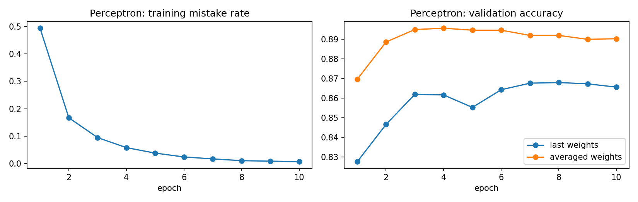
Figure 2. Perceptron training mistake rate and validation accuracy with last vs averaged weights (plus).

4.3 MLP with batch normalization and dropout
Each hidden layer is Linear → BatchNorm1d → ReLU → Dropout, followed by a final Linear layer to 150 logits. The network is trained with cross-entropy loss, Adam (learning rate 1e-3, weight decay 1e-5), batch size 128, and early stopping on validation accuracy (patience 3, best weights restored).
- Batch normalization normalises each hidden unit over the mini-batch. It keeps activations in a stable range, which helps with sparse TF-IDF input where short and long queries produce very different pre-activation magnitudes.
- Dropout randomly zeroes a fraction p of hidden units during training, so the network cannot rely on single rare words. It is switched off at inference.
The final model has two hidden layers of 1,024 and 512 units, batch normalization and dropout 0.5 (about 21 million parameters).
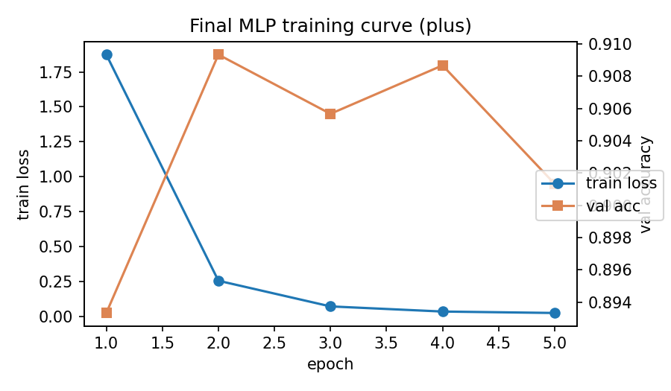
Figure 3. Training loss and validation accuracy of the final MLP (plus). Early stopping restores the best epoch.

4.4 Out-of-scope detection by thresholding softmax confidence
For a query with softmax output p, let conf = max_k p_k. If conf < T the query is rejected as out-of-scope; otherwise the top intent is returned. Two metrics move in opposite directions as T grows:
- In-scope accuracy: fraction of in-scope queries that are accepted and correctly classified (a correct answer that gets rejected counts as an error).
- OOS recall: fraction of OOS queries that are rejected.
Threshold rule (on validation): choose the T with the highest OOS recall such that in-scope accuracy stays at or above 85%. For the perceptron, which has no probabilities, the same rule is applied to its raw top score.

5. Experiments and Results

5.1 Depth and width (validation, plus)
Architecture | Depth | Params (M) | Epochs | Val accuracy
2x(1024,512) | 2 | 21.1 | 7 | 90.77%
3x512 | 3 | 10.8 | 6 | 90.63%
2x(512,256) | 2 | 10.4 | 9 | 90.40%
1x1024 | 1 | 20.6 | 5 | 90.33%
1x512 | 1 | 10.3 | 7 | 90.30%
1x256 | 1 | 5.2 | 6 | 90.23%
Table 3. MLP depth and width grid (dropout 0.3, batch normalization). Best row highlighted.
All six architectures land within 0.6 points of each other (90.2% to 90.8%). A single layer of 256 units is almost as good as two layers of 1,024 and 512. The task is limited by the information in bag-of-words features, not by model capacity. We keep the best configuration, 2 × (1024, 512).

5.2 Batch normalization and dropout ablation (validation, plus)
BatchNorm | Dropout | Epochs to best | Val accuracy
No | 0.0 | 11 | 91.00%
No | 0.3 | 6 | 91.00%
No | 0.5 | 10 | 91.50%
Yes | 0.0 | 5 | 90.70%
Yes | 0.3 | 7 | 90.77%
Yes | 0.5 | 5 | 90.93%
Table 4. Ablation on the best architecture.
- Dropout 0.5 is best with and without batch normalization. With about 21M weights and 15k training sentences, strong regularisation matters.
- Batch normalization did not raise accuracy here (best 90.9% with vs 91.5% without) but it converges faster: 5 to 7 epochs vs 6 to 11. With sparse TF-IDF input and Adam, training is already stable, so the main benefit of batch normalization is speed. All differences are within about half a point, close to run-to-run noise. The final model keeps batch normalization, as the brief requires, with dropout 0.5.

5.3 Bag-of-words vs TF-IDF (validation, plus)
Features | Perceptron val acc | MLP val acc
BoW (binary) | 89.73% | 91.10%
TF-IDF | 89.03% | 90.93%
Table 5. Feature comparison.
The two representations perform almost identically. Queries are short, so a word rarely occurs twice (term frequency is almost always 1), and the MLP's first layer can learn its own per-word weighting, which makes the IDF factor largely redundant.

5.4 Perceptron vs MLP on small, imbalanced and plus (test)
Config | Train size | Perc. acc | MLP acc | Perc. OOS rec. | MLP OOS rec. | MLP T
small | 7,500 | 87.20% | 88.80% | 32.30% | 65.50% | 0.315
imbalanced | 10,525 | 87.13% | 89.47% | 39.60% | 71.30% | 0.445
plus | 15,000 | 88.89% | 90.13% | 65.70% | 80.00% | 0.555
Table 6. Test results. Accuracy is in-scope accuracy without rejection; OOS recall is at each model's validation-chosen threshold.
At the chosen threshold the plus MLP keeps 84.87% in-scope accuracy on test (with rejection) while rejecting 80.00% of OOS queries. On validation this T kept accuracy at 85%; on test it lands slightly below, which is the honest consequence of not tuning on test.
- The MLP beats the perceptron by 1.2 to 2.3 points in accuracy.
- The larger gain is in OOS detection. At a similar in-scope accuracy, softmax confidence rejects 1.2 to 2 times more OOS queries than the perceptron's raw score. Softmax probabilities sum to 1 and are comparable across queries; a raw perceptron score is not a calibrated confidence.
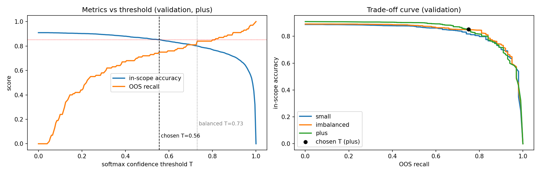
Figure 4. In-scope accuracy and OOS recall as the threshold changes (left) and the resulting trade-off curve for each configuration (right). Validation set.

5.5 Effect of training size and class imbalance
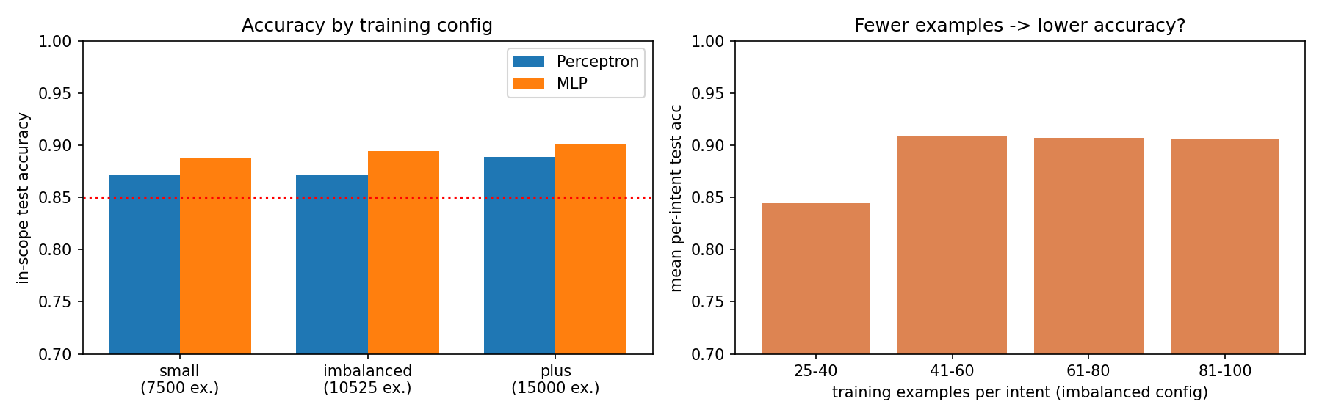
Figure 5. Test accuracy by configuration (left) and per-intent accuracy by number of training examples in the imbalanced configuration (right).
Training size. Going from small (50 per intent) to imbalanced (25 to 100) to plus (100 per intent), accuracy rises 88.8% → 89.5% → 90.1%. OOS recall at the chosen threshold rises much more: 65.5% → 71.3% → 80.0%. More data makes the model more confident on in-scope queries, so a higher threshold can be used and more OOS queries fall below it.
Train examples per intent | Intents | Test acc (plain) | Test acc (class-weighted)
25-40 | 30 | 84.44% | 85.33%
41-60 | 30 | 90.89% | 92.67%
61-80 | 29 | 90.69% | 89.54%
81-100 | 61 | 90.66% | 89.84%
Table 7. Mean per-intent test accuracy in the imbalanced configuration.
Imbalance. Intents with only 25 to 40 training examples reach 84.4%, about 6 points below intents with 41 or more. Weighting the loss by inverse class frequency helps the rare intents (+0.9 to +1.8 points) but costs about 1 point on frequent ones, so overall accuracy is unchanged (89.44% vs 89.47%). OOS recall improves slightly (72.9% vs 71.3%). Beyond about 40 examples per intent, extra data for that intent brings little gain.

5.6 Alternative: OOS as a 151st class
The plus configuration contains 250 OOS training examples. Training a 151-class MLP that treats OOS as its own class gives 81.10% OOS recall at 84.84% in-scope accuracy, almost the same as thresholding (80.00% at 84.87%). Thresholding reaches this level without any OOS training data, so it generalises to new kinds of off-topic questions, which is why we deploy it.

6. Error Analysis
Table 8 lists the ten intent pairs with the most confusions on the plus test set (in-scope queries, no threshold). Counts are shown in both directions.
Intent A | Intent B | A→B | B→A | Why they get confused
change_user_name | user_name | 8 | 2 | "call me a different name" vs "what did I tell you to call me": same key words; the difference is the question form, which bag-of-words cannot see.
credit_score | improve_credit_score | 1 | 9 | "credit score" dominates both; the deciding verbs (raise, up, contribute) are rare. Some test queries genuinely mix both.
redeem_rewards | rewards_balance | 9 | 0 | "how many points do I have to cash": "points" is a strong balance word. Errors go one way only.
todo_list | todo_list_update | 3 | 6 | "did I add X to my todo list" is a lookup, but "add" is the strongest update word.
calendar | calendar_update | 8 | 0 | "did I set March 10th as my appointment" asks about the calendar but contains update verbs (set, mark).
current_location | share_location | 4 | 4 | Nearly identical wording; the test set labels "what is my current location" as share_location, so partly label noise.
ingredients_list | recipe | 6 | 1 | "what is needed to make lasagna" asks for ingredients, but make/cook + dish is the recipe pattern.
meal_suggestion | restaurant_suggestion | 3 | 3 | Whether the user wants a dish or a place ("suggestions for dinner places tonight") is often only implied.
pto_request | pto_request_status | 4 | 2 | "how is a vacation request made" vs "is my vacation a go": same topic words, different action.
bill_due | pay_bill | 3 | 3 | "what's the latest I can pay my bill" asks for a due date but contains "pay".
Table 8. Ten most confused intent pairs (MLP, plus, test).
Pattern. Every pair belongs to the same domain and shares an object (credit score, todo list, calendar, bill, location), differing only in a read vs write action or in question vs command form. TF-IDF is a bag of words: it keeps which words appear but not their order or the sentence structure, so "did I add eggs to my list" and "add eggs to my list" produce almost the same vector. Longer n-grams, a model over word order (CNN or LSTM on embeddings) or a pretrained sentence encoder would separate these intents.
False accepts. The OOS queries most often answered anyway were mapped to who_made_you ("who invented the internet"), calculator, recipe ("what oil is best for chicken") and directions. These queries sit close to an in-scope domain and share its vocabulary, so the softmax is confident even though the request is out of scope. Softmax over-confidence of this kind is a known limitation of confidence thresholding.

7. Chatbot Application
The model is served behind our own API, as required. A single Python process (app/app.py) runs FastAPI and mounts a Gradio user interface; the UI sends every message to the /predict endpoint over HTTP.
Endpoint | Purpose
POST /predict | input {"text", "session_id"}; returns intent, reply, is_oos flag, top-3 intents with confidences, threshold, latency
GET /health | model information and test metrics
GET /logs | download the full conversation log as CSV
/ | Gradio chat interface
Table 9. API endpoints.
- Replies: a hand-written template for each of the 150 intents (for example balance: "I can check your account balance. Which account: checking or savings?").
- Out-of-scope: if the top confidence is below T = 0.555 the bot says it cannot help and asks the user to rephrase.
- Debug panel: shows the top-3 intents with confidences, the accept/reject decision, the confidence against T, and the latency (about 30 to 50 ms on CPU).
- Logging: every turn is appended to a CSV file with timestamp, session id, text, predicted intent, confidence, OOS flag, top-3 and reply.
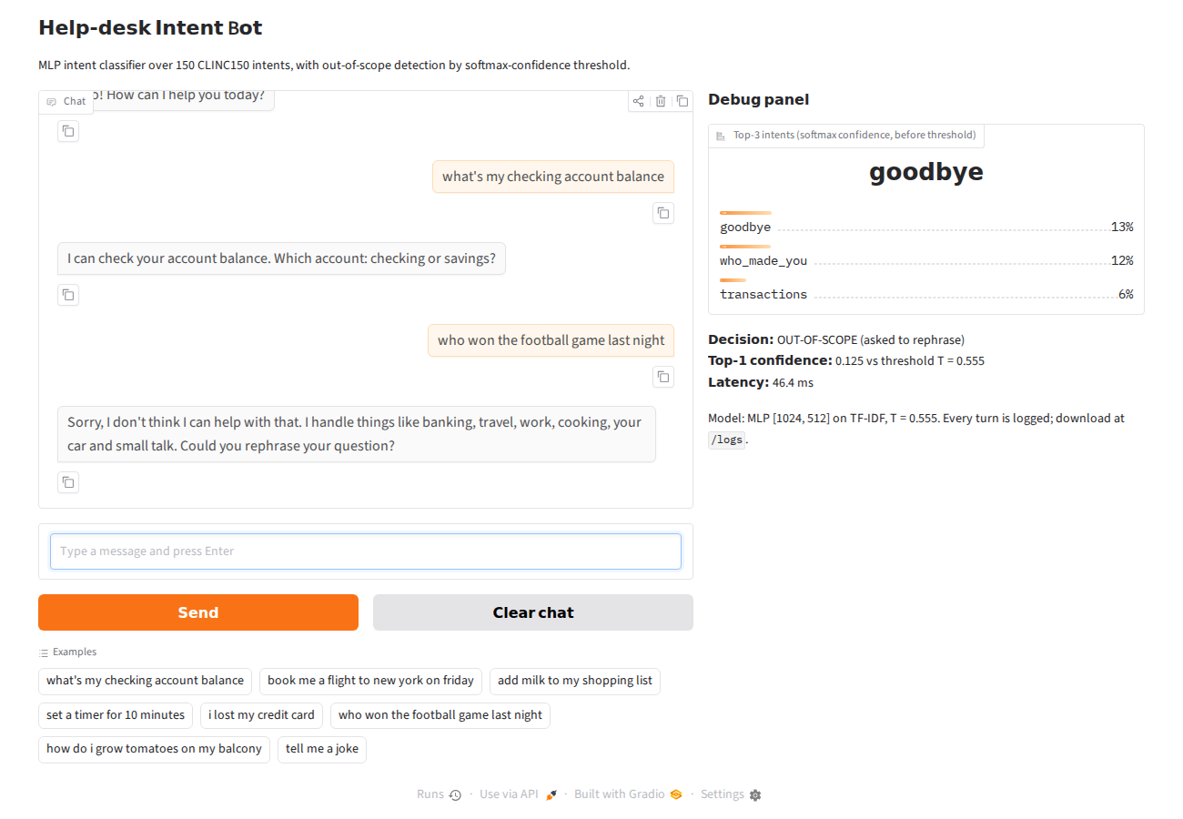
Figure 6. Chat interface with the debug panel. The last query is correctly rejected as out-of-scope (confidence 0.125 < T).
Deployment. The app/ folder is a ready Hugging Face Space (Gradio SDK): app.py, requirements.txt, and the artifacts folder (mlp.pt, tfidf.joblib, config.json, templates.json). A smoke test (app/test_api.py) checks the endpoints without starting a server.

8. Conclusion
We built a working intent-classification chatbot for 150 CLINC150 intents. The MLP reaches 90.13% in-scope test accuracy, above the 85% target, and outperforms the from-scratch perceptron in both accuracy and, more clearly, OOS detection (80.00% vs 65.70% OOS recall). Our main findings:
- Model capacity barely matters on bag-of-words features: all architectures were within 0.6 points.
- Dropout is the regulariser that matters; batch normalization mainly speeds up convergence.
- More training data improves OOS detection much more than it improves accuracy, because in-scope confidence rises.
- Rare intents (25 to 40 examples) lose about 6 points; class weighting redistributes accuracy rather than increasing it.
- Most errors come from word order and question form, which bag-of-words cannot represent.
Limitations and future work. Replace TF-IDF with a model that keeps word order; calibrate confidences (temperature scaling) or use energy-based OOS scores to reduce confident false accepts; and collect more examples for rare intents.

References
[1] S. Larson et al., "An Evaluation Dataset for Intent Classification and Out-of-Scope Prediction," EMNLP-IJCNLP, 2019.
[2] D. Hendrycks and K. Gimpel, "A Baseline for Detecting Misclassified and Out-of-Distribution Examples in Neural Networks," ICLR, 2017.
[3] S. Ioffe and C. Szegedy, "Batch Normalization: Accelerating Deep Network Training by Reducing Internal Covariate Shift," ICML, 2015.
[4] N. Srivastava et al., "Dropout: A Simple Way to Prevent Neural Networks from Overfitting," JMLR 15, 2014.
[5] Y. Freund and R. Schapire, "Large Margin Classification Using the Perceptron Algorithm," Machine Learning 37, 1999.

