ASSIGNMENT 2

DATA STRUCTURES LAB

Vinay Kumar Jain
18114082
O3

Problem1.

In this Problem, you have to implement a simple transposition cipher, where this cipher encrypts and decrypts a sequence of characters by dividing the sequence into blocks of size n, where n is specified by the encryption key. If the input text has a length that is not a multiple of n, the last block is padded with null characters ('\0'). In addition to n, the key also specifies two parameters a andb. For each block, the i-th output character, starting from 0 as usual, is set to the j-th input character, where j = (ai + b) mod n. For appropriate choices of a and b, this will reorder the characters in the block in a way that can be reversed by choosing a corresponding decryption key (n, a′, b′).Task to Perform Write a program transpose.c that takes n, a, b, inputfile.txt in argv[1], argv[2], argv[3], and argv[4], respectively, applies the above encryption; and writes the result to outputfile.txt. Further, write a program inverseTranspose.c that decrypt the outputfile.txtand result in a new file named decryptedOutputfile.txt. Finally, write a program compareFiles.c to find the equivalence between the inputfile.txt and decryptedOutputfile.txt files. You may assume that n, a, and b are all small enough to fit into variables of type int. Your program should exit with a nonzero exit code if n is not at least 1 or if it is not given exactly four arguments, but you do not need to do anything to test for badly-formatted arguments. You should not make any other assumptions about the values of n, a, or b; for example, either of a or b could be zero or negative.

Three files created transpose.c, inversetranspose.c and comparefiles.c

DATA STRUCTURES USED:
*file pointer
*static array
*integer data type

ALGORITHMS USED:
*fopen, fscanf, fprintf, fclose
*arguments from user in main method
*fseek, ftell, rewind, for loops, character compare
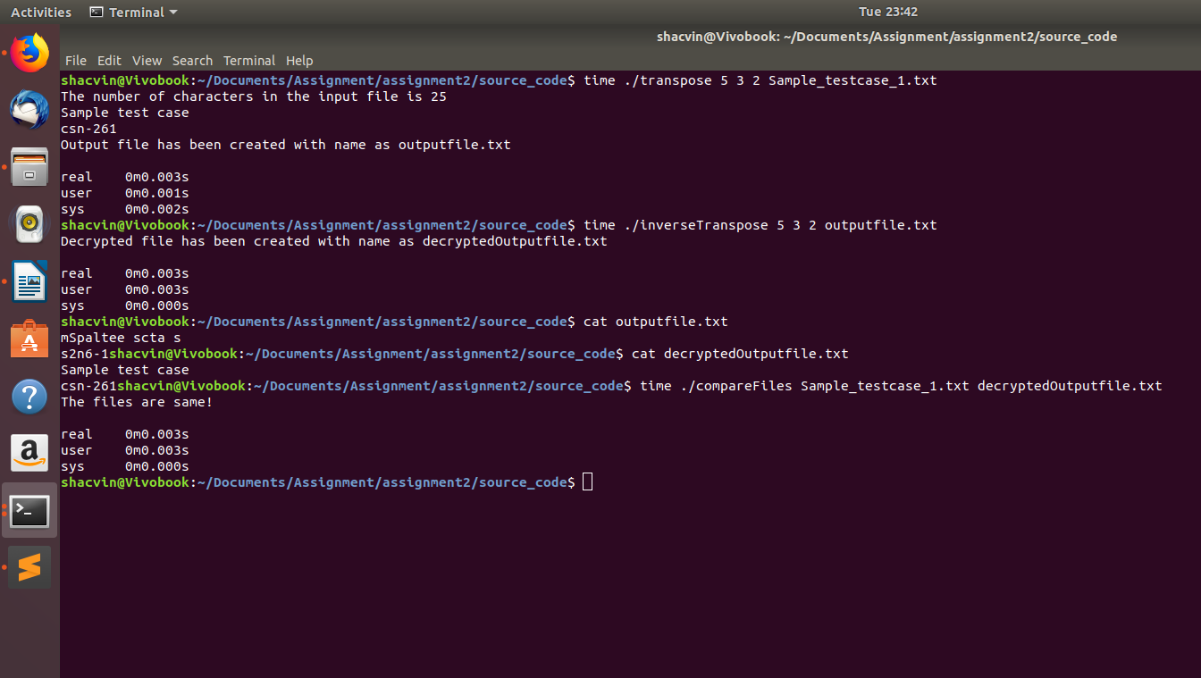
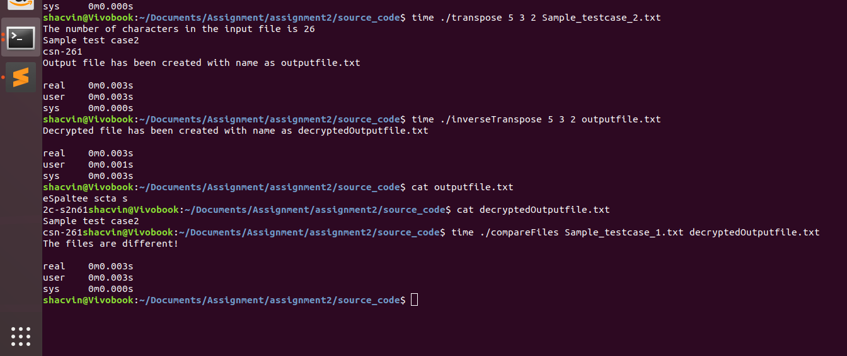

Problem2: Medial axis transformation (MAT) A region can be represented either by its interior or by its boundary. Here we represent the region by its interior using one of the most common methods called image array. In this case we have a collection of pixels. Since the number of elements in the array can be quite large, the main objective is to reduce its size by aggregating equal-valued pixels. A general approach is to treat the region as a quadtree, where the region is represented as a union of maximal non-overlapping square blocks whose sides are in power of 2. The quadtree can be generated by successive subdivision of the image array into four equal sized quadrants. If the sub-array does not consist entirely of 1s or entirely of 0s, it is then further subdivided into quadrants and sub-quadrants, etc. Task to perform: Write a C program, MAT.c to represent any region (in image array representation), into its quadtree form. Input: Sample region is represented as n x n array (as shown in Fig. 1 using 6 x 6 matrix). The format of the input file should be as follows: the pixel values in the input file are separated by a single space and rows are separated by a newline character (refer to the sample L2_P2_inputsample.txt file shared in Piazza).

DATA STRUCTURES USED:

*dynamic array
*double,integer data type
*file pointer

ALGORITHMS USED:

*recursive function
*fopen, fscanf, fclose
*arguments from user in main method
*fseek, ftell, rewind, for loops
