TITLE PAGE

Assignment1
DATA STRUCTURES LAB

Name – Vinay Kumar Jain
Enrollment Number – 18114082
Sub-Batch – O3

Problem Statement 1:
Write a C program to create a
student management system, where
the students’ information are
stored in a doubly circular linked list, as shown in Figure 1.
The structure of each node from the
list is shown in Figure 2. Initially, the circular doubly linke
d list is empty and the student personal
data is entered from the filename “
StudentData.xlsx
” that contains the data of 13 students
)name, D.O.B., address and phone no( in tabular form. The progr
am should have the following
operations:
insert, delete, search, modify, sortand print. While inserting, a unique roll number in the linked list is assigned to each student, where the starting roll number should be 101 and the list should always be in sorted according to their roll number )ascending order(.
However, when a deletion operation is performed, the roll number of the deleted student node is stored in a queue named unusedRollNo. These deleted roll numbers from the unusedRollNo queuewillbeallotted to the new students on next insertion operations.

Perform the testing of your code with the following TestCases:
)Initially the list is empty(
delete )roll number 108( - delete the student node with roll number 108
insert - insert first student data from the “StudentData.xls” file )Row2(
insert - insert second student data from the “StudentData.xlsx” file )Row3(
insert - insert 3rd student data from the “StudentData.xlsx” file )Row4(
insert - insert 4th student data from the “StudentData.xlsx” file )Row5(
delete )roll number 102( - delete the student node with roll number 102
delete )roll number 101( - delete the student node with roll number 101
insert - insert 5th student data from the “StudentData.xlsx” file )Row6(
insert - insert 6th student data from the “StudentData.xlsx” file )Row7(
insert - insert 7th student data from the “StudentData.xlsx” file )Row8(
print - print the linked list with the roll number, name and D.O.B
sort )name( - sort the name according to student names
print - print the linked list with the roll number, name and D.O.B
modify )roll number 103( - modify the student node having roll number 103
print - print the linked list with the roll number, name and D.O.B

Note
: In ‘modify’ function, the programmer can update the other fie
lds except the roll number of a student.

- Algorithms Used:
Bubble sort, basic insertion and deletion operations on a circular doubly linked list, and in queue, fscanf, switch cases, fgets, memset, string comparison, swap node method.
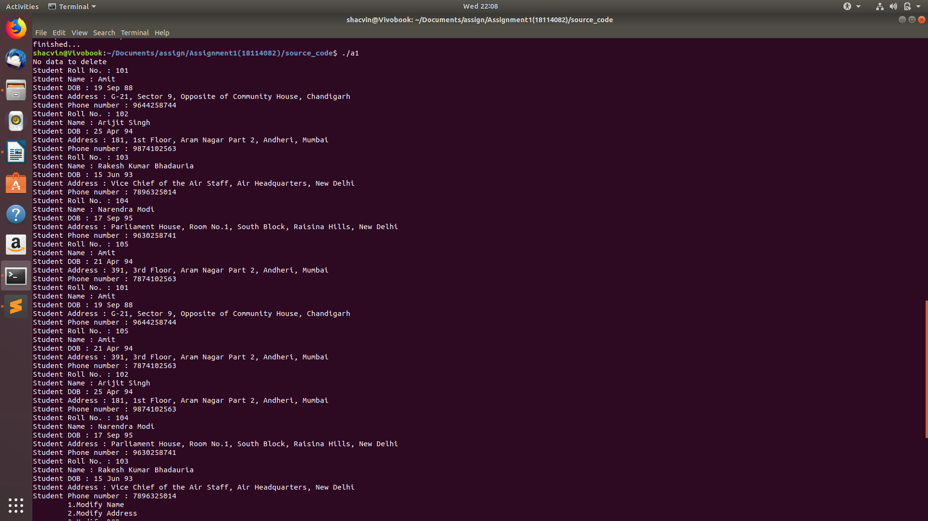
- Data Structures used:
int, long long int, char array, struct, circular doubly linked list, pointers, file pointer.

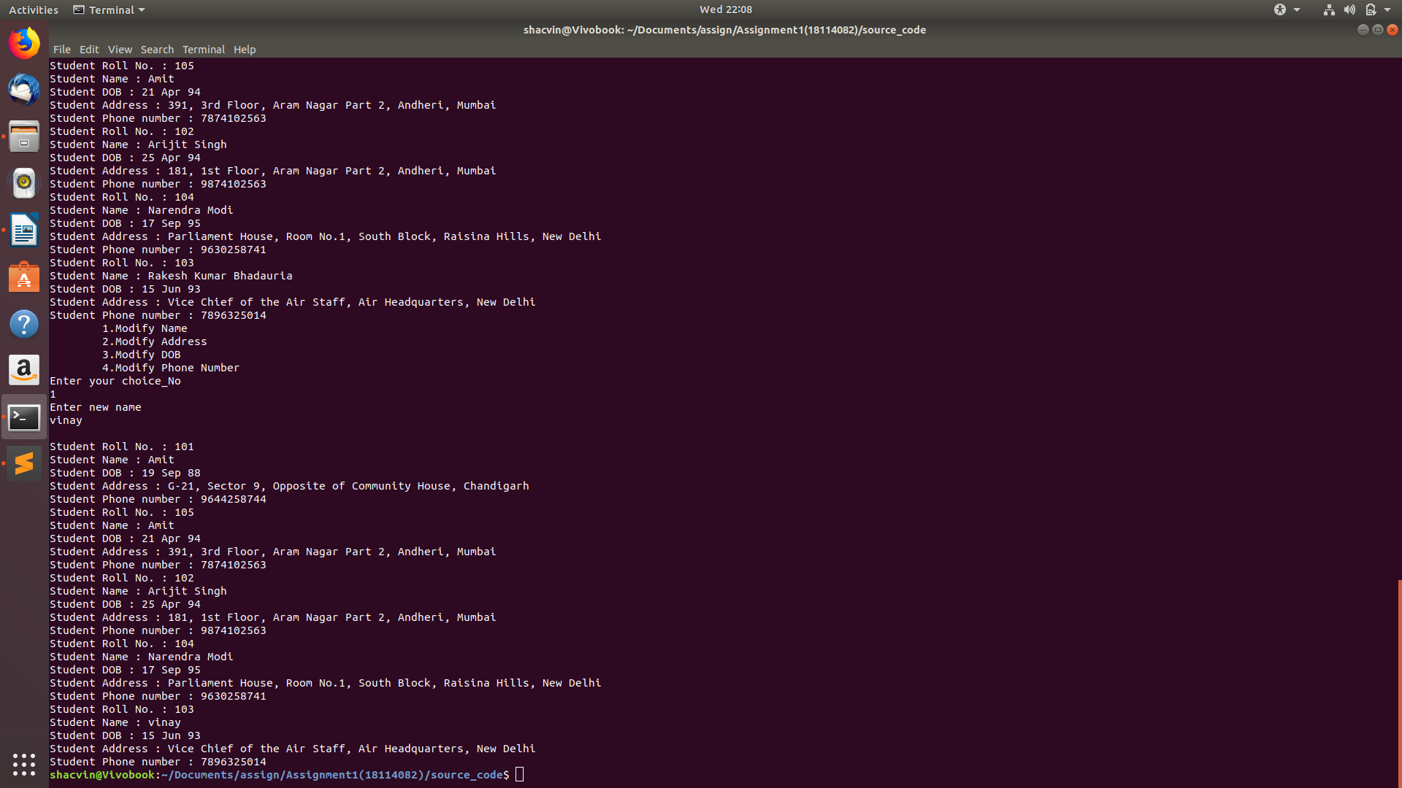

Problem Statement 2:
Write a C Program for resizeable deque using dynamic memory all
ocation, where a deque can
perform the insertion and deletion operations at its both ends.
The capacity of the deque
depends on the number of elements currently stored in it, accor
ding to the following two rules:
●
If an element is being inserted into a deque, when it is alread
y full, then its capacity is
doubled of its current size.
●
After removing an element from a deque, if the number of elemen
ts are equal to the half
of the capacity of the deque, then its capacity is made half of
its current size.

- Algorithms Used:
Basic insertion and deletion operations in a deque, functions like realloc, memmove used.

- Data Structures used:
Deque, pointers, integer array, struct



Problem Statement 3:
Given a digital image in a 3D array format. For a particular im
age pixel, the color shade of that
pixel is Red if the pixel value at that position of the matrix
corresponding to RED is greater than
that of GREEN and BLUE. Same goes for GREEN and BLUE shades als
o. Write a C program
that can perform following operations on the given image file:
●
Remove all Red shades.
●
Remove all Green shades.
●
Remove all Blue shades.
●
RedOnly: Preserve any red shades
in the image, but remove all
green and blue.
●
GreenOnly: Preserve any green shades in the image, but remove
all red and blue.
●
BlueOnly: Preserve any blue s
hades in the image, but remove a
ll red and green.
Further, write a function to check the output files with the gi
ven output sample files.
Perform the testing of your code with the following TestCases:
Input:
Q3_ip_Red.dat, Q3_ip_Green.dat and Q3_ip_Blue.dat are the thre
e files with red, green
and blue pixel values for the image file Q3_ip.jpg
Output after removing only green:
Q3_op_Red.dat, Q3_op_Green.dat and Q3_op_Blue.dat
are the output files w.r.t. red, green and blue pixel values af
ter removing green from the input
file Q3_ip.jpg, respectively.

- Algorithms Used:
Read from external file using fopen and fscanf, print to create output file using fprintf, compare array values.

- Data Structures Used:
struct, dynamic array, file pointer.


