PRACTICAL LAB: JAVASCRIPT OPERATORS MASTERY
Course: DFK20013 Web Design Technology
Topic: 3.1.1 Variables, Data Types, and Operators
Duration: 60 – 90 Minutes
Student Name | SYUHADA BINTI MOHD SYAZWAN YAP
Registration No | 10DIT24F1247
Date | 04/03/2026

1. Learning Outcomes
By the end of this lab, students should be able to:
- Implement Arithmetic Operators for calculations.
- Use Assignment Operators to update values efficiently.
- Control application states using Increment/Decrement.
- Validate user access using Relational and Logical operators.

2. Practical Task: The All-in-One Operator Workshop
Create a file named lab_operators.html. Copy and complete the coding below.

HTML
<!DOCTYPE html>
<html lang="en">
<head>
<meta charset="UTF-8">
<title>DFK20013: JS Operators Workshop</title>
<style>
body { font-family: 'Segoe UI', sans-serif; max-width: 850px; margin: 2rem auto; background-color:
#f0f2f5; padding: 20px; color: #333; }
section { background: white; padding: 25px; border-radius: 12px; margin-bottom: 25px; box-shadow: 0
4px 6px rgba(0,0,0,0.1); } h2 { color: #2c3e50; border-left: 5px solid #3498db; padding-left: 10px; margin-top: 0; }
.output-box { background: #2c3e50; color: #27ae60; padding: 15px; border-radius: 6px; font-family:
'Courier New', monospace; margin-top: 10px; }
.short-note { background: #fff3cd; color: #856404; padding: 15px; border-radius: 6px; margin-top: 15px; border-left: 5px solid #ffc107; display: none; font-size: 0.9rem; } input { padding: 8px; width: 100px; border-radius: 4px; border: 1px solid #ccc; }

button { padding: 8px 20px; background: #3498db; color: white; border: none; border-radius: 4px; cursor: pointer; font-weight: bold; } button:hover { background: #2980b9; } code { background: #eee; padding: 2px 4px; border-radius: 3px; font-weight: bold; color: #d63384; } </style>
</head>
<body>

<header style="text-align: center; margin-bottom: 30px;">
<h1>JavaScript Operators Mastery</h1>
<p>Follow the steps and observe the Console and UI outputs.</p> </header>

<section>
<h2>Task 1: Basic Arithmetic (Check Console)</h2>
<p>This task demonstrates background calculations using <code>+</code>, <code>-</code>, <code>*</code>, <code>/</code>, <code>**</code>, and <code>%</code>.</p>
<button onclick="runTask1()">Run Console Logic</button> </section>

<section>
<h2>Task 2: POS System (Arithmetic & Assignment)</h2>
<p>Price: RM 50.00. <strong>Promo:</strong> Buy > 4 units to get RM 20.00 discount.</p>
Quantity: <input type="number" id="qty" value="1">
<button onclick="runTask2()">Calculate Total</button>
<div id="outPOS" class="output-box">Final Total: RM 0.00</div>
<div id="notePOS" class="short-note"></div> </section>

<section>
<h2>Task 3: Stock Control (Increment & Decrement)</h2>
<p>Simulating inventory updates.</p>
Stock Level: <span id="stockVal" style="font-size: 1.5rem; font-weight: bold;">10</span><br><br>
<button onclick="runTask3('inc')">Add (+)</button>
<button onclick="runTask3('dec')" style="background:#6c757d;">Remove (-)</button>
<div id="noteStock" class="short-note"></div> </section>

<section>
<h2>Task 4: Gate Access (Relational & Logical)</h2>
<p>Rules: Age 18+ OR (Age 13+ AND Parent present).</p>
Age: <input type="number" id="age" placeholder="Age">
<label><input type="checkbox" id="parent"> With Parent?</label><br><br>
<button onclick="runTask4()" style="background:#27ae60;">Verify Entry</button>
<div id="outSecurity" class="output-box">Status: Waiting...</div>
<div id="noteSecurity" class="short-note"></div> </section>

Inside the <script> tag, type all the following code:
JAVASCRIPT:
1. | 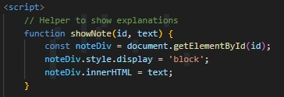
2. | 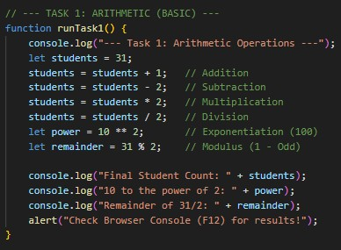

3. | 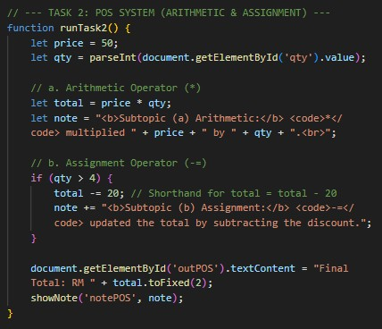
4. | 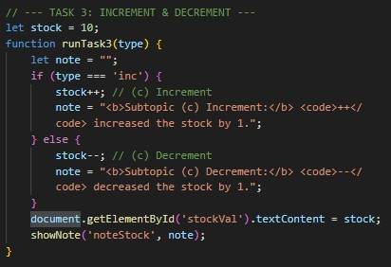
5. | 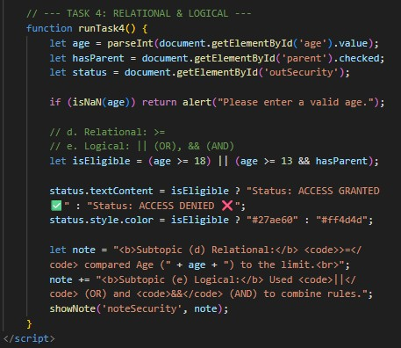

Capture a screenshot of the output from the previous steps. Observe the results and explain your understanding of the process.
1. | Screenshot of the output  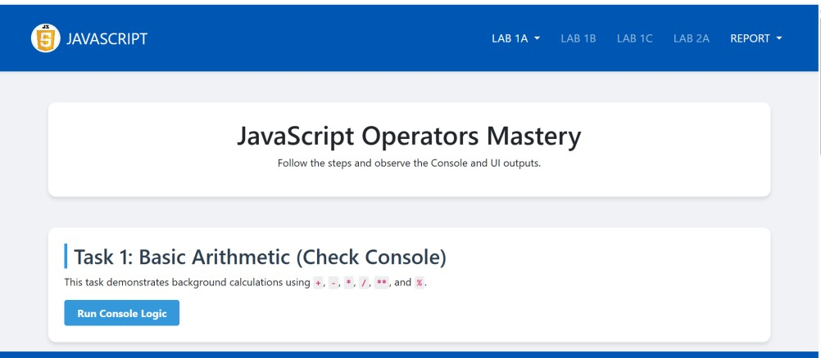
Explanation
This function shows a hidden note on the webpage. It finds an element by its id, makes it visible, and inserts the given text inside it. It demonstrates basic DOM manipulation in JavaScript.

2. | Screenshot of the output  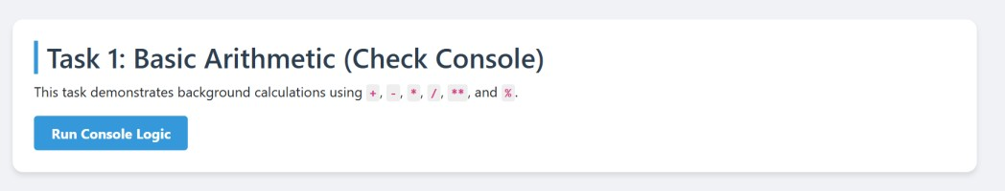  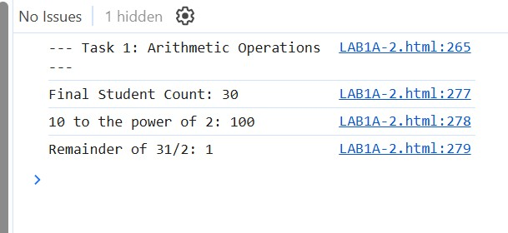
Explanation
This function shows a hidden note on the webpage. It finds an element by its id, makes it visible, and inserts the given text inside it. It demonstrates basic DOM manipulation in JavaScript.

3  . | 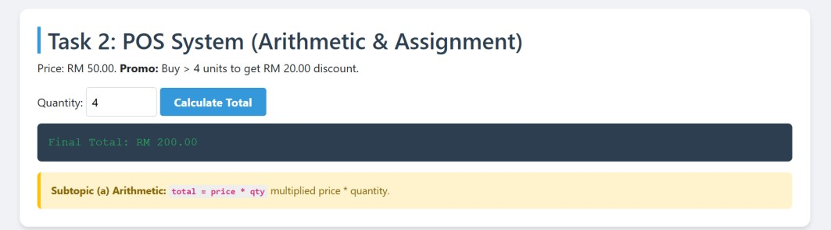  Screenshot of the output  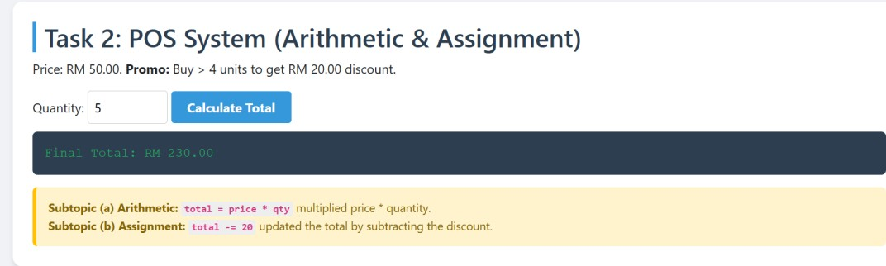
Explanation
This task shows how arithmetic and assignment operators are used in a program. The total price is calculated by multiplying the price by the quantity. The result is stored in a variable using the assignment operator (=). If the quantity is 4 or more, a RM20 discount is subtracted from the total. The total is then updated with the new value. This task shows how calculations are done and how values are updated in a program.

4. | 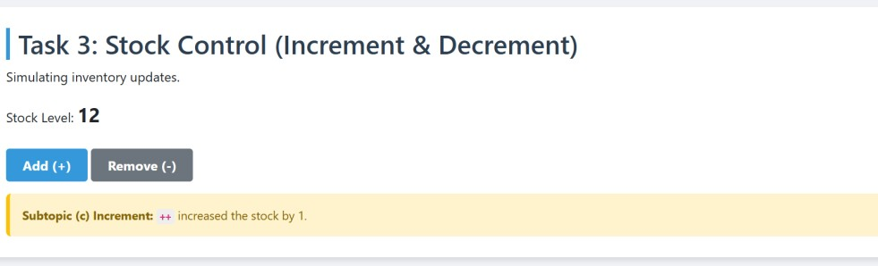  Screenshot of the output  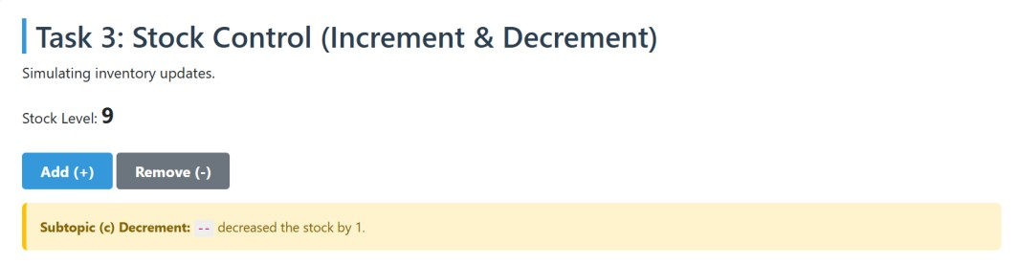
Explanation
This task shows how increment (++) and decrement (--) operators work. The increment operator increases the stock by 1 when the “Add (+)” button is clicked. The decrement operator decreases the stock by 1 when the “Remove (-)” button is clicked. The stock value changes immediately after each action. This shows how variables can be increased or decreased easily in a program.

5. | Screenshot of the output  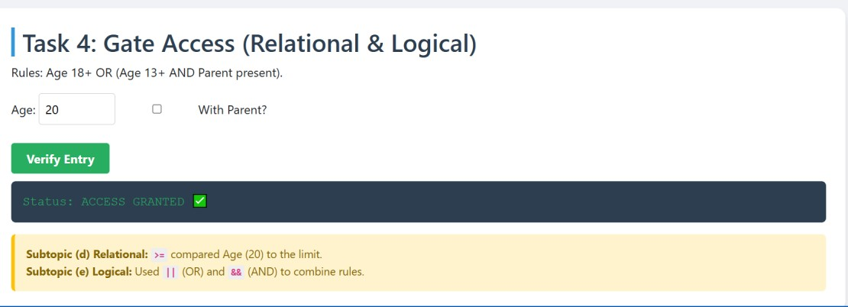  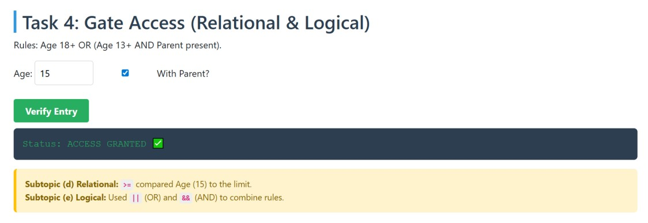  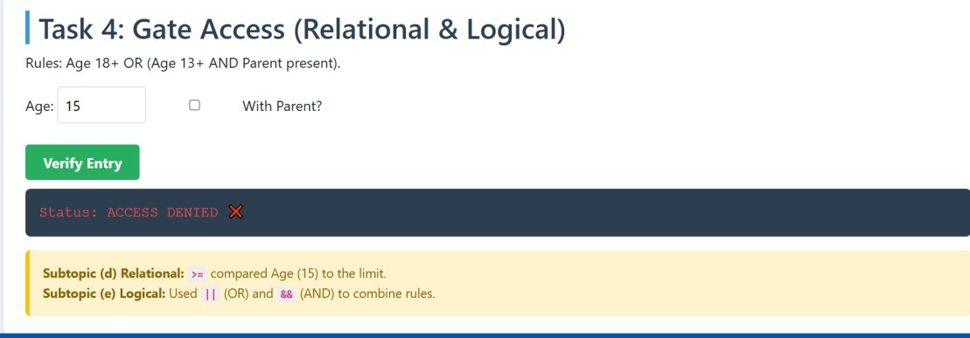
Explanation
This task shows how relational and logical operators are used to make decisions. The relational operator checks the age requirement, such as age 18 or above. The logical operators (OR and AND) are used to combine conditions. Access is granted if the person is 18 or older, or if the person is 13 or older and has a parent with them. If the conditions are not met, access is denied. This shows how programs use conditions to decide outcomes.

3. Quick Check (Reflection)
Instruction: Answer the following questions based on your coding results.
- Modulus Utility: Based on Task 1, if students % 2 returns 0, is the number even or odd?
- Shorthand Power: In Task 2, rewrite total -= 20 using the standard assignment method.
- Logical Priority: In Task 4, why did we put (age >= 13 && hasParent) in parentheses?
- Time Calculation: (Extra Challenge) If a variable totalMinutes = 130, write the formula to find the remaining minutes after converting to hours using the Modulus operator.

