Lab Activity 3.3: Construct form validation using Bootstrap and JavaScript

STUDENT INFORMATION
Name | Registration No | Date
SYUHADA BINTI MOHD SYAZWAN YAP | 10DIT24F1247 | 11/3/2026

Learning Outcomes:
- Construct client-side form validation using JavaScript.
- Construct Bootstrap form components for improved user experience.
- Perform form submission and validation errors gracefully.

Step 1: Setting Up the Document Structure & Styling
Create a new file named _{passport_form.html}. We will start by defining the Purple Theme using CSS variables and styling the passport photo container to meet the 35mm x 45mm requirement.

HTML
<head>
<meta charset="UTF-8">
<meta name="viewport" content="width=device-width, initialscale=1.0">
<title>Lab 3.3: Passport Application Form</title>
<link
href="https://cdn.jsdelivr.net/npm/bootstrap@5.3.0/dist/css/bootstrap
.min.css" rel="stylesheet">
<style>
:root { --primary-purple: #6f42c1; --hover-purple: #59359a; -light-purple: #f3e5f5; }
body { background-color: var(--light-purple); padding: 40px 20px;
}
.form-container { max-width: 800px; margin: auto; background: white; padding: 40px; border-radius: 15px; border-top: 8px solid var(--primary-purple); }
.text-purple { color: var(--primary-purple); }
.bg-purple { background-color: var(--primary-purple) !important;
}
.btn-purple { background-color: var(--primary-purple); color:
white; }
.btn-purple:hover { background-color: var(--hover-purple); color:
white; }
.passport-photo { width: 3.5cm; height: 4.5cm; object-fit: cover; border: 3px solid #f8f9fa; outline: 1px solid #dee2e6; display: block; margin: 0 auto 10px auto; }
.form-control:focus, .form-select:focus { border-color: var(-primary-purple); box-shadow: 0 0 0 0.25rem rgba(111, 66, 193, 0.25); }
#rangeValue { background-color: var(--primary-purple); color: white; padding: 2px 10px; border-radius: 10px; font-size: 0.9rem; }
#successMessage { display: none; }
</style> </head>

Step 2: Constructing the UI (Form Components)
Add the HTML body. This includes the Success Alert, Passport Image, Floating Labels, and Input Groups. Note the use of _{novalidate} in the form tag to allow custom JavaScript handling.

HTML
<div class="container">
<div class="form-container shadow-lg">

<div class="mb-3">
<a href="LAB2_1.html" class="text-decoration-none textpurple small fw-bold">&larr; Back to Profile</a>
</div>

<h2 class="mb-4 text-center fw-bold text-purple">Passport
Application</h2>
<hr class="mb-5">

<div id="successMessage" class="alert alert-success alertdismissible fade show" role="alert">
<strong>Success!</strong> Your application has been validated and submitted gracefully.
<button type="button" class="btn-close" data-bsdismiss="alert" aria-label="Close"></button>
</div>

<form class="row g-4 needs-validation" id="passportForm" novalidate>
<div class="col-12 text-center">
<img src="img/profile.png" class="passport-photo rounded shadow-sm" alt="Profile">
<p class="text-muted small">Standard Passport Size
(35mm x 45mm)</p>
</div>

<div class="col-md-6">
<div class="form-floating">
<input type="text" class="form-control" id="firstName" placeholder="First Name" required>
<label for="firstName">First Name</label>

<div class="invalid-feedback">First name is required.</div> </div>
</div>

<div class="col-md-6">
<div class="form-floating">
<input type="text" class="form-control" id="lastName" placeholder="Last Name" required>
<label for="lastName">Last Name</label> <div class="invalid-feedback">Last name is required.</div>
</div>
</div>

<div class="col-md-12">
<label for="userEmail" class="form-label fwbold">Contact Email</label>
<div class="input-group has-validation">
<span class="input-group-text bg-purple textwhite">@</span>
<input type="email" class="form-control" id="userEmail" placeholder="e.g. name@mail.com" required> <div class="invalid-feedback">Please enter a valid email address.</div>
</div>
</div>

<div class="col-md-6">
<label for="citizenStatus" class="form-label fwbold">Citizenship</label>
<select class="form-select" id="citizenStatus" required>
<option selected disabled value="">Select status...</option>
<option>Citizen</option>
<option>Permanent Resident</option>
</select>
<div class="invalid-feedback">Selection required.</div> </div>

<div class="col-md-6">
<label for="yearsResidency" class="form-label fwbold">
Residency Years: <span id="rangeValue">25</span>
</label>
<input type="range" class="form-range" min="1" max="50" value="25" id="yearsResidency">
</div>

<div class="col-md-12">
<label class="form-label d-block fwbold">Gender</label>
<div class="form-check form-check-inline"> <input class="form-check-input" type="radio" name="gender" id="male" required>

<label class="form-check-label" for="male">Male</label>
</div>
<div class="form-check form-check-inline"> <input class="form-check-input" type="radio" name="gender" id="female" required>
<label class="form-check-label" for="female">Female</label>
</div>
<div class="invalid-feedback">Please select a gender.</div> </div>

<div class="col-12">
<div class="form-check">
<input class="form-check-input" type="checkbox" value="" id="invalidCheck" required>
<label class="form-check-label" for="invalidCheck"> I confirm that all information provided is accurate.
</label>
<div class="invalid-feedback">You must agree before submitting.</div> </div>
</div>

<div class="col-md-6">
<div class="form-floating">
<input type="password" class="form-control" id="password" placeholder="Password" required>
<label for="password">Password</label> <div class="invalid-feedback">Please enter a password.</div> </div>
</div>

<div class="col-md-6">
<div class="form-floating">
<input type="password" class="form-control" id="confirmPassword" placeholder="Confirm Password" required>
<label for="confirmPassword">Confirm
Password</label>
<div class="invalid-feedback" id="confirmFeedback">Passwords do not match!</div>
</div>
</div>

<div class="col-12 mt-5 d-flex gap-2">
<button class="btn btn-purple w-75 py-3 fw-bold shadow-sm" type="submit">SUBMIT APPLICATION</button>
<button class="btn btn-outline-secondary w-25 py-3 fw-bold shadow-sm" type="reset" id="resetBtn">RESET</button> </div>

</form>
</div>
</div>

Step 3: JavaScript Logic (Validation & Interaction)
Implement the script to handle Range Slider updates, Password Matching, and Graceful Error Handling.

HTML
<script>
(function () {
'use strict'

const form = document.getElementById('passportForm'); const successDiv = document.getElementById('successMessage'); const resetBtn = document.getElementById('resetBtn'); const rangeInput = document.getElementById('yearsResidency'); const rangeValue = document.getElementById('rangeValue');
// Update range value display
rangeInput.addEventListener('input', function() { rangeValue.textContent = this.value;
});

// Form Validation Logic
form.addEventListener('submit', function (event) { if (!form.checkValidity()) { event.preventDefault(); event.stopPropagation();
successDiv.style.display = 'none';
} else {
event.preventDefault();
successDiv.style.display = 'block';
window.scrollTo({ top: 0, behavior: 'smooth' });
}
form.classList.add('was-validated');
}, false);

// Reset Logic
resetBtn.addEventListener('click', function() { form.classList.remove('was-validated'); successDiv.style.display = 'none';
rangeValue.textContent = "25"; // Reset range display to default });

})();
(function () {
'use strict'
const form = document.getElementById('passportForm'); const password = document.getElementById('password'); const confirmPassword =
document.getElementById('confirmPassword');

// Fungsi untuk menyemak padanan kata laluan function validatePassword() {
if (password.value !== confirmPassword.value) {
// Jika tidak sama, set ralat custom
confirmPassword.setCustomValidity("Passwords do not match");
} else {
// Jika sama, kosongkan ralat (sah) confirmPassword.setCustomValidity("");
}
}

// Jalankan fungsi setiap kali pengguna menaip password.addEventListener('change', validatePassword); confirmPassword.addEventListener('keyup', validatePassword);
// Kekalkan logik submit anda yang sedia ada form.addEventListener('submit', function (event) {
// validatePassword dipanggil sekali lagi sebelum submit untuk kepastian
validatePassword();
if (!form.checkValidity()) { event.preventDefault(); event.stopPropagation();
} else {
event.preventDefault();
document.getElementById('successMessage').style.display =
'block';
window.scrollTo({ top: 0, behavior: 'smooth' });
}
form.classList.add('was-validated');
}, false);

// ... (Logik Range dan Reset anda yang lain)
})();
</script>
<script
src="https://cdn.jsdelivr.net/npm/bootstrap@5.3.0/dist/js/bootstrap.b undle.min.js"></script>

Task Recap for Students:
- Step 1: Copy CSS to define the look and the specific 3.5cm x 4.5cm image size.
- Step 2: Construct the form using Bootstrap's grid and specialized components.
- Step 3: Apply the JavaScript to enable live slider updates and ensure the passwords match before submission.
- Observation: Notice how the _{was-validated} class triggers red/green borders and messages gracefully without refreshing the page.

STEP-BY-STEP VALIDATION:
Please provide a screenshot for every completed step. For each image, write a short observation explaining the logic behind the code you just implemented. This helps solidify your mastery of Bootstrap!
Progress Step  Step 1  Step 1 | Screenshot of Output | Your Observation & Understanding

- SCREENSHOT OUTPUT (COMPLETE):
Desktop View

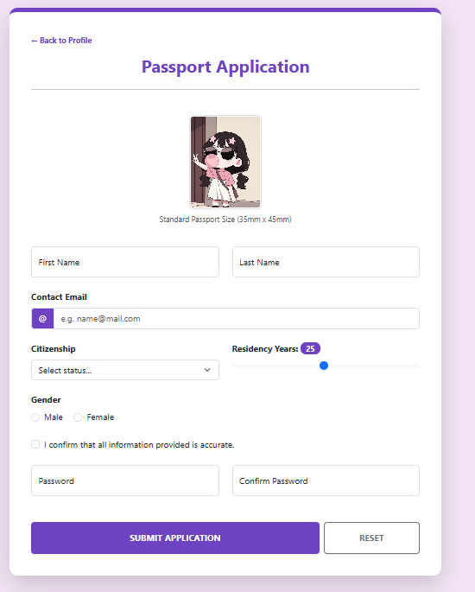

Mobile View
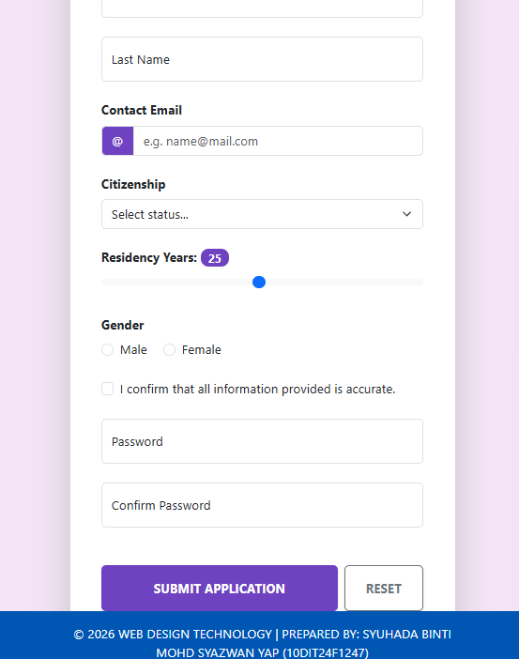
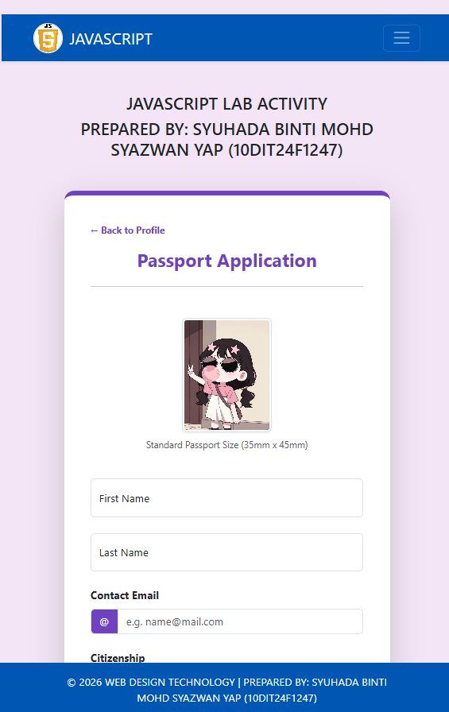

6. LAB SUBMISSION TASK
Ensure you have completed all steps successfully!
- Compress your folder: _{RegNo_Date.zip}.
- Report: Create a PDF containing all screenshots and explanations:
Report_RegNo_Date.pdf.
Happy Coding! Success is in your hands!

