Election Cycle Market Analysis

Peter Cosgrove | Rebecca Strauss | Shadab Tajwar
Long Island University | Long Island University | Long Island University

Abstract
This paper will continue to build on previous research and analysis of the stock market from other published works of academia as well as some of our own insights and theories. We will utilize machine learning and deep learning to help predict the future prices of a stock, commodity, or asset class. With the timing and requirements of this paper, we have decided to incorporate current events into our model. The 2024 United States Presidential Election is one with great anticipation and polarization. We will assess the stock market based on many different factors of United States election years, focusing on the time period between election day, typically the first Tuesday in November, and Inauguration day, which occurs on either January 20th or January 21st of the following calendar year.
Keywords— Machine Learning, Deep Learning, Price Prediction, Technical Analysis, Fundamental Analysis, Public Sentiment, United States Election
Introduction
The origins of the stock market in the United States trace back to the late 1700s when a small group of merchants created the Buttonwood Tree Agreement to trade stocks and bonds. This was the origin of the New York Stock Exchange (NYSE), officially formed in 1817. Since its inception, the stock market has attracted a variety of participants—speculators, informed investors, and even those with insider knowledge—each attempting to predict stock prices over different timeframes, whether for the end of the day, the following day, or the next month. There is a long withstanding hypothesis that the stock market will follow what is known as an Efficient Market Hypothesis. This operates under the assumption that all markets are already priced to perfection using all known data, creating the implication that it is impossible to outperform and predict the future in the process. Our goal is to disprove the hypothesis by creating a predictive model that will outperform the Efficient Market Hypothesis.

- TYPES OF STOCK MARKET ANALYSIS
- Fundamental Analysis
The purpose of Fundamental analysis is to determine the fair market value, or true value of a stock. It does so by analyzing many micro and macroeconomic factors. This includes public sentiment like newspapers, social media, TV, and other forms of social interaction that may contribute towards the price of a stock. Observing when institutional investors may have a liquidation event, based on anticipated tax reduction, is an example of an economic factor that contributes to the price of a stock without directly involving anything to do with individual performance. This selloff by institutional investors usually occurs midway through Q4 of the year. Given the nature of our focus, geo-political factors should have a more fairly large impact on the markets in our window of choice.
- Technical Analysis
The technical analysis of a stock requires the examination of fixed data. It focuses solely on information that is objective. Unlike emotional trading, technical analysis relies exclusively on numerical data, allowing it to account for factors that human judgment might overlook.Typically, this method uses charts to identify trading signals, which are then combined with fundamental analysis to develop a comprehensive investment strategy.
- Incorporating AI Techniques
As technology continues to rapidly advance, institutional and retail investors continue to incorporate new techniques to attempt to gain an edge in the free market. The use of Decision Trees, Support Vector Machines, Artificial Neural Networks, Naive Bayes, Random Forest and Long Short-Term Memory have all proven to be helpful when analyzing fundamental and technical data points to predict the prices of assets. Each of these techniques attempt to identify patterns and relationships, while also incorporating sentiment analysis.
- RELATED WORK
We have identified three main pieces of peer-reviewed literature that covered the principles of deep learning in relation to the stock market. These papers incorporated their own versions of fundamental and technical analysis to arrive at their own levels of prediction accuracy. These three papers were written in the last 5 years, however, based on how ever-changing the markets are, we cannot fully guarantee their accuracy of present day predictions based on several factors that were not present at the time of their research. We have also considered and analyzed additional papers that discuss the wide net that capital markets have to offer. Beyond just publicly traded corporations that are listed on the NYSE, there are other commodities or assets that are speculated and traded every business day, or in other cases such as Bitcoin, in a continuous market. We chose to incorporate the S&P 500, Gold and Oil into our own model in an attempt to more accurately predict the closing price in comparison to the Efficient Market Hypothesis. Each of these assets are long standing and are presumably highly correlated to politics in comparison to other assets.
- Online Tuning of Hyperparameters in Deep LSTM
This paper utilizes a Deep Long Short-Term Memory model focused on time-series forecasting, while experimenting with the online tuning of hyperparameters. The integration of a Genetic Algorithm (GA) allowed for the online tuning of learning rate, number of neurons and dropout rates. This integration allows the model to dynamically adjust to variations in the data, enhancing prediction accuracy. The GA iteratively searches for optimal hyperparameter configurations, leveraging a population-based approach to evaluate various combinations and select those that improve performance. The model is tested on several time-series datasets, showing that the DLSTM with online hyperparameter tuning consistently outperforms traditional DLSTM models with static hyperparameters.

The below graphic represents the basic framework needed to train and test the predictive model. The figure on the next pages assists in explaining the process of how hyperparameters are fine-tuned to achieve optimal results. [1]

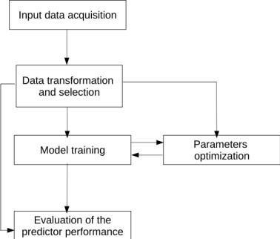

Figure.1: Flowchart for general financial forecasting with Artificial Intelligence model predictions.

The research formulated from this paper is ultimately rooted in prediction. The results gathered generally indicate that sentiment analysis in combination with financial data is the best approach to optimize a portfolio than just analyzing the financial data alone. A challenge was to keep any model involving sentiment analysis simple as there is a seemingly infinite amount of information available publicly. Using good discernment to identify data that is relevant and has an effect on stock price in the short and long term is the most important when considering this route of prediction.
- Using AI to Make Predictions on Stock Market
This paper touches on the previously mentioned topics of fundamental and technical analysis while also incorporating quantitative analysis. Each contributed to an educated decision-making process on their trading. This paper is particularly focused on short-term price prediction on general stock by strictly using time series data of stock price. The dataset featured 82 randomly chosen stocks from the NYSE with Alpha Vantage API to retrieve the data. The API provided intraday times series, daily time series, weekly time series and monthly time series. Several different methods of creating their predictive model were considered and tested with issues regarding overall performance, complexity, and computing power.
The below chart demonstrates the final results obtained, with a correct prediction rate of 70% based on predicted and actual price change for the next day. [2]

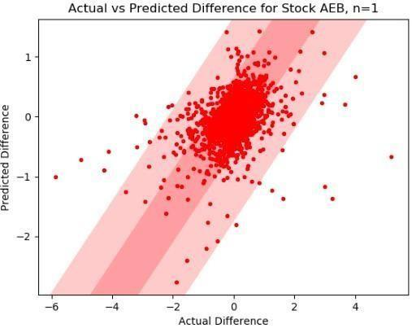

Figure.2: Prediction versus Actual Price Change over 1 day

C. Effectiveness of AI in Stock Market Prediction Bases on Machine Learning
This paper featured the utilization of regression machine learning to predict the stock price at the end of the business day based on historical price data. Traditional technical analysis was sourced from Yahoo Finance while fundamental analysis was sourced from public Twitter accounts that are associated with the stock market. Among ML algorithms, the decision tree (DT), support vector machine (SVM), and artificial neural networks (ANN) are the most popular ones employed to predict stock markets [In this study, besides using the ANN, DT, and SVM models, logistic regression (LR), Gaussian naive Bayes (GNB), Bernoulli Naive Bayes (BNB), random forest (RF), k- nearest neighbor (KNN), and XGboost (XGB) are employed for classification strategy; Linear regression and long short- term memory (LSTM) were used in regression problems. [3]
Although the machine learning aspects of their study were fairly complex, the diagram below displays how the framework was designed.

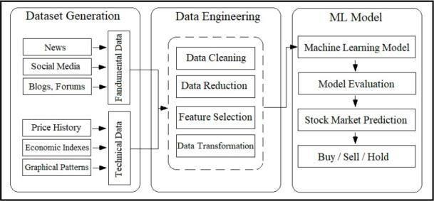

Fig. 3: The framework of model training to predict the stock market
The training data, the validation data and the testing data were all separated to help build the model. The model of this study was evaluated based on the performance of the prediction regarding the validation data. The overall conclusion of this study was that the SVM model was able to predict public sentiment with an accuracy of 76%. Based on the further analysis of the data, the model is not sufficient for long-term forecasting as the linear regression model cannot predict the closing price within a reasonable range of error on consecutive days as additional input would be necessary.

D. Long-Term Forecast of Energy Commodities Price Using Machine Learning
This paper focused on the long-term forecast of traditional models while using neural networks and random forest. It used these traditional machine learning models to analyze energy commodities with data from the International Monetary Fund (IMF). Oil, Coal, and Gas are all analyzed in the dataset for this study. The price of energy commodities is very much dependent on the world around us. World economic and political factors can influence the price of commodities and change them very drastically in a short period of time.
A hybrid model was composed to forecast based on several traditional econometric models. After weighing each model appropriately, artificial neural networks (ANN) were used to process information and capture nonlinear relationships between data points. The feedforward multi-layer perceptron (MLP) went through a trial and error to select the most important parameters and provide them based on the ANN for output. With over 1400 different combinations of ANN models and 1000 different random forest trees, this study went very in-depth with complex forecasting methods to identify irregularities in commodities

trading, excluding major world events that were marked prior to running the model to ensure accuracy. The conclusion formed from this paper suggests that random forest models were the most accurate when compared to other models run. The RF model was simple and delivered accurate long term results.
- Predicting the Price of Bitcoin using Machine Learning
Bitcoin is a very controversial asset class in the eyes of traditional investors. It represents a threat to the institutional traders as there are many different aspects that are not represented. At this time of writing this, Bitcoin’s total market capitalization is above $700 Billion. If it were traded as a stock or an index, it would be considered a top 10 asset in the public domain. This paper demonstrates the implementation of a Bayesian optimized recurrent neural network (RNN) and Long Short Term Memory (LSTM) network to achieve Bitcoin price prediction. The main goal of the paper was to determine to what degree the direction of the price of Bitcoin can be predicted using machine learning. The LSTM model took significantly more computing power and time to train in comparison to the RNN model. Each fell short of expectations in terms of accuracy of prediction with the LSTM at 52.78% accuracy and the RNN at 50.25% accuracy. This study was from 2016 when Bitcoin was far less popular and regulated. With Bitcoin gaining popularity by the day in public sentiment and in terms of actual capital invested, we believe that we can implement an accurate model in the present day with the help of the research provided in this paper. [5]
- ALGORITHM DESIGN
As per various studies cited here, Random Forest is a popular and successful model used for predicting the future movement in financial data. Random Forest is well suited for modeling intricate relationships by capturing non-linear and complex patterns. Financial data typically has such patterns in its price movement. Random Forest is a decision tree-based model that uses random samples across multiple trees to find an average pathway towards reliable probability and this works well in predicting market price behavior. The financial data will be pulled from Yahoo Finance (a very reliable and clean data set) for the past 10 years where it will be split between training (up to the past 90 days) and test validation (past days days). The training price data will be run through the Random Forest model algorithm and then the test pricing data will be predicted using the model. The code will compare the predicted result (direction of price) to next day’s actual closing price to determine the accuracy of the prediction for each day in the past 90 days. We will then capture the direction (up/down) of the next day’s (tomorrow’s) expected price movement.
A. Asset Selection
To use for our input prices, we have selected 8 asset classes with varying degrees of correlation. This included the S&P500 index (SPX) which is comprised of the 500 top companies listed in the US. From this index, we also picked Tesla and Apple which are 2 of the most talked about and invested companies in the world. The Tesla stock also experiences quite a bit of volatility which makes it interesting from a predictive perspective. Added to this list are commodities Oil and Gold, cryptocurrency standard Bitcoin, and finally the 20-year US Treasury fund TLT and the US Dollar index versus other currencies commonly referred to as the DXY.
For training the data we decided to import prices since 2010 and exclude the last 90 days for testing and validating the accuracy of the prediction. This training data will be run into the 3 models to fit or train the model and then the test set will be fed in as a prediction set to determine both past 90-day accuracy as well as the prediction price result for tomorrow which will be compared to our prediction (up/down) of the price. We will adjust the models with various numbers of hyperparameters to include a number of Random Forest or number of epochs and sequence length and layers or depth of the model in the case with Long Short-Term Memory.

We will also test with various inputs besides the closing price of the symbol including volume and moving averages.
B. Random Forest
Random forest is a machine learning algorithm which combines the output of multiple decision trees in order to figure out a single predictive result. It is easy to use and flexible and works well with both classification and regression problems. Decision trees are fairly commonly used in machine learning problems but can be prone to bias and over fitting. The random forest decision tree algorithm has shown to solve some problems more successfully than standard decision trees because the multiple trees form an ensemble especially with data that is considered unpredictable like weather and stock forecasting. In ensemble methods, the decision of multiple models is aggregated to determine the most common and likely result. Because the data is processed independently in multiple trees this approach works well to reduce variable nature inherent in asset price behavior. The key benefits of Random Forest are reduced risk of over fitting, flexibility in the type of data, and a simple way to test various variables to determine their importance in the data set. After testing multiple variables like price, volume and moving averages it was straightforward to determine that the most consistent and reliable prediction result accuracy was from just using the data and end of data price. Some of the key difficulties of Random Forest have been shown to be that it can be more time consuming and more complex than a single decision tree model but, in the training, and testing of our data the Random Forest models performed faster and more consistently than the other models investigated include LSTM and SVM.
C. LONG-SHORT TERM MEMORY
RNN’s were included to assist in predicting sequential data. LSTM assisted in capturing and remembering long term dependency. LSTM is adaptive and can adjust based on incoming data. It can automatically learn relevant features from historical data which was advantageous for our research.
Recurrent Neural Networks were implemented with a deliberate strategy in mind, to discern and predict patterns within sequential data. The utilization of Long Short-Term Memory played a remarkable role in capturing and retaining long term dependencies. The dynamic elements of LSTM allowed for the adjustment of parameters during real time to correct itself with newly implement data points. The ability to adjust allowed for optimization as the model evolved over time.
The ability of LSTM to make informed predictions also played a large role in our research. Extracting the most influential data allowed for results to return with slightly more accuracy.
For the prediction sheet, we will update the predicted price as well as our own predictions starting by 11.20.23 and finishing by 12.8.23 so there is ample time to evaluate and analyze the results and then make our conclusions.
- MIDPOINT CONCLUSION
At the midpoint of the project, we determined that our analysis will not be perfect, but if the correct technical analysis is analyzed along with a simple understanding of how the present world is unfolding, we will be able to build a final model that will predict accurately compared to our human predictions. SPX, TSLA, APPL, OIL, BTC, DXY, GOLD, and TLT will all be predicted by our final model. This moderate time period also includes major geo-political events that are unprecedented, as well as anticipated traditional Q4 results such as large institutions trading off for what is known as a Tax Loss Harvesting event. In spite of these factors, we will attempt to build this model to the best of our ability utilizing the best-known datasets and compiling the best possible code to accurately predict the price of the given assets for each time period. [4]

- FINAL RESULTS
The overall length of human prediction spanned 14 days of the market being open, with a half day on “Black Friday”, November 24 2023. Bitcoin is traded 24/7/365, but since our datapoint were at the market close at end of day, we have used those calculations for Bitcoin. The human versus AI test began on November 20 2023, where the prediction from each of the 3 models plus the human prediction for each of the 4 students would be captured prior to 10am the next day. The models would be run after 5pm and allowed to run overnight to complete prediction cycle. Also, to track the success of the results we set up $1,000,000 paper trading accounts (fictional money) using the software Trading View were based on the predictions we would buy/sell the assets listed above at around 10am and track the profit and loss of each predictor. The size of each purchase would amount to approximately $10,000 or 10% of the account. To simplify matters we would just buy ‘long’ positions and hold them until the direction up/down of prediction changed. As a comparison we also set up 1 account to be a passive account which would just buy and hold all assets for the 14 days and 1 account would be a coin flip.

For prediction the model would predict tomorrow’s closing price. After research it was discovered that predicting any farther into the future was discovered to be inaccurate.
Example of Prediction using RF model.
[*********************100%%********************] 1 of 1 completed
Average Mean Absolute Error: 2.17
R-squared (R2) Score: 0.84
Total Accuracy for the Last 90 Days: 51.11%
AAPL

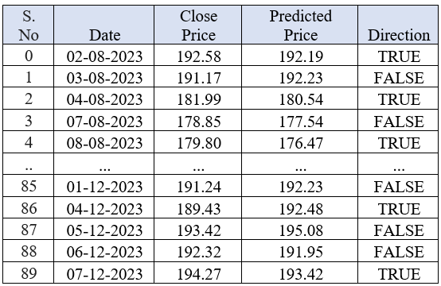
Figure.4: Predicted Closing Price and Direction of an AAPL Stock

Last Known Price: 194.27
Predicted Tomorrow's Price using Random Forest: 193.42
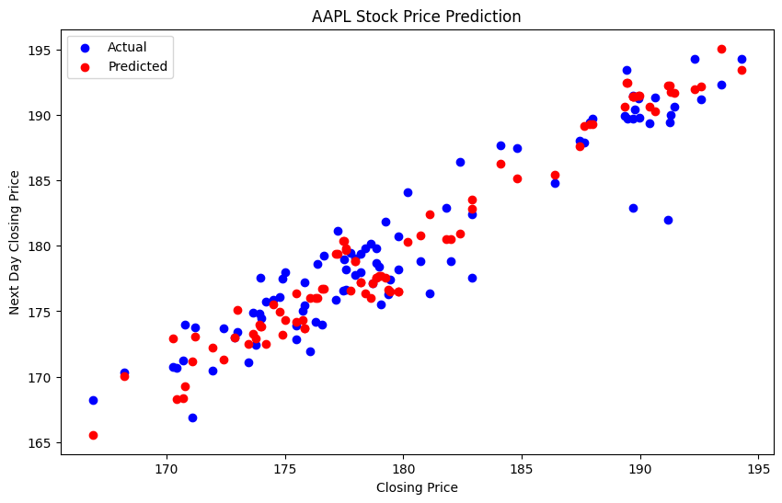
Figure.5: Scattered Dot plot of AAPL Stock Price Prediction
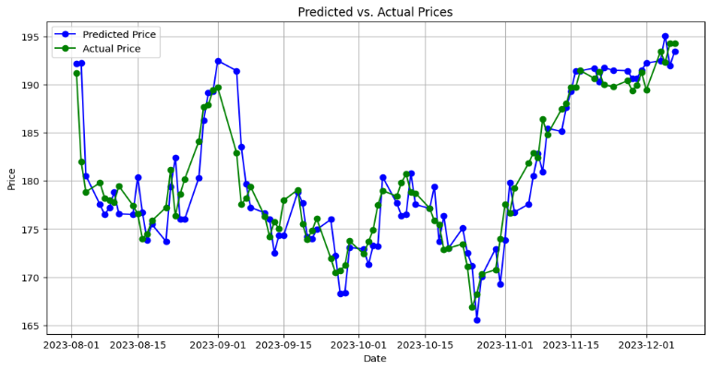
Figure.6: Line plot of Prediction Vs Closing Price of AAPL Stock
After 14 days the results for the trading accounts based on the daily buying or selling of assets. The AI had the best results with a $36,000 increase in value (3.6% return) What has to be factored into the results was the timing of the exercise seemed to coincide with a significant upside move in the price of Bitcoin and TLT and a downside move in Oil. On the equity side the price of S&P 500, Tesla, and Apple did end up positive but there were some fluctuations in up/down movement so the bulk of the returns were captured from the movement upwards in Bitcoin and Bonds (20-year TLT) and the ability for the AI to buy and hold these and appropriate times. The AI had better returns than all 4 students as well as the passive approach. One exception was the coin flip which returned slightly better end result than the AI. AI did 2x times better than the worst student and close to 50% better than the best student and the passive model. Another important note to make is that this was limited test constrained to 3 weeks and it should be possible to say that the AI could have just gotten lucky as is obvious the case with the coin flip. At one point in the middle of the testing phase the coin flip was doing the best and so if the test phase had been shorter the results of the trial could be significantly different. Also, as you can see from the accuracy of the predictions, it’s close to 50% but what you can say about the AI is that its bias from fundamental events is discounted unlike the human predictors who could have been swayed by new events or market sentiment.
Both the RF and SVM model were consistent in the predictions and easy to track from daily run to run. The DNN (Deep Neural Network) model was based on LSTM algorithm which followed a layered approach of 10 layers, 50 nodes or neurons per layers and a training run with 10 epochs and sequence size of 7 was very inconsistent in its price and prediction from run to run. Although the direction seemed to be consistent the price differences between runs made the model seem unreliable and therefore not a recommended approach. For instance, in some runs the price for the S&P 500 would be consistently $100 below the current prices and then in the next run it would be $100 dollars above the current.
These runs were executed from different systems within a few minutes of each other.
Run 1: Total Accuracy for the Last 90 Days: 48.89% ^SPX
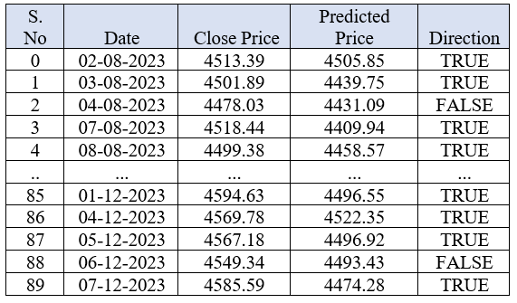
Figure.7: Predicted Closing Price and Direction of an SPX Index (Run1)

Run 2: Total Accuracy for the Last 90 Days: 47.78%
^SPX
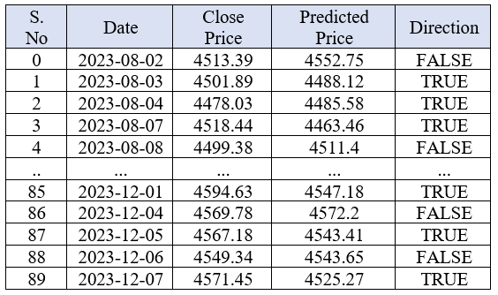
Figure.8: Predicted Closing Price and Direction of an SPX Index
Run-2(One hour later)
Attempts to optimize the LSTM model using different density layers, sequence sizes, unit sizes were found to not increase the past 90-day accuracy and provided closest to 50% accuracy with the results. “Online Tuning of Hyperparameters in Deep LSTM for Time Series Application” was reviewed to determine if any other optimizations can be made and discovered that there does exists a DLSTM model that leverages several layers of LSTM models and uses dynamic tuning of the hyperparameters to produce a result with close to 1/3 the error of the static tuned model as used in this example. Future testing utilizing this DLSTM approach could be warranted.
In the end the consistency and quickness of the Random Forest (RF) model made it an obvious choice for this exercise. Although there was close to 18 hours lag between prediction and sale/ purchase if one were to execute trades right after prediction then the Random Forrest would beat the timing of SVM an LSTM by several hours an if running in a standalone workstation possibly overnight. It would be curious to see how the trading results would differ if the time between prediction and execution were within the same relative time frame.
In conclusion, there are some positive results from the trial that could warrant further investigation and research. It’s inconclusive whether using AI would be beneficial as an investment strategy but there are signs that it may provide a more objective and consistent approach to investing methodology.
Below is the net increase/decrease in funds in our simulated trading accounts.
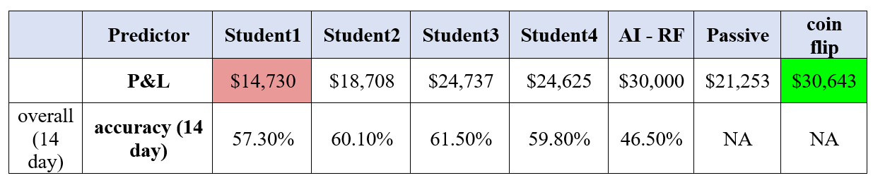
Figure.9: Profit & Loss and Final Accuracy of AI Model vs Humans
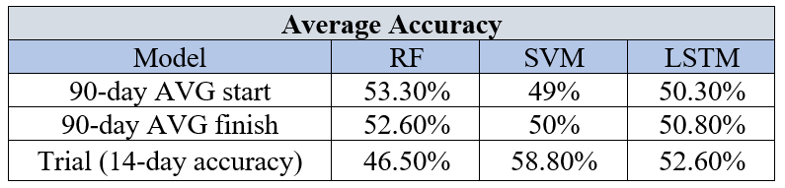
RF-Random Forrest, SVM- Support Vector Machine, and LSTM- Long Short-Term Memory
Figure.10 Average Accuracy of 90-day start to finish Trail

- ADDITIONAL RESULTS

In our pursuit of a comprehensive understanding of the LSTM-based model proposed in this paper, we extend our analysis to encompass additional dimensions.

In the figure below, the predictions for TSLA are shown for the next 60 days. In our previous LSTM research, the model was generally more accurate when the asset in questions was less volatile on a day-to-day basis. With a fairly large trading volume, TSLA has been volatile in the past and may also be in the future. The 60-day prediction forecasts are sharp increase in trading price for TSLA. Our model does not include sentiment analysis to monitor ongoing macroeconomic factors, so there are many factors that are not taken into account.
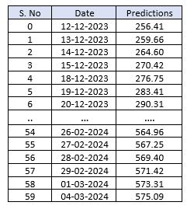
Figure.11: LSTM Prediction of Tesla stock for next 60- days
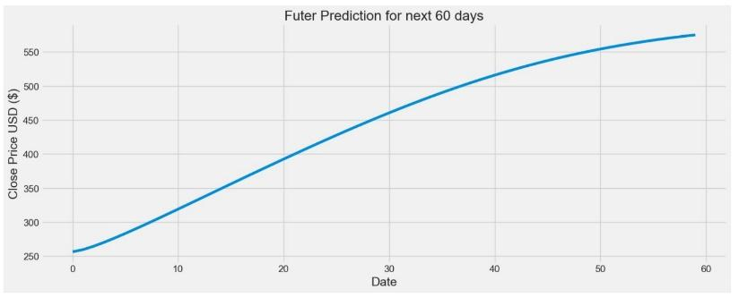

Figure.12: Line plot of LSTM Prediction of Tesla stock for next 60 days
- ACKNOWLEDGMENT
This paper was written as a midterm project presentation for AI790 as part of the Masters of Science - Artificial Intelligence program at Long Island University. Our professor Reda Nacif Elalaoui has assisted in the guidance of the knowledge needed for this paper as well as direct feedback for continuous improvement.
Contributions:
  - Data Analysis , Literature Review, and Model Creation by Rebecca Strauss
  - Literature Review, Model Creation, and Composition by Peter Cosgrove
  - Literature Review and Project Analysis by Shadab Tajwar

REFERENCES

- F. G. D. C. Ferreira, A. H. Gandomi and R. T. N. Cardoso, "Artificial Intelligence Applied to Stock Market Trading: A Review," in IEEE Access, vol. 9, pp. 30898 - 30917, 2021, doi: 10. 1109/ ACCESS.2021.3058133.
- Sohrab Mokhtari, Kang K. Yen, Jin Liu, Effectiveness of Artificial Intelligence in Stock Market Prediction based on Machine Learning, arXiv preprint arXiv:2107.01031, 2021
- Alice Zheng and Jack Jin, Using AI to make Predictions on Stock Market, Standford University, 2017
- Gabriel Paes Herrera, Michel Constantino, Benjamin Miranda Tabak, Hemerson Pistori, Jen-Je Su, Athula Naranpanawa, Long-term forecast of energy commodities price using machine learning, Energy, Volume 179, 2019
- Sean McNally, Predicting the price of Bitcoin using Machine Learning x15021581 MSc Research Project in Data Analytics 9th September 2016
- Subba Rao Polamuri, K. Srinivas, A. Krishna Mohan, Stock Market Prices Prediction using Random Forest and Extra Tree Regression, September 2019
- Michel Ballings, Dirk Van den Poel, Nathalie Hespeels, Ruben Gryp, Evaluating multiple classifiers for stock price direction prediction, 2015
- N. Bakhashwain, A. Sagheer “Online Tuning of Hyperparameter in Deep LSTM for Time Series Applications” International Journal of Engineering & Systems, 2020

