PFA screenshot for reference

Login:

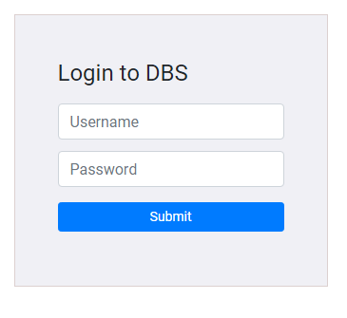

Login – Validation

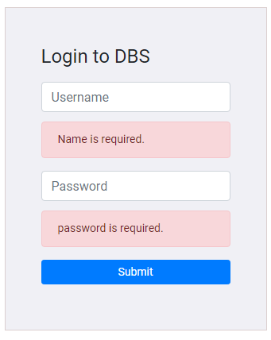

Home screen: Desktop View

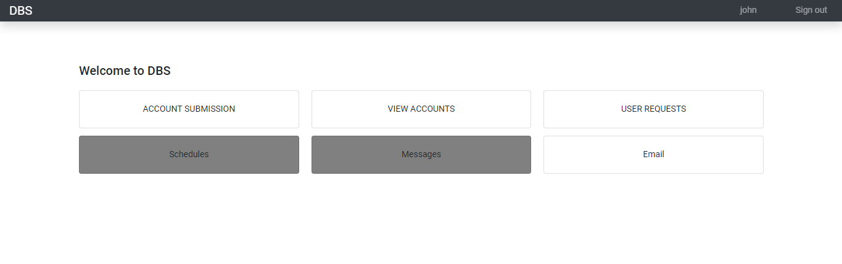

Homescreen : Mobile view

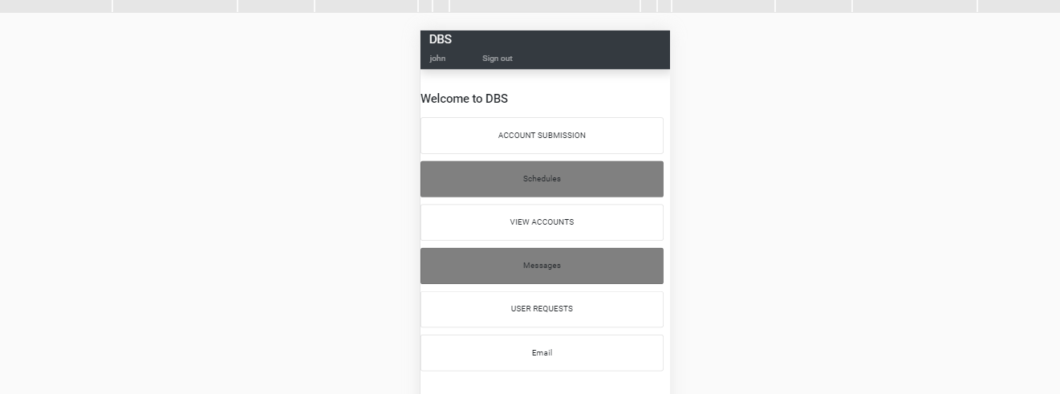

Account submission

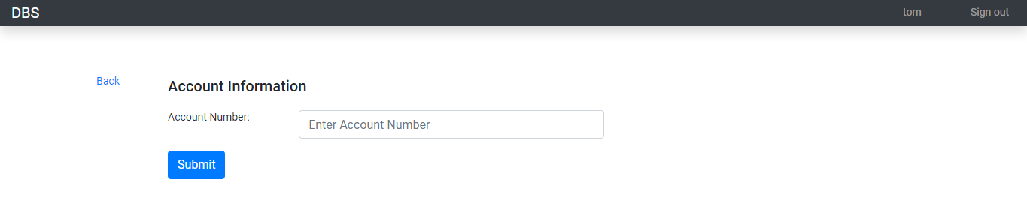

Exclusion Account

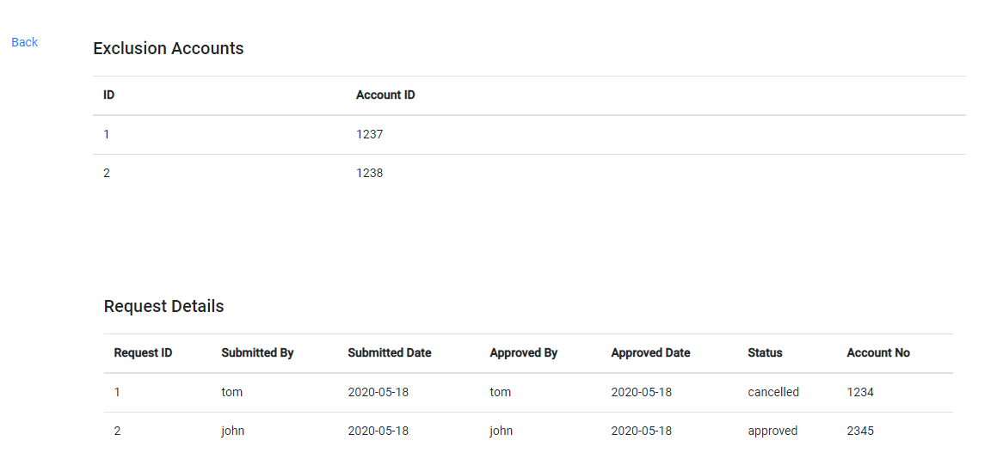

Approval screen for Admin user

