**To kill a process on Windows**

Step 1: Find the process id

netstat -ano | findstr 8080

Step 2: Open command prompt as administrator and kill the process

taskkill /F /pid 1088

In my case port 8005 was already in use so I used the same above steps.

[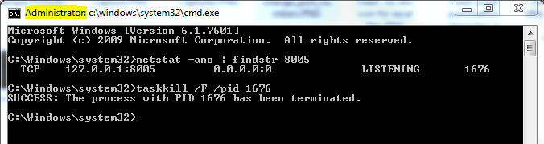](https://i.stack.imgur.com/XiEWI.png)